






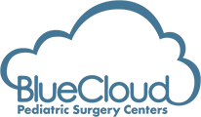
Confidential

Blue Cloud Community Meeting
May 28th, 2026

Confidential

Vision: To Be A Leader In Safety and Quality For Pediatric Patients Treated in Surgery Centers


Mission-Driven Impact Core Values

Expand Access to Care

Exemplify Safety & Quality

Reduce Costs to Patients & Payers
Cheerfully Work Hard

Individually Empathetic

Keep Commitments


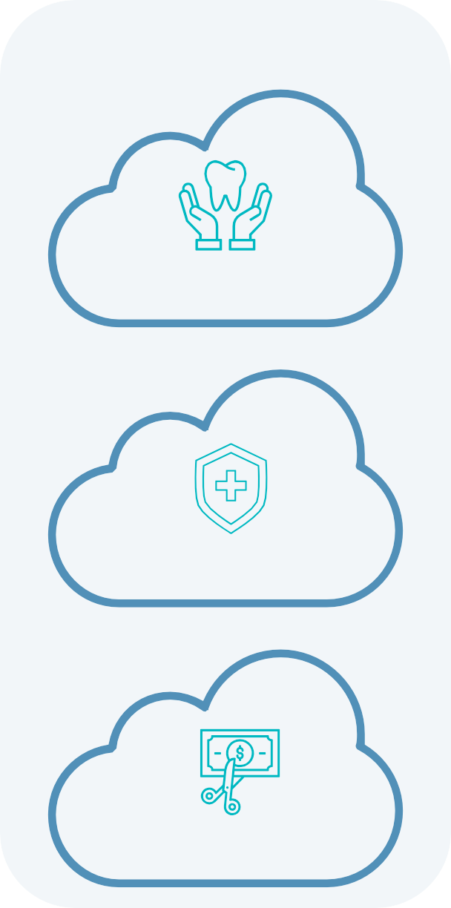
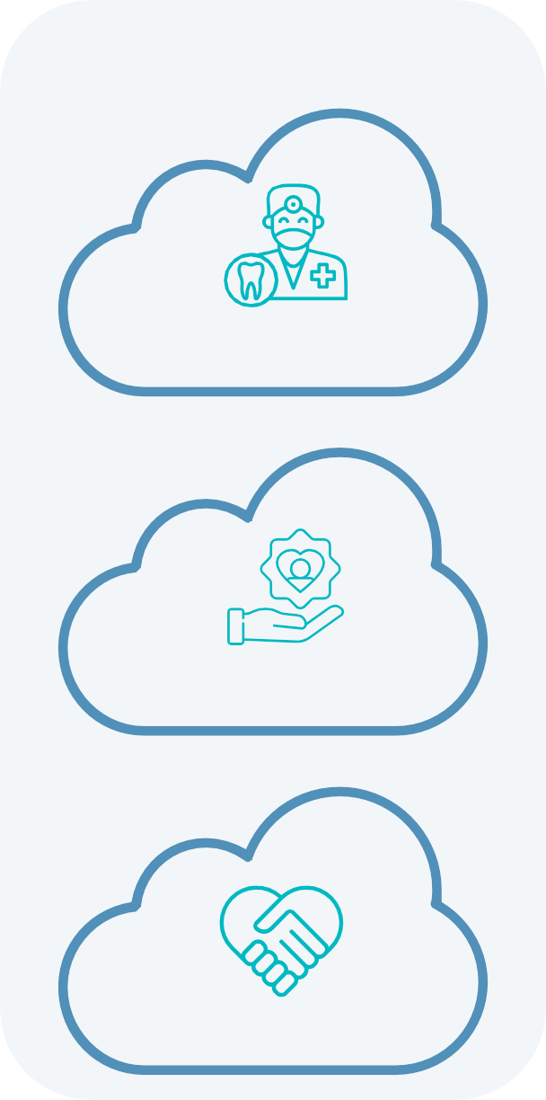

1

Confidential
1.
2.
3.
4.
5.
Per CDC 2024
Per Casamassimo et al. 2009 Per AAPD 2021
Based on total patients served in 2025 Estimated per TPG Y Analytics methodology
2

Blue Cloud’s Benefits to the Greater Boston area
Blue Cloud drives improved oral health outcomes and quality of life for vulnerable pediatric patients with limited access to quality care



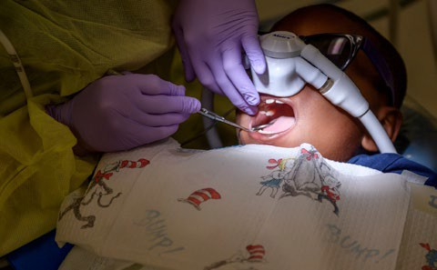



High Disease Prevalence:
- Tooth decay is the most common chronic disease among children in the US, and over 1 in 10 U.S. children have an untreated cavity
  - Children living in poverty are 2x as likely to have untreated cavities than children from higher income families1
  - Left untreated, cavities can cause pain, infection, and affect childhood development2
Limited Access to Care:
- Hospital operating rooms increasingly deny pediatric dental care in the U.S., which disproportionately affects poor and minority children on Medicaid3
Societal Need
65K+
Patients served annually4
~93%
Medicaid/CHIP payor mix
Estimated impact
$14.5K generated per patient
for restorative care5
Key Impact Metrics
Blue Cloud addresses prevalent need and removes barriers to access to care, improving oral health and quality of life for vulnerable children
Output Outcomes Impact
Restorative and surgical procedures administered
Reduced dental pain and discomfort
Improvement in oral health
Value
$
Reduced disability-adjusted life years (DALYs) lost

Confidential
3

Blue Cloud Provides Outstanding Care and Critical Access to Underserved Pediatric and Special Needs Populations




Clear Value Prop Leading Results & Patient Testimonials

Quality of care is without question Blue Cloud’s top priority
“I want to express my deepest gratitude to the entire staff for the care my little sister and brother received during their surgeries… The nurses in the back were equally wonderful and so gentle and attentive throughout the entire process. I am forever grateful for the compassion and professionalism shown to us.”
-Guardian, Miami’s Children’s

9.5 / 10
Avg. Patient Satisfaction Score

Highest Quality Care
- Patient high-level incident report rate of <0.02% (75% below industry average)

- 6 – 18 month wait time without Blue Cloud
“The entire process went smoothly, and I definitely would recommend this facility, they are amazing with children. Thank you for such a wonderful experience for my son it was very helpful to be able to get all of his stuff finished within one visit.”
–Parent, Cleveland Children’s
<24 hours
Blue Cloud consultation exams are scheduled upon referral

Access & Convenience
Blue Cloud accepts all payers and payer types – Provides affordable access to patients who may otherwise go untreated
- Efficient scheduling and visit structure optimizes number of patient visits

“Staff is always super friendly starting with correspondence over the phone. They absolutely keep the entire family in mind. The Doctor was very thorough in his explanation with the plan of action.”
–Parent, Santa Maria Children’s

~17%
Of patients have Special Needs

Population-Tailored Experience

- Facilities, processes and provider
expertise all specifically tailored to pediatrics and patients with special needs and their families


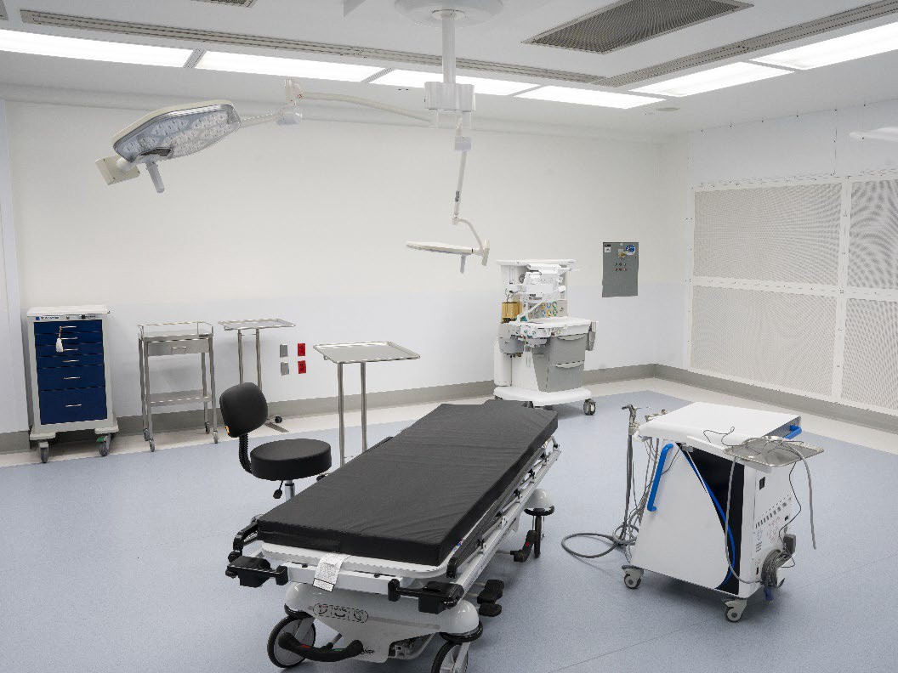

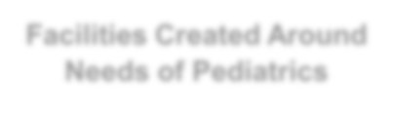


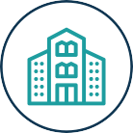










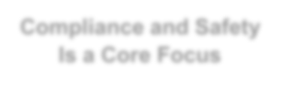


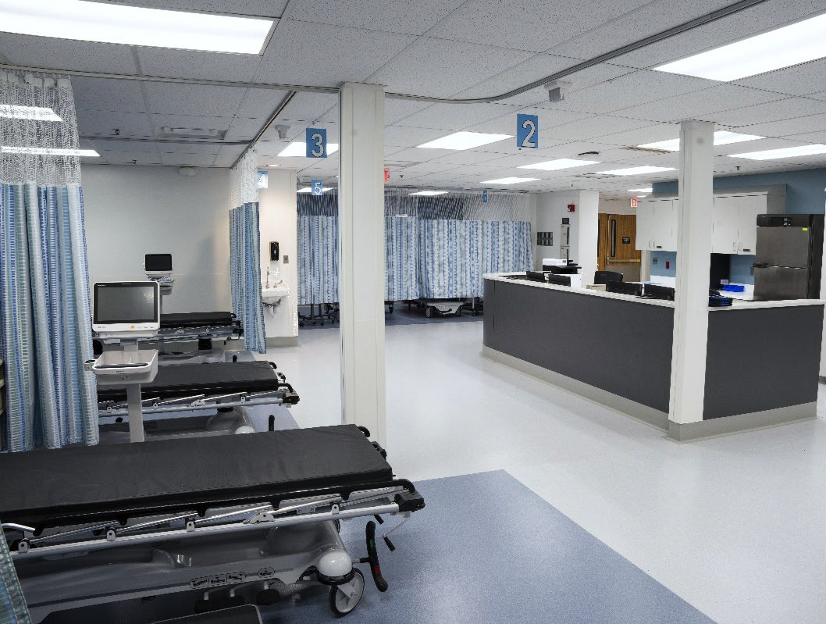
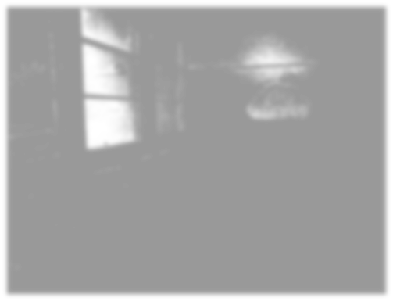
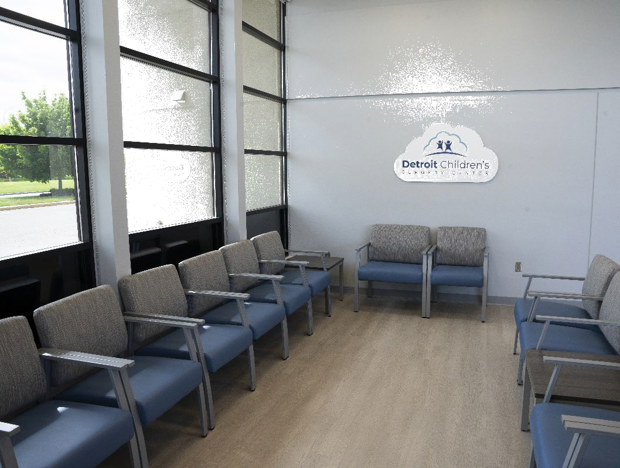
Confidential
Facilities are uniquely tailored towards pediatrics to ensure safer pediatric and special needs procedures compared to in-office alternatives
✓
✓
Specialized Tools and Supplies
Life-saving Equipment in Case of Emergency
- Pediatric-friendly Waiting Areas
All centers are AAAHC or JCAHO accredited (ambulatory healthcare facility gold standard)
~15%
Turnaway Rate1
(Key Compliance & Safety Measure)
<0.02%
High-Level Incident Report Rate
(75% Below Industry Avg.)

Modern Centers Built to Best-in-Class Safety and Care Quality Standards

Facilities Created Around Needs of Pediatrics
Critical Access Point
For Underserved Populations
Compliance and Safety Is a Core Focus
Community dentist referrals ensure high-need Medicaid / CHIP patients are only referred out of
medical necessity

16k+
Patients Seen Every Quarter

Source: ASC provider safety data per Third Party Market Study
Turnaway rate refers to referrals that are turned away due to potential factors that could complicate general anesthesia (e.g., patients who are fragile, underweight or have other conditions making general anesthesia unsafe) – Blue Cloud has high established compliance standards and only takes patients for whom procedures under general anesthesia is the appropriate course of treatment4

Confidential

Transfer of Ownership
Patients and community partners are being informed of the planned ownership transition, invited to attend a community meeting, and given the opportunity to provide feedback.

Transfer of Ownership

  - Dr. Kumar plans to retire this fall and transfer ownership of Northeast Ambulatory Center to Blue Cloud.
  - The proposed transaction remains subject to Massachusetts DPH Determination of Need review and other regulatory approvals.

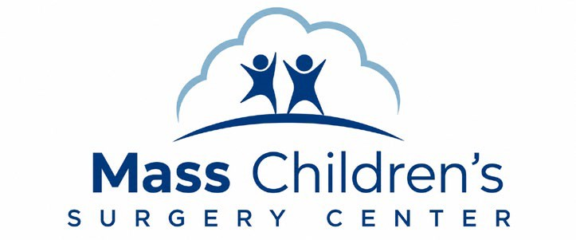
Service Transition
This transition creates an opportunity to preserve the Center as a local outpatient access point while shifting its focus toward pediatric dental surgery, a service line that can meaningfully benefit underserved children, special needs patients, families, and payors across the Greater Boston community.
5

  - The Center will continue operating as a single-specialty ambulatory surgery center.
  - Services will transition from pain management procedures to dental surgeries under general anesthesia.
  - Blue Cloud focuses on pediatric and special needs patients who are in need of access to general anesthesia.
Community Benefit







- & Impact

  - Expands access to care for the pediatric and special needs population
  - Significantly reduces the cost of care to the state and taxpayers
  - Reduces wait times for patients with limited access to anesthesia



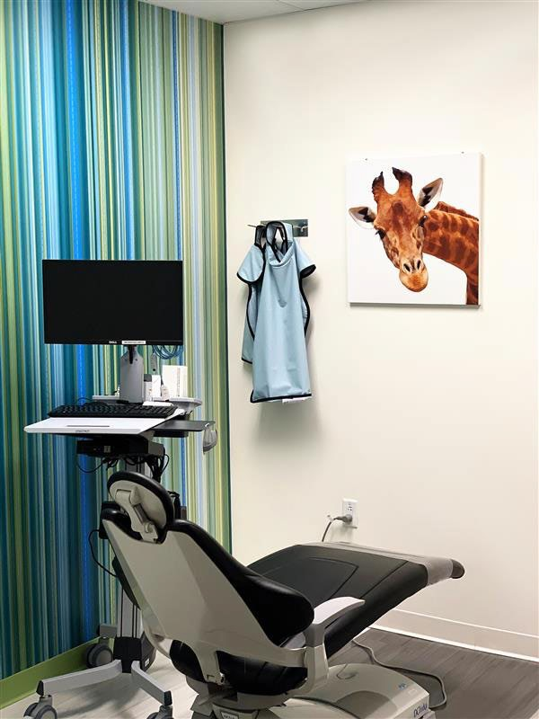
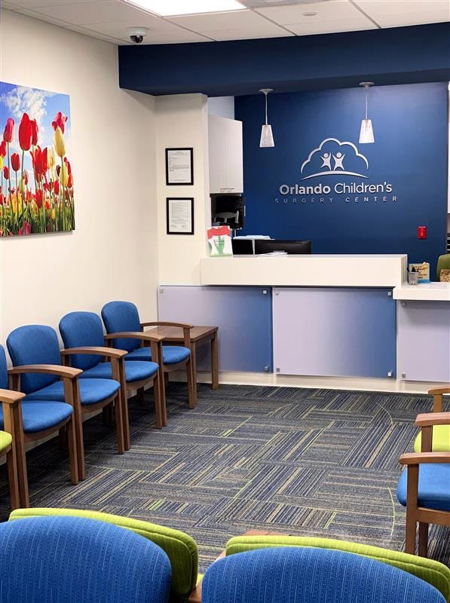
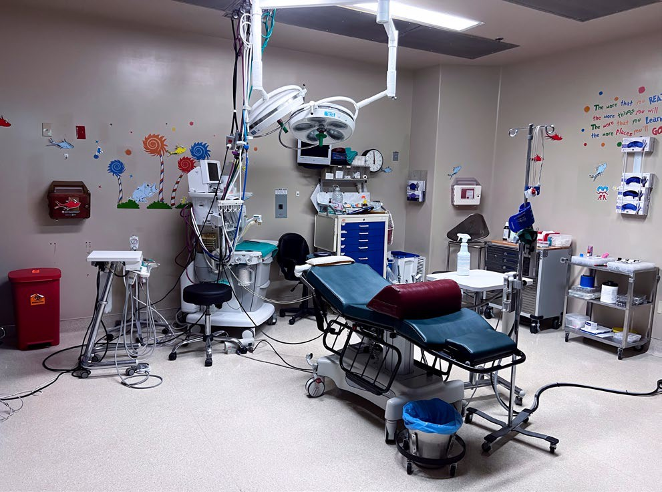
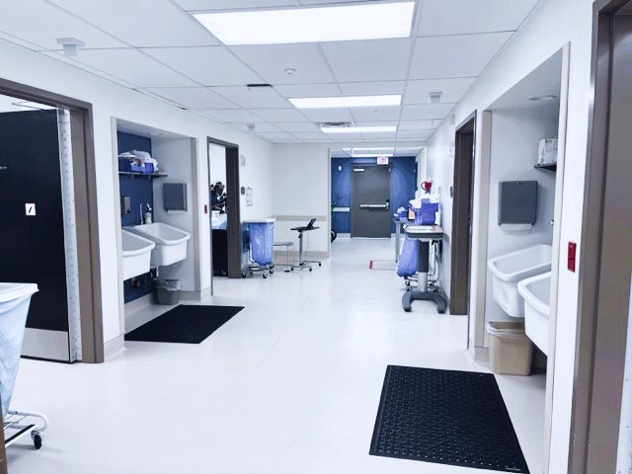
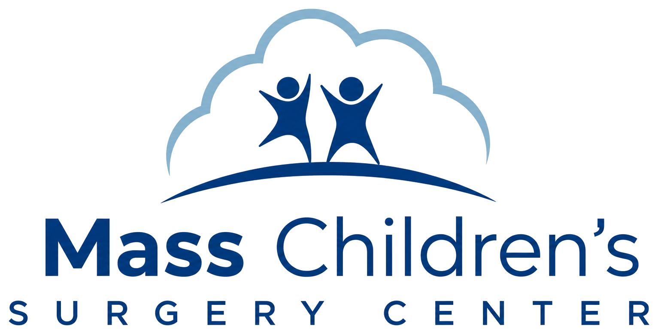
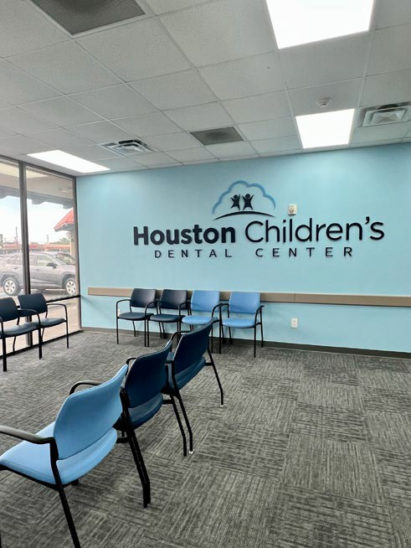
Confidential

Blue Cloud Designs
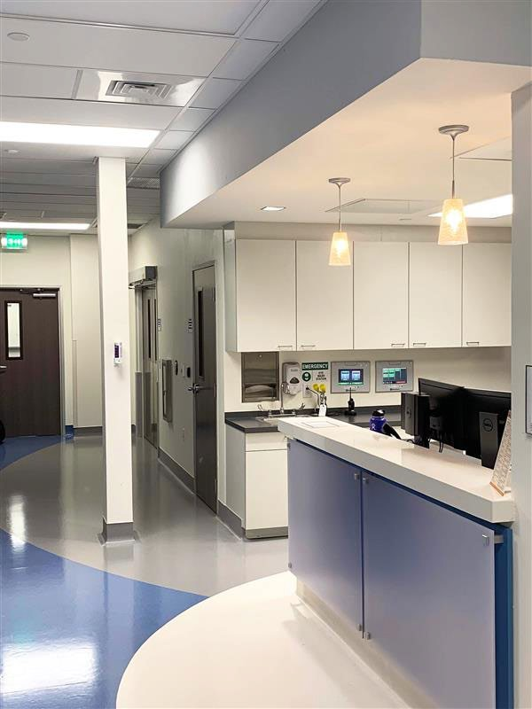

6

