Massachusetts Department of Public Health

Community Water Fluoridation Information for Water Operators

Angela M. Verheyen MSDH, RDH Office of Oral Health Program Lead

Introduction

This training is intended for Massachusetts water operators who work with Public Water Systems (PWS) and adjust fluoride levels for safe drinking water consumption. The slide deck will address fluoride reporting forms and issues, the Water Fluoridation Reporting System (WFRS), My Water’s Fluoride (MWF), tips for managing non-optimal fluoride levels, 2023 challenges and the new 2024 CWF quality awards criteria.

If you have any questions, email oral.health@mass.gov.

Overview

- Community Water Fluoridation (CWF) Statement
- CWF Reporting Forms
- Water Fluoridation Report System and Documentation Process
- Reports and Reporting Form Issues
- My Water's Fluoride Reporting Levels
- System Challenges
- Protocols and Processes
- 2024 CWF Quality Awards Criteria

Community Water Fluoridation (CWF)

The Massachusetts Department of Public Health strongly supports community water fluoridation as a safe, cost-effective, and proven practice promoting good oral health. Today, over 4 million people in Massachusetts receive the benefits of community water fluoridation.

The Office of Oral Health (OOH) also recognizes water operators' hard work and dedication to providing communities with the oral health benefits of
optimally fluoridated water.

Benefits of Fluoride

- For over 75 years, people in the United States have been drinking water with added fluoride and enjoying the benefits of better dental health. Water fluoridation is beneficial for reducing and controlling tooth decay and promoting oral health across the lifespan.

- Evidence shows that water fluoridation prevents tooth decay by providing frequent and consistent contact with low fluoride levels.

- Fluoridated communities reduce tooth decay by 25% in children and adults compared to communities that do not have fluoridated water sources.

- Additional evidence shows that school children living in communities where water is fluoridated at the optimal level of 0.7ppm have, on average, 2.25 fewer decayed teeth compared to children living in non-fluoridated communities.

Water Fluoridation Reporting System

What is the Water Fluoridation Reporting System (WFRS)?
  - WFRS is an online tool that helps states manage the quality of their water fluoridation programs. WFRS information is also the basis for national reports that describe the percentage of the U.S. population who receive fluoridated drinking water through community water systems.

  - Massachusetts has 132 fluoridated communities with 79 adjusted water systems that report fluoride levels to the OOH. Monthly fluoride reports are sent to the OOH and results are put into WFRS. WFRS is managed by the Centers for Disease Control and Prevention (CDC).

CWF Fluoride Reporting Form A

Fluoridation Report A

Purpose: This form is to be used by the PWS to document finished
fluoride concentrations from treatment plants. All pumping fluoridated sources MUST be tested daily for fluoride at the distribution system's entry point or after the fluoride application point.

Fluoride Reporting Form A

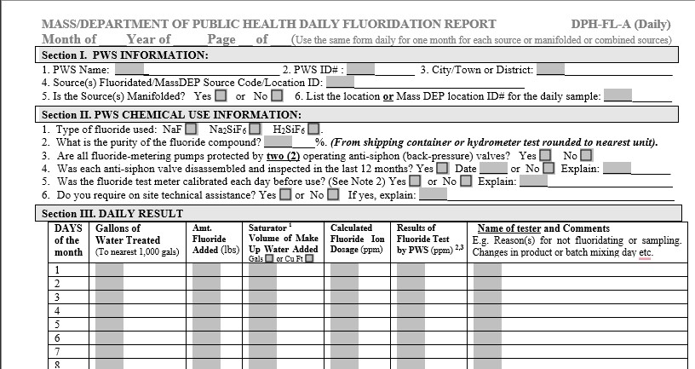

Reporting Form A Issues

Form A
    - Fluoride results are not averaged at the end of the month.
    - If fluoride was not added on any day, a reason must be stated in the comment area.

CWF Fluoride Reporting Form B

Fluoridation Report B (DPH-FL-B)

Purpose: This form is to be used by the PWS to document fluoride concentrations in the distribution system of the PWS.
  - At least four (4) distribution samples per month. One water sample from a tap(s) that represents the water from the distribution entrance point. At least one (1) distribution sample should be collected at a location(s) at a school or located within =1-2 miles upstream or downstream of a school.
  - If the system is providing water to other consecutive PWS, it must evenly distribute its 4 weekly distribution samples across the entire combined distribution system.

Reporting Form B Issues

Form B

The school sample is not collected, and/or the school sample is not documented on the form
    - Four distribution samples are not collected

Fluoride Reporting Form B

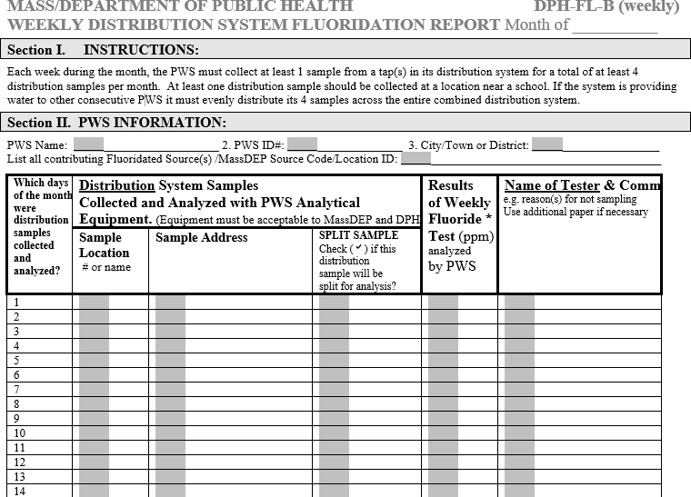

CWF Fluoride Reporting Form C

Fluoridation Report C (DPH-FL-C)

Purpose: This form is to be used by the PWS to evaluate the accuracy of the PWS fluoride testing equipment or laboratory. Each month, at least one (1) distribution sample MUST be split and analyzed by the PWS and a Massachusetts-certified laboratory.

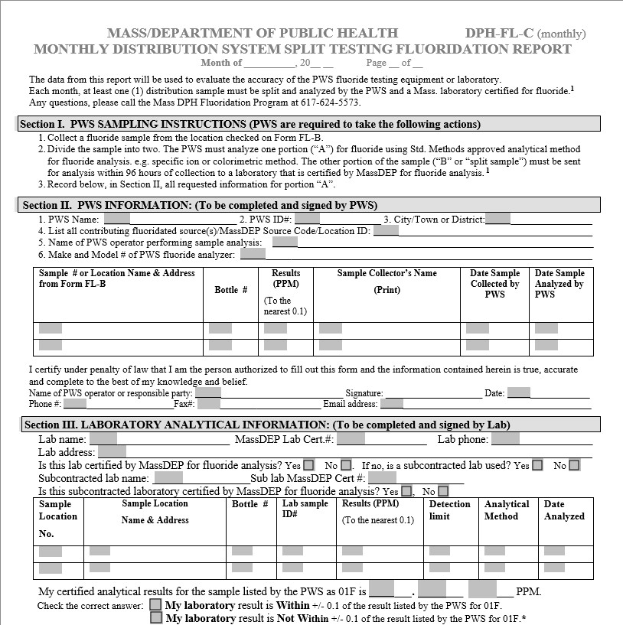
Fluoride Reporting Form C

Massachusetts Department of Public Health | mass.gov/dph 14

Reporting Form C Issues

Form C
- The form is sent in without lab results, or form C is missing from the report submission
- OOH was not notified within seven days, as stated on Form C, when the split sample was not within +/-0.1ppm
- Month-to-month PWS and lab results not with +/-0.1ppm are submitted without an indication of an internal protocol to address the not within results

Additional Reporting Form Issues

- Submission is missing forms
- Incorrect monthly reports submitted to the OOH
- Low fluoride readings or no fluoride added and no explanation in the comment area of the form
- Forms are sent as separate PDFs or some other format. Reports should be sent as one PDF with the following naming format – Town Name-PWS Number-Month and Year
  - For example: Acton-2002000-September 2023
- Reports must be submitted via email to oral.health@mass.gov
- Reports must be received on the 10th day of the following month
  - Example: February reports will be due on or before March 10th

Documenting in WFRS

Information from the CWF Reporting Forms are input into WFRS by OOH.

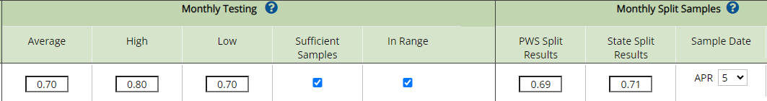
Image Credit: https://nccd.cdc.gov/DOH_WFRS/Shared/FluorideDataEntry_ByMonth.aspx

Average
- These are the results of the fluoride test average on Form A (multiple wells are averaged together as one monthly average)
High and Low Reading
- These readings are pulled from monthly fluoride reports

Documenting in WFRS Continued

Sufficient Samples Check Box
There must be a sample for each day of the month to be considered sufficient samples.

In Range Check Box
Form A monthly average must be in the range of 0.6-0.8 ppm as close to the optimal
0.7 ppm.

Monthly Split Sample
This information comes directly from Form C results of the PWS split , and Lab split results with sample date.

My Water's Fluoride Information

My Water’s Fluoride (MWF) allows consumers to learn about the fluoride level in
their drinking water. A snapshot of what can be accessed through MWF
- Fluoridation status
- Fluoridation levels by city and town
- The number of people served
- The water source

As of June 1, 2023, the OOH turned MWF from a basic level report to an advanced level report.
- Advanced level displays all reports in MWF, the Fluoridation Status Report (with operational summary), Natural Systems Report Fluoridation status report, Operational Report, and the Average Fluoride Levels Report.

Addressing Common Problems

Water Operators have shared internal protocols or processes for addressing non- optimal fluoride levels, including:
- The split sample is not within +/- 0.1ppm.
  - Re-test the same sample if it is available
This can be set up as a standing order with the lab
  - Complete a more involved look at your system
- When the monthly average fluoride (form A) is less than 0.6ppm or greater than
0.8 ppm
- Troubleshoot the system
- Calibrate the instrument in question
- Clean out the saturator
- Contact DEP for technical support

Many Communities have experienced system challenges

Workforce Challenges
System Challenges
  - Key positions are vacant
  - Loss of historical knowledge when folks retire
  - New employees
  - A limited number of staff trained on fluoride and reporting systems

Equipment Challenges
- Aging equipment
- Critical equipment updates and repairs that take fluoride offline for months
- Temporary suspensions due to product shortages

2024 New CWF Quality Awards Criteria

The criteria for CWF Quality Awards have been updated for 2024
  - Adjusts the fluoride concentration of their drinking water
  - Achieves a monthly average fluoride level that is within the optimal range for a minimum of 9 reporting months within a calendar year
    - Where the optimal range is defined as 0.6-0.8 ppm, with the goal of falling as close to the optimal fluoridation level of 0.7 ppm as possible
  - Documents their fluoride levels in the CDC’s Water Fluoridation
Reporting System
    - The Office of Oral Health requires timely reporting of monthly data from water operators to manage this requirement on their behalf.

THANK YOU

Connect with DPH

@MassDPH

Massachusetts Department of Public Health mass.gov/dph

