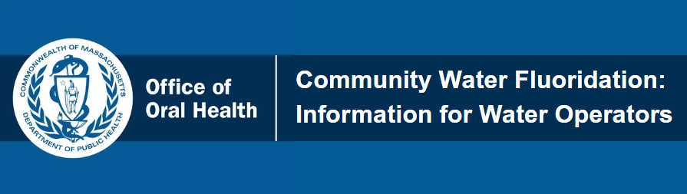

Frequently Asked Questions on Community Water Fluoridation

Q: What is fluoride and how does it protect teeth?
A: Fluoride is a mineral found in soil, water, and rocks. Almost all water contains some naturally occurring fluoride. It works by strengthening the hard outer layer of the teeth, called enamel, making teeth more resistant to tooth decay, and reducing bacteria that can cause tooth decay. Tooth decay is a preventable chronic disease affecting all age groups. Oral health is integral to general health.
Fluoride is naturally occurring. Fluoride has no known interactions with any medications.

Q: What is community water fluoridation? How does it benefit everyone?
A: Community water fluoridation – or CWF – is the process of adjusting the amount of fluoride in drinking water to a level recommended for preventing tooth decay and improving oral health. CWF prevents tooth decay by providing frequent and consistent contact with the optimal levels of fluoride. There is 25% less tooth decay in communities with optimal levels of fluoride in the public water supply compared to communities that do not fluoridate.
Over 4 million people in Massachusetts receive the oral health benefit of fluoride in their drinking water. Not all public health interventions reach everyone. CWF has the potential to reach everyone in a community with a public water supply and improve access to better oral health for all.
Look up your community’s fluoridation status here: https://www.mass.gov/info-details/community-water-fluoridation-status

Q: Beyond the health benefits of community water fluoridation, what other benefits are there to adding/adjusting the fluoride in our community water supply?
A: The optimal level of fluoride in drinking water reduces tooth decay (cavities) by about 25% for everyone, which has the potential to save each person $32 each year in dental treatment costs¹. For every $1 spent on fluoride, there is an estimated $20 return on investment in savings in dental treatment costs.

Q: What is the optimal level of fluoride to prevent tooth decay?
A: The optimal fluoride concentration in water recommended for tooth decay prevention is 0.7mg/L or ppm as established by the consensus of the scientific community. When determining the optimal level, all sources of fluoride are considered. This recommended optimal level aims to best support dental health and minimize risks like dental fluorosis (excessive fluoride leading to discoloration, mottling, and sometimes pitting of the enamel of the teeth).
To view your community’s average monthly fluoride level, consult “My Water’s Fluoride”, select “Massachusetts”, and under “fluoridation reports” you can review your water system’s “average fluoride levels by month report”.

Q: Our constituents are reaching out more frequently with questions about the safety of community water fluoridation. Has anything changed about the safety of CWF?
A: Based on the consensus of scientific literature, the Massachusetts Department of Public Health (DPH) continues to recommend that municipalities amend the levels of fluoride in drinking water to align with 0.7 milligrams per liter (mg/L) to help prevent tooth decay and promote good oral health.
DPH will continue to monitor the consensus of the scientific community and update our recommendations if warranted to inform local community decision making and ensure the protection of the health and safety of everyone in Massachusetts.
There are many concerning claims and lots of misinformation circulating in the media and on social media about fluoride. Some of these claims are related to a recent report from the National Toxicology Program (NTP). The report suggests a connection between certain higher levels of fluoride and lower IQ in children, but the report’s findings are based on studies in places with twice or more than twice the level of fluoride that is recommended in U.S. drinking water and maintained in Massachusetts. Therefore, nothing in the report warrants any changes in drinking water consumption or the use of toothpaste with fluoride in Massachusetts.

Q: Based on the recent news, has the Department of Public Health changed its position on fluoride in drinking water?
A: No. Massachusetts has not changed its position on water fluoridation in drinking water. It is still the position of the Massachusetts Department of Public Health (DPH) that community water fluoridation, within the specified fluoridation standards, is a safe, cost-effective, and proven practice that promotes good oral health within our communities.
Water fluoridation is a public health practice based on a solid foundation of evidence-based research. There are many concerning claims and lots of misinformation circulating in the media and on social media regarding consumption of fluoridated water. These claims are refuted by the overwhelming evidence that supports community water fluoridation.

Q: Our community is considering discontinuing fluoridation. How should we respond? What does the legal process for ending fluoridation look like?
A: M.G.L. c. 111, § 8C governs the fluoridation of public water supplies in Massachusetts. Please consult the statute and your municipality’s legal counsel for questions related to adjustments to the fluoridation of water supplies.
Please communicate any potential changes to your community’s water fluoridation status to DPH at oral.health@mass.gov and the Massachusetts Department of Environmental Protection (DEP) Drinking Water Program (DWP) at program.director-dwp@mass.gov.
In accordance with 310 CMR 22.04 (1) and (4) and MassDEP DWP’s Policy 08-01 Public Water Suppliers must receive MassDEP DWP approval for construction or substantial modification of a Public Water System. DEP considers changes to fluoridation treatment a substantial modification.
- MassDEP Drinking Water Regulations: https://www.mass.gov/regulations/310-CMR-22-the-massachusetts-drinking-water-regulations
- MassDEP/DWP/Policy 08-01: https://www.mass.gov/doc/drinking-water-policy-08-01-substantial-modifications-to-a-public-water-system-that-require-a-permit/download

Q: Would changing our community’s water fluoridation status require any adjustments to our oral health homecare routines?
A: Yes. Changes or disruptions to your drinking water fluoridation status are important to know. If community water fluoridation is newly started or discontinued, all impacted water consumers should be informed. Consumers should be directed to review these changes with their medical and dental/oral health providers to determine if any changes to their oral health homecare routine(s) are needed. For example, if a community stops fluoridating their drinking water, consumers’ medical and dental/oral providers may recommend patients begin taking a prescription fluoride supplement. And vice versa, if a community starts water fluoridation, providers may recommend patients stop taking prescription fluoride supplements.

https://www.nidcr.nih.gov/health-info/fluoride/ask-expert-why-fluoride-good-dental-health
https://ods.od.nih.gov/factsheets/Fluoride-HealthProfessional/
https://www.cdc.gov/fluoridation/about/index.html
Facts About Return on Investment of Oral Health Interventions | Oral Health | CDC
https://pmc.ncbi.nlm.nih.gov/articles/PMC4547570/

