

COMMONWEALTH OF MASSACHUSETTS

RESPONSE SUBMITTED FOR THE
REQUEST FOR RESPONSE (RFR)

RFR NUMBER: PRF56DESIGNATEDOSC

TITLE: AUDIT, ACCOUNTING, COMPLIANCE, SECURITY AND REVENUE RECOVERY SERVICES

Sub-Category: Information Management, Security and Compliance Audits Including Payment Card Industry (PCI) Compliance

BIDDER NAME: Compass IT Compliance, LLC
INSTRUCTIONS:
- The Written RFR Response must be submitted using this “RFR Response Template” so that all Responses appear uniform and consistent for selection purposes and to enable posting on Comm-PASS once selection is completed.
- This WORD document must be used and may not be altered, reformatted or changed in any way or the Response will be subject to rejection. This document must be saved in a WORD format and not in .pdf so that the document may be modified during negotiations if necessary. Bidders may not save this document as a .pdf format. A .pdf format will subject the Response to rejection. Attachments allowable as .pdf submissions will be specifically noted.
- Bidders must enter, or copy and paste information into the spaces provided for each question. The space will expand to accommodate the data entered. The Bidder may open the “footer” and add the Bidder’s Name to print on each page of the Response.
- Bidders may not refer to outside attachments for key information related to answering the questions unless the Attachment is one of the Required Attachments for the RFR Response or is an attachment that must be completed as specified under the “Forms and Terms” tab for this RFR on Comm-PASS. This form will expand to accommodate the addition of response information.
- Each item must be addressed specifically by entering information in the required ANSWER space. If an item is inapplicable, the Response must indicate "N/A" or “Not applicable” or other appropriate explanation.
- The questions presented are the best guess of what information is needed to evaluate Bidders and are not exhaustive. Bidders should be as comprehensive in responding as possible and include all relevant information and considerations to assist in the review of a Response and demonstrate the full capabilities of the Bidder.
- Bidders are responsible for reviewing the “Forms & Terms” tab under this RFR in Comm-PASS for all the listed specifications and the required Forms that must be submitted with the RFR Response (in order to be considered for selection) or upon contract award and execution. Failure to submit the required Forms with the RFR Response, as specified, will be considered sufficient grounds for rejection of the Bidders Response.

Submission of Responses
Bids will be submitted solely through the www.comm-pass SMARTBID process required for Statewide Contracts as outlined in the RFR.

Deadline for Submission
Submit Responses through SMARTBID by Submission Deadline Date listed in the RFR.

RFR RESPONSE PART A

BIDDER AUTHORIZED CONTACT, INTRODUCTION AND CERTIFICATIONS

A-1. Authorized Representative and RFR Contact. Please complete the information below for the Individual who is an Authorized Representative of the Bidder, who can legally bind the Bidder during the RFR Interview and subsequent negotiations, and who shall serve as the RFR Contact for any questions or communication necessary during the procurement. The Bidder must identify its Legal Name as used for filing Tax Returns to the Internal Revenue Service (IRS) and its Federal Employer Identification Number (FEIN).
Bidder Legal Name: Compass IT Compliance, LLC
D/B/A (if operating under this name):
Legal Address (for Tax Return Purposes): 412 Angell Road, North Providence, RI 02904
FEIN: 27-3906966
Commonwealth of Massachusetts Vendor Code (if previously registered in Massachusetts): VC:
Authorized Representative/RFR Contact Name: William J. DePalma
Title: VP of Sales/Managing Partner
Telephone: 401-353-3024
Cell: 401-226-1190
TTY/TTD:
Email Address: wdepalma@compassitc.com
Fax: 401-633-6809
A-2. INTRODUCTION: In the space below notes ad “BIDDER’s INTRODUCTION”, please provide a brief introduction (not to exceed 3 pages in length) that demonstrates the Bidder's qualifications and experience to perform the work requested. Identify which of the categories the Bidder will be bidding on and include a description of the firm philosophy in providing each of the categories that the Bidder is submitting a Response.

A-2. ANSWER:

Bidders will be selected in three major categories. Identify with an “X” which of the RFR Categories are being submitted under this RFR
Compass IT Compliance, LLC, is authorized to provide PCI Approved Quality Security Assessors (QSA); PCI Council Approved Scanning Vendors (ASV) scanning services; and Non-PCI audit, internal control, security and compliance audits and reviews for general information management and security compliance.

X . PCI Security Standards Council Approved Quality Security Assessors (QSAs) and related QSA Consulting Services. Only Approved QSAs may perform PCI Compliance validation.
X . PCI Security Standards Council Approved Scanning Vendors (ASVs) and other Scanning and Compliance and Vulnerability Testing and Security Compliance Scans and Testing. ASVs may also be deemed qualified to provide scanning and other testing and compliance services for non-PCI related compliance audits and reviews.
X . Other Non-PCI related audit, internal control, security and compliance audits and reviews for general information management, security compliance. Full range of audit, compliance reviews and related consulting services for non-PCI related compliance services for Executive Order 504 compliance validation, physical and electronic security of records, PII and confidential information, E-discovery, data breach investigations and remediation, compliance with ITD Enterprise Data Security and other enterprise or Eligible Entity data security policies, G.L. c. 93H and c. 93I and other state and federal data security statutes, and other audits and compliance reviews related to data management systems, and security of Personally Identifiable Information (PII) and other types of confidential and sensitive information. QSAs may bid under this category to provide non- PCI related audit, compliance review and consulting services for non-PCI related compliance audits and reviews.
Bidders will be separately reviewed and ranked in each of the categories in which they bid, and Bidders may bid on any or all of the categories. Bidders will be ranked separately under each category and may or may not be selected to provide more than one category of services, even if a Response has been submitted for more than one category.

ENTER BIDDER’S INTRODUCTION HERE:

After reviewing the Commonwealth of Massachusetts RFR # PRF56DesignatedOSC for Payment Card Industry (PCI) Data Security Standards (DSS) Compliance, Compass IT Compliance, LLC is pleased to respond with the services and support outlined in this document.

Compass IT Compliance, LLC is an IT Audit and Security company headquartered in Rhode Island with an office in Danvers, MA. Compass, formally Lighthouse Computer Services - IT Compliance Group, was founded in 2003 and became Compass IT Compliance in 2010. Compass IT Compliance Qualified Security Assessors have been certified for over 5 years. Our QSA’s have been supporting over 40 different Massachusetts state entities and over 150 merchants and service providers. Our blended experience of technical, business process, security and audit experience offers customers a complete services support solution.

All Compass IT Auditors have more than 18 years of extensive IT audit experience and five years as a Qualified Security Assessor (QSA). Compass IT Compliance Qualified Security Assessors have been in “good standing” with the PCI Security Council for over five years. Compass IT Compliance has developed a mature process and methodology while working with over 40 state entities performing Security Assessments, remediation and Vulnerability scanning and Penetration projects.
The complete list of certifications held by the Compass IT Compliance team is as follows:

- CISA (Certified Information Systems Auditor)
- COBIT® (Control Objectives for Information and Related Technology)
- CIA (Certified Internal Auditor)
- CISSP (Certified Information System Security Professional)
- PCI – QSA (Payment Card Industry - Qualified Security Assessor)
- ASV (Payment Card Industry – Approved Scanning Vendor)
- CGEIT (Certified in the Governance of Enterprise IT)
- CRISC (Certified in Risk and Information Systems Control)
- MCPM (Masters Certificate in Project Management)
- GWAPT (GIAC Web Application Penetration Tester)

Compass specializes in integrating the COBIT® 5 Framework with other well-proven and respected global frameworks to provide a truly integrated and custom approach to fit the precise needs of our clients, no matter the industry they operate in or country they are located in. We excel in mapping the functional and enterprise requirements for a particular sector, process, or regulation such as FFIEC, GLBA, Sarbanes-Oxley, NASD/NYSE, HIPAA/HITECH and PCI to predefined control objectives provided by the COBIT® 5 framework.

Our IT Security, Governance and Compliance services include: PCI Gap Analysis, PCI Remediation support, Policy and Procedure development and hosted policy and procedure portal solution, IT Risk Assessment, Security Program Development, Data Classification and Records Retention, Security Vulnerability Assessment, Penetration Testing, Web Application Penetration Testing, Incident Response handler, Forensic Support, ID Theft Red Flags, HIPAA/HITECH, Business Continuity Planning/DR, DR Testing, Policy development, GLBA, GLBA Training, SOX, Social Engineering, Hosted Secure BCP and Policy/Procedure portal solution and Business Process Re-Engineering.

Compass IT Compliance believes in working closely with State entities to build IT Security awareness and knowledge. Compass IT Auditors have presented to the Massachusetts Higher Education Info Security Group and MA Higher Ed CIO’s on PCI Security and Computer Cloud computing.

For Approved Scanning service, we will use the product QualysGuard PCI, an on demand Web application with no need for hardware or software installation and with a Six Sigma level of accuracy made possible by the industry's most complete vulnerability knowledgebase, an encyclopedic inventory of thousands of known vulnerabilities that covers all major operating systems, services and applications. QualysGuard is being used by the following states and agencies: Arizona, California, Michigan and Department of Treasury.

Compass IT Compliance has over five years of experience efficiently and cost effectively supporting multiple government entities through the PCI compliance process. Our approach, process and methodology had been put to test by the PCI Council through random audits over the last five years. We are proud to say that we have never been put in remediation for failure to meet the stringent requirements enforced by the PCI council. Our attention to detail, technical experience, on-going security training and customer focus are the keys to our ability to assist state entities in mitigating risk and limiting on-going Compliance cost thus helping with their continued success.

A-3. CERTIFICATION OF ACCEPTANCE OF COMMONWEALTH TERMS.
The order of precedence of this Statewide Contract is as follows:

- Commonwealth Terms and Conditions
- Standard Contract Form
- Request for Response PRF56DesignatedOSC (as amended)
- This Contractor’s Response, as amended during negotiations
- Any other non-conflicting provisions, terms or materials incorporated herein by reference by the Contractor

It is expected that any legal review of the required contract forms and attachments will be done PRIOR to submission of the RFR Response and that objections to any language in the RFR or attachments will not be raised after selection and during contract negotiations. This means that the Bidder can not condition execution upon the “opportunity to negotiate final terms” after selection.

Therefore, if the Bidder has any questions related to the interpretation of any language in the required forms or Attachments, these questions must be identified as part of the “On-line Forum” for this RFR during the question and answer period prior to submission, and questions or objections may not be raised at a later date.

Any issues or concerns with the language in the Contract Forms or Attachments, or proposed additions or clarifications to this language MUST BE IDENTIFIED IN DETAIL BELOW as part of the Response, which will be evaluated as part of the selection process, and may not be raised after selection.

Bidders are not authorized to condition execution of a contract with the Commonwealth upon the Commonwealth’s execution of a Bidder contract form, or required use of Bidder Terms and Conditions. Any additional terms and conditions that the Bidder seeks to apply to this Contract MUST BE SPECIFIED IN DETAIL BELOW with a full explanation for consideration as part of the selection process. The Commonwealth shall consider any reasonable “clarification” of terms that defines or outlines the parties’ responsibilities, but does not delete or materially change the Commonwealth terms. Selection for final negotiation of a Contract shall not be interpreted as the Commonwealth’s acceptance of any terms, conditions or recommended clarifications identified in this section and shall be subject to the Commonwealth’s acceptance as part of negotiations. The Commonwealth reserves the right to redact any submitted terms.

The listing of numerous conditions, demands for negotiation of terms, conditioning performance on the Commonwealth’s acceptance of Bidder terms or a demonstration of an unwillingness to operate under the Commonwealth’s boilerplates and terms shall be a significant consideration as part of Qualifications for this Statewide Contract and grounds for rejection of the Bidder’s Response or a significant reduction in points.

A-3. ANSWER:

Compass IT Compliance response: N/A

A-4. Please list the following information if applicable. Failure to identify such contingencies as part of a Response will be considered sufficient cause for immediate termination from the Statewide Contract if such information is discovered during the life of the Contract: Details of the particular incidents do not have to be provided unless to identify mitigation or resolution of the incident.
- Penalties and Bankruptcy: A list of all bankruptcy and other similar proceedings within the past five years relating to the Bidder, any officer, director, partner or member thereof, any affiliate or any related entity.
- Litigation: List any outstanding contingencies, such as lawsuits or other claims or charges against the Bidder related to performance of the services sought under this RFR and any and all investigations, indictments or pending litigation by any federal, state or local jurisdiction relating to the Bidder, any officer, director, partner or member thereof, any affiliate or any related company and all criminal convictions within the last five years relating to the Bidder, any officer, director, partner or member thereof, any affiliate or any related entity.
- Civil Penalties: A list of all civil penalties, judgments, consent decrees and other sanctions within the last five years, as a result of any violation of any law, rule, regulation or ordinance in connection with its business activities relating to the Bidder, any officer, director, partner or member thereof, any affiliate or any related entity.
- Suspensions of any permit or authority to do business: A list of all actions occurring within the last five years which have resulted in revocation or suspension of any permit or authority to do business in any jurisdiction relating to the submitting entity, any officer, director, partner or member thereof, any affiliate or any related entity.
- Debarment from public bidding: A list of all actions occurring within the last five years that have resulted in the barring from public bidding relating to the Bidder, an officer, director, partner or member thereof, any affiliate or any related entity.
- Defaults: The Bidder shall list any situation in which the Bidder’s firm (either alone or as part of a joint venture), or a subsidiary of the Bidder’s firm, defaulted or was deemed to be in noncompliance of any contractual obligations, explaining the situation, its outcome and all other relevant facts associated with the event described. Please also provide the name, title and telephone number of the principal manager of the contract user who asserted the event of default or noncompliance.
- Other Adverse Situations or Potential Conflicts: The Bidder shall provide a description of any present facts known to the Bidder that might reasonably be expected to affect adversely its ability to perform any aspect of this Contract or present a conflict of interest or ethical issue.

A-4. ANSWER:
- Penalties and Bankruptcy: N/A
- Litigation: N/A
- Civil Penalties or actions: N/A
- Suspensions of any permit or authority to do business: N/A
- Debarment from public bidding: N/A
- Defaults: N/A
- Other Adverse Situations or Potential Conflicts: N/A

A-5. Provide a listing of the Bidder’s concurrent material engagements, as well as its current outstanding proposals or bids that could impact the available resources or the provision of concurrent service to multiple Eligible Entities across the Commonwealth. Bidder must be able to certify that the key personnel assigned to this contract will be assigned to Eligible Entity engagements and that the Bidder has the capacity and resources to provide concurrent services to multiple Eligible Entities across the Commonwealth. Bidders must identify in this section if the Bidder seeks to provide services primarily to state department Eligible Entities, or municipalities and local government, or state authorities or to all Eligible Entities.
A-5. ANSWER: Compass IT Compliance does not have any outstanding proposals or bids that will impact our ability to support multiple engagements with the Commonwealth. We have sufficient staff to support and meet the needs of multiple state entities across the Commonwealth.

Compass IT Compliance seeks to provide services to all Eligible Entities.

A-6 RESPONSE CERTIFICATION: By completion of the information in the space provided below and submission of this RFR Response, the Bidder through its Authorized Representative certifies:

that the Response will remain in effect for a period of 120 days from the submission deadline and thereafter until either the Bidder withdraws it, a Contract is executed, or the procurement is canceled, whichever occurs first; and

that the information provided is accurately represented; and

that the Bidder is ready, willing and able to perform the work required as specified, and

that if selected for final contract negotiation, the Bidder is willing to have authorized signatories meet during the period for final negotiation and contract execution (as identified in the Procurement Calendar) to execute the contract without protracted contract negotiations; and

that this Response is being submitted in good faith and without any collusion or fraud; and

that the Bidder certifies that it will comply with the Statewide Contract terms including amendments, for the duration of any contract awarded to the Bidder under this RFR; and

that the Bidder certifies that this Response is submitted in accordance with the order of precedence outlined in Section A.3, that any legal review of the required contract forms and attachments has been be done PRIOR to submission of the RFR Response, and that any recommended clarifications that do not modify or delete the standard terms have been identified and objections to any language in the RFR or attachments will not be raised after selection or during contract negotiations; and

that this Response is not conditioned upon the Commonwealth’s acceptance of any Bidder standard forms or terms, and the Bidder has not conditioned submission of this Response based upon any stated terms in section A-3, and the Bidder has not condition submission of this Response on the ability to negotiate the standard Commonwealth terms, or the Response may be subject to disqualification or a significant drop in points relative to the Qualifications section, and

that the Bidder certifies that if selected for a contract that the Bidder must obtain a Certificate of Good Standing from the Department of Revenue as part of Contract Execution. (See https://wfb.dor.state.ma.us/webfile/Certificate/Public/WebForms/Help/LearnMore.aspx and http://www.dor.state.ma.us/rul_reg/AdminProcedure/AP613.htm; and
- that the Bidder certifies that it must be in good standing for tax compliance and any other requirement for licensing or good standing in the Commonwealth for the duration of the Statewide Contract; including PCI SSC listing of QSA and ASV companies, the Bidder may be disqualified at any time after selection or contract execution if the Bidder is placed on remediation or terminated status by the PCI Council or loses any other required certification.

A-6. ANSWER:

Authorized Representative Printed Name: William J DePalma

Title: Managing Partner/VP of Sales

Date: October 31, 2012

RFR RESPONSE PART B - BIDDER QUALIFICATIONS

In this Section of the Response the Bidder is required to outline the Bidder’s “Qualifications”, the experience, expertise and capabilities to provide the Statewide Contract Services. Details on the specific services and performance details should be included under PART C – WORK PLAN. Part B is limited to demonstrating the Bidder’s Qualifications, and that the Bidder has the requisite skills, experience and expertise to provide the necessary services to Commonwealth Eligible Entities with details of historical demonstrated performance.

In order to promote competition and ensure the most cost effective and comprehensive availability of services, the Commonwealth intends to narrow the field of qualified contractors to the most qualified and competitive firms, not solely based upon low cost but based upon qualifications, success rates, willingness to partner with the Commonwealth, state of the art resources, privacy and security protocols, quality assurance, integrity in audit actions and supplier diversity commitments.

See background policies for current PCI program at: http://www.mass.gov/osc/business-functions/accounts-receivable/ecommerce.html.

Bidders may respond in any of the following three (3) categories of services under this Statewide Contract. If the Bidder is not submitting a response in a category the Bidder must indicate “N/A” or “Not Applicable” in the ANSWER section for EVERY ANSWER section that is not applicable.
- PCI Council Approved Quality Security Assessors (QSAs) and related QSA Consulting Services. Only Approved QSAs can perform PCI Compliance validation.
- PCI Council Approved Scanning Vendors (ASVs) and other Scanning and Compliance and Vulnerability Testing and Security Compliance Scans and Testing. ASVs may also be deemed qualified to provide scanning and other testing and compliance services for non-PCI related compliance audits and reviews.
- Other Non-PCI related audit, internal control, security and compliance audits and reviews for general information management, security compliance. Full range of audit, compliance reviews and related consulting services for non-PCI related compliance services for Executive Order 504 compliance validation, physical and electronic security of records, PII and confidential information, E-discovery, data breach investigations and remediation, compliance with ITD Enterprise Data Security and other enterprise or Eligible Entity data security policies, G.L. c. 93H and c. 93I PII security statutes, or other audits and compliance reviews related to data management systems, and security or Personally Identifiable Information (PII) and other types of confidential information. QSAs may be qualified under this Category to provide other audit, compliance review and consulting services for non-PCI related compliance audits and reviews.

Subcontractor and Prime Bidders. When completing responses the Bidder must indicate if the Bidder will be directly providing the services or contracting out the provision of services through a subcontractor. All subcontractor work will be billed through the Bidder as Primary Contractor under the Primary Contractor’s Tax ID. The Commonwealth does not intend to entertain “joint” bids.

Eligible Entities may contract solely with Contractors approved under the Statewide Contract and may not enter into direct relationships with named subcontractors. Therefore, named subcontractors that desire direct contract relationships for scanning or other services independent of the Primary Contractor must submit their own Response for these services (in addition to being listed as a named subcontractor under a Prime Contractor Response) in order to be considered a Statewide Contractor that can have a direct relationship with Eligible Entities. For Bidders providing both QSA and Scanning Services the Bidder must be able to demonstrate independence of QSA services and Scanning Services to ensure the integrity between scan results and QSA service recommendations.

B-1. FIRM PROFILE

In the ANSWER section below:

State whether the firm is local, national, or international and the total number of employees.

A brief firm history.

State the location of the office(s) from which the work is to be managed and the location from which the work will be performed.
- In-State Presence. Verify that Bidder is a United States firm able to perform on-site work in Massachusetts, with no services being provided outside the continental US. Due to the expense of out of state travel and accommodations, as a costs savings consideration, it is preferred that Contractors have an in state presence, with a local office as opposed to a registered agent location.

State the types of work performed by the office and the percentage of effort devoted to each type.

B-1. ANSWER:
- Compass IT Compliance, LLC is a local firm with offices in Rhode Island, Massachusetts and Connecticut. We have a total of 15 employees including two military veterans.
- Compass IT Compliance, LLC is an IT Security, Audit and Compliance firm. We initially had been a part of Lighthouse Computer Services in Rhode Island as Lighthouse IT Compliance Group formed back in 2003. In 2010, the three original members of the Lighthouse IT Compliance Group purchased the practice from Lighthouse Computer Services and formed Compass IT Compliance. Our goal then and still today is to offer the region’s most experienced IT Audit and Security professionals to assist in meeting the ever growing Compliance and Security needs while offering the best Customer support.
- The locations that work will be managed and performed from will be RI, MA and CT.
- Compass IT Compliance is a United States firm with employees and offices in Massachusetts able to perform on-site work with no charge for travel.
- Types of Work:
PCI Compliance Related services: 70% ( Gap Analysis, Policy and Procedure development, Report on Compliance, Security Vulnerability scanning, Penetration Testing and Security Awareness Training.)
Business Continuity Planning and Policy/Procedure Portal: 10%
IT Audit, Compliance and Security Services: 20%

B-2. PCI COUNCIL APPROVED QUALITY SECURITY ASSESSORS (QSAS) AND RELATED QSA CONSULTING SERVICES.

Section B-2 is limited to PCI-related QSA services required for Commonwealth Eligible Entity Merchants required to engage Approved QSAs for PCI Compliance validation (Eligible Entities accepting credit cards for payments).

By state statute, G.L. c, 93H and 93I Commonwealth Eligible Entities are required to protect Personally Identifiable Information including credit card data. As part of current Commonwealth policy, The Office of the Comptroller and the Information Technology Division require state agency merchants to engage an Approved QSA to independently validate PCI compliance, even if the merchant is not required to have an independent QSA assessment by the PCI Council. Given the seriousness of a data breach, it has been determined that having an independent compliance audit is essential to prevent the significant costs and resources that would result in the event of a data breach.

Therefore, this RFR is seeking Bidders qualified to perform traditional QSA services required by the PCI Council and acquiring banks, and also consulting assistance for the completion and independent SAQ review, and any other PCI vulnerability assessments, even if an Eligible Entity Merchant is not required to have an independent evaluation by the PCI Council or their acquiring bank.

Due to the unacceptable risk to the Commonwealth as a whole if a data breach occurs, the Comptroller (CTR) requires that all State Entities that use the Massachusetts Management and Accounting System (for direct activities or summary reporting) annually verify that their accounts receivables processes using credit cards are PCI compliant, and have been independently validated by a QSA. CTR includes ACH transactions in scope for this validation since NACHA has not identified a specific data security framework for ACH (similar to PCI),

For compliance validations for Eligible Entities required only to complete a “Self-Assessment”, the review is expected to be less expensive and extensive than a full audit for merchants that are required to have a mandated independent validation of compliance. Eligible Entities will complete the validation of a SAQ based upon available funding and the extent of the risks identified during an initial evaluation by a QSA and will seek to remediate any risks identified during this evaluation.

Standards for Payment Card Industry Council approved Vendors are posted at: https://www.pcisecuritystandards.org/approved_companies_providers/index.php.

Bidders are instructed to provide DETAILED THOROUGH responses to EACH of the sections listed below. The Responses should NOT merely be a simple statement that the Bidder can provide the listed service. Bidders may NOT attach brochures or other marketing materials. Therefore, Bidders are expected to enter all relevant details and information in the section below that demonstrates experience, specific projects, and any other information supporting exceptional experience. Sparse answers that do not provide supporting details may subject the Response to rejection.

The Responses should NOT include standard marketing jargon but must be targeted to demonstrate the unique needs of the Commonwealth rather than just a generic bid response. Bidders will be rated on their ability to demonstrate a true understanding the unique needs of public entities, and the needs of the Commonwealth, including demonstrating the ability to properly scope assessments for public entities with budget constraints.

EVERY ANSWER section below must be completed. Indicate “N/A” or “Not Applicable” or “Does not have this expertise” or “Does not provide these services” as appropriate.

- PCI COUNCIL APPROVED QUALITY SECURITY ASSESSORS (QSAs) AND RELATED CONSULTING SERVICES. The Bidder must provide evidence that it is a certified Qualified Security Assessor (QSA) approved by the PCI Security Standards Council: http://usa.visa.com/download/merchants/cisp-list-of-pcidss-compliant-service-providers.pdf https://www.pcisecuritystandards.org/resources/qualified_security_assessors.htm as of the date of this RFR to perform on-site PCI Data Security Assessments and validation for a Level 2, 3, or 4 merchant and Level 2 service providers; and Reports on Compliance (ROC) for Level 1 merchants and service providers.
B-1. a) ANSWER: Compass IT Compliance is a PCI QSA company as we are on the PCI QSA certified list. We have been in good standing with the PCI Council for over 5 years. Qualys is our partner as a Qualified Security Assessor. Qualys ASV # 3728-01-07

- Bidders must demonstrate that the Bidder has continuously for at least five (5) years provided government PCI services providing a full suite of QSA, consulting and remediation services to entities of similar size and complexity as the Commonwealth, with additional points or consideration to well established firms with more extensive experience. If the Bidder has performed for less than the five (5) year minimum, demonstrated cumulative experience of not less than five (5) years in state government PCI services and at least five (5) years in other PCI services comparable to the services required under this RFR. Bidder should demonstrate the ability and capacity to perform the service required with numerous merchant relationships and heterogeneous cardholder data environments. Describe in detail specific projects and contracts, specifically government engagements, and any other information relevant to demonstrate experience and expertise in this area.
B-1. b) ANSWER: Through our time at Lighthouse Computer Services and now at Compass IT Compliance we have over 5 years of PCI Compliance experience and have worked with over 75 different government entities. We have performed Gap Analysis, Remediation support that includes computer network recommendations to limit PCI Scope and on-going compliance needs. In addition, we have assisted with Policy and Procedure development and Security Awareness Training. We have worked on a number Report on Compliance (ROC) for those merchants processing over 6- million transactions a year. Compass has also performed a wide range of Vulnerability Assessments, Penetration testing services – external/internal, network and Web Application utilizing both commercial and open source tools. We have also assisted with Incident response and incident response training.

A sample of clients and references:

UMass Campuses – Presidents office, Amherst, Medical - PCI Gap Analysis, Scanning and Network support
Fitchburg State University – PCI ASV scanning, PCI Gap Analysis, Remediation
Framingham State University – PCI ASV scanning, PCI Gap Analysis, remediation
Quinsigamond Community College – PCI ASV scanning, PCI Gap Analysis, remediation
Westfield State University – PCI ASV scanning, PCI Gap Analysis, Remediation support
Executive Office of Public Safety – PCI Gap Analysis
ITD – PCI Gap Analysis
Board of Registration in Medicine – PCI Gap Analysis
OSD – PCI Gap Analysis
Greenfield Community College – PCI Gap Analysis, PCI ASV Scanning
Sedgwick County Kansas – PCI ASV Scanning, Vulnerability Scanning and PCI Gap Analysis
Office of Consumer Affairs and Business Regulations – PCI Gap Analysis, IT Security assessment, Vulnerability and Penetration testing
Northshore Community College – PCI Gap Analysis

- Bidders must demonstrate significant experience with evaluating and providing assessments of the cardholder data environment of large scale and diversified or decentralized merchants, as well as the ability to assess areas of internal risks for these type of organizations such as insider fraud, unattended devices, social engineering, third party hosting risks, data leakage prevention, and other related risks and provide emerging technology and PCI scope reductions trends and any other considerations. Describe in detail specific projects and contracts, specifically government engagements. And any other information relevant to demonstrate experience and expertise in this area.

B-1. c) ANSWER: Compass ITC, formally Lighthouse Computer Services, has been performing all facets of PCI compliance for a number of State of Massachusetts agencies, as well as other merchants and service providers of varying sizes and IT complexity. Among these services, Compass has performed PCI Risk Assessments, Gap Analysis, PCI Report on Compliance (ROC) Audits, Internal and External Scanning and remediation. Additionally, Compass has performed Data Leakage Scans, Social Engineering, Rogue wireless scanning, forensics and a number of other IT security and audit services. Examples include Quinsigamond Community College where we have performed an annual PCI Risk Assessment for the past three years. Additionally, Compass was engaged to perform an enterprise-wide PCI Risk Assessment for Sedgwick County Kansas, followed by network vulnerability scanning, Security Awareness Training, and remediation support.

- Bidders must demonstrate significant experience with payment processing experience and direct payment processing system audit experience and a clear understanding of the payment processing needs unique to government entities. Audit experience must include the ability to validate that Eligible Entity software and applications are PCI compliant if not already approved by the PCI Council software listing. Describe in detail specific projects and contracts, specifically government engagements. And any other information relevant to demonstrate experience and expertise in this area.

B-1. d) ANSWER: Compass ITC, formally Lighthouse Computer Services, has been performing all facets of PCI compliance for a number of State of Massachusetts agencies, as well as other merchants and service providers of varying sizes and IT complexity. As part of PCI Report on Compliance (ROC) audits, and PCI Risk Assessments, Compass’ QSA’s have significant experience with payment processing and direct payment processing systems. Here are a few references;

UMass Campuses – Presidents office, Amherst, Medical - PCI Gap Analysis, Scanning and Network support
Fitchburg State University – PCI ASV scanning, PCI Gap Analysis, Remediation
Framingham State University – PCI ASV scanning, PCI Gap Analysis, remediation
Quinsigamond Community College – PCI ASV scanning, PCI Gap Analysis, remediation
Westfield State University – PCI ASV scanning, PCI Gap Analysis, Remediation support
Executive Office of Public Safety – PCI Gap Analysis
ITD – PCI Gap Analysis
Board of Registration in Medicine – PCI Gap Analysis
OSD – PCI Gap Analysis
Greenfield Community College – PCI Gap Analysis, PCI ASV Scanning
Sedgwick County Kansas – PCI ASV Scanning, Vulnerability Scanning and PCI Gap Analysis
Office of Consumer Affairs and Business Regulations – PCI Gap Analysis, IT Security assessment, Vulnerability and Penetration testing
Northshore Community College – PCI Gap Analysis Sedgwick County Kansas – Enterprise-wide PCI Risk Assessment, Security Awareness Training, PCI Scanning, and Remediation support.

- Bidders must demonstrate ability to efficiently and effectively develop PCI DSS scope assessments and price engagements reasonably for the size and complexity of the engagement, with a willingness to negotiate scope and pricing relative to the funding available for a merchant Department without compromising the duty to identify PCI risks, remediation and recommendations. Describe in detail specific projects and contracts, specifically government engagements. And any other information relevant to demonstrate experience and expertise in this area.
B-1. e) ANSWER:
Compass IT Compliance has over five years of experience efficiently and cost effectively supporting multiple government entities through the PCI compliance process. Our approach, process and methodology had been put to test by the PCI Council through random audits over the last five years. We are proud to say that we have never been put in remediation for failure to meet the stringent requirements enforced by the PCI council. Our attention to detail, technical experience, on-going security training and customer focus is key to our ability to assist our clients in mitigating risk and limiting on-going Compliance cost thus helping with their continued success.

- Please identify if the Bidder is PA-QSA qualified. https://www.pcisecuritystandards.org/approved_companies_providers/payment_application_qsas.php.Payment Application Qualified Security Assessor (PA-QSA) companies are organizations that have been qualified by the Council to have their employees assess compliance to the PCI PA-DSS standard. Identify how long the Bidder has had this qualification and the extent of expertise and experience in this area.

B-1. f) ANSWER: Compass is presently not PA-QSA qualified. We are reviewing the certification and entertaining becoming certified in 2013.

- Please identify if the Bidder has Pin Transaction Security (PTS). Identify how long the Bidder has had this qualification and the extent of expertise and experience in this area.
B-1. g) ANSWER: Compass does not have PTS.

- Please identify if the Bidder has PCI PFI Certification. The Council maintains a list of approved PCI Forensic Investigators to replace the individual payment card brand lists as of March 1, 2011. View the list of approved PCI Forensic Investigators. https://www.pcisecuritystandards.org/approved_companies_providers/pfi_companies.php Identify how long the Bidder has had this qualification and the extent of expertise and experience in this area.
B-1. h) ANSWER: Compass is not PCI PFI certified at this time.

- Please identify if the Bidder has Point-to-Point Encryption (P2PE) qualifications.
  - Qualified Security Assessors Point to Point Encryption/ (QSA (P2PE)s companies are organizations that have been qualified by the Council to have their employees assess PCI P2PE Solutions.
  - Qualified Security Assessors Point to Point Encryption assessors are employees of these organizations certified by the Council to validate P2PE Solutions.
  - Payment Application Qualified Security Assessors Point to Point Encryption / PA-QSA (P2PE)s are organizations that have been qualified by the Council to have their employees assess PCI P2PE Solutions and Application.
  - PA-QSA (P2PE)s are employees of these organizations who have been certified by the Council to validate P2PE Solutions and P2PE Applications. They are the only assessors who are qualified to perform Domain 2 assessments.

Identify how long the Bidder has had any of these qualifications and the extent of expertise and experience in this area.

B-1. i) ANSWER: Compass is presently not PA-QSA qualified. We are reviewing the certification and entertaining becoming certified in 2013.

- Please Bidder expertise relative to providing assessments and security reviews for PCI Compliance for emerging mobile payment acceptance solutions as demand for these services increase. Identify how long the Bidder has had this qualification and the extent of expertise and experience in this area.

B-1. j) ANSWER: Compass’s Certified IT Auditors have performed all facets of IT Audit and Security services for nearly ten years as a company, and individually over 20 years on average. Our extensive experience includes organizations that utilize mobile applications to facilitate transaction processing. We have completed physical and logical controls reviews and Security Audits of these systems for highly regulated financial services organizations and also merchants.

- Please identify any other PCI related qualifications or expertise not previously mentioned that demonstrates qualifications to provide PCI QSA services. Identify how long the Bidder has had this qualification and the extent of expertise and experience in this area.
B-1. k) ANSWER: Compass IT Compliance holds certification for the following areas:

Compass IT Compliance has been performing IT Risk Assessments, Audit and Security services for over 10 years. We initially started assisting financial institutions with meeting the requirements of the Federal and State banking examiners. Due to the complexity of the technology and enforcement of regulations we feel this experience has helped us to transition to PCI compliance world. We continue to support financial institutions and now a number of healthcare providers with meeting HIPAA/HITECH. Our services have consisted of IT Risk Assessment, Outsourced IT Audit, Outsourced IT Compliance Officer, Vulnerability Assessments, Penetration Testing, Incident response, Incident Response training, Security Incident Post Mortem support and also IT forensic support.

Our experience working with multiple different federal/state and industry regulations has helped us with our ability to cost effectively leverage IT General control design to meet these overlapping requirements.

Additional Certifications:
Certified Web Application Penetration Tester – Certified since 2011
Certified Incident Response Handler – Certified in 2012
Certified Information Systems Auditors- All IT Auditors since 2005
Certified in IT Governance – Since 2006

- Use of Subcontractors for QSA Services. It is presumed that the selected Bidder will be responsible for and perform all the duties and requirements of this RFR. In this section, the Bidder must identify any subcontractors that will or may be used to conduct any of the work described in this Section, including the names of subcontractors, summaries of their qualifications, experience and duties and responsibilities for performance. The Bidder will remain the sole point of contact and will be responsible for all performance under the contract. For all subcontractors the following information is required in this Response: the name of the firm that will provide direct services; the anticipated number of Full-Time Equivalent (FTE) hours the subcontractor will be utilized during a work week; and the individual performance area(s) the subcontractor will be used under a resulting contract.

B-1. l) ANSWER: Compass will utilize an independent consultant to assist with performing PCI services. Erin Benson who is a Certified Information Systems Auditor with over 15 years experience will be assisting with the Gap analysis process. All work will be reviewed by a Compass IT Compliance QSA prior to submitting to customer.

- Qualifications to provide robust Reporting, Results and Analysis for QSA Services. Bidders must demonstrate the capability to provide detailed assessments, analysis of scoping environments, reports and any other information required by Eligible Entities. The Office of the Comptroller and the Information Technology Division track overall PCI compliance for state departments. Contractors will be required to provide overall state compliance assessments, reduction in PCI scope recommendations, and other information for overall PCI compliance.

Please complete this section fully. Do not refer back to other sections.

- Please list and describe types of reporting that your company would provide during the engagement and the frequency of the reports. Also describe a final report that your company would provide at the completion of a QSA engagement.
- Identify if Bidder provides an on-line monitoring/reporting system and describe how the Bidder’s online system will be accessed, security, hours of access, content, and cost.

Identify how Bidder reports can be used to assist Eligible Entity merchants with managing their PCI Security compliance needs (particularly, the PCI Self-Assessment Questionnaire, Report on Compliance, Vulnerability, Scans, and Penetration tests).

Describe how Bidder will allow web-based access to CTR and ITD for central monitoring of compliance status for all Commonwealth merchants.

Describe if reports provide detailed and summary level reporting to management specifying areas of risk, along with recommended corrective actions.

Describe if reporting applications provide the ability to report compliance status of Commonwealth merchants to the Merchant Services Provider(s).

Describe if reporting applications provide the ability to present an on-line Certification of Compliance Validation.

Describe any other relevant information detailing reporting options and recommendations for QSA engagements.

List the titles of available sample reports and Attach samples of QSA available reports (Attachment). (Sample reports may be submitted as .pdf Attachments)

B-1. m) ANSWER:
- Compass IT Compliance will allocate an Auditor in Charge (AIC) for the project. The AIC will manage the project and give project status reports as needed and required based on the complexity of the project. In addition, Compass will offer a secure extranet portal to securely share information, project plan, and deliverables. The color coded ( red – failed section of PCI DSS, yellow – need to fix some things to meet requirements and green – passed section of the PCI DSS) Gap Analysis deliverables will be in draft format to allow for the entity to review and give feedback prior to moving to final. Compass will offer support in completing the appropriate Self-Assessment Questionnaire. We will supply both executive and technical reports when performing security assessment services. To close out the project Compass will present the findings to the executive team to insure all questions are answered and information is explained clearly and concisely. If remediation project plan is required, Compass can assist through the process of implementing the necessary plan to complete any remediation steps.
- Compass IT Compliance information secure sharing portal is available 24x7 from any location. QualysGuard portal is available 24x7 and have 24x7 phone support for resolving any technical questions or PCI ASV problem resolution.
- Compass IT Compliance reports will identify gaps between PCI DSS requirements and the entities environment. We will supply recommendations identified either technical or administrative that need to be resolved to successfully meet PCI Compliance. The vulnerability assessment and penetration testing results will be issued in both technical and executive reports. The technical reports will be issued in a easy to follow format from a technical remediation perspective based. Findings will be prioritized based on criticality to the entity. Executive report will be a high level report to give the Executive team insight to the entities security posture.
- Compass will give CTR and ITD access to the Compass Compliance Secure Information sharing portal. Representatives from both groups at any time can see act projects and status.
- Compass will supply detailed documentation that gives a summary, findings, risk ratings and recommendations for remediation.
- Yes, the QualysGuard solution for PCI scanning will allow for easy set-up and delivery of reports to acquiring banks and processors.
- Yes, the QualysGuard solution for PCI scanning will allow for easy set-up and delivery of certification reports. Compass has a certification that is given for the successful completion of the annual PCI ROC process.
- Compass will supply necessary reporting assistance with the remediation project plan. The Compass Compliance Portal Policy and Procedure solution offers a mapping capability to show policy/procedure evidence to the PCI DSS. Our portal allows up to date status on policy and procedure compliance.

- SEE APPENDIX A - SAMPLE REPORTS

B-3. SCANNING SERVICES – QUALIFICATIONS

Bidders selected in this category must have exceptional experience and expertise in providing a full suite of scanning and security testing and penetration services to identify vulnerabilities and test remediation efforts for PCI Compliance and for non-PCI security compliance testing.

When completing responses the Bidder must indicate if the Bidder will be directly providing the services or contracting out the provision of services through a subcontractor. All subcontractor work will be billed through the Bidder as Primary Contractor under the Primary Contractor’s Tax ID. The Commonwealth does not intend to entertain “joint” bids. Eligible Entities may contract solely with Contractors approved under the Statewide Contract and may not enter into direct relationships with named subcontractors. Therefore, named subcontractors that desire direct contract relationships for solely scanning or other service independent of the Primary Contractor must submit their own Response for these services (in addition to being listed as a named subcontractor under a Primary Contractor Response) in order to be considered a Statewide Contractor that can have a direct relationship with Eligible Entities. For Bidders providing both QSA and Scanning Services the Bidder must be able to demonstrate complete independence of QSA services and Scanning Services.

Bidders are instructed to provide DETAILED THOROUGH responses to EACH of the sections listed below. The Responses should NOT merely be a simple statement that the Bidder can provide the listed service. Bidders may NOT attach brochures or other marketing materials. Therefore, Bidders are expected to enter all relevant details and information in the section below that demonstrates experience, specific projects, and any other information supporting exceptional experience. Sparse answers that do not provide supporting details may subject the Response to rejection.

The Responses should NOT include standard marketing jargon but must be targeted to demonstrate the unique needs of the Commonwealth rather than just a generic bid response. Bidders will be rated on their ability to demonstrate a true understanding the unique needs of public entities, and the needs of the Commonwealth, including demonstrating the ability to properly scope assessments for public entities with budget constraints.

EVERY ANSWER section below must be completed. Indicate “N/A” or “Not Applicable” or “Does not have this expertise” or “Does not provide these services” as appropriate.

- PCI COUNCIL APPROVED SCANNING VENDOR (ASV). For PCI Compliance services, the Bidder must provide evidence that it is a certified Approved Scanning Vendor (ASV) approved by the PCI Security Standards Council at: https://www.pcisecuritystandards.org/approved_companies_providers/approved_scanning_vendors.php of the date of this RFR to perform internal and external network vulnerability scans for all merchants and service providers with externally-facing IP addresses.
B-3. a) ANSWER: Qualys is an Approved Scanning Vendor (ASV), with Certificate Number 3728-01-07, which can be verified at the above URL. QualysGuard® PCI Compliance (PCI) provides businesses, online merchants and Member Service Providers the easiest, most cost-effective and highly-automated way to achieve compliance with the Payment Card Industry Data Security Standard. Known as PCI DSS, the standard provides organizations the guidance they need to ensure that credit cardholder information is kept secure from possible security breaches. QualysGuard PCI draws upon the same highly accurate scanning infrastructure and technology as Qualys' flagship solution, QualysGuard - used by thousands of organizations around the world to protect their networks from the security vulnerabilities that make attacks against networks possible.
- For PCI compliance services, Bidders must demonstrate a minimum level of at least 5 (five) years experience providing the same type of full suite ASV services to entities of similar size and complexity as the Commonwealth, with additional points or consideration to well established firms with more extensive experience. Identify how long the Bidder has had this qualification and the extent of expertise and experience in this area.

B-3. b) ANSWER:

Qualys is the largest provider of PCI-ASV scanning services worldwide and works closely with PCI-SSC. Qualys has been providing services for at least 7 years, since standards were first released by the PCI Council. Almost 70% of ASVs use Qualys. Delivered via our cloud platform, QualysGuard PCI is the most accurate, easiest to use solution for PCI compliance testing, reporting and submission. QualysGuard PCI enables merchants and Member Service Providers to promptly complete the PCI self-assessment questionnaire, and conduct network and web application security scans to efficiently identify and eliminate security vulnerabilities. The QualysGuard PCI "auto submission" feature completes the compliance process, allowing users to submit compliance status to one or multiple acquiring banks.For Scanning services, the information collected and stored is encrypted in AES 128 and is not accessible by Qualys personnel as the encryption is based on a hash of an individual’s username and password and data in transit is encrypted via SSLv3 128 bit encryption.

Qualys maintains two primary Qualys Secure Operations Centers (SOCs). The SOCs are located in Santa Clara, USA and Frankfurt, Germany. The Santa Clara, USA data center undergoes annual 3rd party SAS70 certification. The Frankfurt, Germany data center is audited under BS 7799. All Qualys machines and racks are secured in a locked, private vault that requires the use of a badge and biometric authentication for access. Only customer-authorized personnel have any logical access to their own vulnerability scan data.

For all personnel involved in this project, criminal background checks have been performed and no exceptions were found. If is required, confidentiality agreements will be signed and Criminal Offender Report can be completed.

You can learn more about Qualys solutions and how our clients have achieved success using Qualys at the following links:

http://www.qualys.com/products/qg_suite
http://www.qualys.com/customers
http://www.qualys.com/resources

A sampling of public sector clients can be found at http://www.qualys.com/customers/customers/#government

Government
• Arkansas State Highway & Transportation Department
• Australian National Security Council
• County of Santa Clara
• County of Ventura
• Florida Department of Health (Case Study)
• Idaho Dept of Lands
• Ideal Innovations (Case Study)
• Marine Corps Community Services (Case Study)
• State of Arizona
• State of California
• State of Michigan
• St. Croix County
• The Department of Treasury - Office of Comptroller

- For PCI compliance services, Bidders must demonstrate ability to efficiently and effectively develop ASV scope assessments and price engagements reasonably for the size and complexity of the engagement, the PCI or other level of risk, with a willingness to negotiate scope and pricing relative to the funding available for a merchant Eligible Entity without compromising the duty to identify PCI compliance and other vulnerability risks, remediation and recommendations, and provide emerging technology and PCI or vulnerability risk scope reductions recommendations.
B-3. c) ANSWER: ASV/Vulnerability scanning for PCI is based on the number of devices within Scope. The PCI-DSS is clear in that all devices that handle Card holder Data must be included in the scope of an engagement so the scope is set. Compass recommends to all of our clients to always minimize the scope of the PCI environment from the beginning to help control the actual number of devices that are subject to the PCI-DSS requirements. We have the ability and knowledge to assist clients in minimizing their PCI scope provided the changes do not impact the business process.

- SCANNING SERVICES TYPES: (PCI and Non-PCI related). Bidders must be able to furnish a broad range of scanning services including, but not limited to the scanning types displayed below. Identify whether the Bidder provides the listed type of scans, how long the Bidder has performed these types of scans and the extent of expertise and experience in EACH area. :
- Server Hardening Scans
- PCI Compliance Scans
- Penetration Tests
- Vulnerability Scans
- Application Scans
- Web Application Scan s
- Mobile Device Security Scans/Reviews
- Network scans/port scans/traffic monitoring/packet scanning
- Virus Scans
- And any other available scan or testing options for system or other vulnerabilities

B-3. d) ANSWER: The various tools that are employed by Compass provide many of these services. Scans can be customized to meet the specific needs of each client. The Qualysguard Vulnerability Management solution provides the ability to perform Security, Compliance, PCI, Vulnerability and Web Application Scanning for any size organization.
QualysGuard PC provides scanning of servers as well as many other types of devices to ensure that they are “hardened” in accordance with a defined policy, whether internally developed or externally defined. Qualys’ move into IT compliance management has particularly benefited the company’s client base in such heavily regulated industries as financial services, retail, manufacturing, government and health care. In 2008, Qualys introduced Qualys Policy Compliance (PC); which extended the platform’s global scanning capabilities to collect IT compliance data across the organization and map this information into policies to document compliance for auditing purposes. QualysGuard PC enables organizations to analyze and collect configuration and access control information from their networked devices and web applications and automatically maps this information to internal policies and external regulations in order to document compliance. QualysGuard PC is fully automated and helps reduce the cost of compliance without requiring the use of software agents.

Qualys was founded in 1999 at the height of the technology bubble, when Internet security was just beginning to appear on executive agendas. The company launched QualysGuard in December 2000, making Qualys one of the first entrants in the vulnerability management market. QualysGuard’s market entry was marked by a powerful combination of highly accurate and easy-to-use scanning technology that pioneered the revolutionary new approach to delivering security applications through the web that would become known as “Software-as-a-Service,” or SaaS. QualysGuard Vulnerability Management (VM) is an industry leading and award-winning solution that automates network auditing and vulnerability management across an organization, including network discovery and mapping, asset management, vulnerability reporting and remediation tracking. Driven by our comprehensive KnowledgeBase of known vulnerabilities, QualysGuard VM enables cost-effective protection against vulnerabilities without substantial resource deployment.

NeXpose Community edition by Rapid7 offers similar capabilities but for smaller scale engagements. Metasploit Community/Pro is used for Penetration Testing, Social Engineering engagements, and Web Application testing. NMAP, and WireShark are used to test Network traffic, port scanning, traffic monitoring and packet scanning. Compass also provides Mobile Device Security Reviews, Active Directory Security Reviews and Virtualization environment assessments.
- Server Hardening Scans - Compass Service: Yes Years of Experience: 5 Level of Expertise: Expert
- PCI Compliance Scans - Compass Service: Yes Years of Experience: 5 Level of Expertise: Expert
- Penetration Tests - Compass Service: Yes Years of Experience: 3.5 Level of Expertise: Expert
- Vulnerability Scans - Compass Service: Yes Years of Experience: 7 Level of Expertise: Expert
- Application Scans - Compass Service: Yes Years of Experience: 4 Level of Expertise: Expert
- Web Application Scan - Compass Service: Yes Years of Experience: 3 Level of Expertise: Expert
- Mobile Device Security Scans/Reviews - Compass Service: Yes Years of Experience: 5 Level of Expertise: knowledgable
- Network scans/port scans/traffic monitoring/packet scanning - Compass Service: Yes Years of Experience: 9 Level of Expertise: Expert
- Virus Scans - Compass Service: Yes Years of Experience: 9 Level of Expertise: Expert
- And any other available scan or testing options for system or other vulnerabilities
Social Engineering - Compass Service: Yes Years of Experience: 10 Level of Expertise: Expert

Additional Information:
Since 2008, Qualys has continued to broaden the scope of its on-demand services to address new threat vectors, particularly web sites and web applications, with the releases of QualysGuard Web Application Scanning (WAS), Qualys Guard Malware Detection, Qualys SECURE Seal and most recently with the introduction of the QualysGuard Web Application Firewall (WAF) for automated protection of web sites.

QualysGuard WAS uses the scalability of our cloud platform to allow organizations to discover, catalog and scan any and all of an organizations web applications. QualysGuard WAS scans and analyzes custom web applications and identifies vulnerabilities that threaten underlying databases or bypass application access controls.

QualysGuard MDS enables organizations to scan, identify and remove malware infections from their websites. QualysGuard MDS utilizes behavioral and static analysis to detect malware and monitor web sites on an ongoing basis.

QualysGuard WAF, currently in beta testing, delivers enterprise-grade web application security without the costs, footprint, and complexity associated with appliance-based web application firewall solutions. It protects web applications from attack vectors by enhancing default web application configurations and virtual patching. QualysGuard WAF also improves web site performance by reducing page load times and optimizing bandwidth, leveraging our global network of web caches.

QualysGuard SECURE Seal enables organizations to demonstrate to online customers that they maintain a proactive security program. SECURE Seal includes scanning for the presence of malware, network and web application vulnerabilities and validates the integrity of SSL certificates. Organizations showing no critical security issues can display a QualysGuard SECURE Seal on their web sites.

At the RSA Conference in 2012 USA, Qualys introduced new services and major technological innovations to the QualysGuard Cloud Platform extending its capabilities to help customers improve the security of their IT systems and applications, further automate their compliance initiatives for IT-GRC, and provide online protection against cyber attacks while reducing operational costs and increasing the efficiency of their security programs.

In an ongoing effort to make security and compliance easy and affordable for businesses of all sizes, Qualys also now offers several free security services, including BrowserCheck, FreeScan and SSL Server Test, which have proved particularly popular with smaller businesses.

- QUALIFICATIONS TO PROVIDE ROBUST REPORTING, RESULTS AND ANALYSIS FOR ASV SCANNING AND PENETRATION TESTING AND OTHER SCANNING SERVICES. Bidders must demonstrate the capability to provide detailed reports and any other information required by Eligible Entities related to scanning services. The Office of the Comptroller and the Information Technology Division track overall compliance for state departments. Contractors will be required to provide reports on compliance and risk assessments.
Please complete this section fully. Do not refer back to other sections.

- Please list and describe types of reporting that your company would provide during the engagement and the frequency of the reports. Also describe a final report that your company would provide at the completion of a scanning engagement, or for ongoing engagements, annual year end reporting.
- Identify if Bidder provides an on-line monitoring/reporting system and describe how the Bidder’s online system will:

Identify what reporting or other services are available to assist Eligible Entity merchants with managing their Security compliance needs (particularly Vulnerability Scans and Penetration tests).

Identify if Bidder is able to allow web-based access for central monitoring of compliance status for all Commonwealth merchants provided to CTR.

Identify how Bidder plan s to provide detailed and summary level reporting to management specifying areas of risk, along with recommended corrective actions.

Describe any other relevant information detailing reporting options and recommendations for ASV engagements for PCI Compliance and other scanning and testing engagements for non-PCI related security and compliance audits.

List the titles of available sample reports and Attach samples of ASV available reports (Attachment). (Sample reports may be submitted as .pdf Attachments)

B-3. e) ANSWER: -.
- QualysGuard provides two PCI network reports — the PCI Executive Report and PCI Technical Report. These reports include current vulnerability data returned from the most recent external scans on your network, including all IP addresses in your PCI account.

The PCI reports provide similar information suitable for different workflows. The PCI Executive Report is used to submit to the acquiring bank to document PCI compliance. This report provides summary level information only.

The PCI Technical Report includes a Detailed Results section with technical details about detected vulnerabilities to assist you with remediation. Both reports must be submitted to your Approved Scanning Vendor for review and approval. Then once approved by the ASV, your PCI Executive Report can be submitted to your acquiring banks or QSA to demonstrate compliance with PCI standards. You are required to submit network reports to your acquiring banks on a quarterly basis.
- QualysGuard is delivered via a Software as a Service (SaaS) platform. As a SaaS solution, QualysGuard PCI doesn't require any software be deployed or maintained. Setup is completed within minutes through a secure Web connection from anywhere worldwide. All scanning, reporting, and remediation tracking is conducted online via an easy to use web interface. The PCI reports provide similar information suitable for different workflows. The PCI Executive Report is used to submit to the acquiring bank to document PCI compliance. This report provides summary level information only.
- The PCI Technical Report includes a Detailed Results section with technical details about detected vulnerabilities to assist you with remediation. Both reports must be submitted to your Approved Scanning Vendor for review and approval. Then once approved by the ASV, your PCI Executive Report can be submitted to your acquiring banks or QSA to demonstrate compliance with PCI standards. You are required to submit network reports to your acquiring banks on a quarterly basis.
- Since QualysGuard PCI is a Software as a Service (SaaS) platform, access to monitor compliance is achieved from a common web interface. The interface provides the current PCI compliance status for each merchant, including the percentage and number of live IPs in compliance with the quarterly external scanning requirement. The next due date for the PCI network report to meet the quarterly external scanning requirement per the PCI DSS is also available.
- As described in the response to question 1 of this section, QualysGuard provides two PCI network reports — the PCI Executive Report and PCI Technical Report.

The PCI Executive Report includes your overall compliance status, the compliance status for each scanned host, and the scan configuration settings used. An overall PCI compliance status of PASS is required to be compliant with the PCI Data Security Standard. This status indicates that all hosts in the report passed the PCI compliance requirements. A PCI compliance status of PASS for a single host/IP indicates that no vulnerabilities or potential vulnerabilities, as defined by the PCI DSS compliance standards set by the PCI Council, were detected on the host.

The PCI Technical Report includes the same PCI compliance status as the PCI Executive Report plus a Detailed Results section. This section provides detailed vulnerability information sorted by host, so you can quickly find and eliminate network security vulnerabilities.

The Detailed Results section of the report shows all detected vulnerabilities and potential vulnerabilities sorted by host. The vulnerabilities with a PCI status of FAIL caused the host to receive the PCI compliance status FAIL. All vulnerabilities and potential vulnerabilities with a PCI status of FAIL must be remediated to pass the PCI compliance requirements. The vulnerabilities with a PCI status of PASS are vulnerabilities that the PCI compliance service found on the hosts. Although these vulnerabilities are not in scope for PCI, we do recommend that you remediate the vulnerabilities in severity order.

For each vulnerability, the following information is provided: a description of the threat, the possible consequences if the vulnerability is exploited, and a verified solution to remediate the issue. Other details include the vulnerability severity level, PCI severity level, category and industry reference numbers like CVE ID and Bugtraq ID

- A wide variety of reporting options exist that are tailored based on the specific type of scanning that is conducted. Please see the response to section B-3 d) above for an overview of the various services provided by Qualys. More information on some of the types of available reports is available here:

http://www.qualys.com/support/faq/vulnerability/#What%20are%20QualysGuard's%20reporting%20capabilities?

http://www.qualys.com/support/faq/vulnerability/#What%20are%20the%20pre-defined%20scan%20reports%20and%20their%20features?

- Screen shots and video demos of QualysGuard workflow and sample reports can be found at the following links:

http://www.qualys.com/products/demos/pci/demo.html
http://www.qualys.com/enterprises/qualysguard/pci-compliance/features/
https://community.qualys.com/docs/DOC-1592
http://www.demosondemand.com/DemoStage3/index.asp?sessID=QLYS001&promotion_id=2693&startTime=0

https://community.qualys.com/docs/DOC-1322
https://community.qualys.com/docs/DOC-1323
https://dum21w3618van.cloudfront.net/videos/qg-video-series/patch.mov

Also see Appendix D

B-4. OTHER NON-PCI RELATED AUDIT, INTERNAL CONTROLS, SECURITY AND COMPLIANCE
REVIEWS.
The Commonwealth of Massachusetts, pursuant to G.L. c. 93H and 93I has responsibility to safeguard data deemed Personally Identifiable Information (PII), in addition to protections mandated by other state and federal statutes and regulations for other types of confidential data. The duties to protect PII under G.L. c. 93H and 93I apply equally to both PCI covered data (credit card holder data) and non-PCI covered data (all other personally identifiable information (PII)). PCI QSA services are covered under Section B-2. Above. This Section includes NON-PCI related services.

For Executive Departments governed by Executive Order 504, a self-assessment process has been completed to document the types of confidential and PII data collected and retained by Departments. In addition, the Information Technology Division (ITD) has published Enterprise Security Standards for the protection of confidential, sensitive and PII.

NOTE: ACH transactions (electronic check) transactions with bank account information is considered PII under G.L. c. 93 H and 93I. Therefore, the Commonwealth deems bank account information and ACH transactions to create the same level of data breach risk as credit card holder data.
Therefore, this Section of the Statewide Contract seeks to qualify contractors that can assist Eligible Entities with the audit and testing of information and data systems and protocols to ensure that all non-PCI related sensitive data, confidential data and PII, as identified under G.L. c. 93H, c. 93I, and other state and federal laws and regulations is properly safeguarded to prevent data breaches, and to provide consulting services to assist with mitigation and remediation of vulnerabilities and data breaches (PCI or non-PCI related). QSAs seeking to provide non-PCI related security and risk assessments, which can use many of the same evaluation considerations and tools used for PCI assessments, should complete this Section.

Bidders must demonstrate the qualifications and experience to provide a full suite of non-PCI related information management, quality assurance, data management, protocol and security audit and compliance review services and resources available, and details about the various types of audit and compliance related to information management systems and procedures and security management systems and procedures and compliance audits that are geared to business improvements and efficiencies, government compliance, internal controls and quality assurance and to protect personally identifiable information and other sensitive data.

Bidders are instructed to provide DETAILED THOROUGH responses to EACH of the sections listed below. The Responses should NOT merely be a simple statement that the Bidder can provide the listed service. Bidders may NOT attach brochures or other marketing materials. Therefore, Bidders are expected to enter all relevant details and information in the section below that demonstrates experience, specific projects, and any other information supporting exceptional experience. Sparse answers that do not provide supporting details may subject the Response to rejection.

The Responses should NOT include standard marketing jargon but must be targeted to demonstrate the unique needs of the Commonwealth rather than just a generic bid response. Bidders will be rated on their ability to demonstrate a true understanding the unique needs of public entities, and the needs of the Commonwealth, including demonstrating the ability to properly scope assessments for public entities with budget constraints.

EVERY ANSWER section below must be completed. Indicate “N/A” or “Not Applicable” or “Does not have this expertise” or “Does not provide these services” as appropriate.

- Identify the relevant qualifications and experience to provide a full suite of non-PCI related information management, quality assurance, data management, protocol and security audit and compliance review services. NOTE: If the Bidder has completed the QSA portion of this Response, the relevant qualifications listed to QSA should be identified here (not just cross referenced).

B-4. a) ANSWER: Compass IT Compliance IT Auditors are all Certified Information Systems Auditors (CISA) with a solid understanding of multiple different Federal/State Privacy and Security regulations such as GLBA, ID Theft Red Flags, FISMA, FFIEC and HIPAA/HITECH. The CISA certification is a well-respected certification that requires both technical and Audit experience. The identification and remediation of violations of these regulations is a very complex practice that can become costly and time- consuming.

Compass IT Compliance provides experienced, certified IT Auditors to perform your IT audit and compliance work at a lower cost than maintaining your own internal auditing staff. By outsourcing your IT Audit and Compliance requirements to Compass, you can save costs while ensuring complete IT compliance by employing objective, certified consultants from an independent and trusted IT leader.

Compass can help you minimize and manage your IT Compliance burden:

•Compass' expertise in IT Auditing and Compliance spans multiple industries, software platforms, and applications

•Each member of our IT Compliance team is a Certified Information Systems Auditor (CISA)

•Each IT Auditor possesses more than 18 of experience within the industry

•All of our projects follow the strict CoBiT® Framework, ISO or the NIST guidance, adhering to specific industry and government standards

•We possess a proven track record of success in the financial services sector

•All of our work in the banking industry closely follows the latest FFIEC Guidance
- Please identify if the Bidder has Patient Safety and Quality Improvement Act of 2005 Statute and Rule qualifications. The Patient Safety and Quality Improvement Act of 2005 (PSQIA) establishes a voluntary reporting system designed to enhance the data available to assess and resolve patient safety and health care quality issues. To encourage the reporting and analysis of medical errors, PSQIA provides Federal privilege and confidentiality protections for patient safety information, called patient safety work product. PSQIA authorizes HHS to impose civil money penalties for violations of patient safety confidentiality. PSQIA also authorizes the Agency for Healthcare Research and Quality (AHRQ) to list patient safety organizations (PSOs). PSOs are the external experts that collect and review patient safety. Identify how long the Bidder has had this qualification and the extent of expertise and experience in this area.

B-4. b) ANSWER: Compass has not been involved with the Patient Safety and Quality improvement Act of 2005 Statue and Rule.

- Please identify if the Bidder has HIPAA SECURITY GUIDANCE qualifications. HHS has developed guidance to assist HIPAA covered entities in complying with the risk analysis requirements of the Security Rule for entities handling health records. http://www.hhs.gov/ocr/privacy/hipaa/administrative/securityrule/rafinalguidancepdf.pdf . Identify how long the Bidder has had this qualification and the extent of expertise and experience in this area.
B-4. c) ANSWER: Compass has over five years of experience assisting covered entities with meeting HIPAA and HIPAA/HITECH – Privacy and Security requirements. Our IT Security Assessment will measure the client to the requirements of the HIPAA/HITECH regulations; TITLE XIII—HEALTH INFORMATION TECHNOLOGY, of the ‘‘American Recovery and Reinvestment Act of 2009’’.

Our services include the following

• The application of the HIPAA Security Rule
• The Privacy Rule
• Business Associate Agreements
• Breach Notification
• Accounting of Disclosures
This process includes the review of documents (policies, procedures, diagrams, notices, logs etc., interviews, walkthroughs, as well as the testing of controls through manual and automated methods.
  - All risks will be noted, and recommendations for remediation will be provided.
Here are more details on the Privacy and Security Rules that the client will be audited to:
The Privacy Rule protects all individually identifiable protected health information (PHI) processed and/or maintained by the Business Associate. It is not specific to electronic information and applies equally to written records, telephone conversations, etc.
The Security Rule covers the security of electronic protected health information (ePHI). It prescribes a number of required policies, procedures and reporting mechanisms that must be in place for all information systems that process ePHI within the Business Associate. It also prescribes a number of required and addressable implementation specifications designed to protect the confidentiality, integrity and availability of ePHI within the enterprise. These specifications fall into five categories:
• Administrative Safeguards
• Physical Safeguards
• Technical Safeguards
• Organizational Requirements
• Policies and Procedures
The key to compliance with the Security Rule lies in the language of the law: implementing “reasonable and appropriate” measures.

Compass also has helped a number of covered entities with meeting Meaningful Use Core Objective 15. Performing IT Security Risk Assessment along with developing IT security policies/procedures and Security awareness training.

- Please identify if the Bidder has any of the following certifications. Identify how long the Bidder has had the qualification and the extent of expertise and experience in this area.

- Certified Information Privacy Professional (CIPP) by International Association Of Privacy Professionals (IAPP) is a privacy and data protection certification in compliance within the US. IAPP provide other certifications as well.
- Certified Information Privacy Professional/Information Technology (CIPP/IT)
Certified Information Privacy Professional/Government (CIPP/G)
- Certified Information Security Auditor (CISA) is a professional IT security certification governed by ISACA. CISA is suited for IT security auditors, or anyone who has an interest in this area.
- Certified Information Security Manager (CISM) by ISACA is aimed towards security professionals with IT Security management responsibilities.
- Certified in the Governance of Enterprise IT (CGEIT)
Certified in Risk and Information Systems Control (CRISC)
- Certified Information System Security Professional (CISSP) certification by ISC2 is a globally recognized standard of achievement. CISSP is a senior certification for IT professionals throughout the world.
- ACA International (Association of Credit and Collection Professionals);
- FISMA, Federal Information Security Management Act (FISMA);
- SAS-70 Audit documenting control objectives and control activities examined by an independent accounting and auditing firm)
- other awards or professional affiliations that demonstrate qualifications to provide Contract services.

B-4. d) ANSWER:
- No
- No
- Yes – all Compass IT Compliance IT Auditors hold the CISA certification for at least 1 year with at least 18 years of IT and audit experience
- Yes
- Yes to both CGEIT and CRISC
- * In process with expected completion by Q2 2013
- No
- Yes
- Yes SAS-70 and the replacement SSAE 16
- CIA – Certified Internal Auditor
GWAPT – GIAC certified web application penetration tester
MCPM – Masters Certification Project Management
- Please identify any other Non-PCI related qualifications or expertise not previously mentioned that demonstrates qualifications to provide data management, security, compliance and other data security audit services. Bidders must provide a detailed explanation of the experience, types of projects that have been performed and any additional details supporting a significant level of expertise in auditing compliance and security protocols for other types of information and data management systems to protect personally identifiable information and other sensitive data.
B-4. e) ANSWER: Compass IT Compliance has developed the Compass Compliance Portal that is multi-faceted, providing full Business Continuity Planning Services including; Business Impact Analysis, Risk Assessment, testing, training and maintaining of our fully secured, compliant, hosted BCP Solution for organizations. Additionally, our Policy and Procedure portal facilitates the entire process for creating and maintaining policies and procedures securely and remotely.
- Qualifications to provide robust Reporting Requirements, Results and Analysis for Non-PCI Compliance .Audits. Bidders must demonstrate the capability to provide detailed assessments, analysis of scoping environments, reports and any other information required by Eligible Entities for a Non-PCI related audit.

Please complete this section fully. Do not refer back to other sections.

- Please list and describe types of reporting that your company would provide during the engagement and the frequency of the reports. Also describe a final report that your company would provide at the completion of a an engagement.
- Identify if Bidder provides an on-line monitoring/reporting system and describe how the Bidder’s online system will be accessed, security, hours of access, content, and cost.
- Identify how Bidder reports can be used to assist Eligible Entity merchants with managing their non-PCI Security compliance needs (particularly application reviews, internal protocols, Vulnerability, Scans, and Penetration tests).
- Describe if reports provide detailed and summary level reporting to management specifying areas of risk, along with recommended corrective actions.
- Describe if reporting applications provide the ability to present an on-line Certification of Compliance Validation.
- Describe any other relevant information detailing reporting options and recommendations for non-PCI related engagements.
- List the titles of available sample reports and Attach samples of available reports (Attachment). (Sample reports may be submitted as .pdf Attachments)

B-4. f) ANSWER:
1.Compass IT Compliance will allocate an Auditor in Charge (AIC) for the project. The AIC will manage the project and give project status reports as needed and required based on the complexity of the project. In addition, Compass will offer a secure extranet portal to securely share information, project plan, and deliverables. The color coded results ( red – failed section, yellow – need to fix some things to meet requirements and green – passed section) IT Security Risk Assessment deliverables will be in draft format to allow for the entity to review and give feedback prior to moving to final. We will supply both executive and technical reports. To close out the project Compass will present the findings to the executive team to insure all questions are answered and information is explained clearly and concisely. If remediation project plan is required, Compass can assist through the process of implementing the necessary plan to complete any remediation steps.

2. Compass IT Compliance information secure sharing portal and Compliance Portal are available 24x7 from any location. The QualysGuard portal is available 24x7 and have 24x7 phone support for resolving any technical questions or vulnerability false positive problem resolution.

3. Compass IT Compliance reports will identify gaps between regulatory requirements and the entities environment and risk rate. We will supply recommendations identified either technical or administrative that need to be resolved to successfully meet regulation. The vulnerability assessment and penetration testing results will be issued in both technical and executive reports. The technical reports will be issued in a easy to follow format from a technical remediation perspective based. Findings will be prioritized based on criticality to the entity. Executive report will be a high level report to give the Executive team insight to the entities security posture.

4. Compass reports will risk rate findings and supply recommendations for remediation. All information will be supplied via the Compass Compliance Secure Information sharing portal.
5. Compass will supply an attestation letter signed by the independent Certified Information Systems Auditor reviewing process taken to complete the Security assessment.
6. Compass IT Compliance Portal is a solution to help meet on-going IT Compliance administrative requirements as it pertains to policies and procedures. Compass Compliance portal allows for a cost effective approach to managing, maintaining your IT Security Policies with ability to map your policies and procedures to particular industry standards and State/Federal Guidance.
7. See Appendix B
B-5. BIDDER SECURITY AND PRIVACY QUALIFICATIONS.
  - Describe in detail the security that you have in place to safeguard the confidentiality of Commonwealth data and systems that may be accessed during performance. With certain merchant Departments, access to data and systems is restricted by state and federal law. Personnel conducting performance may be required to sign confidentiality agreements and undergo a CORI Criminal Offender Report.
  - Describe in detail the ability to communicate, send files, download files, etc. from the Internet at all times in a secure manner.
  - Identify resources that Bidder has to ensure adequate security of its own employees’ conduct and behavior while working with Commonwealth Eligible and Entity information and systems and at Commonwealth locations.
  - The Bidder must describe their procedures for informing a client when the client’s data has been, or may have been, inadvertently disclosed/compromised and its data breach support protocols.
  - Describe the Bidder’s Disaster Recovery Capabilities.
  - Describe in detail any other Security and Privacy standards and protocols that support the services under this Statewide Contract and Eligible Entity compliance with G.L. c. 93H and G.L. c. 93I and other data security requirements.

B-5. ANSWER:

  - Compass ITC, formally Lighthouse, has worked with the State of Massachusetts for the past five years, and adhered to stringent privacy, confidentiality and security requirements. In fact, all of our projects require that our auditors work within the context of client privacy, confidentially and security. Compass uses a secured project portal (hosted at Rackspace) for all sensitive file-handling as it uses SSL encryption. All auditors use PGP (or equivalent) full disk encryption on their personal systems to ensure that any/all confidential information is protected at all times. Compass does not, and will not take any hard copies of confidential information off the client’s premises per our policies.
  - Compass uses a secured project portal (hosted at Rackspace) for all sensitive file-handling as it uses SSL encryption. All auditors use PGP (or equivalent) full disk encryption on their personal systems to ensure that any/all confidential information is protected at all times. Compass does not, and will not, take any hard copies of confidential information off the client’s premises per our policies.
  - All Compass resources are insured, certified, and highly experienced. All resumes of resources that may be part of the audit work for the Commonwealth are attached in Appendix C.
  - If there was a compromise (that was confirmed) of confidential information, per our Incident Response Policy, Compass would notify all affected organizations in writing and by phone. Further, Compass would work with each entity to identify the extent of the compromise.
  - Compass has a BCP/.DR plan, and ensures that all critical documents are properly backed up at Rackspace. Each auditor also maintains a local encrypted folder for each client that they are assigned to.
- As an auditing and security firm, Compass adheres to the most stringent federal (Like US Patriot Act and GLBA), state regulations (Like MA 2012 CMR17) and industry standards (Like PCI), as well as best practices as defined by COBIT and ISO.

B-6. QUALIFICATIONS - KEY PERSONNEL ASSIGNED TO CONTRACT. Key personnel include principals/partners, managers, and onsite supervisors; all other staff are considered non-key personnel. The Bidder must certify that all named key personnel in the Response are the Bidder's employees or subcontractors. These specific individuals shall perform the Contract services unless they becomes unavailable for performance under the Contract for reasons of the individual's death, disability, incapacity, relocation, retirement, resignation or termination of the underlying employment relationship. The Bidder will be required to notify the Office of the Comptroller immediately in the event of the unavailability of any key personnel. Key personnel designated or assigned to the valuation engagement must perform as designated in the absence of termination from the firm or other unavoidable circumstances. Bidders submitting a response to this RFR shall be considered to have accepted this condition.

During the period of the Contract, key personnel assigned to the performance of the Contract services may be removed or replaced from work on this Contract by the Bidder only upon the prior written approval of the engaging agency. A significant change in the key personnel listed in the Response prior to, or after, the execution of the Contract, which is unsatisfactory to the engaging agency, shall be grounds for disqualification of the Response or termination of the Contract. Key personnel designated or assigned to the engagement must perform as designated in the absence of termination from the firm or other unavoidable circumstances. Bidders in response to this RFR shall be considered to have accepted this condition. Bidders should describe resources available to replace or supplement assigned personnel should circumstances dictate at some stage of the multi-year contract period.

In the spaces provided below, list the key personnel who will be assigned to this project and identify the following information for each individual. Do not refer to or attach resumes. All relevant information must be contained here for the Contract Manager and separate cells for all principals/partners, managers and on-site supervisors.

CONTRACT MANAGER NAME: William J DePalma
Title: Managing Partner/VP of Sales
Telephone: 401-353-3024
Mobile Phone: 401-226-1190
Email Address: wdepalma@compassitc.com
Fax: (401) - 633-6809
Qualifications and Experience:
List specific contract services to be performed by this individual, level of responsibility, any relevant professional certifications, level of effort, the percentage of time devoted to the Contract or the number of hours anticipated to be performed for each specific service.

Bill DePalma is a Co-Founder of Compass IT Compliance and a Managing Partner. Bill is responsible for Contract Management and Customer support. We anticipate about 10 hours a month of support.
Individual Name: Bill Franklin
Title: Managing Partner/ Senior IT Auditor/ PCI-QSA/ CGEIT/CISA
Telephone: 978-821-4863
Mobile Phone: 978-821-4863
Email Address: bfranklin@compassitc.com
Fax: 401-305-4525
Qualifications and Experience:

List specific contract services to be performed by this individual, level of responsibility, any relevant professional certifications, level of effort, the percentage of time devoted to the Contract or the number of hours anticipated to be performed for each specific service.

PCI Qualifications and Experience:

PCI – QSA
CISA Certified – ISACA
COBIT 4 Certification – ISACA

Areas of expertise:
• Information Technology Governance, Auditing and Compliance.
• Information Technology Security Controls
• Information Technology Risk Assessments
• Change Management
• Project Management
• Software Development

Bill Franklin is a Co-Founder of Compass IT Compliance and a Managing Partner. Bill Franklin will be assisting with field Auditing, IT Governance, Risk Assessments and remediation support. Bill has 30 years of professional experience with five years + experience as a Qualified Security Assessor and seven years as a Certified Information Systems Auditor.
We anticipate about 10 hours a month of support on the contract.

Individual Name: Jerry Hughes
Title: Managing Partner/Sr Auditor/PCI-QSA/CISA/
Telephone: 860-933-5403
Mobile Phone: 860-933-5403
Email Address: jhughes@compassitc.com
Fax: 401-305-4525
Qualifications and Experience:

List specific contract services to be performed by this individual, level of responsibility, any relevant professional certifications, level of effort, the percentage of time devoted to the Contract or the number of hours anticipated to be performed for each specific service.
Experience:
Jerry Hughes is a Co-Founder of Compass IT Compliance and is also a Managing Partner. Jerry Hughes will be assisting with field Auditing, IT Governance, Security Awareness Training, Risk Assessments and remediation support. Jerry has over five years + experience as a Qualified Security Assessor and eight years as a Certified Information Systems Auditor Jerry Hughes has over 25 years of experience helping companies become compliant with internal industry and government regulations such as Sarbanes-Oxley, HIPAA and GLBA. Mr. Hughes, a Certified Information Systems Auditor (CISA), has extensive IT auditing experience—especially within the financial industry—and has participated in dozens of customer, corporate, federal and state audits.
He has developed Compass ITC into one of the Northeast’s premier consulting firms in the area of IT Governance, Assurance and Compliance services. Our team of CISA-certified auditors, all certified in the international framework called Control Objectives for Information and related Technologies (COBIT), offers a full suite of IT Compliance services within the banking, insurance, health care, energy and education sectors, and has received 100% client satisfaction feedback.

Project tasks:
Jerry will be the co-liaison contact with CTR and will coordinate and supervise the task to be performed. He also will be presenting the updates for the project.

Time Allocated:
The percentage of time devoted to the project will be 1 % of the time defined for consulting services per entity.

Areas of expertise:
Information Technology Governance, Auditing and Compliance
Information Technology Security Controls
Information Technology Risk Assessments
Business Continuity Planning & Testing
Sarbanes-Oxley
Gramm-Leach-Bliley Act
HIPAA (Privacy & Security Rules)
Records Management
Change Management
Project Management
Software Development

Individual Name: Adam Cravedi
Title: Senior IT Auditor/CISA/CISSP ( pending Spring 2013) and Certified Web Application Penetration Tester
Telephone: 401-353-3024
Mobile Phone: 774-200-6281
Email Address: acravedi@compassitc.com
Fax:
Qualifications and Experience:

List specific contract services to be performed by this individual, level of responsibility, any relevant professional certifications, level of effort, the percentage of time devoted to the Contract or the number of hours anticipated to be performed for each specific service.

PCI Qualifications and Experience:

CISA Certified – ISACA
COBIT 4 Certification – ISACA

Areas of expertise:
- Web Application Penetration Testing
- Internal and External Vulnerability Assessment
- Virtualization Technology
- Cloud Computing
- Information Technology Governance, Auditing and Compliance.
- Information Technology Security Controls
- Information Technology Risk Assessments
- Change Management
- Project Management
- Software Development

Adam Cravedi is a Senior IT Auditor. Adam will be assisting with field Auditing, Penetration Testing and Vulnerability Assessments, Security Awareness Training, Risk Assessments and remediation support. Adam has over 20 years of professional IT and Audit experience with a background in supporting and designing networks in highly complex and regulated environments. He has exceptional experience with performing a wide range of IT Security services from Vulnerability Assessments, Penetration Testing, Web Application Pen Testing and Social Engineering. Adam is a Certified Information Systems Auditor and Certified Web Application Penetration Tester. We anticipate about 10 hours a month of support

Individual Name: Elkin Castano
Title: Senior IT Auditor
Telephone: 401-353-3024
Mobile Phone:
Email Address: ecastano@compassitc.com
Fax:

Qualifications and Experience:

List specific contract services to be performed by this individual, any relevant professional certifications, level of responsibility, level of effort, the percentage of time devoted to the Contract or the number of hours anticipated to be performed for each specific service.
PCI Qualifications and Experience:

CISA Certified – ISACA
COBIT 4 Certification – ISACA

Areas of expertise:
• Specializes in IT Audits of financial and industrial companies.
• Wide experience as a consultant for data security and information technology.
• Focused on the following core competencies:
- COBIT
- Sarbanes Oxley Act
- Compliance regulation
- Security Policies
- Physical Security
- Network and System Security

Experience:

Elkin Castano has eighteen years of experience in the audit field. Ten of them working in PWC. Elkin has been responsible for the evaluation of information technology controls in various IT environments. Including; evaluation of IT Key controls, audits to production and development applications, implementation of audit tools, compliance regulation audits, assessment, design and implementation of risk management solutions for electronic business, COBIT 4 Framework Implementation and application, application of Sarbanes Oxley framework, test and documentation IT Key controls for Sarbanes Oxley Act, design of security frameworks and infrastructure, analysis security measures implemented in Windows 2000/XP, AS/400, SQL, IIS, Cisco Routers and Cisco PIX. He has also been responsible for evaluating telecommunications platforms for the financial sector and the analysis of security measures implemented in internet banking.

Project tasks:
Elkin will perform the QSA on site review according with the scope defined (SAQ support, Initial interviews, pre-assessment, testing, presentation of recommendation and submission of ROC).
The percentage of time devoted to the project will be 100% (80 hours) for QSA per entity assigned.

Individual Name:
Title:
Telephone:
Mobile Phone:
Email Address:
Fax:

Qualifications and Experience:

List specific contract services to be performed by this individual, any relevant professional certifications, level of responsibility, level of effort, the percentage of time devoted to the Contract or the number of hours anticipated to be performed for each specific service.

Identify other specialists or individuals within the firm who will be assigned to this contract, the functions they will perform and hourly rates.
ANSWER:

B.7. References: The Response must include a MINIMUM of two (2) references for EACH category of services that the Bidder is submitting a Response under this RFR. The References should be from references for which the Bidder performed the most relevant, comparable work of the type requested in this RFR (a state or large local government entity). The Office of the Comptroller reserves the right to verify references included in the Response and to conduct other reference checks as deemed appropriate.

REFERENCE #1. PCI ASSESSMENT (QSA) AND CONSULTING SERVICES

Reference name: Terri O’Neil

Firm/Agency: UMASS

Phone: # (774)-455-7585

Fax: # (774)-455-7592

Email Address: toneil@umassp.edu

Description and date(s) of services provided: Annual PCI Gap Assessment, Consulting Services at the UMASS Amherst, Shrewsbury and Lowell campuses.

REFERENCE #2. PCI ASSESSMENT (QSA) AND CONSULTING SERVICES

Reference name: Ken Dwyer

Firm/Agency: Quinsigamond Community College

Phone: # (508)-853-2300

Fax:

Email Address: kdwyer@qcc.mass.edu

Description and date(s) of services provided:
PCI Risk Assessment, Consulting services and PCI ASV scanning Services – 4 years

REFERENCE #3. PCI ASSESSMENT (QSA) AND CONSULTING SERVICES

Reference name: Chris Hirtle

Firm/Agency: Westfield State University

Phone: # ( 413 )-572-5455

Fax:

Email Address: chirtle@wsc.mass.edu

Description and date(s) of services provided: PCI Risk Assessment and PCI ASV scanning services. ( 2 years) Assisted with Policy and Procedure development and minimizing scope for PCI compliance.

REFERENCE #1. SCANNING SERVICES

Reference name: Chris Purser

Firm/Agency: Sedgewick County, Kansas

Phone: # (316) 660-7600

Fax:

Email Address: cpurser@sedgwick.gov

Description and date(s) of services provided: Internal and External Vulnerability Scans – 3 year agreement and PCI Risk Assessment and Consulting Support

REFERENCE #2. SCANNING SERVICES

Reference name: Sherry Horeanopoulos

Firm/Agency: Fitchburg State University

Phone: # (978)-665-3416

Fax:

Email Address: sah@fsc.edu

Description and date(s) of services provided: Annual PCI Gap Assessment, Consulting Services and PCI ASV services – 4 years

REFERENCE #3. SCANNING SERVICES

Reference name: Rick Bucchi

Firm/Agency: Evolution One

Phone: # (860) 678-3412

Fax:

Email Address: rbucchi@evolution1.com

Description and date(s) of services provided: Security Assessment/ PCI Risk Assessment and Internal/External Scanning and Penetration Testing

REFERENCE #1. OTHER INFORMATION MANAGEMENT AUDITS, INTERNAL CONTROLS, SECURITY AND COMPLIANCE REVIEWS

Reference name: Janice Forstrom

Firm/Agency: Northshore Community College

Phone: # ((978) 762-4000 ext. 4462

Fax:

Email Address: jforsstrom@northshore.edu

Description and date(s) of services provided: MA Privacy 201 CMR 17 Risk Assessment along with PCI Risk Assessment in 2010

REFERENCE #2. OTHER INFORMATION MANAGEMENT AUDITS, INTERNAL CONTROLS, SECURITY AND COMPLIANCE REVIEWS

Reference name: Dan Persson

Firm/Agency: Winchester Savings Bank

Phone: # (781) 368-9299

Fax:

Email Address: dpersson@winchestersavings.com

Description and date(s) of services provided: Outsourced IT Audit , Security and Compliance Reviews since 2008

REFERENCE #3. OTHER INFORMATION MANAGEMENT AUDITS, INTERNAL CONTROLS, SECURITY AND COMPLIANCE REVIEWS

Reference name: Pat Curley

Firm/Agency : The Kraft Group – New England Patriots

Phone: # (508) 549-0272

Fax:

Email Address: PatC@TheKraftGroup.com

Description and date(s) of services provided: PCI Compliance, 201 CMR 17 Risk
Assessment, Policy and Procedure development , Vulnerability Scanning and Penetration Testing since 2009

RFR RESPONSE PART C – WORK PLAN

SCOPE OF PERFORMANCE- SPECIFIC SERVICE DESCRIPTIONS
C.1 This section provides Bidders with the opportunity to outline their full suite of available services. However, the Bidder may not merely attach a brochure or listing of services. This section should be presented in a logical way to guide an Eligible Entity through the process of how an actual engagement would unfold.
This section of the Bidder’s Response should identify in DETAIL the complete range/suite of services available in each of the Categories for which the Bidder completed qualifications under Part B- Qualifications. Please identify a work plan of how your firm would approach an engagement and perform the services. It is understood that specific engagements have not yet been identified or scoped; therefore Bidders should identify a work plan model that can be adapted to individual engagements identifying how the Bidder approaches an engagement, what resources and information are required, what dependencies need to be considered, what types of questions should an Eligible Entity be prepared to address, the process for implementation and expected outcomes.
Bidders are instructed to provide DETAILED THOROUGH responses to EACH of the items listed below. The Responses should not be a simple statement that the Bidder can provide the listed service. Note that the questions listed are not exhaustive but identify only some of the key questions that the Bidder should address. The Bidder should incorporate each of the questions into the Response. Answers to questions do not have to be answered in the order of the questions presented but can be answered in any order provided the content is addressed in detail.
It is expected that the Response will provide more depth and breadth than the listed questions below. Bidders will be qualified based upon the most comprehensive and best value work plans for each of the categories that they are submitting a bid.

Note also that if the Bidder is submitting a response for more than one category that each category is a stand-alone category and will be reviewed and ranked separately from other categories, so each section should be submitted with a complete and detailed work plan.

WORK PLAN SCOPE OF PERFORMANCE- SPECIFIC SERVICE DESCRIPTIONS

PCI COUNCIL APPROVED QUALITY SECURITY ASSESSORS (QSAS) AND RELATED QSA CONSULTING SERVICES.

For new Eligible Entity merchants using credit cards, identify how the Bidder will assist the merchant with the successful completion of the PCI Self-Assessment Questionnaire (SAQ) or Report on Compliance (ROC) for all Commonwealth merchants and/or service providers.

The PCI SAQ must be used to address any system(s) or system resource component(s) involved in processing, storing, or transmitting cardholder data. Identify what the process is to kick-off an engagement and whether the Bidder has an intake or engagement form to develop a Statement of Work (SOW) scope for a project.

Describe what tasks /work would be performed, step-by-step, when completing a QSA project.

What would Eligible entity be asked to do to facilitate your normal business process? What Eligible Entity resource requirements would your company have in terms of space, dedicated staff, and computer access from an Eligible Entity? Please describe in detail.

Based upon the information provided in this RFR, describe the various types of typical engagement options. If there are various types of engagements, describe in detail these various types and scopes. Stating that each engagement is unique is insufficient. Here the Bidder must demonstrate capabilities, approach, level of performance, etc. so that the PMT and Eligible Entities can gauge the value of the proposed services in relation to prices for these services to compare against multiple Bidders that may be considered for an engagement.

Schedule of Implementation: Summarize how a project statement of work (SOW) would be implemented, accompanied by a Schedule of Implementation to include a project timetable, by phase if applicable.
- It is presumed that Bidders will not charge for their learning curve on overall Commonwealth PCI and other Enterprise policies and procedures, including Commonwealth current information security protocols and the review of the policies, processes, and procedures currently governing merchant entity e-commerce. Confirm Bidder’s protocols for this performance.
- Describe the specific services and procedures the Bidder follows to provide the necessary guidance to Eligible entities to achieve PCI compliance and security compliance for PCI related data. Describe how the Bidder determines areas of non-compliance and its extent (critical, important, minor).
- Describe how the Bidder will identify issues of concern and communicate to the merchant entity potential deficiencies or lack of controls that may result in a potential data breach or failure to achieve PCI compliance. Describe how Bidder will present alternate remediation or compensating control options.
- Describe how Bidder will provide services in an efficient, scheduled manner to allow for efficient use of Eligible Entity Agency and project resources.
- Describe how the Bidder will provide tools and time availability to allow for day-to-day management of merchant entity projects.
- Describe how Bidder will prepare SAQ and ROC documents for submission to merchant banks and the Attestation of Compliance to the Office of the Comptroller.
- Describe how Bidder will provide regular status reports for Eligible Entity compliance on a Statewide basis to the Office of the Comptroller including accomplishments, issues and concerns, and future activities.
- Describe how Bidder will consult and advise the Commonwealth on information security in the emerging mobile payment acceptance solutions landscape as demand for these services increase.
- Describe in detail what process the Bidder has established and ready to implement to assist an Eligible Entity that has a potential data breach under G. L. c. 93H or 93I. What “staging” or emergency preparation could be established ahead of time to prepare or mitigate a data breach. What services does the Bidder provide to establish this preparedness plan ahead of time.

C-1. A. ANSWER: [Insert Work Plan – Full Service Description Here)
- Compass ITC’s auditors evaluate all entities new and recurring each time to clearly identify where payment card information resides within their environments. The focus is on everywhere payment card information is stored, transmitted, or processed, and everything connected to it. This defines the scope of the PCI engagement, which SAQ applies (or ROC), and finally how each control objective in the SAQ (or ROC) must be addressed.
- Compass ITC would first define the clear scope of the PCI engagement with the client, and develop a Statement of Work (SOW) that outlines the project and what is require d of Compass and the client. At the kickoff, several request forms are provided to firm up scoping and to begin the discovery process.
- At a high level the process goes as follows:
  - Statement of Work – signed agreement
  - Project kickoff call to set project dates and expectations
  - Compass sets up a secured project portal for all confidential file-handling
  - The discovery process begins;
    - Compass provides the client an information request list
    - Interviews are setup for key individuals as needed
    - An on-site facility walkthrough are scheduled
    - Compass will follow-up with requests/questions as needed
  - Draft report(s) are created
  - Exit Audit (review of draft deliverables)
  - Any discrepancies are addressed any final evidence is provided as needed
  - Final reports are created and uploaded to the secured portal
  - Final deliverables and presented as needed to management
  - Follow up remediation is available as needed (case by case basis)
- For each engagement, each entity would need to be available for initial project kickoff calls and follow up calls/meetings as needed to facilitate the engagement. Each entity would need to pull together the requested information and upload it as required. Additionally, each entity would need to facilitate the scheduling of interviews and walk-throughs as needed. Finally, each entity needs to review all draft and final deliverables as needed.
- Compass ITC offers a number of PCI services as follows;
  - PCI Gap Analysis/Risk Assessment & SAQ completion
  - PCI Report on Compliance (ROC) Audit
  - Quarterly Internal or External Vulnerability Assessments
  - Internal or External Penetration Testing
  - PCI Remediation
- Phase1 (1 – 2 weeks)
  - Project kickoff
  - Request of information (provided to entity and completed by entity)
Phase2
  - Discovery (1 – 2 weeks)
    - Review of requested evidence
    - Observation
    - Interviews
    - Facility Walkthrough(s)
Phase3
  - Exit Audit (1 -2 weeks)
    - Draft Deliverables provided and reviewed
    - Additional Evidence requested as needed to make changes
    - Deliverables are finalized
    - Deliverables are presented to Management as needed
- Compass ITC has been working with the State of Massachusetts entity’s for the last five years, and are very comfortable with these entities, the related policies and procedures etc… As a result of this fact, there is no learning curve required for these entities. In the event that a new entity is introduced, the learning curve would be minimal, and would have no financial or timeline impact on these projects.
- Compass ITC follows the prescribed process as defined in #2 & #3 for all engagements. Any /all risks encountered are weighted (Probability x Impact) to yield the residual/composite risk for each control objective. For each risk identified, the control weakness is clearly articulated, and remediation direction is provided so that each entity understands the highest risk (those that need to be addressed first), down to the lowest risks (those that need to be addressed after all High and Medium risks have been properly mitigated), and how to address each finding.
- Each finding will be defined as stated in #8 above, and as part of the deliverables, will be presented to management as needed. Follow up remediation is also available for all findings identified.
- As previously defined, Compass has a clearly defined process for all engagements, and our auditors have over twenty years of experience working with different organizations of all sizes. Our process is efficient, and has been tested over the past five years as Lighthouse/Compass has worked the various state agencies. We our very cognizant of our client’s needs and finite resources, and as such are respectful of your time and budgets.
- Compass ITC will use the secured project portal to facilitate the project along, and from the initial project kickoff a time line will be created and project-managed to ensure that client expectations have been met every time.
- Per the PCI validation process, Compass ITC will facilitate getting the quarterly external vulnerability Assessment reports to the entity’s Acquiring bank, and annually the completed SAQ or Report on Compliance (ROC) and accompanying Attestation of Compliance (AOC) would be provided to the Acquiring bank. All deliverables will be place on the secured project portal for the Comptrollers review as needed.
- A state-wide status report will be uploaded to the project portal for the Comptroller to track overall PCI Compliance in one easy place. The report will list the services contracted with for each entity, the status, the current risk level, recommendations and next steps.
- Compass ITC will provide the Commonwealth with semi—annual educational seminars that will provide information on changes to the PCI DSS, new threats, and emerging technologies.
- Compass ITC would first validate that the entity in question has an Incident Response Policy, and that it has been properly distributed, training been provided, and that it is tested annually. Our IT Forensics team would be involved as needed, and would provide the necessary guidance every step of the way.

WORK PLAN SCOPE OF PERFORMANCE- SPECIFIC SERVICE DESCRIPTIONS

PCI COUNCIL APPROVED SCANNING VENDOR (ASV) AND INTERNAL AND EXTERNAL SECURITY AND VULNERABILITY SCANS
Bidders selected in this category must provide the broadest and most sophisticated state of the art suite of scanning and internal and external security and vulnerability audits and penetration testing resources and tools. In this section

Bidder must provide a very detailed description of all available scanning, internal and external penetration testing resources and tools, and any other manual or automated tools and resources available by the Bidder for testing security compliance and vulnerabilities.

Bidder should specifically address the following types of tools and a complete work plan and description of how each is implemented, including what resources are needed from an Eligible Entity to use these tools.

- Hardening Scans
- PCI Compliance Scans (all available)
- Penetration Tests (network, application, other)
- Vulnerability Scans
- Application Scans
- Web Application Scan s
- Mobile Device Security Scans/Reviews
- Network scans/port scans/traffic monitoring/packet scanning
- Virus Scans
- And any other available scan or testing options for system or other vulnerabilities

C-1. B. ANSWER: [Insert Work Plan – Full Service Description Here]
Compass IT Compliance offers IT Security Audit and Assessment services designed to help you identify security weaknesses before they can be exploited, and provide you with the knowledge and guidance to correct these exposures and make your IT environment more secure. Compass’ IT Security services are performed by experienced professionals using industry proven methods and expert tactics. Our IT Security services help identify threats to your network security infrastructure and processes, including data vulnerabilities, hardware and software vulnerabilities, transmission vulnerabilities, configuration errors, and leakage of sensitive information. Our testing can be of a general nature, or it can be focused on regulatory compliance, such as FISMA/NIST, FFIEC/GLBA, HIPAA/HITECH, or PCI.
Compass’ Security Services Include:
- Vulnerability assessment and Penetration Testing
- Wireless Network Security
- Social Engineering
- Security Architecture Review
- Virtualization and Cloud Security
Vulnerability Assessment and Penetration Testing
Professional external network security assessments always start with vulnerability identification at the network perimeter. Compass then examines and analyzes network security safeguards to ensure appropriate security procedures, controls and policies are in place and effective. We have developed an expert methodology using industry leading tools to perform in-depth, customized security reviews that produce vital data for reducing risk. Our external network security testing service includes:
- Vulnerability Assessment – automated testing evaluates specific systems and individual devices for known weaknesses. A Vulnerability Assessment identifies technical vulnerabilities in computers and networks, as well as weaknesses in policies and practices related to the operation of these systems.
- External Vulnerability Assessment – The Vulnerability Assessment identifies what services your hosts are offering, and whether or not the policies and procedures associated with them are in line with industry and company standards for security.
- Internal Vulnerability Assessment – Compass designs its Internal Vulnerability Assessment to find existing vulnerabilities in internal hosts, such as servers, workstations, printers, routers, switches and other network devices and infrastructure components. In addition, Compass will attempt to determine the root causes of the vulnerabilities identified.
- Penetration Testing – using vulnerability assessment results, our analysts attempt to bypass identified security weaknesses; we can determine how a system may be compromised and where additional safeguards are needed.
- Security Auditing – validates that there is a functional security mechanism for every security requirement.
Methodology for External Network Security Testing
Our objective is to examine the subsystems, components and security mechanisms of the external, Internet-facing network infrastructure and identify security weaknesses. Compass analysts are highly experienced and skilled, and will work with clients to create the most suitable test plan. We can perform external security testing remotely, and use a variety of scanning tools in combination to improve the accuracy of test results and produce sound, actionable recommendations.
Compass’ approach to external network vulnerability assessments and penetration testing consists of these key stages:
- Security Architecture Review
- Vulnerability Analysis Test Plan
- Network Mapping and Data Collection
- Threat Model Identification
- Vulnerability Identification
- Penetration Testing
- Analysis and Reporting
Questions The Report Will Answer
- What are the most critical vulnerabilities that threaten the security of perimeter defenses?
- What is the probability that a hacker could penetrate the perimeter and gain access to data?
- Do I have unauthorized hosts on my network?
- How do I prioritize the vulnerabilities found, create a plan for improvement and get budget approved?
Security Testing results and analysis are presented in a comprehensive report. The report details the vulnerabilities present and/or exploited in the network, network devices and specific systems. The impact of vulnerability exploitation is discussed and may be used as input for further risk analysis. In addition to describing the current security posture, we provide recommendations for safeguarding systems, including tools, policies, procedures and information sources.
Wireless Network Security
Wireless networks are obvious targets for hackers, corporate espionage and spammers. Whether authorized or rogue, a wireless network can provide a backdoor to your core IT infrastructure—and you need a thorough wireless security assessment from a partner you can trust.
Compass Wireless Testing will:
- Determine if a wireless network is vulnerable to attack
- Find unauthorized wireless access points
- Identify vulnerable laptops connected to rogue access points
- Determine how far a wireless network extends outside the physical boundaries of a facility
- Test the authorization and authentication system
- Determine how well wireless IDS/IDP is working
- Determine if the wireless deployment meets compliance requirements
Methodology for Wireless Security Testing
Compass Wireless Testing examines the subsystems, components and security mechanisms of a wireless network and identifies any weaknesses. Our analysts consider two types of wireless network threats: 1) security key enumeration and 2) rogue/ad-hoc wireless access. From there, Compass Wireless Testing consists of these key stages:
- Security Architecture Review
- Vulnerability Analysis Test Plan (includes outdoor and indoor testing)
- Network Mapping and Data Collection of Accessible Networks
- Threat Model Identification
- Vulnerability Identification
- Penetration Testing (optional)
- Encryption Key Enumeration
- Analysis and Reporting
Questions Our Report Will Answer
- Do you have unauthorized wireless access points?
- How far does your wireless network extend?
- Is your wireless IDS/IDP working to keep unauthorized users from your core network and data resources?
- Does your wireless deployment meet regulatory requirements for PCI, PHI, etc.?
Wireless Testing results and analysis are presented in a comprehensive report detailing the vulnerabilities present and/or exploited in the network, network devices and specific systems. The impact of vulnerability exploitation is discussed and may be used as input for further risk analysis. In addition to describing the current security posture, we provide recommendations for safeguarding systems, including tools, policy, procedures and information sources.
Social Engineering
Compass performs Security Awareness Testing in an attempt to trick employees into divulging confidential information that may be used to compromise network defenses and critical systems. This form of security assessment targets people and processes instead of technology.
Methodology for Social Engineering Testing
We work with clients to define the targets, location and method of social engineering to be employed. The end results can produce vital data for reducing risk. Our Security Awareness Testing service is divided into three equally important parts:
- Targets – persons from whom the security analyst will attempt to coerce sensitive information.
- Means – resources used to coerce sensitive information from the target; can include telephone, e-mail, fax, text messaging, social media and face-to-face communication.
- Sensitive Information –scope of data the security analyst will attempt to coerce from the target; ranges from user login credentials to network design specs.
Compass’ approach to Security Awareness Training includes four components:
- Phishing – analysts work with the client to create a targeted phishing message from a supposedly trusted source. Compass analysts track the open and click through rate and follow up with employees that inadvertently reveal information.
- Pre-Texting – Compass analysts make phone calls impersonating someone with perceived authority or privilege in order to gather key information like user names, passwords, access codes, etc.
- Baiting – Compass analysts leave a USB flash drive or other form of mobile storage media in an open area in order to identify employees that attempt to use the device, and those who turn it in to the appropriate department.
- Tailgating (or Piggy-backing) – Compass analysts attempt to bypass physical security at client sites in order to roam unescorted, looking for open offices, unattended sensitive information, open/unlocked storage areas and unsecured workstations. Compass analysts will also perform an after-hours walk-through looking for unsecured sensitive information, open/unlocked storage areas and unsecured workstations.
Questions The Report Will Answer
- How effective is my security awareness training?
- How effective is my physical security?
- What are the risks that confidential information can be leaked to unauthorized persons?
Security Awareness Testing results and analysis are presented in a comprehensive report. The report details the vulnerabilities present and/or exploited using social engineering techniques. In addition to describing the current security posture, we provide recommendations for improving security and reducing risk.
Security Architecture Review
Business urgency rather than security is most often the focus when implementing network architecture. Architecture design flaws are often discovered after implementation when a security event reveals vulnerabilities. Simply installing state of the art technology does not always eliminate security flaws.
Security is best implemented using a multi-layered approach. Compass’ approach to Security Architecture ensures that all the layers work together well to form a strong security posture for your organization.
Security Architecture Review Methodology
The Architecture Review and Design focuses on a set of structured interviews with business areas supported by the network and technology staff supporting the business units coordinated through a client project manager. The review includes:
- An Asset Inventory of the systems and related risks and threats from within and outside the organization.
- A review of the Business areas supported by the infrastructure to understand the asset risk, compliance requirements, and required controls.
- A technical review of the architecture to determine how well the business needs are being served including operations and security management.
- A detailed report with recommendations, migration plans and documentation to support business objectives and growth plans.
The review process will focus on two major components of network security: The perimeter security and the internal access control security architecture.
Perimeter Security Architecture Review
The perimeter security architecture consists primarily of a Firewall configured to safeguard your network from Internet based attacks. In addition to a firewall, your perimeter could also include an Intrusion Detection/Protection system, proxy server, or web/content filtering system.
A Compass Perimeter Security Audit thoroughly evaluates the firewall and firewall rule base for known security risks and policy violations. As a first line of defense against attacks, firewalls must be implemented and maintained properly. But many organizations have added specific firewall rules for a one-time situation and forgotten to delete them. Or, they may have inherited firewalls from a merger or acquisition without an accurate grasp of the rule base. Our Firewall Audit is designed to address these concerns and more with a detailed analysis that reduces risks and increases perimeter security.
Firewall Audit Methodology
Compass security analysts will meet with a designated project manager to define the specific goals of the Firewall Audit. From there, our security analysts perform a thorough security review of firewall setup that addresses:
- Software version
- Physical security/controlled access
- Configuration
- Rule base implementation and enforcement
- Rule usage
Compass examines the rule base to validate the traffic that is intended to pass through the firewall. Most firewalls protect several network segments or DMZs. Our analysts authenticate the rule base by testing access between each of the protected segments and isolating any unintended access. We work to identify any potential security vulnerabilities using both a manual and automated review process comparable to NIST SP800-41 recommendations and industry best practices.
Although the firewall is the primary focus of the Perimeter Security Assessment, Compass analysts will review and recommend additional security components as part of the process.
Compass will also execute a non-threatening, low-bandwidth scan or penetration test on the firewall to discover if any ports have been left open. We can perform a Firewall Audit remotely with no travel costs, or on site, depending on the test plan most suitable to the client.
Internal Access Control Assessment
Compass will focus on your Microsoft Active Directory implementation to ensure that your internal access security meets industry and regulatory compliance guidelines. We have developed a proven methodology for reviewing Microsoft Active Directory to ensure that your systems and data are secured from accidental and/or unauthorized access.
Active Directory Audit Methodology
Compass security analysts will meet with a designated project manager to define the specific goals of the Active Directory Audit. From there, our security analysts perform a thorough security review of the Active Directory configuration that addresses:
- AD Structure – Directory Hierarchy, Organizational Units, Sites, Locations, Users and Computers
- Access Control – Policy and procedure review for managing and reviewing access rights
- Administration – Domain and Local Administrator account assignment and management
- Implementation – Server hardening rules, new server provisioning rules, baseline imaging
- Policy Review – Default Domain Policy, Default Domain Controller Policy, other Group Policies
- Microsoft Baseline Security Analyzer – Review results for MBSA scans
- Sites and Domains – multi-site, multi-domain configurations, and the Knowledge Consistency Checker (KCC)
- Domain Controller FSMO Roles – multi-site, multi-domain configurations
Compass analysts review all the information gathered and compare the configuration to industry best practices and Microsoft recommended hardening guidelines. We will make recommendations for improving the provisioning of servers and access rights, utilizing domain policies and GPOs for directory wide control, and administrator account security guidance for better accounting and monitoring.
Questions The Report Will Answer
- Do you have open ports on your firewall?
- Are firewalls acquired via a merger or acquisition properly configured?
- Is the deployed rule base correctly implemented and enforced by the firewall?
- Does our Group Policy implementation achieve the security we are striving for?
- Does our server deployment prevent risk to unauthorized access or information leakage?
- Are user access rights properly configured, managed and reviewed?
Security Architecture Assessment results and analysis are presented in a comprehensive report detailing software revisions risks, known security threats, risk exposure and/or policy violations and recommendations on firewall rule base changes, Active Directory structure changes, provisioning guidance, and GPO recommendations.
Virtualization and Cloud Security
One of today's most rapidly evolving and widely deployed technologies is server virtualization. Many organizations are already realizing the cost savings from implementing virtualized servers. Systems administrators love the ease of deployment and management for virtualized systems. There are even security benefits to virtualization - easier business continuity and disaster recovery, single points of control over multiple systems, role-based access, and additional auditing and logging capabilities for large infrastructures.
However, with these benefits comes a dark side. Virtualization technology is the focus of many new potential threats and exploits, presenting new vulnerabilities that must be managed. In addition, there are a vast number of configuration options that security and system administrators need to understand, with an added layer of complexity that has to be managed by operations teams. Virtualization technologies also connect to network infrastructure and storage networks. These technologies require careful planning with regard to access controls, user permissions, and traditional security controls.
Many organizations are evolving virtualized infrastructure into private clouds - internal shared services running on virtualized infrastructure. Security architecture, policies, and processes will need to adapt to work within a cloud infrastructure. There are many changes that security and operations teams will need to accommodate to ensure assets are protected.
Methodology for Virtualization Assessments
The objective of Compass’ Virtualization Audit is to identify risks within the virtual environment and recommend remediation actions to address and minimize the identified risks. The risks and associated remediation actions will be prioritized to aid in resource and project planning. Our virtualization assessment consists of these key stages:
- Evaluate virtualization assessments or audits performed within the past 2 years
- Evaluate existing virtualization policies and procedures
- Interview IT and business units management and staff
- Review IT architecture documentation and network diagrams
- Review physical security controls, including facility tours
- Identify effective IT controls
- Identify IT control risks
- Recommend remediation for identified risks
- Prioritized risks based on risk level
Virtualization and Cloud Security results and analysis are presented in a comprehensive report detailing the vulnerabilities present and/or exploited in the implementation, security and management of the virtual architecture. The impact of vulnerability exploitation is discussed and may be used as input for further risk analysis. In addition to describing the current security posture, we provide recommendations for safeguarding systems, including tools, policy, procedures and information sources.

- OTHER NON-PCI RELATED AUDIT, INTERNAL CONTROLS, SECURITY, REMEDIATION AND COMPLIANCE REVIEWS. Services under this category include information security audits and compliance reviews of standards, systems and controls to protect personally identifiable information and other sensitive data. Includes all types of audits, compliance and quality assurance reviews and testing for information and data management systems (paper or electronic), security compliance, Executive Order 504 compliance validation, PCI compliance, physical and electronic security of records, PII and confidential information, E-discovery, data breach investigations and remediation, or other audits and compliance reviews related to data management systems and security.

Describe a detailed work plan of all the various types of Non-PCI related audit, internal control, quality assurance, security and compliance services available for Eligible Entities.

Describe what level of E-Discovery, forensic audit, data breach management, and other specialized services are available that are related to the audit of confidential data, information management systems (paper and electronic) and how these services are used and managed.

Describe what tasks / work is to be performed by your company for completing a Non-PCI related audit or compliance or security review project.

What would Eligible entity be asked to do to facilitate your normal business process? What Eligible Entity resource requirements would your company have in terms of space, dedicated staff, and computer access from an Eligible Entity? Please describe in detail.

Based upon the information provided in this RFR, describe the various types of typical engagement options. If there are various types of engagements, describe in detail these various types and scopes. Stating that each engagement is unique is insufficient. Here the Bidder must demonstrate capabilities, approach, level of performance, etc. so that the PMT and Eligible Entities can gauge the value of the proposed services in relation to prices for these services to compare against multiple Bidders that may be considered for an engagement.

Schedule of Implementation: Summarize how a project statement of work (SOW) would be implemented, accompanied by a Schedule of Implementation to include a project timetable, by phase if applicable.
- It is presumed that Bidders will not charge for their learning curve on overall Commonwealth Enterprise policies and procedures, including Commonwealth current information security protocols and the review of the policies, processes, and procedures currently governing merchant entity e-commerce. Confirm Bidder’s protocols for this performance.
- Describe the specific services and procedures the Bidder follows to provide the necessary guidance to Eligible entities to achieve security compliance for non-PCI related data. Describe how the Bidder determines areas of non-compliance and its extent (critical, important, minor).
- Describe how the Bidder will identify issues of concern and communicate to the Eligible Entity potential deficiencies or lack of controls that may result in a potential data breach. Describe how Bidder will present alternate remediation or compensating control options.
- Describe how Bidder will provide services in an efficient, scheduled manner to allow for efficient use of Eligible Entity Agency and project resources.
- Describe how the Bidder will provide tools and time availability to allow for day-to-day management of merchant entity projects.
- Describe in detail what process the Bidder has established and ready to implement to assist an Eligible Entity that has a potential data breach under G. L. c. 93H or 93I.
- What “staging” or emergency preparation for a data breach or E-Discovery could be established ahead of time to prepare or mitigate a data breach? What services does the Bidder provide to establish this preparedness plan ahead of time.
C-1. C. ANSWER: [Insert Work Plan – Full Service Description Here]
- & 2. In addition to PCI DSS Audit work, Compass ITC provides full IT Audit, Compliance, and Security Services that include, but are not limited to the following:
  - MA 201CMR17 audit and risk services
  - Gramm Leach Bliley Act Audits
  - General Controls and Application Controls audits
  - ISO and COBIT Framework Assessments
  - Network and Security Assessments
  - Internal and External Network Vulnerability and Penetration tests
  - Social Engineering Audits
  - Security Awareness Training
  - Business Continuity Program Portal (SaaS secured solution)
  - Policy and Procedure Portal (SaaS secured solution)
  - HIPAA/HITECH Audits
  - Incident Response planning, testing, and training
  - All facets of remediation
- & 3. Compass ITC follows a prescribed process for all engagements, and adheres to our Quality Assurance Policy and Procedures to ensure the highest level of quality and service. At a high level the process goes as follows:
  - Statement of Work – signed agreement
  - Project kickoff call to set project dates and expectations
  - Compass sets up a secured project portal for all confidential file-handling
  - The discovery process begins;
    - Compass provides the client an information request list
    - Interviews are setup for key individuals as needed
    - An on-site facility walkthrough are scheduled
    - Compass will follow-up with requests/questions as needed
  - Draft report(s) are created
  - Exit Audit (review of draft deliverables)
  - Any discrepancies are addressed any final evidence is provided as needed
  - Final reports are created and uploaded to the secured portal
  - Final deliverables and presented as needed to management
  - Follow up remediation is available as needed (case by case basis)
- For each engagement, each entity would need to be available for initial project kickoff calls and follow up calls/meetings as needed to facilitate the engagement. Each entity would need to pull together the requested information and upload it as required. Additionally, each entity would need to facilitate the scheduling of interviews and walk-throughs as needed. Finally, each entity needs to review all draft and final deliverables as needed.
- The services listed in #1 would all follow the prescribed process defined in #2&3 above, and the cost estimates for these services are enumerated below;
  - MA 201CMR17 audit and risk services - $1000-$3000
  - Gramm Leach Bliley Act Audits - $1500
  - General Controls and Application Controls audits $1000-$3000
  - ISO and COBIT Framework Assessments $1000-$4000
  - Network and Security Assessments $1000-$3000
  - Internal and External Network Vulnerability and Penetration tests $1000-$5000
  - Social Engineering Audits $1500
  - Security Awareness Training $1000
  - Business Continuity Program Portal (SaaS secured solution) $500-$1000/month
  - Policy and Procedure Portal (SaaS secured solution) ) $500-$1000/month
  - HIPAA/HITECH Audits $1000-$3000
  - Incident Response planning, testing, and training $1000-$3000
  - All facets of remediation ($150/hr)
- Phase1 (1 – 2 weeks)
  - Project kickoff
  - Request of information (provided to entity and completed by entity)
Phase2
  - Discovery (1 – 2 weeks)
    - Review of requested evidence
    - Observation
    - Interviews
    - Facility Walkthrough(s)
Phase3
  - Exit Audit (1 -2 weeks)
    - Draft Deliverables provided and reviewed
    - Additional Evidence requested as needed to make changes
    - Deliverables are finalized
    - Deliverables are presented to Management as needed
- Compass ITC has been working with the State of Massachusetts entity’s for the last five years, and are very comfortable with these entities, the related policies and procedures etc… As a result of this fact, there is no learning curve required for these entities. In the event that a new entity is introduced, the learning curve would be minimal, and would have no financial or timeline impact on these projects.
- Compass ITC follows the prescribed process as defined in #2 & #3 for all engagements. Any /all risks encountered are weighted (Probability x Impact) to yield the residual/composite risk for each control objective. For each risk identified, the control weakness is clearly articulated, and remediation direction is provided so that each entity understands the highest risk (those that need to be addressed first), down to the lowest risks (those that need to be addressed after all High and Medium risks have been properly mitigated), and how to address each finding.
- Each finding will be defined as stated in #8 above, and as part of the deliverables, will be presented to management as needed. Follow up remediation is also available for all findings identified.
- As previously defined, Compass has a clearly defined process for all engagements, and our auditors have over twenty years of experience working with different organizations of all sizes. Our process is efficient, and has been tested over the past five years as Lighthouse/Compass has worked the various state agencies. We our very cognizant of our client’s needs and finite resources, and as such are respectful of your time and budgets.
- Compass ITC will use the secured project portal to facilitate the project along, and from the initial project kickoff a time line will be created and project-managed to ensure that client expectations have been met every time.
- Compass ITC has worked with a number of client’s to provide computer forensic services to minimize losses and provide the necessary recommendation for actions to ensure that the client is moving in a compliant and legal manner. This is accomplished by working with each client and their legal and compliance arms as available, to ensure that each step in the process is a coordinated, thought-out process.
- Compass ITC would first validate that the entity in question has an Incident Response Policy, and that it has been properly distributed, training been provided, and that it is tested annually. Our IT Forensics team would be involved as needed, and would provide the necessary guidance every step of the way.

C-2. CUSTOMER SERVICE AND TRAINING SERVICES

This section provides Bidders with the opportunity to outline their full suite of available customer service and training services. Statewide Contracts are required to provide training and support to the Commonwealth merchant community. Include in this description how the Bidder will meet the following requirements:

- Identify what Bidder provides as basic training at no additional cost on the use of the Bidder’s on-line systems. The Bidder may deliver the initial training via an interactive web-based training solution or in person at a training facility, which at the discretion of the Commonwealth, may include multiple Regional/geographical locations within the Commonwealth of Massachusetts. Training must be available to all Eligible Entities falling under the scope of this solicitation.
- Identify available customer service arrangements available to the Office of the State Comptroller and the Commonwealth’s merchant community. Most servicing needs of the merchant community are anticipated to be coordinated through the Eligible Entities themselves.
- Identify whether the Bidder provides technical support to Eligible Entities via a toll-free telephone number during normal business hours, which are between 8:00 a.m. and 5:00 p.m. Eastern Time, Monday through Friday.
- Identify all other relevant customer service information. Eligible Entities will use this section to contact Bidders for issues, therefore, this section should be as detailed as possible with the range of available services.

C-2. ANSWER:
- Compass can provide custom {PCI training as needed on our robust web-based system. The training would address the general requirements of the PCI DSS, and security compliance in general to help each entity improve their overall security posture. In addition, we can offer HIPAA/HITECH and ID Theft Red Flags Training solutions. All training solutions can be offered in the classroom, webx or hosted training courses.
- As with all of Compass ITC’s clients, we provide full customer service support as needed to support each engagement. In the even the Comptroller has any questions or needs a status update on any entity’s compliance, a simple request to your Account Manager is all that is required. A response is guaranteed within 48 hours, and sooner for emergencies.
- Compass has a toll free number, and each entity will be provided an auditor in charge (AIC) that will facilitate the entire project from the initial kickoff call to the delivery of final reports. AIC’s are available during normal business hours, however after hours arrangements will be made as needed.
- Compass ITC can be reached day or night at:
wdepalma@compassitc.com P: 401-415-6161 or 888-246-7593 | F: 401-305-4525 | C: 401-226-1190.
Compass IT Compliance, LLC. 1800 Mineral Spring Ave #135 | North Providence, RI 02904. www.CompassITC.com

PART D. OTHER RELEVANT INFORMATION AND VALUE-ADDED SERVICES.

Describe any related value-added services that have not been included already that would be advantageous to the Commonwealth and Eligible Entities. Include any value-added services, specialties, enhanced reporting, cost-effective fees and services, experience, employee training, etc. that you feel sets your company apart.

Describe why the Bidder is the preferred Bidder since the PMT will be selecting only the highest qualified Bidders who are committed to a continuing and increasingly successful partnership with the Commonwealth. Successful past performance will not guarantee continued selection under this Statewide Contract. Describe the performance being offered that sets the Bidder apart from competitors and what resources, services, or specialties are being offered that demonstrate qualifications, commitment to partnership, best interests of the Commonwealth, or a level of service that is exceptional in comparison to other competitors that supports selection of the Bidder.

Partnership Commitment. Bidders must demonstrate a significant commitment to partner with the Commonwealth and Eligible Entities to achieve the highest level of compliance and ensuring that methods prevent fraud, waste and abuse of Commonwealth funds and resources.

This section should be detailed, since this section may be used as a primary section for making final selections of Qualified Bidders after reviews of Qualifications, Work Plans and Pricing.

- ANSWER: Compass IT Compliance understands the challenge of staying up to date on the latest Security trends, Compliance concerns and budget challenges facing state entities. We believe investing in our employee’s education is key to offering better services and solutions. Our goal is to share this knowledge and real world experience through the Compass IT Compliance, Security and Audit Speaking and webx series. These free presentations will allow for information sharing with private industry and public sector with the purpose of building awareness and growing knowledge.

In addition, our Compass Compliance Portal solution is an ideal cost effective managed solution for managing, maintaining and training staff on IT Security Policies, Procedures and Business Continuity Planning. The recent breach in South Carolina brought to light that lack of up to date policies and procedures played are part in the breach.

RFR RESPONSE PART E - COST RESPONSE

- Bidders must provide a detailed cost schedule that provides all services and pricing for services which demonstrate the most cost effective pricing for the Commonwealth for each of the service categories bid in Section C and D. BIDDERS MUST IDENTIFY ANY AND ALL COSTS OR CHARGES THAT CAN BE BILLED UNDER THE STATEWIDE CONTRACT. COSTS NOT IDENTIFIED MAY NOT BE CHARGED.
- Bidder must provide a SEPARATE PRICE PROPOSAL FOR EACH of the separate categories for which the Bidder is submitting a Response, even if the pricing is repetitive. Each Cost proposal will be reviewed separately.
  - PCI Council Approved Quality Security Assessors (QSAs) and related QSA Consulting Services.
  - PCI Council Approved Scanning Vendors (ASVs) and other Scanning and Compliance and Vulnerability Testing and Security Compliance Scans and Testing.
  - Other Non-PCI related audit, internal control, security and compliance audits and reviews for general information management, security compliance.
- Pricing must be identified for each fiscal year of the contract (FY 2013 – ending June 30, 2013 – FY 2016). These pricing models will be posted for Eligible Entities to use to select Bidders for specific engagements. Pricing may be negotiated for each particular engagement; however, pricing may not be increased during the initial period of the Contract without approval from the PMT.
- Bidders must provide schedule that includes volume discounts based upon the number of Eligible Entity merchants that participate in purchasing services and how the Bidder would track performance and calculations. Bidders are also required to provide a Prompt Payment Discount (PPD) if payment is desired to be made in less than the standard forty-five days following invoicing. Bidders may not calculate discounts or credits as part of individual invoices (other than PPD) without prior approval of the PMT.
- State Departments are required to encumber funds to cover the total cost of an engagement. Therefore, each engagement Statement of Work (SOW) must be documented prior to the start of performance to ensure that costs are contained. Bidders must be able to cost out engagements in or to support a capped maximum obligation for the entire engagement.
- In order to evaluate Bidders under this RFR, Bidders must present their cost proposals with the following options, each with a detailed explanation of how the proposal was developed and ensuring that ALL services have been included and priced. If the Bidder does not provide a cost proposal for each of the following options, the Bidder must specifically identify which option is not offered and why. Failure to provide cost proposals for each option will make comparisons more difficult.
  - Composite Blended Rates with Maximum Obligation. Bidder must provide option for hourly rates as Composite Blended hourly rates that include all related fringe benefit costs and profit. All other direct, clerical, administration, indirect, overhead and incidental costs, such as travel, accommodations, meals, non-deliverable related printing, equipment, and supplies must also be included in the blended rate and may not be separately billed. Describe how the pricing for an engagement is calculated.
  - Separately billed Time and Materials services with Maximum Obligation. Describe how the pricing for an engagement is calculated and demonstrates cost containment. .
  - Project Based SOW with Maximum Obligation. Describe how the pricing for a project-based engagement would be calculated that is based not on time and materials actually used, but on a project completion basis that is paid based upon completion of milestones, but not billed on an hourly rate with time and materials and demonstrates cost containment.
  - Identify other Considerations. Include any other dependencies, contingencies or considerations that may impact pricing for an engagement.
  - Preferred Model. Identify the preferred model for Eligible Entities that provides the highest level of performance at the most cost effective pricing and demonstrates cost containment. Provide a full explanation of how this model is the preferred model in comparison to the other models proposed and how this model support the most cost effective pricing for the proposed services.

The following is a standard price list. Prices and packages are subject to negotiation with each Department and will depend upon the Department’s payment application and negotiated PCI Quote Form/SOW.

Pre-Assessment Package Cost is $2600
- Review of network diagram
- PCI Consulting assistance
- Pre-SAQ readiness (recommendations)
- Quarterly scans (review, SAQ recommendation, 1 IP).
- Recommendations (if apply) in order to be compliant.

***All remediation is handled outside the scope of this package…

Annual Assessment Package Cost is $2600
- PCI consulting assistance
- Review of network diagram
- SAQ Report
- Quarterly Scans (review, SAQ, 1 IP)
- Offering the previous package (recommendations) and the SAQ report ready to go after implementation of recommendations (If any).
***All remediation is handled outside the scope of this package…

Annual White Box External Penetration Testing (PCI requirement)
Cost per External IP Addresses - 1- 3 IP (Cost $500).
Between 4-249 IPs the cost is $25 per each additional IP.
Over >249 IPs the cost is $20 per each additional IP.

Security Consulting/PCI/HIPAA/MA Privacy/IT Audit
Consulting assistance is $150 an hour/ recommend block of hours agreement. Pricing will depend on the scope of the vulnerability assessment, ROC and penetration test/scan, network environment and number of internal/external IPs.

Wireless Scans/ Internal Vulnerability Scanning /Social Engineering
$150 an hour block of hours agreement. Pricing will depend on the scope of the vulnerability assessment and penetration test/scan, network environment and number of internal/external IPs.

APPENDIX A - SAMPLE PCI REPORTS (B-1 m.)

Sample ROC

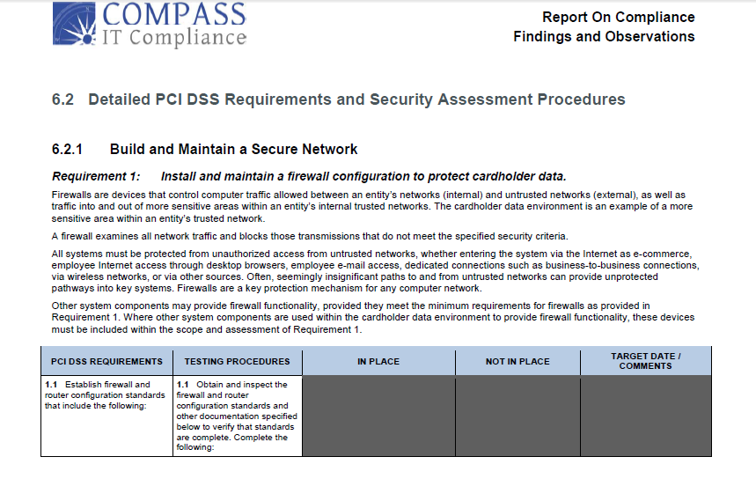

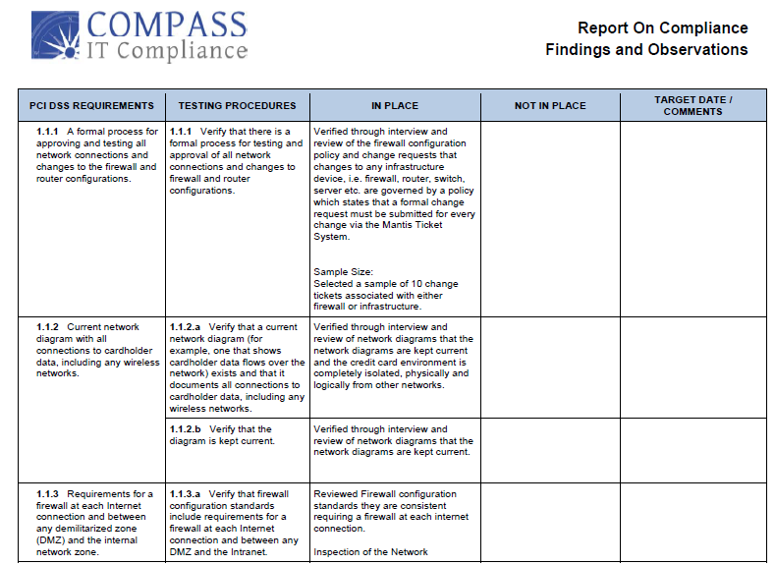
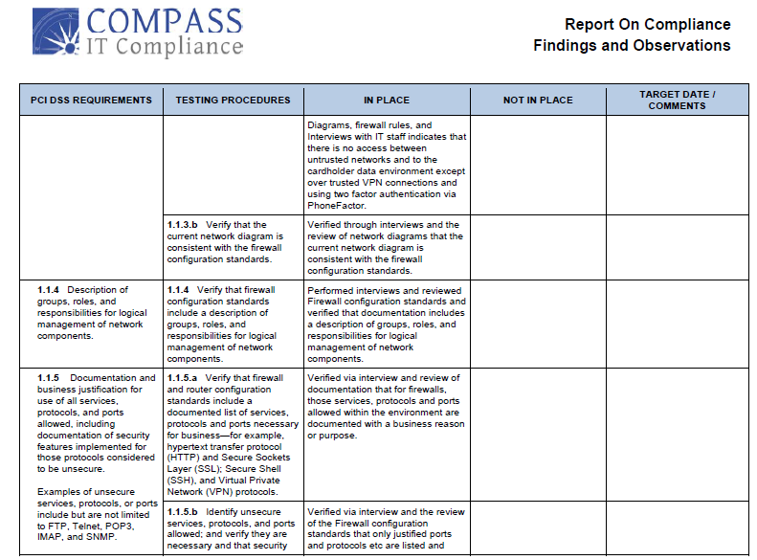
Sample PCI Gap Analysis/Risk Assessment
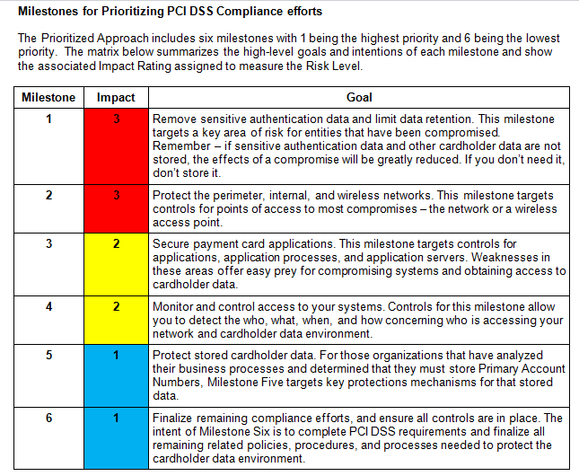

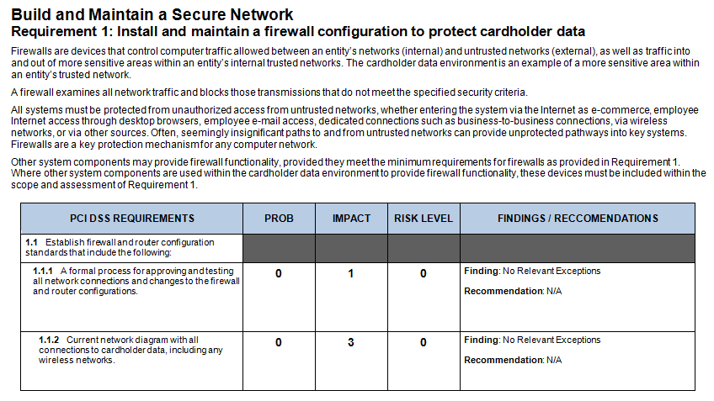
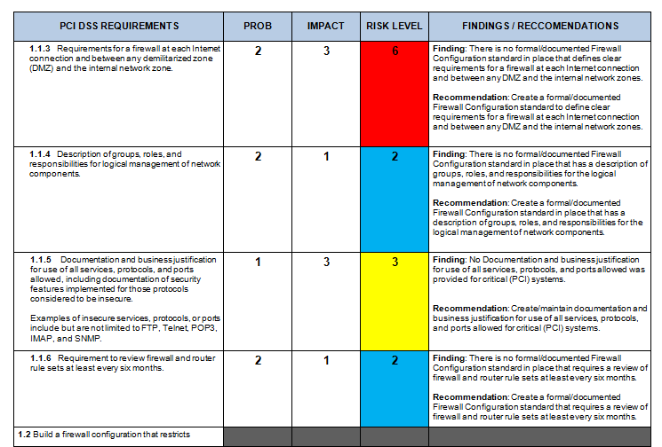
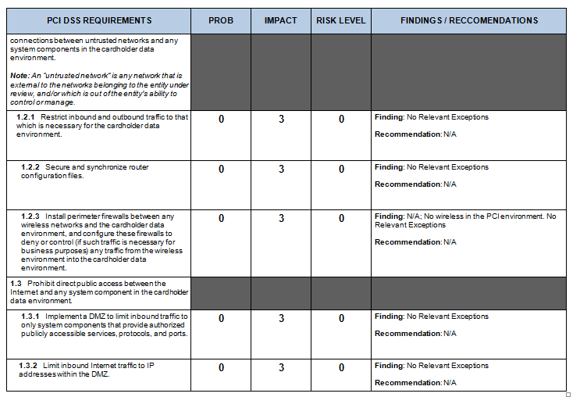

APPENDIX B - SAMPLE AUDIT REPORTS (B- 4f.)
    - IT Integrated Framework
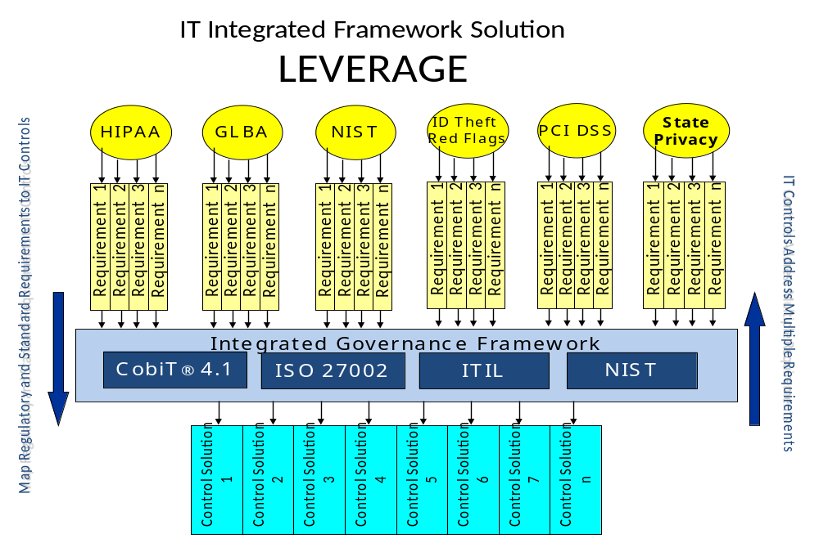
    - Sample NIST SP 800-53 R3 Findings and Remediation Recommendations

A Risk Level for a particular control objective is arrived at by evaluating the probability of a vulnerability being exploited, and multiplying it by the impact it could have on the business. The probability is a subjective value based on the information gathered, and the auditor’s knowledge and experience. The impact on the business is derived as much as possible from the information gathered through inquiries, interviews and observation, with the gaps filled in by the auditor’s conclusions based on the data.

Probability X Impact = Risk Number
The following scale is used to determine the probability and the Impact:
- 0 – Not Identifiable
- 1 – Low
- 2 – Medium
- 3 – High

A probability of 2 and a business impact of 3 would result in a Risk Number of 6.  2 (Probability) X 3 (Business Impact) = 6 (Risk Number) |  | The lowest risk number would be a 0 and the highest would be a 9.  Probability is in the column labeled Prob and Impact is in the column labeled Impct.

The risk levels are as follows:

Risk Number | Priority Ranking | Recommendation
0 | No Identifiable Risk | No Action
1 or 2 | Low | Areas that can be remediated as time permits.
3 or 4 | Medium | To be remediated after the High Priority Ranking items are addressed. Should be monitored regularly to ensure changes in business processes and or IT systems do not raise the probability or occurrence and/or the impact on the business.
6 or 9 | High | Management should focus on remediation of these weaknesses immediately.

NIST SP 800-53 R3 Sample Audit Report
NIST SP 800-53 R3 | Control Evidence | Risks Identified | Risk  Prob  (P) | Risk  Impact  (I) | Risk  P X I | Remediation  Recommendation
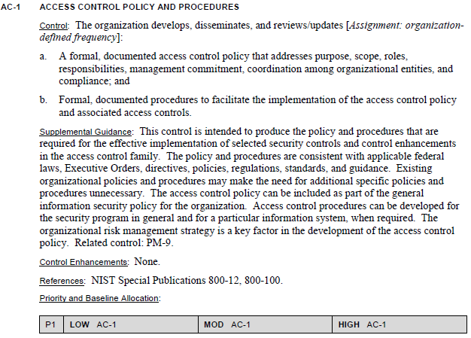 | Through interview, review of documentation, and observation it was determined that the Access Control Policy exists, was approved by management, and is being followed. The Policy is complete, containing all required critical elements of the client’s environment. | N/A | 0 | 2 | 0 | N/A
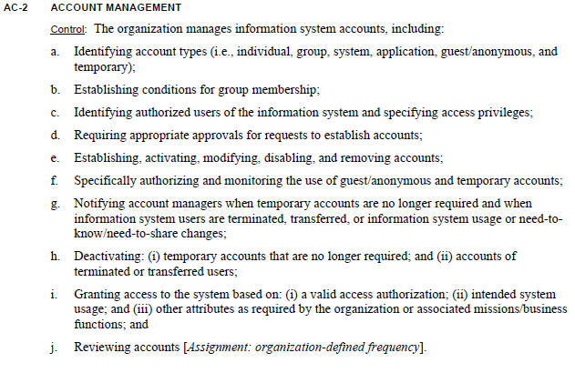 | While the organization has thorough documentation, including detailed policies and procedures for governing account management, it was verified through testing of samples and observation that old accounts have not been removed. | The failure to remove old accounts presents unnecessary risk to the organization of unauthorized access to confidential information. | 2 | 2 | 4 | Educate employees on the company’s policies to ensure that procedures to review and remove old accounts are followed constantly.
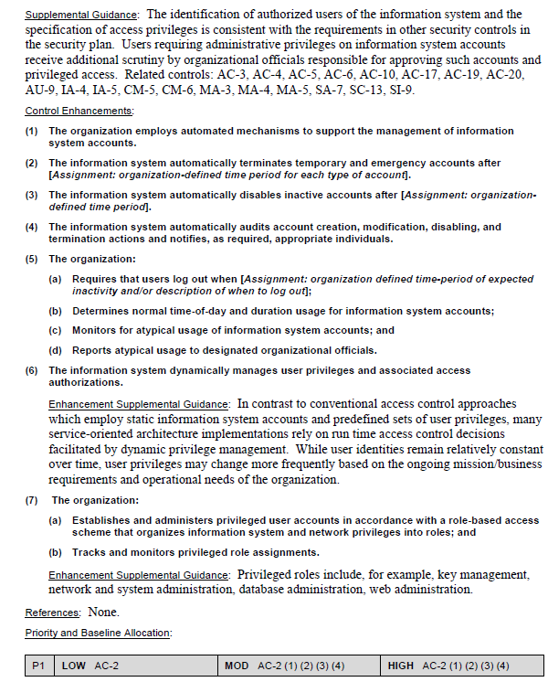

ISO 27002 Sample Audit Report
Domain  High Level  Control  Objective | ISO 27002  Control Objective Description | FFIEC | GLBA | ITIL | ISO 17799 | Control Evidence | COBIT®  Control Maturity  Rating | Risks Identified | Risk  Prob  (P) | Risk  Impact  (I) | Risk  P X I | Remediation  Recommendation
Plan and Organize:  2 - Define the Information Architecture | DEFINE THE INFORMATION ARCHITECTURE:  The information systems function creates and regularly updates a business information model and defines the appropriate systems to optimize the use of this information. This encompasses the development of a corporate data dictionary with the organization's data syntax rules, data classification scheme and security levels. This process improves the quality of management decision making by making sure that reliable and secure information is provided, and it enables rationalizing information systems resources to appropriately match business strategies. This IT process is also needed to increase accountability for the integrity and security of data and to enhance the effectiveness and control of sharing information across applications and entities. | Partial  Yes & No  at Detail Level | Partial  Yes & No  at Detail Level | No | Partial  Yes & No  at Detail Level | While the organization has a very detailed, multi-tiered strategic plan, there is no formal Data Classification Policy. | 2 | The lack of a Data Classification Policy and practice can lead to confidential data inadvertently being compromised. | 2 | 2 | 4 | Develop a Data Classification Policy and disseminate it to appropriate staff. Additionally, classify all critical systems, and media.
Plan and Organize:  3 - Determine Technological Direction | DETERMINE TECHNOLOGICAL DIRECTION:  The information services function determines the technology direction to support the business. This requires the creation of a technological infrastructure plan and an architecture board that sets and manages clear and realistic expectations of what technology can offer in terms of products, services and delivery mechanisms. The plan is regularly updated and encompasses aspects such as systems architecture, technological direction, acquisition plans, standards, migration strategies and contingency. This enables timely responses to changes in the competitive environment, economies of scale for information systems staffing and investments, as well as improved interoperability of platforms and applications. | Partial  Yes & No  at Detail Level | Partial  Yes & No  at Detail Level | No | Partial  Yes & No  at Detail Level | There is an IT plan in motion as a product of the strategic plan. There are regular meeting held to ensure proper direction and execution. | 4 | N/A | 0 | 2 | 0 | N/A
Plan and Organize:  4 - Define the IT Processes, Organization and Relationships | DEFINE THE IT PROCESSES, ORGANIZATION AND RELATIONSHIPS:  An IT organization is defined by considering requirements for staff, skills, functions, accountability, authority, roles and responsibilities, and supervision. This organization is embedded into an IT process framework that ensures transparency and control as well as the involvement of senior executives and business management. A strategy committee ensures board oversight of IT, and one or more steering committees in which business and IT participate determine the prioritization of IT resources in line with business needs. Processes, administrative policies and procedures are in place for all functions, with specific attention to control, quality assurance, risk management, information security, data and systems ownership, and segregation of duties. To ensure timely support of business requirements, IT is to be involved in relevant decision processes. | Partial  Yes & No  at Detail Level | Partial  Yes & No  at Detail Level | Partial  Yes & No  at Detail Level | Partial  Yes & No  at Detail Level | There is a functional organizational structure in place that includes an organizational chart and job descriptions. | 4 | N/A | 0 | 2 | 0 | N/A
Plan and Organize:  5 - Manage the IT Investment | MANAGE THE IT INVESTMENT:  A framework is established and maintained to manage IT-enabled investment programs and that encompasses cost, benefits, prioritization within budget, a formal budgeting process and management against the budget. Stakeholders are consulted to identify and control the total costs and benefits within the context of the IT strategic and tactical plans, and initiate corrective action where needed. The process fosters partnership between IT and business stakeholders; enables the effective and efficient use of IT resources; and provides transparency and accountability into the total cost of ownership (TCO), the realization of business benefits and the ROI of IT-enabled investments. | Partial  Yes & No  at Detail Level | No | Yes | Partial  Yes & No  at Detail Level | There is a framework in place to properly manage the IT investment. It includes a strategic plan, IT organizational structure, regular IT meetings, and execution. | 4 | N/A | 0 | 2 | 0 | N/A
Plan and Organize:  6 - Communicate Management Aims and Directions | COMMUNICATE MANAGEMENT AIMS AND DIRECTION:  Management develops an enterprise IT control framework and defines and communicates policies. An ongoing communication program is implemented to articulate the mission, service objectives, policies and procedures, etc., approved and supported by management. The communication supports achievement of IT objectives and ensures awareness and understanding of business and IT risks, objectives and direction. The process ensures compliance with relevant laws and regulations. | Partial  Yes & No  at Detail Level | No | No | Yes | Management direction and objectives are conveyed to the staff as needed through regular communications in the way of quick daily updates/meetings. | 4 | N/A | 0 | 2 | 0 | N/A
Plan and Organize:  7 - Manage IT Human Resources | MANAGE IT HUMAN RESOURCES:  A competent workforce is acquired and maintained for the creation and delivery of IT services to the business. This is achieved by following defined and agreed-upon practices supporting recruiting, training, evaluating performance, promoting and terminating. This process is critical, as people are important assets, and governance and the internal control environment are heavily dependent on the motivation and competence of personnel. | Partial  Yes & No  at Detail Level | Partial  Yes & No  at Detail Level | Partial  Yes & No  at Detail Level | Partial  Yes & No  at Detail Level | A competent staff is in place and maintained for the creation and delivery of IT services to serve the business. | 4 | N/A | 0 | 2 | 0 | N/A
Plan and Organize:  8 - Manage Quality | MANAGE QUALITY:  A QMS is developed and maintained that includes proven development and acquisition processes and standards. This is enabled by planning, implementing and maintaining the QMS by providing clear quality requirements, procedures and policies. Quality requirements are stated and communicated in quantifiable and achievable indicators. Continuous improvement is achieved by ongoing monitoring, analysis and acting upon deviations, and communicating results to stakeholders. Quality management is essential to ensure that IT is delivering value to the business, continuous improvement and transparency for stakeholders. | Partial  Yes & No  at Detail Level | No | No | Partial  Yes & No  at Detail Level | The organization has appropriate structure in place to manage quality. | 4 | N/A | 0 | 2 | 0 | N/A
Plan and Organize:  9 - Assess and Manage IT Risks | ASSESS AND MANAGE IT RISKS:  A risk management framework is created and maintained. The framework documents a common and agreed-upon level of IT risks, mitigation strategies and residual risks. Any potential impact on the goals of the organization caused by an unplanned event is identified, analyzed and assessed. Risk mitigation strategies are adopted to minimize residual risk to an accepted level. The result of the assessment is understandable to the stakeholders and expressed in financial terms, to enable stakeholders to align risk to an acceptable level of tolerance. | Yes | Yes | Partial  Yes & No  at Detail Level | Partial  Yes & No  at Detail Level | There is no evidence of an ongoing Risk Management Framework. | 2 | The lack of a Risk Management Framework exposes the organization to threats at all levels. | 2 | 2 | 4 | Develop and implement a formal Risk Management Framework, and share with appropriate staff members. Ensure ongoing assessments take place and are documented and followed up on.
Plan and Organize:  10 - Manage Projects | MANAGE PROJECTS:  A program and project management framework for the management of all IT projects is established. The framework ensures the correct prioritization and co-ordination of all projects. The framework includes a master plan, assignment of resources, definition of deliverables, approval by users, a phased approach to delivery, QA, a formal test plan, and testing and post-implementation review after installation to ensure project risk management and value delivery to the business. This approach reduces the risk of unexpected costs and project cancellations, improves communications to and involvement of business and end users, ensures the value and quality of project deliverables, and maximizes their contribution to IT-enabled investment programs. | Partial  Yes & No  at Detail Level | No | Partial  Yes & No  at Detail Level | No | There is no formal PMO in place, however in practice the organization does manage projects effectively. | 3 | The lack of a formal PMO presents a level of risk in the event that there is turnover in staff as the process may not continue being performed at the same level. | 1 | 2 | 2 | Develop and implement a more formalized PMO structure to minimize the risks that turnover in staff presents.
Acquire and Implement:  1 - Identify Automated Solutions | IDENTIFY AUTOMATED SOLUTIONS:  The need for a new application or function requires analysis before acquisition or creation to ensure that business requirements are satisfied in an effective and efficient approach. This process covers the definition of the needs, consideration of alternative sources, review of technological and economic feasibility, execution of a risk analysis and cost-benefit analysis, and conclusion of a final decision to ‘make’ or ‘buy’. All these steps enable organizations to minimize the cost to acquire and implement solutions whilst ensuring that they enable the business to achieve its objectives. | Yes | Partial  Yes & No  at Detail Level | Partial  Yes & No  at Detail Level | Partial  Yes & No  at Detail Level | The organization has good IT direction, and the structure in place to implement changes as needed, | 4 | N/A | 0 | 2 | 0 | N/A
Acquire and Implement:  2 - Acquire and Maintain Application Software | ACQUIRE AND MAINTAIN APPLICATION SOFTWARE:  Applications are made available in line with business requirements. This process covers the design of the applications, the proper inclusion of application controls and security requirements, and the development and configuration in line with standards. This allows organizations to properly support business operations with the correct automated applications. | Partial  Yes & No  at Detail Level | Partial  Yes & No  at Detail Level | Partial  Yes & No  at Detail Level | Partial  Yes & No  at Detail Level | Software is acquired and developed as needed to meet business objectives, however there is no formal SDLC in place. | 2 | The lack of a formal SDLC can lead to poor development practices resulting in a potential data compromise. | 2 | 2 | 4 | Develop and implement a formal SDLC to ensure consistent, secure, coding practices.
Acquire and Implement:  3 - Acquire and Maintain Technology Infrastructure | ACQUIRE AND MAINTAIN TECHNOLOGY INFRASTRUCTURE:  Organizations have processes for the acquisition, implementation and upgrade of the technology infrastructure. This requires a planned approach to acquisition, maintenance and protection of infrastructure in line with agreed-upon technology strategies and the provision of development and test environments. This ensures that there is ongoing technological support for business applications. | Partial  Yes & No  at Detail Level | Partial  Yes & No  at Detail Level | Partial  Yes & No  at Detail Level | Partial  Yes & No  at Detail Level | There is good structure in place to acquire and maintain technology as needed. | 4 | N/A | 0 | 2 | 0 | N/A
Acquire and Implement:  4 - Enable Operation and Use | ENABLE OPERATION AND USE:  Knowledge about new systems is made available. This process requires the production of documentation and manuals for users and IT, and provides training to ensure the proper use and operation of applications and infrastructure. | Partial  Yes & No  at Detail Level | No | Partial  Yes & No  at Detail Level | Partial  Yes & No  at Detail Level | The organization's staff was knowledgeable and competent to properly manage new and current systems. | 4 | N/A | 0 | 0 | 0 | N/A
Acquire and Implement:  5 - Procure IT Resources | PROCURE IT RESOURCES:  IT resources, including people, hardware, software and services, need to be procured. This requires the definition and enforcement of procurement procedures, the selection of vendors, the setup of contractual arrangements, and the acquisition itself. Doing so ensures that the organization has all required IT resources in a timely and cost-effective manner. | Yes | No | No | Partial  Yes & No  at Detail Level | The organization has a good strategic direction and process, however there was no evidence of a formal procurement process. | 2 | The lack of a formal procurement process can lead to higher risk systems being acquired, to inappropriate financial burden, or needed systems being overlooked. | 2 | 2 | 4 | Implement a formal procurement policy/process and disseminate to the organization as needed..

APPENDIX C – Compass Employee Resumes (B-5c)

The personnel that will be involved in the project as well as their qualifications, if Compass is selected, are:

Jerry Hughes –Compass IT Compliance Practice Leader / Senior IT Auditor
Telephone: (860)228-5074
Email Address: jhughes@Compassitc.com
Fax: (401)616-3713

Jerry Hughes, IT Compliance Practice Leader for Compass IT Compliance, has over 25 years of experience helping companies become compliant with internal, industry and government regulations such as Sarbanes-Oxley, HIPAA and GLBA. Mr. Hughes, a Certified Information Systems Auditor (CISA), has extensive IT auditing experience—especially within the financial industry—and has participated in dozens of customer, corporate, federal and state audits.
Mr. Hughes has developed Compass into one of the Northeast’s premier consulting firms in the area of IT Governance, Assurance and Compliance services. His team of CISA-certified auditors, all certified in the international framework called Control Objectives for Information and related Technologies (COBIT), offers a full suite of IT Compliance services within the banking, insurance, health care, energy and education sectors, and has received 100% client satisfaction feedback.

Education | - 1990 Graduate from the University of Rhode Island with a BS in Applied Mathematics and a Minor Computer Science  - Masters Certificate in Project Management from George Washington University in 2000 (MCPM)  - Certified Information Systems Auditor (CISA)  - COBIT 4 Certified (IT Governance Institute)  - Qualified Security Assessor, (QSA) – PCI, 2007  - Certified in Risk and Information Systems Control (CRISC)
Experience | - 25 years in the financial industry  - Have managed/run (5) different core banking systems  - In-depth knowledge of all facets of Financial Core Systems  - Strategic Planning  - Risk Management  - Records Management  - Strong Sarbanes-Oxley knowledge  - In-depth IT Audit knowledge and experience  - Information Systems Audit and Control Association Member (ISACA)
Solutions | - Project Managed a number projects including several very large projects with outstanding results  - Responsible for all Customer, Corporate, Federal and State Audits with outstanding results  - Developed Disaster Recovery & Business Continuity Plans and tested annually for very large Enterprise Systems  - Assisted a number of clients in all facets of IT Governance  - Participated in all regulatory and internal audits with exemplary results
Industries | - Financial Industry Expertise  - Payment Card Industry Expertise  - SOX Expertise

Bill Franklin - IT Governance, Auditing & Compliance Senior Consultant
Telephone: (978) 821-4863
Email Address: bfranklin@Compassitc.com
Fax: (401) 334-0719

Education | - Master of Science in Computer Information Systems – Bentley College 1989  - Certified Information Systems Auditor (CISA)  - COBIT 4 Certified (IT Governance Institute)  - Information Systems Audit and Control Association Member (ISACA)  - The Institute of Internal Auditors Member (IIA)  - Qualified Security Assessor, QSA – PCI, 2007
Experience | - Over 20 years of experience in the Information Technology arena in both the Financial and Training & Development industries  - Ability to connect business objectives with technology systems and initiatives to enable IT to align with the goals of an organization, identify risks, and Achieve Compliance with Regulatory Requirements and Best Practice for IT Controls  - IT Audit and Compliance Consulting  - Sarbanes-Oxley IT audit process from identification of controls through remediation of weaknesses  - IT Risk Assessments and Remediation in various industries with specialization in the banking arena  - Senior Level IT Management  - Provided leadership and management of IT staff in US and international locations in both the financial and training & development industries  - Software Development and Project Management  - IT project management and development of enterprise wide system development and implementation on client/server and web applications
Solutions | - Responsible for Customer IT Audits and Risk Assessments resulting in high praise from clients and external auditors and regulators. Projects included:  - Communication and interaction with clients, business leaders, and staff  - Project management  - Mapping to Relevant Industry Regulations and Guidelines  - Development and Presentation of Final Deliverables to Senior Management and the Board of Directors  - Responsible for IT Projects to implement:  - Disaster Recovery Plan  - Business Continuity Plan  - Professional Services Automation System (PSA) for a global organization  - 360º Survey and Feedback System requiring strict confidentiality of information through a web based application to a global client base
Industries | - Financial Industry  - Training and Development Industry

Solutions | - Responsible for:  - Compliance regulation Audits  - Evaluation information technology controls.  - COBIT 4 Framework Implementation and application  - Sarbanes Oxley Framework application  - Analysis security measures implemented in Windows 2000 and Cisco Routers.  - Analysis security measures implemented in internet banking.  - Implement penetration test services providing real life threat based assessment of an organization's security by using realistic techniques to identify and exploit known security vulnerabilities.
Industries | - Financial Industry Expertise  - Payment Card Industry Expertise  - SOX Expertise

Adam Cravedi – IT Auditor
Telephone: (774) 249-4012
Email Address: acravedi@Compassitc.com

Education | - Certified Information Systems Auditor (CISA)  - Certified Information Application Penetration Testing (GWAPT)  - Master of Science in Management Operation and Information Technology – Worcester Polytechnic Institute, 2000  - Bachelors of Science in Electrical Engineering – Worcester Polytechnic Institute, 1996
Experience | - Over 20 years of experience in the Information Technology arena in the Financial, Higher Education and Healthcare industries  - Excellent understanding of information technology, information security, business continuity and their roles in the organization  - Proven leadership abilities and the willingness to work as part of a team or individually to deliver high quality services to the entire organization  - IT Management  - Provided leadership and management of IT staff in the financial, higher education and healthcare industries  - Information Security Officer  - Developed an encompassing Information Security Program as a baseline for information security  - Developed the Information Security Awareness Training program for educating all members of the organization
Solutions | - Responsible for IT Projects to implement:  - Disaster Recovery Planning  - Business Continuity Planning  - IT Risk Assessments  - Virtualization projects  - Data Storage strategies  - Financial Core Processing Conversions
Industries | - Financial Industry  - Higher Education  - Healthcare

Elkin Castano - IT Governance, Auditing & Compliance Senior Consultant
Telephone: (401) 338-4580
Email Address: ecastano@CompassITC.com
Education | - Professional Systems Engineer - EAFIT University, Medellín - Colombia  - SQL Security Audit – New Horizons, 2004  - Certified Information Systems Audit CISA – ISACA, 2004  - Qualified Security Assessor, QSA – PCI, 2007  - Approved Scanning Vendor, ASV – PCI, 2007  - QualysGuard Certified Specialist – Qualys, 2007
Experience | - Over 18 years experience in the audit field.  - Specialized in IT Audits of financial and industrial companies  - Wide experience as consultant on data security and information technology  - In-depth IT Audit knowledge and experience (CISA Certified)  - Analyzed security measures implemented in various IT environments.  - Evaluate telecommunications platforms for the financial sector.  - Assess, design and implementation of risk management solutions for electronic business.  - Audited production and development applications.  - Design of security frameworks and infrastructure.  - Analysis security measures implemented in Windows 2000/XP, AS/400, SQL, IIS, Cisco Routers and Cisco PIX  - Audit production and development applications.
Solutions | - Responsible for:  - Compliance regulation Audits  - Evaluation information technology controls.  - COBIT 4 Framework Implementation and application  - Sarbanes Oxley Framework application  - Analysis security measures implemented in Windows 2000 and Cisco Routers.  - Analysis security measures implemented in internet banking.  - Implement penetration test services providing real life threat based assessment of an organization's security by using realistic techniques to identify and exploit known security vulnerabilities.
Industries | Financial industry specialist

APPENDIX D – ASV and Vulnerability Scan Sample reports (B-3e)

Internal Vulnerability Audit
Full Technical Report

Table of Contents
1.0 Scope 1
2.0 Assessment Environment 1
3.0 Tools 1
4.0 Results 2
4.0.1 Zero Day Vulnerabilities 2
4.0.2 Confirmed Vulnerabilities 2
4.0.3 Potential Vulnerabilities 2
4.0.4 Open Ports and Running Services 2
4.1 Executive Summary 3
Table 4.1.1: Site Scan Status 3
Table 4.1.2: Unique Vulnerabilities 3
Table 4.1.3: Total Vulnerabilities 4
4.1.1 Summary of Results 5
4.2 Server Vulnerabilities 9
4.2.1 Summary of Results 9
4.2.2 Detailed Results 11
4.2.3 Server Recommendations 19

1.0 Scope
Customer(the Client) has engaged Compass IT Compliance, LLC (Compass) to perform internal and external vulnerability assessments of their network infrastructure at all of their office locations. Compass’ Vulnerability Assessment services help the client to identify security vulnerabilities that may exist on scanned workstations, servers, network printers, and any other network attached device. Compass will offer remedial actions required to correct these exposures if requested.

2.0 Assessment Environment
The vulnerability assessments were conducted during the period of February 8 – February 9, 2012. The QualysGuard scanning appliance was configured at the client’s main office to conduct the scanning.

3.0 Tools
QualysGuard Vulnerability Management (VM) automates the lifecycle of network auditing and vulnerability management across the enterprise, including network discovery and mapping, asset prioritization, vulnerability assessment reporting and remediation tracking according to business risk. QualysGuard VM utilizes both a centralized vulnerability database and local scanning appliance to provide comprehensive vulnerability assessments for clients.

The QualysGuard VM scans all devices on the client’s network for known and potential vulnerabilities. Reports are generated detailing all of the discovered events and ranking them from Urgent (5) to Minimal (1) in criticality and impact. The results are then used to produce the assessment report.

4.0 Results

4.0.1 Zero Day Vulnerabilities
Zero day vulnerabilities are vulnerabilities for which there is no countermeasure available to mitigate the exposure. Qualys identifies zero-day vulnerabilities and updates them as patches and other countermeasures are developed. Zero-day vulnerabilities have been high-lighted in this report. Zero-day vulnerabilities should be reviewed and assessed for risk to the organization. In some cases, mitigating controls are or can be put into place.

4.0.2 Confirmed Vulnerabilities
Confirmed vulnerabilities level 3 and above pose a heightened security risk and as such, prompt remediation should be implemented to avoid the possibility of a network breach or host hi-jacking, which could lead to data theft or possible service interruption.
Once remediation of the higher level vulnerabilities has been accomplished, a plan should be developed to remediate the remaining lower level vulnerabilities (Level 1 and 2) in a reasonable time period.

4.0.3 Potential Vulnerabilities
Potential vulnerabilities are listed in the full technical report. These items are listed in the reports due the fact that the scanner detected a possible vulnerability but was unable to confirm the risk through the information gathered. As such all possible vulnerabilities should be reviewed to determine whether the item is an actual vulnerability or can be removed from the list. If a determination is made that confirms the vulnerability, immediate remediation should be implemented.

If after a thorough review a false positive has been determined or if the vulnerability cannot be remediated due to business need, these vulnerabilities should be documented with said business need or that it has been investigated and established as a false positive. Additional efforts should be made to monitor and secure the host further if there is no other means of remediation.

4.0.4 Open Ports and Running Services
Open ports and running services have known risks or could allow access to privileged information. The ports and services identified should be reviewed to determine whether there is a business need. If the port or service is required to carry on normal business, a justification should be documented along with the associated business need; otherwise, they should be disabled. It is important to note that although a justification may exist for open ports and running services, additional efforts should be made to further monitor and secure the host, if possible.

The following sections provide a high level summary of all of the Vulnerability scans completed. Detailed information for remediation of the identified vulnerabilities is available in the full vulnerability report located on the Client Portal Extranet. Also please note that any Affected System highlighted in Yellow indicates a repeat finding from the last scan report.

- 4.1 Executive Summary
Overall Compass scanned 48 devices. A total of 2055 instances of vulnerabilities were discovered. This number includes every vulnerability discovered on every device including confirmed and potential vulnerabilities as well as information gathered. Each occurrence of a vulnerability is counted on every device scanned. A total of 190 unique vulnerabilities (potential, confirmed, risk Levels 3-5) were discovered. The table below breaks down the unique vulnerabilities by device type, risk level and status (confirmed or potential). Included in these findings were 32 (16.8%) unique Zero-day vulnerabilities.
- Table 4.1.1: Site Scan Status
Site Name | Status | IP Addresses Defined | Devices Scanned
Servers | Completed | 6 Unique IPs | 3
Network Devices | Completed | 10 Unique IPs | 7
Printers | Completed | 13 Unique IPs | 12
Workstations | Completed | 38 Unique IPs | 26

- Table 4.1.2: Unique Vulnerabilities
Devices | Risk Level |  |  |  |  |  |  |  |  |  |  |  | Totals
Devices | 5 |  |  |  | 4 |  |  |  | 3
Devices | Confirmed |  | Potential |  | Confirmed |  | Potential |  | Confirmed |  | Potential
Servers | 5 | 15.6% | 0 | 0.0% | 12 | 37.5% | 0 | 0.0% | 15 | 46.9% | 0 | 0.0% | 32 | 16.8%
Network | 0 | 0.0% | 1 | 25.0% | 0 | 0.0% | 0 | 0.0% | 1 | 25.0% | 2 | 50.0% | 4 | 2.1%
Printers | 0 | 0.0% | 0 | 0.0% | 3 | 30.0% | 0 | 0.0% | 6 | 60.0% | 1 | 10.0% | 10 | 5.3%
Workstations | 21 | 14.6% | 0 | 0.0% | 58 | 40.3% | 1 | 0.7% | 59 | 41.0% | 5 | 3.5% | 144 | 75.8%
Totals | 26 | 13.7% | 1 | 0.5% | 73 | 38.4% | 1 | 0.5% | 81 | 42.6% | 8 | 4.2% | 190
Totals | 27 |  | 14.2% |  | 74 |  | 38.9% |  | 89 |  | 46.8%

The details from Table 4.1.2 result in a Simple Weighted Average (SWA) risk score of 3.7. This calculation only considers risk levels 5, 4, and 3 and is based on unique vulnerabilities.
SWA = ((26 x 5) + (74 x 4) + (89 x 3)) / 190 = 3.7
When the entire scope of vulnerabilities are considered (excluding information) the Full Weighted Average (FWA) is determined to be 3.1. The following table and formula show how this number is calculated.

- Table 4.1.3: Total Vulnerabilities
Severity | Confirmed |  | Potential |  | Total
5 | 116 |  | 1 |  | 117
4 | 490 |  | 1 |  | 491
3 | 806 |  | 87 |  | 893
2 | 426 |  | 74 |  | 500
1 | 32 |  | 22 |  | 54
Total | 1870 |  | 185 |  | 2055

FWA = ((117 x 5) + (491 x 4) + (893 x 3) + (500 x 2) + (54 x 1)) / 2055 = 3.1

4.1.1 Summary of Results
The following information is a summary of the overall findings:
Vulnerabilities Total | 2055 |  | Average Security Risk |  |  |  |  |  | 3.9

Vulnerabilities By Severity
Severity | Confirmed | Potential | Information Gathered | Total
5 | 116 | 1 | - | 117
4 | 490 | 1 | - | 491
3 | 806 | 87 | - | 893
2 | 426 | 74 | - | 500
1 | 32 | 22 | - | 54
Total | 1870 | 185 | - | 2055

5 Biggest Categories
Category | Confirmed | Potential | Information Gathered | Total
Local | 721 | 0 | - | 721
Windows | 473 | 89 | - | 562
Internet Explorer | 267 | 0 | - | 267
Security Policy | 110 | 44 | - | 154
General Remote Services | 82 | 41 | - | 123
Total | 1653 | 174 | - | 1827

Vulnerabilities by Severity
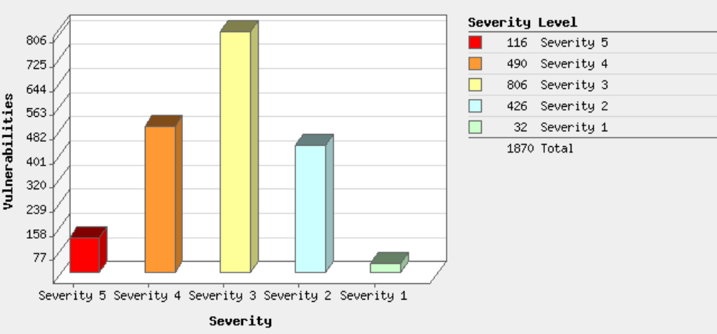

Potential Vulnerabilities by Severity
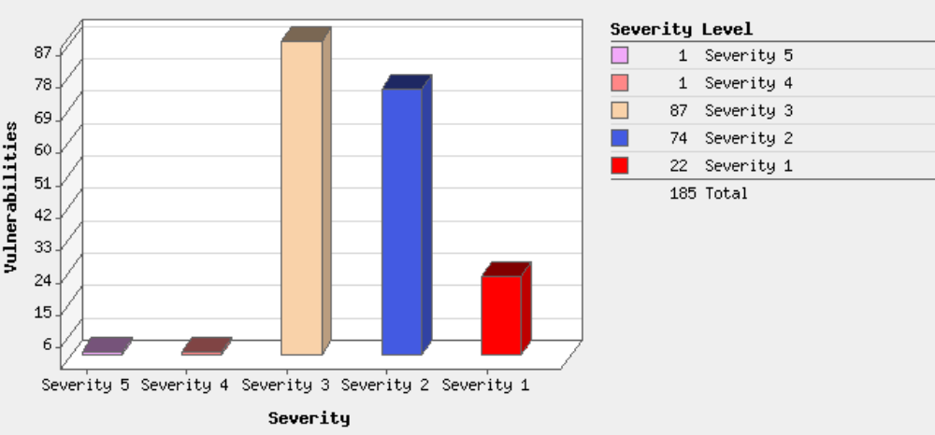

Operating Systems Detected
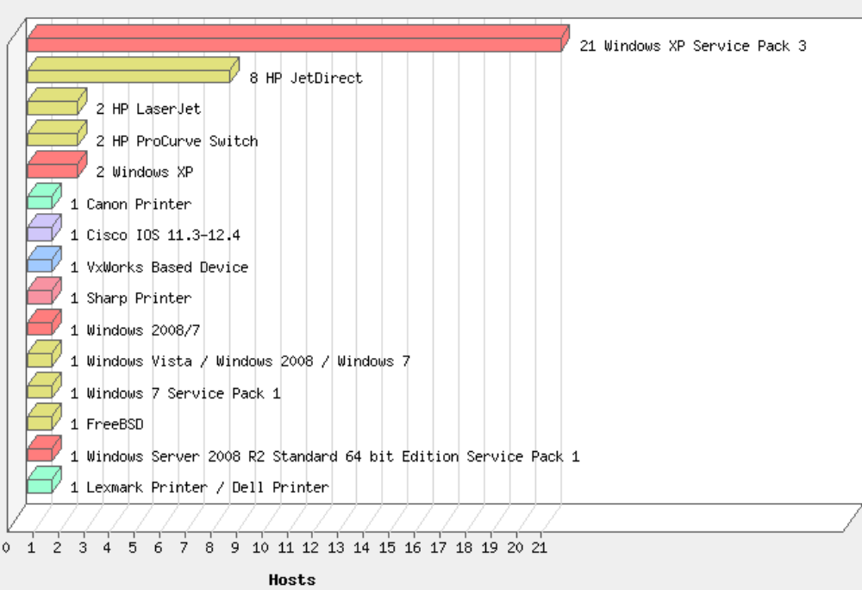

Services Detected
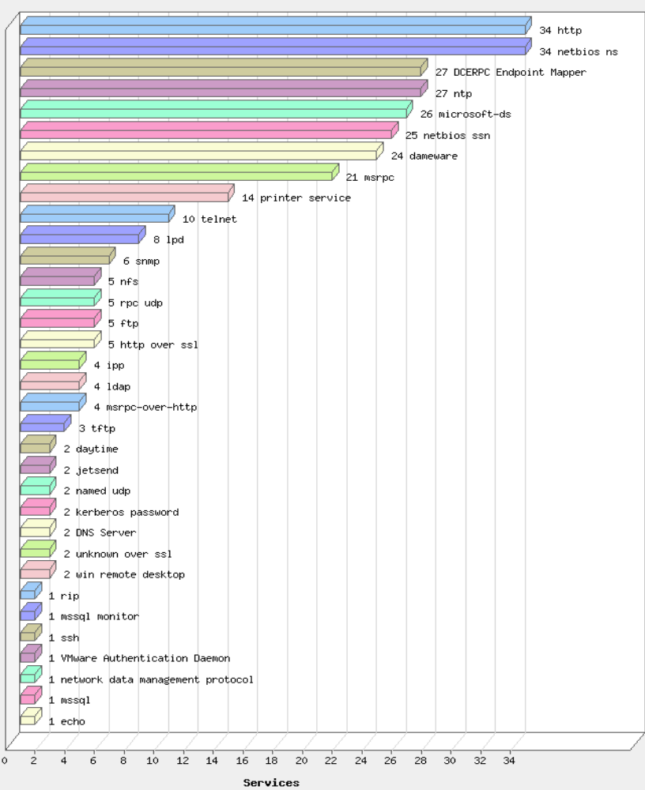

The full detailed report will be made available for the client’s review when the report is delivered. The following sections list the detailed vulnerabilities by Host, grouped by device classes (Servers, Network Devices, Computers, Printers, etc). All Urgent, Critical and Serious findings will be documented. Any Moderate or Minimal findings that Compass deems relevant will also be noted. Information Gathered will only be available in the full details report(s).

- 4.2 Server Vulnerabilities

4.2.1 Summary of Results
Vulnerabilities Total | 54 |  | Average Security Risk |  |  |  |  |  | 3.3

Vulnerabilities By Severity
Severity | Confirmed | Potential | Information Gathered | Total
5 | 5 | 0 | - | 5
4 | 12 | 0 | - | 12
3 | 15 | 0 | - | 15
2 | 18 | 3 | - | 21
1 | 0 | 1 | - | 1
Total | 50 | 4 | - | 54

5 Biggest Categories
Category | Confirmed | Potential | Information Gathered | Total
Windows | 24 | 1 | - | 25
General Remote Services | 7 | 0 | - | 7
Local | 6 | 0 | - | 6
Internet Explorer | 6 | 0 | - | 6
Security Policy | 3 | 1 | - | 4
Total | 46 | 2 | - | 48

Vulnerabilities by Severity
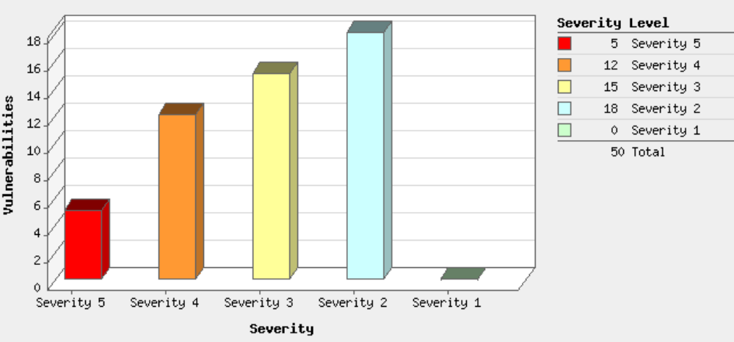

Potential Vulnerabilities by Severity
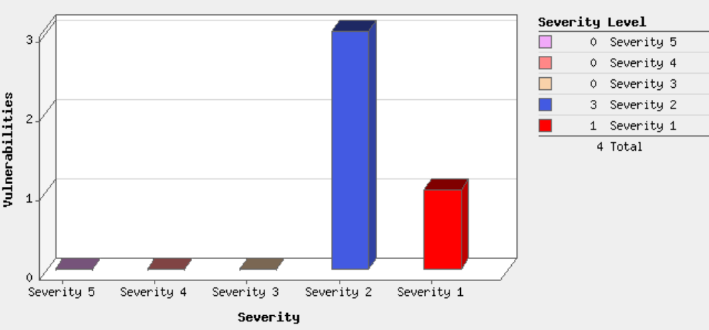
Operating Systems Detected
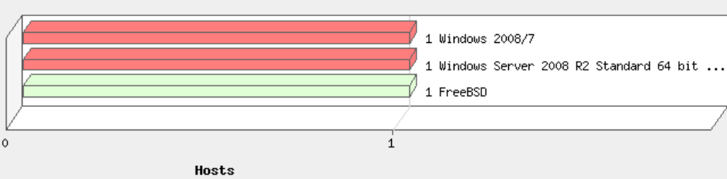

4.2.2 Detailed Results
Confirmed Vulnerabilities
Risk | Threat | Impact | Solution | Affected Systems
Urgent:5 | Microsoft Cumulative Security Update of ActiveX Kill Bits (MS11-090) | A remote code execution vulnerability exists in the Microsoft Time component. When the binary behavior is used in Internet Explorer, the behavior may corrupt the system state in such a way that an attacker could execute arbitrary code. An attacker who successfully exploits this vulnerability could gain the same user rights as the logged-on user. Users whose accounts are configured to have fewer user rights on the system could be less impacted than users who operate with administrative user rights. | Patch:  Windows Server 2008 for x64-based Systems SP2  (http://www.microsoft.com/downloads/details.aspx?familyid=28598ef6-13fb-44fd-8c76-599af7b0a01d)

4.2.3 Server Recommendations
The client, compared to its peers, has a relatively fewer number of vulnerabilities. This could indicate that regular scanning and patch maintenance programs are in place. The following vulnerabilities should be investigated further:
- Many of the listed Vulnerabilities are new indicating that the server has not been maintained in several months. It is recommended that the server be reviewed and all missing critical and security patches be applied as soon as possible.
- Maintain patches for all versions of Microsoft Windows Operating Systems.
- SSL certificates and settings should be reviewed to ensure the highest level of security is supported.
- Review and ensure DNS settings are configured correctly to ensure domain security.

PCI – Attestation of Scan Compliance Report

 |  | Compass IT Compliance, LLC Scan Report - Attestation of Scan Compliance
 | Scan Customer Information |  |  |  |  | Approved Scanning Vendor Information
 | Company: |  |  |  |  | Company: Compass IT Compliance, LLC
 | Contact: |  | Title: |  |  | Contact: | Title:
 | Telephone: |  | E-mail |  |  | Telephone: | E-mail:
 | Business Address: |  |  |  |  | Business Address:
 | Country: USA |  | City: |  |  | Country: | City:
 | State/Province: MA |  | ZIP: 02210 |  |  | State/Province: | ZIP:
 | URL: |  |  |  |  | URL:

- Scan Status
- Compliance Status
- Number of unique components scanned: 102
- Number of identified failing vulnerabilities: 0
- Number of components found by ASV but not scanned because scan customer confirmed components were out of scope: 8
- Date scan completed: December 14, 2011
- Scan expiration date (90 days from date scan completed): March 13, 2012

- Scan Customer Attestation
Customer attests on December 14, 2011 that this scan includes all components* which should be in scope for PCI DSS, any component considered out-of-scope for this scan is properly segmented from my cardholder data environment, and any evidence submitted to the ASV to resolve scan exceptions is accurate and complete. Customer also acknowledges the following: 1) proper scoping of this external scan is my responsibility, and 2) this scan result only indicates whether or not my scanned systems are compliant with the external vulnerability scan requirement of PCI DSS; this scan result does not represent my overall compliance status with PCI DSS or provide any indication of compliance with other PCI DSS requirements.

- ASV Attestation
This scan and report was prepared and conducted by Compass IT Compliance, LLC under certificate number, according to internal processes that meet PCI DSS requirement 11.2 and the PCI DSS ASV Program Guide. Compass IT Compliance, LLC attests that the PCI DSS scan process was followed, including a manual or automated Quality Assurance process with customer boarding and scoping practices, review of results for anomalies, and review and correction of 1) disputed or incomplete results, 2) false positives, and 3) active scan interference. This report and any exceptions were reviewed by Adam Cravedi.

PCI – ASV Audit Report

Compass IT Compliance, LLC

Company – PCI ASV Audit Report

Audited on January 6, 2012
Reported on January 12, 2012

Table of Contents
1. Scan Information 1
2. Component Compliance Summary 1
3. Vulnerabilities Noted for each IP Address 2
3.1. 2
3.2. Consolidated Solution/Correction Plan for the above IP Address: 2
3.2.1. Further Investigation Required 2
3.3. 3
3.4. 3
3.5. 4
4. Special Notes by IP Address 4
5. Vulnerability Details 5
5.1. High 5
5.1.1. ISAKMP Allows Weak IPsec Encryption Settings (ipsec-weak-encryption-settings) 5
5.2. Low 6
5.2.1. A running service was discovered (generic-service-open) 6
5.2.2. TCP timestamp response (generic-tcp-timestamp) 6

1. Scan Information

Scan Customer Company: | ASV Company: Compass IT Compliance, LLC
Date scan was completed: January 06, 2012 | Scan expiration date: April 05, 2012

2. Component Compliance Summary

IP Address
IP Address

- 3. Vulnerabilities Noted for each IP Address

3.1. 63.86.6.15

IP Address | Vulnerabilities Noted per IP address | Severity Level | CVSS Score | Compliance Status | Exceptions, False Positives, or Compensating Controls Noted by the ASV for this Vulnerability
IP Address | Undefined CVE, ISAKMP Allows Weak IPsec Encryption Settings | high | 8.8 |  | False Positive noted by Adam Cravedi: Client has removed weak ciphers and verified only strong ciphers are available.
 | Undefined CVE, A running service was discovered | low | 0.0
 | Undefined CVE, A running service was discovered | low | 0.0
 | Undefined CVE, A running service was discovered | low | 0.0
 | Undefined CVE, TCP timestamp response | low | 0.0

- 3.2. Consolidated Solution/Correction Plan for the above IP Address:

3.2.1. Further Investigation Required
PCI ASV could not determine the software running on the target system. The following solutions apply to a variety of software. Choose the one that applies to your system type.
- For FreeBSD
These vulnerabilities can be resolved with a single step. The estimated time to perform this step is 5 minutes.
- Remediation Step | - Estimated Time
Disable TCP timestamp responses on FreeBSD | 5 minutes
- For OpenBSD
These vulnerabilities can be resolved with a single step. The estimated time to perform this step is 5 minutes.
- Remediation Step | - Estimated Time
Disable TCP timestamp responses on OpenBSD | 5 minutes
- For Cisco
These vulnerabilities can be resolved with a single step. The estimated time to perform this step is 5 minutes.
- Remediation Step | - Estimated Time
Disable TCP timestamp responses on Cisco | 5 minutes
- For Microsoft Windows
These vulnerabilities can be resolved with a single step. The estimated time to perform this step is 5 minutes.
- Remediation Step | - Estimated Time
Disable TCP timestamp responses on Windows | 5 minutes
- For Linux
These vulnerabilities can be resolved with a single step. The estimated time to perform this step is 5 minutes.
- Remediation Step | - Estimated Time
Disable TCP timestamp responses on Linux | 5 minutes

- 3.3. IP Address
IP Address | Vulnerabilities Noted per IP address | Severity Level | CVSS Score | Compliance Status | Exceptions, False Positives, or Compensating Controls Noted by the ASV for this Vulnerability
 | Undefined CVE, A running service was discovered | low | 0.0

4. Special Notes by IP Address
IP Address | Note | Item Noted (remote access software, POS software, etc.) | Scan customer's declaration that software is implemented securely (see next column if not implemented securely) | Scan customer's description of actions taken to either: 1) remove the software or 2) implement security controls to secure the software

5. Vulnerability Details
- 5.1. High
These vulnerabilities must be corrected and the environment must be re-scanned after the corrections. Organizations should take a risk-based approach to correct these types of vulnerabilities, starting with the ones having the highest CVSS scores.

5.1.1. ISAKMP Allows Weak IPsec Encryption Settings (ipsec-weak-encryption-settings)
Severity | High
CVSS Score | 8.8 (AV:N/AC:M/Au:N/C:C/I:C/A:N)
Description | The ISAKMP endpoint allows short key lengths or insecure encryption algorithms to be negotiated. This could allow remote attackers to compromise the confidentiality and integrity of the data by decrypting and modifying individual ESP or AH packets.
- Affects
IP Address | Port | Instance | Compliance Status | Evidence | Exceptions, False Positives, or Compensating Controls Noted by the ASV for this Vulnerability
 |  |  |  | Running vulnerable ISAKMP service. | False Positive noted by Adam Cravedi: Client has removed weak ciphers and verified only strong ciphers are available.
- Solution
Modify the ISAKMP settings to only allow secure encryption algorithms to be negotiated.

- 5.2. Low
Organizations are encouraged, but not required, to correct these vulnerabilities.

5.2.1. A running service was discovered (generic-service-open)
Severity | Low
Description | A service was found to be running on the system.
- Affects
IP Address | Port | Instance | Compliance Status | Evidence | Exceptions, False Positives, or Compensating Controls Noted by the ASV for this Vulnerability
 | 500/udp | ISAKMP |  | ISAKMP on UDP port 500
- Solution
If the service is not required for normal business operations, it should be disabled. Leaving unecessary services running on a system provides malicious users with additional attack vectors when attempting to compromise a system.

5.2.2. TCP timestamp response (generic-tcp-timestamp)
Severity | Low
Description | The remote host responded with a TCP timestamp. The TCP timestamp response can be used to approximate the remote host's uptime, potentially aiding in further attacks. Additionally, some operating systems can be fingerprinted based on the behavior of their TCP timestamps.
References | URL: http://www.forensicswiki.org/wiki/TCP_timestamps, URL: http://www.ietf.org/rfc/rfc1323.txt, URL: http://uptime.netcraft.com
- Affects
IP Address | Port | Instance | Compliance Status | Evidence | Exceptions, False Positives, or Compensating Controls Noted by the ASV for this Vulnerability
 |  |  |  | Apparent system boot time: Sat Dec 12 11:12:00 CST 2009
- Solution
- Cisco
Disable TCP timestamp responses on Cisco
Run the following command to disable TCP timestamps:
no ip tcp timestamp
- FreeBSD
Disable TCP timestamp responses on FreeBSD
Set the value of net.inet.tcp.rfc1323 to 0 by running the following command:
sysctl -w net.inet.tcp.rfc1323=0
Additionally, put the following value in the default sysctl configuration file, generally sysctl.conf:
net.inet.tcp.rfc1323=0
- Linux
Disable TCP timestamp responses on Linux
Set the value of net.ipv4.tcp_timestamps to 0 by running the following command:
sysctl -w net.ipv4.tcp_timestamps=0
Additionally, put the following value in the default sysctl configuration file, generally sysctl.conf:
net.ipv4.tcp_timestamps=0
- OpenBSD
Disable TCP timestamp responses on OpenBSD
Set the value of net.inet.tcp.rfc1323 to 0 by running the following command:
sysctl -w net.inet.tcp.rfc1323=0
Additionally, put the following value in the default sysctl configuration file, generally sysctl.conf:
net.inet.tcp.rfc1323=0
Microsoft Windows
Disable TCP timestamp responses on Windows
Set the Tcp1323Opts value in the following key to 1:
HKEY_LOCAL_MACHINE\System\CurrentControlSet\Services\Tcpip\Parameters
Sample Penetration Test Report

Network Penetration Test
Full Technical Report

For: | Client Name
Contact:


This document and its contents represent confidential information between Compass IT Compliance, LLC and Company. As such this document may not be shared with any outside party without the expressed consent of Compass IT Compliance, LLC and Company.

Table of Contents
1. Executive Overview 1
1.1. Summary 1
1.2. Scope 1
1.2.1. Target Devices 1
1.2.2. Schedule and Time Window 1
1.2.3. Scanned Hosts and Networks 1
1.3. Contact Information 1
1.3.1. Client Contact: 1
1.3.2. Compass Contact: 1
1.4. Methodology 2
1.4.1. Discovery 2
Table 1.4.1.1 External Devices: 2
Table 1.4.1.2 External Devices: 2
Table 1.4.1.3 Internal Devices on LAN: 2
Table 1.4.1.4 Internal Devices in DMZ: 3
1.4.2. Assessment 3
1.4.3. Exploitation 3
1.5. Vulnerability Summary 4
1.6. Internal Penetration Test 7
1.7 Conclusions 11
2. Technical Details 12
2.1. Technical Summary 12
2.1.1. Company URL 12
2.1.1.1. Invalid SSL Certificate Detected 12
2.1.1.2. Apache Coyote Version Disclosure 12
2.1.2. Company URL 13
2.1.2.1. Invalid SSL Certificate Detected 13
2.1.3 Company URL 13
2.1.3.1. Invalid SSL Certificate Detected 13
2.1.4. Company URL 14
2.1.4.1. Invalid SSL Certificate Detected 14
2.1.4.2. Cookie Not Marked As HttpOnly 15
2.1.4.3. Internal Server Error 15
2.1.4.4. Auto Complete Enabled 16
2.1.4.5. Tomcat Exception Report Disclosure 17
2.1.4.6. Tomcat Version Disclosure 18
2.1.4.7. Tomcat Version Is Out Of Date 18
2.1.4.8. E-mail Address Disclosure 21
2.1.4.9. [Possible] Internal Path Leakage (*nix) 22
2.1.5. 174.123.66.61 22
2.1.5.1. Invalid SSL Certificate Detected 22
2.1.6. IP Address 23
2.1.6.1. Invalid SSL Certificate Detected 23
2.1.7. 83.217.224.250 24
2.1.7.1. Invalid SSL Certificate Detected 24

1. Executive Overview

- 1.1. Summary
Compass IT Compliance (Compass) was asked to perform both an Internal and External Penetration test as part of the PCI Audit project. Overall no Urgent level findings were discovered and no open access paths were discovered. Several points of potential information leakage were investigated, but no confidential information was discovered. These are noted where discovered, however, browsers vary significantly and are not with-in the scope of this test.
- 1.2. Scope

1.2.1. Target Devices
The scope of this penetration test was defined by the client representative. The assessment included an external penetration test against IP addresses selected from each of their Data Centers and an internal penetration test against their development office in Italy. All discovered devices within these networks were potential targets for penetration testing. The individual IP addresses were selected by the Compass auditor based on results from various Vulnerability Assessments conducted for the client. Denial-of-Service attacks and system down time were to be avoided as well.

1.2.2. Schedule and Time Window
The tests were allowed to take place starting August 27, 2012 and continuing until September 17, 2012. Testing was allowed to occur anytime of day or night.

1.2.3. Scanned Hosts and Networks
The following hosts/networks were scanned. Devices that were not found to be active (did not respond to network traffic) are not included in the remainder of this report.
- Company URL

- 1.4. Methodology

1.4.1. Discovery
Using Nmap network mapper and NeXpose by Rapid7 discovery of the client’s networks was performed. The table below lists the networks that were scanned. In total, 97 devices were discovered.
- Table 1.4.1.1 External Devices:
Mobile |  | Mobile |  | Mobile
- Table 1.4.1.2 External Devices:
Assistive | Office | demomobile | Office
 | Company URL | Company URL
- Table 1.4.1.3 Internal Devices on LAN:
IP | Device | Notes
IP Address | Device Name | WiFi Access Point
- Table 1.4.1.4 Internal Devices in DMZ:
IP | Device | Notes

1.4.2. Assessment
Using the list of discovered devices from the Discovery Phase, several tools were used to assess the weaknesses and potential attack points for each device. Section 2 of this report details the vulnerabilities tested and discovered, as well providing information about each discovered vulnerability, remediation steps and recommendations.

The tools used include Qualys’ Qualysguard Vulnerability scanner, W3af Attack Framework, Portswigger’s Burp Suite v1.4, and McAfee’s SiteDigger v1.0. The NeXpose scanner was used to detect vulnerabilities with the Web Server software and Operating System. W3af attack framework was used to assess potential penetration points and run various attack sequences against them. Burp was used to spider the web sites looking for open directories, form processing weaknesses, Cross-Site Scripting (XSS) and Cross-Site Request Forgery (XSRF) flaws. SiteDigger was used to search Google Hacking Database (GHDB) for known weaknesses.

1.4.3. Exploitation
With the information collected in the Discovery and Assessment phases, the final step of the test was to attempt to penetrate the identified weaknesses in different systems. Using a combination of manual testing, the NetSparker 3.0, Burp Suite, and W3af Attack Framework, the susceptible systems were tested in an attempt to gain access to areas that Compass was not authorized to access.

- 1.5. Vulnerability Summary
This report represents a security audit performed by Compass IT Compliance, LLC. It contains confidential information about the state of your network. Access to this information by unauthorized personnel may allow them to compromise your network.

Site Name | Start Time | End Time | Total Time | Status
 | September 2, 2012 18:25, EDT | September 2, 2012 19:04, EDT | 39 minutes | Success

The audit was performed on 7 systems, 7 of which were found to be active and were scanned.
There were 11 vulnerabilities found during this scan. No Urgent(5) or Critical(4) vulnerabilities were found. Urgent(5) or Critical(4) vulnerabilities require immediate attention. They are relatively easy for attackers to exploit and may provide them with full control of the affected systems. 2 vulnerabilities were Serious(3). Serious(3) vulnerabilities are often harder to exploit and may not provide the same access to affected systems. There were 9 Medium(2) and Low(1) vulnerabilities discovered. These often provide information to attackers that may assist them in mounting subsequent attacks on your network. These should also be fixed in a timely manner, but are not as urgent as the other vulnerabilities.
Vulnerabilities by Severity
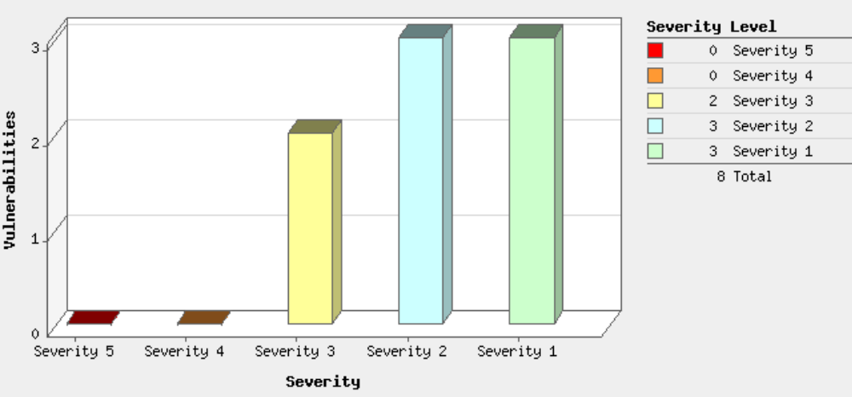

Potential Vulnerabilities by Severity
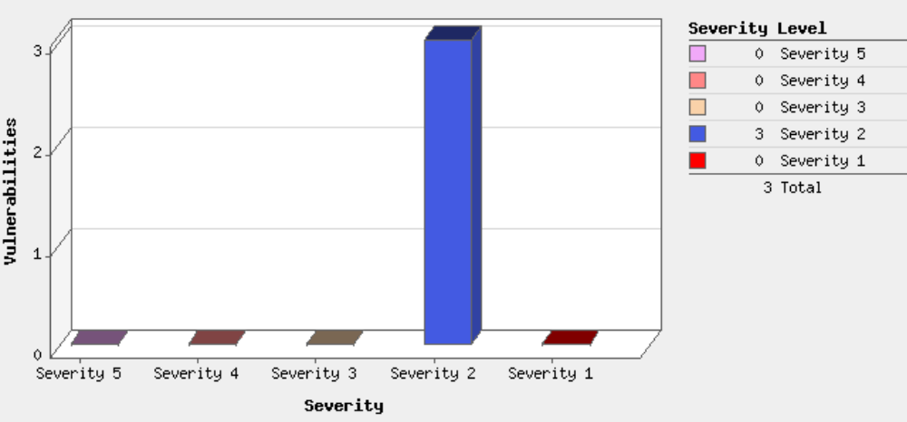
No Urgent(5) or Critical(4) vulnerabilities were found on any of the systems. Serious(3) vulnerabilities were found on two systems. Medium(2) and Low(1) vulnerabilities were found on 5 systems.
Most Prevalent Vulnerabilities
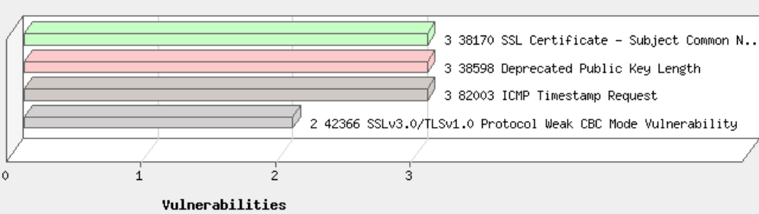
There were 3 occurrences each of the SSL Certificate – Subject Commont Name Does Not Match Server FQDN, Deprecated Public Key Length, and ICMP Timestamp Request Vulnerabilities, making them the most common vulnerability. There were 8 vulnerabilities in the General Remote Services category, making it the most common vulnerability category.
Top 5 Vulnerable Categories
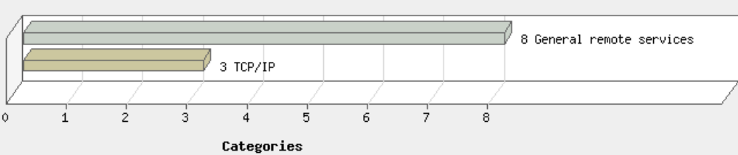
Two operating system was identified during this scan.
Operating Systems Detected
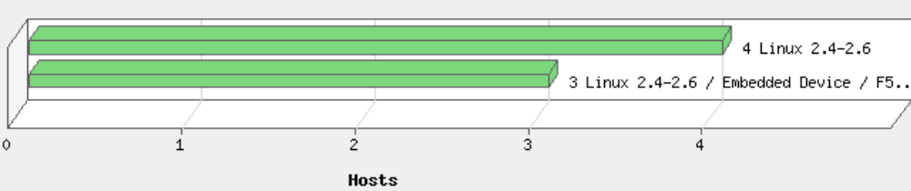
There were 3 services found to be running during this scan.
Services Detected
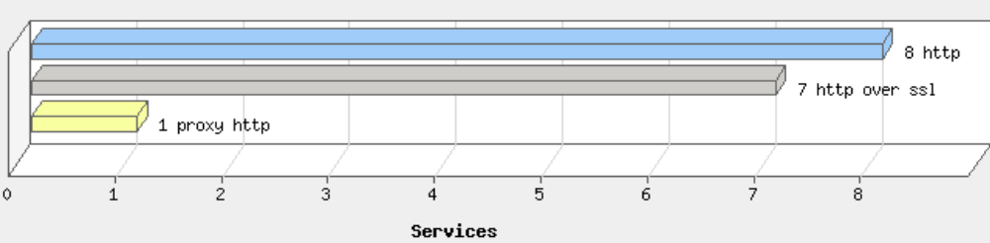

The HTTP service was found on 8 systems, making it the most common service.

- 1.6. Internal Penetration Test
The internal penetration test was actually carried out by the client’s personnel. Compass did provide the following guidelines for conducting the test:
- Demonstrate that only the three users who are authorized to access production can successfully connect from their stations.
- Demonstrate that they are only authorized to connect from their own stations (or designated stations).
- Demonstrate that several users that are not authorized to connect to production are not able to connect from any station (a small sample would be sufficient - at least one connection attempt should be from one of the stations that an authorized user is able to connect from).
- Demonstrate that an unauthorized user cannot remotely connect to a station of an authorized user.
- If the remote connection is possible then you must demonstrate that the unauthorized, remote user cannot connect to production through this station.

The results of the penetration test were then reviewed by Compass. See the results below:

Item #1
Three people are authorized to access to production servers. SSH is used to access the production servers. Access to production servers via ssh is allowed from the Italian facility only (rules on datacenter firewalls). The three users manage their own ssh key pairs and keep them on their own stations. keys.

<Image redacted>

Since the three authorized users access the production servers using the same root account, an access logger logs the ssh key fingerprints as well. This method is used to discriminate access by user. Here are the ssh key fingerprints:

Here is an excerpt from the access log to a mobile server showing access from the four users. Two ssh access attempts are logged. The first one is mauro (compare fingerprint with the screeshot above), the second one is malex. Both access attempts originate from Italian facility IP address ().

Item #2
Production servers are accessible from office only (due to firewall rules). Also, the authentication method used (ssh public key authentication) guarantee that only authorized keys can connect to production servers through ssh.

Item #3
Here are access attempts to Company URL (another production mobile server):

The screenshot below shows a failed connection attempt from Mac by another user (foe):

<Image redacted>

The screenshot below shows (not authorized) failing to to connect from his Mac:
<Image redacted>

Item #4
Here is a screenshot that shows an attempt to remotely connect to a station (Bob’s Mac) authorized to connect to production servers. First, Bob connects to another server in the same private network, then he tries to connect back to his own station. It fails, because personal firewall blocks all external connections.

<Image redacted>

Item #5
This is N/A since remote access to the stations owned by the three persons is blocked by personal firewalls.

- 1.7 Conclusions
Compass has concluded that the overall security stance for the Client’s public facing networks is adequate to prevent unauthorized access to systems and sensitive information. A risk rating of medium-low is representative of the minimal findings discovered during this penetration test. The majority of the systems reviewed had no findings or vulnerabilities. Therefore Compass has awarded an overall rating of 1 – Satisfactory: Risk mitigation and security practices are in place resulting in little risk to Company.

2. Technical Details
- 2.1. Technical Summary
This section will list the top likely candidates for penetration testing and note any significant findings discovered.

2.1.1. Company URL
- 2.1.1.1. Invalid SSL Certificate Detected
Url | http://Company URL/
List of Problems | - The Name on the security certificate does not match the name of the site
- Classification
- PCI 2.0 6.5.4
- PCI 1.2 6.5.9
- OWASP A9
- CWE 259
- CAPEC 459
- WASC 04
- Vulnerability Details
An SSL certificate can be created and signed by anyone. You should have a valid SSL certificate to make your visitors sure about the secure communication between your website and them. If you have an invalid certificate your visitors will have trouble distinguishing between your certificate and those of attackers.
- Impact
Attackers can perform MITM attacks and observe the encryption traffic between your website and the visitors.
- Remedy
Fix the problem with your SSL certificate to provide secure communication between your website and its visitors.
- External References
- OWASP - Insecure Configuration Management
- OWASP - Insufficient Transport Layer Protection
- 2.1.1.2. Apache Coyote Version Disclosure
Url | http://Company URL/
Extracted Version | Apache-Coyote/1.1
- Classification
- OWASP A6
- CWE 200
- CAPEC 170
- WASC 45
- Vulnerability Details
Netsparker identified that the target web server is disclosing the Apache Coyote version in its HTTP response. This information can help an attacker to gain a greater understanding of the systems in use and potentially to develop further attacks targeted at the specific version of Apache.
- Impact
An attacker might use the disclosed information to harvest specific security vulnerabilities for the version identified.
- Remedy
Configure your web server to prevent information leakage from the SERVER header of its HTTP response.

2.1.2. Company URL
- 2.1.2.1. Invalid SSL Certificate Detected
Url | http://Company URL/
List of Problems | - The Name on the security certificate does not match the name of the site
- Classification
- PCI 2.0 6.5.4
- PCI 1.2 6.5.9
- OWASP A9
- CWE 259
- CAPEC 459
- WASC 04
- Vulnerability Details
An SSL certificate can be created and signed by anyone. You should have a valid SSL certificate to make your visitors sure about the secure communication between your website and them. If you have an invalid certificate your visitors will have trouble distinguishing between your certificate and those of attackers.
- Impact
Attackers can perform MITM attacks and observe the encryption traffic between your website and the visitors.
- Remedy
Fix the problem with your SSL certificate to provide secure communication between your website and its visitors.
- External References
- OWASP - Insecure Configuration Management
- OWASP - Insufficient Transport Layer Protection

2.1.3 Company URL
- 2.1.3.1. Invalid SSL Certificate Detected
Url | http://Company URL/
List of Problems | - The Name on the security certificate does not match the name of the site
- Classification
- PCI 2.0 6.5.4
- PCI 1.2 6.5.9
- OWASP A9
- CWE 259
- CAPEC 459
- WASC 04
- Vulnerability Details
An SSL certificate can be created and signed by anyone. You should have a valid SSL certificate to make your visitors sure about the secure communication between your website and them. If you have an invalid certificate your visitors will have trouble distinguishing between your certificate and those of attackers.
- Impact
Attackers can perform MITM attacks and observe the encryption traffic between your website and the visitors.
- Remedy
Fix the problem with your SSL certificate to provide secure communication between your website and its visitors.
- External References
- OWASP - Insecure Configuration Management
- OWASP - Insufficient Transport Layer Protection

2.1.4. Company URL
- 2.1.4.1. Invalid SSL Certificate Detected
Url | http://Company URL/
List of Problems | - The Name on the security certificate does not match the name of the site
- Classification
- PCI 2.0 6.5.4
- PCI 1.2 6.5.9
- OWASP A9
- CWE 259
- CAPEC 459
- WASC 04
- Vulnerability Details
An SSL certificate can be created and signed by anyone. You should have a valid SSL certificate to make your visitors sure about the secure communication between your website and them. If you have an invalid certificate your visitors will have trouble distinguishing between your certificate and those of attackers.
- Impact
Attackers can perform MITM attacks and observe the encryption traffic between your website and the visitors.
- Remedy
Fix the problem with your SSL certificate to provide secure communication between your website and its visitors.
- External References
- OWASP - Insecure Configuration Management
- OWASP - Insufficient Transport Layer Protection
- 2.1.4.2. Cookie Not Marked As HttpOnly
Url | Company URL
Identified Cookie
- Classification
- CWE 16
- CAPEC 107
- WASC 15
- Vulnerability Details
Cookie was not marked as HTTPOnly. HTTPOnly cookies can not be read by client-side scripts therefore marking a cookie as HTTPOnly can provide an additional layer of protection against Cross-site Scripting attacks.
- Impact
During a Cross-site Scripting attack an attacker might easily access cookies and hijack the victim's session.
- Actions to Take
- See the remedy for solution
- Consider marking all of the cookies used by the application as HTTPOnly (After these changes javascript code will not able to read cookies.
- Remedy
Mark the cookie as HTTPOnly. This will be an extra layer of defence against XSS. However this is not a silver bullet and will not protect the system against Cross-site Scripting attacks. An attacker can use a tool such as XSS Tunnel to bypass HTTPOnly protection.
- External References
- OWASP HTTPOnly Cookies
- MSDN - ASP.NET HTTPOnly Cookies
- 2.1.4.3. Internal Server Error
Url | Company URL
Parameter Name | un_jtt_show_parameters
Parameter Type | Querystring
Attack Pattern | ../../../../../../../../../../proc/self/version.php
- Vulnerability Details
The Server responded with an HTTP status 500. This indicates that there is a server-side error. Reasons may vary. The behavior should be analysed carefully. If Netsparker is able to find a security issue in the same resource it will report this as a separate vulnerability.
- Impact
The impact may vary depending on the condition. Generally this indicates poor coding practices, not enough error checking, sanitization and whitelisting. However there might be a bigger issue such as SQL Injection. If that's the case Netsparker will check for other possible issues and report them separately.

It should be noted that only Confirmed and Potential Risk Levels 5, 4 and 3 were reviewed and listed in this report. Risk levels 2 and 1 should be reviewed by the client as time permits.

