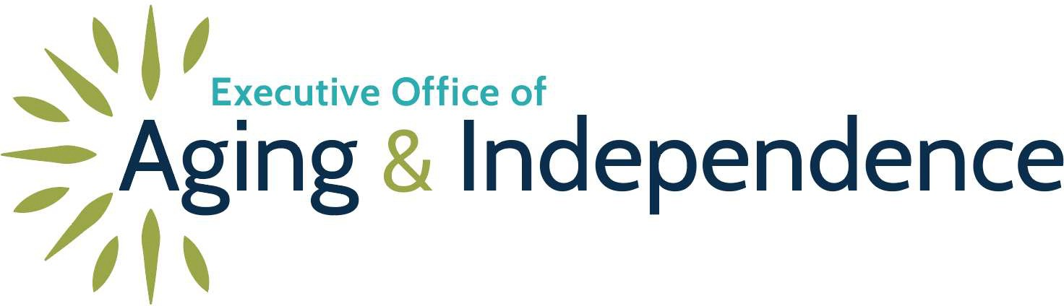

MAURA T. HEALEY
Governor
KIMBERLEY DRISCOLL
Lieutenant Governor
KATHLEEN E. WALSH
Secretary, Executive Office of Health & Human Services
ROBIN LIPSON
Secretary, Executive Office of Aging & Independence

March 7, 2025

Mr. Michael LeBrun, Executive Director Cape Cod Senior Residences
100 Dr. Julius Kelley Lane Pocasset, MA 02559
RE: COMPLIANCE REVIEW REPORT
Dear Mr. LeBrun,
This Compliance Review Report (Report) is written in accordance with 651 CMR 12.09(4) and provides a summary of all pertinent information obtained during a Compliance Review conducted by the Executive Office of Aging & Independence for the following Residence:

Residence Name: | Cape Cod Senior Residences
Address: | 100 Dr. Julius Kelley Lane Pocasset, MA 02559
Initial Certification: | 2/28/2005
Current Certification: | Deemed certified under 651 CMR 12.03(7) since 2/28/2025
Last Compliance Review: | 2/9/2023
# Certified Total Units: | 60
Special Care Residences: | 0
Special Care Units: | 0
Action Taken: | Plan of Correction
Previous Action: | No
Owner: | Pocasset Assisted Living, LP

Cape Cod Senior Residences March 7, 2025
- Summary of Actions.
The Executive Office of Aging & Independence (AGE) conducted an on-site compliance review on March 4, 2025. Cape Cod Senior Residences (Residence) will continue to be certified until AGE issues a notice regarding final approval or denial of the application for recertification. Final approval will be granted when the issues discussed below have been clarified or corrected in writing.
- Findings.
In accordance with 651 CMR 12.09(4)(b), this compliance report cites the specific portion of the law(s) or regulation(s) that have been violated and sets forth the corrective action required to be taken by the Residence.

Continue to next page.

Page 2 of 6

Cape Cod Senior Residences March 7, 2025

FINDING REFERENCE | Subject Area | Regulation Citation | Finding | Corrective Action | Repeat  FINDING¹
A | General Requirements for an ALR - Service and Service Coordination Requirements:  Emergency Response | 651 CMR 12.04(2)(b)(3.)(b.)(c.) | Delayed e-call response time not compliant with the Residence’s policy. | See IV A
B | General Requirements for ALR-Service and Service Coordination:  Quality Assurance and Performance Improvement | 651 CMR 12.04(10)(a)-(c) | Missing or incomplete components of the Quality Assurance and Performance Improvement requirements.  Insufficient documentation of the Evidenced Informed  Falls Prevention Program | See IV A | YES
C | General Requirements for an ALR - Emergency Preparedness Plan and Reporting Requirements:  Reporting Resident Specific Emergencies | 651 CMR 12.04(11)(e) | Resident specific incident reports submitted late to AGE. | See IV A | YES
D | Record Requirements:  Correspondence Log | 651 CMR 12.05(4) | Inconsistent documentation of information necessary for the continuity of care. | See IV A | YES

¹ A finding is determined to be a “repeat finding” if the finding was also cited in the last compliance review report.
Page 3 of 6

- Summary of Compliance Review
  - Service and Service Coordination Requirements - Emergency Response
    - AGE reviewed response times and tests of the emergency response system from the calendar years 2023 and 2024 to determine compliance with Service Coordination requirements.
      - In the month of December 2024 there were 30 e-call response times over the eight minutes required by Residence policy.
      - In the month of June 2024 there were 12 e-call response times over the eight minutes required by Residence policy.
      - In the month of December 2023 there were 15 e-call response times over the eight minutes required by Residence policy.
  - Quality Assurance and Performance Improvement
    - AGE reviewed documentation to ensure the Residence has established an effective, ongoing quality improvement and assurance program for Service Planning, Resident Safety and Medication Quality for the calendar years 2023 and 2024.
Service Planning
      - Documentation of a target date and staff person responsible for follow-up was missing for all calendar years reviewed.
Resident Safety Assurances
      - Documentation of an Evidenced Informed Falls Prevention Program review being included in the annual safety review process was missing for all calendar years reviewed.
Medication Quality Plan
- AGE reviewed the Residence’s quarterly medication documentation audits from February 9, 2023, through the date of the Compliance Review to ensure compliance with SAMM and Residence policies.
  - Documentation of the target date and staff person responsible for follow up was missing for all calendar years reviewed.
Medication administration observation
- AGE observed two PCA staff providing medication assistance to five Residents to ensure the Residence has developed and implemented systems that support and promote safe SAMM:
SAMM
  - One Resident had one expired medication in their medication storage unit.
  - Reporting Resident-specific Emergencies – Incident Reports

Page 4 of 6

    - AGE reviewed the Residence records and submitted incident reports from February 9, 2023 through March 4, 2025, for evidence that all occurrences of an incident or accident that has or may have a Significant Negative Effect on a Resident’s health, safety or welfare were reported to AGE within 24 hours after the occurrence of the incident or accident.
      - The Residence filed 15 incident reports greater than 24 hours after the occurrence of the incident during the period reviewed.
  - Record Requirements - Correspondence Log
    - AGE reviewed the current 90-day Correspondence Log for the Residence required to communicate information necessary to maintain the continuity of care for all Residents.
      - The Residence did not use the Correspondence Log to communicate all significant or pertinent information necessary to maintain the continuity of care for all Residents.
Corrective Actions.
A. General Corrective Actions.
Complete and submit to AGE each of the following:
- A specific plan of what will be or has been done to correct each of the cited in Section II above.
- Provide a description of what will be done to prevent recurrence of each of the issue(s) identified in Section II to ensure the problem does not recur.
- Identify the designation of the individual(s) who will be responsible for monitoring the correction; and,
- The date by which each correction will be achieved.
If a particular finding cannot be corrected within 30 days due to the nature of the corrective action, the Residence’s corrective action response must include a schedule for completion within a reasonable period.
NEXT STEPS:
In accordance with 651 CMR 12.09(4)(g), you are required to respond in writing to the Executive Office of Aging & Independence within 10 days after receiving this notice indicating your agreement or disagreement with the findings. If you agree with the findings, please submit in writing to the Executive Office of Aging & Independence all required information/corrections by April 7, 2025.
If you disagree with the findings, you may request an informal review pursuant to 651 CMR
12.10 (1) by submitting your request using certified mail, return receipt requested, together with a detailed written rebuttal of the findings within 10 days of your receipt of this letter.

Page 5 of 6

If you have any questions regarding this matter, please contact me at 617-222-7411 or by email at Christopher.mundy2@mass.gov
Sincerely,
Christopher Mundy
Assisted Living Certification Specialist

CC: Pocasset Assisted Living, LP 247 Commercial Street
Rockport, ME 04846

Page 6 of 6

