April 2, 2025

Mr. John Lamirande, Executive Director Delaney at the Vale
20 Hill Street
Woburn, MA 01801

RE: COMPLIANCE REVIEW REPORT

Dear Mr. Lamirande,

This Compliance Review Report (Report) is written in accordance with 651 CMR12.09(4) and provides a summary of all pertinent information obtained during an Assisted Living Residence Compliance Review conducted by the Executive Office of Aging & Independence (AGE) for the following Residence:

Name of ALR: | The Delaney at the Vale
Address: | 20 Hill Street  Woburn, MA 01801
Initial Certification: | 3/18/2024
Current Certification: | Certified through 3/18/2026
Last Compliance Review: | Initial Compliance Review
# Certified Total Units: | 120
Special Care Residences: | 2
Special Care Units: | 36
Action Taken: | Plan of Correction required
Previous Action | None
Owner: | LCS Woburn Operations LLC

The Delaney at The Vale April 2, 2025
- Summary of Actions.
AGE conducted an on-site compliance review, pursuant to 651 CMR 12.09, at The Delaney at The Vale (Residence) on March 27, 2025. AGE conducted the site visit after receiving sufficient information to establish a cause to believe that the Residence may not be in compliance with applicable law.

- Findings.
In accordance with 651 CMR 12.09(4)(b), this compliance report cites the specific portion of the law(s) or regulation(s) that have been violated and sets forth the corrective action required to be taken by the Residence.

Continue to next page.

Page 2 of 8

FINDING REFERENCE | Subject Area | Regulation Citation | Finding | Corrective Action | Repeat finding¹
A | General Requirements for an ALR:  Emergency Response | 651 CMR 12.04(2)(b)(3)(b) | Missing system functionality testing required by Residence policy. | See IV A&B
B | General Requirements for an ALR:  Special Care | 651 CMR 12.04(4)(a)(4)  651 CMR 12.04(4)(d) | Issues with physical hazards identified in the Special Care Residence  missing operations reviews. | See IV A
C | General Requirements for an ALR:  Service Plan Development and  Requirements | 651 CMR 12.04(1)(d)  651 CMR 12.04(7)(b)  651 CMR 12.08(a)(2.)(a.)  651 CMR 12.04 (8)(a)(2.)(c.) | Inconsistent with documenting all requirements of Assessments and Service Plans. | See IV A
D | General Requirements for an  ALR:  Quality Assurance and  Performance Improvement | 651 CMR 12.04(10)(a)-(c) | Missing or incomplete components of the Quality Assurance and Performance Improvement requirements.  Unsafe SAMM and LMA. | See IV A&B
E | Training Requirements:  Training Needs Assessment | 651 CMR 12.07(5) | Missing annual training needs assessment. | See IV A&B
F | Resident Rights and Disclosures:  Resident Disclosures | 651 CMR 12.08 | Missing Disclosure of Rights. | See IV A
G | Compliance Reviews of Assisted Living Residences:  Record Review | 651CMR 12.09(3)(e) | Records of monthly SCR safety checks and LMA administration were missing. | See IV A
1 A finding is determined to be a “repeat finding” if the finding was also cited in the last compliance review report.
- Summary of Compliance Review
  - Service and Service Coordination Requirements- Emergency Response
    - AGE reviewed the Personalized Emergency Response procedures developed to provide timely assistance to a Resident in the event of an emergency.
      - Documentation of the Residence’s management testing the system to ensure functionality as required by the Residence policy was missing for the 2024 calendar year reviewed.
  - Service and Service Coordination- Special Care
    - AGE reviewed the Special Care Residence (SCR) operations review from calendar year 2024 through the date of the Compliance Review to verify that the SCR is being administered with all the required safeguards:
      - Documentation to support all the required components of the SCR operations were reviewed for the first half of calendar year 2024 was missing.
      - Age identified deficiencies with operational safeguards related to the risk of potential hazards in the physical environment:
- The heating elements in the common area of the SCR were found to be operational without the required safeguards of supervised access only.
  - General Requirements for an Assisted Living Residence (ALR)-
    - AGE reviewed the documentation of six Resident Records from March 2024 through the date of the Compliance Review to determine compliance with the requirements for Screenings, Assessments and Service Plan Development and Requirements.
Service Plan Development and Requirements
      - Three records were missing documentation that Residents have supervised access to a heating element.
      - Two records were missing documentation of a Service Plan reassessment required within 30-days after the commencement of residency.
      - Three records were missing documentation of the way the Residence shall provide for personal emergency response devices or procedures.
      - Two records were missing documentation confirming the description of services not affiliated with the Assisted Living Residence.
  - Quality Assurance and Performance Improvement
    - AGE reviewed documentation to ensure the Residence has established an effective, ongoing quality improvement and assurance program for Service Planning, Safety Assurances, and Medication Quality from March 18, 2024, through the date of the Compliance Review.
Service Planning
      - Documentation of the audit was missing for the 2024 calendar year reviewed.

Resident Safety Assurances
      - Documentation of the audit was missing for the 2024 calendar year reviewed.
      - Documentation of an Evidenced Informed Falls Prevention Program review being included in the annual safety review process was missing for the 2024 calendar year reviewed.
Medication Quality Plan
    - AGE reviewed the Residence’s quarterly medication documentation audits from March 2024, through the date of the Compliance Review to ensure compliance with SAMM, LMA and Residence policies.
      - Documentation of the audits for all four quarters were missing for the 2024 calendar year reviewed.
Medication administration observation
    - AGE observed one Personal Care (PC) staff and one nurse providing medication assistance to 6 Residents to ensure the Residence has developed and implemented systems that support and promote safe SAMM / LMA.
SAMM
      - AGE observed unsecured over the counter medications in one Resident’s unit.
LMA
      - AGE observed LMA medications were not stored separately from SAMM in one Resident’s medication storage unit as required by the Residence policy.
      - AGE observed unsecured over the counter medication in one Resident’s unit.
      - One Resident’s medication storage unit contained one over the counter medication not on the prescribed medication list.
      - One Resident’s medication storage unit contained one expired medication.
      - One Resident’s medication storage unit contained Exemption C
without a pharmacy label and without a marked open date.
      - One Resident’s Medication Administration Record did not record the area of placement of Exemption C after administration to the Resident.

  - Training Requirements - Training Needs Assessment
    - AGE reviewed the Residence’s documentation for evidence of compliance with training needs assessment regulations.
      - Documentation to support that the Residence has conducted a training needs assessment in the 2024 calendar year was missing.
  - Resident Rights and Disclosures- Resident Disclosures
    - AGE reviewed six Resident records to confirm compliance with the Disclosure of Rights and Services requirements.

      - The required Disclosure forms and notification of the right to bring a Representative prior to the first meeting, were not signed by the Resident, Resident Legal Representative and/or Residence prior to the move-in date in six records.
  - Compliance Reviews of Assisted Living Residences - Record Review
    - AGE reviewed the Residence’s records including all documents that should be maintained in relation to the operations of the Residence.
      - Three Resident’s monthly safety check records were intermittently missing from the time of move-in to the date of compliance review.
      - Two Resident’s monthly LMA administration records were intermittently missing from the time of move-in to the date of compliance review.

- Corrective Actions
  - General Corrective Actions
Complete and submit to AGE each of the following:
- A specific plan of what will be or has been done to correct each of the cited in Section II above;
- Provide a description of what will be done to prevent the recurrence of each of the issue(s) identified in Section II to ensure the problem does not recur;
- Identify the designation of the individual(s) who will be responsible for monitoring the correction; and,
- The date by which each correction will be achieved.
  - Specific Corrective Actions.
Submit to AGE the following:
- Documentation confirming management has tested the functionality of the emergency response system.
- Documentation confirming the completion of a current Quarterly Medication Audit.
- Documentation confirming the completion of a current Safety Assurances Review including monitoring the effectiveness of the Falls Prevention program.
- Documentation confirming the completion of a current Service Plan Review.
- Documentation confirming the completion of a current Annual Training Needs Assessment.

- NEXT STEPS:
In accordance with 651 CMR 12.09(4)(g), you are required to respond in writing to AGE within ten (10) days after receiving this notice indicating your agreement or disagreement with the findings. If you agree with the findings, please submit in writing to AGE all required information/corrections by May 2, 2025.

If you disagree with the findings, you may request an informal review pursuant to 651 CMR 12.10(1) by submitting your request using certified mail, return receipt requested, together

with a detailed written rebuttal of the findings within ten (10) days of your receipt of this letter.

If you have any questions regarding this matter, please contact me at 617-222-7411 or by email to christopher.mundy2@mass.gov.
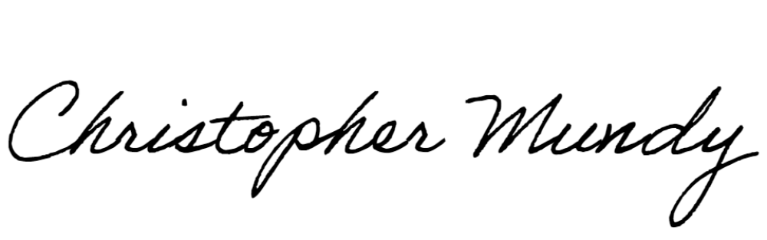
Sincerely,

Christopher Mundy
Assisted Living Certification Specialist
CC: LCS Woburn Operations LLC 400 Locust Street, Suite 20 Des Moines, IA 50309

