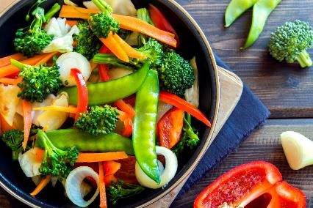

CHAPTER VII:
CONDUCTING AN ENVIRONMENTAL INVESTIGATION

IMPORTANT RESOURCES

Food Protection Program For policy and technical assistance with the environmental
617-983-6712 investigation such as conducting a HACCP risk assessment, initiating enforcement actions and collecting food samples. On-site investigation assistance is often available for larger outbreaks.

Epidemiology Program For technical assistance with the epidemiologic investigation
617-983-6800 such as obtaining medical histories, coordinating stool specimen submissions and developing questionnaires. On-site investigation assistance is often available for larger outbreaks.

State Public Health Laboratory For technical assistance with the collection protocol for
617-983-6616 food and enteric specimens.

Updated February, 2019
The local board of health (LBOH) is the public health agency responsible for conducting an environmental investigation in response to a suspect foodborne illness complaint. The objective of the environmental investigation is to identify the reason for, or source of, contamination and to initiate corrective actions to eliminate contaminated foods or poor food handling practices which may result in contaminated foods. Further illnesses may be avoided if potentially contaminated foods are promptly identified and removed from sale or service to the public and poor food-handling practices are corrected. Other reasons for initiating an environmental investigation include government responsibility, consumer expectation and vindication of innocent establishments. Investigative findings are important information. They, as well as regular inspection reports, are public records and may be subpoenaed for legal proceedings.

A. Being Prepared for an Environmental Investigation

1. Knowledge:
Food inspectors who respond to foodborne illness complaints should be well educated in food microbiology, etiology of foodborne disease, high-risk factors in foodborne illness outbreaks, the application of HACCP principles, food preparation review and food establishment investigation procedures, regulatory provisions and enforcement procedures outlined in 105 CMR 590.000, in order to do a thorough investigation. Courses through the MDPH, the Massachusetts Environmental Health Association, the Massachusetts Health Officers' Association and the Federal Food & Drug Administration's (FDA) ORAU at www.fda.gov should have been completed to be prepared for this level of investigation.

2. Communication:
Good communication skills are also required to conduct a thorough investigation. When identifying yourself to the Person-in-Charge (PIC), explain the purpose of the foodborne illness investigation and be prepared for a variety of reactions. Food establishment operators are often tense, nervous, defensive, and sometimes, in complete denial at the prospect of being responsible for a customer's illness. Stay calm, respectful and professional. Encourage cooperation by explaining that it is the LBOH's responsibility, as well as the food establishment, to ensure that practices and procedures are adequate to prevent foodborne diseases. In some cases, this environmental investigation may help prove that the establishment is not involved, or is not responsible, for the outbreak. If necessary, and only as a last resort, remind the PIC that failure to cooperate in the investigation may result in the suspension or revocation of the food permit. In any situation, maintain an unbiased attitude and assure the PIC that other plausible causes will be addressed.

The designated LBOH spokesperson responsible for talking to the media and affected groups in high-profile investigations, such as larger outbreaks, should also be knowledgeable in risk management issues and have a medical or public health background.

3. Equipment and Forms:
Review Attachment 7-1: Inspection Equipment Checklist and Attachment 7-2: Food Inspection Report Form, found at the back of this chapter, to make sure that you have the required equipment and forms to conduct the investigation.

The primary objective of the environmental investigation is to determine what specific factors may have contributed to the illness or outbreak and, if discovered, assure that they are corrected. Unlike routine inspections, a quality environmental investigation of a foodborne disease outbreak may take several hours because it involves the evaluation of all suspected processes. It should start with a review of the previous routine inspection reports of the implicated food establishment.
A complete 72-hour food history should have been completed as part of the initial complaint intake, so that a reasonable list of possible suspect foods is in-hand when the environmental investigation begins.

B. Sample Collection; Food and Enteric

To avoid important evidence from being inadvertently discarded during your investigation, always identify and collect leftovers of the suspect food(s) immediately. The samples ultimately may not be tested for a variety of reasons, but in some circumstances having the samples could prove invaluable. Food collection should be completed prior to initiating the HACCP risk assessment of the suspect food.

As with food samples, stool specimens must be collected as soon as possible in order to confirm a clinical diagnosis. If, in discussions with the PIC, it is determined that there have been sick food employees, the food inspector must be prepared to handle that issue as well. If possible, and staffing permits, the Public Health Nurse may be called to assist with the issue of sick food employees. Bring an adequate supply of enteric kits and instructions for collection. Determine who is responsible for distributing enteric stool kits to food employees. Determine who is responsible for instructing food employees on how stool specimens should be collected, as well as educating the food service staff on the reason sampling is necessary. See Chapter IX for instructions on collecting, packaging, completing lab submission forms and transporting samples to the State Public Health Laboratory. See Chapter VIII for additional information on sick food employees.

C. Background Information for the HACCP Risk Assessment

1. What is HACCP?
HACCP is a science-based method of evaluating food handling procedures to identify or prevent hazards which contribute to foodborne disease. A HACCP-based investigation focuses on the suspect food or meal implicated, rather than on a cursory inspection of the physical and sanitary facilities of the food establishment. The production of the implicated food item(s) is evaluated for hazards which can contribute to the occurrence of foodborne disease. This is done at each step of handling from receipt to sale or service to the consumer.

The ideal steps in conducting a HACCP risk assessment of the implicated food include actual observation of the suspect food being prepared, taking temperatures and identifying potentially faulty food handling practices. Since this may not be feasible if the food establishment is not producing the implicated food at the time of the investigation, it will be necessary to interview the PIC of food production on how the food was handled from receipt to sale or service. General food handling practices should be evaluated by observing food workers and by measuring temperatures of various Time/Temperature Control for Safety (TCS) foods (formerly potentially hazardous foods).

2. Applied Food Microbiology
An understanding of how pathogens (disease-causing microorganisms) can contaminate food, survive and/or multiply, and in some instances, produce toxins, is essential to evaluate risk. Pathogens may be present in raw foods as well as in infected food employees. Pathogens in food, present either naturally or by contamination, can survive if the food requires no further cooking, or is undercooked. It is important to note that while bacteria may survive and multiply in TCS foods, viruses and parasites may survive but cannot multiply without a living host. Pathogens in infected food employees may be shed in feces, infected lesions and respiratory secretions and thus can be transmitted to food. See Chapter II for a more extensive discussion of disease characterization and pathogenesis.

TCS foods are those high-risk foods in which bacteria can survive, multiply and with certain bacteria, produce toxin. Foods with a pH of 4.6 or above and a water activity of 0.85 a_{w} or greater are regarded as TCS foods. TCS foods are also defined as any food or ingredient, natural or synthetic, in a form capable of supporting the rapid and progressive growth of infectious or toxigenic microorganisms or the slower growth of Clostridium botulinum. Attachment 7-3, the effects of pH, and Attachment 7-4, the effects of water activity (a_{w)} are provided at the end of this chapter. TCS foods include an animal food that is raw or heat-treated; a plant food that is heat-treated or consists of raw seed sprouts, cut melons, cut leafy greens, cut tomatoes or mixtures of cut tomatoes that are not modified in a way so that they are unable to support pathogenic microorganism growth or toxin formation.

The optimum growth temperature range for the majority of pathogens is between 60 and 120 degrees F. Some pathogens such as Listeria and Yersinia grow best under refrigeration temperature ranges. Under optimum growth temperatures, bacteria, in their vegetative state, can double in number every 15 to 20 minutes. At temperatures below freezing, foodborne pathogens may survive but cannot grow. Most pathogens are destroyed at temperatures above 135 degrees F.

While TCS foods may provide the optimum environment for the growth of pathogens, other non-TCS foods may be the causal factor in a foodborne illness outbreak by simply acting as the food vehicle in which bacteria, parasites or viruses can survive until ingested. Some foods, such as cut tomatoes and cut leafy greens, have been added to the TCS food list over the years due to them being implicated as the source of a large number of foodborne illness outbreaks. It is important, however, to remember that non-TCS foods can also be the source of foodborne illness, such as, but not limited to, jalapeno peppers, black pepper and peanut butter, that were found to be implicated as the source of past multi-state foodborne illness outbreaks.

Many pathogens which are naturally found in soil-grown vegetables, grains and spices have a dormant spore state which can be heat shocked into a vegetative state after cooking. With the exception of infant botulism, bacterial spores do not cause foodborne disease. However, if a pathogen's spore, such as Bacillus cereus in rice, is heat shocked into its vegetative state after cooking, the Bacillus cereus bacteria can then multiply rapidly if left at optimum growth temperatures of 60 to 120 degrees F.

3. High-Risk Factors in Food Preparation
Significant factors in foodborne illness outbreaks have been documented in several foodborne disease investigation surveillance studies. They can be divided into three hazard categories: contamination, survival, and growth.

Contamination:
- infected person
- contaminated ingredients
- hand contact/implicated food
- unclean equipment
- toxic container
- cross-contamination
- added poisonous chemicals
- unapproved source
- natural toxicant
- consumption of raw or lightly cooked food of animal origin

Survival:
- inadequate cooking
- inadequate reheating

Growth:
- inadequate refrigeration
- preparation several hours before serving
- inadequate hot-holding
- improper cooling
- anaerobic packaging

D. Application of HACCP Principles in a Foodborne Illness Investigation

A HACCP Risk Assessment Form (Attachments 7-5, 7-6, and 7-7, a blank and completed form with instructions is at the back of the chapter) can be used to facilitate risk assessment of the suspect food and, if used, must be attached to the inspection report. The form is structured to assist with identifying the procedures used in the establishment in preparing the suspect food, as well as to identify corrective actions initiated as a result of the investigation.

A HACCP risk assessment must be conducted for each suspect food item prepared. If baked chicken and gravy is the suspect food, the preparation of each must be evaluated separately. In outbreaks, when multiple foods have been identified, a HACCP Risk Assessment Form can be used to evaluate procedures for a particular category of food such as soups, salads, or sandwiches.

(Please see also Attachment 7-8, Management of Food Safety Practices - Achieving Active Managerial Control of Foodborne Illness Risk Factors and Attachment 7-9, The Process Approach, both from the 2013 Federal Food Code Annexes.)

Figure 7-1. Steps in a HACCP Risk Assessment

1. Identify ingredients, weight/volume, and steps involved in the preparation of suspect food(s).
2. Identify food handling procedures at each step in the preparation of suspect food(s).
3. Based on observation or interview, identify potential hazards and critical control points (CCP).
4. Identify violations and initiate corrective actions.
5. Verify corrective actions undertaken by the food establishment.

STEP 1: Identify ingredients, weight/volume, and steps involved

in the preparation of suspect food(s).

- Ingredients in the suspect food: Obtain recipes and list all ingredients for each suspect food item. Ingredients must be from an approved source, especially high-risk ingredients such as raw shellfish or canned low-acid foods. It is usually not necessary to obtain exact measurements of each ingredient unless there is a question on the pH of the food. Note new changes in recipes or ingredient substitutions. Note that recipes are proprietary information and must be treated with strict confidentiality.

- The suspect food is contaminated at the source (farm/ocean) or at the manufacturing level: Contaminated produce, eggs, seafood and commercially-processed foods have been implicated in many foodborne illness outbreaks. When such products, contaminated at the source, are implicated, it is crucial to obtain as much information as possible from the food establishment or consumer to identify the exact source and/or manufacturer/distributor. Product lot numbers, expiration dates and sales records are necessary when conducting a traceback to identify an implicated source. When investigating such products, be sure to obtain the following product information. See Attachment 7-10: Traceback Methodology for additional information on tracebacks.

Figure 7-2: Manufactured Product Identification

- Brand Name - Package Type
- Product Name - Date of Purchase
- Code/Lot Number - Manufacturer’s Name and Address
- Expiration/Sell by/Use by Date - Distributor’s Name and Address
- Size/Weight - Retail Food Establishment Where Purchased

Shellfish identification tags should always be obtained for clams, oysters, quahogs and other molluscan shellfish associated with a foodborne illness.

c. Volume of the suspect food prepared by the food establishment: List the weight/volume of the suspect food prepared. Large volumes may indicate problems with cooling or food handling procedures, especially if the food was prepared a day or more before service. If the volume was greater than what is normally prepared, different procedures may have been used.

d. Suspect food preparation schedule: Dates and the length of time are important information needed to determine potential time/temperature abuse. It is important to document date and time prepared, when applicable, to determine if there was ample time for temperature abuse which may have resulted in the growth of pathogens or the production of toxin.

e. Identify steps in preparing the suspect food: Each step in the preparation of a food item is regarded as a "control point." List each step or control point on the HACCP Risk Assessment Form. Listing the steps as a flow chart permits the visualization of each preparation step.

STEP 2: Identify food handling procedures at each step in the preparation of suspect food(s):

- Clearly document how the food was handled at each step: The method used to identify food handling procedures at each step is to observe the actual process. Since this may not be feasible in some situations, it is essential to interview the PIC of food production and then walk through the preparation steps in the kitchen afterwards. Identify how suspect foods were thawed, cooked, cooled, reheated, served and transported. Identify how food employees determined final cooking temperatures. Indicate what equipment was used in the preparation of the suspect food. Specify if food workers use disposable gloves or utensils to handle cooked and ready-to-eat foods. Indicate handwashing practices observed.

- Clearly document who prepared the food: It is recommended that the initials of the employee responsible for handling food be documented. An infected food employee with poor hygiene may be the source of contamination. The initials of the actual worker, and not just his/her position are very helpful when comparing the positive or symptomatic food employees to their job functions, to determine if there is a relationship. Inquire if the food employee has been recently ill. Ask if the worker is a new employee, or new to the particular operation, because a new or different food employee unaware of the proper procedure may have been responsible for preparing the suspect food. Review the food establishment's sick or infected food employee policies.

- Focus on the significant factors in foodborne illness outbreaks: When conducting a HACCP Risk Assessment, focus on poor food handling practices which can contribute to foodborne disease. Definitions for each significant factor are listed in Step 3 below, in addition to questions that may need to be addressed during your assessment.

STEP 3: Based on observation or interview, identify potential hazards

and critical control points (CCP):

A critical control point (CCP) is a preparation step in which a hazard, if present, can result in a foodborne disease. For example, any step in the production of a ready-to-eat food such as tuna salad, where contamination is likely to occur, may be considered a CCP since pathogens introduced during storage or preparation may survive until ingested. Thus, each step where contamination occurs in a ready-to-eat food is "critical." However, if a food employee handles raw chicken with bare hands, this step would not be critical, since the chicken would be cooked in the next step, destroying all pathogens introduced into the food. In this example, cooking would be a CCP because adequate cooking is necessary to destroy all pathogens naturally present or introduced during preparation. Failure to cook the chicken properly would allow the survival of pathogens, which could result in a foodborne illness.

The level of risk for a suspect food depends on the probability of occurrence of a hazard or the sequential occurrences of several hazards identified in the preparation procedure. The three main microbiological hazards, as previously mentioned in this chapter are Contamination (C), Survival (S) and Growth/Toxin Production (G/T).

A. Contamination: Determine if there are risks at each step in the food preparation for microbial contamination (C) from either the food employee, food, or improperly cleaned and sanitized equipment/utensils. Food could be raw animal foods already contaminated, or foods which were contaminated at the point of harvesting, and intended to be consumed raw such as lettuce, raspberries and unpasteurized apple cider.

Epidemiological data indicates that microbiological hazards pose the highest risks to the greatest number of persons. Physical and chemical hazards usually affect individuals rather than groups. Microbiological contamination such as bacteria, viruses and parasites are present in infected food employees and raw foods of animal origin. Indirect or cross-contamination from raw foods of animal origin to ready-to-eat foods, that will receive no further heating, can also result in microbiological contamination.

Contributing Factors Associated with Contamination:
- Contaminated Ingredients: The suspect food or a component of the food contained the pathogenic agent when it arrived at the point of preparation.
- Determine if the suspect food harbors contaminants normally found in soil fertilizers or raw animal foods (e.g., raw meat, poultry, seafood, root vegetables, etc.).
- Check to determine if the water/ice supply was possibly contaminated.
- Check to determine if back-flow prevention devices were present on plumbing cross-connections.
- Check to determine if the suspect food was from an approved source.
- Check to determine if the source may have contributed to the suspect food's contamination (e.g. shellfish from a contaminated growing bed).

- Unapproved Source: The suspect food was obtained from a source that does not comply with appropriate regulatory standards (e.g., shellfish harvested from closed growing beds).
- Determine if all foods, including water and ice, were obtained from an approved source.
- Check identification tags on shellfish and if they are retained for 90 days.

- Infected Person: A food employee involved in the preparation of the suspect food was infected or was suspected of being infected at the time the food was prepared. This individual was identified as the probable source of the agent in the outbreak.
- Identify the persons responsible for preparing the suspect foods.
- Determine if any of the food employees were ill before, or during, the time that the suspect food was being prepared.
- Check if any of the food employees were observed with infected cuts or wounds on their fingers or hands.

- Consumption of Raw or Lightly Cooked Food of Animal Origin: The suspect food was eaten raw or after a heat treatment that would not have reduced the level of agent contamination to below an infectious dose.
- Determine if the suspect food of animal origin was served raw or undercooked.
- If required by law, check if consumer advisories were properly posted.

- Cross-Contamination: The pathogen was transferred to the suspect food during preparation by contact with contaminated worker hands, equipment, utensils, drippage, or spillage. If worker hands were the mode of contamination, the worker was not necessarily infected with or a carrier of the organism.
- Determine if raw foods were stored separately from cooked and ready-to-eat foods.
- Check if food employees were properly washing their hands and using a physical safety barrier such as disposable gloves, deli papers and utensils in-between handling raw, and cooked, or ready-to-eat foods.
- Check equipment, utensils and food contact surfaces for proper cleaning and sanitizing between uses.

- Unclean Equipment: the suspect food was prepared with, or stored in, equipment that was contaminated with the agent.
- Check if the equipment and utensils used to prepare the suspect food were properly cleaned and sanitized in accordance with 105 CMR 590.000.

- Hand Contact with Implicated Food: A food employee who was identified as the source of the agent prepared the suspect food with his/her bare hands.
- Check if infected workers used their bare hands to handle or to prepare cooked and ready-to-eat foods.
- Determine if food workers are trained to use physical safety barriers such as disposable gloves, deli papers and utensils in-between handling raw, and cooked, or ready-to-eat foods.

- Added Poisonous Chemicals: The chemical agent was deliberately or inadvertently added to the suspect food. In former cases, this addition typically occurred at the time of preparation or packaging of the suspect food.
- Determine if any toxic substances were improperly stored or used around the suspect food.
- Check if there were any recent situations involving a disgruntled employee possibly seeking revenge.
- Investigate whether any toxic substance in the immediate vicinity of the suspect food may have been mislabeled.

- Natural Toxicant: A chemical agent of biologic origin that occurs naturally in the suspect food or bioaccumulates in the suspect food, prior to, or soon after, harvest.
- Investigate whether a suspect food is known to harbor natural toxicants, such as histamine in scombroid fish, aflatoxins in grain, toxins in poisonous mushrooms, and dinoflagellate toxins in shellfish.

- Toxic Container: A chemical agent originated in the material from which the food container was made. The agent migrated from the container into the suspect food.
- Determine if the suspect food was in direct contact with lead, copper, aluminum, tin, cadmium or other heavy metals.
- Is the suspect food acidic (pH < 7)? The more acidic the product, the greater potential for the metals to leach into foods. Check to see that food is stored in the proper containers.

B. Survival: Determine if pathogens survived (S) the cooking process. The survival of pathogens is determined by the "thermalization" or cooking procedure used. Pathogens are easily destroyed by adequate cooking or reheating. The consumption of undercooked or raw foods of animal origin is a significant factor in foodborne disease outbreaks. Complete cooking times and temperatures can be found in 105 CMR 590.000, Chapter 3-4 Destruction of Organisms of Public Health Concern, Section 3-401 Cooking.

Figure 7-3:
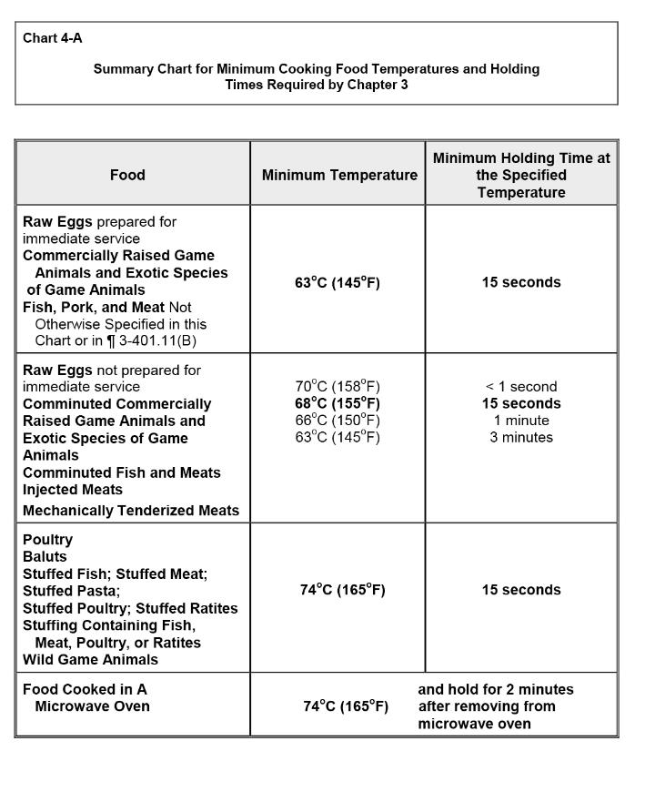
SOURCE: 2013 Federal Food Code, Annex 7, page 746.

Contributing Factors Associated with Survival:
- Inadequate Cooking: The suspect food was not heated to a temperature and for a time adequate to destroy the agent or to reduce the level of contamination to below an infectious dose.
- Determine whether the raw animal origin foods were cooked to proper time/temperatures in accordance with 105 CMR 590.000.
- Check if the establishment has the required food thermometers and whether they are being used to test final cooking temperatures.
- Determine if cooking temperature logs are being used and maintained, if required.

- Inadequate Reheating: The suspect food, which had been previously cooked and cooled, was not heated to a temperature sufficient to destroy the agent or to reduce the level of contamination to below an infectious dose.
- Determine how the suspect food was reheated.
- Determine if the suspect food was properly reheated in accordance with 105 CMR 590.000.
- Determine if a thermometer was used to test the final reheat temperature of the suspect food.

Figure 7-4:
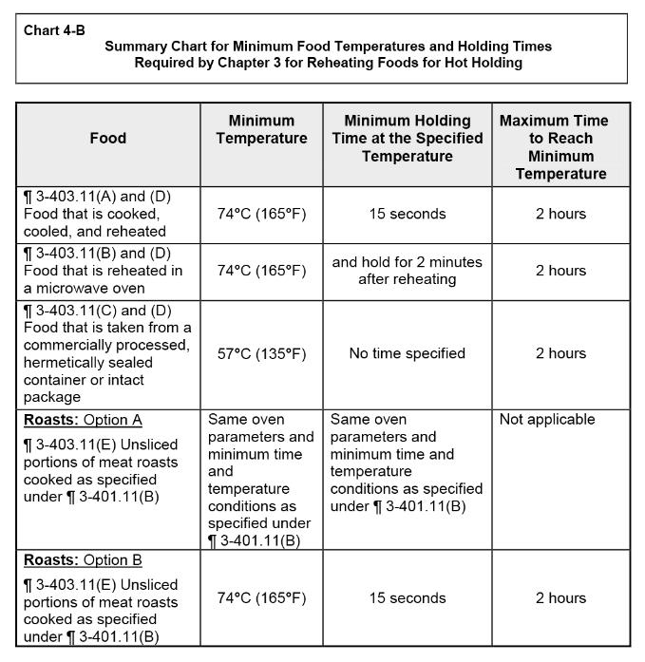

SOURCE: 2013 Federal Food Code, Annex 7, page 747.

C. Growth/Toxin Production: Determine if the pathogens had ample time to grow (G) and/or produce toxin (T). The growth of pathogens and the production of toxins can occur in TCS foods which achieve temperatures between 41 degrees and 135 degrees F for several hours. Time/temperature abuse can result from inadequate cooking procedures, holding at room temperature and inadequate hot and cold holding units. While reheating contaminated food may destroy pathogens, it may not deactivate heat-stable toxins produced by pathogens such as Staphylococcus aureus. It is recommended that TCS foods be cooled from 135 degrees F to 70 degrees F within two hours and from 135 degrees F to 41 degrees F or less within a total of 6 hours.

Contributing Factors Associated with Growth and Production of Toxins:
- Improper Cooling: The suspect food was cooled from a cooking or ambient air temperature to a refrigeration temperature by a means that allowed the growth of a pathogen to an infectious dose or the production of toxin.
- Determine if implicated TCS foods were cooled to 41 degrees F within 6 hours by pre-chilling ingredients, using shallow containers, ice baths or reducing the size of the product.

- Inadequate Refrigeration: The suspect food was not held at a temperature of 41 degrees F or less either due to improperly functioning refrigeration equipment or because it was being held outside of refrigeration. The period of time held at an improper temperature was sufficient to permit the growth of a pathogen to an infectious dose or the production of toxin.
- Determine if there was an adequate number of refrigeration units to maintain the suspect TCS food at or below 41 degrees F.
- Determine if refrigeration units were properly operating at or below 41 degrees F.

- Inadequate Hot Holding: The suspect TCS food was not held at, or above, 135 degrees F due to improperly functioning hot holding equipment, or was not being held in hot holding equipment. The period of time the food was held was sufficient to permit the multiplication and growth of the pathogen to an infectious dose.
- Determine if the suspect food was left out for storage or display at ambient air temperature.
- Determine how long the suspect TCS food was below 135 degrees F.
- Determine if temperatures of suspect foods in hot holding units were at, or above, 135 degrees F.
- Determine if the food employees have and use thermometers to measure temperatures of the suspect TCS food in hot holding units.
- If required, check temperature logs for hot holding units.

- Preparation Several Hours Before Service: The suspect food was prepared long before service, and this practice permitted a time/temperature abuse of the food.
- Determine the length of time between preparation and service of the suspect food.
- Determine how long the suspect food was stored between preparation and service.

- Anaerobic Packaging: The suspect food was stored in a container that provided an anaerobic environment, which permitted the multiplication and growth of the agent.
- Check to determine whether the suspect food was stored in an anaerobic package or container (e.g., vacuum packaging, container filled to capacity and tightly covered, hermetically sealed containers, and garlic in oil products).
- If the suspect food was in a vacuum package or container, investigate at what temperature it was stored.
- Determine if the suspect food was prepared in a cook-chill or sous-vide operation.
- If the suspect food was in a vacuum package or container, review the label storage instructions, and make sure the food establishment was in compliance with label instructions.

Step 4: Identify violations and initiate corrective actions

Documenting violations is a critical step in the investigation, especially if further enforcement action is necessary. Violations may be referenced on the HACCP Risk Assessment Form in the "Item No." column and then attach the form to the food establishment inspection report form. If a HACCP Risk Assessment Form is not completed at the time of the investigation, the violations must be documented on the narrative section of the inspection report form. Failure to properly document violations may result in the LBOH being legally challenged for its actions.

You must also document corrective actions. Indicate immediate corrective or enforcement actions taken, as well as how and when existing violations will be corrected, particularly for critical control points. If violations involving critical control points are detected, a re-inspection should be conducted within 24 to 48 hours to verify correction. In the column "Verified" on the HACCP Risk Assessment Form indicate the date and the inspector verifying correction. Corrective actions may include:

- Modifying faulty food handling practices: Initiating corrective actions is the most critical aspect of the environmental investigation, if unsafe food handling practices are discovered. Ensuring that faulty food handling practices which can result in foodborne disease are corrected is one of the primary objectives of the investigation. Emphasize critical control points correction. Discuss with the PIC monitoring procedures that can be implemented by the food establishment to ensure that steps designated as "critical" are properly carried out by food employees. Correction plans can include recommendations to improve food safety. For example, the use of raw eggs in a Caesar salad dressing may not be a violation of the regulations. However, recommending that the establishment use a pasteurized product is reasonable since the use of a pasteurized product can reduce the risk of disease transmission.

- Education: Efforts to educate the owner/PIC on the risks posed by identified poor food handling practices should be made by the food inspector. In some situations, it may be necessary for the owner to hire a consultant to assist in making changes or training staff. The designated PIC will be required to participate in a food safety management program, if not already certified.

- Removal of contaminated food from sale or distribution: If it is determined that food prepared on the premises is possibly contaminated and may cause a foodborne illness, the LBOH may initiate a voluntary disposal of the food or an embargo in accordance with 105 CMR 590.012. Such action should be taken only with clear evidence of contamination or time/temperature abuse. See Chapter IX: Working with the State Public Health Laboratory for information on taking food samples.

Most of the focus should be placed on foods that will not receive further cooking or reheating, since it is these foods in which bacteria and toxins, if present, may survive until ingested. However, some food poisonings, such as scombroid poisoning can occur even after food is cooked. Remember that corrective actions may not always require disposal.

- Restriction of infected food workers: If a sick food employee is noted at any time during the environmental investigation, work with the PIC to take steps to restrict the food employee from working with food in accordance with 105 CMR 590.000. See Chapter VIII for complete coverage of sick food employees and recommendations for particular things to note during the inspection if hepatitis A is involved. Attachment 7-16 is a model Food Employee Reporting Agreement that can be used by food service establishments to assist with obtaining compliance with illness reporting requirements.

- Emergency closure or suspension of operations: In certain situations, it may be necessary to close an establishment or suspend a particular operation if imminent health hazards exist that cannot be corrected immediately. Failure to immediately correct violations that may result in a foodborne disease, usually associated with critical control points, should invoke an emergency closure or suspension of operation(s).

For example, if it is discovered that a mechanical salad bar refrigeration unit is not maintaining TCS temperatures at or below 41 degrees F, and there is no ice source, the salad bar operation should be closed until the unit is repaired. Another example that may warrant an emergency closure is in an outbreak situation when it is determined that the majority of the food employees must be restricted from working with food, and there are no replacement workers. A food establishment may desire to voluntarily close to avoid negative publicity. Remember, closures and suspensions are a serious matter to all involved and should be well planned before being implemented.

If a closure or suspension is initiated, the permit holder and the PIC must be notified of the order in writing. The order is effective upon posting on the premises. Afterwards, the LBOH must hold a hearing within three business days after receipt of a written request for a hearing. Whether or not a hearing is requested, the LBOH may end the suspension at any time if the reasons for the suspension no longer exist.

Figure 7-5. An Emergency Closure Order Must State the Following:

1. The LBOH has determined that an imminent health hazard exists which requires immediate suspension of operations or closure;
2. The violations leading to that determination; and
3. A hearing will be held, upon written request by the permit holder filed within ten days of receipt of the notice of suspension or closure.

Refer to 590.014 of the MA Food Code for complete information involving the closure
of an establishment.

STEP 5: Verify corrective actions have been undertaken by the establishment

All corrective actions must be verified by the LBOH to ensure that steps to reduce or eliminate the hazards have actually occurred. Failure to correct critical violations or to comply with other necessary measures (e.g., food employee specimen submission or work restrictions) should result in the LBOH taking further enforcement actions such as suspension or emergency closure. Verification may be completed during the investigation by actually observing the corrective actions or by re-inspection.

A HACCP risk assessment may require more than one contact with the permit holder or PIC during site visits or telephone calls in order to obtain all the information necessary to assess the procedures. Elements in the investigation may change and can require shifts of focus in suspect procedures. Try to stay open-minded and patient. When investigating suspect food items, which may have been contaminated prior to being received at the retail food establishment, it is important to obtain as much product information as possible to identify the exact source, and remove contaminated products from distribution.

Conducting a HACCP risk assessment of the implicated food is necessary in order to effectively identify potential hazards or points of contamination and time/temperature abuse. A report that reflects a HACCP-based investigation provides specific information to the reviewer (permit holder, PIC, complainant, LBOH, MDPH Working Group on Foodborne Illness Control, lawyers, etc.) on how the food was handled by the establishment.

Findings may demonstrate how a food establishment is employing safe food handling procedures in preparing the suspect food. Findings may also reveal critical control points in the preparation of the suspect food that were not being safely performed or monitored. In this case, a HACCP risk assessment will clearly identify faulty food handling practices as well as the recommendations to initiate corrective actions. Poor food handling practices can be replaced with safe practices and procedures, thereby averting future occurrences of foodborne disease.

E. National Environmental Assessment Reporting System (NEARS)

In spring 2017, a letter was sent to LBOHs by the Food Protection Program (FPP) requesting voluntary involvement in the CDC's NEARS program which is a nationwide surveillance system designed to capture environmental assessment data from foodborne illness outbreak investigations. Participating in NEARS can greatly assist Massachusetts and other states to prevent foodborne illness outbreaks. The NEARS data can be used to
- Identify environmental causes of outbreaks.
- Take follow-up action to reduce or prevent future foodborne illness outbreaks.
- Evaluate food safety programs and make improvements based on established guidelines.
- Develop or modify program policies or regulations.
- Focus limited program resources on actions with the highest impact.

The CDC and national food safety partners recommend that all food safety programs use NEARS to improve food safety nationally. Environmental assessment data provided by LBOHs is critical to prevent and reduce future outbreaks. The CDC and its national food safety partners will use NEARS to analyze standardized data to understand how and why outbreaks occur, and share findings or recommend actions to better respond to outbreaks and prevent future ones.

Regulatory agencies, such as the FDA, can use information from NEARS to develop intervention strategies and to recommend regulations, such as updates to the Food Code. Food safety programs use this information during outbreak investigations, and on a daily basis, for issuing permits and inspecting restaurants and other facilities.

The LBOH role in NEARS will be to complete the NEARS Establishment Observations Checklist (Attachment 7-12), in addition to other paperwork described in this chapter, but ONLY IN THE EVENT OF AN OUTBREAK. The Food Protection Program will provide technical assistance to complete this form. Additional information about the NEARS program can be found at https://www.cdc.gov/nceh/ehs/nears/

References:

"MA Food Code," Regulation 105 CMR 590.000: Minimum Sanitation Standards for Food Service Establishments, Article X: https://www.mass.gov/files/documents/2018/10/09/105cmr590.pdf

The 2013 FDA Food Code and 2015 Supplement to the 2013 Code are available on FDA’s website at: https://www.fda.gov/Food/GuidanceRegulation/RetailFoodProtection/FoodCode/ucm374275.htm

CIFOR (Council to Improve Foodborne Outbreak Response): Guidelines for Foodborne Disease Outbreak Response - 2nd Edition and Industry Guidelines, plus other resources at http://cifor.us/

https://www.foodshield.org/ Many videos available, particularly FDA videos on actual cases of foodborne illness designed for food service establishments; also, MA-RRT (Rapid Response Team): "Conducting Environmental Assessments."

FDA document for regulators of retail and food service establishments entitled, "Managing Food Safety: A Regulators' Manual for Applying HACCP Principles to Risk-Based Retail and Food Service Inspections and Evaluating Voluntary Food Safety Management Systems." Available at
https://www.fda.gov/downloads/Food/GuidanceRegulation/UCM078159.pdf

Attachments:

Attachment 7-1: Equipment List
Attachment 7-2: Food Inspection Report Form
Attachment 7-3: Effects of pH
Attachment 7-4: Effects of Water Activity
Attachment 7-5: Blank HACCP Risk Assessment Form
Attachment 7-6: Instructions for Completing the HACCP Risk Assessment Form
Attachment 7-7: Completed HACCP risk Assessment Form
Attachment 7-8: Management of Food Safety Practices
Attachment 7-9: The Process Approach
Attachment 7-10: Traceback Methodology
Attachment 7-11: Food Employee Reporting Agreement
Attachment 7-12: NEARS Establishment Observations Checklist

Attachment 7-1: Inspection Equipment Checklist

FIELD EQUIPMENT
Picture I.D.
Inspector Business Cards
Temp Measuring Device (TMD, i.e. Thermocouple, Food Stem Thermometer)
Infra-Red Thermometer (optional)
Alcohol Swabs
160º F Temp. Sensitive Tapes
Sanitizer Test Kits (chlorine, iodine, quaternary ammonia)
pH test papers
Flashlight/Batteries
Clipboard
Black Light/Battery/Bulb (optional)
Educational Materials (optional)
Camera (optional)

RECOMMENDED CLOTHING

Lab Coat

Hair/Beard Restraint

Rubber-Soled Nonslip Footwear

DOCUMENTS
Regulations
Inspection Forms

HAVE ACCESS TO
Sterile Bags & Vials
Cooler & Ice Packs

Attachment 7-2: Food Inspection Report

For copy of most recent version of inspection report, go to: https://www.mass.gov/lists/retail-food

Attachment 7-3: Effects of pH

Attachment 7-Effects of pH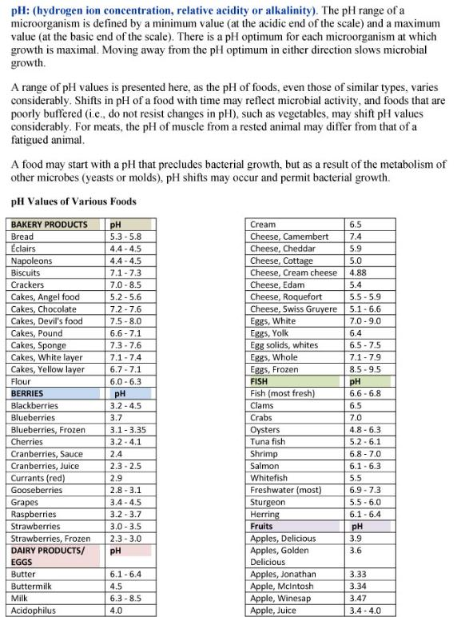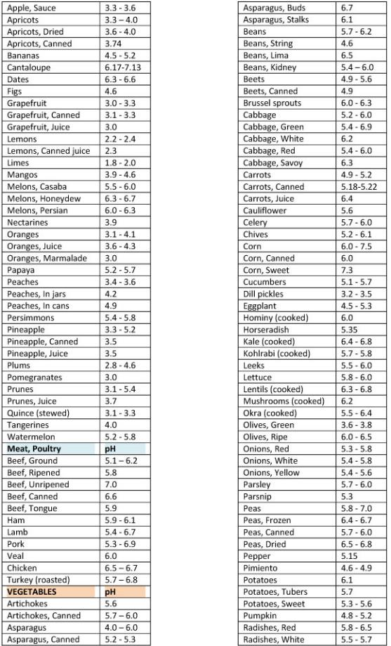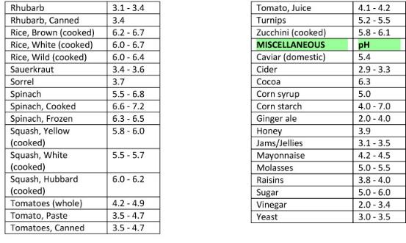
SOURCE: Food and Drug Administration. Bad Bug Book, Foodborne Pathogenic Microorganisms and Natural Toxins. Second Edition, Appendix 3.

Attachment 7-4: Water Activity

Explain What Water Activity is and how it Relates to Bacterial Growth.
Differentiate between the major types of foodborne diseases
- infection, intoxication, and toxin-mediated infection.
Water in food that is not bound to food molecules can support the growth of bacteria, yeast, and mold. The term water activity (a_{w}) refers to this unbound water.
The water activity of a food is not the same thing as its moisture content. Although moist foods are likely to have greater water activity than are dry foods, this is not always so. In fact, a variety of foods may have exactly the same moisture content and yet have quite different water activities.
The water activity (a_{w}) of a food is the ratio between the vapor pressure of the food itself, when in a completely undisturbed balance with the surrounding air media, and the vapor pressure of distilled water under identical conditions. A water activity of 0.80 means the vapor pressure is 80 percent of that of pure water. The water activity increases with temperature. The moisture condition of a product can be measured as the equilibrium relative humidity (ERH) expressed in percentage or as the water activity expressed as a decimal.
Most foods have a water activity above 0.95 and that will provide sufficient moisture to support the growth of bacteria, yeasts, and mold. The amount of available moisture can be reduced to a point that will inhibit the growth of microorganisms.

Water activity values of selected foods
Food | Water activity
Fresh meat and fish | .99
Liverwurst | .96
Cheese spread | .95
Bread | .95
Red bean paste | .93
Caviar | .92
Aged cheddar | .85
Fudge sauce | .83
Salami | .82
Soy sauce | .8
Jams and jellies | .8
Peanut butter | .7
Dried fruit | .6
Cookies | .3
Instant coffee | .2

Predicting Food Spoilage
Water activity (a_{w}) has its most useful application in predicting the growth of bacteria, yeast, and mold. For a food to have a useful shelf-life without relying on refrigerated storage, it is necessary to control either its acidity level (pH) or the level of water activity (a_{w}) or a suitable combination of the two. This can effectively increase the product's stability and make it possible to predict its shelf life under known ambient storage conditions.
Food can be made safe to store by lowering the water activity to a point that will not allow pathogens such as Clostridium botulinum and Staphylococcus aureus to grow in it. The table below illustrates the water activity (a_{w}) levels that can support the growth of particular groups of bacteria, yeast, and mold.

Effect of a_{w} on Spoilage of Foods
a_{w} | Spoilage microorganism | Food
0.90-1.00 | Bacteria | Cottage cheese, meat
0.85 - 9.0 | Bacteria, molds, yeasts | Margarine, condensed milk, whipped butter
0.80 - 0.85 | Yeasts | Fruit syrups
0.75 - 0.80 | Xerophilic molds, molds and yeasts | Dried figs, jams
0.70 - 0.75 | Yeasts | Confections
0.65 - 0.70 | Osmophilic yeasts | Molasses
0.60 - 0.65 | Xerophilic molds, osmophilic yeasts | Dried fruit

Semi-moist foods
For foods with a high water activity correct proper refrigeration is always necessary. These include most fresh foods and many processed foods, such as soft cheeses and cured meats. However, many foods can be successfully stored at room temperature by proper control of their water activity (a_{w}). These foods can be described as semi-moist and include fruitcakes, puddings, and chocolate and caramel sauce.
When these foods spoil, it is usually the result of surface mold growth. Most types of mold do not grow at a water activity level below 0.8. Some will grow slowly at this a_{w}, so it is usually recommended that products of this type not have a water activity greater than 0.75. While this will not completely prevent microbial spoilage, those few yeast and molds that do grow at lower water activities need only to be considered when special shelf life conditions must be met.
Article Sources:

http://extension.psu.edu/food-safety/food-preservation/issues/water-activity-of-foods/water-activity-of-foodstable

http://www.fda.gov/ICECI/Inspections/InspectionGuides/default.htm

If you have questions, contact Dr. Angela Fraser, Associate Professor/Food Safety Education Specialist, Clemson University, Clemson SC.

FBI MANUAL SOURCE: http://www.foodsafetysite.com/educators/competencies/general/bacteria/bac5.html

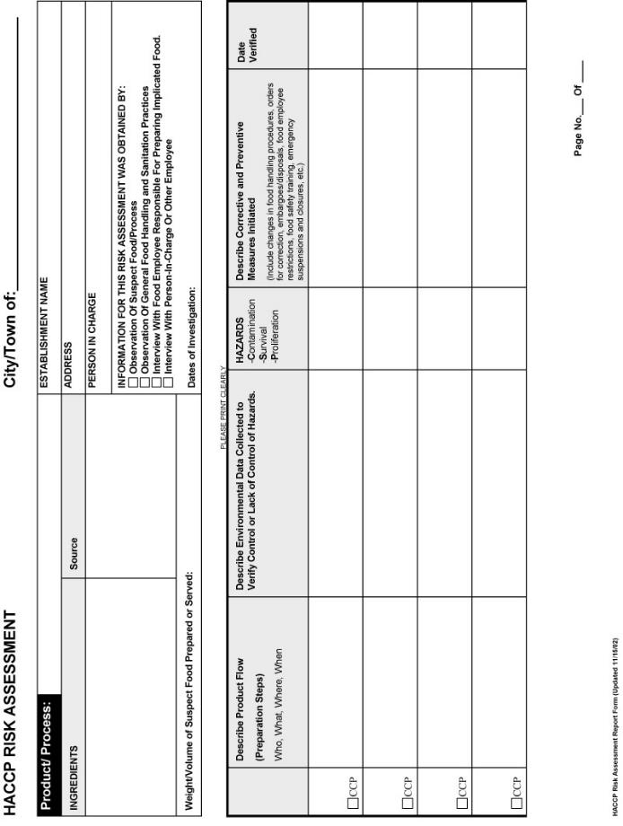
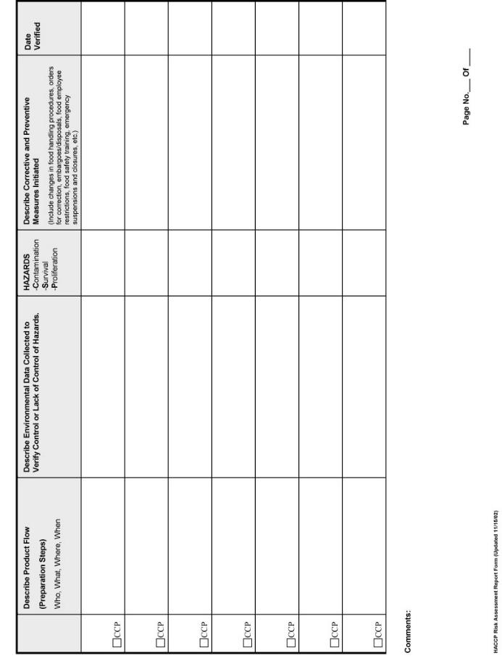
How to Conduct a HACCP Risk Assessment
for an Implicated Food or Food Process.

- Identify List Of Ingredients/ Food Source/ Weight/Volume of Food Prepared
- Confirm general steps used in preparing suspect food. (Use flow diagrams to direct investigation)
- Describe Preparation Steps in greater detail. Use flow diagrams or table to highlight each step. (Explain how food was handled and hazards were controlled at each step from receiving to service or sale) Include:
  - WHO (Identify name of food employee handling suspect food at each step. Include any significant finding relative to health and hygiene).
  - WHAT (Identify what is being done with the food at each step including the type of equipment being used)
  - WHEN (Identify date and time at each step)
  - WHERE (Identify location where food is being handled)
- Identify most likely Critical Control Points (steps in the procedure where food operator must ensure that critical limits are being met to eliminate or significantly reduce the risk of potential hazards.)
- Verify Monitoring Procedures used to control hazards (Identify HOW potential hazards are or are not being reduced or eliminated at each step, especially at critical control points.) Use observations and interviews. Obtain recipes, formulations, operation procedures and monitoring records, if possible.
- Identify Significant Hazards, which may have occurred at each step.
Include:
  - Contamination from raw ingredients, food employee/customer, unclean equipment/utensils, environment.
  - Survival of pathogens in foods that are ready-to-eat or are offered raw or partially cooked.
  - Proliferation (growth) of pathogens and production of toxins in PHFs.
- Identify and Verify Corrective Actions and Preventive Measures taken as a result of the investigation to ensure that hazards resulting from unsafe food and/or inadequate food handling practices have been eliminated or significantly reduced.
Include:
  - Orders for Correction (risk factors and major interventions)
  - Changes in Food Handling Policies and Procedures at each step
  - Embargos/Voluntary Disposals
  - Emergency Suspension or Closure
  - Employee Testing /Restriction/Exclusion
  - Food Employee/PIC Training
  - Orders for Correction (good retail practices)
  - Recalls/Press Releases and News Alerts
  - Equipment/Physical Facility Modifications

- Summarize Contributing Factors identified for the food or process.

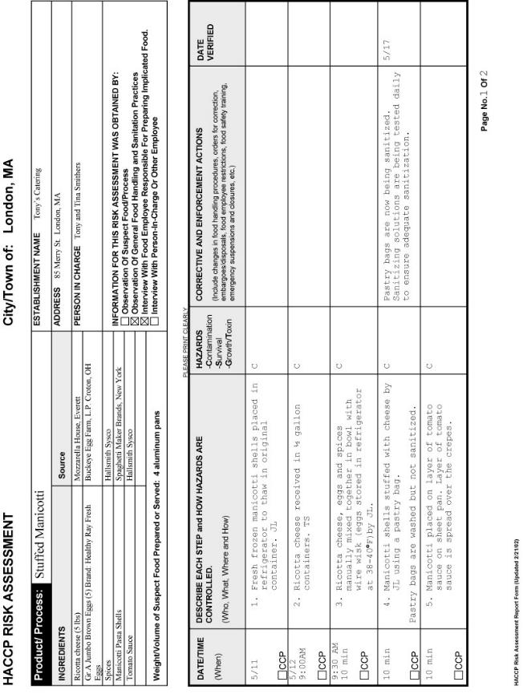
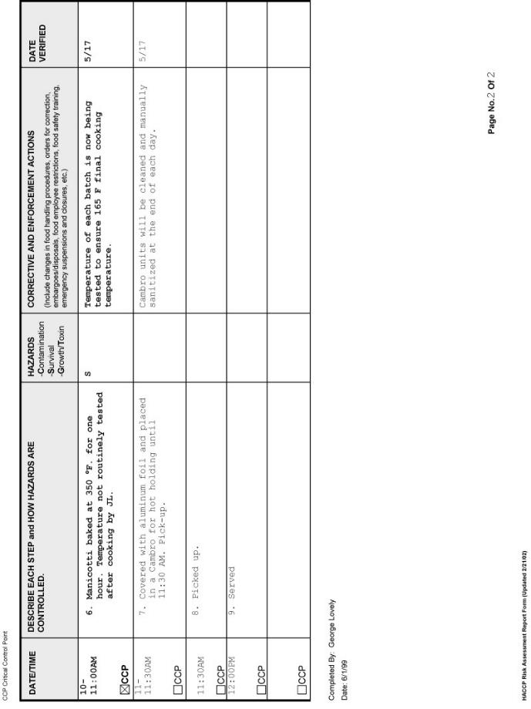
Attachment 7-8 Management of Food Safety Practices

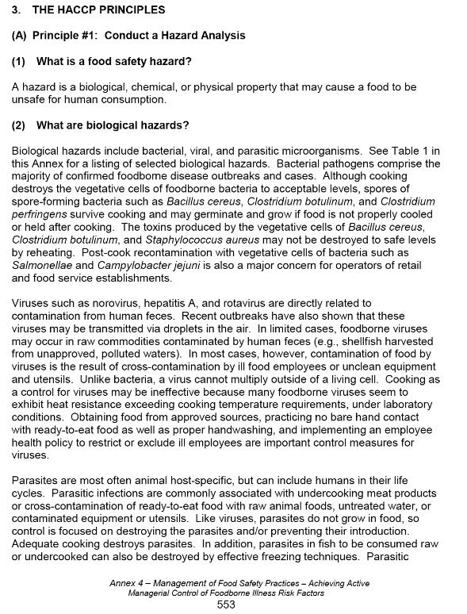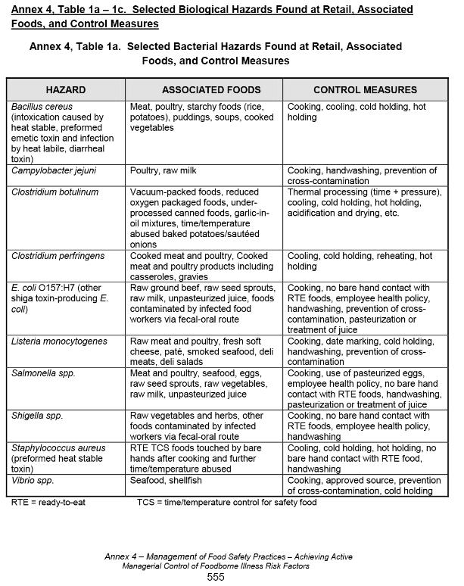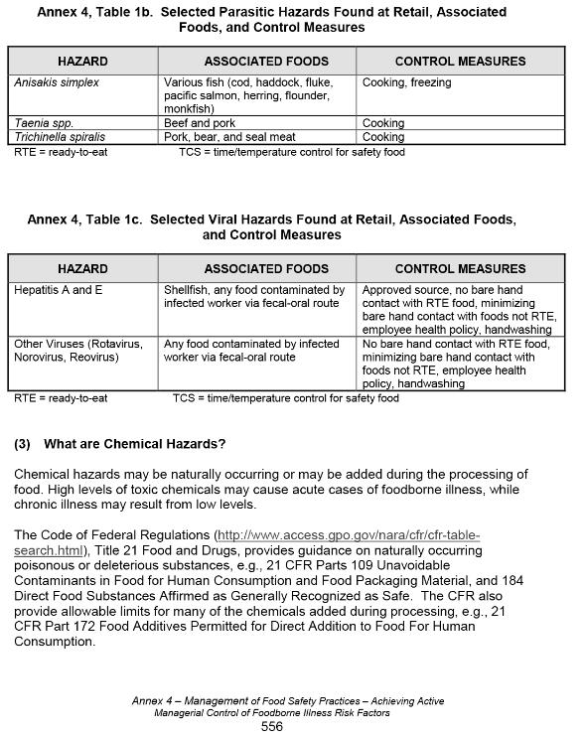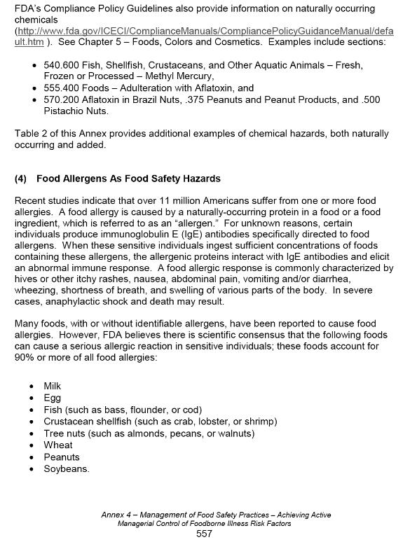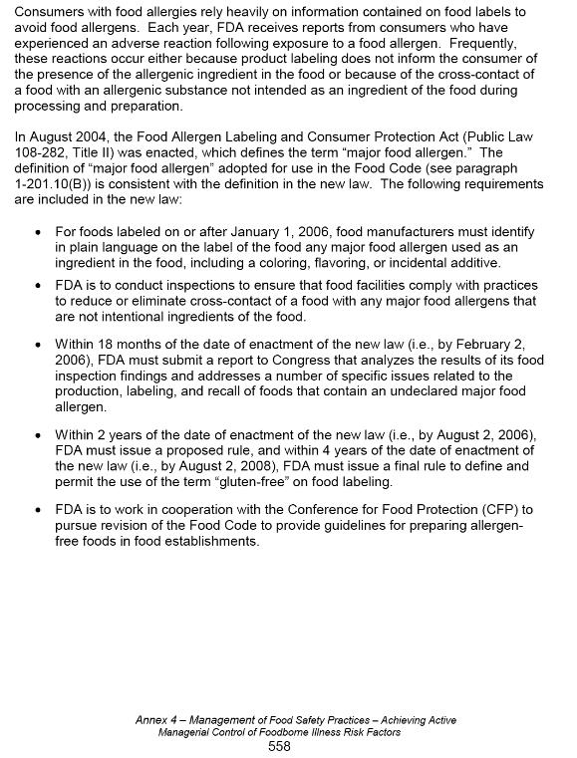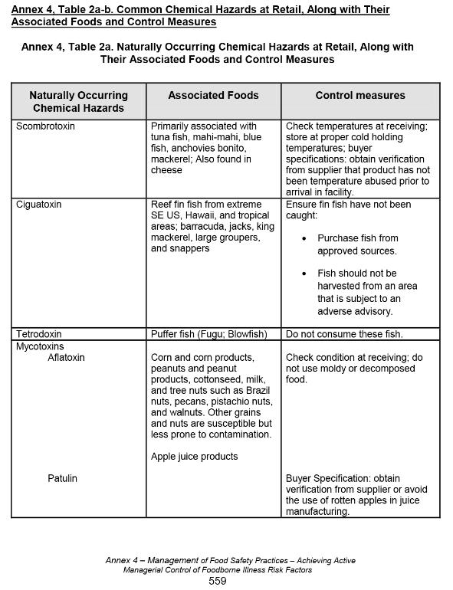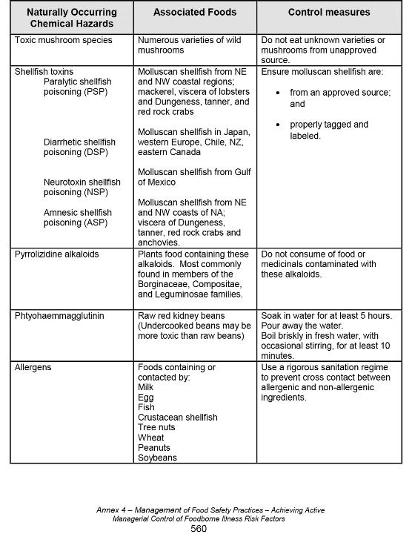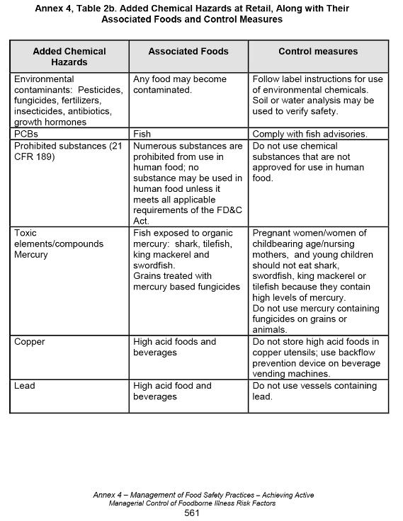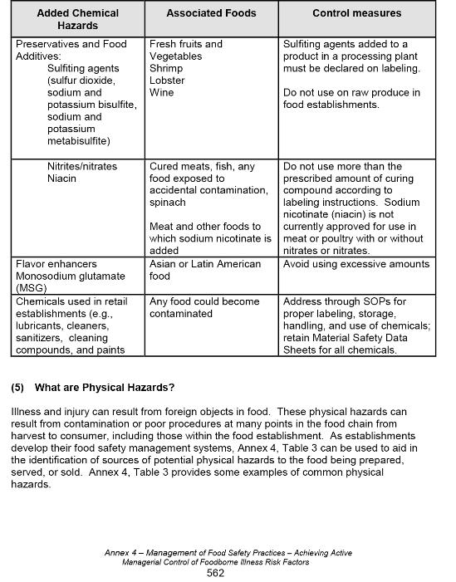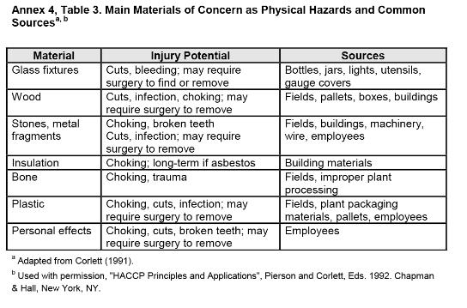

SOURCE: 2013 Federal Food Code, Annex 4, pages 553-563.

Attachment 7-9

Attachment 7-9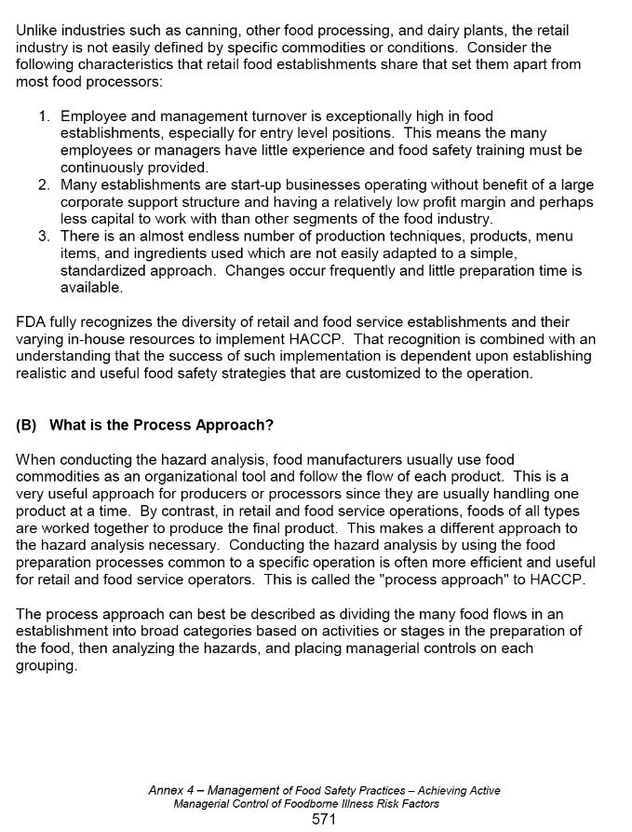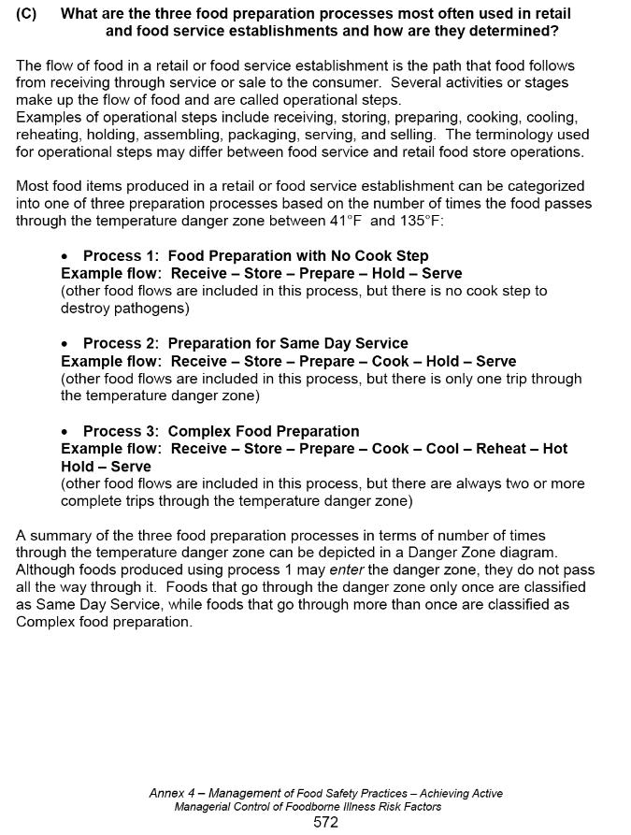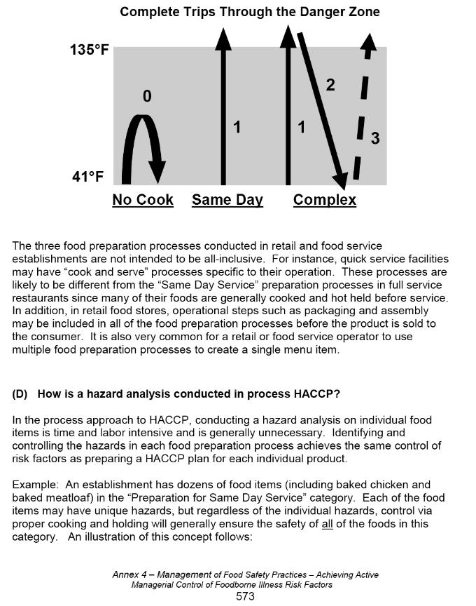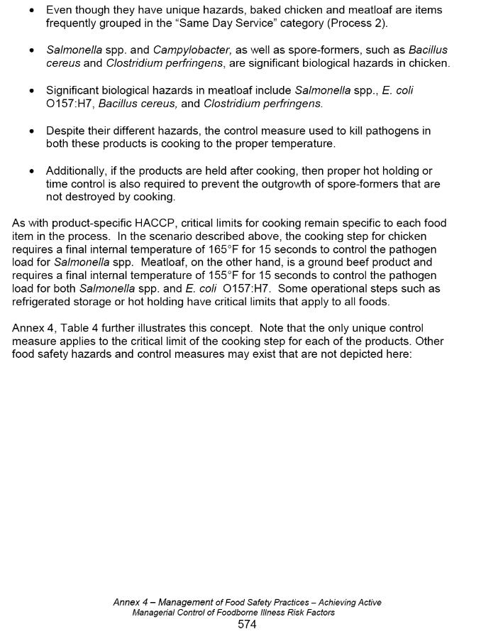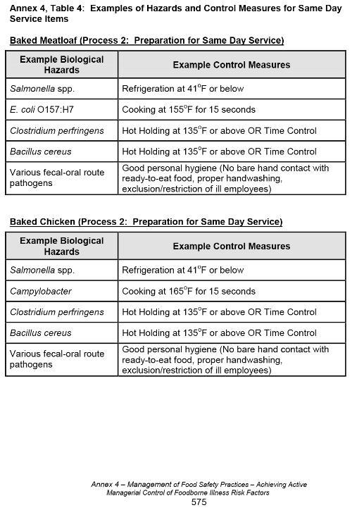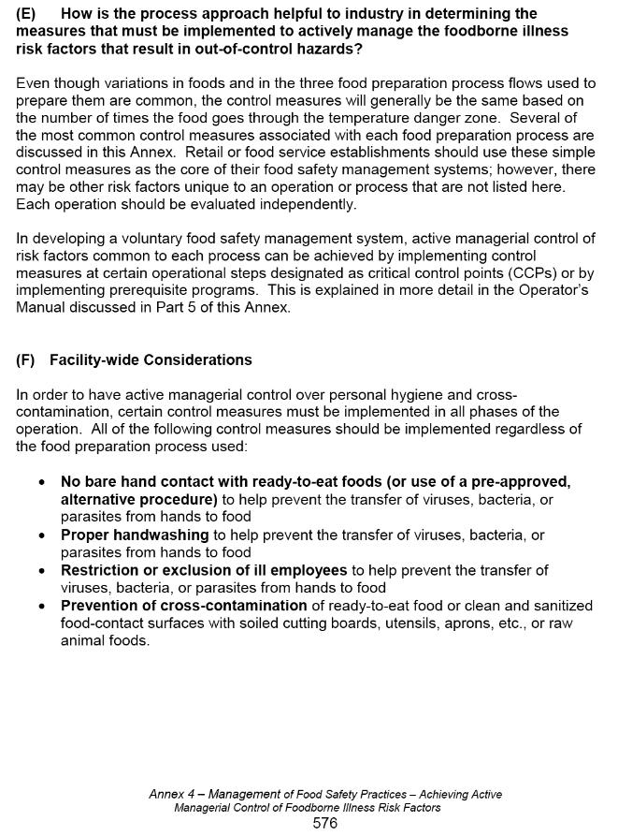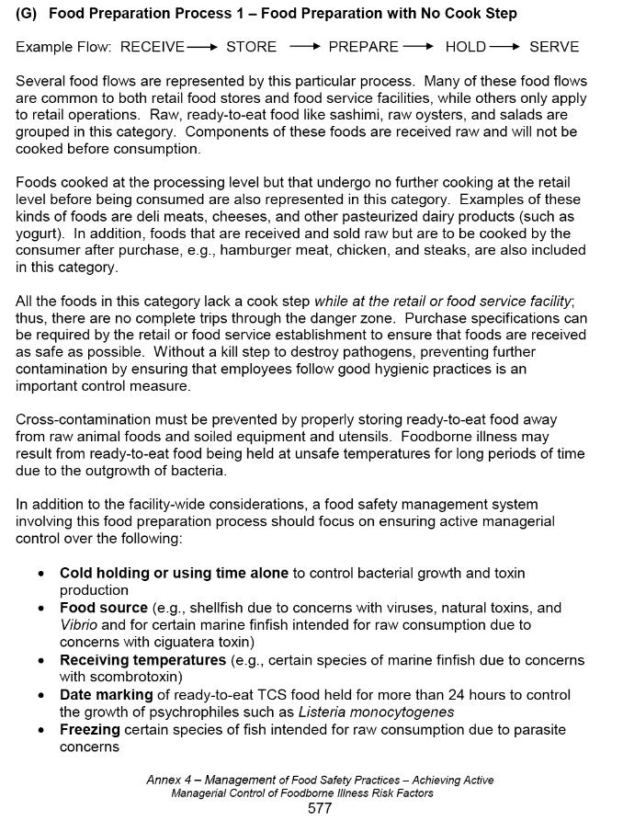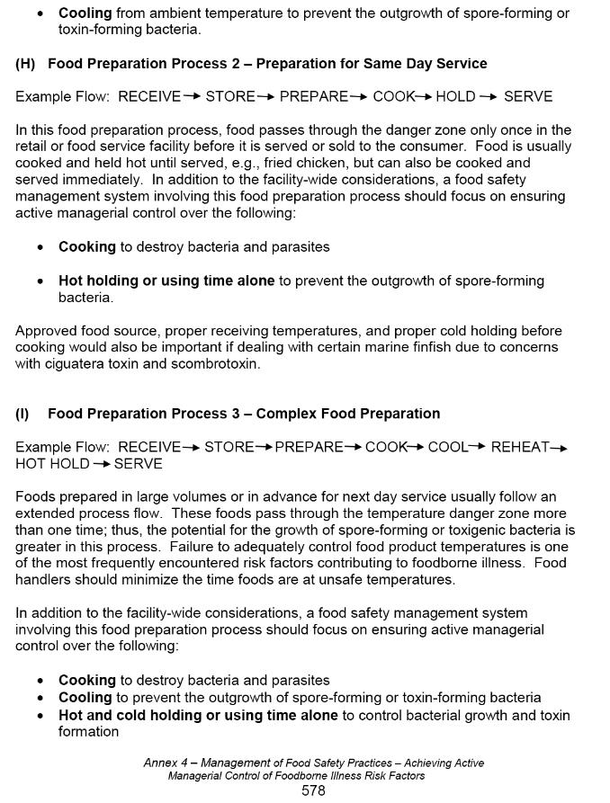

SOURCE: 2013 Federal Food Code, Annex 4, pages 570-579

Attachment 7-10: Traceback Investigation of Food Products

A. Traceback Overview

A traceback investigation is the method used to determine and document the source(s), production location(s), and distribution chain of a food product that has been implicated in a foodborne illness outbreak or is suspected of being adulterated or misbranded. A traceback investigation includes good interviewing techniques, a complete record review, and timely reporting. Additionally, a source investigation may be conducted to determine possible routes or points of contamination and /or misbranding. This investigation includes the inspection of common distribution sites, processors, and/or growers. The Food Protection Program (FPP) is responsible for conducting and coordinating traceback investigations within Massachusetts in cooperation with local, federal and other state agencies.

B. Reasons for Conducting Tracebacks

Traceback investigations are conducted:
1) to identify the source and distribution of the implicated food in order to remove the adulterated/misbranded product from the marketplace,
2) to assist in distinguishing between two or more implicated food products/ingredients,
3) to determine potential routes and/or sources of contamination in order to prevent future illnesses.

C. Information Needed for Tracebacks

1) Before a traceback is initiated, the Working Group for Foodborne Illness Control (WGFIC), in conjunction with the local board of health (LBOH) involved in investigating a foodborne illness outbreak, should obtain or complete the Foodborne Illness Complaint Worksheet. That worksheet is used to record the epidemiologic evidence such as suspect etiologic agent, incubation period, onset date of illness, signs and symptoms, laboratory confirmation of etiologic agent, and total number ill by sex and age. See Chapter IV in the Foodborne Illness Investigation and Control Reference Manual, for a copy of the Foodborne Illness Complaint Worksheet and instructions for completing the form.

2) Hazard analysis information is necessary to determine if the suspect food product was the source of contamination and other factors did not contribute to the outbreak. A blank and completed HACCP Risk Assessment Form can be found in Chapter VII, of the Foodborne Illness Investigation and Control Reference Manual.

3) Product Information:
Brand Name Package Type
Product Name Date of Purchase
Code/Lot Number Manufacturer Name and Address
Expiration/Sell by/Use by Date Distributor Name and Address
Size/Weight Retail Food Establishment Where Purchased

Shellfish identification tags should always be obtained for clams, oysters, quahogs and other molluscan shellfish associated with a foodborne illness. Failure by a facility to retain shellfish tags in accordance with regulations is to be cited on the inspection report, and appropriate action taken on product whose source is unknown.

D. Coordination with Other Agencies

1) For fresh fruits and vegetables, the U.S. Food and Drug Administration (FDA) is the primary federal regulatory agency and will be contacted by the FPP in conjunction with the Massachusetts Department of Agricultural Resources (DAR).

2) For fish and molluscan shellfish, the FDA is the primary federal regulatory agency and will be contacted by the FPP in conjunction with the Massachusetts Division of Marine Fisheries (DMF).

3) For meat, poultry, and eggs, The U.S. Department of Agriculture - Food Safety and Inspection Services (USDA-FSIS) is the primary federal regulatory agency responsible for the investigation of meat, poultry and egg products. FPP will contact USDA.

4) The FDA is the primary federal regulatory agency for other food commodities that are manufactured out-of-state, and will be contacted by FPP. The state agency where the suspect food commodity was manufactured may also be contacted by USDA-FSIS.

E. Resources

MA Department of Public Health, Working Group on Foodborne Illness Control, Foodborne Illness Investigation and Control Reference Manual. Chapter VII. October, 2018.

Council to Improve Foodborne Outbreak Response (CIFOR). Guidelines for Foodborne Disease Outbreak Response. 2nd edition. Atlanta: Council of State and Territorial Epidemiologists; 2014.

FDA Guide to Traceback of Fresh Fruits and Vegetables Implicated in Epidemiological Investigations, April, 2001: https://www.fda.gov/downloads/iceci/inspections/inspectionguides/ucm109504.pdf

Food Employee Reporting Agreement
Preventing Transmission of Diseases through Food by Infected Food Employees

The purpose of this agreement is to ensure that Food Employees and Conditional Employees notify the Person in Charge when they experience any of the conditions listed so that the Person in charge can take appropriate steps to preclude the transmission of foodborne illness.

I AGREE TO REPORT TO THE PERSON IN CHARGE:

A. SYMPTOMS OF:
diarrhea, vomiting, jaundice, sore throat with fever, and lesions containing pus on the hand, wrist, or an exposed body part (such as boils and infected wounds, however small.)

B. MEDICAL DIAGNOSIS OF BEING ILL WITH:
norovirus, shiga toxin-producing E. coli, S. typhi (typhoid fever), Shigella spp., non-typhoidal Salmonella, and Hepatitis A, as well as other diseases that may be transmitted through food per 105 CMR 300.000. Contact the Food Protection Program at 617-983-6712 or The Epidemiology Program at 617-983-6800 for additional information.

C. PAST MEDICAL DIAGNOSIS OF DISEASES LISTED ABOVE:
Have you ever been diagnosed as being ill with one of the diseases listed above?
If you have, what was the date of the diagnosis?

D. HIGH-RISK CONDITIONS:
- Exposure to or suspicion of causing any confirmed outbreak of the diseases listed
under Part B above.
- A household member has been diagnosed with diseases listed in Part B above.
- A household member attending or working in a setting experiencing a confirmed
outbreak of one of the diseases listed in part B above.

I have read (or had explained to me) and understand the requirements concerning my responsibilities under 105 CMR 590/2013 Food Code and this agreement to comply with the reporting requirements specified above involving symptoms, diagnoses, and high-risk conditions specified. I also understand that should I experience one of the above symptoms or high-risk conditions, or should I be diagnosed with one of the above illnesses, I may be asked to change my job or to stop working altogether until such symptoms or illnesses have resolved.

I understand that failure to comply with the terms of this agreement could lead to action by the food establishment or the food regulatory authority that may jeopardize my employment and may involve legal action against me.

Food Employee or Conditional Food Employee Name (Please Print)

Signature of Above-named Individual Date

Signature of Permit Holder or Representative Date

This is a model form created by MA Department of Public Health which is offered as a tool for industry to use to aid in compliance with 105 CMR 590.002(E) and the Federal Food Code 2-201.11. The use of this form is voluntary and is not required by state regulation. Revised: October, 2018

