The Commonwealth of Massachusetts
Executive Office of Health and Human Services
Department of Public Health
Bureau of Infectious Disease and Laboratory Sciences
305 South Street, Jamaica Plain, MA 02130

MARYLOU SUDDERS
Secretary
MONICA BHAREL, MD, MPH Commissioner

Tel: 617-624-6000
www.mass.gov/dph

CHARLES D. BAKER
Governor
KARYN E. POLITO
Lieutenant Governor
Division of STD Prevention
Tel: (617) 983-6940
Fax: (617) 983-6962
www.mass.gov/dph/cdc/std

TO: Maternal and Newborn Health Care Providers
FROM: Katherine Hsu, MD, MPH, Medical Director, Division of STD Prevention
Lila Coverstone, RN, Public Health Nurse, Division of STD Prevention
Kathleen Roosevelt, MPH, Director, Division of STD Prevention
DATE: June 30, 2020
RE: Increases in Congenital Syphilis Cases and Stillbirths and Infectious Syphilis in Women
Universal 3rd Trimester Syphilis Screening Recommended
_______________________________________________________________________________________________
Two stillbirths with syphilis and a congenital syphilis case exhibiting symptoms of rash, jaundice, and hepatosplenomegaly at birth have been reported to the Massachusetts Department of Public Health (MDPH) in 2020. One stillbirth occurred in a woman with limited prenatal care who delivered at 28 weeks gestation. The other stillbirth occurred in a woman who delivered at 33 weeks with negative 1st trimester syphilis screening, no history of risk to prompt 3rd trimester re-screening, but in retrospect had a rash compatible with secondary syphilis at 27 weeks. The symptomatic congenital syphilis case was born at 37 weeks to a woman with negative 1st trimester syphilis screening, no history of syphilis symptoms, and no history of risk to prompt 3rd trimester re-screening.
Infectious syphilis rates in Massachusetts continue to increase. Rates have increased 12-fold in men and 8-fold in women of reproductive age over the past two decades. Despite close follow-up of cases of syphilis in pregnant women and their partners, breakthrough cases of congenital syphilis are now occurring. Massachusetts syphilis rates mirror national increases in men and women; nationally, there has also been a sharp rise in rates of reported congenital syphilis cases (https://www.cdc.gov/std/stats18/default.htm).
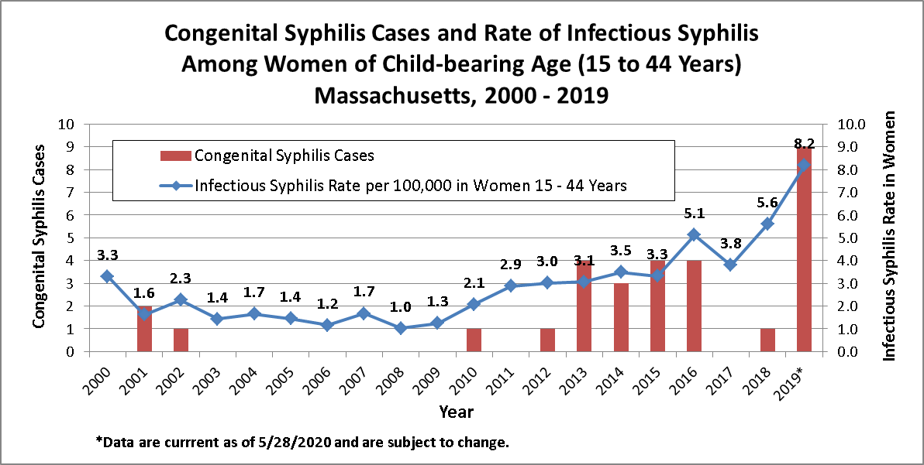
The syphilis rate is rising and projected to exceed 10.0/100,000 women of reproductive age in Massachusetts in 2020. MDPH is therefore recommending universal syphilis screening early in the 3rd trimester (around 27 - 28 weeks gestation), in addition to routine syphilis screening performed at the first prenatal visit. Screening again at delivery should be considered in high-risk women. No infant should leave the hospital without the mother’s serological status having been documented at least once during pregnancy. Although universal screening during the 3rd trimester may not prevent all cases, it encourages overall vigilance for a rare, but extremely serious occurrence: syphilis in pregnant women.
Positive titers on serum non-treponemal assays (e.g. RPR or VDRL) should be confirmed by serum treponemal assays (e.g. TPPA or syphilis IgG/IgM). This remains the best way to identify pregnant women who could transmit syphilis to their fetuses, despite false negative serologic tests that can occur in early primary infection. Increasing suspicion for syphilis and performing syphilis testing in pregnant women presenting with possible syphilis lesions, obtaining a recent sexual history, rapid treatment, and close monitoring will all be important in order to avoid further increases in congenital syphilis in Massachusetts.
Primary syphilis is characterized by chancres, usually occurring on oropharyngeal, genital, or rectal mucosal surfaces, or on any skin surface that is a potential site of inoculation.
Secondary syphilis findings include:
Dermatologic findings which can wax and wane even without treatment, such as:
- body rash, sometimes present on the palms of hands and soles of feet
- mucosal lesions such as condyloma lata or mucous patches
- alopecia
OR systemic signs and symptoms such as:

- fever
- headache
- malaise
- anorexia
- sore throat
- myalgias
- weight loss
- adenopathy

We continue to partner with Massachusetts clinical practices providing prenatal care and delivery, especially on patients reported as newly positive for syphilis. Our public health nurse actively reaches out to the clinical team to provide recommendations for treatment and co-follows cases through delivery. Our epidemiologists interview the patient in an effort to trace and treat partners who can cause reinfection if not also treated.
Please continue to contact the MDPH Division of STD Prevention for:
- Clinical consultation on complex cases, available through the MDPH Division of STD Prevention clinical team (Public Health Nurse, Lila Coverstone, RN and Medical Director, Katherine Hsu, MD, MPH) or the STD Clinical Consultation Network. CDC syphilis treatment and partner management guidelines are available as an app for Apple and Android devices at:www.cdc.gov/std/tg2015/default.htm.
- Management considerations including recommendations for presumptive sex partner treatment.
- Record searches on prior syphilis test titers and treatment history. Please call the MDPH Division of STD Prevention main phone line at 617-983-6940.
- Partner services – contact tracing and notification are automatically performed for new HIV infection and infectious syphilis cases. Please call the MDPH Reporting and Partner Services Line at 617-983-6999 for more information.
  - Case reporting - clinician-completed MDPH DSTDP Case Report Forms are required for all syphilis cases, and provide details on clinical characteristics and treatment which are not automatically reported, unless your clinical organization participates in ESP.

National Network of STD Clinical Prevention Training Centers STD Clinical Consultation Network, www.stdccn.org.
MDPH STD Case Report Forms, www.mass.gov/eohhs/gov/departments/dph/programs/id/std/case-report-forms.html.
Electronic health record Support for Public health, www.esphealth.org.

