How do I connect my Pulse Secure VPN client using the VID authentication system?

Using Internet Explorer version 11, visit https://vpn.mass.gov/vid and click the Proceed button to accept the terms of the Pre Sign-In Notification (Internet Explorer version 11 must be the browser used because of its support for Java). Other browsers including Chrome, Firefox, Safari, Opera and others cannot be used to establish VPN connectivity because they do not allow use of Java to launch the Pulse Secure client.

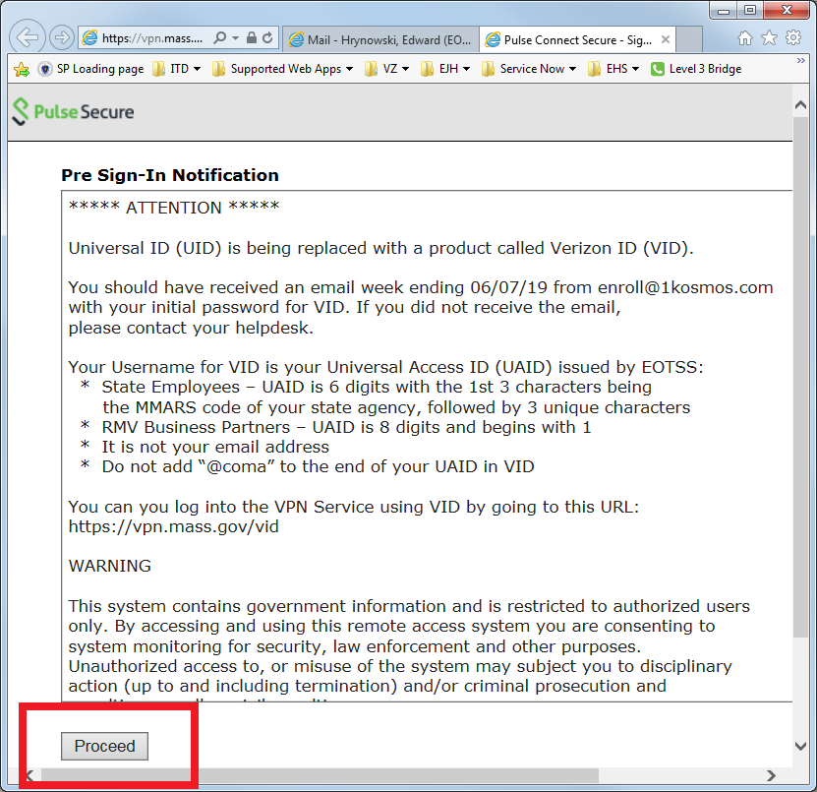

Enter your UAID in the Username field, and password then click the Sign In button or press Enter on your keyboard

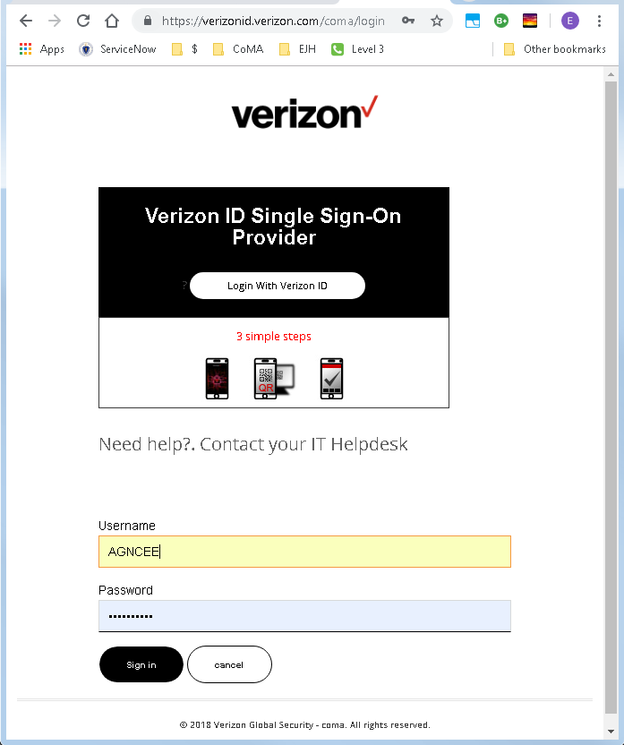

After your credentials are validated, you will receive the page below for selection of the one time passcode delivery method. Click the OTP via EMAIL button, or OTP via SMS button if your VID account includes a mobile phone number and you prefer to receive your one time passcode via SMS text message.

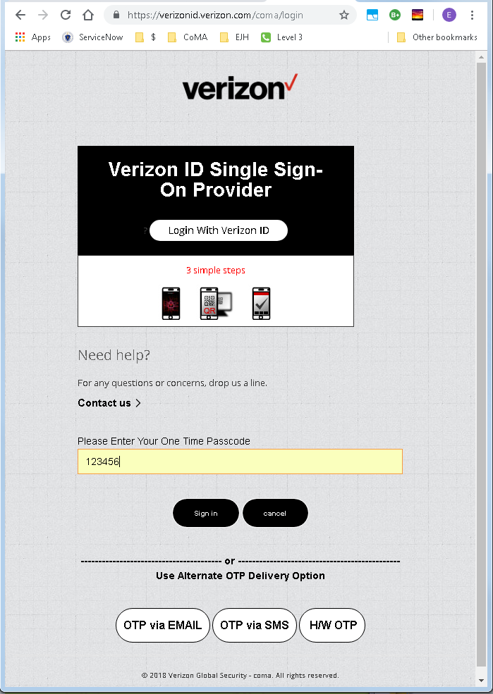

Once you have received your 6 digit one time passcode, enter it in the highlighted field and click the Sign In button or press Enter on your keyboard.

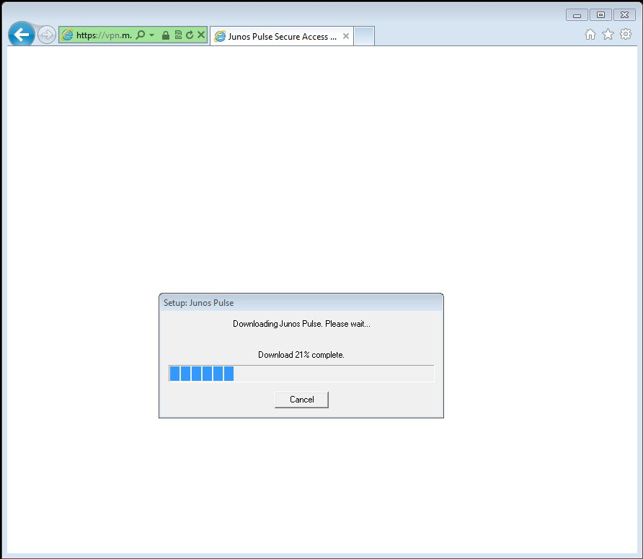

The pulse client will now automatically download and install (this will only occur the first time you connect). You will need to allow or accept any prompts. Once the install is complete you will be automatically connect and you will receive the following screen.
***If you are using a state owned laptop and do not have administrative rights, you will need to contact your local desktop support personnel for assistance with installing the Junos Pulse client****

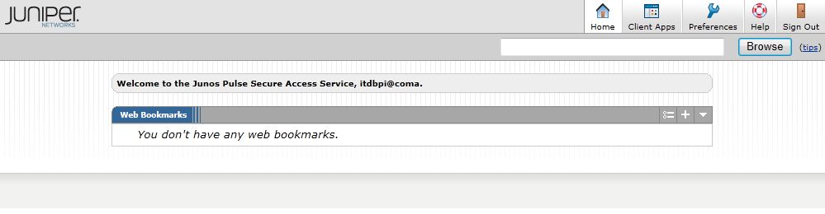

You will receive the Juniper Networks Page once connected. You can close this page and stay connected to the VPN Service.

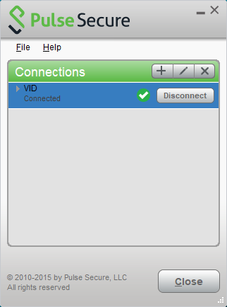

If you open the Pulse Secure client, the VID connection should show “Connected” as its status.

If there is no green checkmark displayed, click the “Connect” button on the VID connection. You may have to go through the Sign In process again. The next time you Sign In to the VPN service using VID, the connection should happen automatically

