Overview:

In order to view and/or manage client level information, users are required to have a consent created in EIM/ESM. Users that enter client data for their organization will have this consent automatically generated by the system and will not need to create one manually. This system consent does not replace any program-specific Consent to Serve or Sharing of Data consents, requiring wet signatures.

However, if users are preparing to facilitate a client referral/transfer of client information, users can manually create consent through EIM/ESM. Users will be required to select what information to be shared including the following scenarios:

Note: This functionality should only be used if users plan to share information with another provider organization.
I
Scenario A: How to access a student record to share basic demographic information (i.e. Face Sheet) across sites.
Complete the following steps to add a consent: Viewing Client Information
Log into EIM/ESM.
- Select the [Clients] module.
Figure 1: EIM top bar with the Clients module highlighted
- Select the [Clients] link from the left navigation menu.
The Client Search page opens.
On this page, the user searches for a Client by entering search criteria in one or more of the fields: Last Name, First Name, ID, ID Type, or Date of Birth.
Figure 2: Client Search page
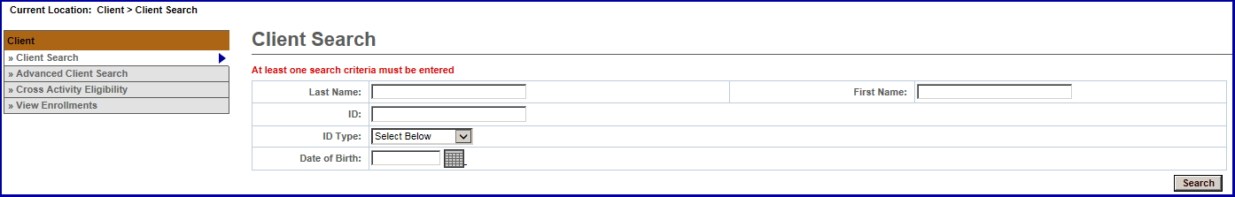
- Enter Search criteria in the fields.
- Select the Search button.
The Search Results appear at the bottom of the page.
Figure 3: Client Search page with Results at the bottom
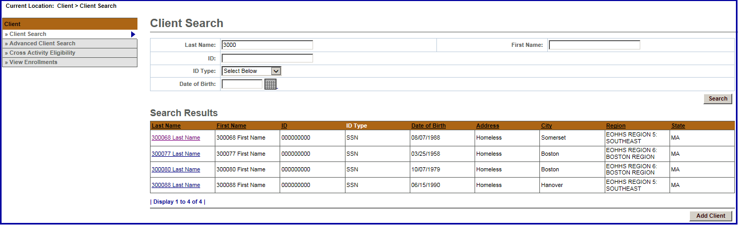
- Select the contract link.
The Applicant Face Sheet Summary appears.
Figure 4: Applicant Face Sheet Summary
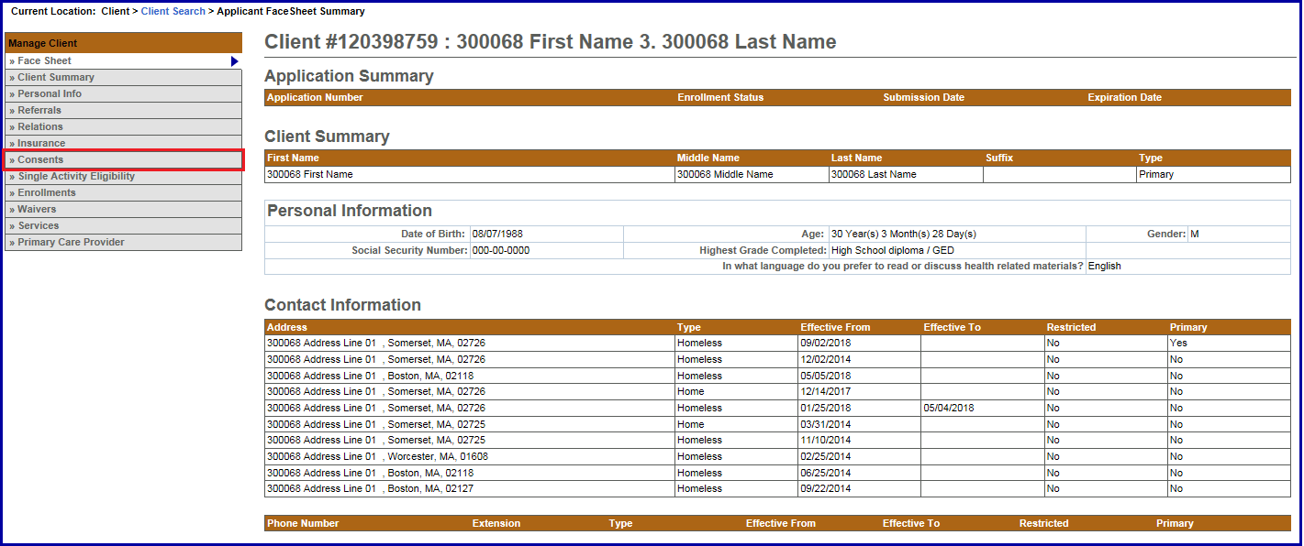
- Select Consents from the navigation bar.
The Consents page appears.
Figure 5: Consents page
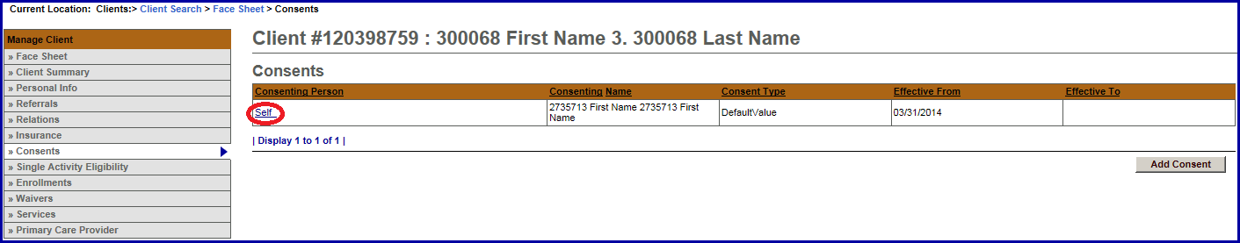
- Select the auto-generated Self link.
The Update Consent page appears.
Figure 6: Update Consents page with Add Organization Link button highlighted
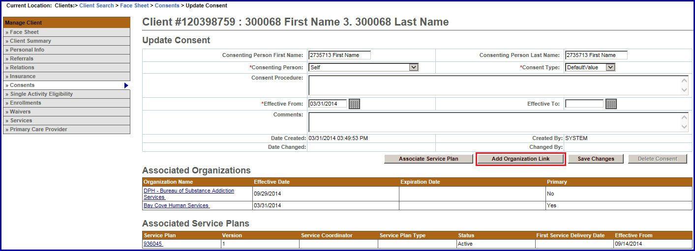
- Select the [Add Organization Link] button.
The Add Consent Organization Link page appears.
Figure 7: Add Consent Organization Link page
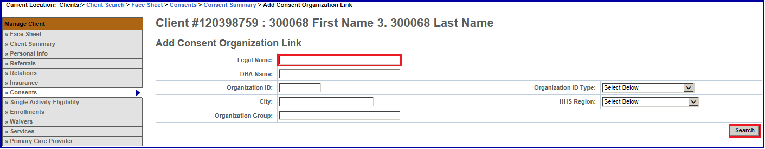
- Add a legal name of the school in the Legal Name field. (Hint: Use %name for search criteria).
- Select the [Search] button.
The Add Consent Organization Link page appears with search results at the bottom.
Figure 8: Add Consent Organization Link page with Legal Name added and Search results
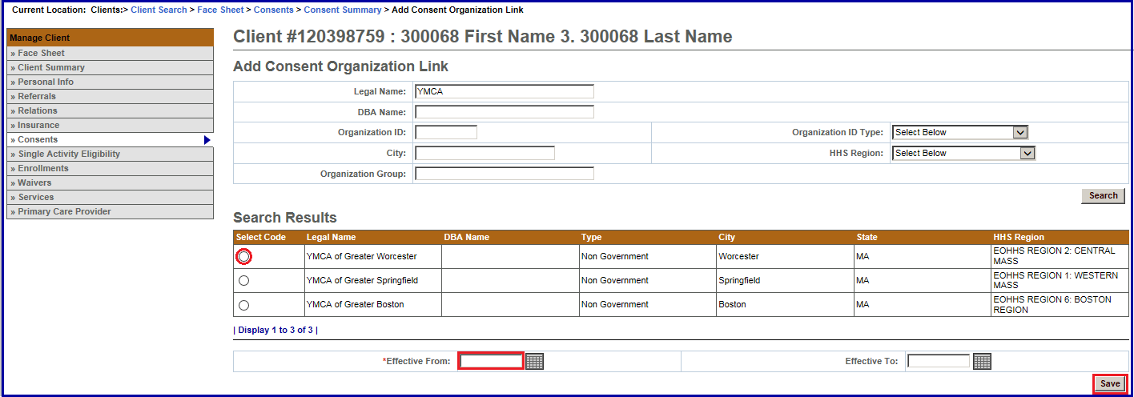
- Select the radio button next to the individual site/school of your choice.
- Enter a date in the Effective From field or use the Calendar icon to select a date. (Note: This should match enrollment date).
- Select the [Save] button.
The Update Consent page appears.
Figure 9: Update Consent page with the Associated Service Plans at the bottom
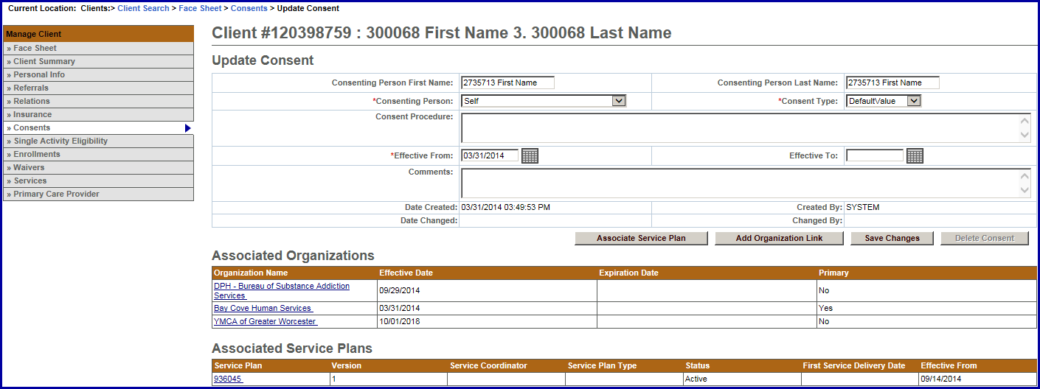
Scenario B: How to access a student to share basic demographic information as well as all service plan data (i.e. encounters).
Complete the following steps to view or update information:
- Access a Client’s Application Face Sheet Summary.
- Select Consents from the navigation bar.
Figure 10: Applicant Face Sheet Summary
The Update Consent page appears with a link for the Associated Service Plans at the bottom.
Figure 11: Update Consents page with Associated Service Plan link highlighted
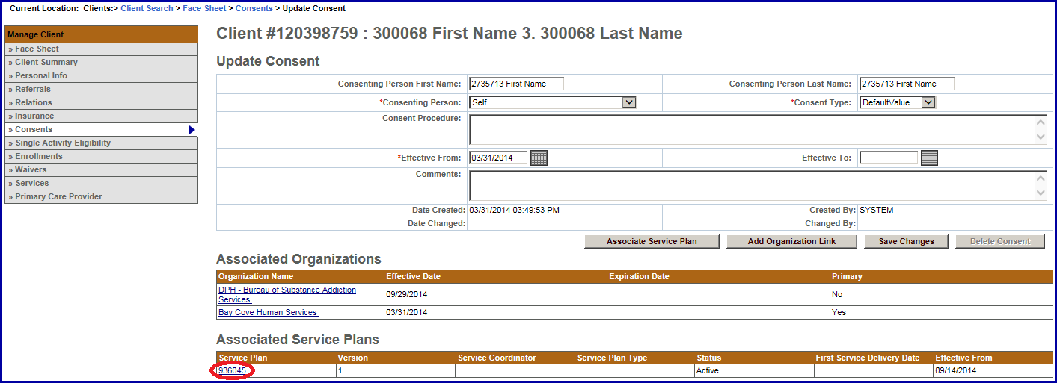
- Select the Associated Service Plan link to find the appropriate provider to verify that a school has been identified. If no school is identified, complete Scenario C.

Scenario C: A parent organization is enrolling a student in a sub-organization or satellite site (how to connect a service plan with basic information to forward).
Complete the following steps to enroll a student in sub-organizations or satellite sites to add services to be delivered:
- Access the Update Consent page.
Figure 12: Update Consents page with Add Organization Link button highlighted
- Select the [Add Organization Link] button, if no school is identified.
The Add Consent Organization Link page appears.
Figure 13: Add Consent Organization Link page
- Enter the legal name of school in the Legal Name field.
- Select the [Save] button.
Virtual Gateway Customer Service
1-800-421-0938
*

