To: Interested Parties March 16, 2018
Re: Continuity of Care Frequently Asked Questions

Starting March 1, 2018, new Accountable Care Organization (ACO) and Managed Care Organization (MCO) contracts became effective. The goal of these contracts is to improve the quality of care and health outcomes for MassHealth members. ACOs are groups of doctors, hospitals, and other health care providers who come together to provide coordinated, high-quality care to MassHealth members. This way, MassHealth members get the right care at the right time. ACOs coordinate physical health care, mental health care, addiction treatment, and long-term care for individuals with disabilities. MassHealth will closely monitor ACOs’ performance to track and hold ACOs accountable for their success in improving care and health outcomes for members.

These changes apply to MassHealth managed care members. In general, this includes members under age 65 who do not have another primary insurer, either commercial or Medicare, and are not in a long-term care facility.

General Program Questions
- How do MassHealth’s new ACO and MCO plans compare to current plans?
Before March 1, 2018, managed care members were enrolled in two types of plans: the Primary Care Clinician (PCC) Plan and MCOs.
  - Members enrolled in the PCC Plan received care (including pharmacy) other than behavioral health services from MassHealth’s fee-for-service (FFS) network. Claims for these members were submitted to MassHealth according to MassHealth billing rules and authorization requirements and were paid at MassHealth rates. Members enrolled in the PCC Plan received behavioral health services from MassHealth’s behavioral health vendor, the Massachusetts Behavioral Health Partnership (MBHP). Claims for behavioral health services for members in the PCC Plan were submitted to MBHP according to MBHP’s billing rules and authorization requirements and were paid at MBHP’s negotiated rates.
  - Members enrolled in one of MassHealth’s six MCOs received MCO-covered services from the contracted network of their MCO. Claims for these members were submitted to the MCO, its pharmacy benefit manager (PBM) or, in some cases, to a behavioral health subcontractor. These claims were paid according to the MCO’s billing rules (including authorization requirements, formulary, etc.), and at the MCO’s negotiated rates.
  - Whether a member was enrolled in the PCC Plan or an MCO, certain services have been and will continue to be provided through the MassHealth FFS system. These include non-emergency medical transportation and certain long-term services and supports such as personal care attendant, group adult foster care, adult foster care, day habilitation, and adult day health services. They also include skilled nursing facility, chronic disease hospital, and rehabilitation hospital stays of more than 100 days.

Starting March 1, 2018, members began enrolling in new plan options:
  - MassHealth still has a PCC Plan that operates in the same way as the PCC Plan did before March 1. However, primary care providers who now participate in ACOs are no longer available in the PCC Plan. MassHealth also still has an MCO program, with two MCOs—Boston Medical Center Health Plan (BMCHP) and Tufts Health Public Plan (Tufts)—rather than six. BMCHP operates statewide. Tufts operates in all regions except the Southeast.

  - In addition, MassHealth has three Primary Care ACOs: Steward Health Choice, Community Care Cooperative (C3), and Partners HealthCare Choice. Primary Care ACOs use MassHealth contracted primary care providers that are exclusive to the ACO and use MassHealth’s FFS network of contracted specialists and hospitals. MBHP provides behavioral health services, and Primary Care ACOs ensure that behavioral health services are integrated with physical health services for members. Like claims in the PCC Plan, claims for non-behavioral health services are submitted to MassHealth according to MassHealth administrative and billing rules and are paid at MassHealth rates. Claims for behavioral health services are submitted to MBHP according to MBHP’s administrative and billing rules and are paid at MBHP’s negotiated rates.
  - MassHealth also has13 Accountable Care Partnership Plans (Partnership Plan). Each Partnership Plan is formed by a provider-led ACO and one of five MCOs. Members enrolled in Partnership Plans receive care from the contracted network of the Accountable Care Partnership Plan. Accountable Care Partnership Plans are responsible for coordinating health care services, including integrating behavioral health and physical health. Like claims in the MCOs, claims are submitted to the Partnership Plan (or its PBM or behavioral health subcontractor) according to the Partnership Plan’s billing rules (including authorization requirements, formulary, etc.), and are paid at the Partnership Plan’s negotiated rates. Along with Primary Care ACOs, Partnership Plans are one of MassHealth’s new ACO plan options.
For more information about these managed care options, please go to MassHealth’s Payment & Care Delivery Innovation for Providers Web page, MassHealth Health Plan Choices Web page (for members) or Appendix A of this FAQ on page 11.

Member Questions
- What should a member do if one or some of their providers are not in their ACO network?
See example situation and corresponding options below.
Situation: The member gets primary care health services from a community health center (CHC) that joined a certain ACO. The member also receives specialty care from several providers. On March 1, 2018, this member was “special assigned” to the ACO that their CHC joined. This member may make a different plan selection at any point for any reason prior to June 1, 2018. This member has specialty providers who are not in the ACO’s new network. The member should check the ACO’s provider directory or call the ACO to find out.
Option 1: The member can choose to stay in the ACO, but not all of their providers are in that ACO’s network:
- Because of the continuity of care period, the member may continue to see their out-of-network providers for a minimum of 30 days. In order to see out of network providers after the 30-day continuity-of-care period, the member should contact their plan.
- If the member is in an Accountable Care Partnership Plan, the plan may add the provider to their network, enter into a single case agreement for certain services, or help the member identify specialists who are available in their network.

- If the member is in a Primary Care ACO, the provider will have to join the MassHealth FFS network to continue seeing the member after the continuity-of-care period ends.

Option 2: The member can choose to leave their ACO and join a different managed care plan to maintain in-network access to one or more of their specialty providers:
- This member may continue to see their primary care provider at their CHC during the 30-day continuity-of-care period.
- This member will have to choose a different primary care provider (PCP) who is available in their new plan and can call their new plan (or MassHealth for Primary Care ACOs and the PCC Plan) for assistance in making a selection.
- If this member receives other services from their CHC, they may continue to see the CHC for these services, even after the continuity period, as long as appropriate network arrangements are in place from the member’s new plan.
- What happens with appointments scheduled before March 1?
Members may continue to see their current providers for appointments and ongoing treatments and services scheduled before March 1 for a minimum of 30 days from their date of enrollment, even if their provider is not part of the member’s new plan network. Providers who are not part of the new plan’s network will need to make arrangements with the Accountable Care Partnership Plan, MCO, or MassHealth in order to be paid by the new plan.
- During the continuity of care period, will providers be paid for services which normally do not require a referral/authorization (e.g. a primary care visit) regardless of whether they were scheduled before or after 3/1?
Yes.
- If a member received an assignment to a plan, do they still have access to the 90-day Plan Selection Period to select a plan?
Yes. Members have the full 90-day plan selection period to choose their health plan. The selection period begins on March 1 or the date when they are first enrolled. After the 90-day plan selection period, a 9-month fixed enrollment period begins during which members can switch plans for only certain exception reasons. Members received a packet in the fall that outlined the choices available to them in the area where they live. If they have any questions about the plans available in their area, they can call MassHealth Customer Service at 1-800-841-2900; TTY: 1-800-497-4648 or visit MassHealthChoices.com.
- How have MassHealth, the Accountable Care Partnerships, and MCOs outreached to members?
For members whose PCPs joined ACOs last fall, MassHealth made assignments for about 800,000 members to these ACOs to make it easier for these members to keep their primary care relationships. MassHealth sent notices to all these members during November and December informing them of this assignment. The notice listed the member’s specific PCP and the specific ACO. It encouraged the member to explore their plan options at MassHealthChoices.com and to call with questions or concerns. Members whose PCPs did not join an ACO also received letters in November and December informing them about MassHealth’s new health plan options and encouraging them to make a selection before March 1. If these members did not select a plan before March 1, they stayed with their existing plan if it remains available, or they were assigned to one of the available options in their area.
- ACO and MCO plans are now sending members welcome packages that include member handbooks, ID cards, and other information about their plans. This information has been or will be sent on or about the member’s date of enrollment. All member handbooks and other member education materials have been approved by MassHealth. Materials include information about covered services, plan benefits, services that require prior authorizations and referrals, instructions on where to find a provider, details about member rights, and important contact information for the plans.

- In addition, all ACO and MCO plans have had public-facing customer service phone lines up and running since November 2017 and have been engaging with members and providers who have questions.
- All plans have mechanisms for communication with members with regarding continuity of care:
  - Several plans are issuing automated notices to members who use out-of-network providers or services that would normally require authorization during the continuity period.
  - Other plans have a more targeted approach, using a combination of claims monitoring and direct member outreach from the plan’s care manager or the member’s primary care provider to facilitate transitions to the plan’s network and authorization requirements.
- In addition, MassHealth has over 200 specially trained customer service representatives who are available to help members learn about their health plan options, select and enroll in a plan. MassHealth has extended its customer service hours for enrollment assistance during the month of March, including Monday-Thursday evenings until 7pm and Saturdays from 9:30am to 1:30pm.

Provider Contracting and Billing
- Which providers can be in-network for MassHealth’s new ACO and MCO plans?
All provider types except for primary care providers may participate, as they did prior to March 1, in any ACO/MCO network as long as they contract with the plan. Providers who wish to join a network may:
- Contract with the MCOs for participation in their MCO and/or Partnership Plan products, and/ or
- Enroll with MassHealth for participation in MassHealth’s FFS network, which is available to members in the PCC Plan and the three Primary Care ACOs, and/or
- Contract with a plan’s behavioral health network or behavior health subcontractor’s network (i.e. Tufts, Beacon and MBHP).

Each PCP participating in an ACO may only empanel members who are also enrolled in that ACO. This means that MassHealth members enrolled in other plans will not be able to select that provider as their PCP. This situation has been referred to as “primary care exclusivity.” Exclusivity is related to empanelment only.
- Primary care exclusivity applies at the site level. As is the case today, individual clinicians may have relationships with two or more sites of care where they practice (e.g., on different days of the week), and these sites may or may not all be in the same ACO; these arrangements continue to be permitted without changes.
- Primary care exclusivity does not apply to PCPs serving members in the Special Kids Special Care Program.

A PCP may provide services to a member as long as the provider has the appropriate contracts and authorizations with the member’s plan. For example, if the provider is contracted with the member’s plan and has the appropriate referrals (if required), that provider may continue to provide services such as:
- Medication assisted treatment (MAT);
- Behavioral health services;
- Specialty outpatient services or office visits;
- Coverage services for affiliated practices.

- How will plans arrange for payment during the continuity-of-care period for out of network providers?
Each MCO and Accountable Care Partnership Plan has an approach to contracting with and paying out of network providers during this period. Providers should outreach to the plan directly to understand their approach. In many cases, plans may put in place single case agreements with providers.
If a provider wishes to join the network of the ACO or MCO on a permanent basis, the provider should reach out to the plan directly to arrange for inclusion and payment, as they would have done with an MCO previously.
For the PCC Plan and Primary Care ACOs, MassHealth cannot make single case agreements for these plans under its regulatory authority. Instead, out-of-network providers should seek to enroll with MassHealth as a provider and become credentialed by MassHealth. Once enrolled, they will be paid according to the MassHealth fee schedule. Providers who do not wish to continue to provide services to MassHealth members may disenroll at any time.
- What should a provider do if they wish to join the network of an ACO?
For the PCC Plan and Primary Care ACOs, MassHealth has developed an expedited process for provider enrollment. Providers interested in enrolling should call MassHealth customer service at 1-800-841-2900; TTY: 1-800-497-4648. For MCOs and Accountable Care Partnership Plans, providers should contact the MCOs’ contracting departments.
- When should a provider begin arranging payment from a member’s new plan?
Providers should begin outreaching to a member's new plan as soon as they can verify the plan in MassHealth’s Eligibility Verification System (EVS), and should work with the plan of record on the date of service.
- What if a provider does not wish to receive payment from the member’s new plan?
MassHealth strongly encourages providers to see members during the continuity-of-care period and enter into payment arrangements with the member’s new health plan.
- Does “primary care exclusivity” impact providers and members during the continuity-of-care period?
No. Members may continue to see their providers including their PCP, and providers should work with the member’s current plan at the time of service (as displayed in EVS) to arrange payment.
- Where can I find out which plan a member is enrolled with?
Providers can confirm enrollment in EVS.

Prior Authorizations (PAs)
- How will authorizations granted by the member’s current plan that extend beyond 3/1 be handled by the member’s new plan?
During the continuity-of-care period, all existing PAs for services and for provider referrals will be honored by the new plan. Members can continue to see all providers currently providing their care during this period, even if that provider is not in their new plan’s network. Providers should check member eligibility in EVS and reach out to the member’s new plan to put future authorizations in place.

- Have legacy MCOs and the PCC Plan transferred prior authorization information to members’ new plans? Should providers only be pursuing PAs with the new plan?
To the extent possible, MassHealth, MBHP/Beacon, and all MCOs have shared PA information with new plans for members who are transitioning. MassHealth and the new plans have been working to add known PAs into their systems to prepare for new enrollees. Providers should contact the member’s new plan after March 1 (as displayed in EVS) where new authorizations or renewals are required. If a provider has any question about the status of a PA, the provider should contact the plan.

Behavioral Health
- What is the continuity-of-care period for outpatient and non-24 hour diversionary behavioral health services?
Behavioral health contractors have agreed to extend continuity of care for these services to 90 days.
- If our agency is currently contracted with existing MassHealth behavioral health plans (MBHP, Tufts, and Beacon), will that contract extend to the new plans?
During the continuity-of-care period, all existing PAs for services and for provider referrals will be honored by the new plan. In the majority of cases, including the PCC Plan and Primary Care ACOs, behavioral health provider contracts with MBHP, Tufts, and Beacon will extend to the new plans. If a provider has a question about their network participation, they should contact the plan directly.
- How will members continue accessing Medication-Assisted Treatment (MAT) during and after the continuity-of-care period?
Members can continue accessing MAT from their current prescribers throughout the continuity period, with or without a referral and regardless of the prescriber’s network relationship with a plan.
- For Accountable Care Partnership Plans and MCOs:
  - MassHealth expects plans to make sure that all new enrollees are able to access a sufficient network of MAT prescribers.
  - Plans evaluated their MAT networks before March 1st to ensure their networks were adequate to meet the needs of their members.
- For members in the PCC Plan and Primary Care ACOs:
  - MassHealth is credentialing and enrolling any willing, qualified provider of MAT services to ensure access for members in these plans.
- For providers (including primary care):
Regardless of which ACO model a provider is associated with, providers may contract with any plan or MassHealth for the provision of MAT services.
- How should MAT providers bill for MAT services when the member’s PCP is in a different ACO from the MAT provider?
MAT providers, including PCPs and Office-Based Opioid Treatment (OBOT) sites, may continue to contract with any and all plans, including ACOs and MCOs, to provide services, including services to members who are not assigned to them for primary care services. MAT providers should contract with any plan whose members they wish to treat and should bill these plans as they would bill any other plan.
- If a therapist is not in-network for a client’s new health plan, can the therapist continue to bill the member’s old plan after March 1st (as long as there are still authorized sessions)?
Providers must bill the member’s plan of record as it appears in EVS on the date of service. For example, for a member enrolled in a new ACO or MCO plan on March 1, 2018, the provider should bill the new plan for any services on that date. The new plan will honor the authorized sessions for services provided during the duration of the continuity-of-care period or the duration of the authorization, whichever comes first. In a small number of cases, a member may appear in FFS on a date of service between March 2nd and March 10th, and in those cases behavioral health providers should submit a claim to the managed care plan of record on March 15th. Please contact that plan with any questions.
- How can a MassHealth member or a provider identify which behavioral health plan the member is assigned to if they cannot find the letter they were sent by MassHealth?
The member should call MassHealth Customer Service: 1-800-841-2900; TTY: 1-800-497-4648. A provider can check EVS. When a provider is looking up member eligibility and plan assignment in EVS, they should use the MassHealth ID 1000 number.

Long-Term Services and Supports
- For LTSS services paid for directly by MassHealth and not by the ACO/MCO, will MassHealth implement extension protocols if PCPs won’t sign PAs for members they have not seen/perhaps met?
Most members’ PCPs are not changing because members were prospectively assigned to ACOs based on their existing PCP. However, if a member’s PCP does change (e.g., because the member selects a different plan), providers and members should work with new plans and PCPs to get a new authorization and/or referral in place for LTSS services that are paid for directly by MassHealth. The new referral and authorization are not needed until the existing authorization has expired, or until the member has experienced a significant change as defined in the program regulations.
- How can LTSS providers receive authorization to speak to the plan on behalf of a member?
There is no change to current policy on a plan’s communications. The plan will work with the member or designated representative.
- If a member is transferring from the PCC plan to an Accountable Care Partnership Plan or MCO (or vice versa), will a provider need to reapply to the new plan for a new PA during or after the 30 day period?
If a PA is already in place for the 30 day continuity-of-care period, it will be honored by the member's new plan, whether they are moving from an ACO/MCO to the PCC plan or vice versa. The member and/or provider should work with the member's new plan to arrange for authorizations beyond the 30 day continuity-of-care period.
- Are Adult Foster Care providers and other LTSS providers who were paid directly by MassHealth (not by MCOs) affected by ACOs?
No, Adult Foster Care, Group Adult Foster Care, Personal Care Attendant, Adult Day Health, and Day Habilitation providers will continue to be paid directly by MassHealth.
- How will providers know if 30 days is the end date of the authorization?
Providers should contact the member’s new plan to confirm current authorization status. However, as a general rule, during the continuity-of-care period, authorizations from prior plans will be honored until the expiration of the authorization or 30 days, whichever comes first.

Pharmacy
- How have pharmacy claims been processed since March 1, 2018?
Consistent with previous practices, pharmacies are being paid by the member’s plan, subject to its rules, formulary, and rates:
- If the member was in the PCC Plan or a Primary Care ACO, the pharmacy is paid by MassHealth, according to the MassHealth rate methodology. Pharmacies should submit claims to the Pharmacy Online Processing System (POPS) as they have in the past.
- If the member was in an MCO or an Accountable Care Partnership Plan, the pharmacy is paid by the appropriate MCO (or its PBM). Rates are based on contracts between the MCO/Partnership Plan and pharmacies. As was previously the case, MCOs and Partnership Plans maintain their own formularies and may have formulary differences from each other and from the MassHealth Drug List.

- How have pharmacy networks changed as of March 1?
For members in the PCC Plan and Primary Care ACOs, all pharmacies (both retail and specialty) contracted with MassHealth will be in-network. For members in Accountable Care Partnership Plans and MCOs, pharmacies must be contracted with the appropriate MCO in order to be in-network.
Pharmacies contracted with MCOs should confirm directly with these MCOs that those contracts extend past March 1, 2018. Pharmacies should also verify which products are covered if the ACO and/or MCO offers multiple products.
- What if a member switches to a new plan that does not contract with their previous pharmacy provider?
If a pharmacy is not part of the new plan’s network, it will need to make appropriate arrangements with the Accountable Care Partnership Plan, MCO, or MassHealth in order to be paid by the new plan after the continuity-of-care period.
For any other questions regarding pharmacy networks, including specialty pharmacies, pharmacists should call the plan and PBM phone numbers listed in Appendix B on page 14.
- Will copays change with the introduction of the new ACO and MCO contracts?
No. Pharmacy copays for all MassHealth ACO and MCO members will not change due to the new ACO and MCO contracts.
- What changes in enrollment can members expect after March 1, 2018?
A significant number of members have shifted to a different plan, since they have been enrolled in whichever ACO plan their PCP participates in.
Members have the option to switch plans freely for the first 90 days of their enrollment. Members who are enrolled in the PCC Plan can switch into an ACO or MCO at any time.
Members who changed plans on March 1, 2018, may also experience a change in their PBM. Please see the Appendix B on page 14 for pharmacy contact numbers, by plan.
- How can a pharmacy identify a member’s plan?
Pharmacies should identify the member’s plan on the date of service and bill the appropriate plan or PBM. Pharmacies can continue using members’ plan-specific enrollment cards to verify eligibility. Each ACO (including each Primary Care ACO as well as each individual Partnership Plan) and MCO will issue its own unique card to its members, which members may bring with them to the pharmacy. BIN/PCN/group number combinations are provided on these cards.
- What if a MassHealth member does not have his/her membership ID card available at the pharmacy?
If the member does not have the card available when requesting service at a pharmacy (or if the BIN/PCN/group is unavailable for any reason), below are three ways to confirm MassHealth eligibility and plan enrollment:
- A list of BIN/PCN/Group number combinations can be found in Appendix C on page 15
- Consult MassHealth’s Eligibility Verification System (EVS) at https://newmmis-portal.ehs.state.ma.us/EHSProviderPortal/providerLanding/providerLanding.jsf
- Submit a claim to MassHealth’s Pharmacy Online Processing System (POPS): If the pharmacy is unsure which plan a MassHealth member is in, it may bill POPS. If the member is enrolled in an MCO or Partnership Plan, POPS will send information back in the denial message to help the pharmacy identify the correct plan to bill. Once a member’s ACO/MCO plan is identified, additional required information (such as the member’s plan-specific ID number) use the contact information in Appendix B on page 14.
- What if the member’s new plan or PBM denies a pharmacy claim?
Pharmacists should call the new plan’s pharmacy help desk to address the issue. The contact information for all plans is listed in Appendix B.
- Can a member switch plans if she or he is dissatisfied with the new plan or PBM?
All MassHealth members may switch plans for any reason during the first 90 days of their enrollment. Members enrolled in the PCC Plan may switch to an ACO or MCO at any time.
- If a previous payor has expired an authorization as of 2/28/18, even though there is documentation from the physician for refills after that date, what should the provider do?
The provider should contact the new plan to establish a new authorization.
- If a member has an existing PA and switched plans on March 1, will the new plan honor the existing PA?
Yes, the authorization will be honored by the new plan for at least the 30-day continuity-of-care period or until the end date of the authorization, whichever is first. MassHealth and MCOs made every effort to ensure PAs were transferred to a member’s new plan before March 1, 2018.
More information about continuity of care can be found in Pharmacy Facts 111.
If a member’s plan has not yet authorized a prescription, pharmacists may submit an emergency override claim to ensure the member does not experience an interruption in care.
- How can a pharmacy submit emergency override claims?
For members in the MassHealth PCC plan or a Primary Care ACO, pharmacies can submit claims with a value of “03” for Level of Service (field 418). MassHealth will pay the pharmacy for at least a 72-hour, non-refillable supply of the drug. After the prescription is adjudicated, the pharmacy should remove the “03” from the Level of Service field before the next fill. The MassHealth Drug Utilization Review (DUR) unit at UMass must be contacted during normal business hours to obtain PA for additional refills. DUR can be reached at 1-800-745-7318.
For members in Partnership Plans and MCOs, pharmacies should follow the specific directions listed in Appendix D on page 16 to submit emergency override claims.
- How long can a pharmacy provide an emergency supply using the “emergency override” mechanism?
All pharmacy providers can provide at least a 72 hour emergency supply of a prescribed drug. All ACOs, MCOs, and MassHealth will provide payment for these emergency prescribed drugs.
- If a prescription has no remaining refills and the original prescriber is not in the member’s new plan, will a new prescription from that prescriber be honored?
Yes, the new prescription will be honored.

- If a member’s previous plan restricted the member to one pharmacy under a controlled substances management program (CSMP), does this restriction carry over after March 1?
MCOs and Partnership ACO plans will be notified of new members who are currently enrolled in a CSMP at MassHealth or their previous MCO. The new plan will evaluate the member’s case and make a determination about future CSMP participation.
- If a member cannot get an appointment with a physician to obtain a new prescription or PA within 30 days, what should the member do?
Members, as well as the pharmacy, should contact the provider to get a new prescription on file as soon as possible.
If a PA is needed, members and pharmacies should work with the provider to ensure the necessary documentation is submitted to the new plan. Pharmacies should issue emergency overrides to ensure that appropriate continuity of care is provided while the authorization is in process.
- For drugs where PA has been granted for multiple months but where the member must make a monthly office visit for each 30-day refill (e.g., narcotics), what should the member do if the prescriber is not in the member’s new plan?
If the prescriber is not in the new plan, members and their providers should contact their new plan to make appropriate arrangements. During the 30-day continuity-of-care period, the member can see their existing provider, even if the provider is not in the new plan’s network. If the member will continue to need a new prescription every 30 days for the medication, a new PA may be required by the plan. Providers, members, and pharmacies should work together to ensure the new plan has all of the necessary information.
- What should a pharmacist do if a member’s PBM isn’t responsive in addressing an issue?
They should call the member’s ACO or MCO plan at the phone numbers listed in Appendix B on page 14.
- What should a pharmacist do if a member’s ACO or MCO plan isn’t responsive in addressing an issue?
They should call MassHealth’s Customer Service Center at 1-800-841-2900 (TTY: 1-800-497-4648).
- Will medical supplies previously billed under the MassHealth pharmacy benefit (e.g., diabetic test strips) continue to be covered under the pharmacy benefit by all MassHealth ACOs and MCOs?
All medical supplies previously covered under MassHealth’s pharmacy benefit continue to be available through a member’s MCO or ACO plans’ pharmacy benefit. Pharmacists should direct questions regarding billing and dispensing procedures to the member’s MCO or Partnership plan. For members enrolled in the PCC Plan or a Primary Care ACO, pharmacists should contact MassHealth with questions.
- How did MassHealth change its 340B policy on March 1, 2018?
On March 1, 2018, ACO Partnership Plans and MCOs were no longer permitted to pay Community Health Centers (CHCs) for drugs purchased through the 340B program. CHCs which carry only 340B pharmacy stock (many have non-340B stock as well) may dispense 340B drugs if necessary during the 30-day continuity of care period. Partnership Plans and MCOs may continue to pay hospitals and hospital licensed health centers for drugs purchased through the 340B program. Partnership Plans and MCOs must continue to identify all 340B claims when reporting encounters to MassHealth using Submission Clarification Code 20.
The PCC Plan and Primary Care ACOs will continue to pay all 340B covered entities (including eligible CHCs) for drugs purchased through the 340B program, consistent with current policy. Billing practices do not have to change for these members.

Appendix A
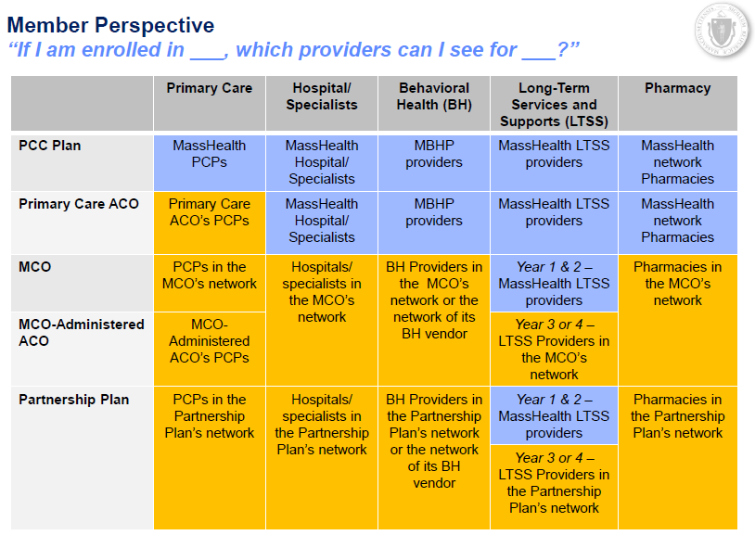
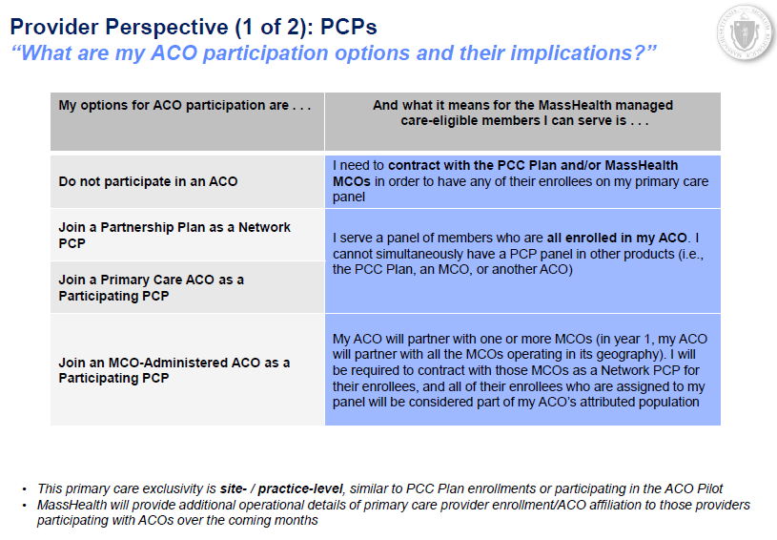

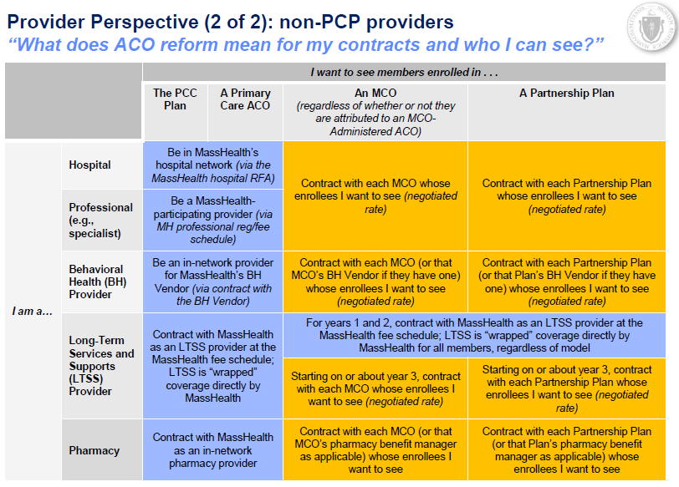

Appendix B: Help for Pharmacies
Plan Name | Method to Determine Member ID | Pharmacy Help Desk
Be Healthy Partnership (HNE) | 1-800-310-2835 (HNE Member Services) | 1-800-918-7545 (Optum Rx)
Berkshire Fallon Health Collaborative | 1-866-275-3247  (Eligibility Verification) | 1-800-364-6331  (CVS Caremark)
Fallon 365 Care
Wellforce Care Plan (Fallon)
My Care Family (NHP) | 1-800-421-2342 (CVS Caremark)  If you don’t have member’s address, contact  1-800-462-5449  (ACO’s Customer Service Desk) | 1-800-421-2342  (CVS Caremark)
BMC HealthNet Plan | 1-888-566-0010  (choose pharmacy option in call menu to reach Envision, BMC’s PBM) | 1-888-566-0010  (choose pharmacy option in call menu to reach Envision, BMC’s PBM)
BMC HealthNet Plan Community Alliance
BMC HealthNet Plan Mercy Alliance
BMC HealthNet Plan Signature Alliance
BMC HealthNet Plan Southcoast Alliance
Tufts Health Together | 1-877-683-6174 (CVS Caremark)  If you don’t have member’s address contact 1-888-257-1985 (MCO and ACO customer service desk) | 1-877-683-6174  (CVS Caremark)
Tufts Health Together with Atrius Health
Tufts Health Together with BIDCO
Tufts Health Together with Boston Children’s ACO
Tufts Health Together with CHA
Primary Care Clinician (PCC) Plan | Submit claims to POPS | 1-866-246-8503 (Conduent/POPS)
Community Care Cooperative (C3)
Partners HealthCare Choice
Steward Health Choice

Appendix C: BIN/PCN/Group Numbers for ACOs, MCOs and PCC Plan
Accountable Care Partnership Plans | MCO Partner | PBM | BIN | PCN | Group
Be Healthy Partnership (HNE) | HNE | OptumRX | 610593 | MHP | HNEMH
Berkshire Fallon Health Collaborative | Fallon | CVS Caremark | 004336 | ADV | RX6429
BMC HealthNet Plan Community Alliance | BMCHP | Envision | 610342 | BCAID | MAHLTH
BMC HealthNet Plan Mercy Alliance | BMCHP | Envision | 610342 | BCAID | MAHLTH
BMC HealthNet Plan Signature Alliance | BMCHP | Envision | 610342 | BCAID | MAHLTH
BMC HealthNet Plan Southcoast Alliance | BMCHP | Envision | 610342 | BCAID | MAHLTH
Fallon 365 Care | Fallon | CVS Caremark | 004336 | ADV | RX6430
My Care Family (NHP) | NHP | CVS Caremark | 004336 | ADV | RX1653
Tufts Health Together with Atrius Health | Tufts | CVS Caremark | 004336 | ADV | RX1143
Tufts Health Together with BIDCO | Tufts | CVS Caremark | 004336 | ADV | RX1143
Tufts Health Together with Boston Children’s ACO | Tufts | CVS Caremark | 004336 | ADV | RX1143
Tufts Health Together with CHA | Tufts | CVS Caremark | 004336 | ADV | RX1143
Wellforce Care Plan (Fallon) | Fallon | CVS Caremark | 004336 | ADV | RX6431
Primary Care ACOs | MCO Partner | PBM | BIN | PCN | Group
Community Care Cooperative (C3) | MassHealth | Conduent | 009555 | MASSPROD | MassHealth
Partners HealthCare Choice | MassHealth | Conduent | 009555 | MASSPROD | MassHealth
Steward Health Choice | MassHealth | Conduent | 009555 | MASSPROD | MassHealth
MCOs* | MCO Partner | PBM | BIN | PCN | Group
BMC HealthNet Plan | BMCHP | Envision | 610342 | BCAID | MAHLTH
Tufts Health Together | Tufts | Caremark | 004336 | ADV | RX1143
PCC Plan | MCO Partner | PBM | BIN | PCN | Group
Primary Care Clinician (PCC) Plan | MassHealth | Conduent | 009555 | MASSPROD | MassHealth

*Members of the Lahey Clinical Performance Network ACO should submit claims to the appropriate MCO using the information above.
Appendix D: Emergency Override Codes for Plans
Accountable Care Partnership Plans | Emergency Override Code
Be Healthy Partnership (HNE) | Call 1-800-918-7545 (Optum Rx) for override
Berkshire Fallon Health Collaborative | Value of “03” in field 418 (level of service)
BMC HealthNet Plan Community Alliance | Overrides by phone call only:  1-888-566-0010
BMC HealthNet Plan Mercy Alliance | Overrides by phone call only:  1-888-566-0010
BMC HealthNet Plan Signature Alliance | Overrides by phone call only:  1-888-566-0010
BMC HealthNet Plan Southcoast Alliance | Overrides by phone call only:  1-888-566-0010
Fallon 365 Care | Value of “03” in field 418 (level of service)
My Care Family (NHP) | 11112222333
Tufts Health Together with Atrius Health | 11112222333
Tufts Health Together with BIDCO | 11112222333
Tufts Health Together with Boston Children’s ACO | 11112222333
Tufts Health Together with CHA | 11112222333
Wellforce Care Plan (Fallon) | Value of “03” in field 418 (level of service)
Primary Care ACOs | Emergency Override Code
Community Care Cooperative (C3) | Value of “03” in field 418 (level of service)
Partners HealthCare Choice | Value of “03” in field 418 (level of service)
Steward Health Choice | Value of “03” in field 418 (level of service)
MCOs
BMC HealthNet Plan | Overrides by phone call only:1-888-566-0010
Tufts Health Together | 11112222333
PCC Plan | Emergency Override Code
Primary Care Clinician (PCC) Plan | Value of “03” in field 418 (level of service)

