
UFR e Filing

OSD

User Guide for Contractors

July 1, 2002

Objectives 1
Introduction 1
Assumptions 1
System Requirements 1
Profile registration and maintenance 2
Request New Profile 2
- Complete Profile Request 2
Log Into UFR eFiling System 7
- Log In From eFiling Home 7
Forgot Password 9
- New Password Request 9
- Receive email Notification 10
Update User Profile 12
- Receive Profile 12
- Change Password 12
- Change Contact Information 15
Filing UFRs 18
Overview of Filing Process 18
View Filings for UFR Filing Period 19
- View Filings for a UFR Filing Period 19
- View Documents for a Submitted Filing 21
Select CPA for UFR Filing Period 24
- Search for and Assign a CPA for a Fiscal Year 25
File UFR (Complete, Alternate and Exempt) 29
- Create a UFR Filing 29
Refile/Piecemeal File UFR 39
- Create a Refile/Piecemeal Filing 39
File for Extension 49
- Create a File for Extension 49
Submit D-1 Performance Measures 58
Complete D-1 Performance Measures 58
References 63
UFR Search 65
Basic Search for UFRs 65
Advanced Search for UFRs 69

Objectives

- Guide the Contractor through the profile registration process
- Guide the Contractor through the profile maintenance process
- Guide the Contractor through the filing process
- Guide the Contractor through searching for UFRs

Introduction
The contractors with the assistance of their assigned CPA firms work collectively to compile, prepare, and submit the UFR filing to the OSD. As such, the design of the UFR eFiling system attempts to balance automation and flexibility by providing an electronic method of submitting the UFR filing online while helping guide and navigate the users through the necessary steps of the UFR filing process. Contractors will be required to register themselves to the system and request for a profile to be created. Once approved, this user profile will help identify the users of the system and provide the necessary security and access privileges to the system in completing the online UFR filing transactions.

This document is intended to serve as guide to Contractors for registering with the UFR eFiling site and filing UFRs online. Detailed instructions are provided for all the major functional areas available to Contractors, including:

- Requesting a User Profile for their organization,
- Logging into the UFR eFiling system,
- Filing UFRs,
- Maintaining their organization ’s user profile, and
- Searching for Filed UFRs

Assumptions
Before the Contractor can begin using the UFR eFiling system, several prerequisites must be satisfied:

- The Contractor has the proper means to access the UFR eFiling System (i.e.: ISP, compatible browser, operating system, office suite)
- The Contractor conducts filings with the Operational Services Division satisfying the business requirements of the eFiling application

System Requirements
The following system requirements must be met to utilize the features of the eFiling System:

- Internet Access through an ISP (i.e. dial-up, ISDN, cable modem, etc.) or LAN
- Microsoft Internet Explorer 4.0 or Netscape Navigator 4.5 (For best results, MS IE 5.0 or Netscape 6.0 or above are recommended)
- Microsoft Office 97 or greater (MS Excel, MS Outlook)

Profile registration and maintenance

Request New Profile

At the conclusion of this section, the user will be able to request a new profile with the OSD eFiling system.

Complete Profile Request

1. Open up the local browser (i.e. Internet Explorer, Netscape Navigator) and type the UFR eFiling URL, https://ufr.osd.state.ma.us/home.asp, into the Address box.

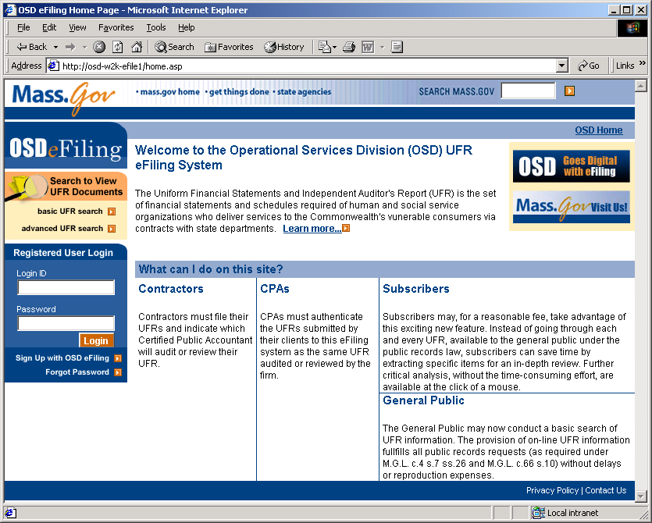

2. At the UFR eFiling home page, click on the Sign Up with OSD eFiling link in the Registered User Login box.

The User Profile Request screen will appear.

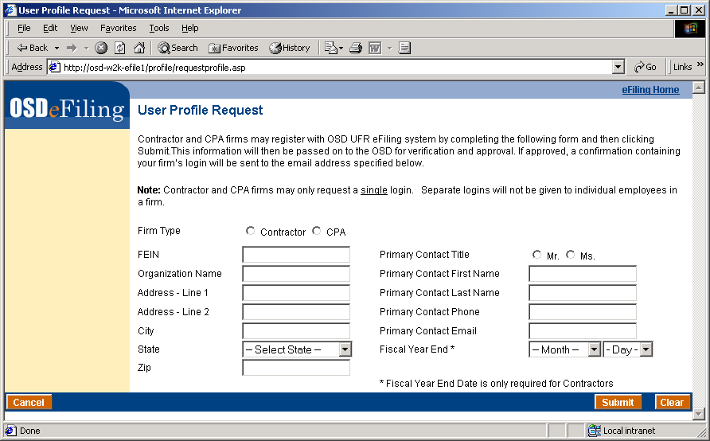

The following fields are required:

- Firm Type (Contractor/CPA)
- FEIN (Federal Employer Identification Number)
- Organization Name
- Address (Street, City, State, Zip)
- Primary Contact (Title, Name, Phone, Email)
- Fiscal Year End (Month and Day)

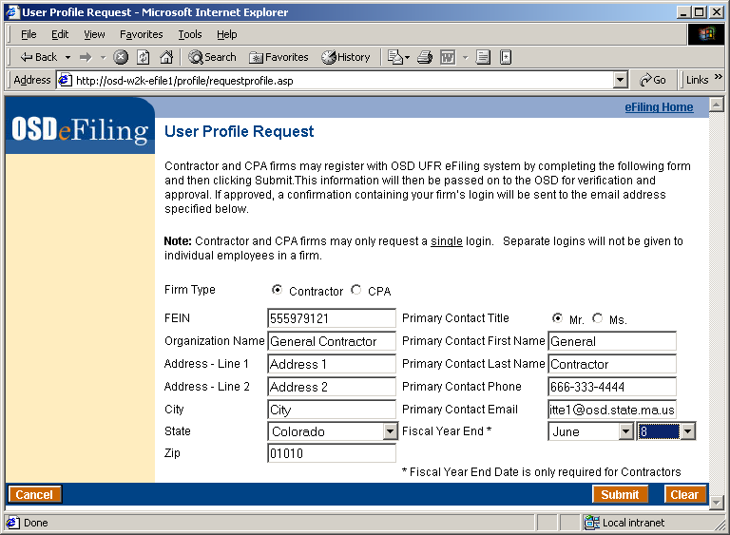
Submit Profile Request

3. Once all the required fields have been completed, click Submit.

The Review User Profile Request screen will appear. Ensure that the information presented is valid and all your user information is as desired.

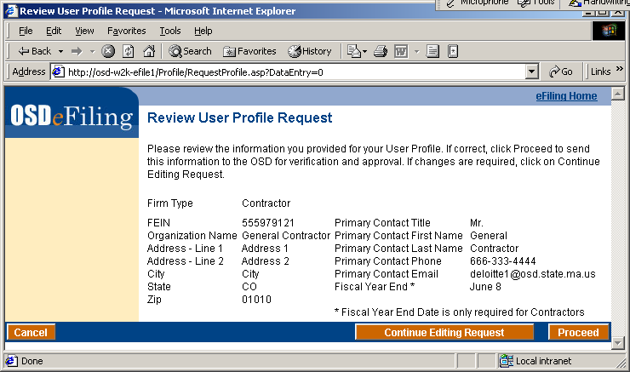

4. Click Proceed.

The Profile Creation Request Confirmation screen will appear.

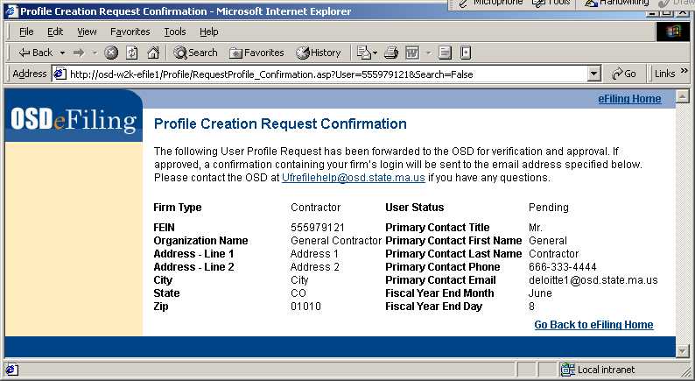
Click the Go Back to eFiling Home link to return to the OSD eFiling homepage. An email will also be sent to the address listed in the Profile Request indicating that the profile request was submitted.

NOTE: Each profile request is reviewed by OSD. Thus, it may take some time for OSD to review and approve the profile. However, this action occurs only once, and your profile persists through filing years.

5. Confirmation from OSD. After the profile creation request has been approved by OSD the account will be established and you will receive the following confirmation, with includes the initial assigned password.

At this point your account is now active and you can logon using the FEIN and assigned password contained in the email.

NOTE: For security, it is recommended that you change your password after initially logging into the eFiling application.

Log into UFR eFiling System

After concluding this section, the user should be capable of:

- Logging into UFR eFiling System
- Viewing the Contractor Anchor page

Login from eFiling Home

- Open up the local browser (i.e. Internet Explorer, Netscape Navigator) and type the UFR eFiling URL, https://ufr.osd.state.ma.us/home.asp, into the Address box.

- Enter the login ID and password into the Login ID and Password fields in the Registered User Login box.

The login information is the same as was provided to you in an email sent by the UFR eFiling administrator when your profile was approved.

- Click the Login button.

Upon a successful login, the UFR Filing for Contractors page will appear.

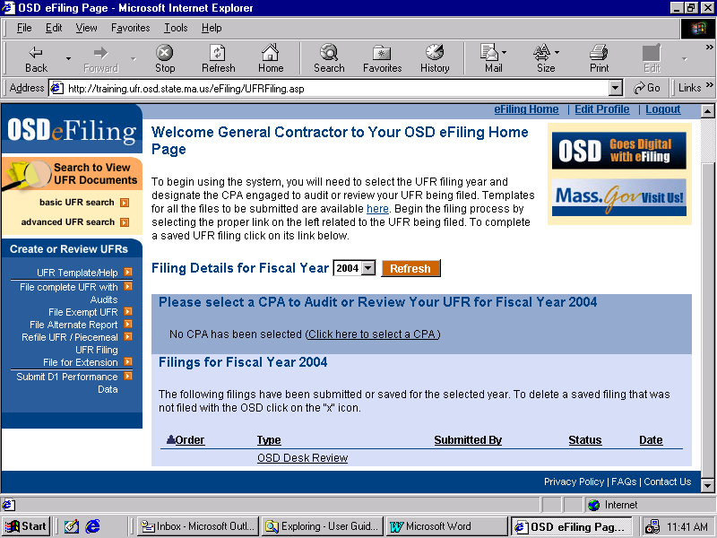

Forgot Password

After this section is complete, the user will be able to request a new password from the UFR eFiling system and log back in.

New Password Request

- At the eFiling homepage, click the Forgot Password link in the Registered User Login box.

- Enter your Login ID into the Login ID field and your email address as it is in your user profile into the email Address field.

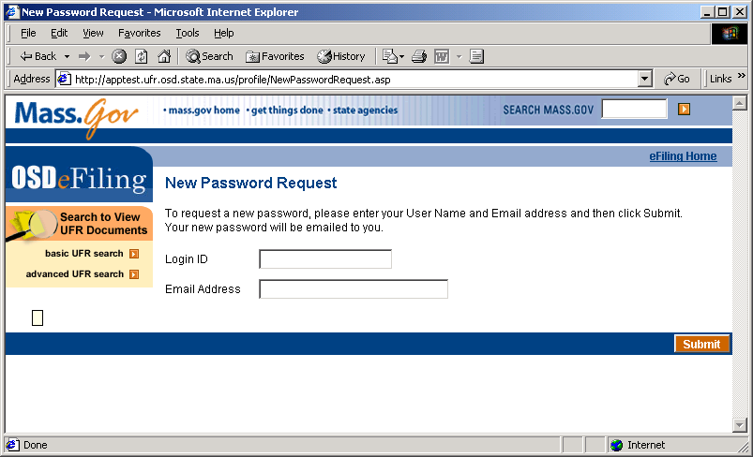

- Click Submit.

The Password Request Confirmation screen will appear

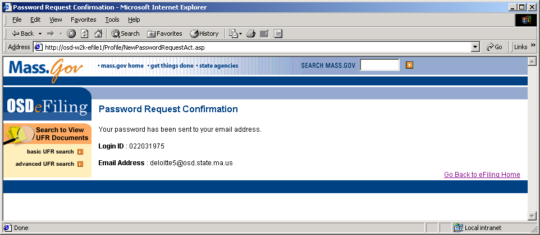

Receive email Notification

4. Open your local e-Mail program (i.e. MS Outlook, Eudora, Netscape Messenger) assigned to the email address that is stored in you UFR eFiling profile.

An email entitled Password Enclosed will appear sent from the UFR eFiling Administrator address. Enclosed is the reset password that you may use to log into the eFiling application.

NOTE: For security, it is recommended that you change your password again on logging into the eFiling application.

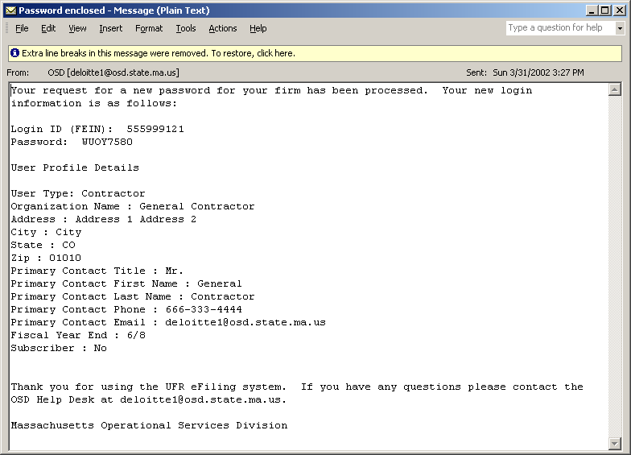

Update User Profile
After concluding this section, the Contractor will be able to perform all functions relating to the maintenance of their user profile including:
- Receiving their profile
- Change password
- Modify profile

Receive Profile

- Open your local e-Mail program (i.e. MS Outlook, Eudora, Netscape Messenger) assigned to the email address that is stored in you UFR eFiling profile.

An email entitled Password Approved will appear sent from the UFR eFiling Administrator address. Enclosed is the username and password that you may use to log into the eFiling application.

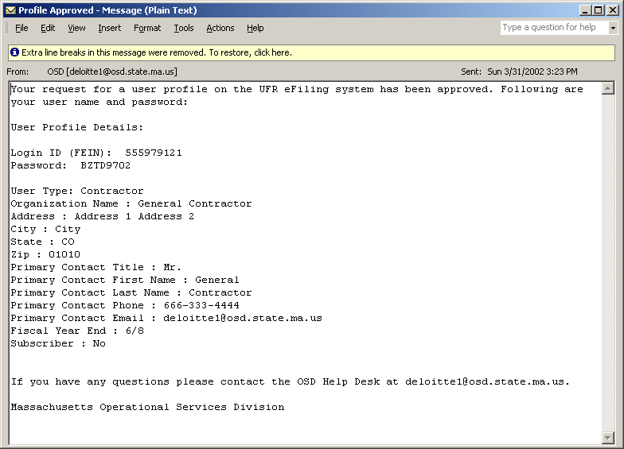

- Use this information when logging into the UFR eFiling System.

Change Password

- At any non-transactional page, click the Edit Profile link on the top left of the page.

The Edit Your Profile screen will appear. All the fields will contain the most current data.

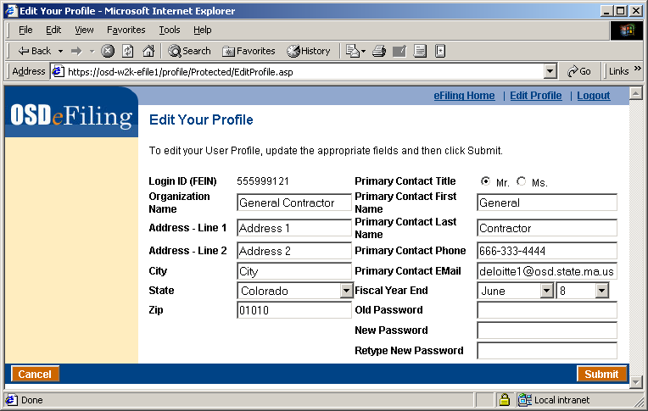

- Enter your current password into the Old Password field.

- Enter your new password into the New Password field.

Retype this password in the Retype New Password field to ensure there is no mistake.

- Click Submit.

The Review Edit Profile screen will appear.

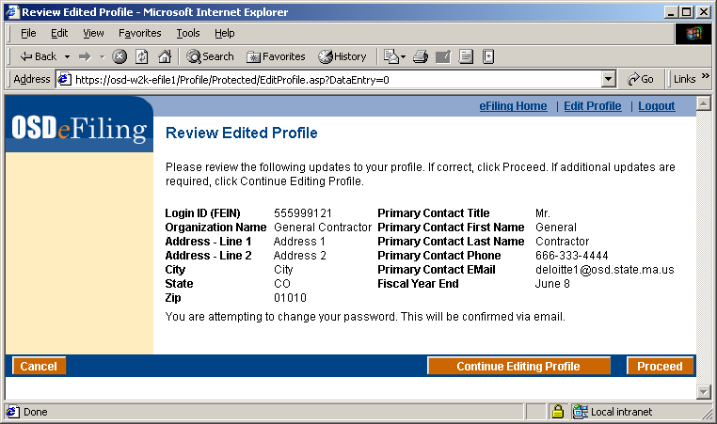

- After the information has been verified as correct, click Proceed.

The User Profile Update Confirmation screen will appear.
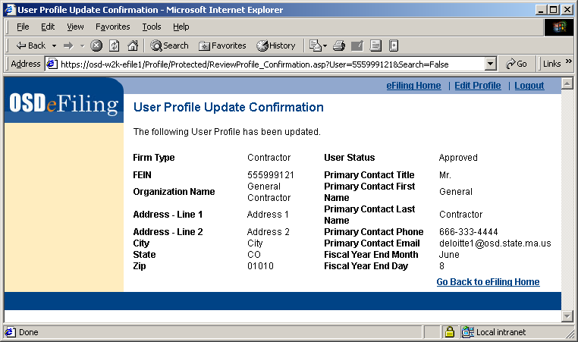

- Click on the Go Back to eFiling Home to go back to your anchor page (Contractor Anchor page).

An e-Mail will also be sent to the address listed in the Profile entitled Profile Updated from the UFR eFiling administrator address. Enclosed is the summary of the profile changes, in this case only, the new password will also be enclosed

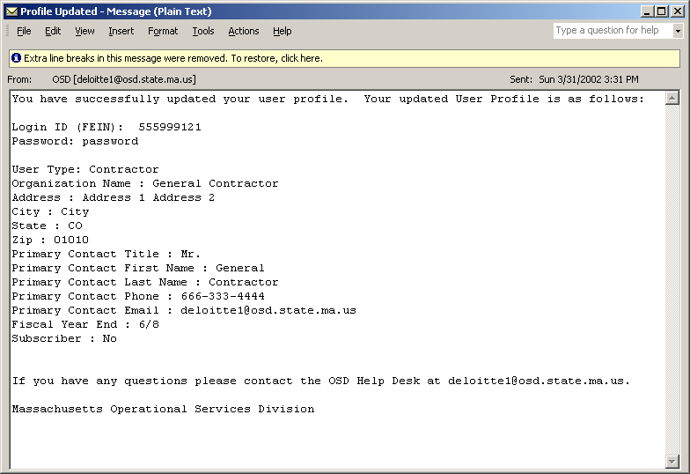

NOTE: It is recommended that on your first entry into the eFiling application that you change your password.

Change Contact Information

- At any non-transactional page, click the Edit Profile link on the top left of the page.

The Edit Your Profile screen will appear. All the fields will contain the most current data.

- Enter your new information into the designated field.

The fields that can be edited are:

  - Organization Information (Name, Address)
  - Contact Information (Title, Name, Phone, Email)
  - Password Information

NOTE: The Login ID (FEIN) is a unique identifier of the user in the eFiling system. This value cannot be changed.

- Click Submit.

The Review Edit Profile screen will appear.

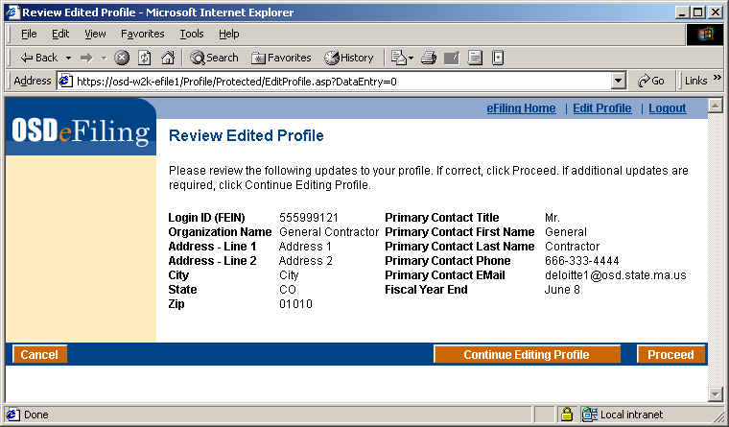

- After the information has been verified as correct, click Proceed.

The User Profile Update Confirmation screen will appear.

An e-Mail will also be sent to the address listed in the Profile entitled Profile Updated from the UFR eFiling administrator address. Enclosed is the summary of the profile changes.

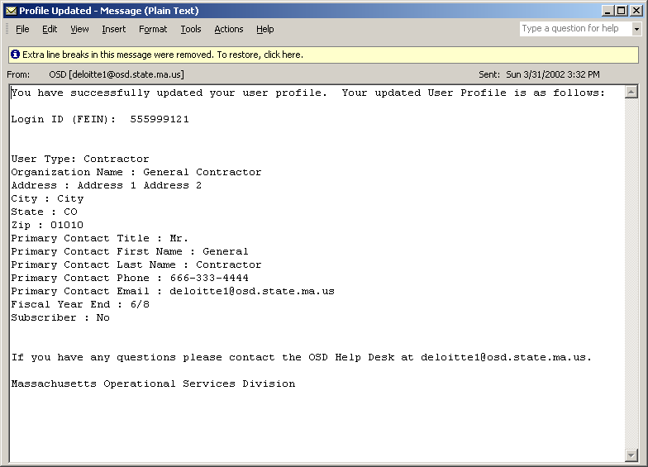

Click on the Go Back to eFiling Home to go back to your anchor page (UFR Filing for Contractors).

Filing UFRs

Overview of Filing Process

The UFR eFiling system allows Contractors and CPAs to submit their UFR files and documents online. The system provides a list of UFR filing transactions available to the users. For each UFR filing transaction, the system will list the UFR documents that are generally filed with OSD. Types of UFR filing transactions include:

- UFR filing with Audited Financials
- Refile UFR / Piecemeal UFR Filing
- Alternate Report Filing
- Exempt Filing
- Request for Extension

While the system helps navigate the user through the UFR filing transaction, the process by which the Contractors and CPA work together to compile and prepare the UFR information is outside the scope of the system features. The system serves as the mechanism by which UFR information is transmitted electronically online to OSD and is not intended for use as an online “workspace”. As the system provides for the flexibility in allowing both the Contractors and CPAs to initiate and complete the UFR filing transaction asynchronously, it was agreed upon by the participants in the Joint Application Design (JAD) workshops that Contractors would only be able to delete files that were uploaded by them but CPAs would be able to delete any file that was included in the UFR filing transaction prior to final submission to the OSD. This process provides an additional level of assurance to the CPAs that typically have signatory authority on specific documents and facilitates the correction of any unintended or unauthorized changes to the UFR filing. In addition, submission of the UFR to OSD would automatically generate emails that notify the parties of the UFR filing status and submittal.

The UFR eFiling system will use a combination of “approval” mechanisms for authenticating the submission of the UFR filings and also the documents that comprise such filings. As UFR filings move to an electronic process, the “wet” signatures found on paper documents will now need to be transformed into an electronic medium. As determined by the Contractor and CPA design workshop participants, a scanned signature of the scanned document and the use of the login information (i.e., username and password) will provide the approval mechanism necessary in the submission of the UFR filings.

Registered Contractors will be required to log into the system. Upon successful login, the Contractors will be presented the “UFR Filing Details” web page. This window provides a listing of the UFR filing transactions that have been submitted or in progress for a given filing period. Based on the necessity for auditing services for the given UFR filing period, the Contractor will be able to assign a CPA for that filing period. This is accomplished in the “CPA Assignment for UFR Filing Period” web page. Contractors will be able to search for registered CPAs and assign a single CPA firm for that specific UFR filing period. Upon selecting the specific UFR transaction from the “UFR Filing Details” web page, they will be navigated to the “Information Upload” web page where they will be able to attach requisite UFR documents. After uploading the documents, the Contractors will be able to save the current state of the UFR filing (for completion later) or submit the UFR filing to the OSD for review. In the “Transaction Review” web page, the Contractors will be able review the UFR filing transaction information and attached documents. Once the UFR filing is submitted to the UFR, the Contractor will receive a “Receipt and Confirmation” page that provides the Contractors with a record of the UFR filing transaction.

The following are detailed instructions for completing the filing process.

View Filings for UFR Filing Period

Upon the completion of this section, the Contractor should have the ability to:

- Select a UFR Filing Period
- View Filings in the Filing Period
- View Documents within the Filing for that Period.

Prior to the execution of this section, it is assumed that the following have been established:

- Contractor has been registered and approved with the eFiling system
- Contractor has had tracking initiated by an OSD Administrator for a given fiscal year

View Filings for a UFR Filing Period

- At your Contractor Anchor Page, select a Fiscal Year to retrieve details from the drop down box and click the Refresh button.
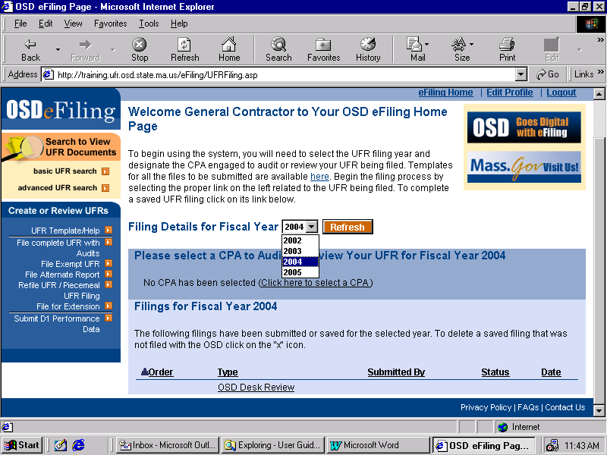
The Filings for Fiscal Year list of filings will be refreshed for the year selected. The OSD Desk Review folder will also be visible for that Fiscal Year. This folder will always exist in your filings. This is where all OSD related documents (i.e. Desk Review Guides, CAPs) will reside.

NOTE: The OSD will only be able to see filings and documents that have been ‘Submitted to OSD’.
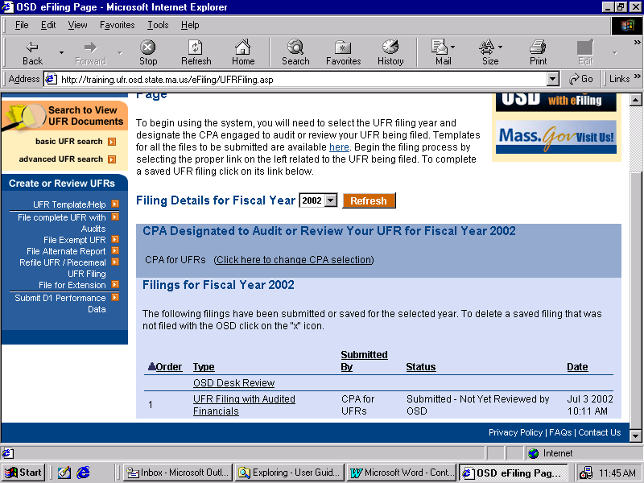
- Click on any of the column headings.

The list will reappear. The list will be sorted descending on the selected column. Clicking the column again will sort the list ascending on that column.
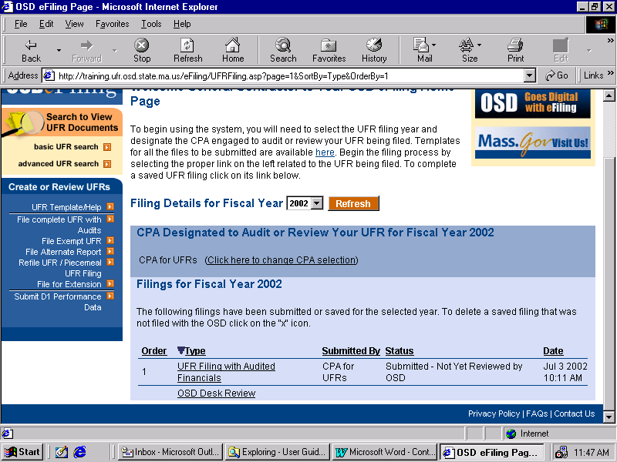

View Documents for a Submitted Filing

- Click on any Filing listed.

The Filing Receipt and Confirmation for that Filing will appear. The following information is displayed in the window:
  - Who submitted the filing to the OSD,
  - When the filing was submitted to the OSD,
  - Receipt Number,
  - Fiscal Year,
  - Contractor contact information,
  - CPA contact information,
  - All Documents uploaded for the filing.

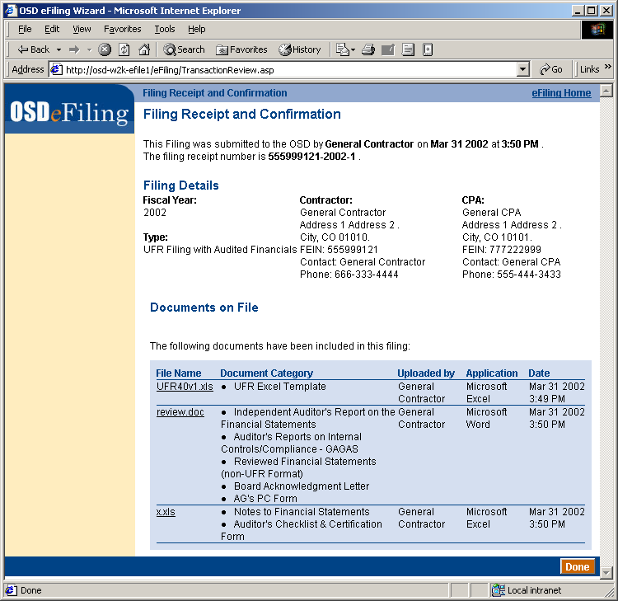

- Click on a document in the File Folder.

The OSD e-Filing Document Viewer will appear in a separate window. The selected document, by default will appear exactly as it was uploaded, under the Native viewing type. Two other viewing methods are possible:

- FulView – FulView is a free-downloadable viewer which will render the document in its own format. If the computer downloading the document does not have the appropriate software such as Microsoft Office, FulView can be used to view the document.

NOTE: FulView will not render Adobe Acrobat files unless Acrobat Reader is installed on the viewing computer.

- HTML – The document can also be rendered in HTML which can be viewed in a web browser.

NOTE: HTML rendering is not possible for Adobe files.

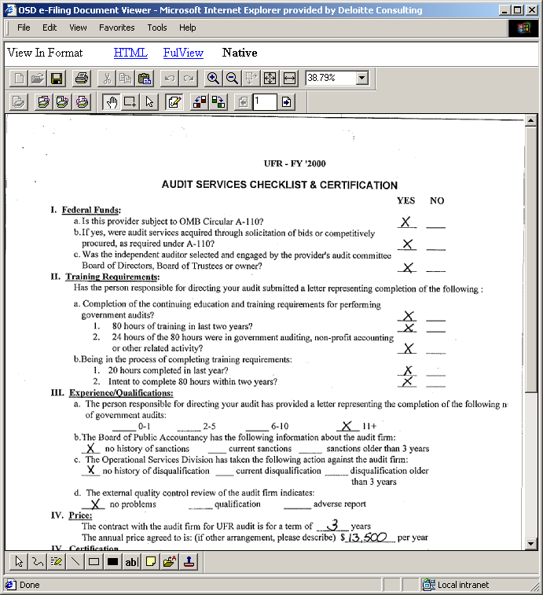
A .tif file viewed in the OSD eFiling Document Viewer

NOTE: The document that is viewed may be accessed as a read only file. Changes may be made, but if saved will only be saved to the local computer. No changes are transmitted to the Server where the original document resides.

- Click Done on the Filing Receipt and Confirmation page.

The Contractor Anchor page will appear.

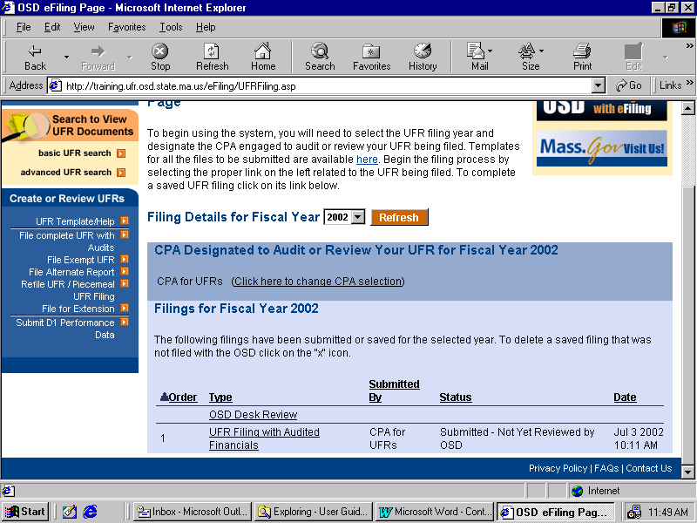

Select CPA for UFR Filing Period

After concluding this section, the Contractor should have the ability to:
- Access the CPA Search tool to find a CPA
- Assign a CPA to the Filings for a Fiscal Year

Prior to the execution of this section, it is assumed that the following have been established:

- Contractor has been registered and approved with the eFiling system
- Contractor has had tracking initiated by an OSD Administrator for a given fiscal year

The following filings require a CPA to be associated with them:

- File Complete UFR with Audits
- File Alternate Report
- Refile UFR/Piecemeal UFR Filing

The selection of the CPA starts at the Contractor Anchor page. This method is the same whether you are assigning a CPA for the first time or selecting a different CPA. After you select a CPA for a fiscal year, the CPA will have access to all of your filings to which they are selected. The assigned CPA will also have the capability to submit filings on behalf of your firm.

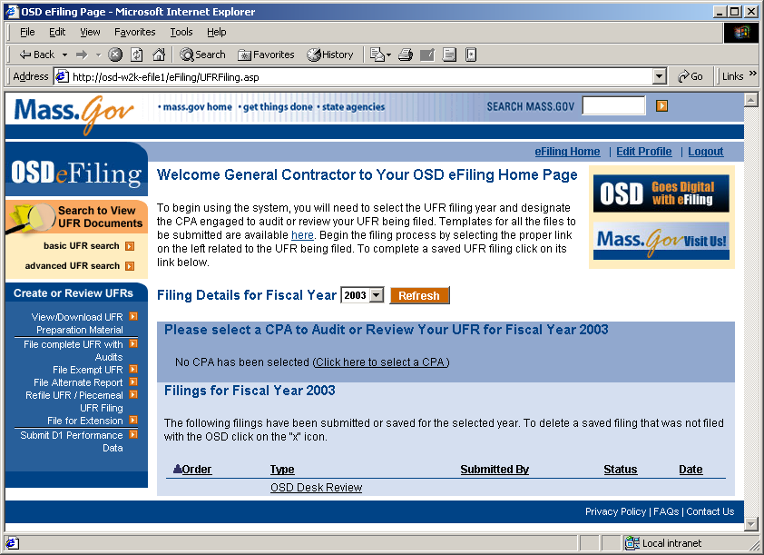

Note: The CPA Firm will have to have already applied for and received a User Profile for the UFR eFiling System.

Search for and Assign a CPA for a Fiscal Year

- From the Contractor Anchor page, click the Click Here to Select a CPA.

The CPA Assignment for UFR Filing Period screen will appear.

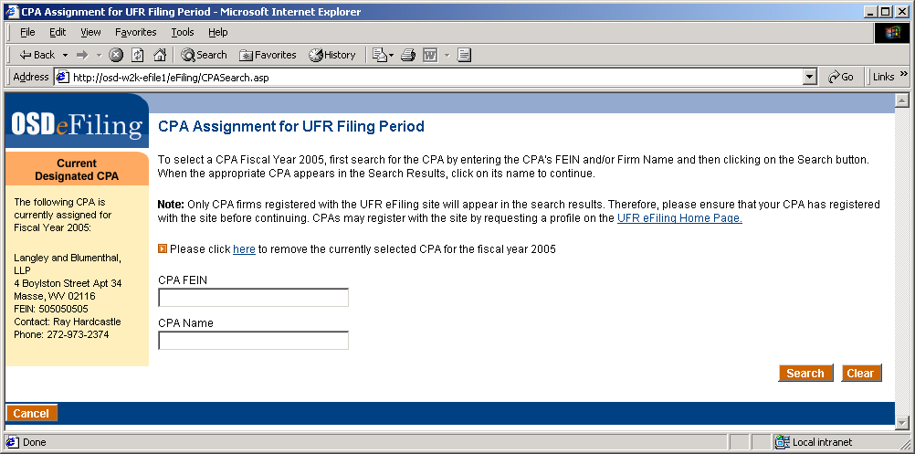

- To search for a CPA, enter criteria relevant to the search. The search criteria that are provided are:

  - CPA Name
  - CPA FEIN

Wildcard searches (i.e. Delo*) are permitted and any or all criteria can be entered. Click the Search button to search for CPAs. Matching CPAs will appear in blue under the Search Results header.

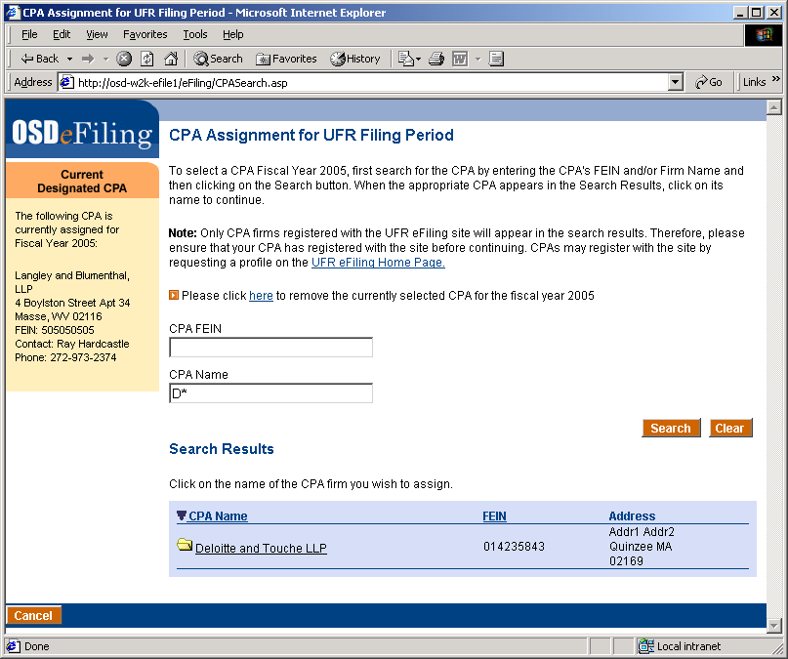

Clicking on any of the column headings sorts the results ascending/descending on that column. The number of pages appears at the bottom right. Clicking on the page number will cause the selected page to appear.

- Click on the name of the CPA you wish to designate for the selected fiscal year.

The CPA Assignment summary screen will appear. The information on this screen includes the CPAs contact information.

NOTE: Selecting a new CPA while an existing filing is unsubmitted for that fiscal year will delete that filing from the UFR eFiling system.
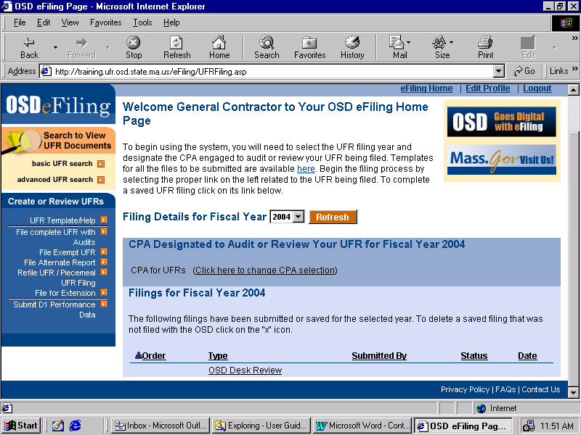
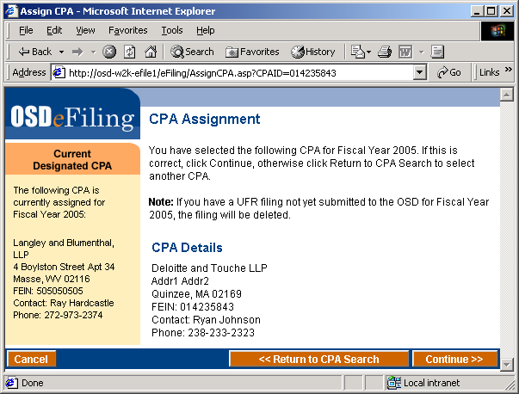

- To confirm your CPA, click Continue >>.

The Contractor Anchor page will reappear. The CPA that was selected will now appear under the header, CPA Designated to Audit or Review Your UFR for Fiscal Year YYYY.

An e-Mail will also be sent to the address listed in your Profile entitled You Have Chosen a CPA from the UFR eFiling administrator address. Enclosed is the CPA designated to audit or review your filings for that fiscal year.

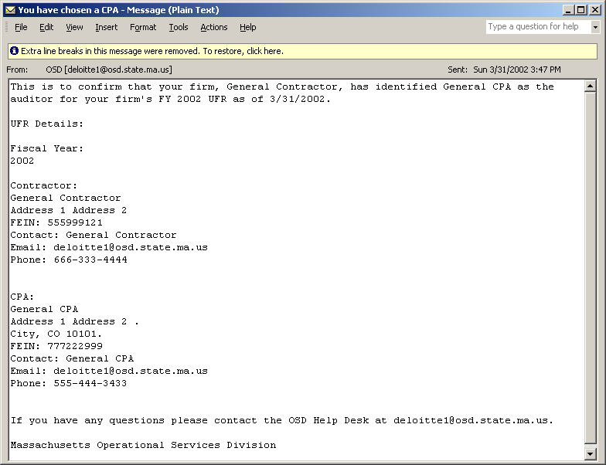

File UFR (Complete, Alternate and Exempt)

At the end of this section, the Contractor should have the ability to:

- Create a UFR Filing
- Link to complete the D-1 system to complete D1 Requirement, if necessary
- Upload Required Documents
- Submit the UFR Filing
- Check the Status of the Filing

Prior to the execution of this section, it is assumed that the following have been established:

- Contractor has been registered and approved with the eFiling system
- Contractor has had tracking initiated by an OSD Administrator for a given fiscal year
- Contractor has selected a CPA within the UFR eFiling System

Create a UFR Filing
- At the Contractor Anchor page, click the link in the Create or Review UFRs box for the type of UFR Filing you wish to conduct. There are three types of UFR Filing options available:

- File Complete UFR with Audits
- File Exempt UFR
- File Alternate Report
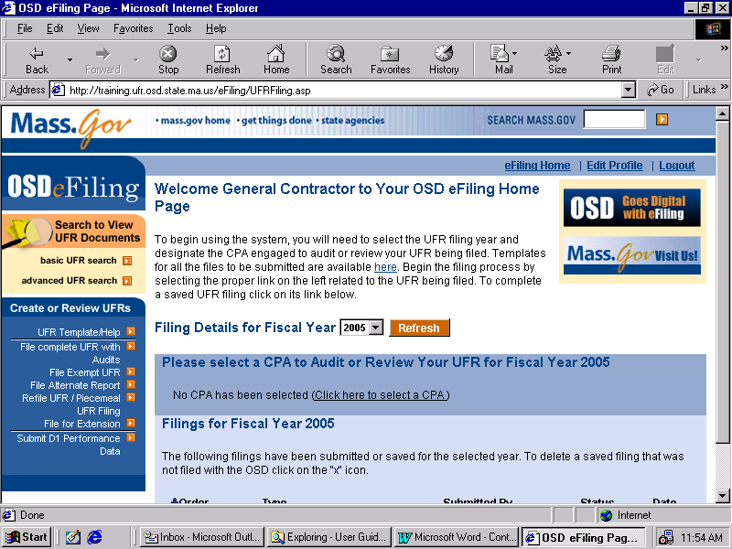

The Create Filing screen will appear. The dropdown choices of Fiscal Year reflect the fiscal years for which you have been permitted to file by OSD.

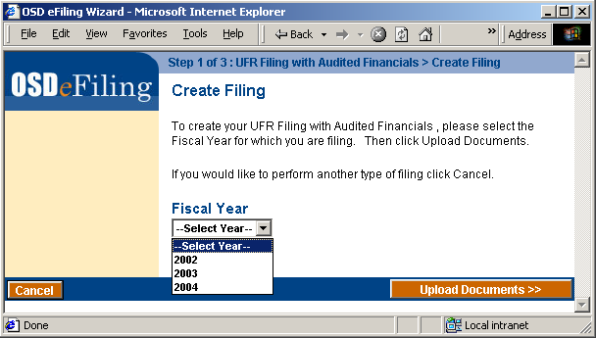

If the type of filing is File Exempt UFR, then the screen would also have a dropdown for the type of exempt filing:

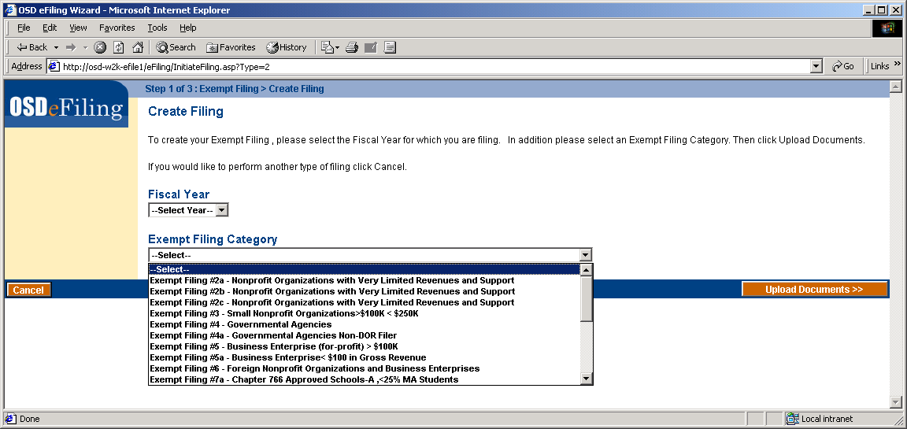

- Select a Fiscal Year from the dropdown box, and the Exempt Filing Category from the dropdown (if required), and click Upload Documents >>.

At this point, the eFiling System will perform a validation on your D-1 Filing requirement for the fiscal year. This is a check done on the D-1 Filing System. If you need to file D-1 performance data and you have not, you may not file a UFR. The D-1 Filing Requirement screen will appear, prompting you to go to the D-1 System and complete performance data. For more information, please refer to the UFR Handbook.

NOTE: Contractors conducting Exempt filings do not need to complete D-1 performance measures for that fiscal year.

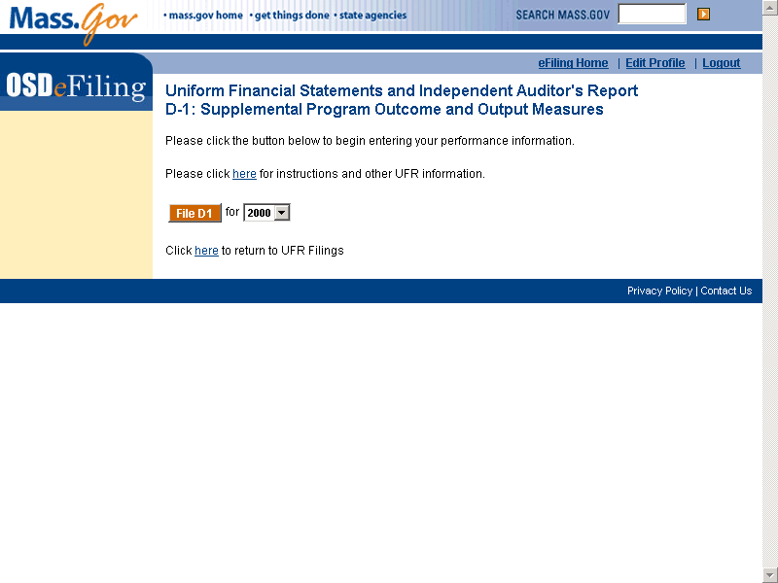

If the D-1 is not required or has been completed, the Information Upload page will appear for the Refile/Piecemeal filing. Please read the directions on the page carefully. The required documents for this filing are displayed in the Required Documents Check List window.

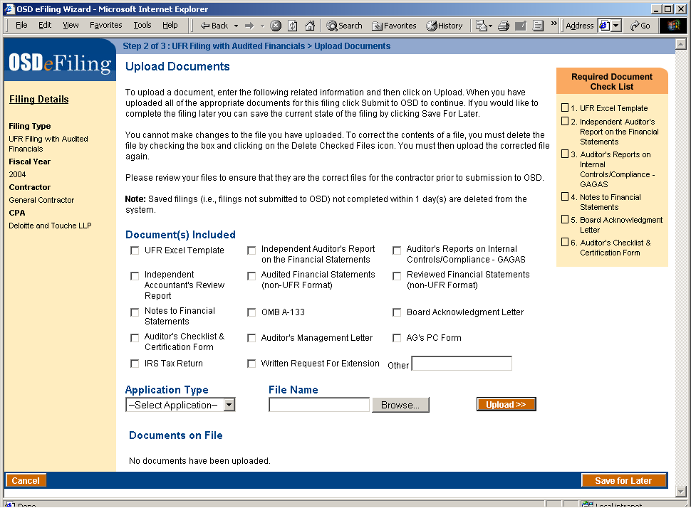

NOTE: It is possible to save the filing for later by clicking the Save for Later button. However, any unsubmitted documents and filings left for more that 24 hours will be deleted.

- To upload documents for the filing, select one or more document categories from the checkboxes under Document(s) Included. Then select the type of file being uploaded from the Application Type dropdown list.

NOTE: The UFR Excel template must be selected on its own; it cannot be categorized with any other document. The UFR Excel template must be an Excel file type.

The File type given in the dropdown must match the extension of the file that is selected to be uploaded. Zip files may not be uploaded into the eFiling system. They must be uncompressed first, and then the unzipped documents must be uploaded separately.

To select the file to upload, click the Browse button.

The Choose File browser will appear.

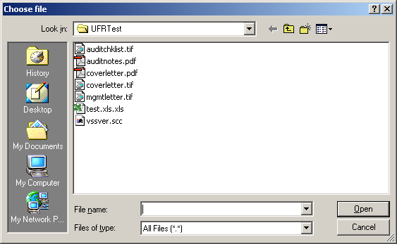

Select the file by clicking to the appropriate directory and double-clicking the desired file.

Click the Upload >> button. The please wait screen will appear.

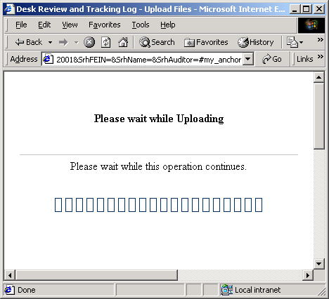

Upon successful completion of the upload, the Upload Files screen will reappear. The document just uploaded will appear in the list of Documents on File.
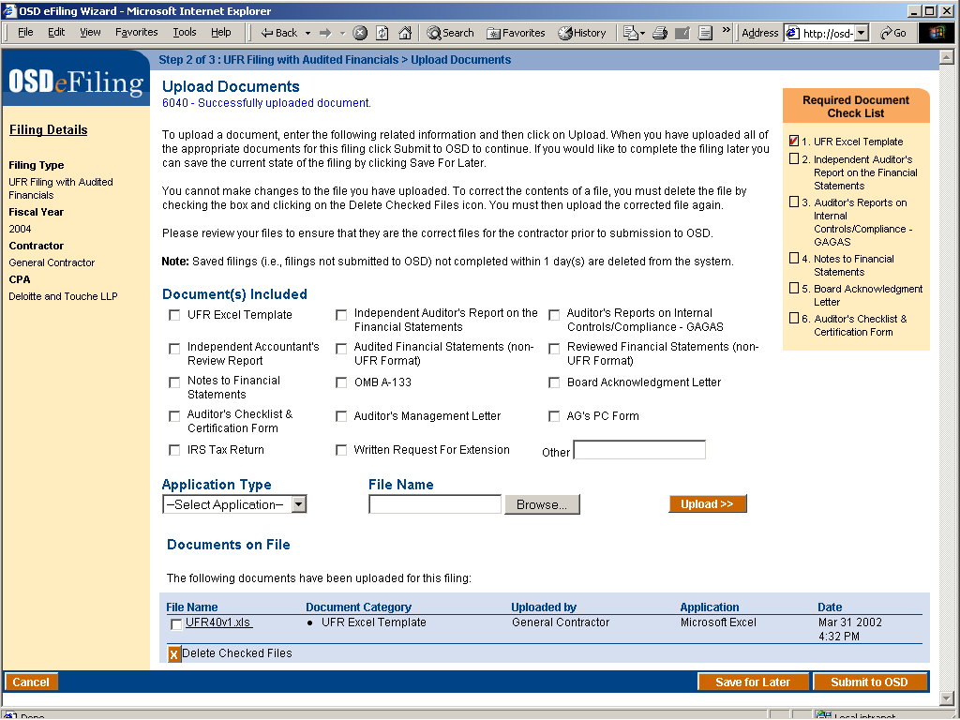

Clicking on the file name will bring up the OSD eFiling Document Viewer.

- To delete a document, check the box adjacent to the file name and then click the Delete Checked Files button.

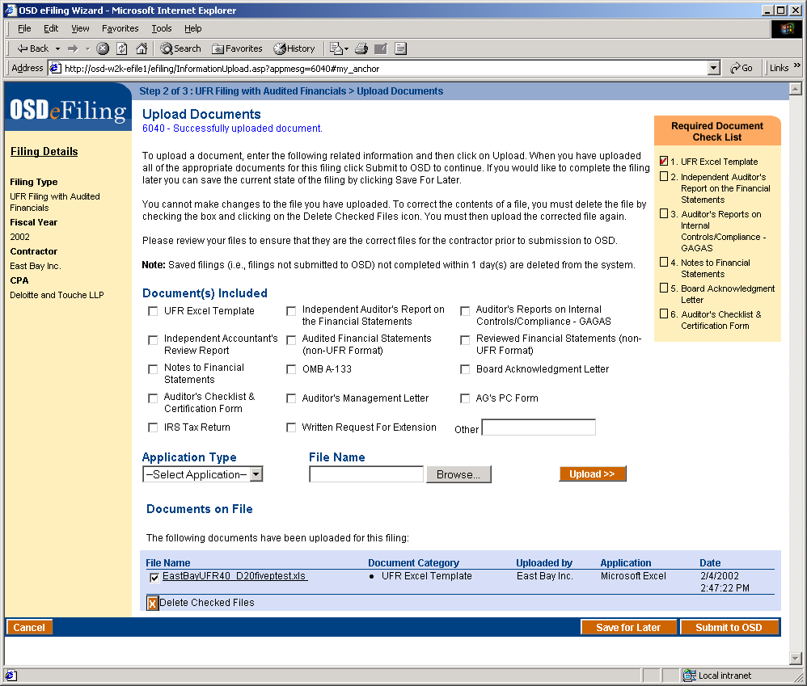

The information upload page will reappear. The file will be deleted from the UFR eFiling system.

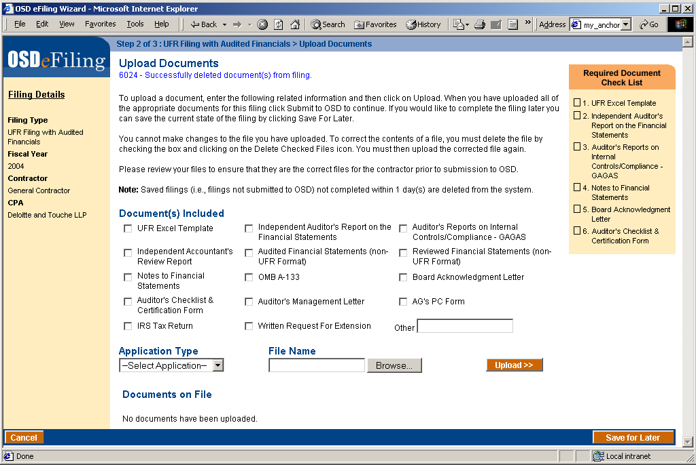

- Once you have uploaded all of the required documents and any other documents you wish to include in the filing, click the Submit to OSD button.

The Please Wait screen will appear.

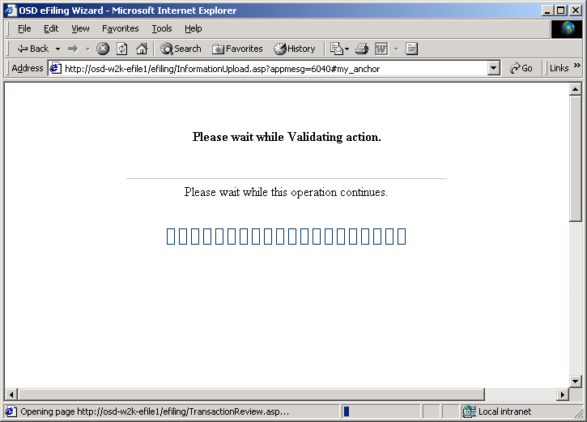

Upon successful validation of the filing, the Review filing screen will appear. The information that is displayed is:

  - Fiscal Year
  - Contractor contact information
  - CPA Contact information
  - Documents on File

NOTE: At this point, the uploaded documents are still being staged in the eFiling system. Carefully review this information prior to final submission to OSD to ensure that this is the correct information to be submitted for the UFR Filing.

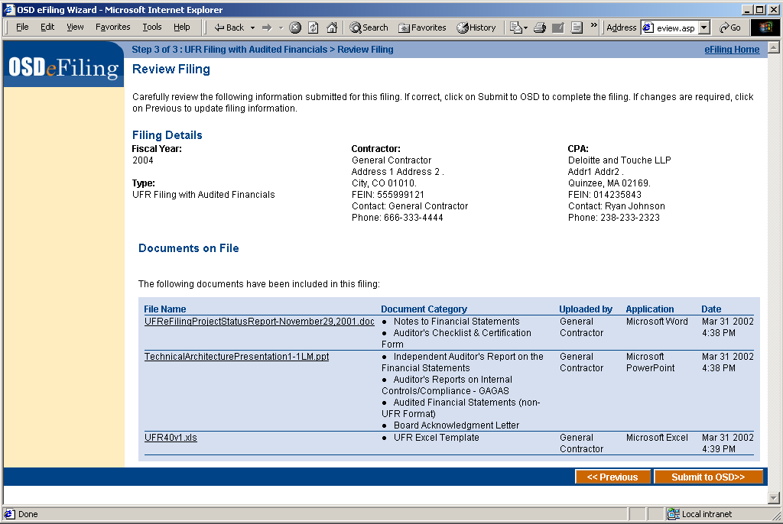

- If all the information presented, including the uploaded documents, click
Submit to OSD >>.

The Please Wait screen will appear.

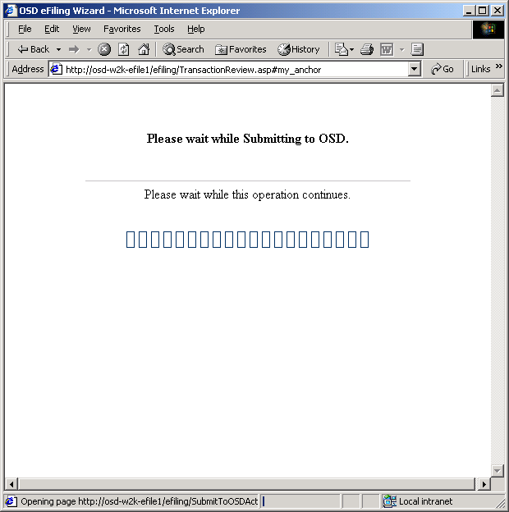

When the Submittal is finished, the Filing Receipt and Confirmation screen appears. The following information is displayed in the window:
  - Who submitted the filing to OSD,
  - When the filing was submitted.
  - Receipt Number
  - Fiscal Year
  - Contractor contact information
  - CPA Contact information
  - Documents on File

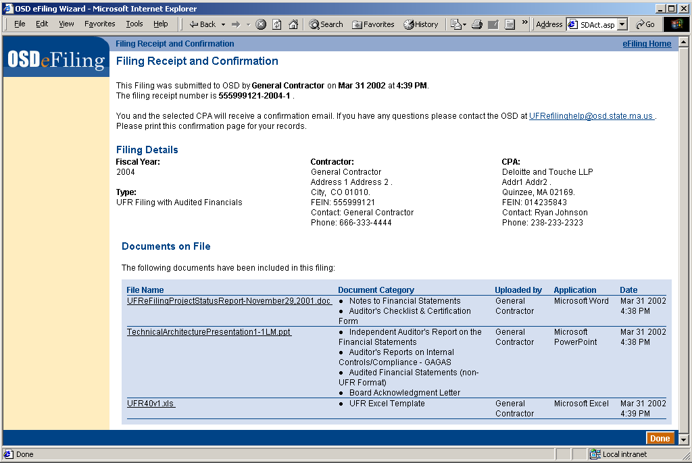

Clicking on a document name under the File Name heading in the Documents on File box will bring up the OSD eFiling Document Viewer.

NOTE: Upon successful submission to the OSD, the UFR eFiling system closes the filing to any changes. This file is now visible to OSD and to FOI requests.

For your records, it is recommended that you print this receipt screen.

A confirmation e-mail will be sent to your email address as well as your CPA, as given in your profile. This e-mail will contain a summary of the information that was presented to you in the Filing Receipt.

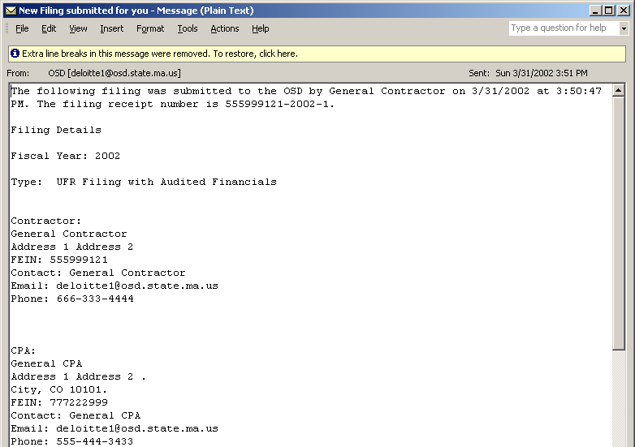
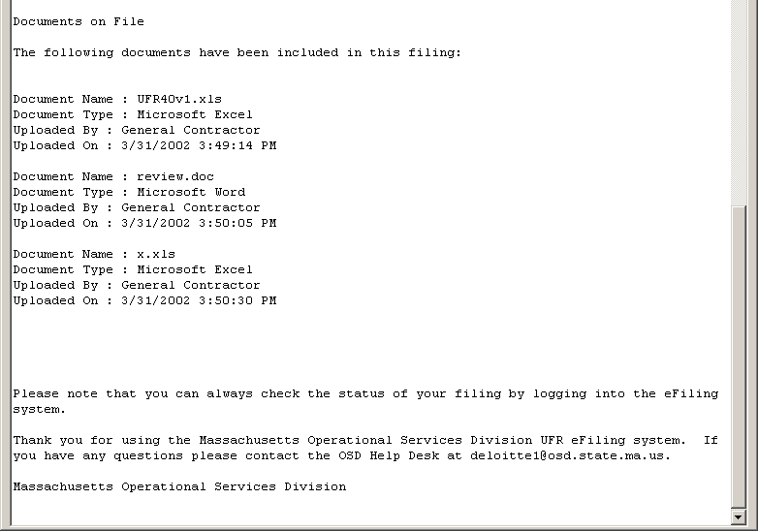

Refile/Piecemeal File UFR

After completion of this section, the Contractor should have the ability to

- Create a Refile/Piecemeal UFR Filing
- Link to complete the D-1 system to complete D1 Requirement, if necessary
- Upload Required Documents
- Submit the UFR Filing
- Check the Status of the UFR Filing

Prior to the execution of this section, it is assumed that the following have been established:

- Contractor has been registered and approved with the eFiling system
- Contractor has had tracking initiated by an OSD Administrator for a given fiscal year
- Contractor has selected a CPA within the UFR eFiling System

Create a Refile/Piecemeal Filing

- In the Create or Review UFRs box, click the Refile UFR/Piecemeal UFR Filing choice.

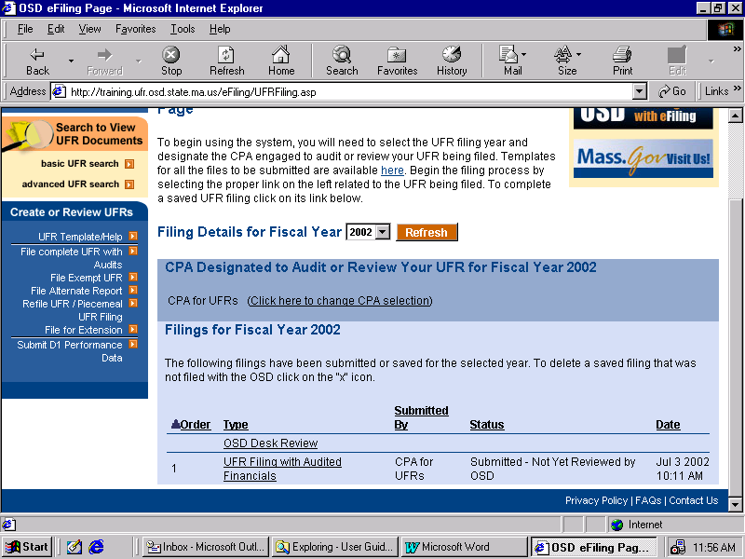

The Create Filing screen will appear. The dropdown choices of Fiscal Year reflect the fiscal years that for which you have been permitted to file by OSD.

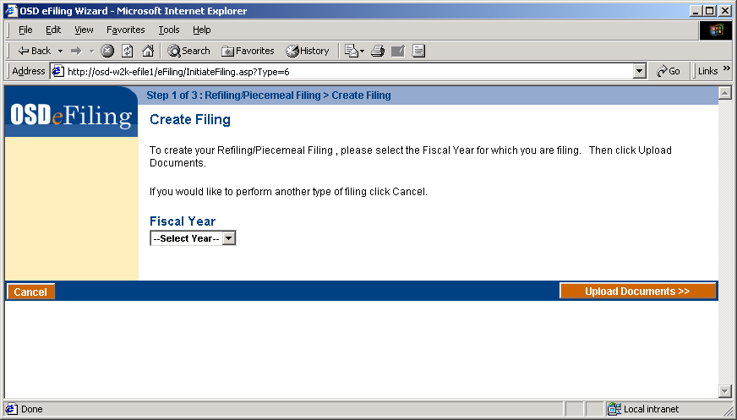

- Select a Fiscal Year from the dropdown box and click Upload Documents >>.

At this point, the eFiling System will perform a validation on your D-1 Filing requirement for the fiscal year. This is a check done on the D-1 Filing System. If you need to file D-1 performance data and you have not, you may not file a UFR. The D-1 Filing Requirement screen will appear, prompting you to go to the D-1 System and complete performance data. For more information, please refer to the UFR Handbook.

If the D-1 is not required or has been completed, the Information Upload page will appear for the Refile/Piecemeal filing. Please read the directions on the page carefully. There are no required documents, as this is a refiling of the UFR, thus nothing is displayed in the Required Documents Check List window.

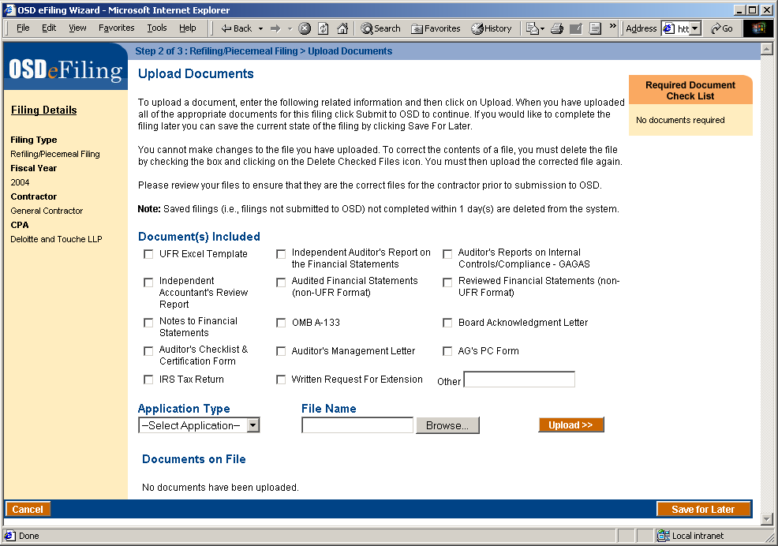

NOTE: It is possible to save the filing for later by clicking the Save for Later button. However, any unsubmitted documents and filings left for more that 24 hours will be deleted.

- To upload documents, select one or more document categories from the checkboxes under Document(s) Included. Select the type of file being uploaded from the Application Type dropdown list. To select the file to upload, click the Browse button.

The Choose File browser will appear.

Select the file by clicking to the appropriate directory and double-clicking the desired file.

Click the Upload >> button. The please wait screen will appear.

Upon successful completion of the upload, the Upload Documents screen will reappear. The document just uploaded will appear in the list of Documents on File.

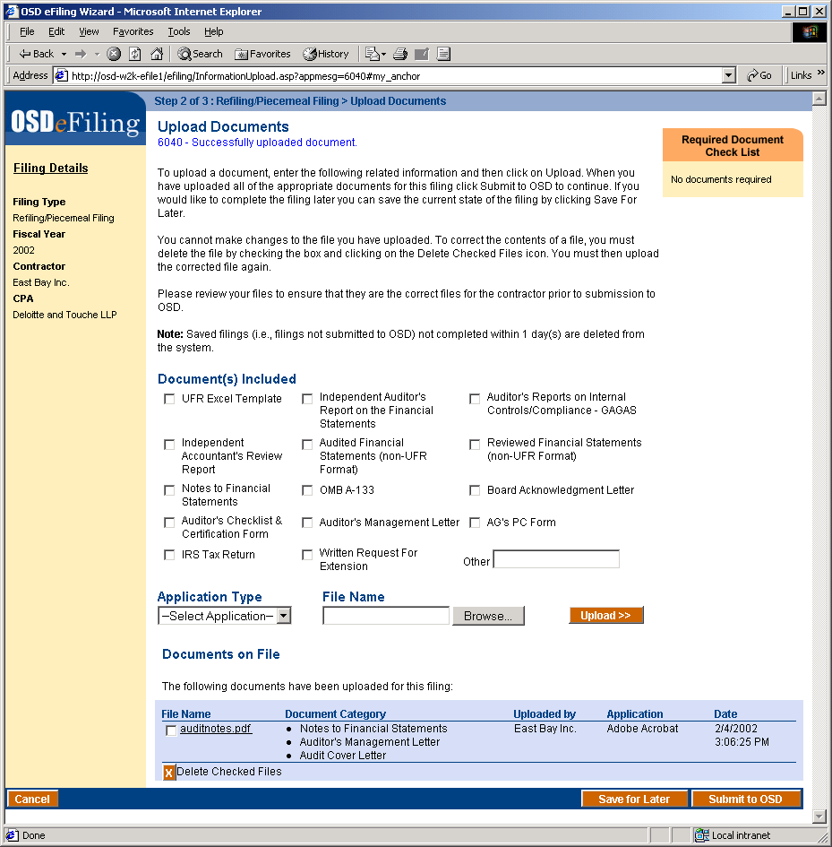

Clicking on the file name will bring up the OSD eFiling Document Viewer.

- To delete a document, check the box adjacent to the file name.

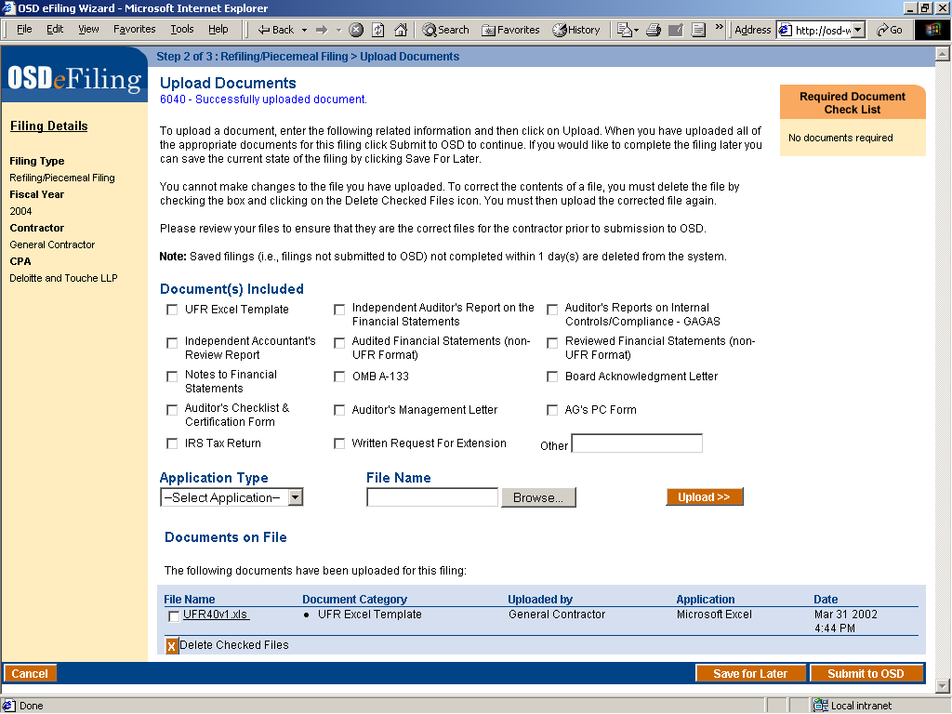

- Click the Delete Checked Files button.

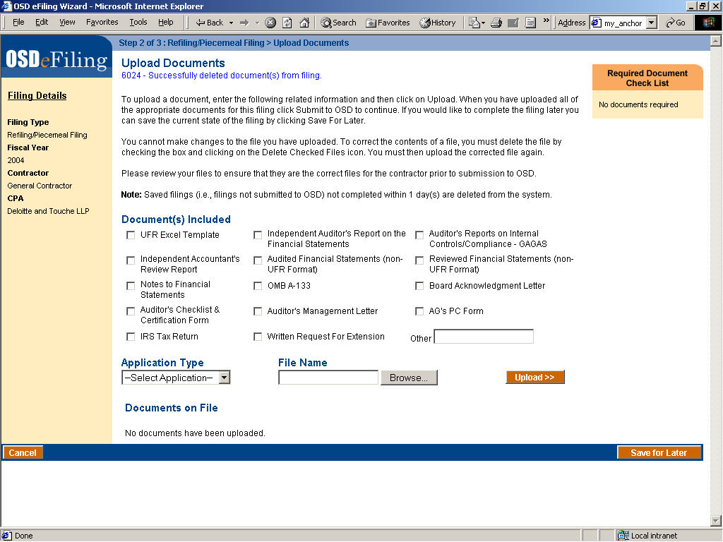

The file will be deleted from the UFR eFiling system.

- After the required files and additional files that you wish to supply to the OSD have been uploaded, click the Submit to OSD button.

The Please Wait screen will appear.

Upon successful validation of the filing, the Review filing screen will appear. The information that is displayed is:

  - Fiscal Year
  - Contractor contact information
  - CPA Contact information
  - Documents on File

NOTE: At this point, the documents are still being staged in the eFiling system. Carefully review this information prior to final submission to OSD to ensure that this is the correct information to be submitted for the File for Extension.

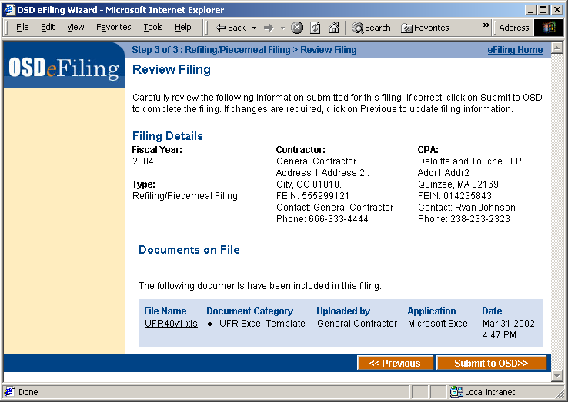

- If all the information is correct, including the uploaded documents, click Submit to OSD >>.

The Please Wait screen will appear.

When the Submittal is finished, the Filing Receipt and Confirmation screen appears. The following information is displayed in the window:
  - Who submitted the filing,
  - When the filing was submitted.
  - Receipt Number
  - Fiscal Year
  - Contractor contact information
  - CPA Contact information
  - Documents on File

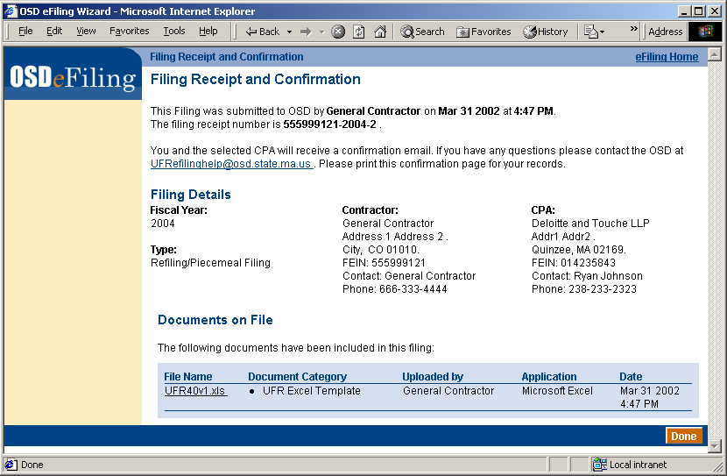

Clicking on a document name under the File Name heading in the Documents on File box will bring up the OSD eFiling Document Viewer.

NOTE: Upon successful submission to the OSD, the UFR eFiling system closes the filing to any changes. This file is now visible to OSD and to FOI requests.

For your records, it is recommended that you print this receipt screen.

A confirmation e-mail will be sent to the email address as is listed in you user profile. This e-mail will contain a summary of the information that was presented to you in the Filing Receipt.

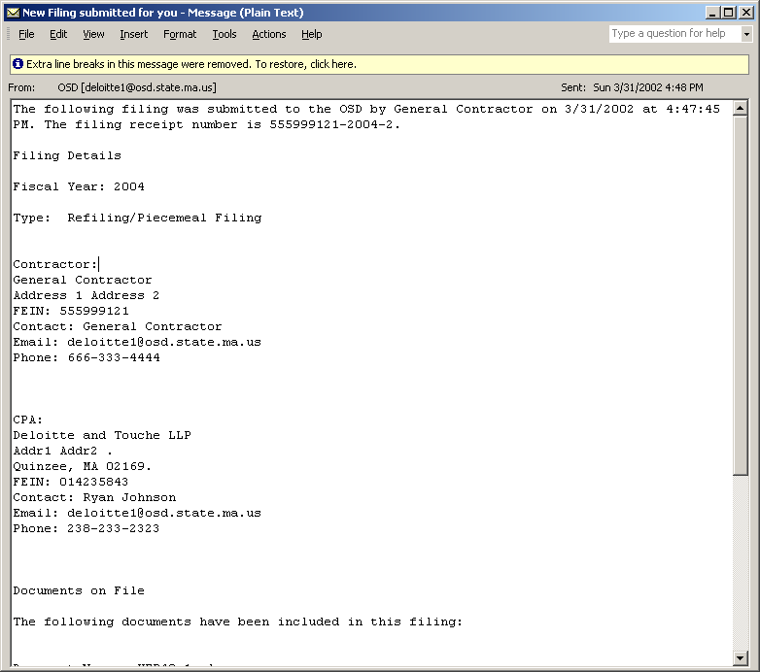
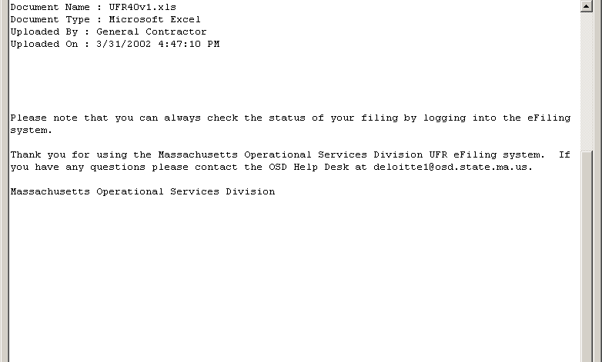

File for Extension

On completion of this section, the Contractor should have the ability to:

- Create a File for Extension
- Upload the Letter for Extension
- Submit the File for Extension
- Check the Status of the Extension

Prior to the execution of this section, it is assumed that the following have been established:

- Contractor has been registered and approved with the eFiling system
- Contractor has had tracking initiated by an OSD Administrator for a given fiscal year

Create a File for Extension

- In the Create or Review UFRs box in the left margin, click the File for Extension choice.
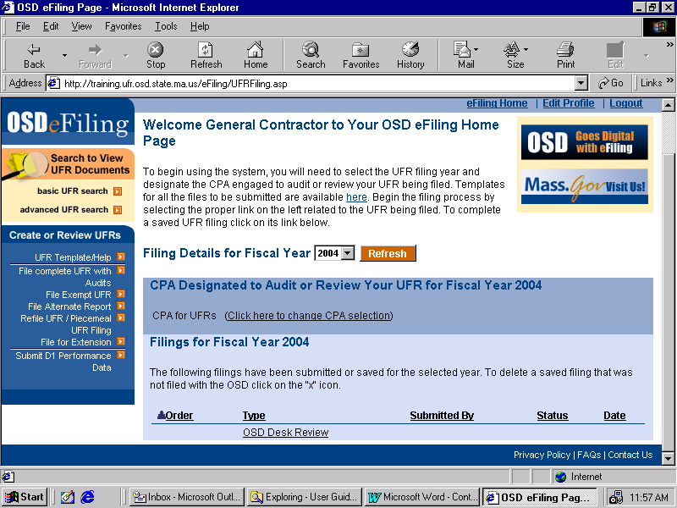

The Create Filing screen will appear. The dropdown choices of Fiscal Year reflect the fiscal years for which you have been required to file by OSD.

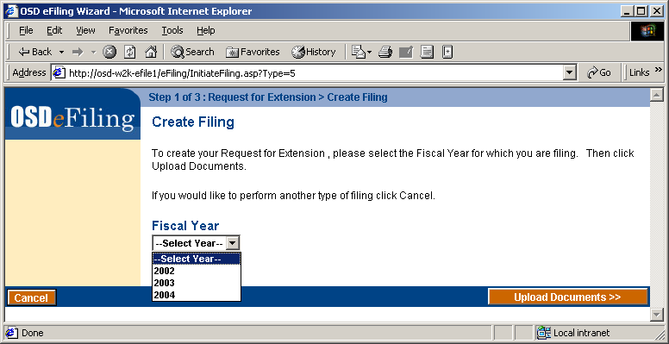

- Select a Fiscal Year from the dropdown box and click Upload Documents >>.
The Information Upload page will appear for the File for Extension. Please read the directions on the page carefully. The required document for this filing, the Written Request for Extension, is displayed in the Required Documents Check List window.

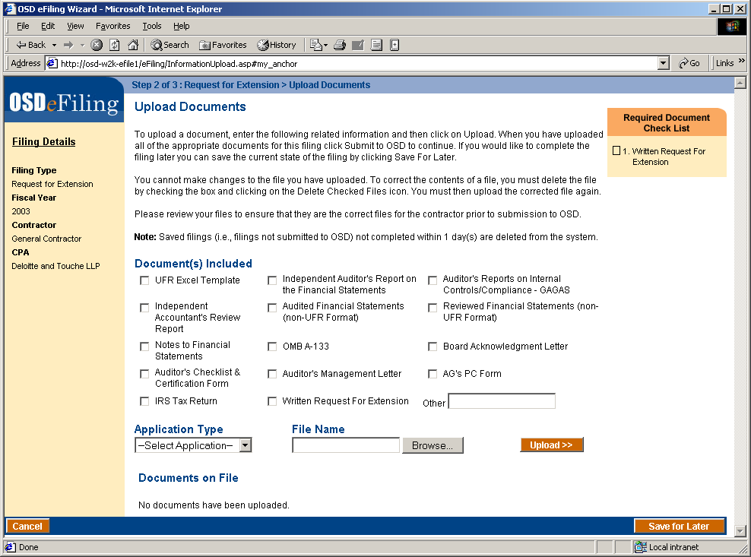

NOTE: It is possible to save the filing for later by clicking the Save for Later button. However, any unsubmitted documents and filings left for more that 24 hours will be deleted.

- To upload the documents, select one or more document categories from the checkboxes under Document(s) Included. Select the type of file being uploaded from the Application Type dropdown list. To select the file to upload, click the Browse button.

The Choose File browser will appear.

Select the file by clicking to the appropriate directory and double-clicking the desired file.

Click the Upload >> button. The please wait screen will appear.

Upon successful completion of the upload, the Upload Documents screen will reappear. The document just uploaded will appear in the list of Documents on File.

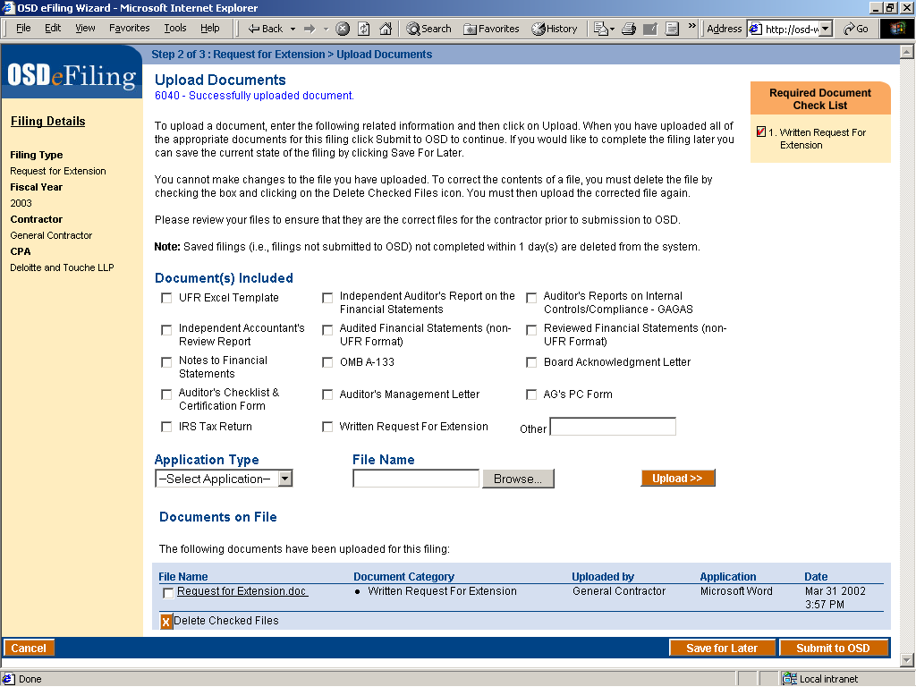

Clicking on the file name will bring up the OSD eFiling Document Viewer.

- To delete a document, check the box adjacent to the file name and click the Delete Checked Files button.

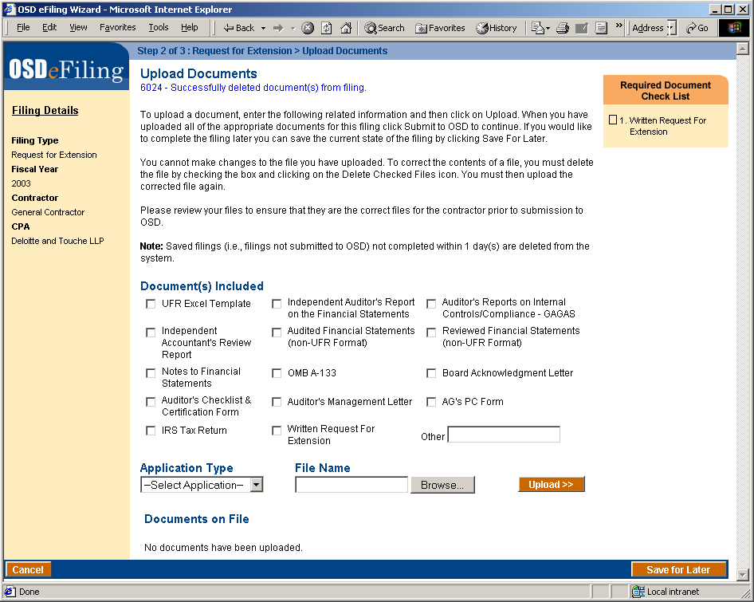

The file will be deleted from the UFR eFiling system.

- After the required files and additional files you wish to supply to OSD have been uploaded, click the Submit to OSD button.

The Please Wait screen will appear.

Upon successful validation of the filing, the Review filing screen will appear. The information that is displayed is:

  - Fiscal Year
  - Contractor contact information
  - CPA Contact information
  - Documents on File

NOTE: At this point, the documents are still being staged in the eFiling system. Carefully review this information prior to final submission to OSD to ensure that this is the correct information to be submitted for the File for Extension.

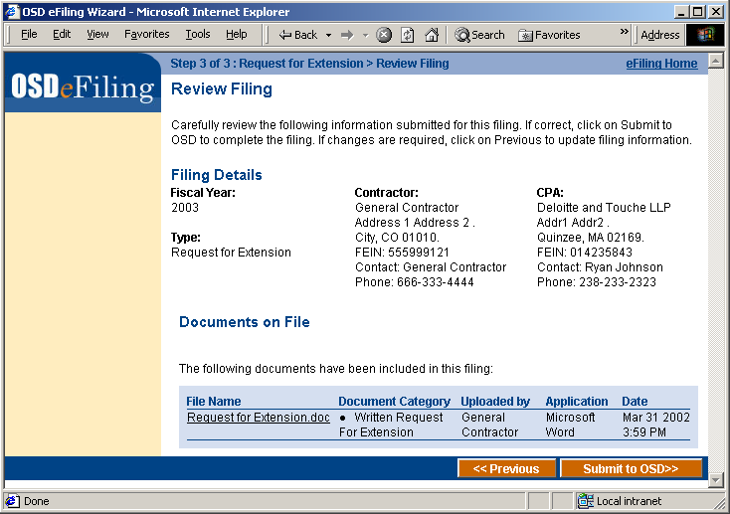

- If all the presented information, including the uploaded documents, are correct, click Submit to OSD >>.

The Please Wait screen will appear.

When the Submittal is finished, the Filing Receipt and Confirmation screen appears. The following information is displayed in the window:
  - Who submitted the filing to OSD,
  - When the filing was submitted to OSD,
  - Receipt Number,
  - Fiscal Year,
  - Contractor contact information,
  - CPA contact information,
  - Documents on File

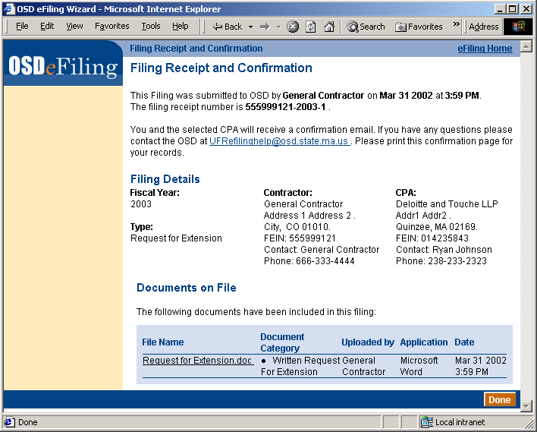

Clicking on a document name under the File Name heading in the Documents on File box will bring up the OSD eFiling Document Viewer.

NOTE: Upon successful submission to the OSD, the UFR eFiling system closes the filing to any changes. This file is now visible to OSD and to FOI requests.

For your records, it is recommended that you print this receipt screen.

A confirmation e-mail will be sent to your email address as well as your CPA, as given in your profile. This e-mail will contain a summary of the information that was presented to you in the Filing Receipt.

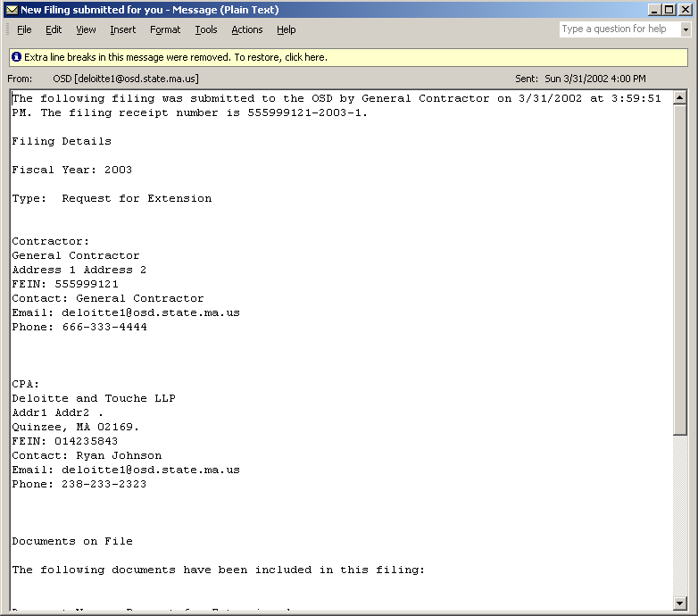
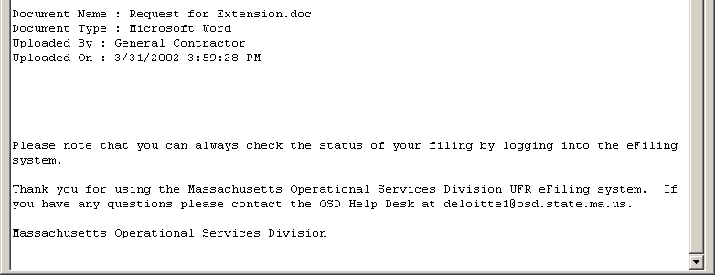

NOTE: Request for extension must be reviewed by OSD and receipt of this email confirmation is not an approval. OSD will contact the contractor with a formal approval.

Submit D-1 Performance Measures
After concluding this section, the Contractor should have the ability to:

- Access the D-1 Performance Measures
- File D-1 Performance Information

Complete D-1 Performance Measures

- At the Contractor Anchor page, click the Submit D1 Performance Data link in the Create or Review UFRs box.

The D-1 Performance Requirement screen will appear.

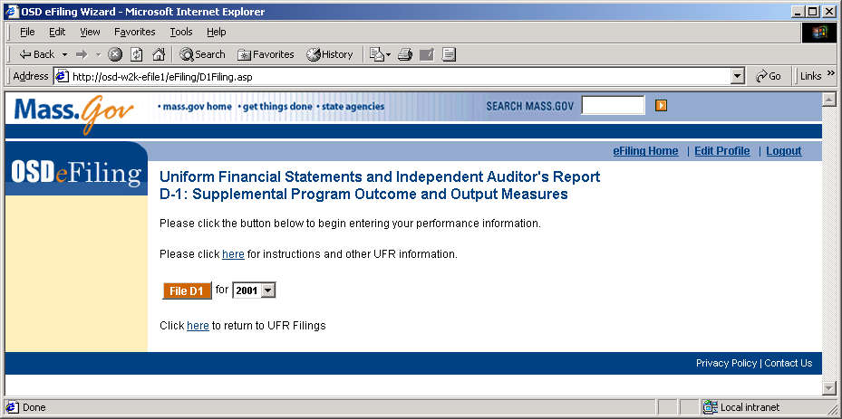

- Select the Fiscal Year from the dropdown menu and click File D-1.

This will be the fiscal year that will be brought up once you enter the D-1 system. There is no need to log in again, as you are already logged into the UFR eFiling system. Instead, you will be directly taken to the D-1 performance measures input.

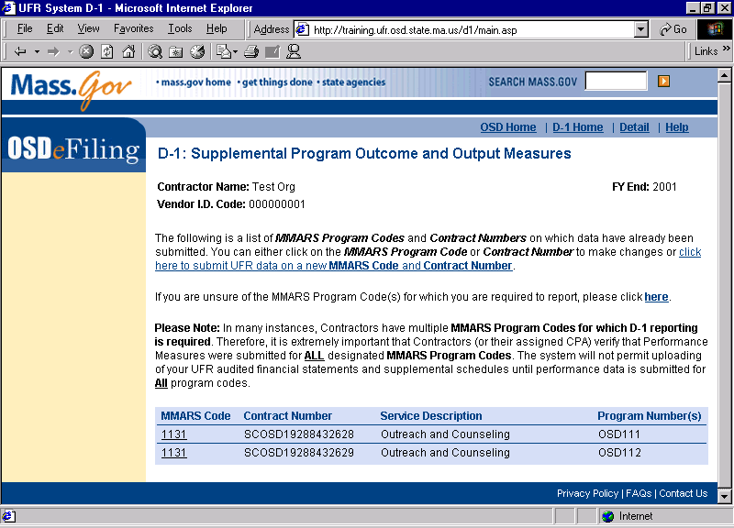

- The D-1 Supplemental Program Outcome and Output Measures screen permits you to either enter performance information on a new MMARS program code, view and make changes to performance information that has already been entered, or identify your organization’s MMARS program codes for which you are required to submit D-1 performance information.

- To enter new performance information, click on the underlined phrase “…to submit UFR data on a new MMARS Code and Contract Number.”
- To view and make changes to performance information that has already been entered, click on the MMARS Codes or Contract Numbers that already appear on the bottom of the screen and edit as needed.
- To see the program codes that your organization is required to report on, the program codes that have been exempted or the program codes for which performance data has already been successfully submitted, click on the underlined word, “here” in the sentence that begins “If you are unsure of the MMARS program codes……”.

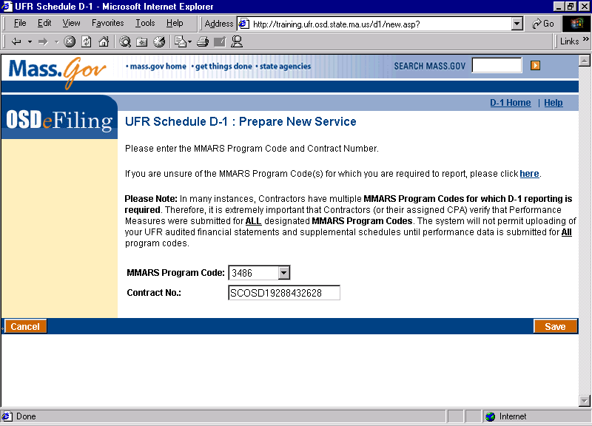

- UFR Schedule D-1: Prepare New Service screen

- To enter new performance information, enter the four-digit MMARS program code assigned by the Purchasing Department by clicking on the MMARS program code dialogue box. Highlight and click on the appropriate program code. This program code may be alpha or numeric. A list of the program codes that require reporting of performance information will appear.
- Enter the sixteen digit MMARS contract (SC + agency + 11 digits, for example, SCDMH 12345678909). Click “Save”.

Please Note: Some four digit MMARS program codes have been identified with both a 4 digit MMARS program code and a sub-code that has been assigned to factor in the unique needs of consumers served in those programs or to otherwise address unique circumstances specific to the purchasing agency. This sub-coding system is specific to the D-1 UFR reporting requirement and does not apply to any other reporting or contracting document.

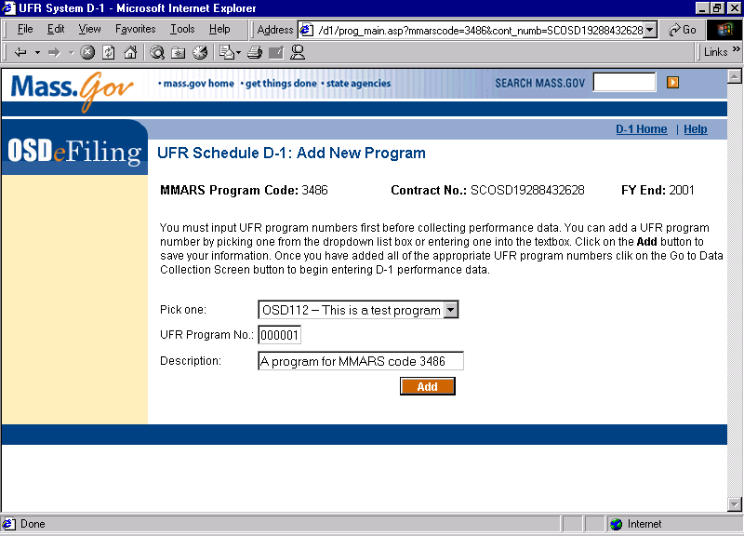

- The UFR Schedule D-1: Add New Program screen permits you to either view and use UFR program number information that has already been entered or enter UFR program number information on a new MMARS program code.

- To view and use UFR program number information that has already been entered, click on the “Pick One” box and select an already entered UFR program number.
- If no UFR program numbers have been entered, complete the “UFR Program No.” and “Description” box. Click “Add”.
- A screen will appear with the UFR program number and description information that was just entered. To edit this information, click on the “Remove” box. If the information is correct, click on “Go to Data Collection Screen” to begin entering performance data.

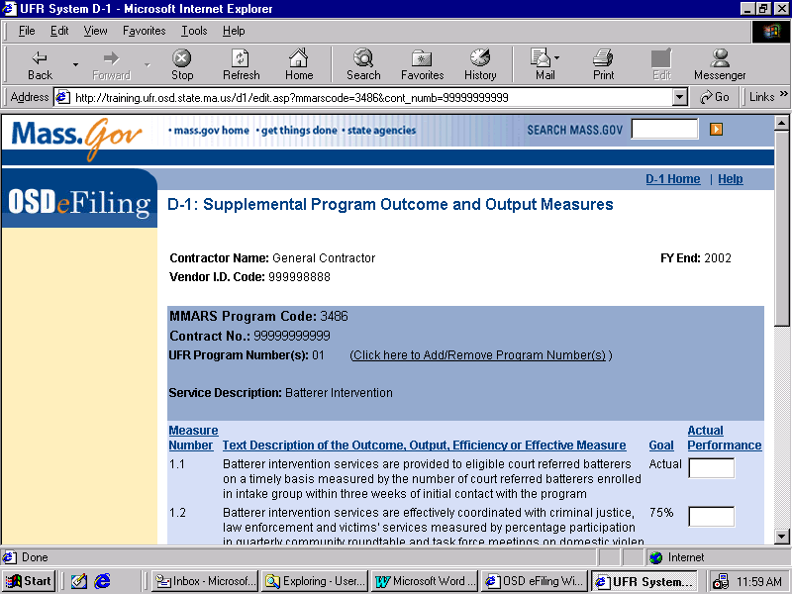
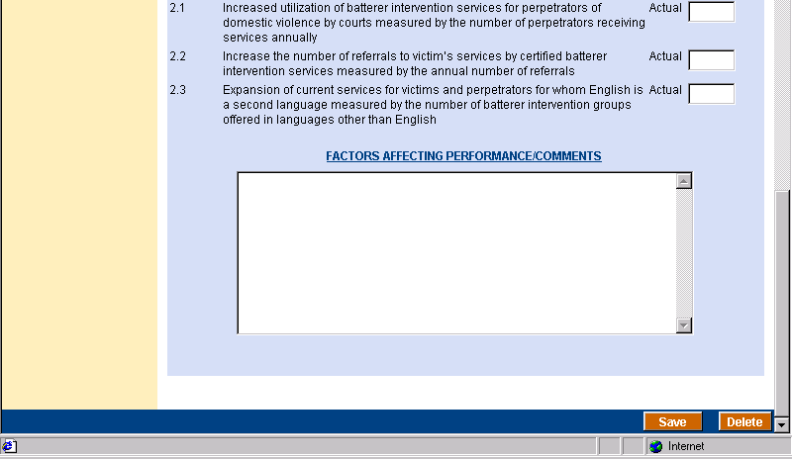

4. The D-1 Supplemental Program Outcomes and Output Measures screen displays the performance measures for the MMARS program code selected. Use the tab key or your mouse to scroll up or down when entering performance data. For each performance measure, the “Goal” column will be completed in one of three ways depending on the nature of your contract with the state-purchasing agency:

- In some cases, purchasing agencies developed statewide contract goals and all contracts for that program code contain the same goal. If the “Goal” column is already completed with a number, it is a statewide performance measure and no entry is necessary. In this case, click on the “Actual Performance” box for this performance measure and enter the numerical information that reflects your actual performance.
- In other cases, purchasing agencies developed contract specific goals to account for unique consumer needs, geographic considerations, funding levels, etc. If this field is blank, enter the contract specific goals directly from your contract. If you have questions about the number to fill in, please call the purchasing agency contact. Then, click on the “Actual Performance” box for this performance measure and enter the numerical information that reflects your actual performance.
- In yet other cases, no formal goals have been identified. Rather, purchasing agencies have decided to use the year to compile baseline data on which to establish contract goals for future years. If this field contains the word “actual”, no entry is necessary. In this case, click on the “Actual Performance” box for this performance measure and enter the numerical information that reflects your actual performance.
- “Factors Affecting Performance” This narrative field is optional and provides an opportunity to identify externalities or factors beyond the control of the contractor that may have impacted performance. To ensure client confidentiality, please do not use client names. When you have finished, you may either click “Delete” to remove the data entered or “Save”. You must click on “Save” to save the data that has been entered.

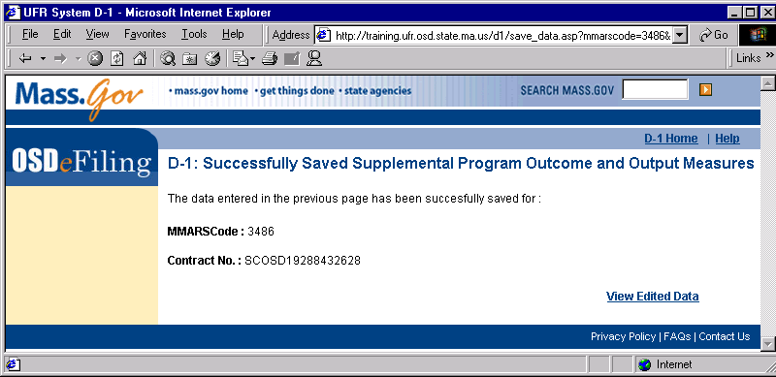

5. If data was entered into all required fields, the D-1 Successfully Saved Supplemental Program Outcomes and Output Measures screen will appear. From this screen, you may

- view the D-1 data just prepared by clicking on “View Edited Data”
- return to the home page to enter additional performance data by clicking on “D-1 Home” or
- exit the program

If a required field was left blank, the performance screen will re-appear with a red “error message” identifying where performance information is missing. All blank fields must be filled in for data to be saved to the database. If you have questions about goals or specific performance measures, please call the purchasing agency contact person.

References

The following is a list of important links found throughout the pages of the D-1 System. These links are provided to assist in the navigation through the site and to provide access to its features.

OSD Home = opens to the OSD Internet Home Page where you can access the Purchase of Service Home Page by clicking on “Items of Interest to Purchase of Service.”

D-1 Home = opens to the first screen, “D-1 Supplemental Program Outcome and Output Measures”.

Detail = provides a summary of all performance data previously entered by program code for viewing or printing.

Help = opens to a page with useful information and links.

OSD Privacy Policy = links to a page where you may view Operational Services Division Web Site Privacy Policy.

FAQs = provides answers to general questions on the UFR eFile and D-1 performance reporting requirements.

Contact Us = provides an email address for sending questions to OSD on the UFR eFile and D-1.

Helpful Tips:
To navigate between the D-1 and the UFR eFile application, use the task bar at the bottom of the screen, “OSD eFiling Wizard”. Please do not use the back button.

To navigate within the D-1 application, you may either use the back button or click on “D-1 Home”.

UFR Search

After concluding this section, the Contractor should have the ability to:

- Conduct UFR Basic Searches
- Conduct UFR Advanced Searches

Basic Search for UFRs

- Click on the Basic UFR Search link. This link is found on the Home page as well as any non-transactional page.

The Basic UFR Search window appears

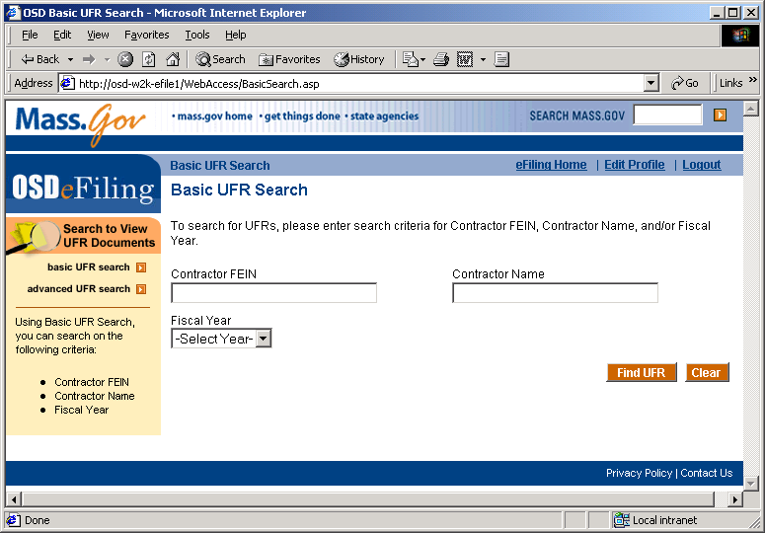

- To search for a Contractor’s UFR, enter criteria relevant to the search. You can provide any or all of the following criteria:

  - Contractor’s FEIN
  - Contractor Name
  - Fiscal Year

Wildcard searches are permitted (by appending an “*” to any criteria entered) and values for any or all criteria can be entered. Click the Search button to search for a UFR. Search results will appear in blue at the bottom of the screen.

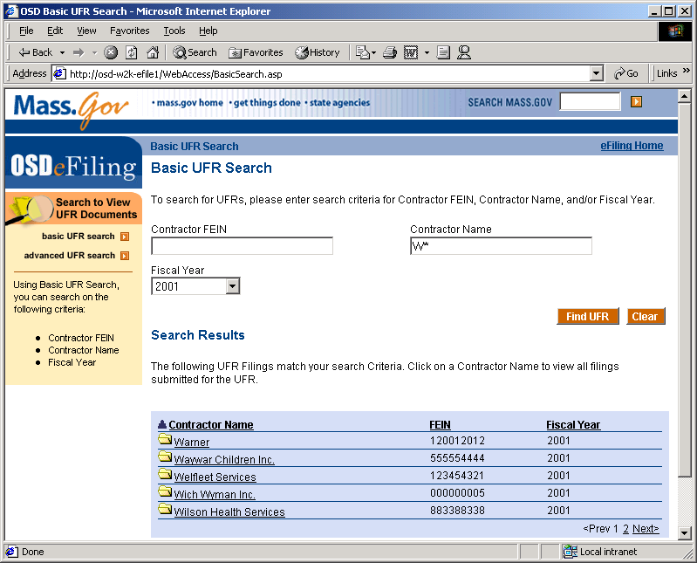

Clicking on any of the column headings sorts the results ascending/descending on that column. The number of pages appears at the bottom right. Clicking on the page number will cause the selected page to appear.

- To view filings submitted for a UFR in the search results, click on a Contractor’s name in the search results.

The UFR Details page for that contractor’s fiscal year will appear.

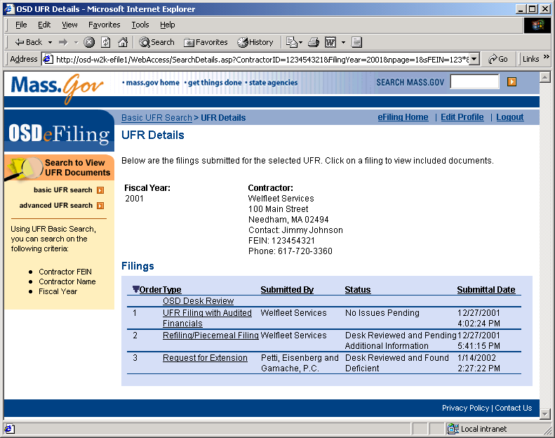

Clicking on any of the column headings sorts the results ascending/descending on that column. The number of pages appears at the bottom right. Clicking on the page number will cause the selected page to appear.

- Click on a filing type in the Filings list to view all documents submitted for the filing. The UFR Documents page will appear.

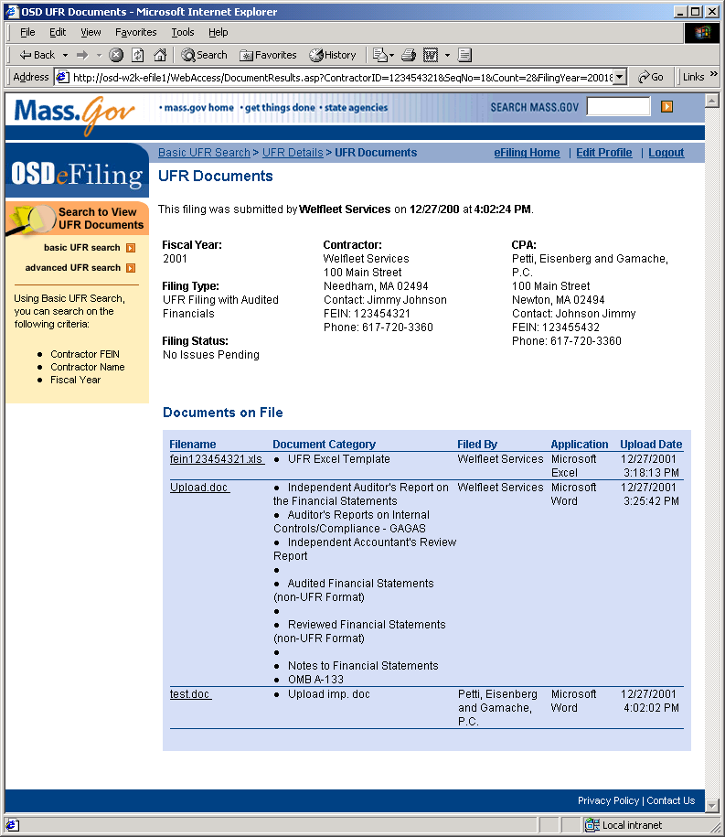

- To view a document, click on the document’s file name.

The OSD e-Filing Document Viewer will appear in a separate window. The selected document, by default will appear exactly as it was uploaded, under the Native viewing type. Two other viewing methods are possible:

- FulView – FulView is a free-downloadable viewer which will render the document in its own format. If the computer downloading the document does not have the appropriate software such as Microsoft Office, FulView can be used to view the document.

NOTE: FulView will not render Adobe Acrobat files unless Acrobat Reader is installed on the viewing computer.

- HTML – The document can also be rendered in HTML which can be viewed in a web browser.

NOTE: HTML rendering is not possible for Adobe files.

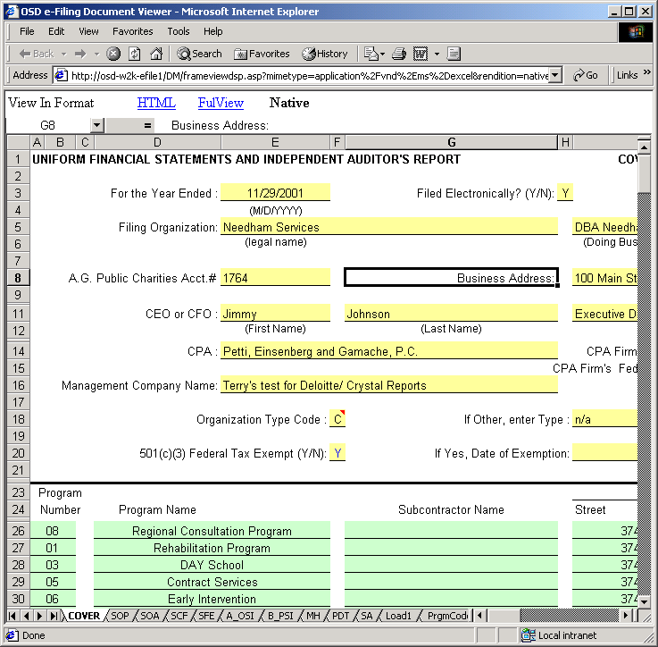
An .xls file viewed in the OSD eFiling Document Viewer

NOTE: The document that is viewed may be accessed as a read only file. Changes may be made, but if saved will only be saved to the local computer. No changes are transmitted to the Server where the original document resides.

Advanced Search for UFRs

- Click on the Advanced UFR Search link. This link is found on the Home page as well as any user-accessible page.

NOTE: This page is available only to subscribers to the OSD eFiling system. For more details, please refer to the subscription details page.

The Advanced UFR Search window appears

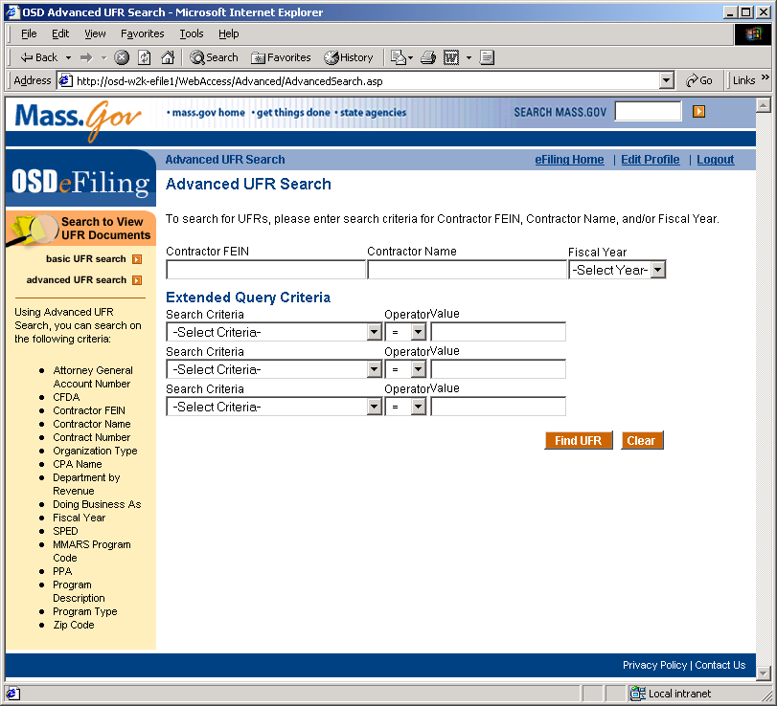

NOTE: Basic UFR Search is also accessible to any subscriber, but with reduced functionality from Advanced UFR Search.

- To search for a Contractor’s UFR, enter criteria for a Contractor’s FEIN, Contractor’s Name, or the UFR Fiscal Year and/or develop up to three of your own queries under the Extended Query Criteria.

To develop your own query, under “Extended Query Criteria,” select a Search Criteria from the drop down list box, an Operator (i.e., “=”, “>”,”<”, etc.), and a Value. For example, if you select “CPA” for the Search Criteria, “=” for the Operator, and “Deloitte & Touche” for the Value, then you will find all UFRs where the Contractor designated “Deloitte & Touche” as the CPA for at least one filing.

The following table outlines all the Search Criteria on which you can search:

  - Contractor’s FEIN
  - Contractor Name
  - Fiscal Year
  - Attorney General Account Number
  - Catalogue of Federal Domestic Assistance Number
  - Organization Type
  - CPA Name
  - Purchasing Department
  - Doing Business As
  - Fiscal Year
  - Special Education Contractor
  - MMARS Program Code
  - Principal Purchasing Agency
  - Program Description
  - Program Type
  - Zip Code

Note: Wildcard searches are permitted and any or all criteria can be entered.

Click the Search button to search for all UFRs that match the search criteria you entered. All the UFRs that match will appear in the Search Results.

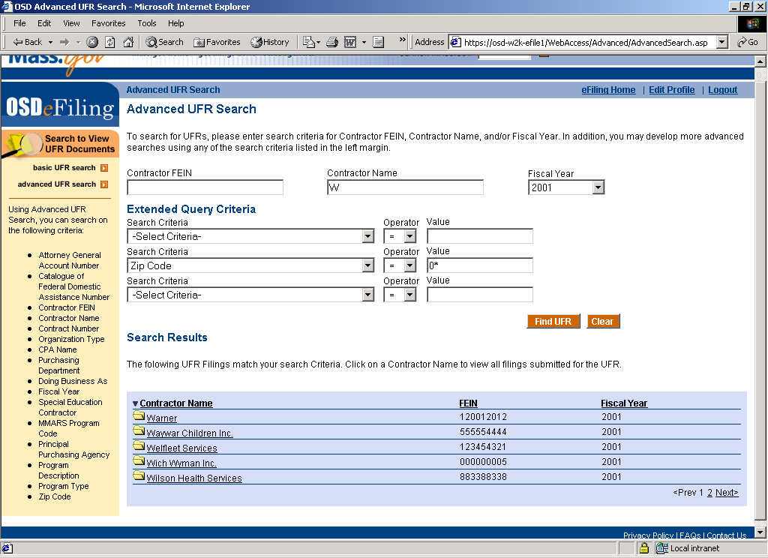

Clicking on any of the column headings sorts the results ascending/descending on that column. The number of pages appears at the bottom right. Clicking on the page number will cause the selected page to appear.

- To view filings submitted for a UFR in the search results, click on a Contractor’s name in the search results.

The UFR Details page for that contractor’s fiscal year will appear.

Clicking on any of the column headings sorts the results ascending/descending on that column. The number of pages appears at the bottom right. Clicking on the page number will cause the selected page to appear.

- Click on a filing type in the Filings list to view all documents submitted for the filing. The UFR Documents page will appear.

- To view a document, click on the document’s file name.

The OSD e-Filing Document Viewer will appear in a separate window. The selected document, by default will appear exactly as it was uploaded, under the Native viewing type. Two other viewing methods are possible:

- FulView – FulView is a free-downloadable viewer which will render the document in its own format. If the computer downloading the document does not have the appropriate software such as Microsoft Office, FulView can be used to view the document.

NOTE: FulView will not render Adobe Acrobat files unless Acrobat Reader is installed on the viewing computer.

- HTML – The document can also be rendered in HTML which can be viewed in a web browser.

NOTE: HTML rendering is not possible for Adobe files.

0An .xls file viewed in the OSD eFiling Document Viewer

NOTE: The document that is viewed may be accessed as a read only file. Changes may be made, but if saved will only be saved to the local computer. No changes are transmitted to the Server where the original document resides.

