Background

INDOOR AIR QUALITY
PRE-OCCUPANCY ASSESSMENT

Converse Middle School
234 Converse Street
Palmer, Massachusetts

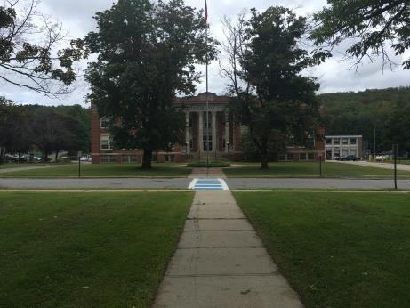

Prepared by:
Massachusetts Department of Public Health
Bureau of Environmental Health
Indoor Air Quality Program
September 2018
Building: | Converse Middle School
Address: | 234 Converse Street, Palmer, Massachusetts
Requestor: | Josh Mathieu, Health Agent, Palmer Board of Health
Date of Pre-Occupancy Assessment: | September 14, 2018
BEH IAQ Staff Conducting Assessment: | Mike Feeney, Director, Indoor Air Quality (IAQ) Program
Date of Building Construction: | 1922 with an addition in 2005
Proposed use of Building:
Temporary use as a school for students from the Quaboag Middle/High School.
Prior use of Building:
This building was constructed as a school, and was used first as a high school and then as a middle school until it was closed in 2017.

Methods
BEH/IAQ staff performed a visual inspection of building materials for water damage and/or microbial growth and examined the space for the presence of odors or other environmental concerns.

Visual Observations
The building has unit ventilators for ventilation as well as openable windows. No evidence of active water leaks or other moisture concerns were observed in walls or floors throughout the complex. As reported by Palmer Public Schools staff, the building had a new roof installed in 2012. Some water-damaged ceiling tiles were noted, which were likely due to historic water leaks prior to the roof replacement.

Recommendations
Based on observations and measurements at the time of the visit, the following recommendations are made:
- Ensure that new filters are installed in unit ventilators prior to use.
- Use windows as needed to supplement fresh air supply as needed.
- Replace water-damaged ceiling tiles, as needed.
- Refer to resource manual and other related IAQ documents located on the MDPH’s website for further building-wide evaluations and advice on maintaining public buildings. These documents are available at: http://mass.gov/dph/iaq.

