**INDOOR AIR QUALITY ASSESSMENT**

**Water Damage Investigation**

**Conway Town Hall**

**32 Main St**

**Conway, MA**

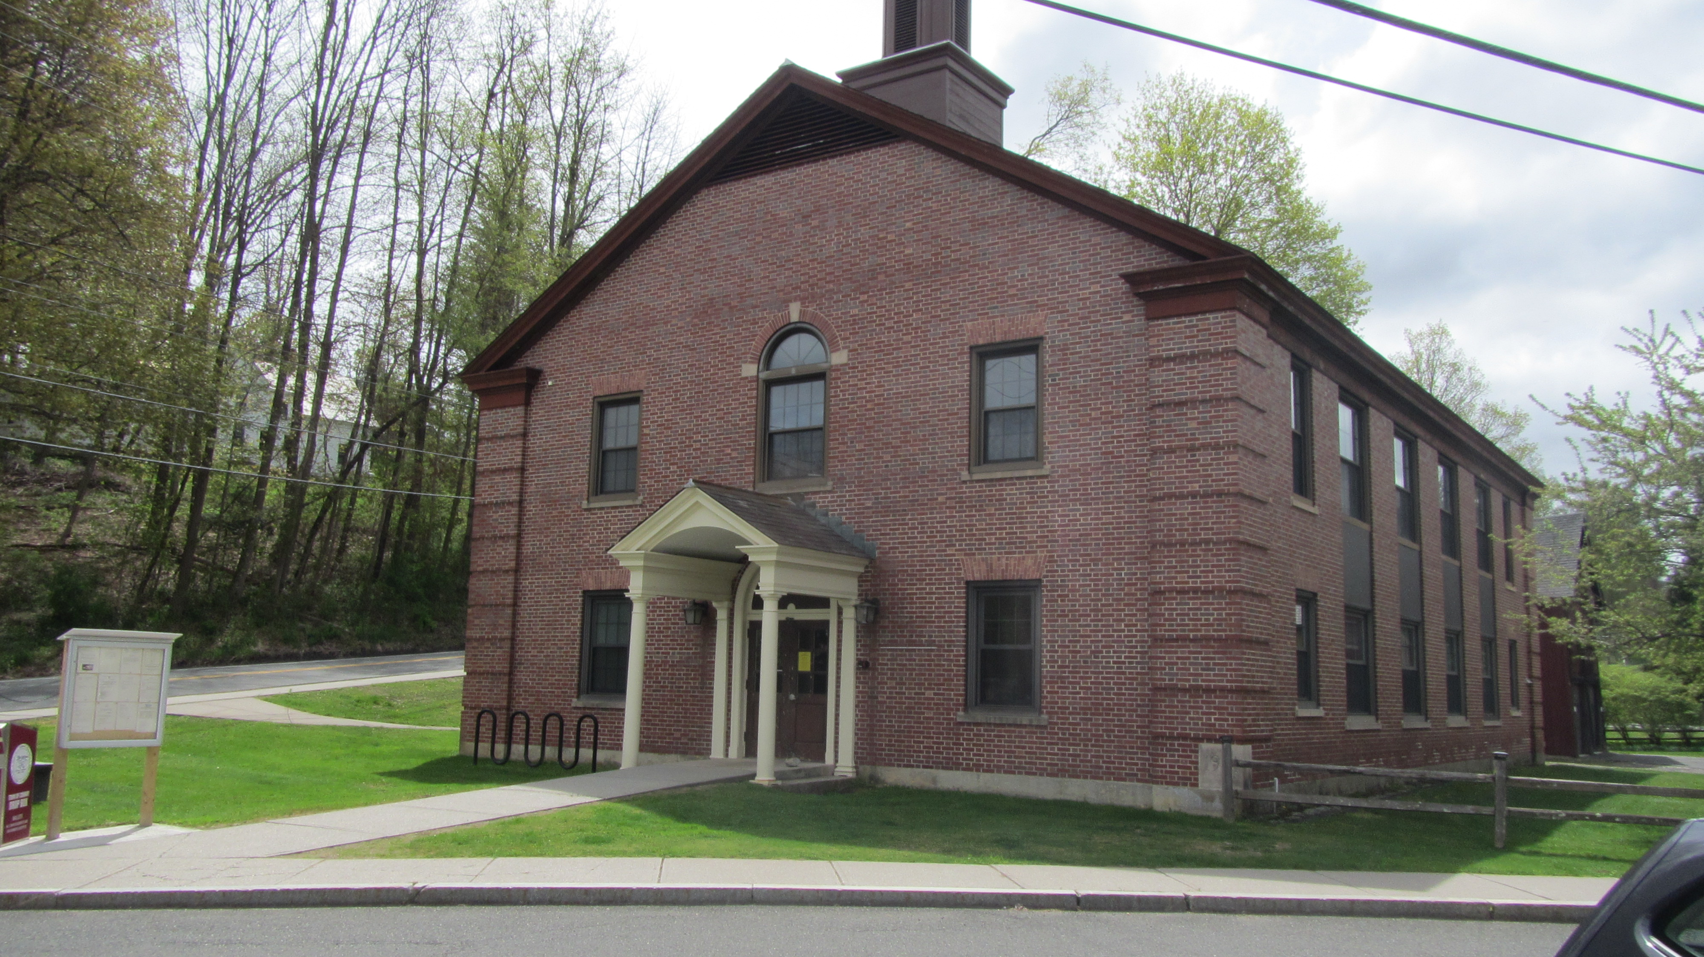

Prepared by:

Massachusetts Department of Public Health

Bureau of Climate and Environmental Health

Indoor Air Quality Program

June 2024

# BACKGROUND

|  |  |
| --- | --- |
| Building: | Conway Town Hall (CTH)  Records Vault |
| Address: | 32 Main St, Conway, MA |
| Assessment Contact: | Véronique Blanchard  Town Administrator |
| Reason for Request: | Water damage in records vault |
| Date of Assessment: | May 3, 2024 |
| Massachusetts Department of Public Health/Bureau of Environmental Health (MDPH/BEH) Staff Conducting Assessment: | Michael Feeney, Director,  Indoor Air Quality (IAQ) Program  Thomas Murphy, Environmental  Analyst, IAQ Program |
| Date of Building Construction: | Conway Town Hall was constructed in 1951. |
| Building Description: | The water damage occurred in a records vault. |
| Windows: | Openable |

# INTRODUCTION

The IAQ Program was contacted by Conway Town Administrator Veronique Blanchard concerning water damage to records of lower shelves along an outside wall of the records vault.

# METHODS

Please refer to the IAQ Manual and appendices for methods, sampling procedures, and interpretation of results (MDPH, 2015).

# IAQ TESTING RESULTS

The following is a summary of indoor air testing results. Only a limited area of the building near where the flooding/water damage occurred was tested.

* ***Temperature*** was within the recommended range of 70°F to 78°F in all areas on the day of assessment.
* ***Relative humidity*** was within the recommended range of 40 to 60% in the areas.

# DISCUSSION

IAQ staff visited the CTH to assess the conditions in the records vault and to determine whether conditions inside the vault caused stored records to become water-damaged.

As reported by CTH staff, records located on the lowest two shelves that are against an exterior wall had become wet and subsequently had mold growth. The vault is constructed of brick and mortar. An examination of the vault wall in direct contact with the CTH exterior wall revealed that brick mortar was significantly darker ~2 feet above the floor (Picture 1).

The exterior wall that corresponds to the location with water damage appears to be originally constructed to contain a large window frame (Picture 2 and 3). It is likely that the vault was added after the frame of the building was designed and constructed. It is also likely the rough window opening was bricked in as the vault was constructed, leaving the windowsill in place. When windows were replaced, sections between windows were covered with metal panels (called spandrels), including the former likely bricked-in, rough opening for a window adjacent to the vault. The combination of the spandrel installed over the bricked-in window may be a pathway for water to enter the interior of the CTH to wet brick and mortar in the vault, which in turn wets porous materials in close proximity or in contact with the wet brick and mortar.

Based on observations, the following are possible sources of water that are wetting vault brick mortar from rain bearing weather systems.

* The CTH does not have a gutter/downspout system along either roof edge. Rainwater runs off the roof onto a tarmac apron along the foundation of the building (Picture 4). This design allows rainwater to splash and keep exterior wall bricks moist, which can migrate into the building.
* Water may penetrate behind the spandrel below the 2nd floor windowsill above the vault. The installation of the panel enclosed the sill drip. Without a drip edge, water can moisten the underside seam of a windowsill that can result in water penetration of the building overtime. If the sealant between the windowsill and metal panel is missing, eroded or otherwise damaged, water will penetrate behind the spandrel and travel downwards to the windowsill outside the vault to wet the brick-and-mortar side of the vault.
* As reported by CTH staff, new electrical equipment was installed in the general vicinity of the vault which required holes to be drilled in the exterior wall (Picture 5). If these openings are not properly sealed, rainwater may enter the CTH exterior wall.
* In driving rain from the northeast, water may penetrate through any seams along the sides or bottom of the vault spandrel.

Some or all of these conditions can contribute to rainwater entering the CTH exterior wall to cause wetting of the vault brick and mortar.

Another possible water source is condensation. Moisture removal is important since increased water vapor concentrations in the vault can lead to condensation if an object has a temperature below the dew point. Therefore, any surface that had a temperature below the dew point would be prone to condensation under these temperature and relative humidity conditions. Prolonged relative humidity concentrations indoors above 60 percent can foster mold growth in susceptible porous materials such as cardboard, paper, books, cloth, and other materials, which are present in the vault. Of note, is the use of metal shelves located on the exterior wall in the vault. Since the building was constructed in 1951, it is unlikely that the CTH exterior walls, spandrel, or vault walls, are insulated. Without insulation, the vault wall would serve as a thermal bridge which may lower the shelves’ temperature below the dew point, resulting in condensation moistening of books or other materials stored along this wall during extreme cold weather or during hot, humid weather. It is important to note that the vault area is shaded by trees and a hill, reducing its warming by direct exposure to sunlight (called thermal gain). Without heating, brick and mortar remain moist and can be more prone to water penetration, particularly during heavy volume easterly wind rainstorms. This process would occur during summer months, and it is likely to cause water damage and mold growth to the books and other porous materials stored on the metal shelves on the exterior wall.

# CONCLUSIONS/RECOMMENDATIONS

The source of water moistening the brick and mortar causing the water damage to records in the vault can be from multiple locations. A decision should be made concerning the mold-contaminated materials stored in the vault. These boxes, documents, books, and other stored materials will continue to be a source of mold associated particulates. As an initial step, consider options concerning the preservation of materials stored in this area. Since many of these materials appear to be historical records, an evaluation concerning disposition of these materials must be made. Porous materials that are judged not worthy of preservation, restoration, or transfer to another media (e.g., computer scanning) should be discarded. Where stored materials are to be preserved, restored, or otherwise handled, an evaluation should be done by a professional book/records conservator. This process can be rather expensive and may be considered for conservation of irreplaceable documents that are colonized with mold. Due to the cost of book conservation, disposal or replacement of moldy materials may be the most economically feasible option.

In order to address the conditions described in this assessment, the recommendations to be made to improve indoor air quality in this building are divided into short-term and long-term corrective measures. The short-term recommendations can be implemented as soon as practicable. Long-term measures are more complex and will require planning and resources to adequately address the overall indoor air quality concerns within the building. In view of the findings at the time of this visit, the following short-term measures should be considered:

## Short Term Recommendations

1. Do not store records on the lower two shelves where vault brick and mortar are discolored.
2. Refrain from storing records on the shelf against the exterior wall.
3. Examine the spandrel seam sealant and repair as needed.
4. Examine all exterior wall openings where new electrical service was installed and render watertight, as necessary.
5. The IAQ Program recommends conducting a full IAQ assessment of the CTH when it is fully occupied.
6. Refer to the resource manual and other related indoor air quality documents located on the MDPH’s website for further building-wide evaluations and advice on maintaining public buildings. These documents are available at [**http://mass.gov/dph/iaq**](http://mass.gov/dph/iaq).

## Long-Term Recommendations

1. Remove the spandrel on the exterior wall to examine the rough window opening and sill. Consult with a mason regarding removal of the cement windowsill outside the vault and seal the rough window opening.
2. In order to prevent a thermal bridge, move the shelf to prevent direct contact with the vault exterior wall. Install insulation of a sufficient R value to prevent temperature transfer to the metal shelf.
3. Install a gutter-downspout along the roof edge to reduce rainwater exposure to the exterior

walls.REFERENCES

MDPH. 2015. Massachusetts Department of Public Health. Massachusetts Department of Public Health Indoor Air Quality Manual: Chapters I-III. Available at: <https://www.mass.gov/lists/indoor-air-quality-manual-and-appendices#indoor-air-quality-manual->

US EPA. @005. Mold remediation in Schools and Commercial Buildings. [Mold in Schools and Commercial Buildings | US EPA](https://www.epa.gov/mold/mold-schools-and-commercial-buildings)

**Picture 1**

**Shelves inside vault
Note darker color of brick mortar (black arrow) compared to upper section of photo (white dotted arrow
**

**Shelves inside vault**

**Note darker color of brick mortar (black arrow) compared to upper section of photo (white dotted arrow**

**Picture 2**

**Vault water damage located behind panel-sealed window
Note brick discoloration below windowsill (arrow)
**

**Vault water damage located behind panel-sealed window**

**Note brick discoloration below windowsill (arrow)**

**Picture 3**

**Vault water damage located behind panel-sealed window
Note how metal panel is installed to completely cover underside of the windowsill above vault (arrow) 
**

**Vault water damage located behind panel-sealed window**

**Note how metal panel is installed to completely cover underside of the windowsill above vault (arrow)**

**Picture 4**

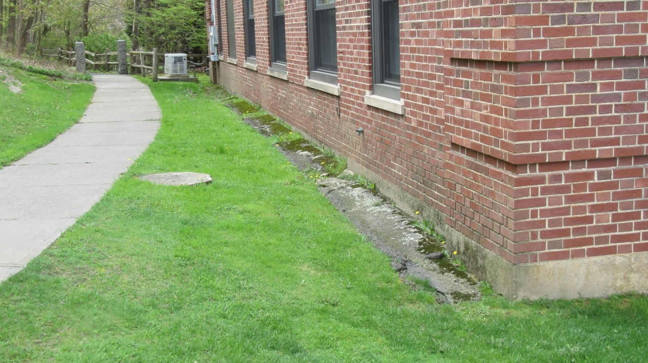

**Tarmac apron covered with moss and soil**

**Picture 5**

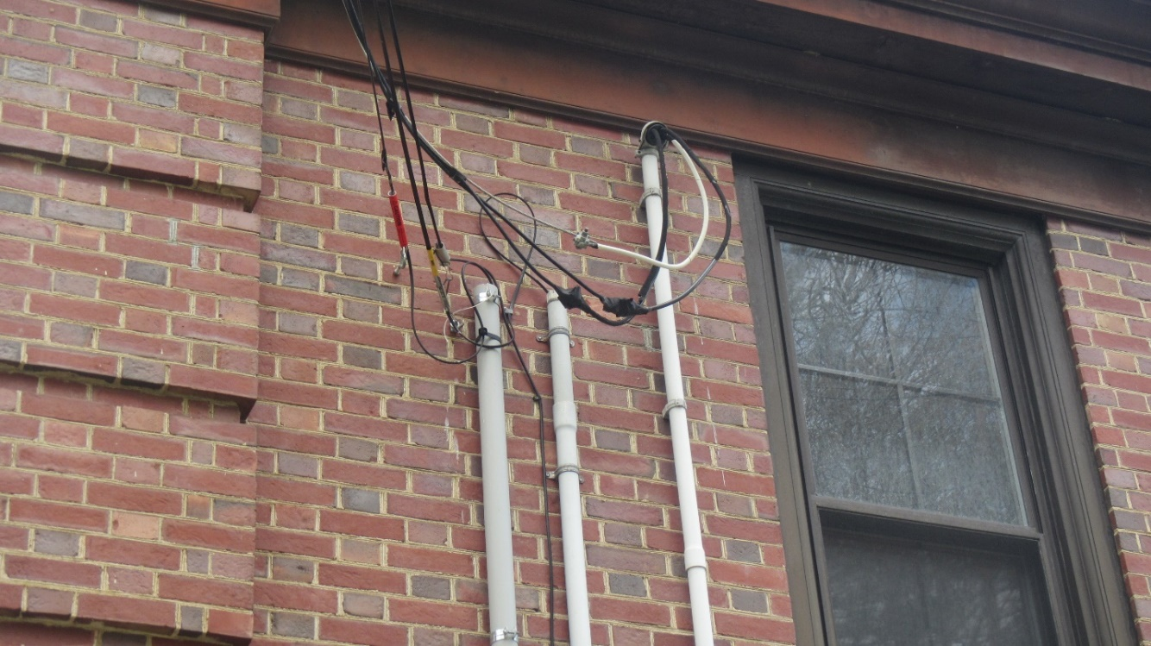

**Recently installed electrical service**