The Trustees of Reservations: Request for Certificate of Inclusion
on
Request for Certificate of Inclusion for the Coskata-Coatue Wildlife Refuge, Nantucket
2023

The Trustees of Reservations
200 High Street
Boston, MA 02110

Contents
Site Map 1
Impact Avoidance & Mitigation Plan 2
I. Site Description 2
a. Site Map 2
b. Property Description and Amenities 3
II. Ownership and Management Entities 3
III. Responsible Staff 3
IV. Piping Plover Habitat, Population, and Productivity 5
V. Tern Habitat and Other State Listed Species 7
VI. Beach Operations and Management 8
a. Beach Hours 8
b. Recreational Activities: 8
c. Parking and Roads 9
d. Beach Cleaning and Refuge Management 9
e. Seasonal Installations 9
f. Rules and Regulations and Permit Policies 10
g. Law Enforcement 10
h. Other Operations (e.g., fireworks, public events) 10
i. Essential Vehicle Use 10
j. Outreach and Education 11
VII. Bird Management and Monitoring 11
a. Monitoring 12
b. Staffing Levels and Qualifications: 12
c. Tern Management 12
VIII. Covered Activities 12
a. OSV Use in the Presence of Unfledged Chicks 13
b. Recreation and Beach Operations 15
Reduced symbolic fencing around nests: 15
Reduced proactive symbolic fencing and nesting deterrents: 15
c. Contingency Plan 16
d. Reporting 16
e. Staffing (Implementation vs Non-implementation) 17
IX. Budget 17
Appendix 19
Mitigation Plan 23

Site Map
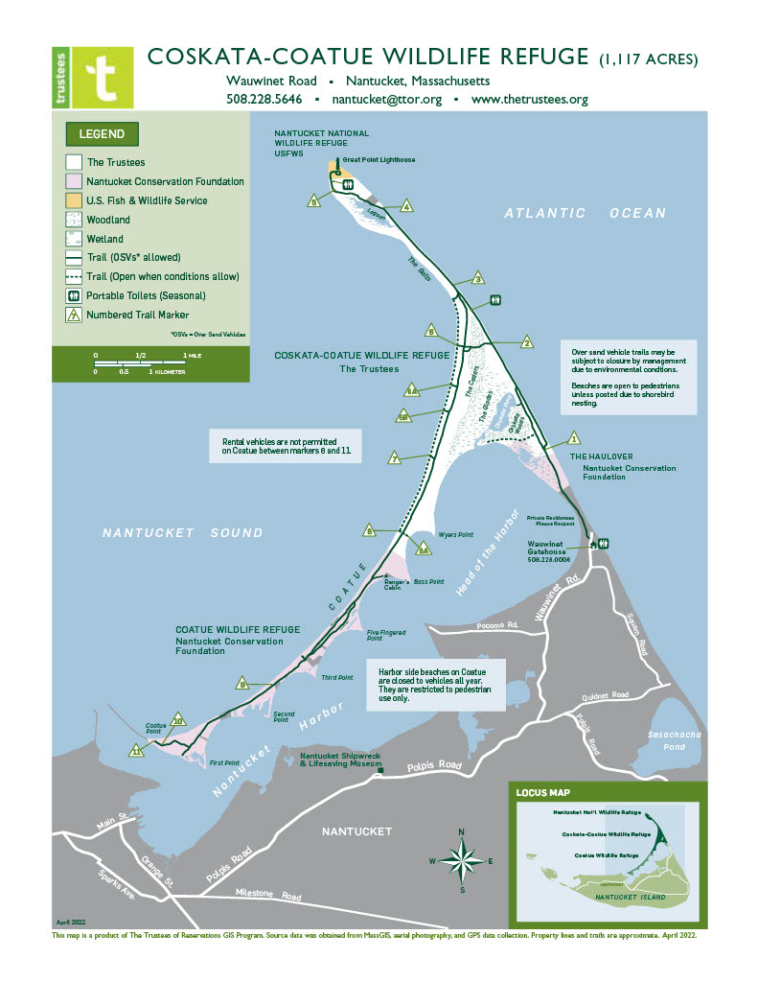

Impact Avoidance & Mitigation Plan
The Trustees of Reservations, Coskata- Coatue Wildlife Refuge
2023

I. Site Description

a. Site Map
Figure 1: Property and trail map of Coskata-Coatue Wildlife Refuge. Trustees owned parcels are shown in white.
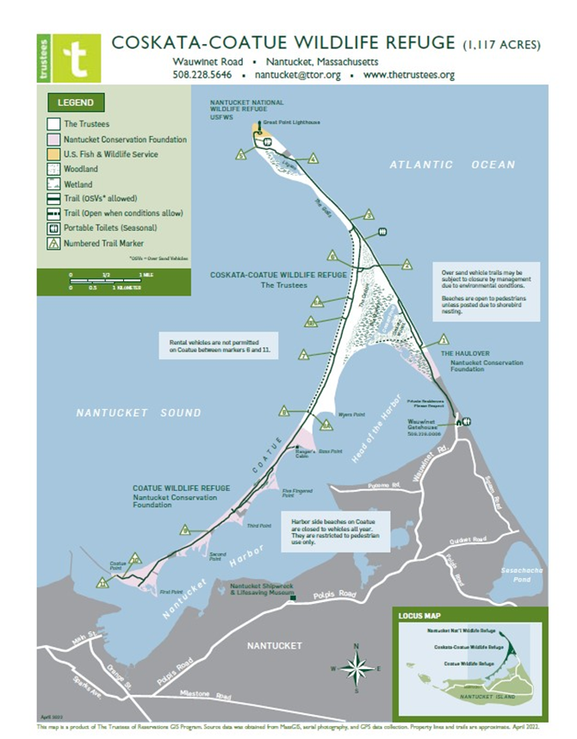

b. Property Description and Amenities
The Trustees of Reservations, one of the oldest land conservation organizations in the United States, was founded in 1891 by Charles Eliot, a landscape architect, who sought to protect open spaces from development. Our mission is to preserve areas, for public enjoyment and use, of exceptional scenic, historic, and ecological value throughout Massachusetts. We frequently collaborate with other conservation groups and government agencies that share our mission.
The Coskata-Coatue Wildlife Refuge (CCWR) is owned and managed by The Trustees of Reservations. The property spans 1,117 acres and includes woodlands, salt and freshwater marshes, dunes, coastal ponds, and beaches. The refuge sits on Nantucket Island’s northernmost peninsulas, the Great Point peninsula which extends north and the Coatue peninsula extending to the west. The entirety of the Great Point and Coatue peninsulas are comprised of three properties owned by three separate entities (Figure 1). At the tip of Great Point lies Nantucket National Wildlife Refuge which is owned by US Fish and Wildlife Service but is now managed by the Trustees of Reservations. South of the refuge is the Haulover, owned and managed by the Nantucket Conservation Foundation (NCF) and to the west is Coatue Wildlife Refuge also owned by NCF. The beach system at CCWR is highly dynamic. East-facing shoreline fronting the open Atlantic Ocean is battered by high surf and is subject to periods of flooding and extreme erosion. While the western beaches are slightly more stable, they are still exposed to the wind and waves of Nantucket Sound. Changes in the shoreline due to erosion or deposition of sediment are virtually constant, and washover areas or blowouts are a prominent and ever-changing feature of the landscape. The size, excellent condition, and varied habitats of CCWR make the property home to an impressive array of common and state listed flora and fauna.
The beaches of CCWR, in addition to their obvious ecological value as an expansive, high-quality beach/dune system, represent a heavily used recreational resource. The refuge’s scenic and expansive shores offer some of the best surf fishing on the East Coast and are a haven for birdwatchers, photographers, sight seers, and beachgoers alike. On average, the refuge hosts approximately 40,000 visitors annually. Due to its remote location and expansiveness, the refuge is most often accessed by 4WD over-sand vehicles (OSV). To support such visitation, the Trustees maintain a network of OSV trails with one access point originating at the Haulover. Balancing the needs of the refuge’s wildlife with the interests of human visitors to CCWR is a constant management challenge. Effectively managing the sometimes competing uses of these properties is a central preoccupation for the Trustees. Access is integral to the organization’s mission and OSV access in particular, is currently a vital part of the Trustees’ operations on Nantucket. Inclusion in the HCP program will allow management flexibility to maintain some access during the shorebird breeding season that may otherwise be impossible given state and federal shorebird guidelines.

II. Ownership and Management Entities
The Trustees if Reservations owns and manages the Coskata-Coatue Wildlife Refuge.

III. Responsible Staff
Russ Hopping, Lead Ecologist/Coastal Ecology:
Oversees statewide coastal ecology program including shorebird management. Oversees a team of two Coastal Ecologists and 5-6 seasonal Shorebird Technicians. Works with state and federal officials and partners in the implementation of the program. Began ecology career by managing piping plovers and least terns at Crane Beach, Ipswich, starting in 1991. Completed undergraduate research on migratory shorebirds at Crane Beach in 1991. B.S. in Human Ecology and M.S. in Environmental Studies.
Darci Schofield, Islands Portfolio Director
Oversees The Trustees operations on Martha’s Vineyard and Nantucket including 3,000 acres of land, 14 miles of beach, nine Trustees places open to the public including Coskata-Coatue Wildlife Refuge, and 70 staff during the summer season. Over last two decades, she has created over 1,300 acres of protected land, published 15 plans on climate-smart parks, climate vulnerability and natural resilience and assisted 20 cities in New England on the planning and development climate-smart parks for nature-based resilience, and provided research and technical assistance to park and recreation agencies across the U.S. on parks for health, equity, and resilience. Darci has a BA in Environmental Science from Boston University, an MS in Forest Ecosystem Science from the University of Maine, Orono, and is certified in Leadership and Negotiation from Harvard Law School.
Diane Lang, Stewardship Manager:
Diane administers the management plan for the wildlife refuge, including shorebird management and enforcing refuge regulations and educating the public about these regulations. Worked in beach management from 2007 through 2021; 18 years of experience managing Trustees properties, 10 years of experience at OSV management, and 11 years of experience at shorebird management. Originally trained in shorebird management by Massachusetts Audubon in 2005.
Shea Fee, Coastal Ecologist:
Manages the shorebird protection program for Nantucket and Martha’s Vineyard and oversees four seasonal shorebird technicians- one on Nantucket and three on Martha’s Vineyard. She has worked in the field of wildlife conservation since 2013 but began monitoring and protecting shorebirds in 2016. She worked as a Shorebird Technician on the Coskata-Coatue Wildlife Refuge as well as Nantucket National Wildlife Refuge from 2017 to 2020. She assumed her current role as Coastal Ecologist in 2021. Shea earned her bachelor’s degree in Ecology from Connecticut College.
Seasonal Shorebird Technician:
The Trustees hire a full-time, 40 hours per week, seasonal Shorebird Technician during the period of April 1 to Labor Day. They maintain symbolic fencing, monitor nesting shorebirds and their chicks, conduct predator management, provide escort to staff needing to get past shorebird closures for essential maintenance or safety reasons, and record and report shorebird data. The Shorebird Technician is trained and supervised by the Coastal Ecologist and Nantucket Stewardship Manager.
Rangers:
The Trustees hire 8 Seasonal Rangers to enforce rules and regulations and ensure the safety of visitors. Some are part time while other are full time staff. Those who have received training can also supplement shorebird monitoring or function as escorts when needed. Rangers are trained and supervised by the Nantucket Stewardship Manager.

IV. Piping Plover Habitat, Population, and Productivity
In total, the Coskata-Coatue Wildlife Refuge offers 52.5 acres of shorebird nesting habitat based on a 2021 survey. Due to heavy erosion and the resulting steepening and narrowing of the beach, the eastern shore of the refuge provides very little shorebird nesting habitat. The only exceptions being a large washover area on the eastern side of the Glades and several small dune blowouts. Similarly, despite being excellent foraging habitat, the narrow beaches along Nantucket Harbor are often inundated at high tides and provide little room for nesting plovers. The vast majority of nesting takes place on the western beaches facing Nantucket Sound. Comparatively, waves are far less energetic in the Sound, resulting in far less beach overwash and erosion. The calmer waters, wider beaches and substantial wrack line provide ideal foraging habitat as well. Piping plovers tend to nest near the tip and western side of Great Point, a large overwash area on the Galls, and the Sound side beaches of Coatue. They primarily nest on the outer beach but have been known to nest in sparsely vegetated patches in the interdune.

In 2022, Piping plovers utilized all aforementioned locations as nest sites. A total of 5 nesting pairs of Piping plover produced 20 eggs, 20 chicks, and 6 fledglings. Overall Piping plover productivity was 1.20 fledglings per breeding pair for the 2022 season.

Figure 2: Piping plover nest locations and symbolic shorebird fencing 2022 (Great Point)
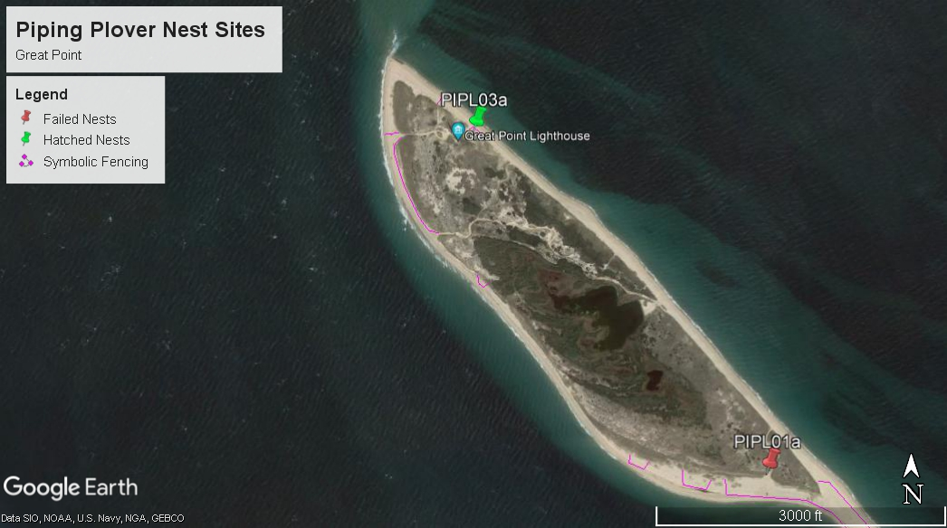

Figure 3: Symbolic Shorebird Fencing 2022 (East beach, Coatue, and Coskata Pond)
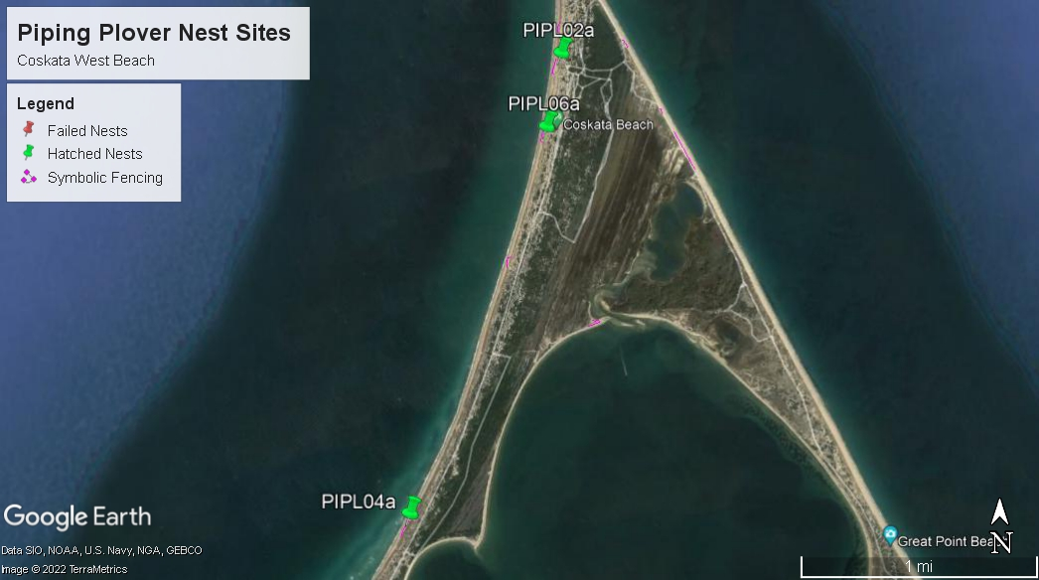

Table 1. 5 Years of Piping Plover Pair Numbers and Productivity
 | 2018 | 2019 | 2020 | 2021 | 2022
# Pairs | 1 | 3 | 3 | 5 | 5
# Fledglings | 2 | 2 | 5 | 4 | 6
Productivity | 2.0 | .66 | 1.67 | .80 | 1.20

Table 2. Historical Averages for Piping Plovers
Historical Plover Averages | # of Pairs | # of Fledglings | Productivity
5 Year Avg 2018-2022 | 3.4 | 3.8 | 1.27

Piping plover productivity has fluctuated greatly in the past decade (Tables 1 and 2). In general, it appears to be chick loss rather than egg predation that limits plover productivity at CCWR. Four out of 5 nests in 2022 hatched all four chicks, but of these 20 chicks, only six successfully fledged. Avian predators are thought to pose the greatest risk to chicks; Herring and Great black-backed gulls are abundant nesters on the property and likely contribute to chick loss and the entire refuge. Additionally, the refuge is easily accessible to American crows, known nest and chick predators. Lastly, upwards of 4 pairs of state listed Northern harrier nest on the refuge and are known to target young shorebird chicks as prey. Given that CCWR supports only a relatively small sample size of plovers, it is to be expected that annual results will fluctuate. However, short term 5-year data seem to suggest an encouraging trend. Productivity as well has pair numbers appear to be experiencing an upswing.

V. Tern Habitat and Other State Listed Species
Terns- Suitable Least and Common tern nesting habitat typically overlaps habitat symbolically fenced for Piping plovers, so additional measures to accommodate nesting terns are often not needed. Terns on CCWR generally prefer to nest on the large overwash area on the northern edge of the Galls and the northernmost tip of Great Point. Numbers of breeding terns on CCWR tend to be rather low (Tables 3 and 4). The most common species to nest on the property is the Least tern. Common terns nest sporadically but usually in numbers less than 5 pairs. Historically, tern productivity has been very low, likely due to the high density of avian predators on the refuge. In 2022, a small Least tern colony of 27 pairs nested on the Galls but was only able to produce 4 fledglings.
Figure 4: Least Tern Colony on the Galls 2022
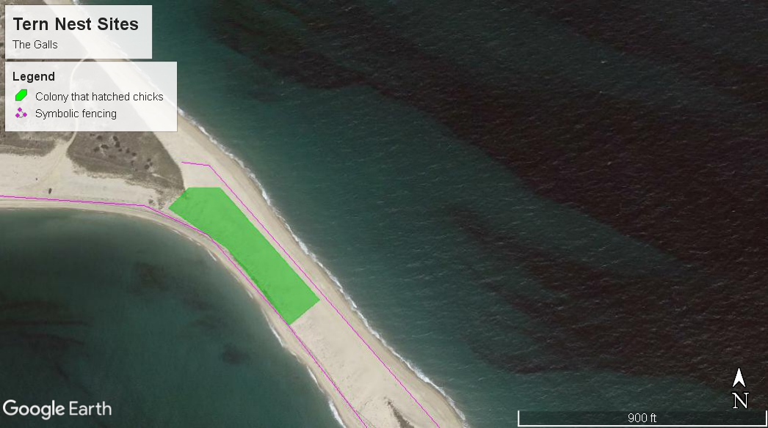

Table 3. 5 Years of Least and Common Tern Pair Numbers
Year | LETE Pair # | COTE Pair #
2018 | 140 | 2
2019 | 7 | 0
2020 | 47 | 0
2021 | 30 | 1
2022 | 27 | 0

Table 4. Historical Averages for Terns
Historical Tern Averages | # of LETE Pairs | # of COTE Pairs
5 Year Avg 2018-2022 | 50.2 | 0.6

Other Listed Species- The Trustees also take several measures to protect rare plants our beaches. Shorebird technicians are trained to look for and identify listed plant species, such as seabeach knotweed (Polygonum glaucum). If found, populations of listed plants are delineated with symbolic fencing to prevent trampling or other disturbance. Often, rare plants are found in areas already fenced for shorebird nesting thus already protected from public impact. Additionally, thoughtful establishment and diligent maintenance of OSV corridors help protect rare flora from OSV related destruction.

VI. Beach Operations and Management
The Trustees manage beaches and over-sand vehicle (OSV) recreation using a management plan which adheres to the Massachusetts Division of Fisheries and Wildlife, Natural Heritage and Endangered Species Program and Guidelines for Managing Recreational Use of Beaches to Protect Piping Plovers and Terns and Their Habitat (1993).

a. Beach Hours
The beach is open from 9am till sunset. With the exception of active surfcasters, who are permitted to be on the property at any time.

b. Recreational Activities:
- OSV use: All historic and potential shorebird nesting habitat is protected by symbolic fencing and signage by April 1st and is maintained at least through the breeding period. Whenever possible, a 50ft buffer is maintained between nests and passing OSVs. One to two days before an expected hatch date, the beach is closed to vehicles up to and beyond 100 yards (300 feet) on either side of the nest site. As the chicks move, the closure is adjusted to maintain that 100-yard buffer. Brood movements are monitored daily by qualified personnel to ensure vehicles are a safe distance away from all chicks. Over-sand vehicle travel is accommodated through a network of interdune, bayside, and oceanside trails linked by occasional crossover trails. In order to protect beach nesting birds pursuant to state guidelines, extensive sections of trail and usually entire sections of beach are closed to nonessential traffic each breeding season. The Trustees, given their multifaceted mission and obligations under various management agreements, seeks to maximize public access to the extent consistent with sound ecological management of wildlife and the physical beach environment itself. Permits for OSV use are sold online through the Trustees website beginning in January and in person at the Wauwinet gatehouse from Memorial Day weekend through October. Permits are distributed at the Wauwinet during operating hours (9am-5:30pm, Memorial Day weekend- October). During the off season (November-May), OSV operators may display proof of permit purchase on their phones. While the Gatehouse is open (May-October), all OSV permits must be affixed to both the rear and front bumpers of the registered vehicle. Permit holder name and contact info as well as vehicle details are entered into a database so all permit holders can be contacted with access updates or violations for a specific permit holder can be recorded.

- Fishing: Individuals engaging in this activity are not allowed within symbolically fenced areas or other marked restricted zones.

- Kiteboarding: Kiteboarding or kite flying is not allowed within 200 yards (600 feet) of the shoreline where there is symbolic fencing and signage. Kiteboard launching and landing is prohibited from any portion of the refuge during the shorebird breeding season.

- Swimming: See Fishing.

- Boating: Boat landing is discouraged where there is symbolic fencing and shorebird signage.

- Birdwatching and photography: See Fishing

- Drones: Drones are prohibited during the shorebird season (April 1 to September 30) unless given permission by local Trustees leadership and the Coastal Ecologist. Permitted drone users must keep their craft at least 200 yards away from any nesting or brooding shorebirds.

c. Parking and Roads
Parking is permitted along the shoreline or in designated pull-outs outside of symbolically fenced habitat. Parking cannot be within the travel corridor established 10 feet away from the toe of the dune. Vehicles are not permitted behind symbolic fencing or where beaches are closed to vehicle traffic due to the presence of unfledged chicks.

d. Beach Cleaning and Refuge Management
Beaches are NOT raked. Trash is picked up by Rangers during routine patrols and removed from the refuge. Recreational beachgoers are expected to “carry in-carry out”. To discourage predator attraction to coastal areas, there are no trash receptacles on the refuge.

e. Seasonal Installations
Every June, stands equipped with life rings are installed along the beach outside of symbolic fencing. Additionally, outhouses are installed Memorial Day through Labor Day.

f. Rules and Regulations and Permit Policies
    - Camping is not allowed
    - Open fires are not allowed
    - Fireworks are prohibited
    - Use of firearms is prohibited except during hunting season
    - Dogs are prohibited from April 1 to September 15
    - Collection of vegetation is prohibited
    - Disturbing birds and other wildlife is prohibited
    - Driving on beach vegetation is prohibited
    - Entry into areas closed for shorebird management is prohibited
    - Littering is prohibited
    - Commercial activities are prohibited without prior permission form the Stewardship Manager
    - Conduct disturbing the tranquility of the refuge and visitors is prohibited

g. Law Enforcement
Rangers are responsible for enforcing all property rules and regulations.
Rangers may periodically request assistance from the USFWS Law Enforcement Officer, Nantucket Police Department and/or the Massachusetts Environmental Police. Rangers patrol assigned areas approximately once per hour. Areas which require more frequent patrol (areas with higher visitation) have a stationary Ranger assigned.
David Wright, Massachusetts Environmental Police
Brian Willard, USFWS Federal Wildlife Officer
Nantucket Police 508-228-1212

h. Other Operations (e.g., fireworks, public events)
At present, one semi-public event, the Great Point Circle celebration, is held on the property at the end of August, after the most active part of the nesting season. No fireworks are allowed on the property. Tours of the refuge are given on an ad hoc basis throughout the nesting season using a 4WD truck. Tour vehicles are not permitted to drive through areas closed to protect shorebirds.

i. Essential Vehicle Use
As per the state shorebird guidelines, essential vehicles use is permitted in areas of beach where unfledged chicks are present but travel should only occur during daylight hours and when absolutely necessary. If possible, alternate travel routes that avoid shorebird broods should be utilized. Essential vehicles include vehicles operated by law enforcement, public safety officials, private property owners and their guests, and Trustees staff trained in shorebird detection. Private property owners are encouraged to use routes to their homes designated by the Trustees that avoid critical brood areas. Additionally, all essential vehicles traveling through chick habitat should not exceed speeds of 5mph and are required to sign in and out in a logbook before and after travel. All Trustees beach staff in addition to private property owners are regularly informed of brood locations.

j. Outreach and Education
Whenever there are changes in beach access during the shorebird season, updates will be distributed to all OSV permit holders via email. These updated will include maps indicating the OSV trails open as well as updates on protected shorebirds. Maps and updates will be developed either by the Coastal Ecologist or the Nantucket Shorebird Technician and will not reveal exact shorebird locations or numbers. Additionally, the Coastal Ecologist will compose an end of season blog post on the Trustees website, summarizing the shorebird season and explaining the importance of the local shorebird population in a statewide and range-wide context. This blog will be shared on various platforms including the Trustees Islands newsletter as well as the local newspapers. Gatehouse and ranger staff are trained to be able to articulate the status and importance of protected shorebirds and are equipped with literature describing shorebird FAQs. They are onsite to educate visitors whenever possible. The Trustees also has a shorebird FAQ webpage (FAQs on Beach Closures during Shorebird Season) can where inquiring visitors be directed.

VII. Bird Management and Monitoring
Symbolic fencing and appropriate shorebird signage are placed around suitable and historic nesting habitat by April 1st in accordance with state guidelines. Symbolic fencing is adjusted throughout the season to accommodate the needs of the shorebirds. Wood posts and metal t-posts strung with rope are used to symbolically protect important nesting habitat. Signs alerting visitors of closed areas and the shorebirds we protect are hung along fence lines. One Shorebird Technician is hired for a 17-week period starting April 1st and works five days a week for 40 hours. To provide 7 day a week coverage, a trained volunteer, Ranger or the Nantucket Stewardship Manager fills in on the Shorebird Technician’s days off. The Shorebird Technician is responsible for locating and recording the courtship, territorial, and nesting behavior of several focal species including Piping plover, American oystercatcher, Least tern, and Common tern. They will also locate and record reproductive data including nest locations, number of eggs laid, number of chicks hatched and number of chicks fledged (Appendix C). They will complete daily observation forms, census forms, and nest attempt and nest failure forms (Appendices B & C) and create maps using GPS locations of nests. In addition, they will record and address any shorebird related violations that may arise (Appendix D) and perform non-lethal predator management if necessary. The Stewardship Manager, Rangers, and Shorebird Technician work closely to design, install, and maintain shorebird related OSV restrictions and communicate them with the public. The Shorebird Technician will also keep track of brood movements to ensure they are at least 100 yards away from OSVs. Additionally, they conduct species censuses during official state census windows. All monitoring will be conducted daily during daylight hours. Shorebird technicians will be provided with binoculars, spotting scope, field notebooks, and a GPS unit to perform their duties. They will be directly supervised by the Nantucket Stewardship Manager and indirectly supervised by the Martha’s Vineyard based Coastal Ecologist.

a. Monitoring
One Shorebird Technician or comparably qualified staff member is on site every day, weather permitting. Staff keep a daily site visit log record all monitoring activities and record shorebird information (Appendix B). Additionally, when staff discover a nest or finds a nest has failed, staff document nest attempt/nest success as well as updates as needed. The Shorebird technician also keeps a detailed digital master list of nesting chronology and results (Appendix C) and is responsible for completing a detailed internal end of season shorebird report. Additionally, census forms completed and submitted to the state at the end of each season.

b. Staffing Levels and Qualifications:
- Stewardship Manager: Trained in shorebird monitoring and beach management.

- Coastal Ecologist: Extensive experience with coastal environments and program management. Experienced in shorebird monitoring and protection.

- Shorebird Technician: Has at least a high school degree and is working towards a degree in biology or natural resources-related field. Trained to identify and monitor shorebirds and their behaviors.

- Rangers: Trained in identifying shorebirds, installing and maintaining symbolic fencing and signage, and educating the public.

c. Tern Management
Because of the layout of the beaches, overlapping habitat preferences, the extent of proactive symbolic fencing, and OSV restrictions necessitated by nesting Piping plovers, tern colonies are typically adequately protected by measures taken on behalf of Piping plovers. When unfledged chicks are present in a tern colony, vehicles (if not already prohibited due to the presence of plover chicks) are excluded at least 100 yards on either side of lines drawn from the margins of the colony, perpendicular to the long access of the beach.
This management plan complies with state and federal guidelines which ensure that there is no adverse impact to or “take” of protected shorebird species. The Trustees report census information to the Massachusetts Division of Fisheries and Wildlife and maintains communication with this agency throughout the nesting season. The Trustees will obtain a valid Order of Conditions from the Town of Nantucket for OSV use on CCWR prior to implementation of this plan.

VIII. Covered Activities
Given the low numbers of nesting pairs on the Coskata-Coatue wildlife Refuge (<7), the Trustees are permitted to expose only one Piping plover pair/ brood/ territory to a potential take through our covered activities. For least terns, a maximum of 15% of the colony area may be affected and a maximum of 20 unfledged chicks may be exposed to take through covered activities. A minimum of 2-4 breeding Least tern pairs and 2.5 Piping plover pairs must benefit from mitigation for every pair, nest, or unfledged chick exposed. When Stewardship staff in consultation with Ecology staff agree to expose a pair, brood, nest, or territory, 24-hour advance notice will be provided to DFW before initiating the covered activity.
The Trustees acknowledge that other listed species not covered by the HCP or associated CMPs including but not limited to Seabeach knotweed, Common tern, and Roseate tern occupy our beaches. Covered activities will not interfere with the survival or success of listed species not covered under this program. For example, if reduced symbolic fencing exposes a population of Seabeach knotweed to trampling or OSV related disturbance, then the covered activity will not be implemented or will be modified to protect this species (i.e. include the plant within the symbolically fenced area).

a. OSV Use in the Presence of Unfledged Chicks
Our concern centers mainly around chicks using crossover roads or other areas of low-lying or unvegetated dune habitat to move between oceanside and bayside beaches as well as pairs nesting close to key OSV access points. With an appropriate mix of close observation and careful management of OSV traffic, we believe procedures outlined in this IAMP allows for continued vehicle access with acceptably low risk to unfledged chicks. The Trustees will adjust the nature and extent of access to the affected area according to the availability of management resources and the overall access picture on the beach (closures “downstream” of a plover pair, for example, may make it pointless to offer access to the general public).
Piping Plover: The OSV travel corridor will be an existing OSV trail, no greater than five yards wide, selected to minimize the likelihood of vehicles coming into proximity of chicks given observed patterns of behavior and movement. There will be no parking or stopping along the corridor until the exposed brood has been passed by at least 200 meters (600 feet) as designated by signs placed by shorebird staff and readjusted as necessary. Travel will occur within a six hour window during daylight hours with two to three escort periods. OSVs will be escorted one by one or in groups of vehicles guided by a qualified Trustees staff member. Trustees staff may conduct escorts either on foot or on ATV operated at no more than 5 miles per hour. The specific circumstances and location will determine which method of controlled access will be implemented.
During the escorted travel period, a Brood Monitor will continuously track affected pairs and their chicks. At least one half-hour before each escort time, the Brood Monitor will locate the brood and account for all unfledged chicks. Once the Brood Monitor has established the locations of chicks, they will notify the Down Island Steward and/or the Coastal Ecologist. If the Down Island Steward or Coastal Ecologist is confident the brood is at least 50 feet from the travel corridor, then the Compliance Monitor will be notified that the OSV trail can be opened for travel. In the event that all chicks are not located, the opening of the OSV trail will be delayed until all chicks can be accounted for or it has been determined by the Brood Monitor that there are no chicks in the OSV trail. In this situation, the Brood Monitor will communicate their determination to the Down Island Steward and/or Coastal Ecologist for confirmation to open the trail. Once confirmation has been given, the Compliance Monitor will be given notice to open the OSV corridor. Monitors will be given lunch and breaks as required by law and will be relieved by other trained staff as needed.
During the entire escort period, the Brood Monitor shall maintain constant visual contact with any plover chicks, using binoculars from a distance of no less than 200 feet. Disturbance of the chicks shall be minimized. Once vehicles have passed through the delineated “chick zone,” which shall extend at least 200 meters (600 feet) past the closest chick, vehicles may proceed to use the sections of beach previously determined to be free of piping plover chicks, in accordance with state and federal guidelines.
Simultaneously, a Compliance Monitor will be located along the escort corridor so that they can stop traffic if a brood ventures less than 50ft from the corridor or enters the OSV trail. The Brood Monitor and Compliance Monitor will communicate primarily through radios with cell phones as a backup.
If at any time during the escorting process the Brood Monitor loses visual contact with one or more chicks, travel through the escort corridor will be stopped until all chicks can be located. Monitors will document in the daily report the approximate time that visual contact with the chick(s) was lost and efforts made to relocate it. Tire ruts will be smoothed out after each period of travel until chicks reach 14 days old. This will be done on foot with rakes or with an ATV and appropriate attachment.
The Down Island Steward, Compliance Monitor, Coastal Ecologist, and each individual Shorebird Technician will have the independent authority to temporarily close the corridor at any time for any reason. For example, if the Brood Monitor determines that chicks have approached within 50 feet of the escort corridor, the Monitor will immediately notify the Compliance Monitors by radio to temporarily halt traffic and allow the chicks to cross the corridor and/or move >50 feet from it. The OSV trail will not reopen until the Compliance Monitor or Brood Monitor determines that it is safe to do so and is confirmed by the Coastal Ecologist and/or Down Island Steward. In such instances, monitors will document in the daily report the approximate time that the OSV trail was closed and the duration of the closure.
The Compliance Monitor, escort, and Brood Monitors may be additional staff brought on specifically for HCP implementation, or they may be existing Rangers (see section V for budget). In either case, the same basic qualifications and training will apply: each will have at least a high school education, be able to safely operate UTV/ATVs, have clear communication skills, and the ability to learn shorebird identification and behavior. They will be trained by the Down Island Steward and Coastal Ecologist in shorebird monitoring and implementation procedures before beginning monitoring and compliance duties. Seasonal Shorebird Technicians may assist with implementation of the escort system, but only to the extent that these duties do not distract from fulfillment of the Technicians’ primary function: daily monitoring and management of nesting shorebirds.
Least Terns: In the event of a least tern colony impinging on use of an important road or access point the Trustees would seek to implement their Compliance Monitoring Protocol (CMP) associated with their HCP COI. For the covered activity of OSV use in the vicinity of unfledged chicks, plan implementation would follow the same escort corridor restraints, traffic control, and travel protocols described above for piping plovers. A maximum of 20 unfledged chicks are allowed to be impacted at a given site. At least one-half hour before escort times, a Brood Monitor must verify the number of chicks in the affected colony and determine the locations of said chicks as best they can. The Brood Monitor must then keep track of chick movements during the travel period to ensure no chicks have entered the travel corridor. Colonies with less than 10 unfledged chicks will only require one monitor. Colonies exceed 10 unfledged chicks will require at least 2 monitors, one stationed at each end of the colony. If it is determined by the Coastal Ecologist or Compliance Monitor that two monitors are insufficient for proper implementation, more monitors may be stationed along the extent of the colony to better ensure chick safety. All monitors will be responsible for assessing chick numbers and movements throughout the escort period. Our 24-hour notification to DFW of a proposed implementation of the plan will include an assessment of the number and developmental stage of chicks present at the colony, the configuration of the colony with respect to shorelines and the affected trail and our proposal for the location of the travel corridor and the size of the associated monitoring staff (which might include multiple monitors) that will suffice to safely keep track of the location of the birds.

b. Recreation and Beach Operations

Reduced symbolic fencing around nests:
At several points along the CCWR OSV trail system, bottlenecks exist at which an access restriction could prevent vehicle access to most or all of the barrier beach system. The blowout area on the eastern side of the Glades is one such area. In the event of birds nesting close enough to a key access point so that the normal 50 yard radius nest buffer would prohibit OSV access entirely, we propose the reduction of the nest buffer to the largest dimension that would allow use of the access road while the pair is courting or incubating. During the critical egg laying period, the buffer around the nest site will be maximized to reduce disturbance as much as possible during this sensitive time. After the egg laying period, fencing may be further reduced to its target radius. Buffer radii should not be less than 10 yards unless special permission is given by DFW to further reduce the buffer radius. Affected birds will be monitored daily by qualified shorebird staff or volunteers though as a practical matter, any pair subject to this covered activity is likely to be in a location that allows for frequent observation by shorebird monitors or rangers throughout the daylight hours. Lingering near the fenced area will be discouraged through signage and verbal instruction from gatehouse and beach staff, in order to reduce stress and disturbance of the nesting birds. If eggs hatch, the protocol for covered activity a.1, described above will immediately be enacted. The same procedure will be used in the case of Least tern nesting.

Reduced proactive symbolic fencing and nesting deterrents:
The Stewardship Manager will consult the Coastal Ecologist to identify potential implementation sites early in the season, before birds would be present. Stewardship staff will delineate the site proposed for this activity and determine its area. An estimate of available nesting habitat on the property will be prepared, using the most recent available aerial photos combined with ground-truthing, to ensure that the area managed under this covered activity remains below 10% of habitat or 2 acres, whichever is less. In keeping with area limitations on this Covered Activity, the Trustees propose reducing symbolic fencing in areas of nesting habitat that may cause significant access impairments if a pair were to nest. Additionally, we propose the use of physical nest deterrents such as flagging, pallets, and wood planks to discourage nesting in a pre-determined area. Deterrents will be installed prior to the onset of territorial or nesting behavior. The site will be monitored daily by Shorebird Technicians throughout the season, and the site will also benefit from frequent (albeit incidental) monitoring by Rangers (some of whom will be shorebird-trained) and other stewardship staff using the access trail. In the event of nesting, symbolic fencing will be erected around the nest consistent with the procedures we describe for the Covered Activity “reduced symbolic fencing around nests,” described above. Nesting deterrents will be maintained throughout the implementation period and will be removed at a date agreed upon by the Down Island Steward and Coastal Ecologist. However, deterrents shall not remain on the beach past August 31st of each year.
In the case of Least terns, a similar protocol to the one described above will be implemented. For well-established colonies that nest in a similar area each year, no more than 15% of the historic colony area (based on at least 2 years of historic nesting data) may be affected. Alternatively, if Least terns are observed prospecting in a new area, then the extent of symbolic fencing reduction or nest deterrents will be based on the distribution of the birds early in their breeding cycle (before egg laying).

c. Contingency Plan
Personnel: In the event that the Brood Monitor or Compliance Monitor is unavailable (e.g., calls in sick), the Nantucket Stewardship Manager or a fully qualified designee shall assume this duty. If a full roster of implementation staff is not available, rangers will suspend use of the OSV corridor until full staffing is once again possible.
Inclement weather: The Nantucket Stewardship Manager will monitor weather forecasts on a daily basis during the implementation period. In the event that a storm warning is predicted by the National Weather Service, or any other weather warning that could jeopardize public safety within a 24-hour period, the escort corridor shall be closed for the duration of the hazard, or the start and/or end time for passage on the corridor may be changed. The escort corridor may not reopen until the Nantucket Stewardship Manager determines it is safe to do so.
Emergencies: OSV permit holders shall be advised verbally and in writing at the time of OSV permit application, via affidavit, that egress from the beach outside of the escort windows shall be strictly prohibited. In the event of a life-threatening medical emergency, the staff of The Trustees and/or emergency responders should be notified. Essential vehicles will assist in escorting the vehicle off of the beach.
Violations: Any violations of the aforementioned protocol will not be tolerated. The Trustees imposes and enforces a zero-tolerance policy. Monitors and Beach Rangers will be in constant contact to ensure enforcement. Beach Rangers will be authorized to revoke OSV permits and eject the violators from the beach. Violators of the escort protocols shall be subject to OSV permit revocation and shall have their rights to operate an OSV on Coskata-Coatue Wildlife Refuge suspended immediately for a period of one year from the date of the violation.

d. Reporting
Once implementation is underway, responsible staff will begin recording the necessary data as described above and in appendices D-F. Depending on the covered activity implemented, shorebird staff will submit weekly reports to DFW describing implementation and the status of affected pairs/broods/nests/chicks (Appendix F). Implementation staff will meet weekly to assess effectiveness and go over issues. After any incident, The Trustees will hold a meeting to discuss what happened and how to prevent it. Additionally, by October 15 of each calendar year, The Trustees will submit an annual HCP report to DFW describing the details of the nesting season and Implementation (see page 11 of the Habitat Conservation Plan for Piping Plover Handbook for more reporting details). The purpose of monitoring and reporting is to assess the effects of implemented activities have on nesting Piping plovers and Least terns and provide the Trustees with a way to gage the efficacy of our IAMP procedures.
- OSV use in the vicinity of unfledged chicks: As required by the HCP, a daily implementation log will be kept to document staffing, frequency of brood monitoring, and compliance with OSV escorting procedures, and will be made available to DFW upon request (Appendix F). Any violations, incidents or accidents associated with the vehicle escort program, including take of a chick(s) shall be recorded and immediately reported to DFW and USFWS staff (Appendices D and F.c). Additionally, every week of implementation, a summary report will be submitted to DFW. The report will include the species affected, age of chicks, a daily vehicle trip count, observations on chick numbers, movement and behavior for each brood, a map of the observed brood ranges, weekly tally and description of any rule violations and enforcement actions taken, weekly tally and description of all observations of broods crossing or approaching <100 feet from the vehicle corridor (both during the OSV travel windows and any other such observations during routine monitoring), and any other notes, observations, or recommendations relevant to operating the escorting program (Appendices F.a & F.b).
- Recreation and beach operations: Data collected include dates of implementation, activity (reduced proactive fencing, nesting deterrents, and reduced fencing around nests), location of activity, acreage of affected area, daily observations of affected pair/broods/chicks and observation times, details on nesting deterrents used as well as maintenance (Appendix F.d.). Shorebird staff will record and report incidents or violations to DFW (Appendices D and F.c).

e. Staffing (Implementation vs Non-implementation)
Regular staffing needs on the Coskata-Coatue Wildlife Refuge require a ranger present from approximately 6AM until 10PM daily for 16 weeks. If the HPC is implemented, the Trustees would likely need the additional staff depending on the covered activity. In the case of OSV use in the vicinity of unfledged chicks, a Brood monitor, escort, and potentially a compliance monitor will be to be hired to implement the activity. Each of these positions will operate 5 days a week for the extent of implementation (maximum 35 days) and will be supplemented by trained rangers if 7 day a week implementation is necessary. Rangers on patrol respond to emergency or urgent situations, oversee visitor safety, and enforce refuge rules and regulations. Regardless of implementation, ranger patrol is necessary whenever visitors are on the refuge. If the refuge is fully staffed for the season, then daily implementation should be possible. If seasonal hiring is an issue, then implementation may be limited to only a few days a week depending on the staff available.

IX. Budget

Cost To Implement HCP Year One

Item | Cost
MESA CMP application fees (one-time fee/3-year COI) | $900
Seasonal and full-time stewardship staff 7 days x 3x a day x 16 weeks | $ 56,496
Compliance monitor, brood monitor, escort- daily while implementing HCP ~35 days/7 days a week, 6 hours per day, plus 8 hours training | $10,710
Fringe benefits (22.5%) | $23,421.60
Fuel , O/H @ 10%, Signs, Uniforms | $2,800
Contingency (5%) | $4,716.38
TOTAL | $94,327.62

Cost Absent of HCP Implementation
Item | Cost
Seasonal and full-time stewardship staff | $56,496
Fringe benefits (22.5%) | $23,421
Fuel ($2,500), O/H @ 10% ($3,089), Signs ($1,000), Uniforms ($500) | $1,800
Contingency (5%) | $4,085.88
TOTAL | $81,717.88

Appendix

- Timing and Summary of Shorebird Program Activities
Activity | Timing and frequency of task
Symbolic fencing installation | By April 1. All possible nesting habitat fenced using metal or wooden posts, nylon rope, and appropriate shorebird related signage. Fencing is adjusted throughout the season to accommodate shorebird movements and tides.
Piping plover monitoring | April 1- Labor Day. Beaches are monitored daily. The shorebird technician works 5 days a week and monitoring is supplemented by other trained staff or volunteers on the shorebird tech’s day off.
Beach patrols | Stewardship rangers patrol the beach daily. April through May 15, between 9AM and 5PM, May 16 through October, 6AM through 10PM, daily. Off season daily patrol is 10AM-4PM, daily.
Rule enforcement | Rules are enforced daily by both rangers and the shorebird tech. Violations are recorded and violators are educated about beach rules and are either given a warning, escorted off the beach, or have their OSV permit revoked depending on the severity or frequency of the offence.
Restrictions to non-essential vehicles | Vehicle restrictions are activated at least 1 day prior to predicted hatch dates for all species of shorebird. If a plover or tern nest was found with a full clutch and a hatch date cannot be determined or an unknown brood is discovered, that section was closed immediately. Restrictions remain in place until all chicks fledge or perish.

- Example of Shorebird Technician Daily Log

Date | Staff | Time | Weather | Fencing Adjustment | Incidents | Predator Activity | #PIPL Adults | #PIPL Chicks | #PIPL Fledges | Pair Notes | Terns | General  Notes

- List of Data Fields Collected for Each Nesting Attempt
  - Terns

- Colony ID  - Colony location  - Colony size and count date (A count)  - Colony size and count date (B count)  - Maximum nest count and date  - Date of first nests  - Date of last nests  - Expected first and last hatch date | - Vegetation cover at nest site  - Habitat type at nest site  - Colony fate  - Causes of nest loss or colony failure  - Date chicks first observed  - Date fledglings first observed  - Productivity

  - Piping plover

- Nest number  - Nest ID  - Found by  - Location description  - Nest latitude and longitude  - Date clutch found  - Number of eggs when clutch was found  - Date clutch completed (if known)  - Number of eggs laid  - Estimated hatch date  - Nest fate (hatched or failed)  - Date nest hatched or failed  - Number of eggs hatched  - Cause of egg loss (indicate of known or suspected)  - Expected fledge date | - Date of chick 1 loss and suspected cause  - Date of chick 2 loss and suspected cause  - Date of chick 3 loss and suspected cause  - Date of chick 4 loss and suspected cause  - Number of chicks fledged  - Expected fledge date  - Actual fledge date  - Exclosed (yes or no)  - Exclosure type  - Date exclosure installed  - Vegetation cover at nest site  - Habitat type at nest site

- Example of Incident Report Datasheet

Date | Vehicle Violation | Kite/  Kiteboard | Drone/  Aircraft | Bike | Boat | Dog | Pedestrian in closed area | Negative interaction | Vandalism/  Theft | Daily Totals | Notes

- Shorebird related OSV restrictions
Site | Closure date | Open date | Closure Location if not already closed for other pairs | Closure length (miles)

- Logs for covered activities

  - Implementation Vehicle Travel Log (OSV use in the vicinity of unfledged chicks)

Date | Vehicle zone ID (if more than one) | No. vehicle trips | Species affected (e.g., PIPL, LETE)

  - Weekly Implementation Datasheet (OSV use in the vicinity of unfledged chicks)
1. Daily Vehicle Trip Count
Day of Week | Monday | Tuesday | Wednesday | Thursday | Friday | Saturday | Sunday
Date
Count

2. Daily Observations: Violations, chick numbers, behavior, and brood range
Date | Day of Week | Notes

3.Weekly tally and description of rule violations:

4. Weekly tally and description of brood travel 100 feet from vehicle corridor:

5. Other Notes, observations, and recommendations:

6. Map of brood range:

  - Implementation Issue Log

Date | Issue | Pair, brood, nest, or chicks affected | Description

  - Observation Logs (Reduced symbolic fencing and nesting deterrents)*

Covered Activity Log
Activity (reduced proactive fencing, reduced fencing around nests, nesting deterrents) | Dates Implemented | Location | Acreage of affected area (if acreage fluctuates throughout the season include adjustments and associated dates) | Details on activity (i.e., what type of deterrent was used) | Affected pair or nest ID (if any) | Description of changes to affected area or fencing

Pair/Brood Behavior Observation Datasheet*
Date | Observation Times | Description of Covered Activity | Behavioral Observations | General Comments | Staff Initials

* To be used primarily by non-shorebird technician staff. The shorebird technician will keep detailed notes on the status and behavior of the affected pair/nest/brood/chicks in their daily observation log.

Mitigation Plan
In order to mitigate for Piping plovers and Least terns that may be impacted under the HCP, The Trustees will implement a comprehensive predator management plan at Crane Beach, Ipswich, Massachusetts, through contracting with US Department of Agriculture-Wildlife Services (USDA-WS). USDA-WS has identified four primary species of predators impacting the reproductive success of nesting shorebirds at Crane Beach: American crow, common raven, great-horned owl, and eastern coyote. Each species has been responsible for shorebird predation at various times of the year and require different management practices.
The primary predator of shorebird nests at Crane Beach has been crows, especially early in the season prior to implementing control. Predator management will prioritize corvid control. In 2023, we will use mock piping plover exclosures baited with hard-boiled chicken eggs to detect avian nest predators. Infrared cameras will confirm species uptaking bait eggs. If American crows or common ravens are observed, USDA-WS will replace plain chicken eggs with DRC-1339-laced chicken eggs to reduce or remove individuals that “key in” on shorebirds. Trustees staff on Crane Beach will set up mock exclosures and place plain bait eggs beginning in early April. Three (3) mock exclosures will be placed in similar locations as in 2022. When Trustees staff observes 100% pre-bait uptake, they will contact USDA staff to conduct a DRC-1339 application. This method has been quite successful in the past. In 2022, of 9 toxicant eggs deployed, 3 were taken by American crows (below average of 18 treated eggs consumed), six were unconsumed and removed by USDA-WS. Crow predation was greatly reduced following this treatment, and nest success on sections of the beach formerly vulnerable to corvids was good for the remainder of the season (like trends in past seasons).
The most conspicuous predator at Crane Beach between 2014 and 2017 was one or more great horned owls with learned predatory behavior targeting plover and tern nests, chicks, and exclosures. Great horned owls also targeted plover exclosures. Owls with this learned behavior were lethally controlled by USDA in 2017 and owl predation ceased until another owl was removed in 2020 that was keying into least terns. For the past two seasons we have not experienced owl predation, but in 2022 we had one instance of great horned owl tracks that were observed on the far east side of the beach. No other presence of this predator was found throughout the season.
During the 2022 season coyotes (or coyote sign) were consistently present through the breeding season and attributed to six nest predations in 2022. We keep in mind the possibility that coyotes may be predating or deterring the presence of other potential predators, such as skunks, raccoons, or feral cats. This could mean that the presence of coyotes on the beach produces a net benefit for nesting shorebirds, potentially even if coyotes predate some nests, chicks, or adults. Decisions on how or whether to manage coyotes at Crane will be based on our best assessment of their overall ecological effects and predation impact.
If called for by observed circumstances in response to predation pressure, owls and coyotes will be controlled by USDA-WS. We will also implement control for other predators identified in USDA’s form WS-12A on an as needed basis if they are documented as a limiting factor to shorebird productivity. Multiple methods of removal will be incorporated including lethal removal using firearms and trapping/euthanasia if necessary.
Based on a scope of work developed by USDA - WS in consultation with Trustees staff, the cost for this comprehensive predator management on Crane Beach is anticipated to be approximately $5500. It will include six months of control which consists of up to five control visits including two night visits. In addition, it is expected Trustees shorebird staff will spend a minimum 60 hours on predator management, costing about $800 (total cost $6300). This plan is expected to benefit an estimated 48 pairs of piping plovers and 215 pairs of least terns based on the five-year (2018-2022) average for this site, resulting in an estimated cost of $131.25 per piping plover breeding pair to benefit from predator control ($6300/48). The proposed covered activities require mitigation for 2.5 pairs per exposed brood, resulting in an estimated mitigation cost of $1,312.50 ($131.25 x 2.5 x 4 broods).
If the Crane Beach plover population declines below the average 48 pairs (see Statewide HCP for more information), The Trustees will fund additional predator management as necessary to meet the truing up requirements of the HCP and will continue to fund predator control during the term of the three year COI as necessary to offset exposure of up to 12 broods (four per year) to the covered activity at an estimated cost of up to $1312.50 per year (at least 2.5 piping plover breeding pairs to benefit annually per exposure).
The Trustees will monitor predator control efforts and provide an annual report to MADFW. This report will contain the number of plover broods exposed to covered activities, number of breeding pairs of piping plovers and least terns benefitting from the comprehensive predator management, program reach and effectiveness (e.g. number of warnings, citations, any violations, changes in public attitude), documentation that the selective predator management was implemented (i.e. paid invoices and contractor final report), piping plover and least tern productivity for the site, causes of nest and/or chick loss, and any mitigation credits or deficits that will be carried over into the following season.

Itemization of Costs for Predator Management (Estimated):
Item | Cost
Contract Services (USDA-WS)/ per year  Staff Time (60hrs) | $5,500  $800
TOTAL | $6,300
Item | Cost

