Requesting an Amendment (CR)
Authorized personnel who have the appropriate user security role can request an amendment through EIM/ESM.  To request an amendment:  - Select the Contracts module.  The Contracts Search page appears.  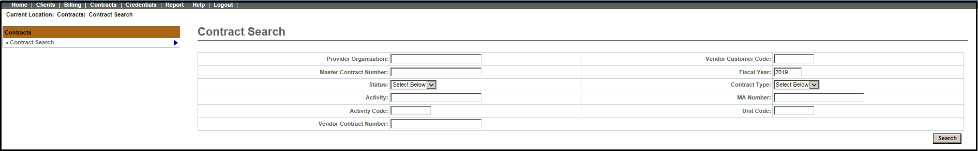  - Enter search criteria for identified contract.  - Select .  The search results appear below.  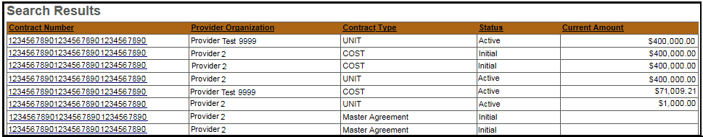  - Select the Contract Number link. | The Contract Summary page appears.  - Select Request Amendment from the navigation bar.  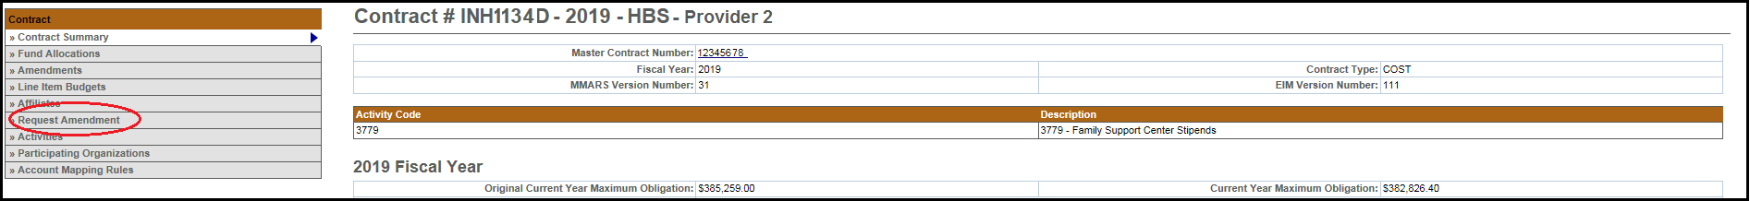  The Select Budget page appears.  - Select the appropriate budget number from the drop down menu and select .

Requesting an Amendment (CR)
The Request Amendment page appears.  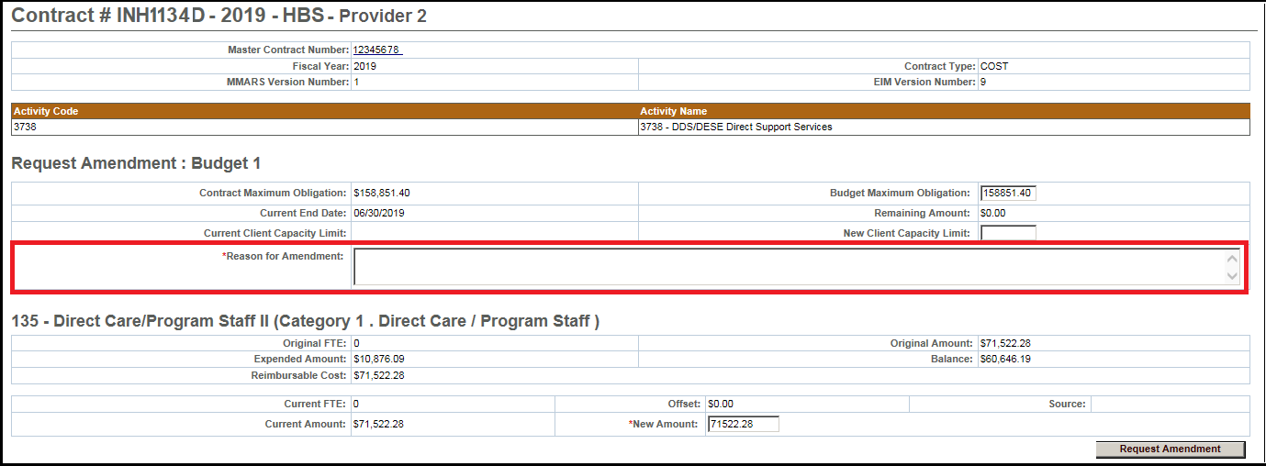  - Enter amendment information, including a reason for the amendment.  - Select.  The Amendment page appears. Notification is sent to designated agency staff by email. | Notes:  - The sum of all New Amount fields must equal the Budget Maximum Obligation field. The Remaining Amount field supports this and will show the difference if the amounts don’t match along with error message.  - New amount cannot be less than the already expended amount for that line item.  - The reason for amendment field is now mandatory.  - New functionality to add a line item budget component.  Questions or need assistance?  Call Virtual Gateway Customer Service  1-800-421-0938  (617-847-6578 - TTY for the deaf and hard of hearing)  8:30 am to 5:00 pm Monday through Friday

