Summary of Job Aid
You use CR/Service Delivery Reports (SDRs) to bill against Cost Reimbursement contracts. The CR Invoice is used to bill for the total amount of line items due for that month services. The CR Invoice also allows you to report services using the Service Delivery Report (SDR) which contains a roster of clients, each with a service delivery calendar to report services on for the month. You can bill for more than one service on the same day by using the multiple calendar functionality in the SDR. Billing for clients is completed by filling out attendance information for each month.
When the information is complete, the provider reports the SDR and then authorizes and submits the CR invoice to EIM, where the service lines are validated.
This reference guide provides users with the steps to successfully bill for CR/SDR contracts in EIM/ESM.

Table of Contents
Logon to Virtual Gateway 1
Add Invoice 1
Update Line Items 3
Create CR-Service Delivery Report 3
Record Client Attendance – Individual 4
Report Multiple Client Attendance (Apply Pattern) 7
Reporting Service Delivery Report 10
Copy Service Delivery Information 10
Edit/Save, Release, Delete or Disapprove an Invoice 11
Authorize or Copy an Invoice 12
Print an Invoice 13
Search for an Existing Invoice 13
Supplemental Invoice - Updating a Line Item(s) 14
Supplemental Invoice - Service Delivery Report 15
Frequently Asked Questions (FAQs) 17
Additional Learning Opportunities 18
Need Assistance? 18
Listing of Figures 18

Logon to Virtual Gateway
In order to use the EIM/ESM application, you must logon to the Virtual Gateway (go to www.mass.gov/vg and click the link “Logon to Virtual Gateway”) and select the Enterprise Management and Enterprise Service (EIM/ESM) business service.
Note: See Logon Assistance Job Aid for more information on accessing the Virtual Gateway.

Add Invoice
- Select the [Billing] module.

Figure 1: EIM top bar with Billing module highlighted
- Select the [Invoice Search] link from the left navigation menu.
- Select the [Add Invoice] button.
Figure 2: Invoice Search page
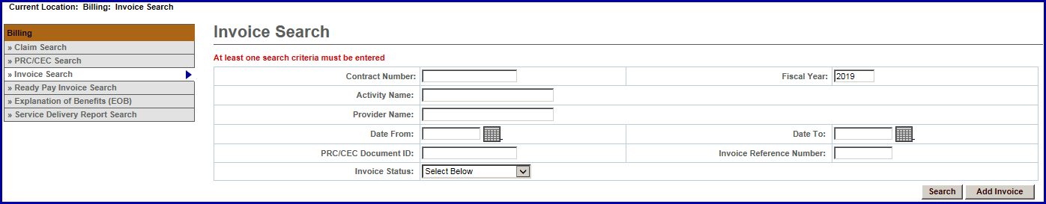
- Select a contract and select the [Select Contract] button.
Note: If you manage a large number of contracts, you might find the Filter helpful. It restricts the Contract listing to only those that meet your filter criteria. For example, you could use “%DDS% if you wanted to show only DDS contracts.
Figure 3: Add Invoice page
- Enter the [*Billing Period From] date. (Use format: MM/DD/YYYY or select the calendar icon)
- Enter the [*Billing Period To] date. (Use format: MM/DD/YYYY or select the calendar icon)
- The [Invoice Reference Number] is an optional field that is available for providers who want to enter a reference number for internal tracking purposes. It may be used later within a PRC search to learn payment status.
- Select the [Save New Invoice] button.
Figure 4: Add Invoice page with Billing Period entered
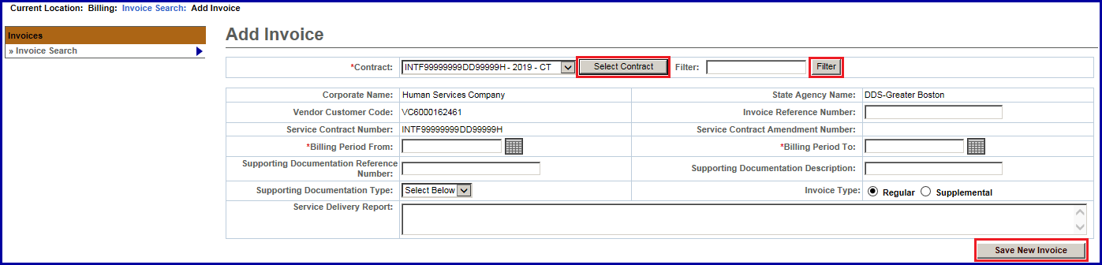
Tips:
- Invoices must be submitted sequentially; if there are no expenses during a billing period, the provider must submit a zero balance invoice.
- If an organization needs to submit more than one invoice a month, a supplemental invoice must be created.

Update Line Items
From the Invoice Summary page, you need to complete the Invoice Amount field(s) to indicate the total invoice amount for the billing month.
- Select the [Edit Invoice] button to enter “edit” mode.
- Enter the [Invoice Amount] for each line item that you are billing for.
Note: DDS/HST brokers should refer to the PV and Route Back-up Sheets for the total invoice amount.
- Select the [Save Invoice] button.
Figure 5: Update Invoice page
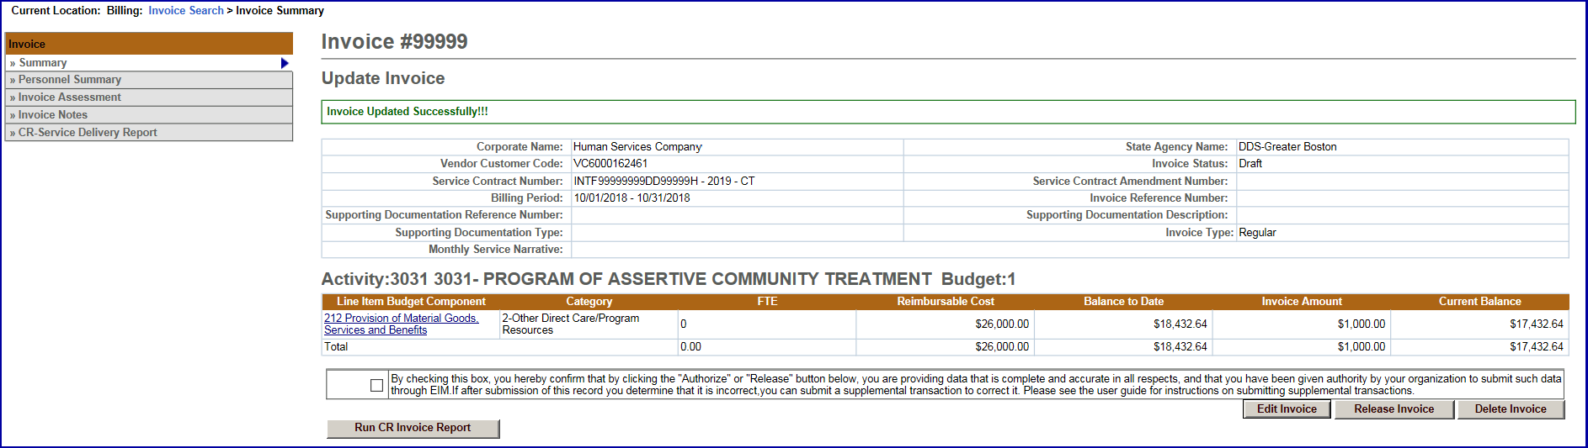
The message “Invoice Updated Successfully!!!” will appear on the Update Invoice page. This also returns you to “read only” mode.

Create CR-Service Delivery Report
From the Update Invoice page, if your contract requires an SDR to be attached with your invoice, you need to now add the Cost Reimbursement-SDR for the billing month.
- Select the [CR-Service Delivery Report] link from the navigation menu.
- Select the [Add New cost Reimbursement SDR] button.
Figure 6: Cost Reimbursement Service Delivery Report with Add New Cost Reimbursement SDR button
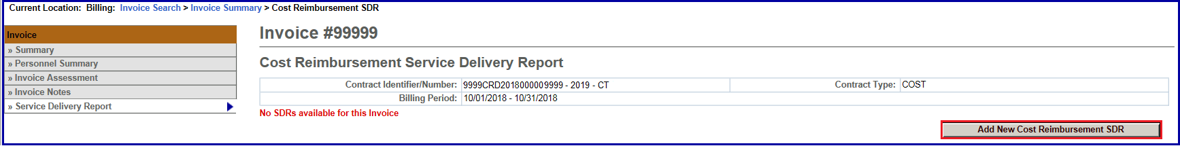
- Select [Activity] from the drop-down menu.
- Select the [Select activity] button.
Figure 7: Cost Reimbursement Service Delivery Report with Activity in the Activity Code field
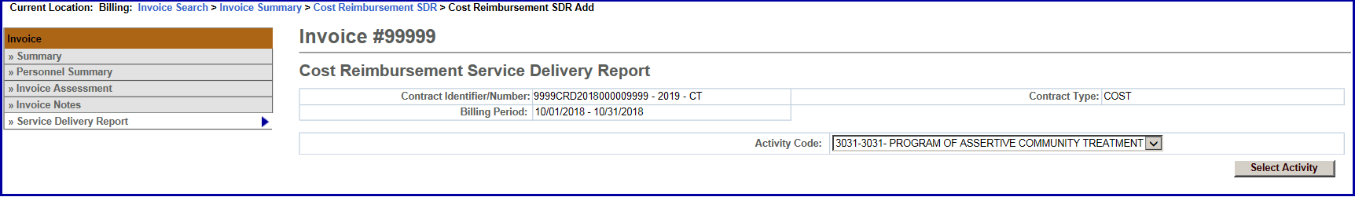
The Cost Reimbursement SDR page appears with the CR/SDR in Draft status.

Figure 8: Cost Reimbursement Service Delivery Report with Activity link
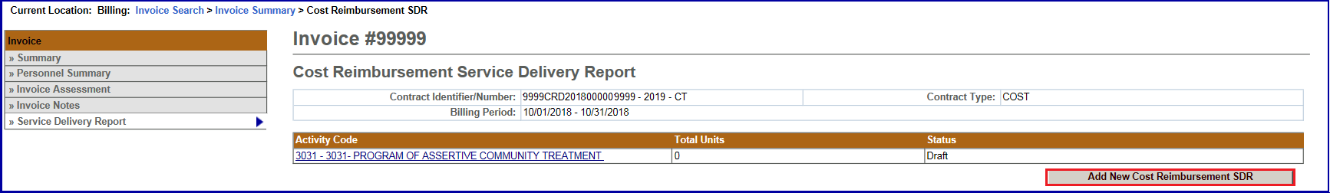
- Select the [Activity Code] link.
The Cost Reimbursement SDR Summary page appears.

Figure 9: Cost Reimbursement Service Delivery Summary
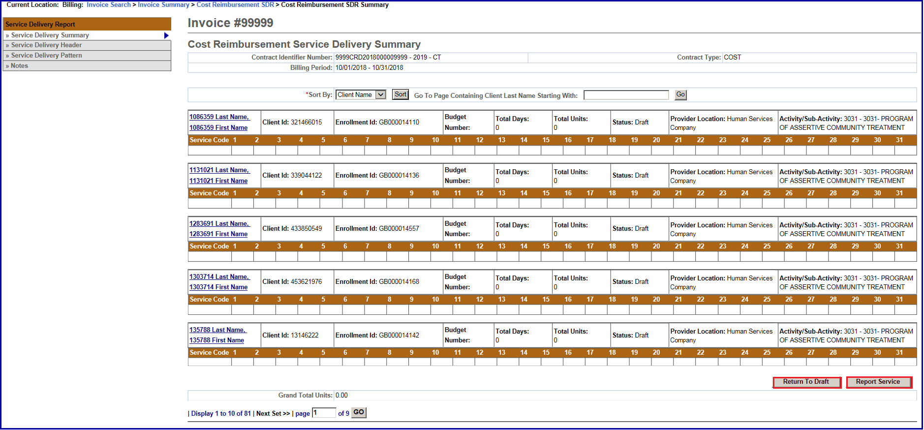

Record Client Attendance – Individual
The SDR has a monthly attendance calendar for each client that is used to report services when billing. Service delivery information may be entered in a single session or throughout the billing period and reported at the end of the month.
If services were delivered to a client during the billing month, a service delivery calendar needs to be updated on the dates service was provided on. If there were no delivered services to a client, the service delivery calendar should remain blank for that client and will be reported as ‘No Delivered Services”.
Each SDR has a default Core Service Delivery calendar to report services on. If additional service codes need reporting, EIM allows up to four (4) core service delivery calendars in a billing month on a regular CR/SDR. If additional core calendars are needed, a supplemental CR/SDR will need to be submitted for the additional services. In addition to reporting the service code, the SDR also reports the attendance status code.
The Cost Reimbursement Service Delivery Summary page appears. This page displays a summary of all enrolled clients associated with the contract.

Figure 10: Cost Reimbursement Service Delivery Summary
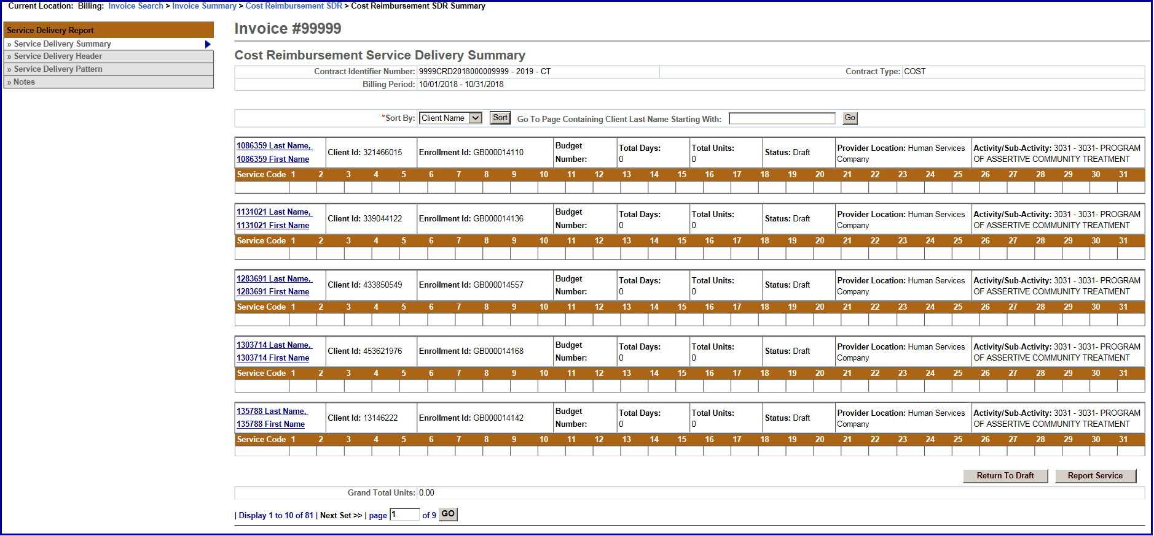
Important Tips:
- You can sort the SDR by Client ID, Enrollment ID, Client Name, and Provider Location. If sorting by Provider Location and you do not see a client record, check the Provider Organization Parent level location. All new or updated interfaced client enrollment records come into EIM at the Parent level of the organization from the agency enrolling system, i.e. Meditech. If providers want a client enrollment associated to a specific billing location, they need to make this association in ESM. Refer to online course 159: Manage Enrollment Locations for more information on this function.
- If you want to go to a page containing a specific client record, you can use the [Go To Page Containing Client Last Name Starting With] field. Simply enter all or part of a client’s last name, select the [Go] button and you will be brought to the page containing that record. You may need to scroll down to see it. Using this feature will “over-ride” any previous sorts.
- When you are finished entering information, always select the [Save Changes] button. If you do not save changes, you will lose the data you entered.
Information Regarding Client Enrollments:
- CR contracts with DDS: If a client enrollment is missing or should no longer appear on the SDR, contact your agency contract manager.
- Select the [Client Name] link to view the client SDR calendar.
The Record Service Delivery page with the Core Service Delivery Calendar #1 displayed.

Figure 11: Record Service Delivery for the client
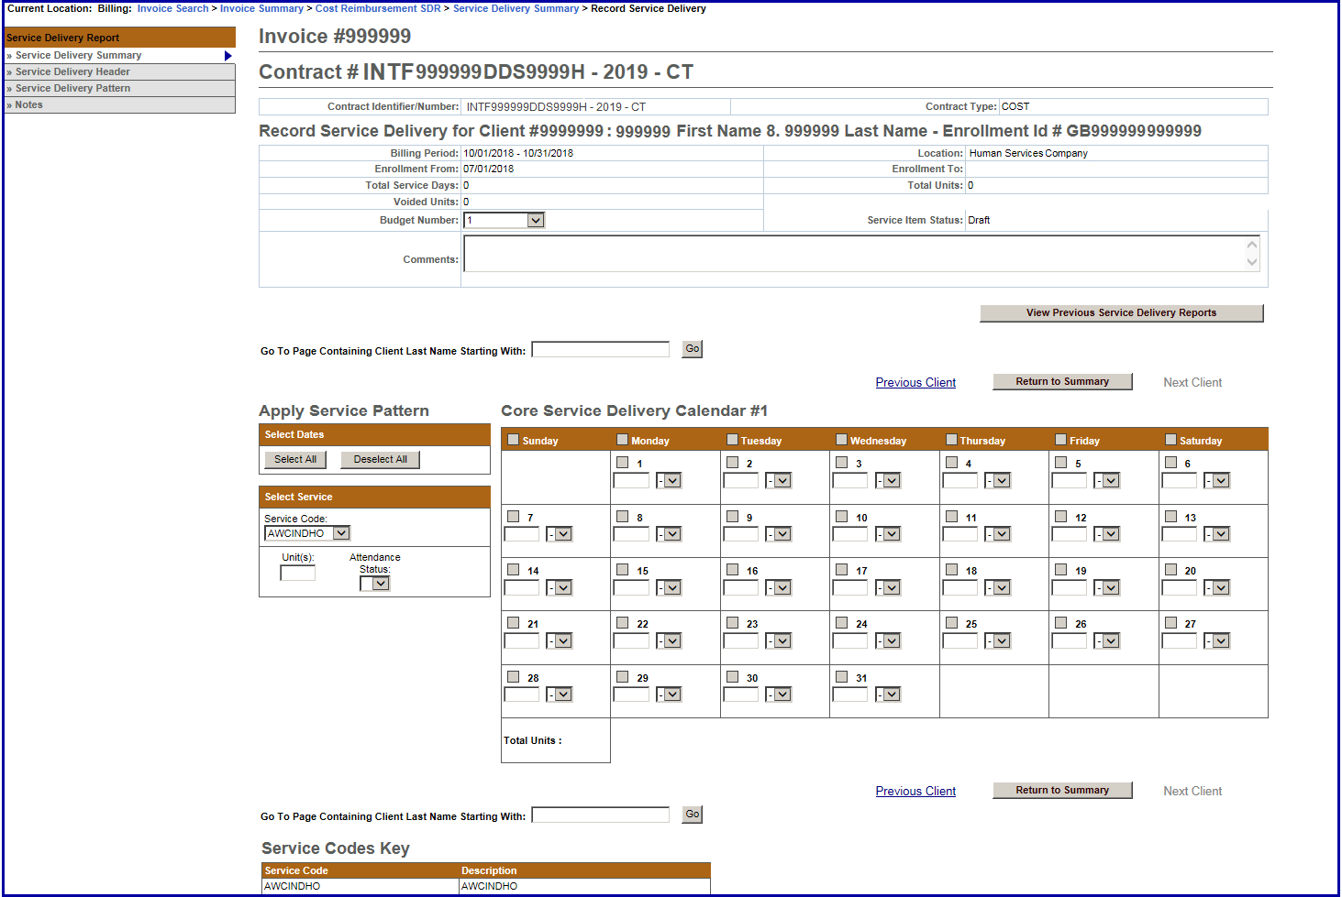
- Using the Select Service section, enter service information on the client record:
  - Place a checkmark next to the billing date(s).
Tips:
If you are billing for every day in the month, use the Apply Service Pattern and select the [Select All] button. This will place a checkmark on each day of the client service delivery calendar.
If you selected all days on the client service delivery calendar and wish to remove them, select the [Deselect All] button. This will remove all checkmarks on the client service delivery calendar.
  - Select the [Service Code] drop down menu to choose the service codeand select the [Select] button.
  - Enter the [Unit(s)].
  - Select the [Attendance Status] from the drop down menu options.
  - Select the [Apply] button.

Figure 12: Core Service Delivery Calendar
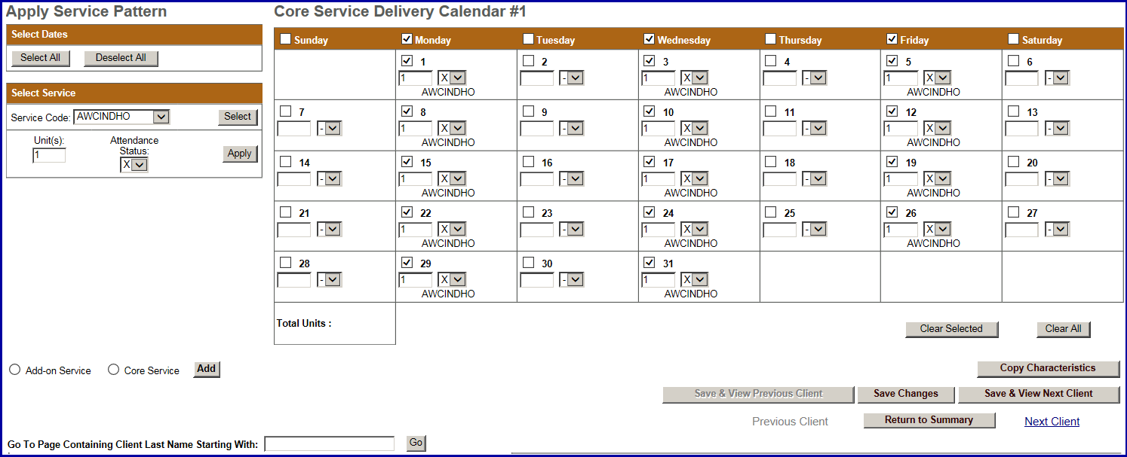
- Select the [Save Changes] button. A message appears, “Record has been updated successfully.”
Figure 13: Record Service Delivery page with message that it has been updated successfully
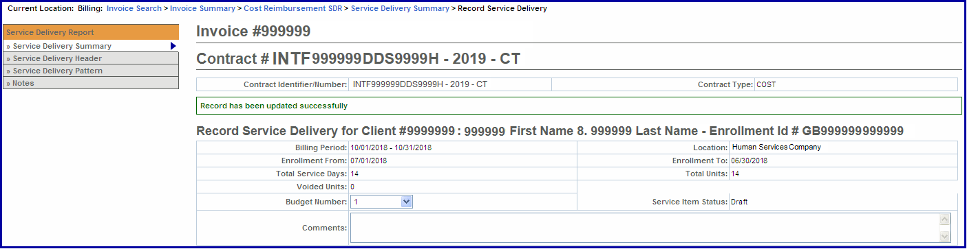
If additional Core calendars are needed,
- Select the radio button next to [Core Service] and select the [Add] button.
Note: At this time CR/SDR does not use Add-on Service calendars.
- Repeat steps above to report other servicers the client had for this billing month.
You repeat the above steps for each client that you need to bill for in the given month. If you have multiple clients whose attendance follows the same pattern, you can use the Service Delivery Pattern option. Refer to Report Multiple Client Attendance (Apply Pattern) section of this job aid for instructions.

Report Multiple Client Attendance (Apply Pattern)
Apply a Service Delivery Pattern:
- Select Service Delivery Pattern from the left navigation menu.

Figure 14: Cost Reimbursement Service Delivery Summary
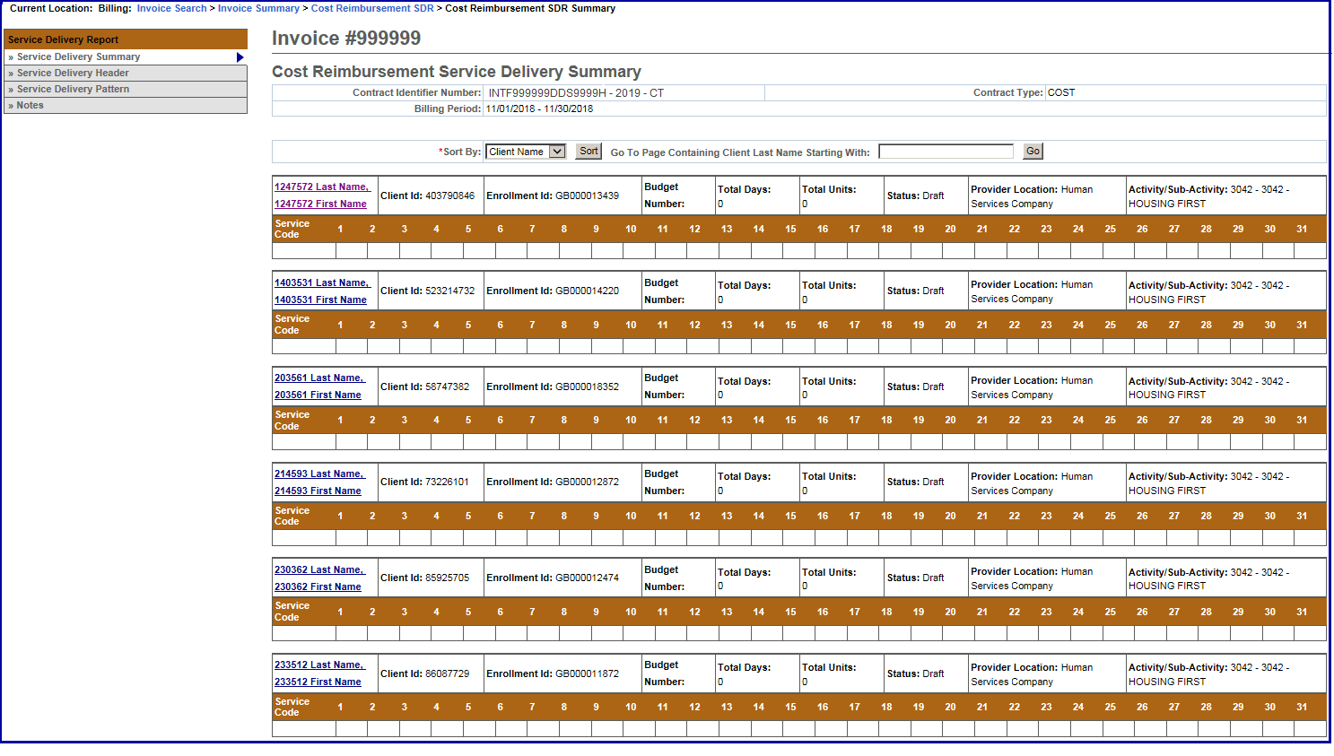
The Service Delivery Pattern page appears. You will note that this page displays the Core Service Delivery Pattern #1 (default) and also displays all of the clients that appear on this SDR.
Figure 15: Core Service Delivery Pattern #1
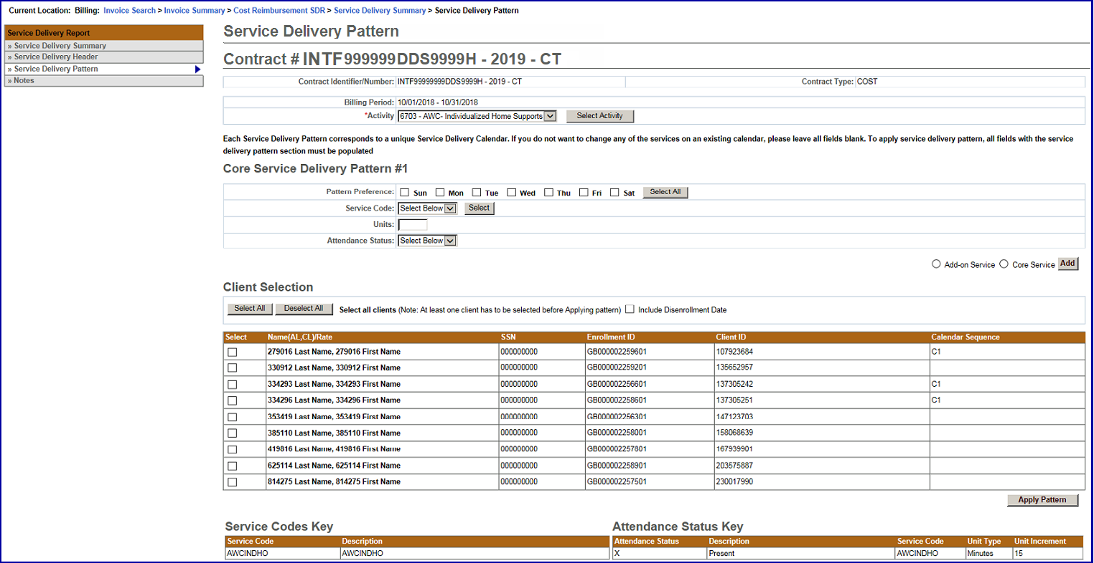
- Select the [Activity Code] from the drop-down menu options and select the [Select Activity] button. If only one activity code exists, the system will default to it, but you need to still select the [Select Activity] button.

Figure 16: Service Delivery Pattern page
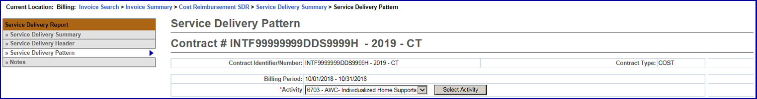
- Under the Core Service Delivery Pattern #1,
- Place a checkmark next to the [Pattern Preference] to indicate the days of the week that you need to report billing on. (If you bill for all seven days, you can select the [Select All] button and it place the checkmarks in the checkboxes for you.)
- Select the [Service Code] drop down menu to choose the service code and select the [Select] button.
- Enter the [Unit(s)].
- Select the [Attendance Status] from the drop down menu options.
Figure 17: Core Service Delivery Pattern #1
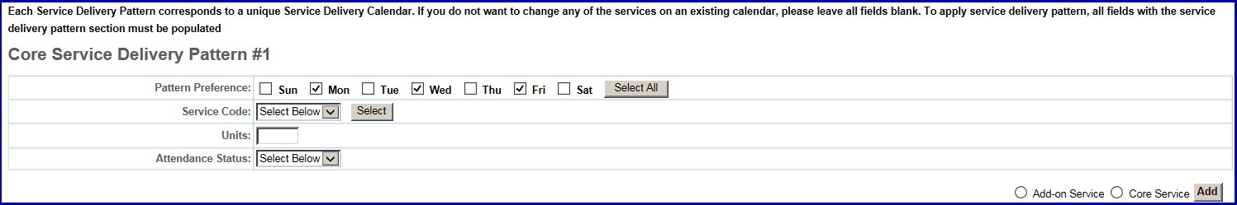
- Under Client Selection,
- Select the [Select All] if all clients on this SDR are reporting the same attendance pattern.
OR
- Place a checkmark next to each client that is reporting the same attendance pattern.
Note: If the Disenrollment Date needs to be included, remember to check the checkbox.
Figure 18: Client Selection
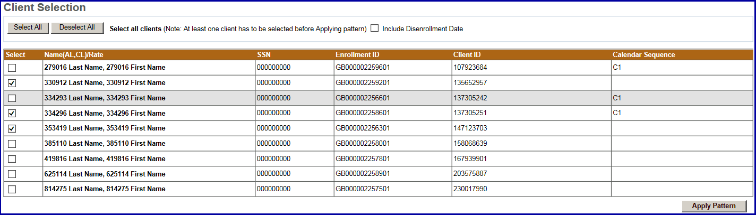
- Select the [Apply Pattern] button. Once the pattern has been applied, the system returns you to the Cost Reimbursement Service Delivery Summary page.

Figure 19: Cost Reimbursement Service Delivery Summary with Pattern applied
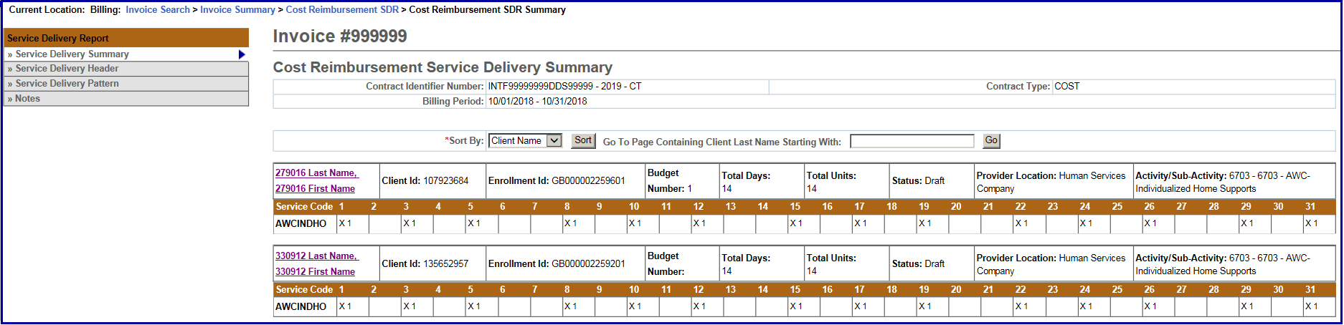
Important Note: After applying a pattern, services can never be removed, they can only be added. The pattern is irreversible. To adjust services, you must edit client records individually.

Reporting Service Delivery Report
Once all of the attendance information has been added for the billing month and you are sure that everything is stated correctly and accurately, the SDR needs to be ‘Reported’.
From the Service Delivery Summary page,
- Select the [Report Service] button.
Reminder: The SDR should remain in “Draft” status until all client attendance is reported. If you are not finished reporting attendance, you should select the “Return to Draft” button. Once you select the “Report Service” button, you cannot edit client attendance on this SDR. You will need to enter and submit a Supplemental CR/SDR.
Figure 20: Services reported for a client
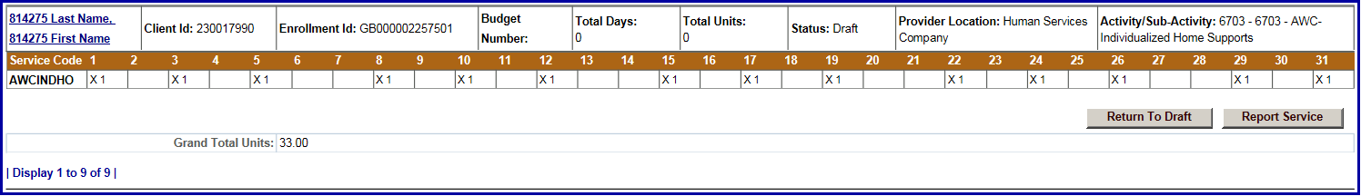
EIM automatically returns you to the Cost Reimbursement Service Delivery Report page and shows that the SDR has been “Reported”.
Figure 21: Cost Reimbursement Service Delivery Report in Reported status
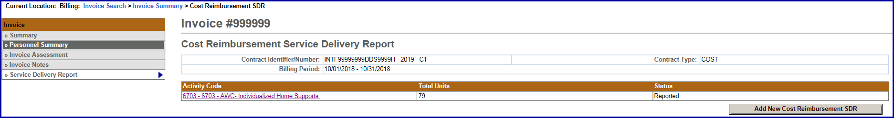
The final status for an SDR attached to a Cost Reimbursement invoice is “Reported.”

Copy Service Delivery Information
- Access the Record Service Delivery page for a client.
- Enter service delivery information if needed. Click [Save Changes], if changes were made from original.
- Select the [Copy Characteristics] button.
- Select one or more clients and select the [Apply Pattern] button.
The Service Delivery Summary page appears with the newly entered information.
Tip: Use [Select All] and [Deselect All] buttons to select or deselect all clients.

Edit/Save, Release, Delete or Disapprove an Invoice
Edit/Save an Invoice:
If you have updated the invoice and want to save it:
- Access the Invoice Summary page.
- Select the [Edit Invoice] button. Update, if necessary.
- Select the [Save Invoice] button. You will receive a confirmation message at the top of the page.
Figure 22: Update Invoice page with message that the invoice was updated successfully
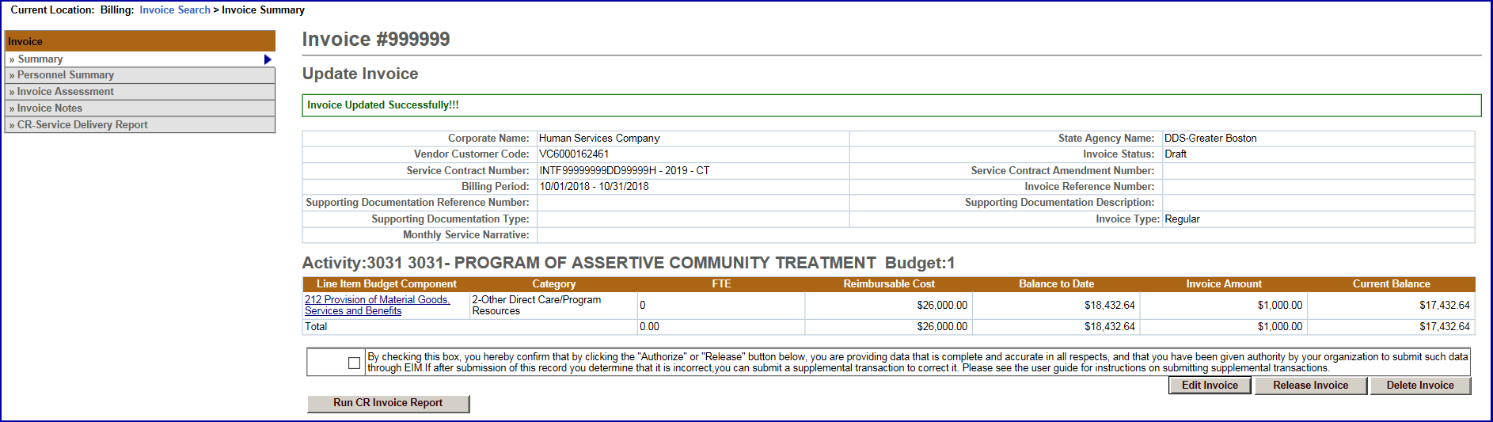
Delete an Invoice:
If you have to delete an invoice:
- Access the Invoice Summary page.
- Select the [Delete Invoice] button.
A message will appear at the top of the page “Are you sure you want to delete this record? Please click “Confirm Delete” to delete the record or “Cancel Delete” to cancel the operation.”
- Select the [Confirm Delete] button to delete this invoice.
Note: If you want to cancel the delete action, select the [Cancel Delete] button.
Figure 23: Update Invoice page with a message asking the user if they are sure they want to delete the invoice.
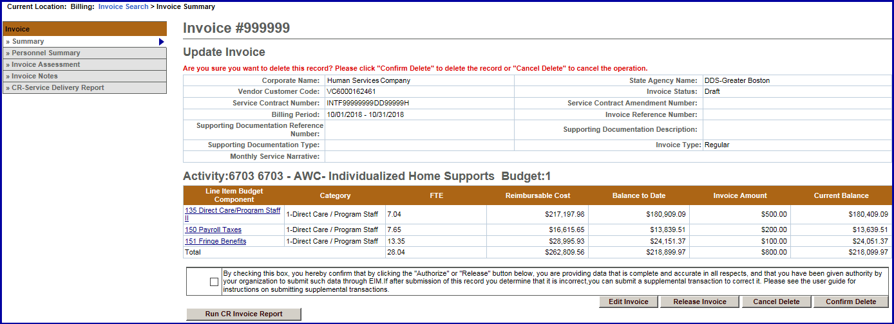

Disapprove an Invoice:
To change the status of an invoice with an error from ready to draft:
- Access the Invoice Summary page of a released invoice.
- Select the [Disapprove Invoice] button. This will return the invoice to a Draft status.

Authorize or Copy an Invoice
Authorize an Invoice:
If the invoice is ready to be authorized and submitted:
- Access the Invoice Summary page of a released invoice.
- Select the checkbox to confirm data is complete and accurate.
By clicking the checkbox you are complying with legal requirements on authorizing an invoice.
Figure 24: Update Invoice with the message that the invoice was released successfully
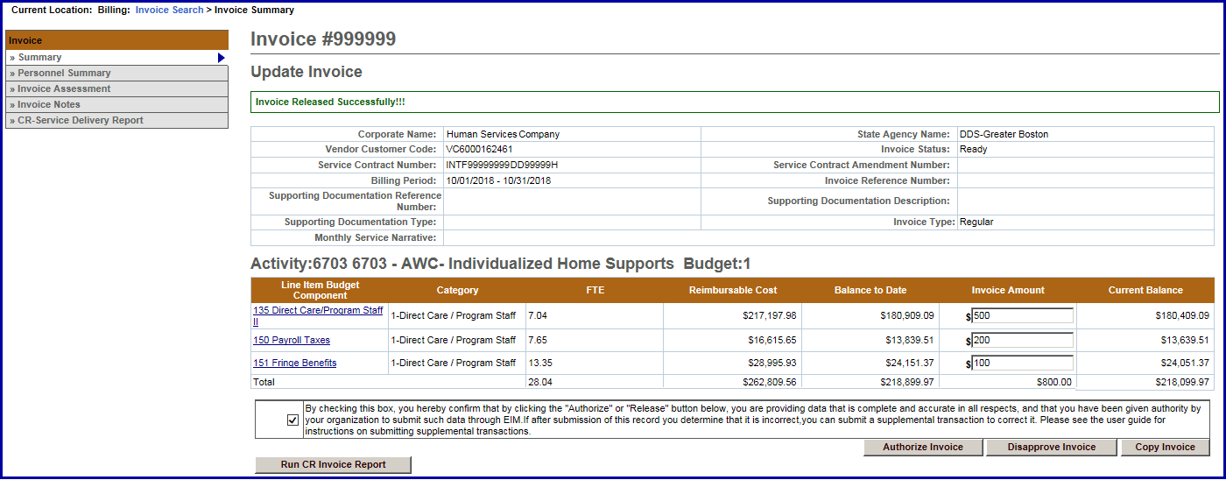
- Select the [Authorize Invoice] button. You will receive a confirmation message at the top of the page.
Figure 25: Update Invoice page with the message that the invoice has been authorized successfully
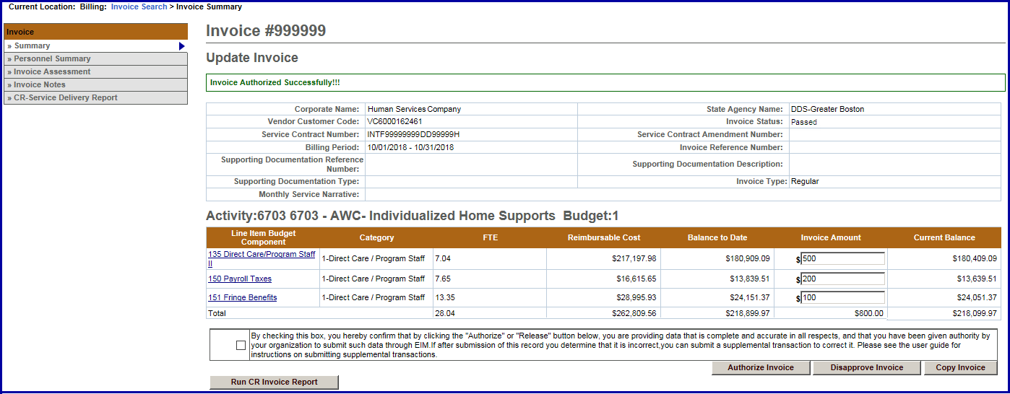

Copy an Invoice:
Note: This does not copy the SDR
- Access the Invoice Summary page of an invoice from a previous month.
- Select the [Copy Invoice] button.
- Enter the new [Billing Period Dates] and any additional information.
- Select the [Save New Invoice] button.

Print an Invoice
Print an Invoice (User must have reports role for both)
There are two ways that an invoice can be printed:
- From the Invoice Summary page
- From the Reports module
To print an invoice from the Invoice Summary screen:
- Access the Invoice Summary page.
- Select the [Run CR Invoice Report] button.
Note: The report will generate a report in view only format for the particular invoice shown on the screen. If a CR-Service Delivery Report in reported status exists for the invoice, it will be printed as well.
To print an invoice from the Reports module:
- Access the Report module.
- Select the Cost Reimbursement Invoice report link within “EIM Reports.”
- Enter required criteria and select the [Run Report] button.
Note: Printing in this way allows you to select an Excel format.

Search for an Existing Invoice
Searching for an Invoice:
- Select the Billing module and then the Invoice Search from the left navigation menu.
- Enter your search criteria in any of the following fields (must include at least one).
Tip: Use the wildcard % to search for records beginning with or ending with a text string. Or use partial criteria by entering the beginning letters or text string.
- Select the [Search] button.
- Select the [Activity Name] link.
The Cost Reimbursement Invoice Summary page appears including information about the invoice you selected.
Supplemental Invoice
- Select the [Billing] module.
Figure 26: EIM top bar with the Billing module highlighted
- Select the [Invoice Search] link from the left navigation menu.
- Select the [Add Invoice] button.
Figure 27: Invoice Search page
- Select a contract and select the [Select Contract] button.
Note: If you manage a large number of contracts, you might find the Filter helpful. It restricts the Contract listing to only those that meet your filter criteria. For example, you could use “%DDS% if you wanted to show only DDS contracts.
Figure 28: Add Invoice page with the Contract field populated
- Enter the [*Billing Period From] date. (Use format: MM/DD/YYYY or select the calendar icon)
- Enter the [*Billing Period To] date. (Use format: MM/DD/YYYY or select the calendar icon)
- The [Invoice Reference Number] is an optional field that is available for providers who want to enter a reference number for internal tracking purposes. It may be used later within a PRC search to learn payment status.
- Select the [Invoice Type of Supplemental] radio button.
- Select the [Save New Invoice] button.
Figure 29: Add Invoice page with fields populated
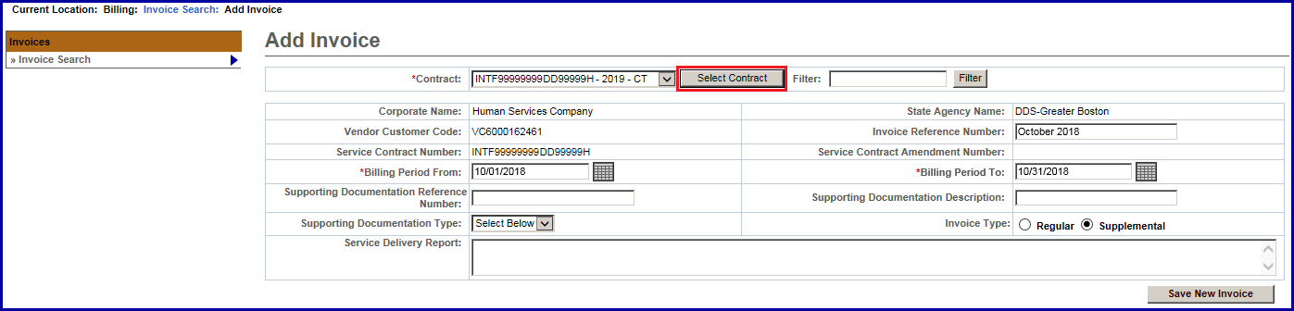

Supplemental Invoice - Updating a Line Item(s)
From the Invoice Summary page, you need to update the Invoice Amount field(s) to indicate the total invoice amount for the billing month.
- Select the [Edit Invoice] button to enter “edit” mode.
- Enter the [Invoice Amount] for each line item that needs to be updated.
- Select the [Save Invoice] button.
Figure 30: Update Invoice page with a message that the invoice was updated successfully
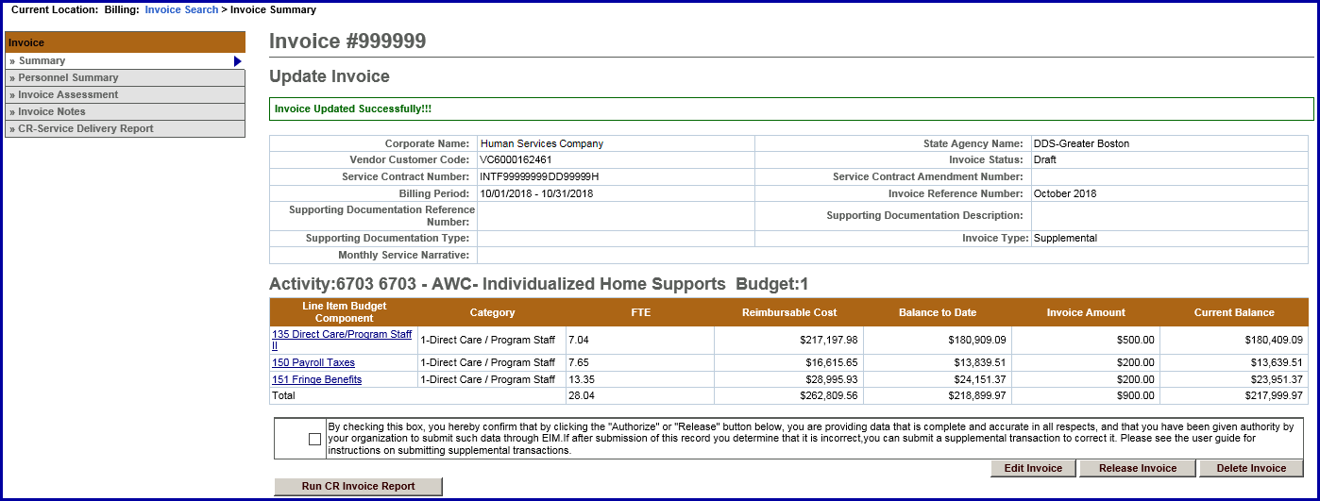
The message “Invoice Updated Successfully!!!” will appear on the Invoice Summary page. This also returns you to “read only” mode.

Supplemental Invoice - Service Delivery Report
From the Invoice Summary page,
- Select the [CR-Service Delivery Report] link from the left navigation menu.
- Select the [Add New Cost Reimbursement SDR] button.
- Select the [Activity] from the drop-down menu.
- Select the [Activity] link.
Figure 31: Cost Reimbursement Service Delivery Report page with activity in the Activity Code field
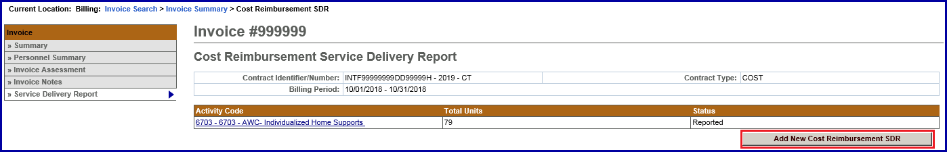
From the Cost Reimbursement Service Delivery Summary page,
- Select the [Client Name] link to view the client SDR calendar.
The calendar will display blank when you first come onto the page.

Figure 32: Record Service Delivery page with a blank calendar
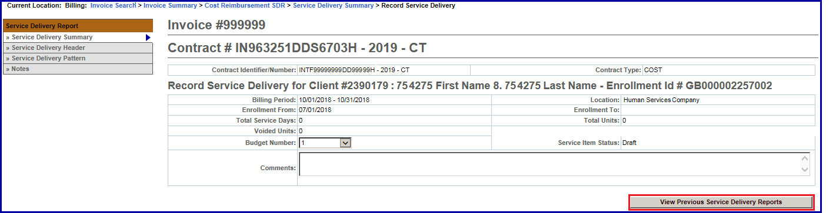
- Select the [View Previous Service Delivery Reports] button.
Figure 33: Previous Service Reports in Draft status
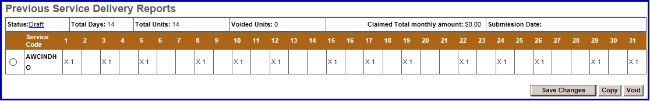
Notice that the Status of this calendar is ‘Draft’. This means that you did not report the SDR prior to the release and authorize so it did not attach itself to the invoice.
There are three buttons listed here: [Save Changes], [Copy] and [Void]. Based on what needs to be modified, select the appropriate button.
- To copy this data, select the radio button next to Service Code and then select the [Copy] button.
This will copy the attendance listed from the previous SDR to the Core Calendar listed below.
Figure 34: Core Service Delivery Calendar
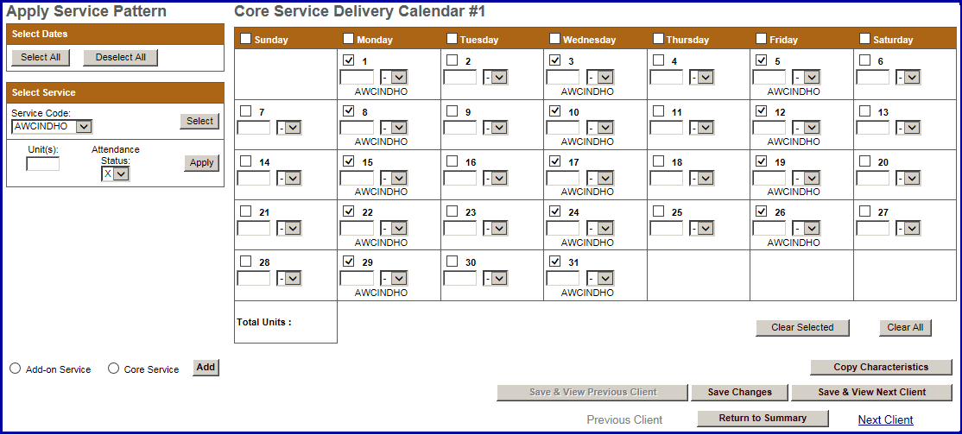
- Verify that the attendance is correct, and then select the [Save Changes] button.
A system verification message will appear on the page.
- Select the [Save & View Next Client] or [Return to Summary] page.

Figure 35: Cost Reimbursement Service Delivery Summary
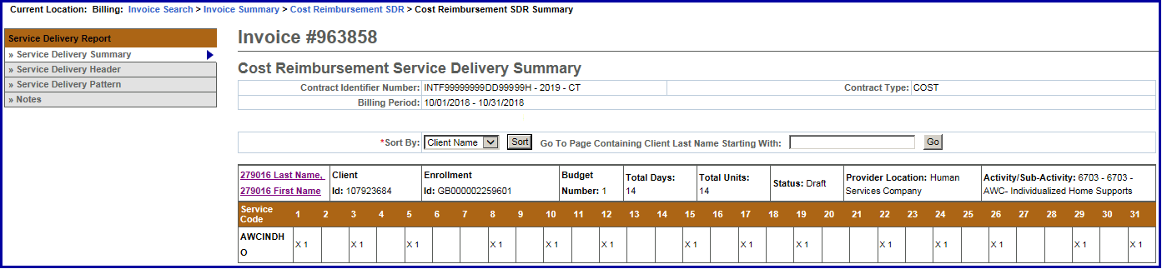
- Once all of the client data has been updated, scroll to the bottom of the Cost Reimbursement Service Delivery Summary page and select the [Report Services] button.
Figure 36: Report Services button
Reminder Note: Once the SDR has been reported, you must also remember to Release and Authorize the CR Invoice.

Frequently Asked Questions (FAQs)
CR-SDR Frequently Asked Questions (FAQs)
- How do I know if I need a CR-SDR?
- Please refer to your contract manager for assistance. Most DDS contracts require an SDR be entered and reported where many other agencies do not at this time.
- How do I attach a CR-SDR?
- While the CR invoice is still in draft status select the “Cost Reimbursement SDR” link from the left navigation menu. Select the “Add new Cost Reimbursement SDR” button; Select the Activity from the drop-down menu and select the “Select Activity” button. Populate the SDR and process the invoice. Refer to the Cost Reimbursement SDR Job Aid for step-by-step instructions.
- What codes do I use in the CR-SDR?
- Please refer to your contract manager for assistance.
- The invoice has been paid, but the Agency is now asking that I submit a CR-SDR now. When I try to enter a CR-SDR the button to add is not highlighted?
- You can only add a CR-SDR when the CR invoice is in a Draft status. You cannot add the SDR to a paid invoice.
- You will need to create a supplemental CR Invoice for the month in question, enter “0” for the Invoice Amount(s), select the ”Cost Reimbursement SDR” link from the left navigation menu; Select the “Add new Cost Reimbursement SDR” button. Select your Activity from the drop-down menu and select the “Select Activity” button. Populate the SDR and process the invoice. Refer to the Cost Reimbursement SDR Job Aid for step-by-step instructions.
- The agency stated that I did not include a CR-SDR with my invoice, but I see the SDR when I look at the invoice. Why isn’t it showing on the agency side?
- If the status of the SDR reads as ‘Draft’ then the “Report Services” button was not selected prior to the invoice being released and authorized. You will need to create a supplemental CR Invoice for the month in question, enter “0” for Line Amount(s), select the ”Cost Reimbursement SDR” link from the left navigation menu; Select the “Add new Cost Reimbursement SDR” button. Select your Activity from the drop-down menu and select the “Select Activity” button. Populate the SDR and process the invoice. Refer to the Cost Reimbursement SDR Job Aid for step-by-step instructions.
- My CR Invoice has been paid, but the agency advised me that the SDR is incorrect. How do I correct an incorrect SDR?
- You will need to create a supplemental CR Invoice for the month in question. Enter ‘0’ for the Invoice Amount(s), select the ‘Cost Reimbursement SDR’ link from the left navigation menu; Select the ‘Add New Cost Reimbursement SDR’ button. Select the ‘Activity’ from the drop-down menu and select the “Select Activity” button. Then select the ‘Activity Code’ link. Select the Enrollment ID link for the client that needs to be corrected. Select the radio button under the Previous Service Delivery Reports heading. Select the [Void] button and then [Save Changes]. The claim is now voided. Enter the new services for that client in the calendar, select the Report Services button and process the Invoice as normal. Refer to the Cost Reimbursement SDR Job Aid for step-by-step instructions.

Additional Learning Opportunities
- Online Learning: To take online course, log into PACE (www.pace.state.ma.us/vg).
- 137 Cost Reimbursement Billing
- Additional EIM/ESM Provider Job Aids are found at:
- Virtual Gateway URL: www.mass.gov/vg/eimesm
- EIM/ESM Provider User Manuals and Instructional Materials

Need Assistance?
- Email the Virtual Gateway Business Operations Unit for assistance:
- EHS-DL-EIM-ESMBusinessOperations@massmail.state.ma.us
- Call the Virtual Gateway Customer Service for assistance:
- 1 (800) 421-0938
- 617-847-6578 (TTY people who are deaf, hard of hearing, or speech disabled)
- Monday – Friday: 8:30am - 5:00pm

Listing of Figures
Figure 1: EIM top bar with Billing module highlighted 2
Figure 2: Invoice Search page 2
Figure 3: Add Invoice page 2
Figure 4: Add Invoice page with Billing Period entered 2
Figure 5: Update Invoice page 3
Figure 6: Cost Reimbursement Service Delivery Report with Add New Cost Reimbursement SDR button 3
Figure 7: Cost Reimbursement Service Delivery Report with Activity in the Activity Code field 3
Figure 8: Cost Reimbursement Service Delivery Report with Activity link 4
Figure 9: Cost Reimbursement Service Delivery Summary 4
Figure 10: Cost Reimbursement Service Delivery Summary 5
Figure 11: Record Service Delivery for the client 6
Figure 12: Core Service Delivery Calendar 7
Figure 13: Record Service Delivery page with message that it has been updated successfully 7
Figure 14: Cost Reimbursement Service Delivery Summary 8
Figure 15: Core Service Delivery Pattern #1 8
Figure 16: Service Delivery Pattern page 9
Figure 17: Core Service Delivery Pattern #1 9
Figure 18: Client Selection 9
Figure 19: Cost Reimbursement Service Delivery Summary with Pattern applied 10
Figure 20: Services reported for a client 10
Figure 21: Cost Reimbursement Service Delivery Report in Reported status 10
Figure 22: Update Invoice page with message that the invoice was updated successfully 11
Figure 23: Update Invoice page with a message asking the user if they are sure they want to delete the invoice. 11
Figure 24: Update Invoice with the message that the invoice was released successfully 12
Figure 25: Update Invoice page with the message that the invoice has been authorized successfully 12
Figure 26: EIM top bar with the Billing module highlighted 14
Figure 27: Invoice Search page 14
Figure 28: Add Invoice page with the Contract field populated 14
Figure 29: Add Invoice page with fields populated 14
Figure 30: Update Invoice page with a message that the invoice was updated successfully 15
Figure 31: Cost Reimbursement Service Delivery Report page with activity in the Activity Code field 15
Figure 32: Record Service Delivery page with a blank calendar 16
Figure 33: Previous Service Reports in Draft status 16
Figure 34: Core Service Delivery Calendar 16
Figure 35: Cost Reimbursement Service Delivery Summary 17
Figure 36: Report Services button 17

