Cost-Share Application

Forest Stewardship Plan & Foresters for the Birds Program

WORKING FOREST INITIATIVE FUNDING

FISCAL YEAR 2019

Application for DCR Cost-Share MUST BE APPROVED PRIOR TO SUBMITTING COMPLETED PLAN TO DCR

Landowners: Massachusetts Forest Stewardship Program
Please read side 2, and then complete 355 West Boylston Street
Application & IRS Form W-9 and mail to: Clinton, MA 01510
978-368-0126 x129 (office) 413-212-3039 (cell)

LANDOWNER PROPERTY

Name Town

Mailing address Road
County

Estimated total acres of property
Acres to be covered by plan
Daytime Phone
Please check the listings that apply to this ownership
Evening Phone
I/We are applying for Stewardship Plan Cost-Share (NEW)
Email I/We are applying for Cost-Share for Bird Habitat Assessment
I/We have an EXISTING Forest Stewardship Plan
Plan preparer (if known) I/We have a state-held CR/WPR on this property
CR Holder:
I/We have an EXISTING Management Plan (CH 61/61A/61B)

Only applications with completed IRS Form W-9 will be processed. Cost-share reimbursement payments are considered reportable by the IRS and must be reported on your income tax returns. The name and address submitted on the form W-9 is to whom and where the reimbursement check will be issued. IRS Form W-9 must be submitted with this cost-share application.

Please contact the Forest Stewardship Office within thirty (30) days of application submission if you (applicant) determine the information on the application to be incorrect or desire to withdraw your application. If you decide at any point to not have a Stewardship Plan prepared for your land, you must notify Massachusetts Forest Stewardship Program

Landowner signature Date

For Departmental Use Only:

Approval Disapproval
Extent approved (acres) Ineligible property or ownership

Initial reimbursement approved ($) No funds available: keep on file

Comments

I certify that this application meets with eligibility requirements of MA Forest Stewardship Program.

DCR Authorizing signature Date

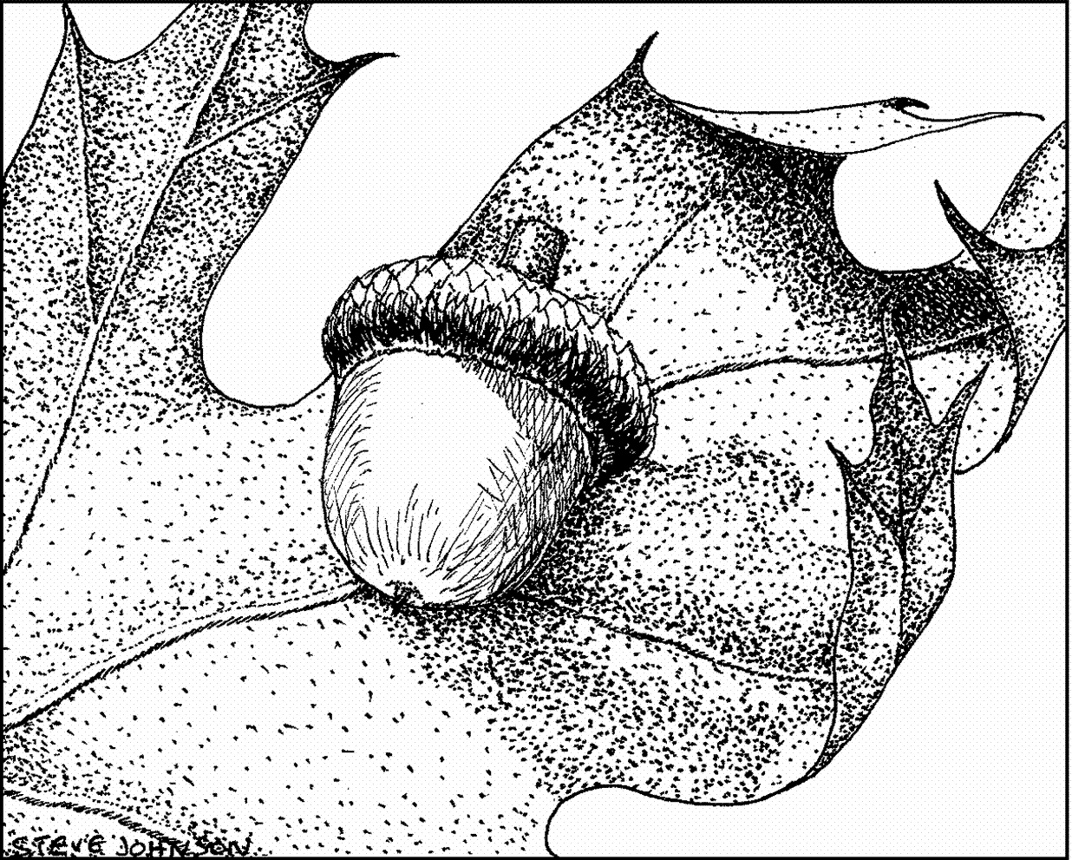
The Forest Stewardship Program
The Massachusetts Department of Conservation and Recreation’s (DCR) Forest Stewardship Program (FSP) supports you in your desire to practice long-term guardianship of your woodlands. The primary objective of the FSP is to reduce the likelihood of development of forest properties by encouraging active forest management.
Working on a ten-year management plan with a Massachusetts Licensed Forester offers an excellent opportunity to learn more about your woodland. To learn more visit https://www.mass.gov/service-details/forest-stewardship-program

Cost-Share Reimbursement Information (for NEW Stewardship Plan applicants):
Who is eligible?
■ Landowners owning woodlands of 10 acres or more (7 of which must be wooded with remaining acres being classified as “eligible”), that are not currently enrolled in Forest Stewardship or Chapter 61, 61A or 61B programs.
■ Landowners currently enrolled in Chapter 61A or 61B that do not have a forest management/stewardship plan are eligible to receive cost-share reimbursement. Eligible private landowners include individuals, trusts, land trusts, clubs, LLC’s, associations, and corporate entities.
■ Municipally-owned forest land parcels are also eligible. Leaseholders are eligible as well.

Forest Stewardship Cost-Share Reimbursement is only for new management plans. Re-certifications and amendments to existing plans are not eligible to receive reimbursement.
*The exceptions to this rule are the case of a new landowner who inherits a plan from the previous owner, and a property with a state-held CR or WPR.

The cost-share application must be approved by DCR before work on the plan begins.

Cost-Share Reimbursement rates:
10 to 36 acres = $910
37 to 499 acres = $910 + $13.00/acre over 36 acres
Over 500 acres = based on a written estimate by MA Licensed Forester & approved by DCR
$9,577 maximum reimbursement for applicants over 500 acres
$14,651 maximum reimbursement for applicants over 1,000 acres

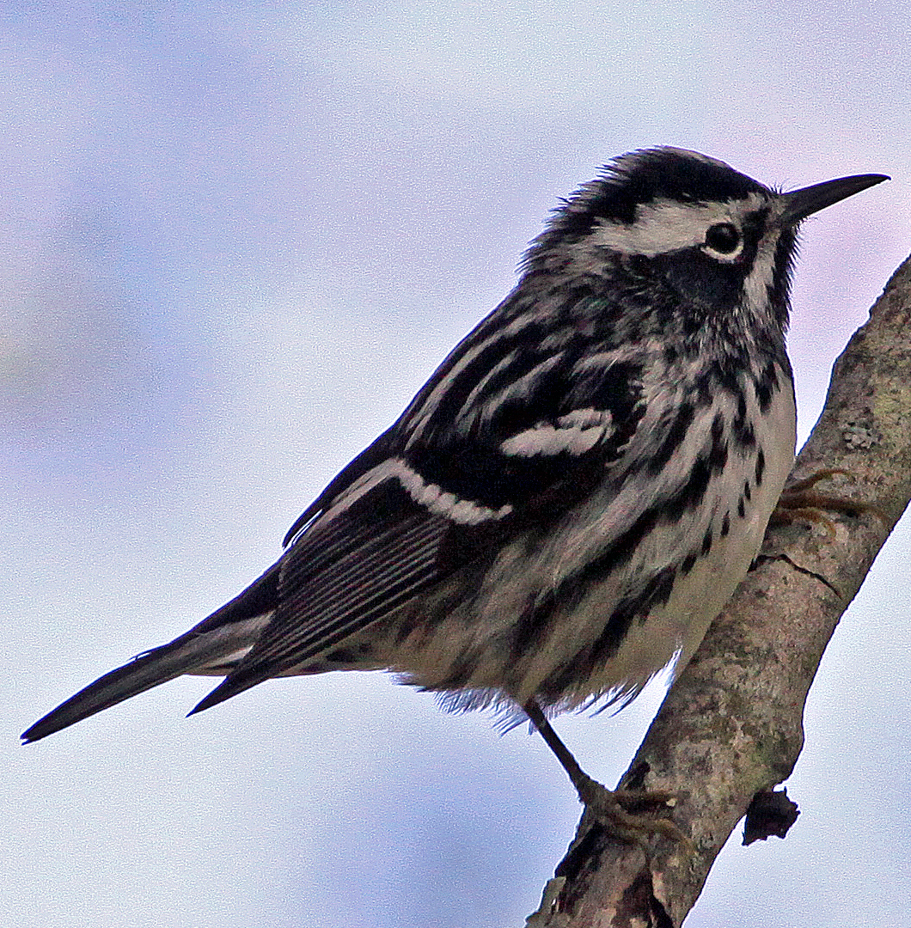
Foresters for the Birds—A Woodland Owner Program Focused on Supporting Songbird Habitat

This program supports landowners with woods who would like to learn more about the bird habitat on their land and how to enhance it in conjunction with other forest management goals.

A Massachusetts Licensed Forester certified in conducting Bird Habitat Assessments will assess your woods for existing and potential bird habitat.

List of Foresters certified in conducting Bird Habitat Assessment: https://www.mass.gov/files/documents/2017/06/zs/Forester%2520Certification%2520May%25202017.pdf

The Bird Habitat Assessment will be integrated into your efforts towards other goals such as improving forest health, generating income, or enhancing recreational trails. These recommendations will then be incorporated into your Forest Stewardship Plan. Reimbursement Information:
Who is eligible?
■ Private Landowners with 10 or more wooded acres that are currently enrolled in the Current Use / Forest Stewardship Program or apply for a Forest Stewardship Plan at the same time.

Cost-Share Reimbursement rates for NEW Forest Stewardship Plan with Bird Assessment:
10 to 20 acres = $300
21 to 50 acres = $400
Greater than 51 acres = $500

Cost-Share Reimbursement rates for EXISTING Forest Stewardship Plan with Bird Assessment:
10 to 20 acres = $600
21 to 50 acres = $800
Greater than 51 acres = $1,000

Cost-Share Reimbursement rates for EXISTING Chapter 61/61A/61B Management Plan with Bird Assessment:
10 to 20 acres = $900
21 to 50 acres = $1,100
Greater than 51 acres = $1,300

Reimbursement payments are considered reportable by the IRS and must be reported on your income tax returns.
You will receive an IRS Form 1099 for this payment.

These programs, funded by the Commonwealth of Massachusetts, are open to all eligible applicants without regard to age, color, disability, national origin, race, religion, marital or family status,
sex or sexual orientation.
Revised January 2019

