INDOOR AIR QUALITY ASSESSMENT

Provincetown Council on Aging
2 Mayflower Street
Provincetown, MA

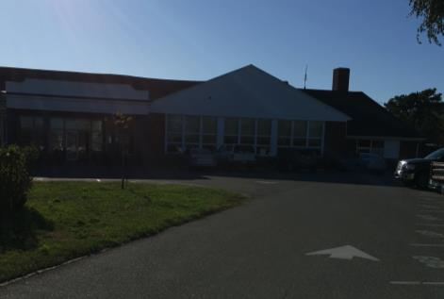

Prepared by:
Massachusetts Department of Public Health
Bureau of Environmental Health
Indoor Air Quality Program
November 2017

Background
Building: | Provincetown Council on Aging (PCA)
Address: | 2 Mayflower Street, Provincetown, MA
Reason for Request: | Concerns about indoor air quality (IAQ) and mold
Date of Assessment: | October 19, 2017
Massachusetts Department of Public Health/Bureau of Environmental Health (MDPH/BEH) Staff Conducting Assessment: | Michael Feeney, Director, Indoor Air Quality Program
Building Description: | The PCA is located in a building complex that was originally constructed as a school. Pictures 1 and 2 show the building layout and location of the PCA in the complex.
Year Built: | 1955, renovated in 2002
Windows: | Openable

Background
On October 5, 2017, the IAQ program received a referral from the Occupational Safety and Health Administration (OSHA) regarding employee complaints of “mold throughout the facility” (OSHA, 2017). IAQ staff visited the PCA on October 19, 2017 to conduct an IAQ assessment of the building. The PCA is located in a section of a building complex that was originally constructed as a school. Pictures 1 and 2 show the building layout and location of the PCA in the complex.
Town officials have reportedly attempted to address concerns about mold in the PCA for four years prior to the IAQ Program visit. In 2013, a consultant examined the building and made the following recommended tasks to remediate mold in the building: “set contaminant and negative air for each room; scrub walls and floors with shockwave mold disinfectant; all carpets to be steam cleaned with mold disinfectant; all floors to be cleaned and buffed to a shine; [and] placed air scrubbers throughout the building to remove any airborne mold (MD, 2013). In 2015, the contractor re-examined the building and made the statement that no remediation was needed for mold (MD, 2015). In 2017, another contractor conducted an evaluation of the building. The consultant recommended removing water damaged ceiling tiles (TI, 2017).

Methods
Please refer to the IAQ Manual for methods, sampling procedures, and interpretation of results (MDPH, 2015).

IAQ Testing Results
The following summarizes indoor sampling results for the PCA at the time of assessment (Table 1).
- Carbon dioxide levels were below 800 parts per million (ppm) in all areas tested.
- Temperature was within the recommended range of 70°F to 78°F in all areas tested.
- Relative humidity was within the recommended range of 40 to 60% in all areas tested.
- Carbon monoxide levels were non-detectable (ND) in all areas tested.
- Fine particulate matter (PM2.5) concentrations measured were below the National Ambient Air Quality Standard (NAAQS) level of 35 μg/m³ in all areas tested.

Ventilation
A heating, ventilating, and air conditioning (HVAC) system has several functions. First it provides heating and, if equipped, cooling. Second, it is a source of fresh air. Finally, an HVAC system will dilute and remove normally occurring indoor environmental pollutants by not only introducing fresh air, but by filtering the airstream and ejecting stale air to the outdoors via exhaust ventilation. Even if an HVAC system is operating as designed, point sources of respiratory irritants may exist and cause symptoms in sensitive individuals.
The PCA has a number of different HVAC systems. The PCA was retrofitted with ceiling/wall-mounted fresh air supplies connected by ducts to air handling units (AHUs) located in the attic space or closets. A number of former classrooms have unit ventilators (univents) that have their fresh air intakes closed, effectively converting each into a fan coil unit (FCU). Air drawn into the unit through the return vent along the bottom is filtered, heated (if needed), and circulated throughout the room. At the time of the visit, most of these units were operating.
It is recommended that HVAC systems be re-balanced every five years to ensure adequate air systems function (SMACNA, 1994). It is unknown when the last time these systems were balanced.

Microbial/Moisture Concerns
IAQ staff found no signs of visible mold inside the building and did not find any musty/mildew odors in any section of the PCA. Water-damaged ceiling tiles were observed in several areas (Table 1). These appear to be old staining from historic leaks. Note that some of the water-damaged tiles are of an interlocking type that may be glued directly to the ceiling; these may be difficult to replace.
Of note is the configuration of the roof over the PCA which is peaked over the majority of the building. Two areas with flat roofs exist in the PCA section of the building complex (Picture 2), the northwest (NW) and southwest (SW) addition. A ramp leading to an exterior door exists between the original building and NW addition (Picture 3). An aerial view of the building shows that a roof valley of the original building empties rainwater onto the flat roof over the ramp (Picture 4), which appears to be poorly or improperly drained, as demonstrated by rotted roof edge wood (Picture 5). The rainwater also moistens the corner of the NW addition, as shown by brick discoloration and moss growth (Picture 6). It is also likely that water enters the seams between the ramp and the SW addition (Picture 7). Water can readily penetrate brick to moisten the interior of walls and lead to mold growth.
Schools constructed in 1955, such as the building that the PCA now occupies, typically have tile floors without slab insulation or vapor barriers. This type of floor can be prone to generating condensation in hot, humid weather, since the slab would have a temperature that is below the dew point. If the floors are covered with carpeting, condensation can moisten it and lead to mold colonization. It is not recommended to use wall-to-wall carpeting on floors that are on slab in contact with soil/sand without insulation and a vapor barrier.
Indoor plants were observed in several areas (Table 1). Plants, soil, and drip pans can serve as sources of mold/bacterial growth. Plants should be properly maintained, over-watering of plants should be avoided, and drip pans should be inspected periodically for mold growth. In addition, plants should not be placed on top of or in the airstream of HVAC equipment such as univents.

Other IAQ Evaluations
Another condition that could adversely affect the NW addition is an open vent in the exterior wall (Picture 8). IAQ staff could not identify ductwork connected to this vent. If this vent is not connected, it can become pressurized in a steady northwest wind which can then pressurize the wall/ceiling plenum to force dust and debris into occupied spaces.
Upon entering the PCA office a noticeable odor of carpet deodorizer was noticed. Carpet deodorizer is a powder that can become aerosolized when vacuumed. A Safety Data Sheet for one kind of carpet deodorizer lists the following: excessive inhalation of dust may cause minor irritation of nose, throat and upper respiratory tract. Sensitive individuals may experience mild skin irritation on prolonged contact (WD-40 Company, 2009).

Conclusions/Recommendations
The following recommendations are made to assist in maintaining IAQ:
- Seal the open vent in the NW addition if not connected to any working vent system.
- Examine the feasibility of increasing the gutter size or changing the configuration over the ramp in Picture 6 to prevent wetting of the NW addition wall.
- Seal the seam between the ramp and the NW addition with an appropriate sealer to render watertight.
- Consider removing all wall-to-wall carpet and replace with appropriate non-porous flooring.
- Discontinue the use of carpet deodorizer.
- Use open windows (weather permitting), to temper rooms and provide fresh air. Keep windows closed during hot, humid weather to maintain indoor temperatures and to avoid condensation problems when air conditioning is activated.
- For buildings in New England, periods of low relative humidity during the winter are often unavoidable. Therefore, scrupulous cleaning practices should be adopted to minimize common indoor air contaminants whose irritant effects can be enhanced when the relative humidity is low. To control for dusts, a high efficiency particulate arrestance (HEPA) filter equipped vacuum cleaner in conjunction with wet wiping of all surfaces is recommended. Avoid the use of feather dusters. Drinking water during the day can help ease some symptoms associated with a dry environment (throat and sinus irritations).
- Remediate leaks leading to water-damaged ceiling tiles and replace the tiles when possible.
- Indoor plants should be properly maintained and equipped with drip pans to prevent water damage to porous building materials and be located away from ventilation sources to prevent the aerosolization of dirt, pollen, or mold. Do not rest plants on porous materials (e.g., cloth, paper).
- Refer to resource manual and other related IAQ documents located on the MDPH’s website for further building-wide evaluations and advice on maintaining public buildings. These documents are available at: http://mass.gov/dph/iaq.

References
MD. 2013. Remediation Plan for 2 Mayflower Lane, Provincetown, MA. Revised Date: April 29, 2013. Mold Doctors, West Yarmouth, MA.
MD. 2015. Letter to Whom It May Concern from Wallace Watson sent December 28, 2015. Mold Doctors, West Yarmouth, MA.
MDPH. 2015. Massachusetts Department of Public Health. Indoor Air Quality Manual: Chapters I-III. Available at: http://www.mass.gov/eohhs/gov/departments/dph/programs/environmental-health/exposure-topics/iaq/iaq-manual/.
OSHA. 2017. Letter to David Panagore, Veterans Memorial Community Center from James E. Mulligan, Area Director, OSHA concerning OSHA Complaint No. 1270871. Occupational Safety and Health Administration, Braintree, MA.
SMACNA. 1994. HVAC Systems Commissioning Manual. 1st ed. Sheet Metal and Air Conditioning Contractors’ National Association, Inc., Chantilly, VA.
TI. 2017. Summary of Test Results for Rich Waldo, Director of Provincetown DPW, Council on Aging, 2 Mayflower St. Provincetown, MA. Target Inspection, West Dennis, MA.
WD-40 Company. 2009. Trade Name: Carpet Fresh Powder Product Use: Rug and Room Deodorizer. http://www.carpetfreshbrand.com/files/pdf/msds-cf-47216985.pdf
Picture 1
School PCA
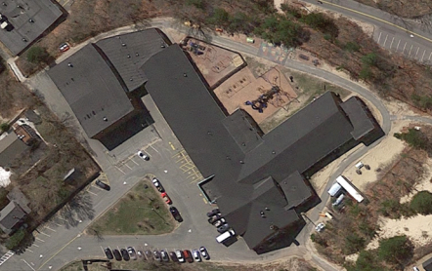

Veteran’s Memorial Building complex

Picture 2
Northwest Addition Southwest Addition
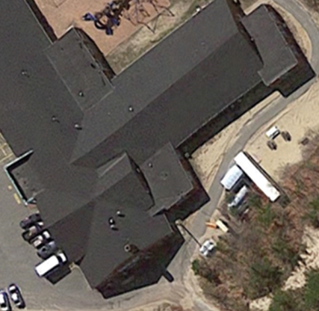

Flat roof sections of PCA that appear to be additions to original building (arrows)

Picture 3
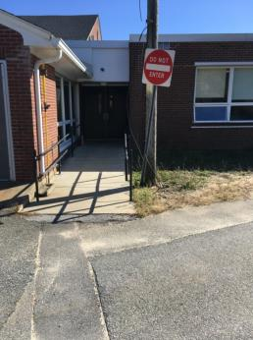
Exterior door with ramp
Picture 4
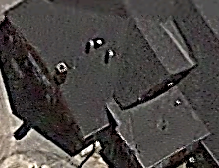
Roof valley directs water toward northwest addition
Picture 5
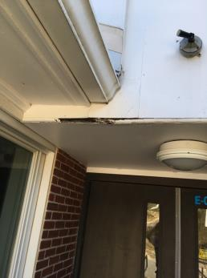
Rotten wood beneath gutter
Picture 6
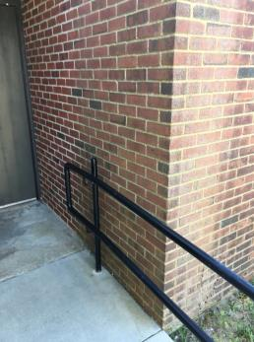
Green discoloration/moss on NW addition wall
Picture 7
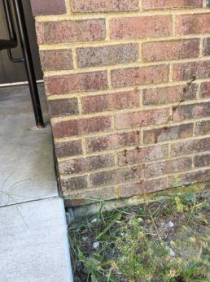
Seam between ramp and NW wall
Picture 8
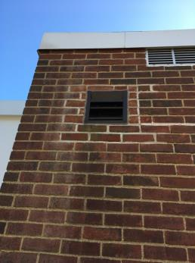
Open vent (arrow) on NW addition exterior wall
Location | Carbon  Dioxide  (ppm) | Carbon Monoxide  (ppm) | Temp  (°F) | Relative  Humidity  (%) | PM2.5  (µg/m³) | Occupants  in Room | Windows  Openable | Ventilation |  | Remarks
 |  |  |  |  |  |  |  | Supply | Exhaust
Background (outdoors) | 353 | ND | 71 | 56 | 12
Pool table room | 394 | ND | 72 | 55 | 8 | 0 | Y | Y | Y
Recreation | 584 | ND | 72 | 58 | 4 | 0 | Y | Y | Y | 10+ water-damaged ceiling tiles
Front desk | 411 | ND | 72 | 56 | 7 | 0 | N | Y | Y | 4 water-damaged ceiling tiles, plants
Dining room | 402 | ND | 72 | 57 | 7 | 1 | Y | Y | Y | Plants
Kitchen | 435 | ND | 72 | 56 | 8 | 0 | N | N | Y
Stage | 402 | ND | 74 | 53 | 8 | 0 | N | Y | Y
Media center | 407 | ND | 72 | 53 | 5 | 1 | Y | Y | Y
PCA office | 446 | ND | 72 | 56 | 7 | 2 | Y | Y | Y | 10+ water-damaged ceiling tiles, plants, wall-to-wall carpeting, odor of carpet deodorizer
PCA director | 419 | ND | 73 | 55 | 7 | 1 | Y | Y | N
71 | 428 | ND | 72 | 58 | 9 | 0 | N | N | N | 5 water-damaged ceiling tiles
73 | 392 | ND | 72 | 56 | 8 | 18 | Y | Y | Y | 10+ water-damaged ceiling tiles
74 | 436 | ND | 71 | 54 | 4 | 0 | Y | Y | Y
75 | 395 | ND | 71 | 57 | 8 | 0 | Y | Y | Y
88 | 428 | ND | 74 | 54 | 7 | 0 | N | Y | Y
89 | 391 | ND | 73 | 55 | 5 | 0 | Y | Y | Y | Plants
90 | 433 | ND | 73 | 53 | 6 | 0 | Y | Y | Y
91 | 448 | ND | 74 | 54 | 6 | 0 | Y | Y | Y
93 | 416 | ND | 74 | 55 | 8 | 0 | Y | Y | Y
101 | 555 | ND | 72 | 57 | 7 | 1 | N | Y | N | 1 water-damaged ceiling tile
106 | 447 | ND | 73 | 55 | 8 | 1 | Y | Y | N

