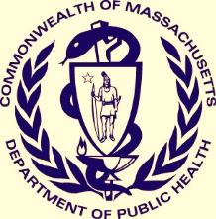
COVID-19 DATA BRIEF 2020
SUICIDAL IDEATION IN MASSACHUSETTS
SUICIDES, SUICIDE ATTEMPTS, AND
Injury Surveillance Program, Massachusetts Department of Public Health Fall 2021
Suicides are a significant yet largely preventable public health problem. The COVID-19 pandemic has placed a renewed focus on mental health, and the purpose of this bulletin is to provide information for practitioners and suicide prevention specialists on the magnitudes, trends, and risk factors of suicides, suicide attempts, suicidal ideation, and mental health in Massachusetts during the pandemic. While “suicide” refers to those who die by suicide, “suicidal ideation” refers to those who have thoughts of suicide and may be at higher risk of dying by suicide. “Suicide attempt” refers to self-directed injurious behaviors with the intent to die, but the outcome is nonfatal. A suicide attempt may or may not result in injury to that person. The Massachusetts Department of Public Health’s (DPH) Suicide Prevention Program works in collaboration with multiple national, state, and local partners to reduce these deaths and injuries.
COVID-19 and Mental Health

Days of Poor Mental Health
- Please note that due to differences in how the Massachusetts Behavioral Risk Factor Surveillance Survey (BRFSS) and the COVID-19 Community Impact Survey (CCIS) are administered, caution should be made when making any direct comparisons between these two surveys. Some of the differences in magnitudes observed here may be partially explained by differences in sampling methods.

- The BRFSS is an annual telephone survey that collects information on the health issues and risk factors of adults across the state. Survey participants were asked how many days over the past month was their mental health not good, with poor mental health being defined as having 15 or more days of poor mental health in the past month. Among those age 25 or older between 2017 and 2019:

- Around 10% of respondents reported poor mental health in the past month.
- Around 9% of males reported poor mental health, compared to 12% of females.
- Younger age groups were more likely to report poor mental health compared to older age groups.

- Between September and November of 2020, the Massachusetts Department of Public Health conducted the CCIS to assess the needs of those impacted by the pandemic. When asked about their mental health, 33% of respondents reported poor mental health within the past month (i.e. between August and October of 2020) (see Figures 1a and 1b).
Sources: MA Behavioral Risk Factor Surveillance System 2017, 2018, 2019, weighted data; MA COVID-19 Community Impact Survey
Table 1. Proportion of CCIS Respondents Reporting 15 or More Days of Poor Mental Health in the Past Month

Demographic Group | Percent
Gender Identity
Male (REF) | 26%
Female* | 34%
Non-Binary* | 68%
Questioning/Not Sure* | 79%
Of Trans Experience* | 62%
Not of Trans Experience (REF) | 33%
Sexual Orientation
Heterosexual (REF) | 31%
Gay or Lesbian* | 41%
Bi/Pansexual* | 55%
Asexual* | 39%
Queer* | 59%
Questioning/Not Sure* | 58%
Age
25-34* | 43%
35-44* | 41%
45-64* | 31%
65+ (REF) | 20%
Race/Ethnicity
White, non-Hispanic (REF) | 33%
Black, non-Hispanic | 32%
Asian, non-Hispanic* | 25%
Hispanic/Latinx* | 35%
American Indian/Alaska Native* | 38%
Multiracial, non-Hispanic* | 49%
Demographic Group | Percent
Income
<$35K* | 42%
$35-74,999K* | 35%
$75-99,999K* | 33%
$100-149,999K* | 31%
$150K+ (REF) | 26%
Education
Less than High School | 36%
High School or GED | 32%
Trade School/Vocational School | 33%
Some College* | 38%
Associate Degree* | 35%
Bachelor’s Degree (REF) | 32%
Graduate Degree* | 29%
Disability†
Blind/Vision Impaired* | 49%
Deaf/Hard of Hearing | 34%
Cognitive Disability* | 72%
Mobility Disability* | 44%
Self-Care/Ind. Living Disability* | 56%
Caregiver
Caretaker of Adult with Special Needs* | 46%
Not a Caretaker (REF) | 33%
Language Spoken
English Only (REF) | 33%
Language Other Than English | 34%
Overall | 33%
Source: MA COVID-19 Community Impact Survey
* Denotes rate is significantly different (p < 0.05) compared to the reference group (REF)
† Reference group for this demographic was those without the disability listed (not included)

- The CCIS found that certain demographic groups reported rates of poor mental health significantly above their respective reference group (noted by ‘REF’ in Table 1 above), highlighting the need to address the health inequities these groups currently face (See Table 1).

- LGBTQ+ respondents were among those most affected by poor mental health. Of the groups listed in Table 1, four of the top five groups reporting the highest rates of poor mental health were LGBTQ+, including those questioning their gender identity, non-binary respondents, those of trans experience, and queer respondents.

- Respondents with disabilities also reported significantly higher rates of poor mental health compared to those without disabilities. In particular, those with cognitive disabilities (72%) and self-care/independent living disabilities (56%) reported especially high rates of poor mental health.

- Among race/ethnicity groups, multiracial respondents reported the highest rates of poor mental health (49%), followed by American Indian/Alaska Natives (38%) and then Hispanic/Latinx respondents (35%).

- Younger respondents were significantly more likely to report poor mental health compared to older respondents.

- Respondents with low incomes were significantly more likely to report poor mental health compared to respondents with higher incomes. In addition, a strong correlation between income and mental health was found, as the proportion of respondents reporting poor mental health went down with each successive increase in the income group.

- Respondents with lower educational attainment tended to have higher rates of poor mental health, although there was not as strong a correlation with education as there was with income. Those with some college education had the highest rates of poor mental health (38%).

- For more information on the CCIS, visit https://www.mass.gov/info-details/covid-19-community-impact-survey.

COVID-19 and Suicidality

Syndromic Surveillance Program
Since January 2019, the Massachusetts Syndromic Surveillance Program has been collecting data from 100% of emergency department (ED) visits within the state. Real time data is transmitted from ED facilities, including data on the reason for the visit and basic patient demographic information. Data are collected at the visit level, so an individual patient may have multiple visits. The Syndromic Surveillance Program relies on definitions created by the CDC to capture ED visits for certain syndromes, such as suicidal ideation and suicide attempts. Figure 2 below shows the number of ED visits per month in Massachusetts for all reasons, suicidal ideation, and suicide attempt between January 2019 and May 2021.

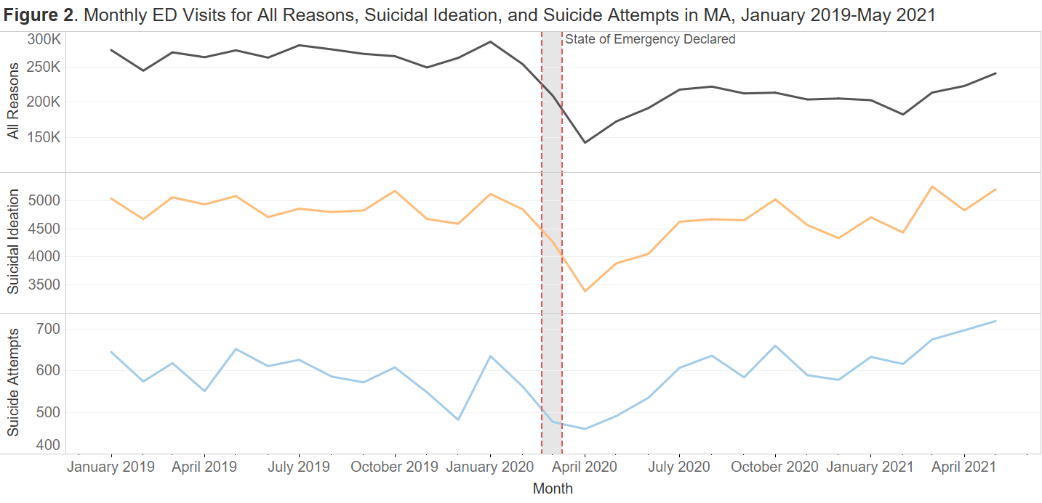
Source: Massachusetts Syndromic Surveillance Program

ED Visit Trends
- Throughout 2019 and early 2020, ED visits across all three syndromes remained relatively constant. Between January 2019 and February 2020, there was an average of 266,290 total monthly ED visits, 4,882 monthly ED visits related to suicidal ideation, and 591 monthly ED visits related to suicide attempts.

- As the COVID-19 pandemic began to unfold, and a state of emergency was declared in early March of 2020, ED visits sharply declined. Between January and April of 2020, total monthly ED visits declined 50%, ED visits for suicidal ideation declined 34%, and ED visits for suicide attempts declined 28%.

- Since April 2020, ED visits across all three syndromes have risen. However, as of May 2021, total monthly ED visits are still down 16% from their peak in January 2020. Conversely, ED visits for both suicidal ideation and suicide attempts in May 2021 are at their highest levels since full reporting began in 2019.

- While recent trends in suicide-related ED visits are rising, the range of data currently available is still limited. Syndromic surveillance started collecting complete data from all facilities in Massachusetts in January 2019, so there are currently only two and a half years of complete data to analyze. Nevertheless, the recent increase in suicide-related ED visits continues to be of concern. DPH will continue to monitor ED trends to see if increasing ED cases continue throughout the summer and will provide updates as needed.

Suicidal Ideation and Suicide Attempts
While recent trends in ED visits show an overall increase in the number of visits related to suicidal ideation and suicide attempts, differences exist by sex and age. Specifically, we noticed that compared to other sex and age groups, females under age 25 saw the largest relative increase in ED visits related to suicide since the start of the pandemic. Figure 3 below shows the number of ED visits per month in Massachusetts for all reasons, suicidal ideation, and suicide attempt between January 2019 and May 2021 by sex for youth between age 0 and 24.

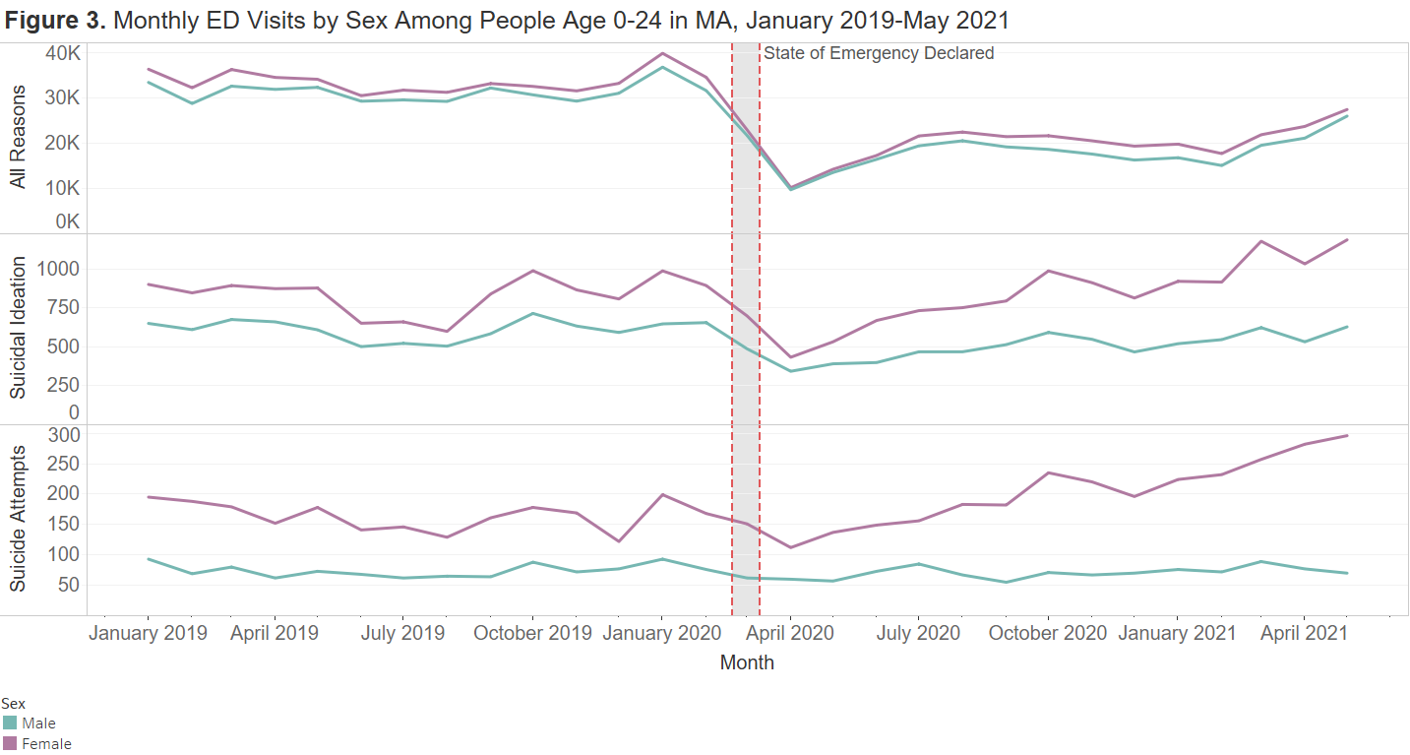
Source: Massachusetts Syndromic Surveillance Program

ED Visit Trends Among Youth Age 0-24
- Throughout 2019 and early 2020, ED visits among youth remained relatively stable, with females consistently having more visits than males. Although females experience higher rates of suicidal ideation and suicide attempts compared to males, females experience much lower rates of suicide deaths (see the following page for more information on recent suicide deaths).

- ED visits sharply declined for youth during the start of the COVID-19 pandemic, even more so than other age groups. Between January 2020 and April 2020, total monthly ED visits declined 74%, ED visits for suicidal ideation declined 52%, and ED visits for suicide attempts declined 41%.

- Since April 2020, ED visits have started to rebound. While total ED visits for youth are still down 30% from what they were in January 2020, the same is not true for ED visits related to suicidal ideation and suicide attempts, especially among female youth. As of May 2021, ED visits for suicidal ideation are 10% higher, and ED visits for suicide attempts are 23% higher than what they were in January 2020.

- Increases in ED visits among youth are almost exclusively driven by increases in ED visits among female youth. As of May 2021, ED visits for suicidal ideation among female youth are 19% higher than what they were in January 2020, and ED visits for suicide attempts among female youth are 29% higher than what they were in January 2020.

- Increases in ED visits among females currently appears limited to female youth. In January 2019, female youth comprised 40% of suicidal ideation ED visits and 52% of suicide attempt ED visits among all females. As of May 2021, those proportions rose to 47% and 61%, respectively.

COVID-19 and Suicides

Increases in people experiencing poor mental health coupled with recent rises in ED visits for suicidal ideation and suicide attempts, especially among female youth, has led to questions about whether there has been a corresponding increase in suicide deaths during the COVID-19 pandemic. For information on recent suicide deaths, the Department of Public Health uses datasets from the Registry of Vital Records and Statistics (RVRS), which collects demographic and injury data from death certificates across Massachusetts. Figure 4 below shows the number of suicide deaths by sex and month for 2019 and 2020:
State of Emergency
Declared
Source: Registry of Vital Records and Statistics (RVRS) 2019-2020. Caveat of preliminary data: Please be advised that these data are preliminary and subject to change. Raw preliminary data may be incomplete or inaccurate, have not been fully verified, and revisions are likely to occur following the production of these data. The Department strongly cautions you regarding the accuracy of statistical analyses based on preliminary data and particularly with regard to small numbers of events.

Suicide Death Trends
- Based on preliminary death data, there were 642 suicides in 2019 and 615 suicides in 2020. These numbers represent a decline in suicides for Massachusetts, which had been rising for several years and peaked in 2018 with 725 suicides. Nationally, suicide rates declined by 2.1% in 2019, but Massachusetts was one of only five states to see a statistically significant decline in suicides between 2018 and 2019.

- Between January 2019 and February 2020, Massachusetts averaged 54 suicide deaths per month. Between March and December of 2020, Massachusetts averaged 51 suicide deaths per month, indicating that suicide deaths continued to decline despite an increase in overall poor mental health during the COVID-19 pandemic.

- Despite recent increases in suicide-related ED visits among female youth, there has not yet been a corresponding increase in suicide deaths among this group. In 2019, there were 19 suicides among females age 0-24, and in 2020, there were 20 suicides, which are in line with what has been observed in previous years and a slight decrease from what was seen in 2018 (N=22).
Inequities in Suicide

While preliminary data shows that overall suicide deaths have fallen in Massachusetts since 2018, those decreases have not been consistent across all demographic groups. In fact, certain groups saw an increase in suicides in 2020 compared to 2019. Table 2 shows the number of suicides in 2019 and 2020 by select demographic groups as well as the percent change in suicides between those two years.

Table 2. Suicides by Selected Demographic Groups in Massachusetts, 2019-2020
- Overall, suicides in Massachusetts in 2020 were 4% lower than what they were in 2019.

- Suicides fell for both sexes, but the decrease among females was larger compared to males.

- Despite the recent increases in ED visits related to suicide among youth, particularly among females, youth suicides actually declined slightly in 2020 compared to 2019. Conversely, there were substantial increases in the number of suicides among middle-age and older adults, which already have the highest suicide rates in Massachusetts.

- Suicides among white, non-Hispanic and Black, non-Hispanic individuals decreased in 2020. However, suicides among Asian, non-Hispanic and Hispanic/Latinx individuals rose in 2020. Additionally, these two race/ethnicities were one of the few groups to see increases in the number of suicides between 2018 and 2019.

- Most counties saw decreases in the number of suicides in 2020. However, three of the four counties that saw an increase in suicides – Barnstable, Bristol, and Norfolk counties – are concentrated in the southeastern portion of the state.
Demographic Group | 2019 | 2020 | Percent Change
Sex
Male | 487 | 471 | -3%
Female | 155 | 144 | -7%
Age
0-14 | 3 | 4 | *
15-24 | 68 | 66 | -3%
25-34 | 101 | 98 | -3%
35-44 | 97 | 95 | -2%
45-54 | 117 | 126 | +8%
55-64 | 153 | 105 | -31%
65-74 | 65 | 79 | +22%
75-84 | 27 | 25 | -7%
85+ | 11 | 17 | +55%
Race/Ethnicity
White, non-Hispanic | 547 | 518 | -5%
Black, non-Hispanic | 32 | 22 | -31%
Asian, non-Hispanic | 21 | 26 | +24%
Hispanic/Latinx | 40 | 45 | +13%
Other/Unknown | 2 | 4 | *
County of Injury
Barnstable | 21 | 31 | +48%
Berkshire | 22 | 19 | -14%
Bristol | 54 | 59 | +9%
Dukes | 2 | 2 | *
Essex | 72 | 59 | -18%
Franklin | 15 | 12 | -20%
Hampden | 44 | 39 | -11%
Hampshire | 18 | 17 | -6%
Middlesex | 114 | 117 | +3%
Nantucket | 2 | 1 | *
Norfolk | 48 | 51 | +6%
Plymouth | 53 | 51 | -4%
Suffolk | 57 | 44 | -23%
Worcester | 88 | 74 | -16%
Total | 642 | 615 | -4%
* Percent change in suicide not calculated for groups with fewer than 6 suicides in either 2019 or 2020.

Source: Registry of Vital Records and Statistics (RVRS) 2019-2020. Caveat of preliminary data: Please be advised that these data are preliminary and subject to change. Raw preliminary data may be incomplete or inaccurate, have not been fully verified, and revisions are likely to occur following the production of these data. The Department strongly cautions you regarding the accuracy of statistical analyses based on preliminary data and particularly with regard to small numbers of events.

Requesting Suicide Prevention and Crisis Management Resources
As part of the CCIS, respondents were asked what mental health services would be most helpful to them. Among the options were suicide prevention and crisis management resources. Across the survey, about 2% of respondents cited that suicide prevention resources would be helpful to them. However, that percentage varied across demographics, with some groups reporting rates as high as 17%. The CCIS was also able to capture the needs of several groups that were not previously known due to low sample size in previous surveys or data that is not collected in surveillance systems. Table 3 lists the proportion of respondents who would like suicide prevention resources from several key demographics:

Table 3. Proportion of Respondents Requesting Suicide Prevention and Crisis Management Resources

Demographic Group | Percent
Gender Identity
Male | 2%
Female | 1%
Non-Binary | 11%
Questioning/Not Sure | 17%
Of Trans Experience | 11%
Not of Trans Experience | 2%
Sexual Orientation
Heterosexual | 1%
Gay or Lesbian | 2%
Bi/Pansexual | 7%
Asexual
Queer | 7%
Questioning/Not Sure | 7%
Age
25-34 | 4%
35-44 | 2%
45-64 | 1%
65+ | <1%
Race/Ethnicity
White, non-Hispanic | 1%
Black, non-Hispanic | 3%
Asian, non-Hispanic | 2%
Hispanic/Latinx | 4%
American Indian/Alaska Native | 3%
Multiracial, non-Hispanic | 4%
Source: MA COVID-19 Community Impact Survey
Demographic Group | Percent
Income
<$35K | 3%
$35-74,999K | 2%
$75-99,999K | 1%
$100-149,999K | 1%
$150K+ | 1%
Education
Less than High School | 3%
High School or GED | 2%
Trade School/Vocational School | 2%
Some College | 2%
Associate Degree | 2%
Bachelor’s Degree | 2%
Graduate Degree | 1%
Disability
Blind/Vision Impaired | 5%
Deaf/Hard of Hearing | 1%
Cognitive Disability | 8%
Mobility Disability | 3%
Self-Care/Ind. Living Disability | 5%
Caregiver
Caretaker of Adult with Special Needs | 4%
Not a Caretaker | 2%
Language Spoken
English Only | 3%
Language Other Than English | 1%
Overall | 2%

- LGBTQ+ populations were among the groups most likely to request suicide prevention services, in particular respondents questioning their gender identity (17%), of trans experience (11%), or who are non-binary (11%). Respondents identifying as bi/pansexual, queer, or questioning their sexual orientation also reported higher rates of requesting suicide prevention services (7%).

- Respondents who reported disabilities were also more likely to request suicide prevention services, including respondents with cognitive disabilities (8%), who are blind/vision impaired (5%), or who have self-care/independent living disabilities (5%). In addition, caregivers of adults with special needs also reported higher rates of requesting suicide prevention services (4%).

- Additional subpopulations that reported higher rates of requesting suicide prevention services include:
  - Younger respondents
  - Hispanic/Latinx respondents
  - Multiracial respondents
  - Respondents with lower incomes
  - Respondents with lower educational attainment
  - Respondents who speak a language other than English

Conclusions and Summary

Suicide remains a major public health problem. Although Massachusetts has one of the lowest suicide rates in the country, we can continue to improve upon this work, especially as it relates to eliminating health inequities. Below are some of the highlights of suicide-related data that DPH has analyzed during the COVID-19 pandemic and some of the programs currently in progress to help address suicide in Massachusetts. Namely, there have been some concerning recent trends regarding increases in poor mental health and suicide-related ED visits. Despite these increases, as of December 2020, there has not yet been a corresponding increase in suicide deaths. However, we know that there is a strong association between mental health and the life stressors people experience, from employment to discrimination to accessing affordable food, housing, and healthcare, among many others. We also know that the COVID-19 pandemic has exacerbated many of these stressors. Although access to clinical mental health services is critical, without also addressing the root causes of these other stressors, it is possible that we may see an increase in suicides in the near future.
Another issue worth addressing is the need for a better system of care for individuals experiencing suicidal ideation. While the ED may be one of the most common referral locations for those individuals, it may not always be the best place for them. Recently, boarding in the ED has become an issue due to the lack of beds, especially among youth. Therefore, alternatives to the ED need to be considered, especially when the ED may not be an option for certain individuals.
Mental Health
- Data from the CCIS showed that the proportion of respondents experiencing poor mental health is higher than what was reported in the BRFSS in 2019. Although the rate of poor mental health has increased across the board, there are still subpopulations that remain disproportionately affected by poor mental health, including females, youth, LGBTQ+ individuals, Hispanic/Latinx individuals, individuals with lower income, and individuals with disabilities.
- For additional information and results regarding the CCIS, including additional breakdowns in mental health data, visit https://www.mass.gov/info-details/covid-19-community-impact-survey.
Suicidal Ideation and Suicide Attempts
- While ED visits for suicidal ideation and suicide attempts decreased at the start of the pandemic (likely because of stay at home orders and people’s hesitation to go to the hospital), suicide-related ED visits have been rising since April 2020. As of May 2021, the number of ED visits for suicidal ideation and suicide attempts are the highest they have been since complete reporting started in January 2019.
- Increases in suicide-related ED visits have been driven mainly by increases in ED visits among female youth. Females under the age of 25 have experienced the greatest increase in suicide-relate ED visit rates.
Suicide Deaths
- Despite these increases in poor mental health and suicide-related ED visits, Massachusetts has not yet seen a corresponding increase in suicide deaths, either overall or among female youth.
- 2018 saw the greatest number of suicides in Massachusetts (n=725). Since then, overall suicides declined in both 2019 (n=642) and 2020 (n=615). 2020 saw the lowest number of suicides since 2014, and this is the first time that overall suicides declined for 2 years in a row since the Massachusetts Violent Death Reporting System (MAVDRS) began reporting in 2003. Despite those successes, disparities remain. Suicides increased in 2020 for several subpopulations, including older individuals, Asian/Pacific Islanders, and Hispanic/Latinx individuals.
DPH Initiatives Addressing Suicide
- DPH offers Signs of Suicide (S.O.S.), a suicide prevention curriculum for middle and high school students, at no cost to any school in Massachusetts.
- DPH works with the Department of Mental Health to offer Zero Suicide Learning Collaboratives across the state.
- DPH’s Suicide Prevention Program is the recipient of a CDC Comprehensive Suicide Prevention Grant aimed to reduce suicides, suicide attempts, and suicidal ideation among high risk populations, including working age men, Hispanic/Latinx men, veterans/military workers, and high-risk occupations.

Where to go for help
__________________

MA Coalition for Suicide Prevention
(617) 297-8774
info@masspreventssuicide.org
__________________

24 hour help line

NATIONAL SUICIDE PREVENTION LIFELINE
https://suicidepreventionlifeline.org/
(800) 273-TALK (8255)
Over 150 languages offered
Press 1 for Veterans
TTY: (800) 799-4TTY (4889)
For more information, contact these programs at
Massachusetts Department of Public Health,
250 Washington Street,
Boston, MA 02108

INJURY SURVEILLANCE PROGRAM (ISP)
Bureau of Community Health and Prevention (BCHAP)
(617) 624-5664 (MAVDRS)
(617) 624-5648 (General injury information)
http://mass.gov/injury-surveillance-program

SUICIDE PREVENTION PROGRAM (SPP)
Bureau of Community Health and Prevention (BCHAP)
(617) 624-5460
http://mass.gov/suicide-prevention-program

BUREAU OF SUBSTANCE ADDICTION SERVICES (BSAS)
(800) 327-5050
TTY: (888) 448-8321
http://mass.gov/orgs/bureau-of-substance-addiction-services

Population-Specific Suicide Prevention Resources

American Indians | Indian Health Service Suicide Prevention | www.ihs.gov/suicideprevention/
Asian Americans | Asian American Suicide Prevention and Education | https://aaspe.net/
Attempt Survivors | Lifeline for Attempt Survivors | https://lifelineforattemptsurvivors.org/
College Students | The Jed Foundation | www.jedfoundation.org/
Disabilities | The Live On Movement | http://liveon.net/
LGBTQ+ | Massachusetts Commission on LGBTQ+ Youth | https://www.mass.gov/orgs/massachusetts-commission-on-lgbtq-youth
 | Massachusetts Transgender Political Coalition | www.masstpc.org/suicide-prevention/
 | Trans Lifeline | https://translifeline.org/
 | The Trevor Project | www.thetrevorproject.org/
Men of Working Age | MassMen | www.massmen.org/
Military Service Members/Veterans | Defense Suicide Prevention Office | www.dspo.mil/
 | Department of Veterans Affairs Suicide Prevention | www.mentalhealth.va.gov/suicide_prevention/
 | Statewide Advocacy for Veterans’ Empowerment | https://www.mass.gov/service-details/statewide-advocacy-for-veterans-empowerment-save
 | Veterans Crisis Line | www.veteranscrisisline.net/
People of Color | National Organization for People of Color Against Suicide (NOPCAS) | http://nopcas.org/
Youth | Youth.gov | https://youth.gov/youth-topics/youth-suicide-prevention
Recursos en Español | Red Nacional de Prevención del Suicidio | https://suicidepreventionlifeline.org/help-yourself/en-espanol/

O’Connor E, Gaynes B, Burda BU, et al. Screening for Suicide Risk in Primary Care: A Systematic Evidence Review for the U.S. Preventive Services Task Force [Internet]. Rockville (MD): Agency for Healthcare Research and Quality (US); 2013 Apr. (Evidence Syntheses, No. 103.) Table 1, Definitions of Suicide-Related Terms. Available from: https://www.ncbi.nlm.nih.gov/books/NBK137739/table/ch1.t1/
Stone DM, Jones CM, Mack KA. Changes in Suicide Rates — United States, 2018–2019. MMWR Morb Mortal Wkly Rep 2021;70:261–268. DOI: http://dx.doi.org/10.15585/mmwr.mm7008a1
CDC – National Center for Health Statistics – Suicide Mortality by State. https://www.cdc.gov/nchs/pressroom/sosmap/suicide-mortality/suicide.htm. February 11, 2021.

