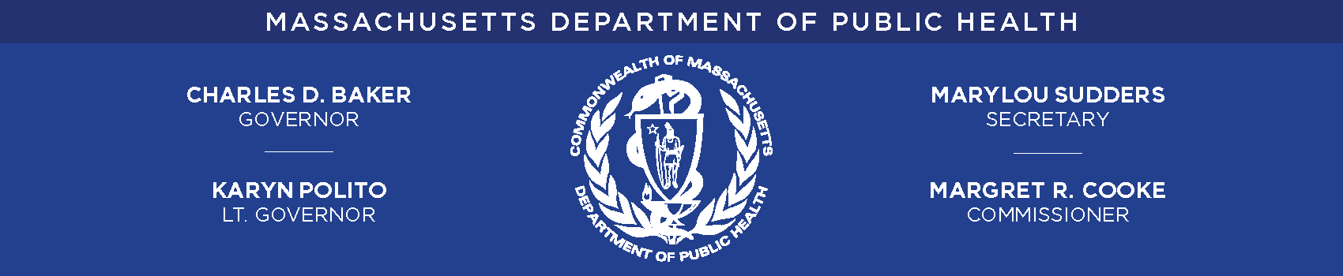
COVID-19 Frontline Healthcare Worker Study:
Legislative Report
January 2023

Legislative Mandate
Pursuant to Section 123 of Chapter 24 the Acts of the Acts of 2022:
The department of public health shall conduct a study and report on the effects of the outbreak of the 2019 novel coronavirus, also known as COVID-19, on frontline healthcare workers, including, but not limited to, nurses, nurse practitioners, physician assistants, certified nurse aids, physicians and other healthcare providers in the commonwealth and their families. The study shall inform current and future practices for the wellbeing and maintenance of frontline healthcare workers. The department shall examine mental health effects including, but not limited to: (i) trauma; (ii) stress related disorders; (iii) depression; (iv) anxiety; (v) substance use disorders; and (vi) suicide. The study and report shall include data on the role of the frontline healthcare worker and various demographic factors including, but not limited to: gender, race, ethnicity, geographic location and age. The study and report shall include data on frontline healthcare workers in various locations throughout the commonwealth and shall identify any trends. The department shall submit a written report with the clerks of the house of representatives and the senate, the house and senate committees on ways and means and the joint committee on public health not later than September 1, 2022.

Executive Summary
Overview
The COVID-19 pandemic is unprecedented in the past century. As of December 29, 2022, there were 2,154,886 confirmed and probable cases of COVID-19, with 22,940 confirmed and probable deaths attributed to COVID-19 among Massachusetts residents. While the physical, mental, and emotional health of many residents of the Commonwealth has been impacted by the pandemic, certain groups, particularly those working in services designated as essential, were disproportionately affected by the pandemic due to the nature of their work. This was especially true for healthcare workers. In addition to increased rates of COVID-19 infection, impacts ranged from sleep disruptions and fatigue to increased anxiety, depression, burnout, and suicide. Potential work-related stressors specific to healthcare include increased patient load, exposure to infectious patients, initial shortages in personal protective equipment (PPE) and lack of a vaccine or at-home COVID-19 testing, working outside of their areas of expertise, frequently evolving infection control and treatment guidance, frequent exposure to dying patients, fear of exposing family members to the virus, financial impacts, stigma, and isolation. Furthermore, throughout the pandemic, healthcare workers have experienced changes in employment status, being unable to physically distance when outside the home due to the nature of work, and/or using public transportation to get to work. Additionally, as the pandemic has moved through different waves, and is now entering an endemic stage, demands on healthcare workers continue to change. It should be noted that while many of the concerns from the early months of the pandemic remain, some have resolved (e.g., PPE availability, vaccines, testing). Yet the experiences of healthcare workers in the early part of the pandemic may continue to impact their well-being, and should be used to inform current and future public health practice.
In an effort to characterize the impact of the pandemic on healthcare workers in Massachusetts, this report presents findings on potential work-related stressors, as well as mental health and substance use outcomes from the Massachusetts COVID-19 Community Impact Survey (CCIS). These data are supplemented with results from relevant employment data on the healthcare worker population in Massachusetts, as well as peer-reviewed literature. In addition, this report includes a description of current activities across the Massachusetts Department of Public Health (DPH) to support mental health among healthcare workers.
Healthcare Worker Defined
In this report, a healthcare worker is defined as someone who works in a healthcare occupation or in a healthcare industry. Occupation describes the kind of work an individual does to earn a living (i.e., job title), while industry describes the activities in which the individual’s employer is engaged. By defining healthcare worker this way, the following types of examples are included: the custodian/environmental services worker (non-healthcare occupation) in the hospital (healthcare industry), as well as the nurse (healthcare occupation) in the elementary school (non-healthcare industry).
There are approximately 566,000 Massachusetts residents employed in healthcare, comprising 16% of the total Massachusetts workforce. The vast majority were employed in traditional healthcare industries (e,g., Ambulatory Healthcare Services, Hospitals, or Nursing and Residential Care Facilities) but an estimated 12% worked in other settings such as elementary schools. Similarly, while an estimated 62% of healthcare workers were employed in healthcare occupations (e.g., Health diagnosis and treating Practitioners, Health technologists and technicians, and Healthcare support occupations), approximately 38% worked in non-clinical roles in the healthcare industry (e.g., Health Educator, Receptionist, Social Worker, Cook, Environmental Service Worker/Custodian). The demographics (including race/ethnicity, age, and sex) of these workers are described in the body of the report.
Data on Healthcare Workers from the COVID-19 Community Impact Survey (CCIS)
In the fall of 2020, DPH administered the COVID-19 Community Impact Survey (CCIS) to better understand the most pressing health needs facing people living in Massachusetts during the pandemic. The CCIS was an online, anonymous survey administered to both adults (ages 25 years and older) and youth (ages 14-24 years) across the Commonwealth. The CCIS reached populations typically underrepresented in traditional public health surveillance data sources, including people of color, LGBTQ+ individuals, and persons with disabilities. The CCIS was a novel survey that was developed to better understand the experiences of the Commonwealth residents during the COVID-19 pandemic. Findings were used by DPH to develop programs and provide resources to support residents in response to the pandemic.
There were 33,800 adult respondents to the CCIS. The final analytic sample for this report included 19,247 employed respondents of which 5,922 were healthcare workers and 13,325 were non-healthcare workers.
As mentioned above, the CCIS was conducted in the fall of 2020. Since then, COVID-19 has moved through different waves, leading to frequently changing demands on healthcare workers. While COVID-19 mitigation strategies (e.g., vaccination, availability of PPE, home testing) have improved, many other work-related stressors remain. The findings of the CCIS reflect a critical time in the COVID-19 pandemic. By understanding the impact on healthcare workers from this first year of the pandemic, we can continue to inform current and future practices for the wellbeing and maintenance of frontline healthcare workers.
CCIS Results
Employment disruption due to the pandemic
Healthcare workers were more likely than non-healthcare workers to report increased hours due to the pandemic (11% vs. 7%). This was true for all industry and occupation groups of healthcare workers, except those in Healthcare support occupations. Yet, 1 in 5 (21%) healthcare workers reported either losing their jobs, having reduced hours, or taking leave. The most common reasons were being laid off or having hours reduced by their employers (46%), needing to take care of children (27%,) and being afraid to get COVID-19 at work (16%).
Among healthcare workers, experiences varied across industry and occupation groups. One in 4 (26%) healthcare workers in the Nursing and residential care facilities industry group and 1 in 3 (34%) workers in Healthcare support occupations reported losing their jobs, having their hours reduced, or taking leave due to the pandemic, the highest of any industry and occupation groups, respectively. These two groups were also most likely to report being worried about paying expenses in upcoming months with 1 in 2 (54%) and 2 in 3 (66%), respectively, reporting this outcome.
Working outside the home, paid sick leave, and employer-provided protections
Overall, healthcare workers were more likely than non-healthcare workers to work outside the home, i.e., be a frontline worker (64% vs. 50%), but the percentage varied across subgroups of healthcare workers. By industry, the percentage working outside the home ranged from 89% of those in Nursing and residential care facilities to 53% of healthcare workers in Ambulatory healthcare services. By occupation, the percentage ranged from 89% of each of Health diagnosis and treating practitioners and Healthcare support occupations to 50% of healthcare workers in other occupations (e.g., management, custodial, etc.).
Healthcare workers in the following demographic groups were significantly more likely to work outside the home compared to their respective reference groups: females (64%) compared to males (59%); those with less than a bachelor's degree (72%) or a bachelor's degree (59%) compared to those with a graduate degree (48%); and those with an annual household income of less than $35,000 (77%) compared to those with an annual household income of $100,000 or more (61%).
Among frontline workers overall, healthcare workers were more likely than non-healthcare workers to report having paid sick leave and employer-provided protections (personal protective equipment and additional health and safety training). Yet, the percentages were not 100%, indicating that there is still need for improvement and there was some variability across subgroups of healthcare workers.
Other potential work-related stressors
Among workers who had ever been tested for COVID-19, healthcare workers were nearly twice as likely to report testing positive compared to non-healthcare workers (8.2% vs. 4.4%). Furthermore, 1 in 6 (17%) healthcare workers in Nursing and residential care facilities reported that someone close to them died of COVID-19, the highest percentage of any subgroup of healthcare workers, and significantly higher than the percentage of non-healthcare workers (11%).
Mental health
While overall, 1 in 3 (35%) healthcare workers reported 15 or more days of poor mental health in the prior month (similar to the finding for non-healthcare workers, 34%), some subgroups of healthcare workers were more likely to experience this outcome. Among those in Nursing and residential care facilities and Healthcare support occupations, 44% and 43% respectively experienced this outcome. Healthcare workers in Nursing and residential care facilities were also more likely to report 3 or more PTSD-like reactions to the pandemic in the previous month, with 33% reporting this outcome, the highest of any subgroup of healthcare workers.
Healthcare workers in the following demographic groups were more likely to report 15 or more days of poor mental health in the prior month compared to their respective reference groups: those aged 25-34 years (44%) compared to those aged 35-44 years (40%); those who identified as female (34%) or non-binary (70%) compared to those who identified as male (27%); those of transgender experience (59%) compared to those not of transgender experience (34%); those with less than a bachelor's degree (37%) compared to those with a graduate degree (30%); those with an annual household income of less than $35,000 (47%) compared to those with annual household income of $100,000 or more (29%); those with a cognitive disability (78%) compared to those without (32%); those with a mobility disability (42%) compared to those without (34%); those with a self-care/independent living disability (73%) compared to those without (34%); and those who are deaf or hard of hearing (44%) compared to those who are not (34%).
When asked which mental health resources might be most helpful, 30% of healthcare workers chose talking with a mental health professional (either in person (15%) or via telehealth (15%) and 16% selected having a mental health application on their mobile phone or tablet. In addition, 1 out of every 65 healthcare workers (1.5%) thought that suicide prevention and crisis resources would be helpful to them.
Substance Use Disorders
Overall, approximately 3 out of 5 (60%) healthcare workers reported using any substance (i.e., legal or illegal drugs, alcohol, or tobacco) in the last 30 days, which was only slightly lower than the percentage of non-healthcare workers (62%). However, percentages varied somewhat across subgroups of healthcare workers ranging from 58% in All other non-healthcare industries to 60% in Nursing and residential care facilities; and 51% among workers in Healthcare support occupations to 62% among Health diagnosis and treating practitioners.
Half of healthcare workers (50%) reported using alcohol in the prior month, which was slightly lower than the percentage of non-healthcare workers (54%). Percentages varied somewhat across subgroups of healthcare workers ranging from: 41% in Nursing and residential care facilities to 53% in All other non-healthcare industries; and 39% among workers in Healthcare support occupations to 56% among Health diagnosis and treating practitioners.
A slightly higher percentage of healthcare workers reported using tobacco in the last 30 days (12%) compared to non-healthcare workers (11%). Healthcare workers in Nursing and residential care facilities (21%) and those working in healthcare support occupations (18%) had the highest reported percentages of tobacco use among healthcare workers by industry and occupation, respectively.
Approximately 2 out of 5 (41%) healthcare workers reported increased use of any substance, which was similar to the percentage of non-healthcare workers (42%). The findings did not vary substantially across subgroups of healthcare workers, but the percentage was slightly lower among health diagnosis and treating practitioners (38%).
Nearly a third of healthcare workers (32%) who drank alcohol reported an increase in use between February 2020 and fall of 2020. This was similar to the percentage of non-healthcare workers (34%). Among healthcare workers, the percentage did not vary much across industry groups. By occupation, percentages ranged from 30% among Health and diagnosis treating practitioners to 43% among those in Healthcare support occupations.
When asked which substance use resources might be most helpful, the highest percentage of healthcare workers selected meeting in person with a therapist (6%), followed by accessing nicotine replacement therapy (4%).
Suicide
Several external studies found that during the pandemic, there was an increase in suicide among healthcare workers as well as an increase in suicidal ideation, and that this increase may continue beyond the pandemic. While the CCIS did not measure suicidality, it did include a question asking respondents to indicate what suicide prevention resources would be most helpful. Overall, 1.5% of healthcare workers reported that suicide prevention resources would be helpful, which was similar to the percentage of non-healthcare workers (1.8%).
Examples of Current Efforts in Massachusetts to Support Mental Health Among Healthcare Workers and Related Resources
Throughout the pandemic, programs from DPH and other Commonwealth agencies aimed to support the entire workforce, including healthcare workers. Efforts were aimed both at curbing the spread of disease, thereby also aiming to alleviate some of the COVID-19-related stressors faced by these workers, as well as directly supporting mental health. For example, DPH developed a website providing mental health resources for healthcare workers experiencing stress, anxiety, and trauma, and the Bureau of Community Health and Prevention’s Injury Prevention & Control Program conducted an assessment of the impact of COVID-19 on social service providers, with a specific focus on burnout. Based on findings, they developed trainings/resources on self-care and trauma-informed practices. In collaboration with Riverside Trauma Center, an awareness campaign was also developed. In addition, the Suicide Prevention Program has continued to promote and support the operation of the National Suicide Prevention Hotline (988) and related programs, including suicide prevention trainings.
The Bureau of Health Care Safety and Quality (BHCSQ) at MPDH has also undertaken numerous initiatives during the pandemic to assist healthcare workers throughout the Commonwealth. For example, the Bureau administered the COVID-19 Outreach Project, in which DPH staff members were assigned long-term care facilities (LTCF) to call and collect real-time data about COVID-19 outbreaks, offer guidance, and connect facilities to resources. They followed up this outreach with in-depth, semi-structured interviews with staff members from these LTCFs. The results indicated that most LTCFs found the Outreach Project to be a useful source of information and resources, as well as emotional support for LTCF staff, opening opportunities for more collaborative relationships between facilities and DPH. However, facilities also felt that there could have been improvements in communication around expectations and streamlining data collection efforts across regulatory entities. All participants expressed feeling overwhelmed and emotionally drained throughout the pandemic.
In addition, pursuant to an Order issued by the Commissioner of Public Health to focus health care personnel resources on responding to COVID-19 (Commonwealth of Massachusetts, April 3, 2020), DPH directed all Massachusetts healthcare facilities to implement policies and procedures for expedited provider credentialing in their emergency management plan and transfer of licensed and certified clinical staff between healthcare facilities. To help nursing homes address staffing shortages during the pandemic, the Centers for Medicare & Medicaid Services (CMS) provided a blanket waiver for the nurse aide training and certification requirements to permit nurse aides to work for longer than four months without having completed their training. To further mitigate staffing shortages DPH coordinated and deployed clinical staffing support to facilities throughout the pandemic using the Massachusetts National Guard and Rapid Response Teams. Additionally, DPH provided PPE, COVID-19 testing supplies, and COVID-19 vaccine clinics to healthcare facilities and personnel.
DPH’s Bureau of Substance Addiction Services (BSAS) also implemented numerous policies to allow for flexibility in staffing substance use disorder (SUD) providers and staff who were already facing ongoing workforce shortages prior to the pandemic. Flexibilities include withdrawing guidelines requiring licensed SUD facilities to staff to their licensed capacity and allowing programs to staff according to the daily census of patients, providing needed flexibility to programs and staff; allowing LPNs or other Qualified Health Care Professionals (as defined by 105 CMR 164.006) to supervise nursing staff, provided that a supervisor is educationally prepared at or above the level of the nursing staff under their supervision; and allowing Opioid Treatment Programs to close one day per week, in alignment with federal regulations. Due to the persistent nature of the workforce shortage, BSAS intends to maintain these flexibilities and identify other opportunities to support staff recruitment, retention, and wellness, particularly for staff with lived experience of SUD, who may be at higher risk for relapse due to the ongoing stress and trauma associated with COVID-19.
In addition, programs such as the COVID-19 Essential Employee Premium Pay provides $500 payments to 500,000 low-income workers, and the Paid Family and Medical Leave (PFML) (Chapter 121 of the Acts of 2018) provides resources to help people in Massachusetts take paid time off for work for family or medical reasons. In addition, complaint lines were established at different agencies throughout the Commonwealth at various points of the pandemic to address concerns about COVID-19 exposure/enforcement, as well as experiences in nursing homes/health care facilities. The Massachusetts Emergency Management Agency (MEMA) and DPH continue to facilitate mask and other PPE distribution to targeted entities across the Commonwealth.

Table of Contents
Executive Summary 3
Introduction 11
Healthcare Worker Defined 13
Employment Characteristics 14
Demographic Characteristics: Healthcare Occupations 16
Demographic Characteristics: Healthcare Industries 19
COVID-19-related Trauma AMONG HEALTHCARE WORKERS: Data from the MASSACHUSETTS COVID-19 Community Impact Survey (CCIS) 22
Overview of CCIS 22
Work-Related Stressors 23
Trauma 33
Stress-related disorders 34
Post-Traumatic Stress Disorder (PTSD) 34
Depression 35
Anxiety 39
Mental Health Resources 42
Substance Use Disorders 42
Current Use 43
Increase of Any Substance 47
Substance Use Resources 50
Suicide 51
Current Efforts to Support Mental Health and Related Resources 53
Vaccine Equity Initiative 53
Related Research, Trainings, and Other Resources (Not Exhaustive) 53
Assessment of Social Service Providers During the COVID-19 Pandemic 53
Suicide Prevention Resources 54
Mental Health Resources for Healthcare Workers Experiencing Stress, Anxiety and Trauma 54
Efforts to Support the Substance Use Disorder Workforce: 55
Select Efforts to Support Healthcare Workers: 55
Other state-wide programs to support workers 56
Conclusion 57
APPENDIX 59
Relevant Questions from the Adult COVID-19 Community Impact Survey (CCIS) 59
REFERENCES 66

Introduction

The COVID-19 pandemic is unprecedented in the past century. As of December 29, 2022, there were 2,154,886 confirmed and probable cases of COVID-19, with 22,940 confirmed and probable deaths attributed to COVID-19 among Massachusetts residents (Massachusetts Department of Public Health, December 19, 2022). On March 10, 2020, Governor Baker ordered non-essential businesses to close or facilitate teleworking to curb the spread of the virus in Massachusetts, while industries designated “COVID-19 essential services” maintained operations (Commonwealth of Massachusetts, March 23, 2020). The following day, the World Health Organization (WHO) declared COVID-19 a global pandemic (World Health Organization, 2020).
While the physical, mental, and emotional health of many adults across the Commonwealth has been impacted by the pandemic, workers in many industries, particularly those working in services designated as essential (Easterly, 2021), were disproportionately affected due to the nature of their work (Hawkins et al., 2021). This was especially true for healthcare workers (Contreras et al., 2021; Washington State, 2021; Gupta et al., 2021; Hossain et al., 2020; Lu, 2020; Washington State, 2021). Previous studies have shown that those responding to tragedies suffer psychological impacts (Werner et al., 2020; Hossain et al., 2020).
Burnout is a phenomenon that has gained more attention during the pandemic. Burnout is defined as “a syndrome conceptualized as resulting from chronic workplace stress” with three aspects: “feelings of energy depletion or exhaustion; increased mental distancing from one’s job, or feelings of negativism or cynicism related to one’s job; and reduced professional efficacy” (World Health Organization, 2022c). While burnout was a growing issue prior to the pandemic, one that professional organizations recognized and sought to address, it has received considerable attention over the past two years (American Medical Association, 2022). Feelings of burnout have contributed to healthcare workers leaving the profession and can have a negative impact on patient care (Chen et al., 2021).
For healthcare workers responding to the pandemic, there may have been a “double exposure” as they dealt with stressors in the workplace as well as stressors in their personal life resulting from the pandemic (Werner et al., 2020; Rabow et al., 2021). Potential stressors include increased patient load, exposure to infectious patients, initial shortages in personal protective equipment (PPE), lack of a vaccine or at-home COVID-19 testing, working outside of their areas of expertise, frequently evolving infection control and treatment guidance, frequent exposure to dying patients, fear of exposing family members to the virus, financial impacts, stigma, and isolation (Werner et al., 2020; Hossain et al., 2020). Throughout the pandemic, healthcare workers have experienced changes in employment status, being unable to physically distance when outside the home due to the nature of work or using public transportation to get to work. Healthcare workers have also expressed concerns about being able to manage expenses and have basic needs met, as well as losing someone close to them from COVID-19 (Nowrouzi-Kia et al., 2021; Rabow et al., 2021). Insufficient sick time was also a concern, with many healthcare workers going to work while sick for fear of losing their jobs (Markkanen et al., 2021). Adding to this stress was the need for many to use public transportation to commute to their workplace, which may have increased their risk of exposure to COVID-19 (Markkanen et al., 2021). Studies have also found that from a geography standpoint, COVID-19 case rates were higher in communities with a higher percentage of workers employed in essential services, including healthcare (Hawkins, 2020). Each of these stressors may have contributed to feelings of anxiety and depression among healthcare workers. Several of these stressors were evaluated among Massachusetts workers, and findings are presented later in this report. Additionally, as the pandemic has moved through different waves, and is now entering an endemic stage, demands on healthcare workers continue to change. It should be noted that while many of the concerns from early on in the pandemic remain, and others (e.g. PPE availability, vaccines, testing) have improved. Yet the experiences of healthcare workers in the early part of the pandemic may continue to impact their wellbeing, and should be used to inform current and future public health practice.
There were notable changes in use of healthcare services during the pandemic. As in other states, Massachusetts issued limits on nonessential healthcare procedures which resulted in decreases in patient volume in some settings (e.g., doctor’s offices) and increases in others (e.g., hospitals) (State of New Jersey, 2020; State of Vermont, 2020; South Dakota, 2020; Commonwealth of Massachusetts, December 7, 2020). Limits on elective procedures meant that operating rooms were not used to capacity. Additionally, in other spaces there were increases in patient volume, notably the surges in emergency room visits and hospital admissions, which likely contributed to the feelings of burnout.
Frequently changing guidance about infection control and occupational health practices, including personal protective equipment (what to use and when) added a layer of complexity and stress to healthcare workers in the earlier phases of the pandemic. Initially, access to appropriate personal protective equipment was also of concern for many healthcare workers (Arnetz et al., 2020).
During the first two and a half years of the pandemic, the number of people working in healthcare has fluctuated as the pandemic moved through different phases. The decreases in patient volume often meant that staff were laid off or deployed to other care settings. Throughout this same period, the pandemic took a disproportionate toll on the health and wellbeing of healthcare workers. Over the course of the pandemic, healthcare workers in a variety of occupation groups have chosen to leave the profession, in levels not previously seen. This phenomenon, coupled with healthcare worker absences due to work-related COVID-19 infection, has contributed to significant staffing shortages across the care continuum (Chervoni-Knapp, 2022; Shang et al., 2020; Yang et al., 2021).
In an effort to counter these staffing shortages, regulations were changed temporarily to facilitate licensing and credentialing of healthcare workers (Commonwealth of Massachusetts, March 29, 2020). In addition, there were changes in training programs to accelerate getting workers in the field (Flotte et al., 2020). Healthcare systems were often able to call on their own staff to fill gaps in staffing. At the beginning of the pandemic, as restrictions on elective surgeries and non-urgent outpatient services such as physical therapy were implemented, some healthcare offices suspended patient care. This created a pool of staff that could be deployed elsewhere in the system to patient care needs, which often required commuting to a new location, learning procedures and protocols for a new work area, and working with new colleagues. Each of these stressors contributed to the increased stress experienced by healthcare workers (Ballantyne & Achour, 2022).
In an effort to characterize the impact of the pandemic on healthcare workers in Massachusetts, this report presents findings on mental health, substance use, and potential work-related stressors from the Massachusetts COVID-19 Community Impact Survey and highlights related data from select DPH programs. This data is supplemented with results from relevant employment data on the healthcare worker population in Massachusetts, as well as relevant peer-reviewed literature. In addition, this report includes a description of current activities across DPH to support mental health among healthcare workers.

Healthcare Worker Defined
The term “front-line healthcare worker” is a broad term that encompasses clinicians and ancillary staff, such as environmental services staff. The Council of State and Territorial Epidemiologists (CSTE) defines healthcare personnel as:
“All paid and unpaid persons working in healthcare settings, home healthcare services, or healthcare occupations within other industries (e.g., school nurses) who have the potential for exposure to patients and/or to infectious materials, including body substances, contaminated medical supplies and equipment, contaminated environmental surfaces, or contaminated air. Healthcare personnel might include, but are not limited to, physicians, nurses, nursing assistants, therapists, technicians, emergency medical service personnel, dental personnel, pharmacists, laboratory personnel, autopsy personnel, students and trainees, contractual staff not employed by the health-care facility, and persons (e.g., clerical, dietary, housekeeping, laundry, security, maintenance, administrative, billing, and volunteers) not directly involved in patient care but potentially exposed to infectious agents that can be transmitted to and from healthcare personnel and patients.”(Council of State and Territorial Epidemiologists, 2020).
The definition of healthcare workers in this report is consistent with the CSTE definition above, and thus includes anyone who works in a healthcare occupation or within the healthcare industry. Occupation describes the kind of work an individual does to earn a living (i.e., job title), while industry describes the activities the individual’s employer is engaged in. The occupation and industry groups used to define healthcare workers along with examples in each group are provided in Table 1. By defining healthcare worker this way, the following examples are included in this definition: the environmental service worker/custodian (non-healthcare occupation) in the hospital (healthcare industry), as well as the nurse (healthcare occupation) in the elementary school (non-healthcare industry).

Table 1. Occupations and industries of healthcare workers
Occupation Group (COC Range¹) | Examples
Health Diagnosis and Treating Practitioners  (3000-3260) | Pharmacist, Pediatrician, General Surgeon, Registered Nurse, Physician’s Assistant, Physical Therapist, Mental Health Therapist
Health Technologists and Technicians  (3300-3540) | Paramedic, Dental Hygienist, Phlebotomy Technician, Medical Laboratory Technician, Licensed Practical Nurse
Healthcare Support Occupations  (3600-3655) | Home Health Aide, Dental Assistant, Medical Assistant, Phlebotomist, Massage Therapist
Other Occupations of Healthcare Workers | Health Service Manager, Counselor, Health Educator, Receptionist, Social Worker, Personal Care Aide, Cook, Custodian
Industry Group (CIC Range²) | Examples
Ambulatory Healthcare Services  (7970-8180) | Physician’s Office, Dentist’s Office, Chiropractor’s Office, Outpatient Office, Home Health Services
Hospitals  (8191-8192) | General Medical Hospital, Specialist Hospital, Psychiatric Hospital, Substance Abuse Hospital
Nursing and Residential Care Facilities  (8270-8290) | Nursing Home, Residential Group Home for People with Disabilities, Hospice Clinic, Elderly Assisted Living Facility, Residential Addiction Recovery Facility
Other Industries with Healthcare Workers | Elementary School, Individual and Family Services, Vocational Rehabilitation Services, Community Housing Service
Notes: 1) COC refers to the 2010 U.S. Bureau of Census Occupation Codes. 2) CIC refers to the 2012 U.S. Bureau of Census Industry Codes.

Employment Characteristics

We used 2015-2019 Current Population Survey (CPS) data to describe the healthcare workforce in Massachusetts immediately preceding the start of the COVID-19 pandemic. As shown in Table 2, in the years leading up to 2020, there were approximately 566,000 people employed as healthcare workers each year in Massachusetts, comprising 16% of the total Massachusetts workforce. The vast majority (88%) were employed in traditional healthcare industries – Ambulatory healthcare services, Hospitals, or Nursing and residential care facilities - but an estimated 12% worked in other settings such as elementary schools. Similarly, while an estimated 62% of healthcare workers were employed in healthcare occupations – Health diagnosis and treating practitioners, Health technologists and technicians, Healthcare support occupations – 38% worked in non-clinical roles such as medical and health services managers in the healthcare industry. Figure 1 shows the breakdown of occupational groups within each industry group. Note that workforce data were not available from the CPS by sub-state geography, thus the data below presents statewide data.

Table 2. Average annual number of healthcare workers by industry and occupation, Healthcare, Massachusetts, 2015-2019
Industry/Occupation | Average annual number of workers¹ | Percent of healthcare workforce, %
Total Massachusetts Workforce | 3,563,000 | -
Total Healthcare Workforce | 566,000 | 100.0
Industry Group | Average annual number of workers¹ | Percent of healthcare workforce, %
Ambulatory Healthcare Services | 216,000 | 38.2
Hospitals | 215,000 | 38.0
Nursing and Residential Care Facilities | 70,000 | 12.4
Healthcare workers in other settings | 65,000 | 11.5
Occupation Group | Average annual number of workers¹ | Percent of healthcare workforce, %
Health Diagnosis and Treating Practitioners | 186,000 | 32.9
Health Technologists and Technicians | 66,000 | 11.7
Healthcare Support Occupations | 100,000 | 17.7
Non-healthcare Occupations | 214,000 | 37.8
Note: 1) Data Source: 2015-2019 Current Population Survey, National Institute for Occupational Safety and Health Employment Labor Force (NIOSH ELF) query system, https://wwwn.cdc.gov/Wisards/cps/cps_estimates.aspx.

Figure 1. Average annual percent of healthcare workers by industry and occupation, Massachusetts, 2015-2019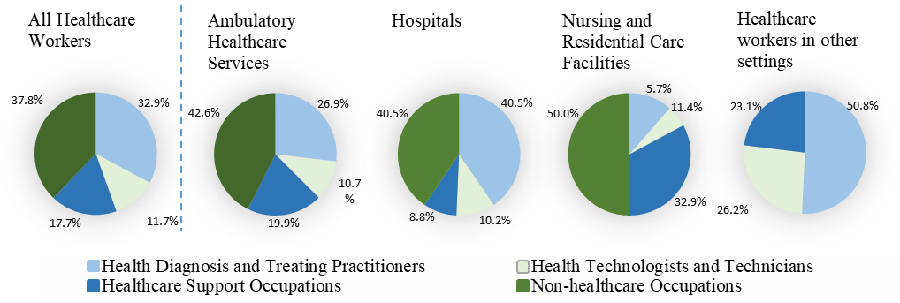
Massachusetts had an annual average of 251,204 establishments in the healthcare industry sector per year from 2015-2019 (Table 3). Wage information for healthcare occupations is presented in Table 4 and shows a range of values across the occupations.

Table 3. Average annual number of establishments in the healthcare industry, Massachusetts, 2015-2019
Industry | Average annual number of establishments¹ | Percent of healthcare establishments, %
Total Massachusetts Establishments | 251,204 | -
Healthcare Industry | 13,740 | 100.0
Ambulatory Healthcare Services | 11,024 | 80.2
Hospitals | 266 | 1.9
Nursing and Residential Care Facilities | 2,449 | 17.8
Note: 1) Data Source: 2015-2019 Quarterly Census of Employment and Wages. Establishment = a single economic unit, typically at one physical location, that produces goods or services.

Table 4. Wage information for healthcare occupations, Massachusetts, 2019
Healthcare Occupation Group | Specific occupations - within COC healthcare occupations (COC code)¹ | Median hourly wage, $² | Median annual wage, $²
Total Massachusetts Workforce | All Occupations | 24.14 | 50,200
Health Diagnosis and Treating Practitioners (COC: 3300-3540) | Registered Nurses (3255) | 42.09 | 87,540
Health Diagnosis and Treating Practitioners (COC: 3300-3540) | Physicians and Surgeons (3060) | ** | **
Health Diagnosis and Treating Practitioners (COC: 3300-3540) | Pharmacists (3050) | 59.39 | 123,530
Health Diagnosis and Treating Practitioners (COC: 3300-3540) | Therapists, All Other (3245) | 29.72 | 61,820
Health Diagnosis and Treating Practitioners (COC: 3300-3540) | Physical Therapists (3160) | 43.96 | 91,440
Health Technologists and Technicians (COC: 3300- 3540) | Licensed Practical and Licensed Vocational Nurses (3500) | 28.03 | 58,290
Health Technologists and Technicians (COC: 3300- 3540) | Health Practitioner Support Technologists and Technicians (3420) | 16.61 – 26.90 | 30,390 – 55,950
Health Technologists and Technicians (COC: 3300- 3540) | Clinical Laboratory Technologists and Technicians (3300) | 27.69 | 57,600
Health Technologists and Technicians (COC: 3300- 3540) | Diagnostic Related Technologists and Technicians (3320) | 34.84 – 41.51 | 72,470 – 86,330
Health Technologists and Technicians (COC: 3300- 3540) | Dental Hygienists (3310) | 41.62 | 86,560
Healthcare Support Occupations (COC: 3600- 3655) | Nursing, Psychiatric, and Home Health Aides (3600) | 15.01 – 17.21 | 31,210 – 35,790
Healthcare Support Occupations (COC: 3600- 3655) | Medical Assistants (3645) | 19.6 | 40,770
Healthcare Support Occupations (COC: 3600- 3655) | Dental Assistants (3640) | 23.29 | 48,450
Healthcare Support Occupations (COC: 3600- 3655) | Healthcare Support Workers, All Other, Including Medical Equipment Preparers (3655) | 17.27 – 23.30 | 35,910 – 48,470
Healthcare Support Occupations (COC: 3600- 3655) | Massage Therapists (3630) | 24.61 | 51,180
Notes: 1) COC = Census Occupation Code; Five leading occupations for respective essential service group; 2) Data Source: U.S. Bureau of Labor Statistic Occupational Employment Statistics (OES), Massachusetts May 2019, https://www.bls/oes/2019/may/oes_ma.htm; OES 2019 data on wages are for occupations across industries, not industry-specific; **Median annual wage is unavailable

Demographic Characteristics: Healthcare Occupations

The demographic characteristics of workers in healthcare occupations vary by occupation group. Figures 2-4 below provide details on these demographic characteristics (e.g., race/ethnicity, age, and sex), comparing each healthcare occupation group to Massachusetts as a whole.

Figure 2. Average annual percent of workers by healthcare occupation groups and race/ethnicity, Massachusetts, 2015-2019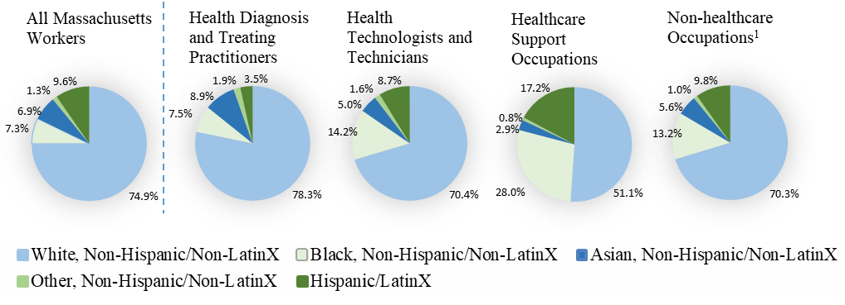
Data Source: 2015-2019 Current Population Survey, NIOSH ELF; Weighted estimates of average annual numbers of workers are: All Massachusetts Workers, N=3,563,000; Health diagnosis and treating practitioners, N=186,000; Health technologists and technicians, N=66,000; Healthcare support occupations, N=99,000; Non-healthcare occupations, N=214,000.
Note: 1) Only includes non-healthcare occupations within the healthcare industry unlike the other healthcare occupation groups. 2) Total sample size for all three healthcare occupation groups and Massachusetts workers are weighted estimates of the numbers of workers

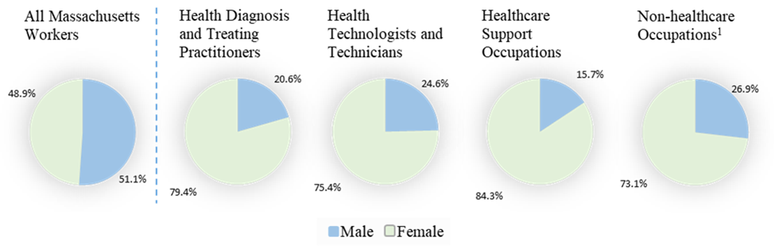
Figure 3. Average annual percent of workers by healthcare occupation groups and sex, Massachusetts, 2015-2019

Data Source: 2015-2019 Current Population Survey, NIOSH ELF; Weighted estimates of average annual numbers of workers are: All Massachusetts Workers, N=3,563,000; Health diagnosis and treating practitioners, N=186,000; Health technologists and technicians, N=66,000; Healthcare support occupations, N=99,000; Non-healthcare occupations, N=214,000.
Notes: 1) Only includes non-healthcare occupations within the healthcare industry unlike the other healthcare occupation groups. 2) Total sample size for all three healthcare occupation groups and Massachusetts workers are weighted estimates of the numbers of workers. 3) This workforce data is only available for male and female sexes.

Figure 4. Average annual percent of workers by healthcare occupation groups and age-group, Massachusetts, 2015-2019
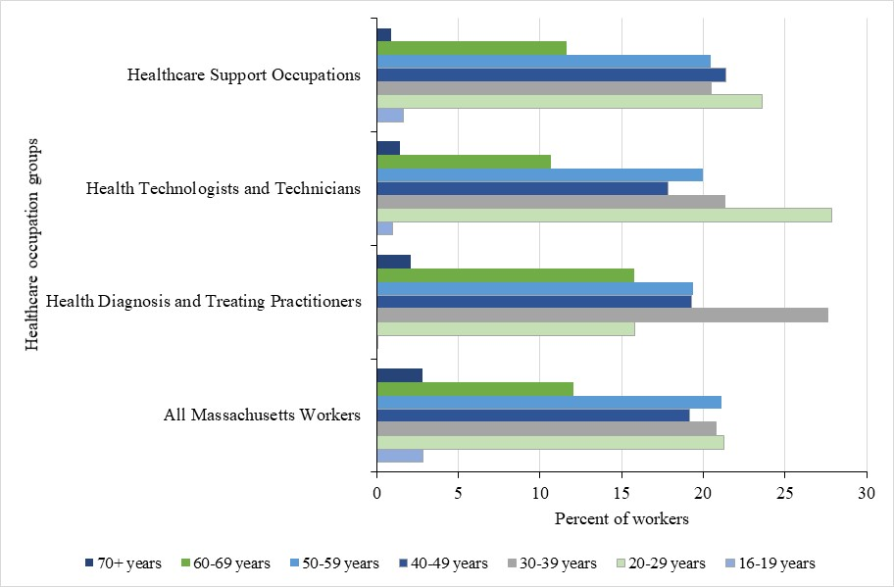
Data Source: 2015-2019 Current Population Survey, NIOSH ELF.
Note: 1) Total sample size for all three healthcare occupations and Massachusetts workers are weighted estimates of the numbers of workers

Healthcare support occupations
There were, on average, an estimated 99,000 workers in Healthcare support occupations each year from 2015-2019. Healthcare support occupations had the lowest median salaries of the three occupation groups examined with a range of $31,210 - $51,180. The majority (84.3%) of workers in healthcare support occupations were female, whereas females comprised only half (48.9%) of all Massachusetts workers. Compared to the other occupation groups examined, this group had the second-largest percentage of younger workers with 25.2% being under age 29. Black, non-Hispanic/non-LatinX and Hispanic/LatinX workers were overrepresented, comprising 28.0% and 17.2% of workers in healthcare support occupations, respectively.
Health technologists and technicians
The occupation group Health technologists and technicians was the smallest of all the healthcare occupations groups examined, with an estimated 66,000 workers. The median income for this group ranged from $30,390 to $86,560. The percentage of Black, non-Hispanic/non-LatinX workers was twice as large in the occupation group health technologists and technicians as compared with the total Massachusetts workforce (14.2% vs. 7.3%). Consistent with the other healthcare occupation groups examined, the majority of workers were female (75.4%). This occupation group had the largest percentage of younger workers of any group examined, with 28.8% under age 29.
Health diagnosis and treating practitioners
The largest healthcare occupation group was Health diagnosis and treating practitioners with 186,000 workers. This occupation group had the highest median income range ($61,820 – $123,530). This group had the highest percentage of White, non-Hispanic/non-LatinX workers (78.3%) of all groups examined. As with the other occupation groups examined, the majority of workers were female (79.4%). Compared to the total Massachusetts workforce, Health diagnosis and treating practitioners tended to be older with a higher percentage of workers aged 60 to 69 years old, and a larger proportion of workers in the 30–39-year-old age range. An estimated 19% of workers in this occupation group were at least 60 years old compared with 15% of all Massachusetts workers.
Non-healthcare specific occupations
There are an estimated 214,000 workers in non-healthcare specific occupations in healthcare settings (i.e., Ambulatory healthcare services, Nursing and residential facilities, and Hospitals). The overall percentage of Black, non-Hispanic/non-LatinX workers was about twice that (13.2% vs. 7.3%) among non-healthcare occupations within the healthcare industry as compared with the total Massachusetts workforce. White, non-Hispanic/non-LatinX workers made up much of this group (70.3%). Like all other healthcare occupation groups examined, the majority of workers in non-healthcare specific occupations within the healthcare industry were females (73.1%).

Demographic Characteristics: Healthcare Industries
The demographic characteristics of workers in the healthcare industry vary by industry subsector/work setting. Figures 5-7 below provide details on these demographic characteristics (e.g., race/ethnicity, age, and sex), comparing each healthcare industry subsector to Massachusetts as a whole.
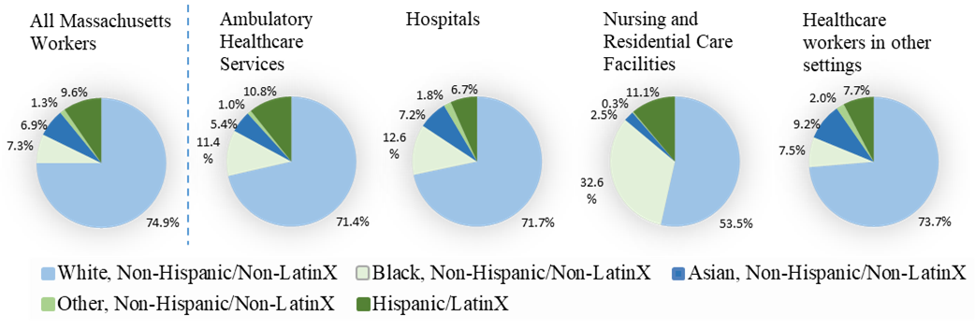
Figure 5. Average annual percent of workers by healthcare industry groups and race/ethnicity, Massachusetts, 2015-2019
Data Source: 2015-2019 Current Population Survey, NIOSH ELF; Weighted estimates of average annual numbers of workers are: All Massachusetts Workers, N=3,563,000; Ambulatory Healthcare Services, N=216,000; Hospitals, N=215,000; Nursing and Residential Care Facilities, N=70,000; Healthcare workers in other settings, N=65,000.
Note: 1) Total sample size for all three healthcare industry groups and healthcare industry workers are weighted estimates of the numbers of workers

Figure 6. Average annual percent of workers by healthcare industry groups and sex, Massachusetts, 2015-2019
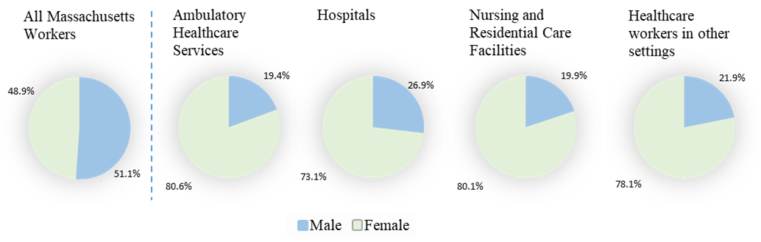

Data Source: 2015-2019 Current Population Survey, NIOSH ELF; Weighted estimates of average annual numbers of workers are: All Massachusetts Workers, N=3,563,000; Ambulatory Healthcare Services, N=216,000; Hospitals, N=215,000; Nursing and Residential Care Facilities, N=70,000; Healthcare workers in other settings, N=65,000.
Note: 1) Total sample size for all three healthcare industry groups and healthcare industry workers are weighted estimates of the numbers of workers. 3) This workforce data is only available for male and female sexes.

Figure 7. Average annual percent of workers by healthcare industry groups and age-group, Massachusetts, 2015-2019
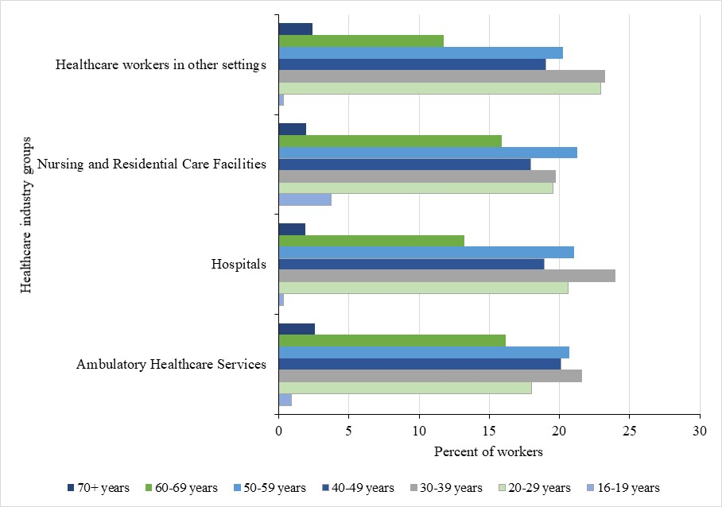
Data Source: 2015-2019 Current Population Survey, NIOSH ELF.
Note: 1) Total sample size for all three healthcare occupations and Massachusetts workers are weighted estimates of the numbers of workers

Ambulatory healthcare services
Ambulatory healthcare services was the largest industry subsector of the three examined with 216,000 workers. This industry group had the second lowest percentage of Black, non-Hispanic/non-LatinX workers (11.4%), also greater than the overall Massachusetts workforce of 7.3% Black, non-Hispanic/non-LatinX. As with the other industry groups examined, the majority of workers in Ambulatory healthcare services were female (80.6%). Compared to the total Massachusetts workforce, Ambulatory healthcare workers tended to be older with a higher percentage of workers aged 60 to 69 years old. An estimated 19% of workers in this industry group were at least 60 years old compared with 15% of all Massachusetts workers. Healthcare workers in other settings (non-healthcare specific occupations) made up nearly half of this industry group (42.6%), with Office & administrative support, Management, and Personal care & service occupations as the largest non-healthcare specific occupation subgroups in this healthcare industry setting.
Nursing and residential care facilities
Nursing and residential care facilities was the smallest industry group examined, employing an estimated 70,000 workers each year, on average, from 2015-2019 in this industry group. An estimated 1 in 3 (32.9%) workers in this industry group worked in Healthcare support occupations. Black, non-Hispanic/non-LatinX workers comprised a third (32.6%) of the workforce in Nursing and residential care facilities and there were more females than males (85.7% vs. 14.3%) in this industry group. Workers in non-healthcare specific occupations, namely Personal care & service, Food preparation & serving related, and Management occupations, made up half of this industry group (50.0%).
Hospitals
There were an estimated 215,000 people, on average, working in the Hospital industry each year between 2015 and 2019. The percentage of Health diagnosis and treating practitioners working in Hospitals was greater than in the Massachusetts healthcare industry as a whole (40.5% vs. 30.5%). An estimated 71.7% of workers in this industry were White, non-Hispanic/non-LatinX, slightly lower than the overall Massachusetts estimate of 74.9%. Consistent with the other industry groups examined, the majority of workers in Hospitals were female (73.1%). This industry group had the largest percentage of workers between the ages of 20 - 39 (44.6%). There were as many workers in non-healthcare specific occupations as Health diagnosis and treating practitioners in this industry group (40.5%). Office & administrative support, Management, and Life, physical, & social science occupations were the largest non-healthcare specific occupation groups in this healthcare setting.

COVID-19-related Trauma AMONG HEALTHCARE WORKERS: Data from the MASSACHUSETTS COVID-19 Community Impact Survey (CCIS)

Overview of CCIS

Data from the Adult Massachusetts COVID-19 Community Impact Survey (CCIS) were used to examine potential work-related stressors, mental health and substance use among healthcare workers as compared to all other workers (non-healthcare workers). In fall of 2020, DPH conducted the CCIS to better understand the most pressing health needs facing people living in Massachusetts during the pandemic. The CCIS was an online, anonymous survey administered to both adults (ages 25 years and older) and youth (ages 14-24 years) across the Commonwealth. The CCIS reached populations typically underrepresented in traditional public health surveillance data sources, including people of color, LGBTQ+ individuals, and persons with disabilities. The CCIS was a novel survey, unlike anything else that exists to characterize the experiences of the Commonwealth residents during COVID-19. Findings were used by DPH to develop programs and provide resources to support residents in response to the pandemic. Additional information on the CCIS is available at https://www.mass.gov/resource/covid-19-community-impact-survey. The list of questions analyzed in this report are included in Appendix A.
Of the 33,800 adult respondents to the CCIS, 23,098 had been employed in the past year. The CCIS included open-ended questions on occupation and industry, and U.S. Bureau of Census codes were assigned to responses using computer-assisted methods. As previously mentioned, for this report, a healthcare worker is defined as a respondent who worked in a healthcare industry or a healthcare occupation (Table 1). The final analytic sample consisted of 19,247 employed respondents - 5,922 healthcare workers and 13,325 non-healthcare workers (Table 5). The breakdown of the sample by industry and occupation is shown in Table 5.
In this section, percentages weighted to the statewide age and educational distribution of Massachusetts residents aged 25 years and older are presented. Also included are 95% confidence intervals for percentages, which are indicators of reliability (or precision) of the estimates. Narrower confidence intervals indicate more precise estimates and wider intervals indicate less precise estimates. Smaller numbers of respondents yield less precise estimates. For comparisons of estimates between healthcare workers and non-healthcare workers, chi-squared tests were used, where a p-value less than or equal to 0.05 was considered statistically significant (i.e., sufficient evidence that the observed difference is not due to chance). In this section, reported differences in the text are statistically significant unless otherwise noted.
It is worth noting that the CCIS was a cross-sectional survey and the data presented here are univariate, descriptive percentages. While statistical associations are documented, we cannot infer causation. Nevertheless, CCIS findings presented in this section of the report are important and shed light on the experiences of healthcare workers during the early stages of COVID.
As mentioned above, the CCIS was conducted in the Fall of 2020. Since then, COVID-19 has moved through different waves, leading to constantly changing demands on healthcare workers. While COVID-19 mitigation strategies (e.g., vaccination, availability of PPE, home testing) have also improved, many other work-related stressors remain. The findings of the CCIS reflect a critical time in the COVID-19 pandemic and by understanding the impact on healthcare workers from this first year of the pandemic, we can continue to inform current and future practices for the wellbeing and maintenance of frontline healthcare workers.
For purposes of this analysis, we did not examine the geographic breakdown of where respondents lived, as the sample size of healthcare workers became very small when stratifying by city/town and/or region. As mentioned in the introduction, we know that COVID-19 rates were higher in communities with a higher percentage of workers employed in essential services, including healthcare (Hawkins, 2020), thus it is likely that the geographic patterns of COVID-19 were in part, driven by what people did for work.
Table 5. Final analytic sample, CCIS (N=19,247 employed respondents)
Industry or Occupation Group | Number of respondents
All healthcare workers | 5,922
Industry:
Ambulatory healthcare services | 2,215
Hospitals | 2,295
Nursing & residential care facilities | 467
All other non-healthcare industries ‡ | 857
Occupation:
Health diagnosis and treating practitioners | 2,463
Health technologists and technicians | 327
Healthcare support occupations | 314
All other non-healthcare occupations† | 2,426
Non-healthcare workers | 13,325

Notes: 1) ‡ refers to all other industries in which healthcare workers are employed; 2) † refers to all other occupations in which healthcare workers are employed. 3) Information on occupation but not industry was available for 88 healthcare workers, and information on industry but not occupation for 392 healthcare workers; 4) Data Source: COVID-19 Community Impact Survey, Massachusetts Department of Public Health.

Work-Related Stressors

Pandemic-related employment disruptions
The COVID-19 pandemic brought changes to many different occupations and industries, whether shifting to remote work, laying off/furloughing employees, or reassigning workers to different roles. This was also the case within healthcare industry and occupation groups. In the CCIS, respondents were asked about whether their employment status or nature of their work changed due to COVID-19. Responses were grouped into the following outcomes: no change in employment; job loss (permanent or temporary); had hours reduced or took leave (paid or unpaid); and change in nature of work (i.e., started a new job, assigned a different role at work, working from home, increase in hours). While an increase in hours was included as a ‘change in nature of work’, this outcome was also examined separately.

Figure 8. Employment disruption: Percentage of healthcare workers reporting job loss, reduced hours, or taking leave due to the pandemic, by industry and occupation
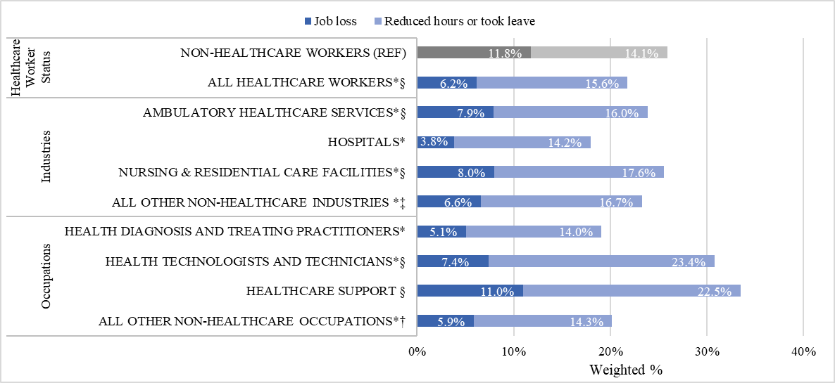
Notes: 1) Census Occupations Codes: Health diagnosing and treating practitioners (COC 3000-3260), Health technologists and technicians (COC 3300-3540), Healthcare support occupations (COC 3600-3655); 2) Census Industry Codes: Ambulatory healthcare services (CIC 7970-8180), Hospitals (CIC 8190), Nursing and residential care facilities (CIC 8270-8290); 3) * refers to a Job Loss percentage that is statistically significantly different from that of the reference group (REF); 4) § refers to a Reduced Hours or Took Leave percentage that is statistically significantly different from that of the reference group (REF) 5) ‡ refers to all other industries in which healthcare workers are employed; 6) † refers to all other occupations in which healthcare workers are employed; 7) Sample size: N =5,556 (healthcare workers); N=12,076 (non-healthcare workers) 8) Data Source: Massachusetts COVID-19 Community Impact Survey, Massachusetts Department of Public Health, Fall 2020.
- Overall, a lower percentage of healthcare workers reported losing their job (6.2%) compared to non-healthcare workers (15.6%). However, percentages varied across healthcare occupation groups from 5.1% among Health diagnosis and treating practitioners to 11.0% among Healthcare support workers.
- Another 15.6% of healthcare workers reported having reduced hours or taking leave due to the pandemic. This percentage was greater than that reported by non-healthcare workers (14.1%).

Figure 9. Employment disruption: Percentage of healthcare workers reporting increased hours due to the pandemic, by industry and occupation
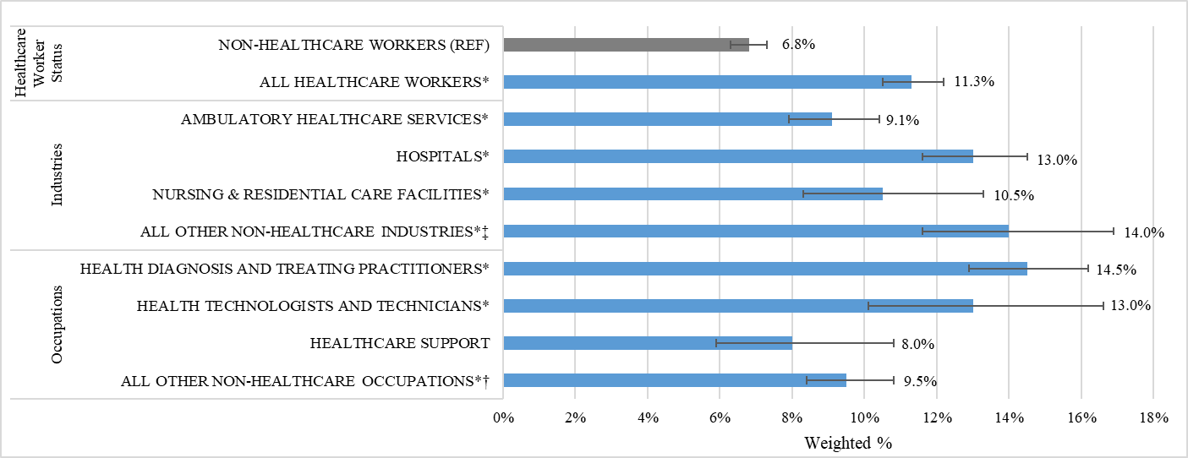
Notes: 1) Census Occupations Codes: Health diagnosing and treating practitioners (COC 3000-3260), Health technologists and technicians (COC 3300-3540), Healthcare support occupations (COC 3600-3655); 2) Census Industry Codes: Ambulatory healthcare services (CIC 7970-8180), Hospitals (CIC 8190), Nursing and residential care facilities (CIC 8270-8290); 3) * refers to a percent that is statistically significantly different from that of the reference group (REF); 4) ‡ refers to all other industries in which healthcare workers are employed; 5) † refers to all other occupations in which healthcare workers are employed 6) Sample size: N =5,717 (healthcare workers); N=12,447 (non-healthcare workers) 7) Data Source: Massachusetts COVID-19 Community Impact Survey, Massachusetts Department of Public Health, Fall 2020.
- A higher percentage of healthcare workers reported having their hours increased during the pandemic (11.3%) compared to non-healthcare workers (6.8%). Among healthcare occupations, 14.5% of Health diagnosis and treating practitioners reported having increased hours. This percentage was also higher than that of non-healthcare workers (6.8%).
- Among healthcare workers who reported job loss, reduced hours, or taking leave, the most common reasons were:
  - “My employer laid me off or reduced my work hours”, (45.6%, 95% CI [42.7%, 48.5%]).
  - “I needed to take care of my child / children”, (27.3%, 95% CI [24.7%, 29.9%]).
  - “I was afraid to get COVID-19 at work”, (15.9% , 95% CI [13.9%, 18.2%]).

Worried about paying any expense
The COVID-19 pandemic had an economic impact on many residents, making it difficult for some people to pay expenses or bills. Survey respondents were asked about the types of expenses they were most worried about paying in the upcoming weeks. This included expenses or bills related to housing, utilities, vehicles, debt (e.g., credit card, student loan), insurance (e.g., health insurance, disability insurance), school or daycare tuition.
Figure 10. Percentage of healthcare workers worried about paying any expense or bill, by industry and occupation
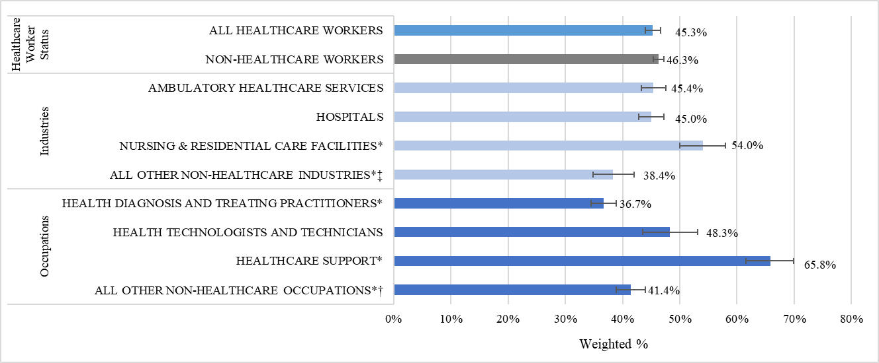
Notes: 1) Census Occupations Codes: Health diagnosing and treating practitioners (COC 3000-3260), Health technologists and technicians (COC 3300-3540), Healthcare support occupations (COC 3600-3655); 2) Census Industry Codes: Ambulatory healthcare Services (CIC 7970-8180), Hospitals (CIC 8190), Nursing and residential care facilities (CIC 8270-8290); 3) * refers to a percent that is statistically significantly different from that of the reference group (REF); 4) ‡ refers to all other industries in which healthcare workers are employed; 5) † refers to all other occupations in which healthcare workers are employed 6) Sample size: N =5,922 (healthcare workers); N=13,325 (non-healthcare workers). 7) Data Source: Massachusetts COVID-19 Community Impact Survey, Massachusetts Department of Public Health, Fall 2020.
- Overall, nearly half of healthcare workers (45.3%) and non-healthcare workers (46.3%) reported being worried about paying at least once expense in upcoming weeks.
- By industry, a higher percentage of healthcare workers who worked in Nursing and residential facilities reported being worried about paying any expense compared to non-healthcare workers (54.0%).
- By occupation, 65.8% of Healthcare support workers reported being worried about paying any expense, which was higher than the percentage for non-healthcare workers (46.3%).

Working outside the home
Throughout the pandemic, many residents could not work from home, facing increased risk of exposure to COVID-19 by needing to work in-person. In the CCIS, employed respondents were considered to work from home (at least some of the time) if they answered either: “I have been working from home” to the question “Has your employer given you any of the following to protect you against COVID-19?” or “I am working from home” to the question “Has your employment status or the nature of your work changed in any of the following ways due to COVID-19?” All others were considered to work outside the home.
Figure 11. Percentage of currently employed healthcare workers working outside the home, by industry and occupation
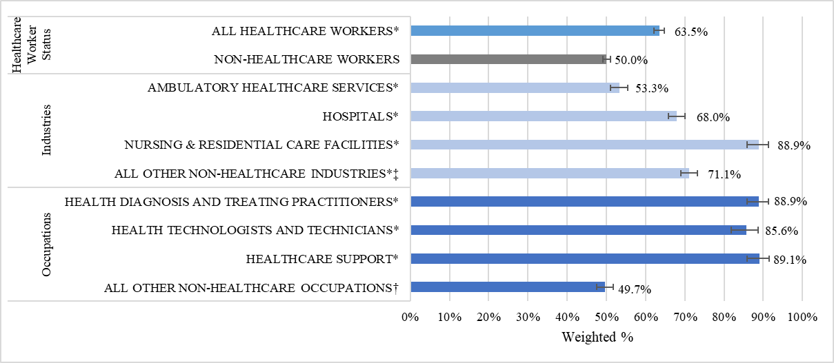
Notes: 1) Census Occupations Codes: Health diagnosing and treating practitioners (COC 3000-3260), Health technologists and technicians (COC 3300-3540), Healthcare support occupations (COC 3600-3655); 2) Census Industry Codes: Ambulatory healthcare services (CIC 7970-8180), Hospitals (CIC 8190), Nursing and residential care facilities (CIC 8270-8290); 3) * refers to a percent that is statistically significantly different from that of the reference group (REF); 4) ‡ refers to all other industries in which healthcare workers are employed; 5) † refers to all other occupations in which healthcare workers are employed 6) Sample size: N =5,688 (healthcare workers); N=12,363 (non-healthcare workers). 7) Data Source: Massachusetts COVID-19 Community Impact Survey, Massachusetts Department of Public Health, Fall 2020.
- Overall, a greater percentage of healthcare workers worked outside the home (63.5%) compared to non-healthcare workers (50.0%,).
- Nearly 9 out of 10 (88.9%) healthcare workers in Nursing and residential care facilities worked outside of the home, which was the highest percent of any industry group of healthcare workers and higher than the percent among the reference group of non-healthcare workers (50.0%).
- Across industry groups, the percentage of healthcare workers who worked outside the home was significantly higher compared to the percentage among non-healthcare workers.
- Healthcare support workers had the highest percentage working outside the home of any occupation group of healthcare workers (89.1%) and higher than the percent of non-healthcare workers (50.0%). Two other occupation groups – Health diagnosis and treating practitioners and Health technologists and technicians - also had higher percentages working outside the home compared to non-healthcare workers.
Figure 12. Percentage of currently employed healthcare workers working outside the home, by select demographics (part 1 of 2)
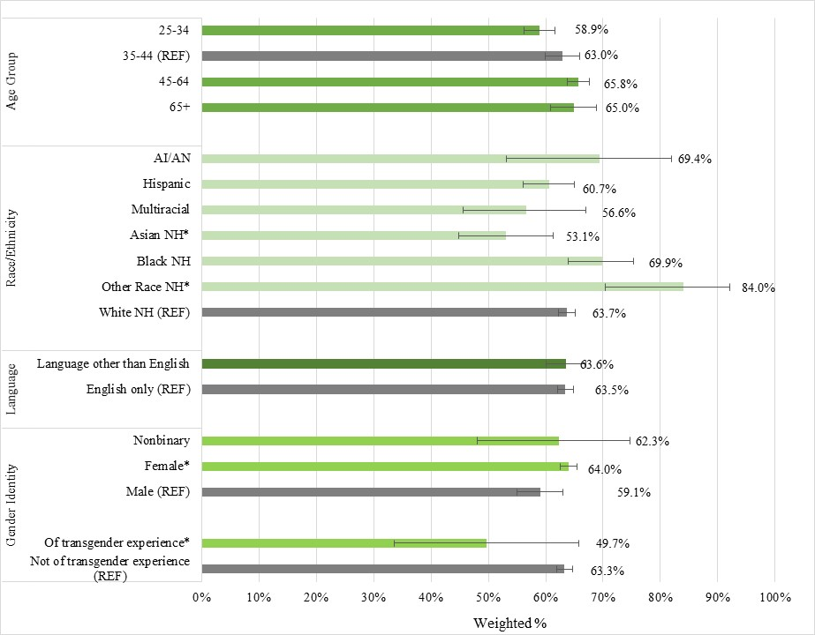
Notes: 1) *refers to a percent that is statistically significantly different from that of the reference group (“REF”, grey bar); 2) Data Source: Massachusetts COVID-19 Community Impact Survey, Massachusetts Department of Public Health, Fall 2020.

Figure 12. Percentage of currently employed healthcare workers working outside the home, by select demographics (part 2 of 2)
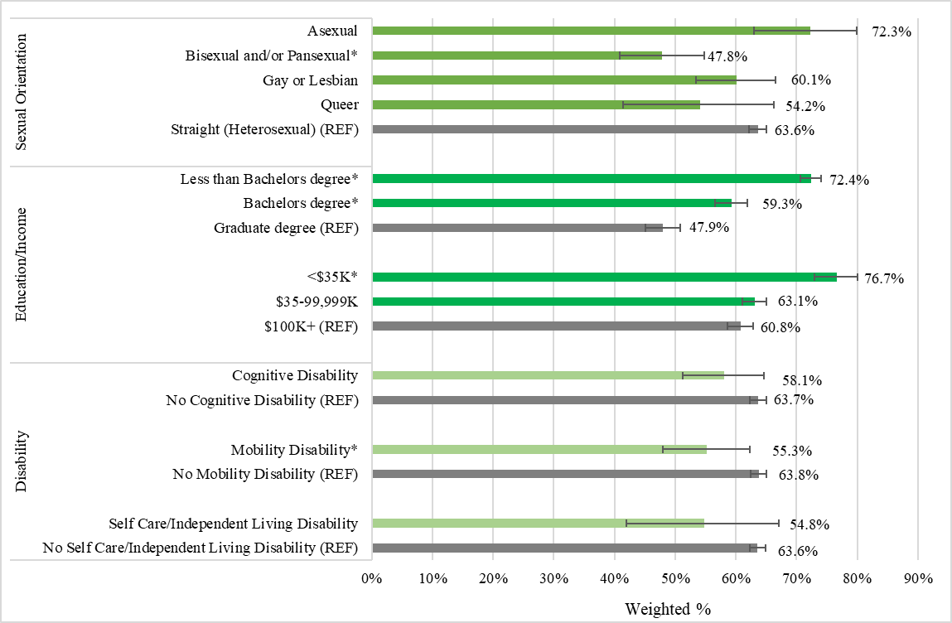
Notes: 1) *refers to a percent that is statistically significantly different from that of the reference group (“REF”, grey bar); 2) The original CCIS also included response options for “Blind/vision impaired” and “Deaf or hard of hearing” but the sample size among healthcare worker was too small to report out on, so it is omitted from this graph. 3) Data Source: Massachusetts COVID-19 Community Impact Survey, Massachusetts Department of Public Health, Fall 2020.
- Higher percentages of healthcare workers in the following demographic groups worked outside the home compared to their respective reference groups:
  - Females (64.0%) compared to males (59.1%)
  - Those with less than a bachelor's degree (72.4%) or a bachelor's degree (59.3%) compared to those with a graduate degree (47.9%)
  - Those with an annual household income of less than $35,000 (76.7%) compared to those with annual household income of $100,000 or more (60.8%)

Work-related reasons for not being able to physically distance when outside the home
Figure 13 shows the percentage of healthcare workers who reported not being able to distance when outside the home for work-related reasons. Work-related reasons including needing to use public transportation for commuting to/from work, working in a crowded environment, or needing to work closely with others as part of the job.
Figure 13. Percentage of healthcare workers reporting work-related reasons (i.e., commute on public transportation, crowded work environment, need to work closely with others as part of job) for not being able to physically distance when outside the home, by industry and occupation
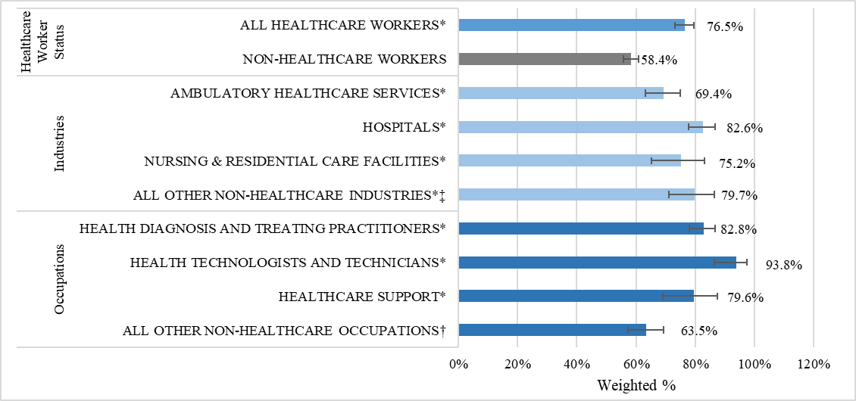
Notes: 1) Census Occupations Codes: Health diagnosing and treating practitioners (COC 3000-3260), Health technologists and technicians (COC 3300-3540), Healthcare support occupations (COC 3600-3655); 2) Census Industry Codes: Ambulatory healthcare services (CIC 7970-8180), Hospitals (CIC 8190), Nursing and residential care facilities (CIC 8270-8290);3) * refers to a percent that is statistically significantly different from that of the reference group (REF); 4) ‡ refers to all other industries in which healthcare workers are employed; 5) † refers to all other occupations in which healthcare workers are employed; 6) Sample size: N =753 (healthcare workers); N=1,607 (non-healthcare workers). 7) Data Source: Massachusetts COVID-19 Community Impact Survey, Massachusetts Department of Public Health, Fall 2020.
- Overall, a higher percentage of healthcare workers reported work-related reasons for being unable to maintain physical distance (six feet of distance) from others when outside the home (76.5%) compared to non-healthcare workers (58.4%).
- More than 80% of healthcare workers who worked in hospitals reported work-related reasons for being unable to physically distance when outside the home (82.6%). This was significantly different from the percentage for non-healthcare workers (58.4%).
- More than 90% of healthcare workers who worked as Health technologists and technicians reported work-related reasons for being unable to physically distance when outside the home (93.8%). This was significantly different from the percentage for non-healthcare workers (58.4%).

Employer-provided protections
Given that many workers have to leave home to do their jobs, thereby being put at higher risk of infection, the workplace remains an important point of transmission, and therefore a key opportunity for prevention. Workplace prevention measures include ventilation, physical distancing, employer-provided personal protective equipment (PPE) and/or masking, enhanced cleaning protocols, and additional health and safety training. Some of these protections provided by employers were examined (Figures 14-15). Figure 16 shows the percentage of respondents working outside the home in healthcare who reported access to paid sick leave.
Figure 14. Percentage of currently employed healthcare workers working outside the home who reported having employer-provided personal protective equipment (PPE), by industry and occupation
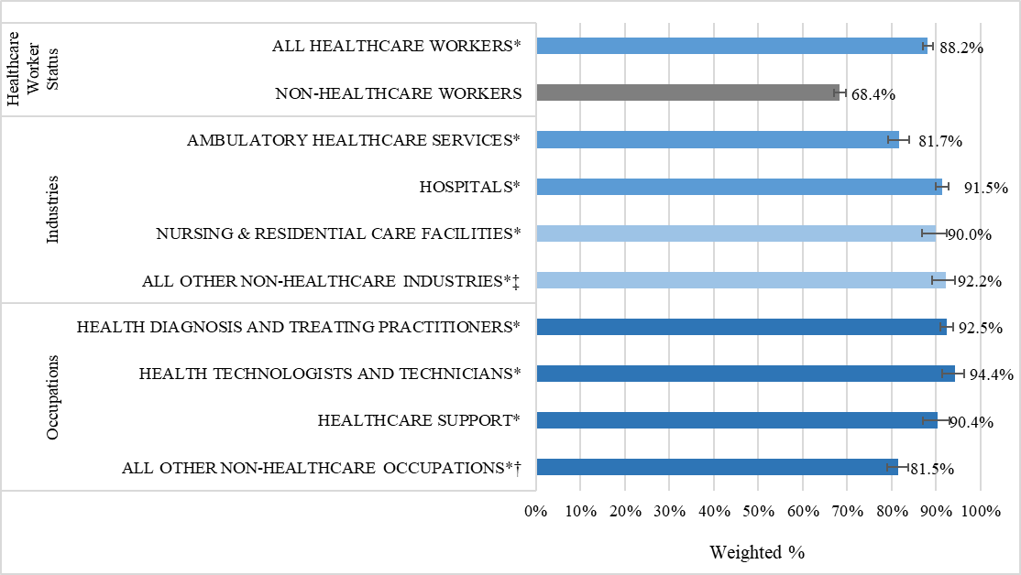
Notes: 1) Census Occupations Codes: Health diagnosing and treating practitioners (COC 3000-3260), Health technologists and technicians (COC 3300-3540), Healthcare support occupations (COC 3600-3655); 2) Census Industry Codes: Ambulatory healthcare services (CIC 7970-8180), Hospitals (CIC 8190), Nursing and residential care facilities (CIC 8270-8290); 3) * refers to a percent that is statistically significantly different from that of the reference group (REF); 4) ‡ refers to all other industries in which healthcare workers are employed; 5) † refers to all other occupations in which healthcare workers are employed; 7) Sample size: N =3,058 (healthcare workers); N = 4,290 (non-healthcare workers). 7) Data Source: Massachusetts COVID-19 Community Impact Survey, Massachusetts Department of Public Health, Fall 2020.
- Overall, a higher percentage of healthcare workers reported having access to employer-provided personal protection equipment (PPE) (88.2%) compared to non-healthcare workers (68.4%). This was consistent across industry and occupation subgroups of healthcare workers.

Figure 15. Percentage of currently employed healthcare workers working outside the home who reported having employer-provided additional health and safety training, by industry and occupation
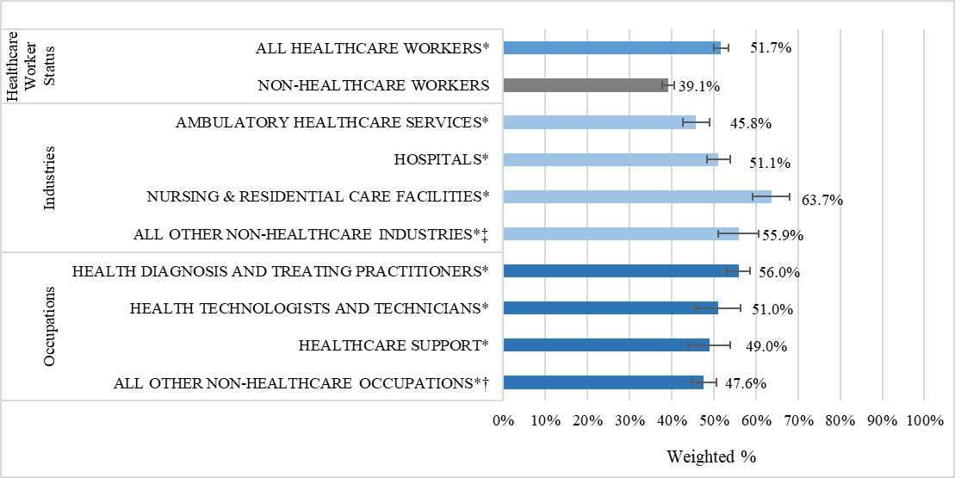
Notes: 1) Census Occupations Codes: Health diagnosing and treating practitioners (COC 3000-3260), Health technologists and technicians (COC 3300-3540), Healthcare support occupations (COC 3600-3655); 2) Census Industry Codes: Ambulatory healthcare services (CIC 7970-8180), Hospitals (CIC 8190), Nursing and residential care facilities (CIC 8270-8290); 3) * refers to a percent that is statistically significantly different from that of the reference group (REF); 4) ‡ refers to all other industries in which healthcare workers are employed; 5) † refers to all other occupations in which healthcare workers are employed; 7) Sample size: N =3,058 (healthcare workers); N = 4,290 (non-healthcare workers). 7) Data Source: Massachusetts COVID-19 Community Impact Survey, Massachusetts Department of Public Health, Fall 2020.
- Overall, a higher percentage of healthcare workers reported having access to additional health and safety training (51.7%) compared to non-healthcare workers (39.1%). This was consistent across industry and occupation subgroups of healthcare workers.

Figure 16. Percentage of currently employed healthcare workers working outside the home who reported having employer-provided paid sick leave, by industry and occupation
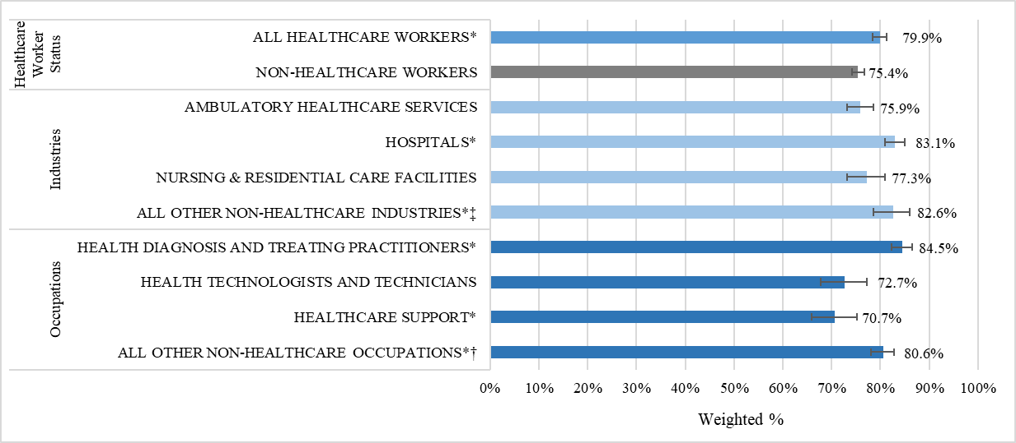
Notes: 1) Census Occupations Codes: Health diagnosing and treating practitioners (COC 3000-3260), Health technologists and technicians (COC 3300-3540), Healthcare support occupations (COC 3600-3655); 2) Census Industry Codes: Ambulatory healthcare services (CIC 7970-8180), Hospitals (CIC 8190), Nursing and residential care facilities (CIC 8270-8290); 3) * refers to a percent that is statistically significantly different from that of the reference group (REF); 4) ‡ refers to all other industries in which healthcare workers are employed; 5) † refers to all other occupations in which healthcare workers are employed; 6) Sample size: N =3,040 (healthcare workers); N=4,264 (non-healthcare workers); 7) Data Source: Massachusetts COVID-19 Community Impact Survey, Massachusetts Department of Public Health, Fall 2020.
- Overall, a higher percentage of healthcare workers reported having access to paid sick leave compared to non-healthcare workers (79.9% vs 75.4%).
- By industry, higher percentages of healthcare workers in Hospitals (83.1%) and All other non-healthcare industries (82.6%) reported having paid sick leave, whereas the percentages for the other groups did not differ from the reference group of all non-healthcare workers.
- By occupation, a lower percentage of healthcare workers in Healthcare support occupations reported having access to paid sick leave (70.7%) compared to non-healthcare workers (75.4%), whereas the percentages were higher for those in Health diagnosis and treating practitioner (84.5%) and all other non-healthcare specific occupation groups (80.6%).

Trauma

Trauma is defined by the Crisis and Trauma Resource Institute by its impact, as “a wound that injures us emotionally, psychologically and physiologically (Chen et al., 2021).” The American Psychiatric Association’s Diagnostic and Statistical Manual of Mental Disorders 5th edition defines trauma in relation to exposures to “death, threatened or actual death, actual or threatened serious injury, or actual or threatened sexual violence.”
A number of studies have shown that healthcare workers have reported having symptoms of trauma during the pandemic (Chen et al., 2021). One study found that 13.3% of survey respondents and 15.2% of those working in intensive care units and those treating COVID-19 patients had symptoms of trauma (Chen et al., 2021).
Factors contributing to trauma response by healthcare workers include high patient load and clinical concerns involving death or potential harm (Hensel et al., 2020; Chen et al., 2021). Additional factors experienced during the pandemic include fears about work-related exposure to COVID-19, fear of spreading infection – particularly to family members, limited access to appropriate personal protective equipment, increased work hours, decision making around rationing of care, increased documentation/recordkeeping (Chen et al., 2021; Kisely et al., 2020; Hossain et al., 2021; Hossain & Clatty, 2021).

Stress-related disorders

Stress-related disorders are a collection of mental health outcomes that result from exposure to trauma. They include conditions such as acute stress disorder, post-traumatic stress disorder (PTSD), adjustment disorder, generalized anxiety disorder, major depressive disorder and grief (Amboss, 2022; Friedman et al., 2011).
One study found that 69% of healthcare workers reported high levels of stress (Chen et al., 2021). That same study found that more than a third of respondents each reported negative impacts on sleep, and fear that there would be a similar disaster in the future, while more than a quarter reported being easily angered, more than a quarter reported experiencing unhappy thoughts or memories, and more than a quarter experienced fear during unexpected events (Chen et al., 2021).
This report will focus on three of these stress-related disorders: PTSD, depression, and anxiety.

Post-Traumatic Stress Disorder (PTSD)
Post-traumatic stress disorder (PTSD) results from witnessing or experiencing a major traumatic event, such as death or serious injury, as well as learning of the traumatic death of close family or friends as well as repeated exposure to the circumstances surrounding that traumatic death (Bryant, 2019; SAMHSA 2014). PTSD can present with a range of symptoms, including “intense or prolonged psychological distress at exposure to reminders of the trauma, hypervigilance, and sleep disturbance” (Bryant, 2019; SAMHSA 2014).
Many studies found that healthcare workers reported symptoms of post-traumatic stress disorder (d’Ettorre et al.,, 2021). These studies found that being a direct care provider, losing a coworker to COVID-19, having a close family member with COVID-19, experiencing COVID-19 symptoms, limited access to personal protective equipment, and extended work hours were associated with post-traumatic stress disorder (d’Ettorre et al., 2021). There is also concern that healthcare workers may experience PTSD in the future as a result of their experiences during COVID-19 (Tan et al., 2020).
In the CCIS, respondents were asked how many PTSD-like related reactions to the pandemic they had experienced in the past month from a validated list of reactions (Prins et al., 2015). Presented in Figure 17 is the percentage of respondents with 3 or more of these PTSD-like reactions.
Figure 17. Percentage of healthcare workers reporting 3+ PTSD-like reactions in the past month due to COVID-19, by industry and occupation
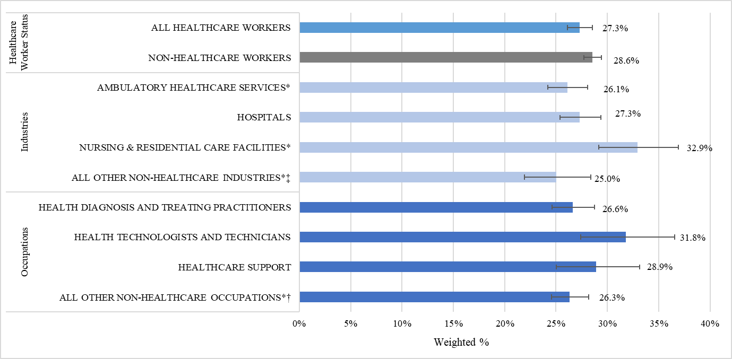
Notes: 1) Census Occupations Codes: Health diagnosing and treating practitioners (COC 3000-3260), Health technologists and technicians (COC 3300-3540), Healthcare support occupations (COC 3600-3655); 2) Census Industry Codes: Ambulatory healthcare Services (CIC 7970-8180), Hospitals (CIC 8190), Nursing and residential care facilities (CIC 8270-8290); 3) * refers to a percent that is statistically significantly different from that of the reference group (REF); 4) ‡ refers to all other industries in which healthcare workers are employed; 5) † refers to all other occupations in which healthcare workers are employed; 6) Sample size: N =5,693 (healthcare workers); N=12,462 (non-healthcare workers). 7) Data Source: Massachusetts COVID-19 Community Impact Survey, Massachusetts Department of Public Health, Fall 2020.
- Overall, more than 1 in 4 (27.3%) healthcare workers reported 3 or more PTSD-like reactions related to the COVID-19 pandemic. This percent was similar to the percent of non-healthcare workers (27.3% vs 28.6%).
- By industry, 32.9% of healthcare workers in Nursing and residential care facilities reported 3 or more PTSD-like reactions, which was the highest percentage of any industry group among healthcare workers and higher than the percentage among the reference group of non-healthcare workers (28.6%).
- By occupation, 31.8% of Health technologists and technicians reported 3 or more PTSD-like reactions. This was the highest percentage of any occupation group of healthcare workers and slightly higher than the percent of non-healthcare workers (28.6%), but this difference was not statistically significant.

Depression
Depression is a mental illness characterized by five or more of the following symptoms during a two-week period, including either a depressed mood or loss of interest or pleasure: significant changed in weight or increase or decrease in appetite, noticeable reduction in physical movement or slowing down of thought, daily fatigue, diminished ability to think or concentrate, or recurring thoughts of death or suicidal ideation, or suicide attempts or plan for death by suicide (Psycom, 2022).
Depression among healthcare workers during the pandemic was attributed to feelings of helplessness as patients succumbed to COVID-19, dealing with patient deaths due to COVID-19, losing coworkers to COVID-19, and feelings of isolation during periods of clinical quarantine and isolation (Feingold et al., 2021; Galea, 2002; Mazure et al., 2000; Jaschek, 2016). One study reported that 46% of healthcare workers reported feelings of depression during the pandemic (Chen et al., 2021). Another survey of physicians found that 15-18% of respondents experienced depression and that 21-22% had suicidal ideations with 1-2% attempting suicide (Bansal, 2020).
The CCIS included questions about mental health, including depression. Respondents were asked to report the number of days during the past 30 days they would describe their mental health as not good, which includes stress, depression, and problems with emotions. Presented here are percentages of respondents who reported that their mental health was not good for at least 15 days during the previous 30 days. This is consistent with way this outcome is assessed in the CDC Behavioral Risk Factor Surveillance System (CDC, 2020). Figure 18 shows the CCIS data from respondents categorized as healthcare workers. Figure 19 examines this mental health outcome by demographics.
Figure 18. Percentage of healthcare workers reporting 15 or more days of poor mental health in the past 30 days, by industry and occupation
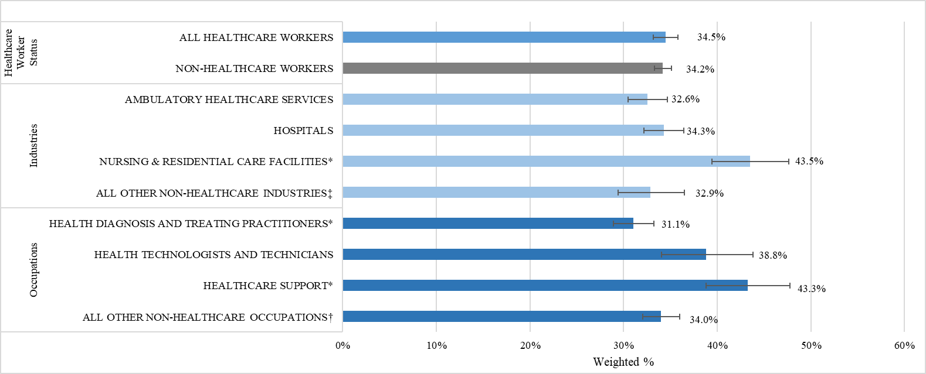
Notes: 1) Census Occupations Codes: Health diagnosing and treating practitioners (COC 3000-3260), Health technologists and technicians (COC 3300-3540), Healthcare support occupations (COC 3600-3655); 2) Census Industry Codes: Ambulatory healthcare services (CIC 7970-8180), Hospitals (CIC 8190), Nursing and residential care facilities (CIC 8270-8290); 3) * refers to a percent that is statistically significantly different from that of the reference group (REF); 4) ‡ refers to all other industries in which healthcare workers are employed; 5) † refers to all other occupations in which healthcare workers are employed; 6) Sample size: N =5,687 (healthcare workers); N=12,740 (non-healthcare workers). 7) Data Source: Massachusetts COVID-19 Community Impact Survey, Massachusetts Department of Public Health, Fall 2020.
- Overall, the percentage of healthcare workers who reported 15 or more days of poor mental health in the past month was similar to the percentage of non-healthcare workers (34.5% vs 34.2%).
- By industry, a higher percentage of healthcare workers in Nursing and residential care facilities reported 15 or more days of poor mental health (43.5% vs 34.2% of non-healthcare workers).
- By occupation, a higher percentage of healthcare workers in Healthcare support occupations reported 15 or more days of poor mental health (43.3% vs. 34.2% of non-healthcare workers).

Figure 19. Percentage of healthcare workers reporting 15 or more days of poor mental health in the past 30 days, by select demographics (part 1 of 2)
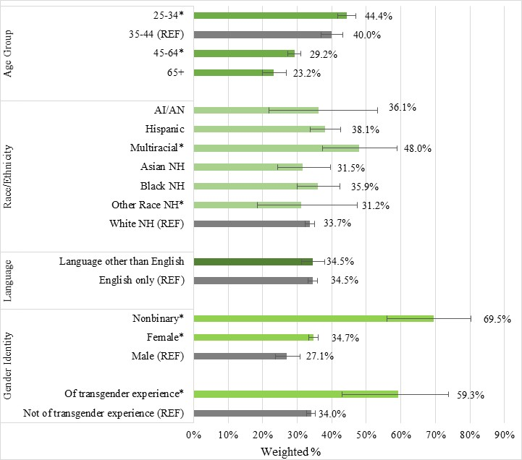
Notes: 1) *refers to a percent that is statistically significantly different from that of the reference group (“REF”, grey bar); 2) Data Source: Massachusetts COVID-19 Community Impact Survey, Massachusetts Department of Public Health, Fall 2020.

Figure 19. Percentage of healthcare workers reporting 15 or more days of poor mental health in the past 30 days, by select demographics (part 2 of 2)
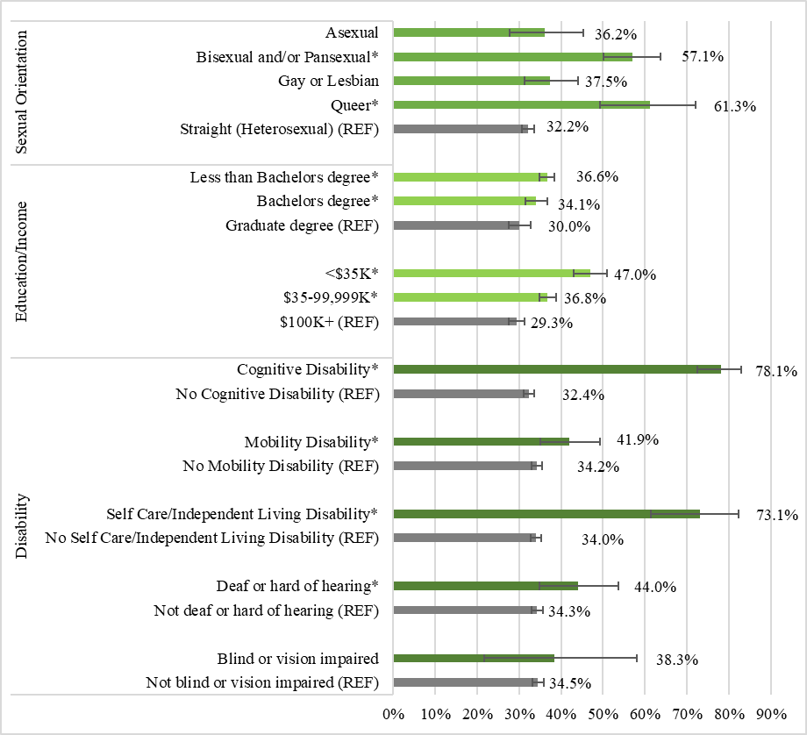
Notes: 1) *refers to a percent that is statistically significantly different from that of the reference group (“REF”, grey bar); 2) Data Source: Massachusetts COVID-19 Community Impact Survey, Massachusetts Department of Public Health, Fall 2020.
- A higher percentage of healthcare workers in the following demographic groups reported 15 or more days of poor mental health, compared to their respective noted reference groups:
  - Those aged 25-34 years (44.4%) compared to those aged 35-44 years (40.0%).
  - Those who identified as female (34.7%) or non-binary (69.5%) compared to those who identified as male (27.1%).
  - Those of transgender experience (59.3%) compared to those not of transgender experience (34.0%).
  - Those with less than a bachelor's degree (36.6%) compared to those with a graduate degree (30.0%)
  - Those with an annual household income of less than $35,000 (47.0%%) compared to those with annual household income of $100,000 or more (29.3%).

Anxiety
Anxiety is defined in the Diagnostic and Statistical Manual of Mental Disorders (DSM)-5 as “excessive anxiety and worry (apprehensive expectation), occurring more days than not for at least 6 months, about a number of events or activities (such as work or school performance)” that the person has difficulty controlling. It is accompanied by three or more of the following: restlessness or feeling keyed up or on edge, being easily fatigued, difficulty concentrating or mind going blank, irritability, muscle tension or sleep disturbance (difficulty falling or staying asleep, or restless unsatisfying sleep). Anxiety significantly impacts one’s ability to function in social or work settings (SAMHSA, 2016).
Increased anxiety and depression were common conditions among healthcare workers since the start of the pandemic (Wang et al., 2020; Young et al, 2021). Increased anxiety resulted from fear of catching COVID-19, having a colleague in the hospital with COVID-19, inadequate PPE or limited access to appropriate PPE, decreased staffing resulting in increased workload and increased work hours (Tuna, 2021; Feingold, 2021). Those workers required to report to the workplace had more anxiety than those who could work from home (Mattila, 2021).
Access to personal protective equipment or thinking that there would be an adequate amount of PPE in the future led to lower levels of anxiety experienced by healthcare workers, as did continuing to work in their original work area rather than being deployed to a new work area (Mattila et al., 2021). Some studies found that more healthcare workers providing direct care to COVID-19 patients reported experiencing anxiety and depression than non-clinical workers (Hossain et al., 2020). Healthcare workers providing care to COVID-19 patients reported experiencing headaches, fatigue, and sleep disturbances (Kang et al., 2020; Kojanov et al., 2021; Chew et al., 2021). Those workers experiencing physical symptoms also had anxiety and depression (Chew et al., 2021). However, one study noted that non-clinical workers experienced more anxiety than clinical workers (d’Ettorre et al., 2020).
In the CCIS, respondents were asked about testing positive for COVID-19, as well as knowing someone close to them who passed away from COVID-19; two potentially work-related factors that may have contributed to feelings of anxiety. Figure 20 shows data from healthcare workers who reported testing positive for COVID-19, among those who worked outside the home. The sample size was too small to report these data by industry and occupation. Figure 21 shows data from healthcare worker respondents on knowing someone close to them who died from COVID-19. It should be noted when interpreting this data that the CCIS did not define “someone close” thus, it was up to interpretation of the respondent.

Figure 20. Percentage of employed respondents who reported testing positive for COVID-19, among those who had ever been tested
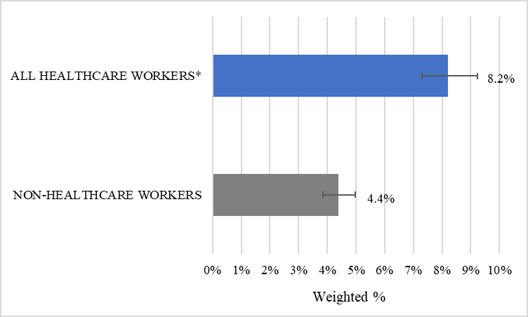
Notes: 1) *refers to a percent that is statistically significantly different from that of the reference group (grey bar). 2) Sample size: N =3,322 (healthcare workers); N=5, 886 (non-healthcare workers). 3) Data Source: Massachusetts COVID-19 Community Impact Survey, Massachusetts Department of Public Health, Fall 2020.
- Among respondents who had ever been tested for COVID-19, a higher percentage of healthcare workers reported testing positive (8.2%) compared to non-healthcare workers (4.4%).
Figure 21. Percentage of healthcare workers reporting that someone close to them died from COVID-19, by industry and occupation.
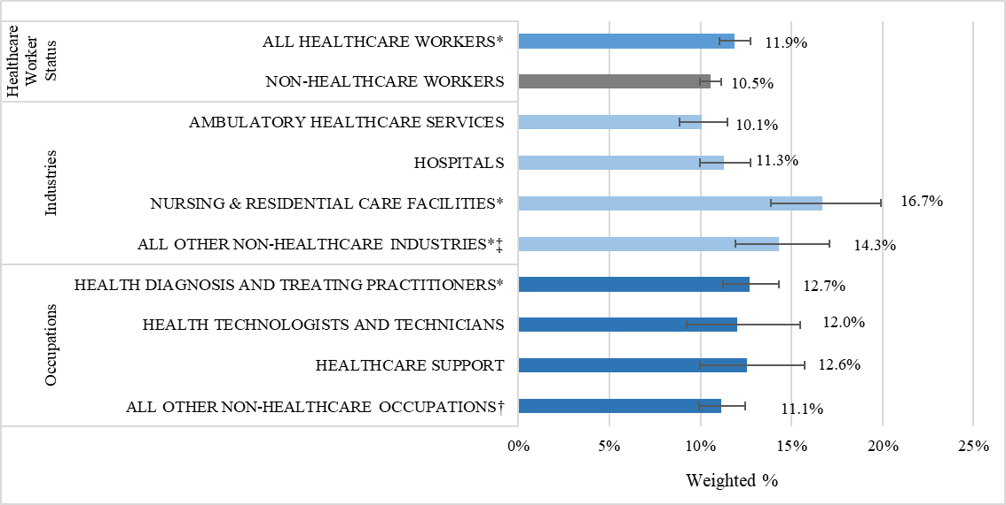
Notes: 1) Census Occupations Codes: Health diagnosing and treating practitioners (COC 3000-3260), Health technologists and technicians (COC 3300-3540), Healthcare support occupations (COC 3600-3655); 2) Census Industry Codes: Ambulatory healthcare services (CIC 7970-8180), Hospitals (CIC 8190), Nursing and residential care facilities (CIC 8270-8290); 3) * refers to a percent that is statistically significantly different from that of the reference group (REF); 4) ‡ refers to all other industries in which healthcare workers are employed; 5) † refers to all other occupations in which healthcare workers are employed; 6) Sample size: N = 5,918 (healthcare workers); N=12,930 (non-healthcare workers). 7) Data Source: Massachusetts COVID-19 Community Impact Survey, Massachusetts Department of Public Health, Fall 2020.
- Overall, a higher percentage of healthcare workers reported knowing someone close to them that died from COVID-19 (11.9%) compared to non-healthcare workers (10.5%).
- By industry, a higher percentage of healthcare workers who worked in Nursing and residential facilities reporting knowing someone close to them who died from COVID-19 compared to non-healthcare workers (16.7% vs. 10.5%).
- By occupation, a higher percentage of Health diagnosis and treating practitioners reported knowing someone close to them who died from COVID-19 compared to the percentage for non-healthcare workers (12.7% vs. 10.5%).

Mental Health Resources
CCIS respondents were asked about the types of mental health resources they thought would be the most helpful for them to support their mental health and well-being. Figure 22 below show what resources were most frequently reported among all healthcare workers.
Figure 22. Mental health resources that healthcare workers reported would be most helpful 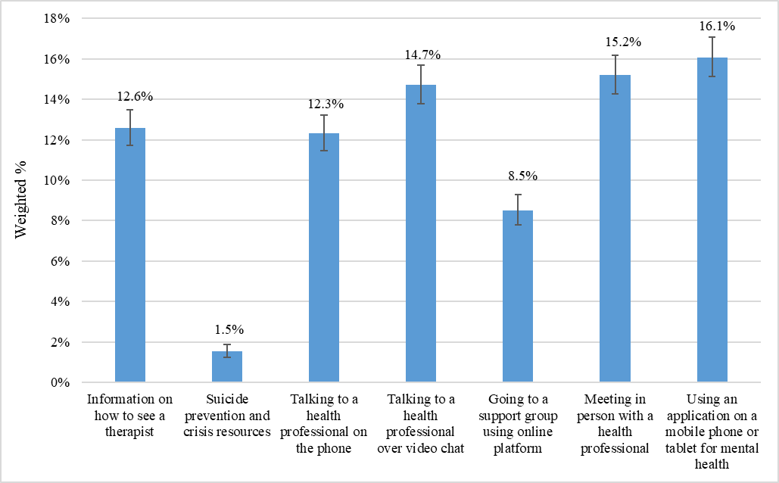Notes: 1) Sample size = 5922 (healthcare workers); 2) Data Source: Massachusetts COVID-19 Community Impact Survey, Massachusetts Department of Public Health, Fall 2020
- When asked which mental health resources might be most helpful, the highest percentage of healthcare workers selected having a mental health application on their mobile phone or tablet (16.1%), followed by meeting in person with a health professional (15.2%) and talking to a health professional over video chat (14.7%).
- 1.5% of healthcare workers thought suicide prevention and crisis resources would be helpful.

Substance Use Disorders

A substance use disorder (SUD) is a disorder affecting an individual’s brain and behavior, which in turn leads to their inability to control their use of substances, such as legal or illegal drugs, alcohol, or tobacco (National Institute of Mental Health, 2021). During the COVID-19 pandemic, worldwide, there has been an overall increase in the proportion of people consuming a range of such substances (Roberts et al., 2021). In Massachusetts, there has been an increase in opioid-related overdose deaths (following a plateau from 2017-2019), with deaths rising in 2020 and 2021 (Massachusetts Department of Public Health, June 2022).
Few studies have looked specifically at substance use among healthcare workers during the pandemic. One study of a healthcare organization in Pennsylvania found that 17% of healthcare workers who responded to a spring 2021 survey reported consuming at least three alcoholic beverages on an average day (Bucca et al., 2022). One study of U.S. workers, not limited to healthcare occupations, found that 13% of respondents reported starting or increasing substance use as a means to deal with stress related to the pandemic (Czeisler et al., 2020). One study found that experiencing symptoms of depression were tied to how often respondents consumed five or more drinks in a day (Young et al., 2021).
The data below show uses the CCIS to examine substance use among healthcare workers in Massachusetts.

Current Use
CCIS respondents were asked to report substances they had used during the past 30 days. Presented below are the percentages of respondents employed in the past year who reported use of:
- Any substance (not including prescription drug or over-the-counter (OTC) medications) (Figure 23)
- Alcohol only (with no other substance) (Figure 24)
- Tobacco like cigarettes, cigars, chew, with or without other substances (Figure 25)
- Marijuana, with or without other substances (Figure 26)
Note that due to a small sample size, it was not possible to examine data from healthcare workers who reported using only tobacco or only marijuana without other substances. Thus, Figures 25 and 26 include those who used tobacco or marijuana with or without other substances, respectively.

Figure 23. Percentage of healthcare workers reporting use of any substance (not counting prescription drug or over-the-counter medications) in the past 30 days, by industry and occupation
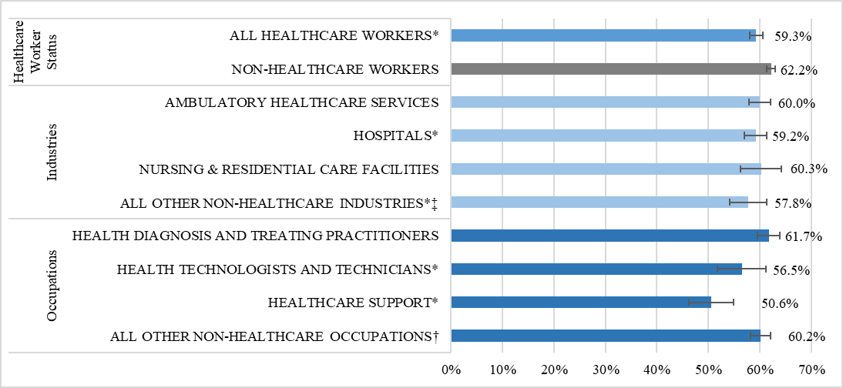
Notes: 1) Census Occupations Codes: Health diagnosing and treating practitioners (COC 3000-3260), Health technologists and technicians (COC 3300-3540), Healthcare support occupations (COC 3600-3655); 2) Census Industry Codes: Ambulatory healthcare services (CIC 7970-8180), Hospitals (CIC 8190), Nursing and residential care facilities (CIC 8270-8290); 3) *refers to a percent that is statistically significantly different from that of the reference group (grey bar); 4) ‡ refers to a healthcare worker that works in any non-healthcare industry; 5) † refers to a healthcare worker who works in any non-healthcare occupation. 6) Sample size: N = 5,922 (healthcare workers); N=12,945 (non-healthcare workers).
- Overall, 59.3% of healthcare workers reported using any substance in the last 30 days, which was slightly lower than the percentage of non-healthcare workers (62.2%).
- Percentages varied somewhat across subgroups of healthcare workers ranging from:
  - 57.8% in All other non-healthcare industries to 60.3% in Nursing and residential care facilities; and
  - 50.6% among workers in Healthcare support occupations to 61.7% among Health diagnosis and treating practitioners.

Figure 24. Percentage of healthcare workers reporting use of alcohol in the past 30 days, by industry and occupation
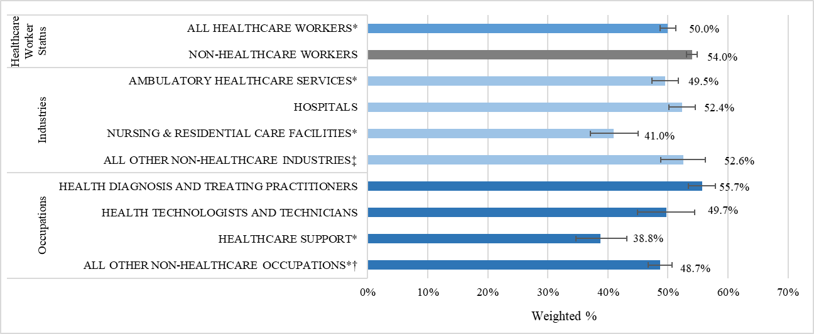
Notes: 1) Occupations Codes: Health diagnosing and treating practitioners (COC 3000-3260), Health technologists and technicians (COC 3300-3540), Healthcare support occupations (COC 3600-3655); 2) Census Industry Codes: Ambulatory healthcare services (CIC 7970-8180), Hospitals (CIC 8190), Nursing and residential care facilities (CIC 8270-8290); 3) *refers to a percent that is statistically significantly different from that of the reference group (grey bar); 4) ~ refers to a healthcare worker that works in any non-healthcare industry; 5) ^ refers to a healthcare worker who works in any non-healthcare occupation. 6) Sample Ns: N = 3,684 (healthcare workers); N=8,437 (non-healthcare workers).

- Half of healthcare workers (50.0%) reported using alcohol in the prior month, which was slightly lower than the percentage of non-healthcare workers (54.0%).
- Percentages varied somewhat across subgroups of healthcare workers ranging from:
  - 41.0% in Nursing and residential care facilities to 52.6% in All other non-healthcare industries; and
  - 38.8% among workers in Healthcare support occupations to 55.7% among Health diagnosis and treating practitioners.

Figure 25. Percentage of healthcare workers reporting use of tobacco in the past 30 days, by industry and occupation
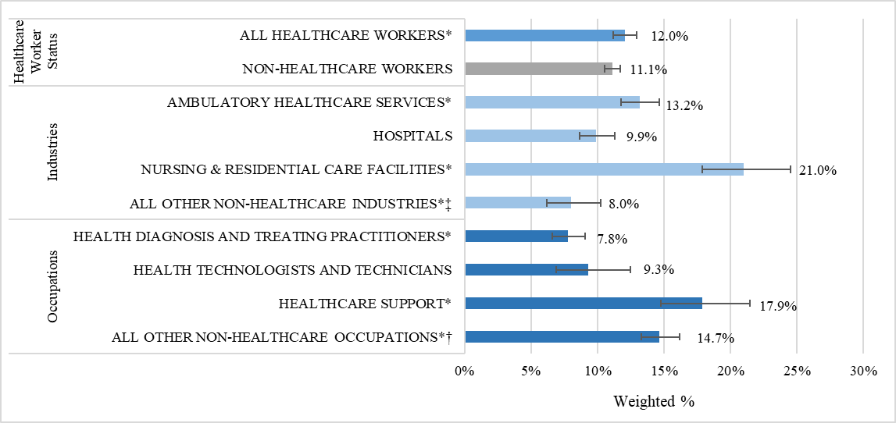
Notes: 1) Census Occupations Codes: Health diagnosing and treating practitioners (COC 3000-3260), Health technologists and technicians (COC 3300-3540), Healthcare support occupations (COC 3600-3655); 2) Census Industry Codes: Ambulatory healthcare services (CIC 7970-8180), Hospitals (CIC 8190), Nursing and residential care facilities (CIC 8270-8290); 3) * refers to a percent that is statistically significantly different from that of the reference group (REF); 4) ‡ refers to all other industries in which healthcare workers are employed; 5) † refers to all other occupations in which healthcare workers are employed 6) Sample size: N = 5,922 (healthcare workers); N = 12,945 (non-healthcare workers); 7) Data Source: Massachusetts COVID-19 Community Impact Survey, Massachusetts Department of Public Health, Fall 2020
- Overall, a slightly higher percentage of healthcare workers reported using tobacco in the last 30 days (12.0%) compared to non-healthcare workers (11.1%)
- Healthcare workers in Nursing and residential care facilities (21.0%) and those working in Healthcare support occupations (17.9%) had the highest reported percentages of tobacco use by industry and occupation, respectively.

Figure 26. Percentage of healthcare workers reporting use of marijuana in the past 30 days, by industry and occupation
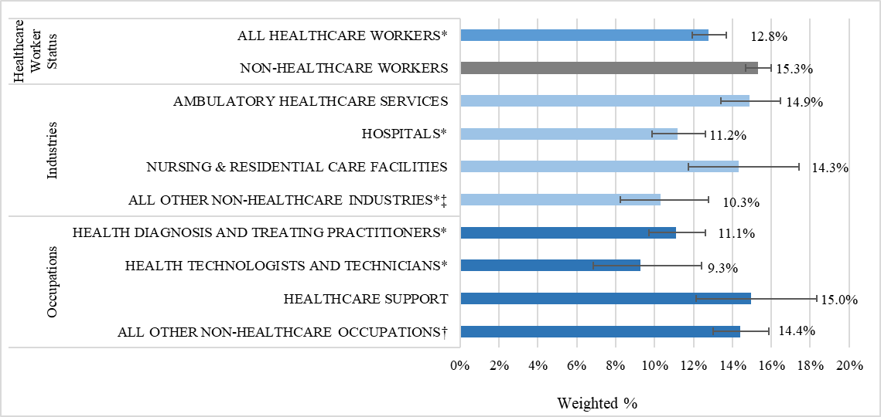
Notes: 1) Census Occupations Codes: Health diagnosing and treating practitioners (COC 3000-3260), Health technologists and technicians (COC 3300-3540), Healthcare support occupations (COC 3600-3655); 2) Census Industry Codes: Ambulatory healthcare services (CIC 7970-8180), Hospitals (CIC 8190), Nursing and residential care facilities (CIC 8270-8290); 3) * refers to a percent that is statistically significantly different from that of the reference group (REF); 4) ‡ refers to all other industries in which healthcare workers are employed; 5) † refers to all other occupations in which healthcare workers are employed 6) Sample size: N = 5,922 (healthcare workers); N = 12,945 (non-healthcare workers); 7) Data Source: Massachusetts COVID-19 Community Impact Survey, Massachusetts Department of Public Health, Fall 2020
- Overall, 12.8% of healthcare workers reported using marijuana in the last 30 days, which was significantly less than non-healthcare workers (15.3%)

Increase of Any Substance
CCIS respondents were also asked to think about usage at the time of survey completion (September to November 2020) compared to before the COVID-19 pandemic (February 2020). Respondents were asked if they were using substances: a lot more; somewhat more; about the same; somewhat less, or a lot less.
The following figures examine healthcare workers’ overall increased use (i.e., responded with “somewhat more” or “a lot more”) (Figure 27), increased alcohol use only (i.e., no other substance, except OTC medications and/or prescription drugs) (Figure 28). Due to small numbers in the sample, it was only possible to examine increased use of alcohol only (with no other substance). It was not possible to do this analysis for tobacco or marijuana only.

Figure 27. Percentage of healthcare workers reporting increased use of any substance (not counting prescription drug or over-the-counter medications) between February 2020 and Fall 2020, by industry and occupation
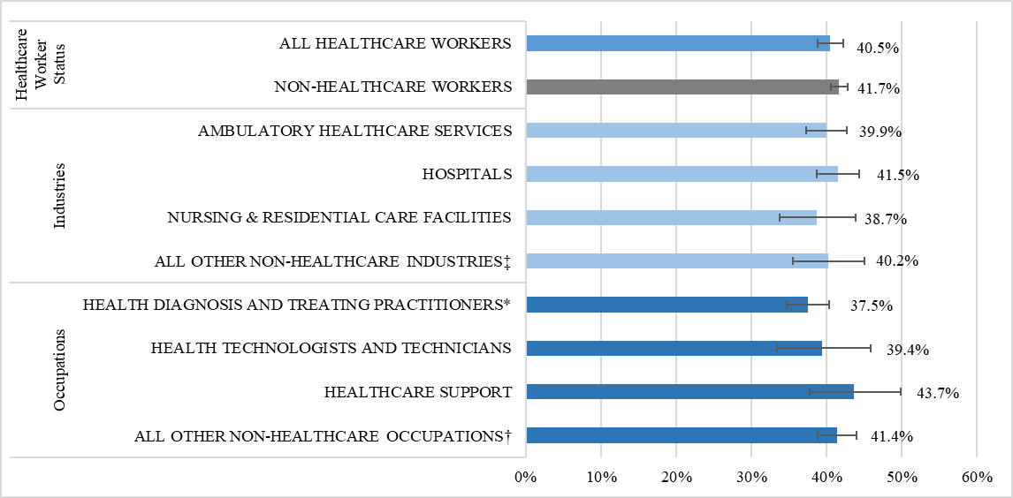
Notes: 1) Census Occupations Codes: Health diagnosing and treating practitioners (COC 3000-3260), Health technologists and technicians (COC 3300-3540), Healthcare support occupations (COC 3600-3655); 2) Census Industry Codes: Ambulatory healthcare services (CIC 7970-8180), Hospitals (CIC 8190), Nursing and residential care facilities (CIC 8270-8290); 3) * refers to a percent that is statistically significantly different from that of the reference group (REF); 4) ‡ refers to all other industries in which healthcare workers are employed; 5) † refers to all other occupations in which healthcare workers are employed; 6) Sample size: N = 3,679 (healthcare workers); N= 8,430 (non-healthcare workers). 7) Data Source: Massachusetts COVID-19 Community Impact Survey, Massachusetts Department of Public Health, Fall 2020
- Overall, 40.5% of healthcare workers reported increased use of any substance, which was similar to the percentage of non-healthcare workers (41.7%).
- The findings did not vary substantially across subgroups of healthcare workers, but the percentage was slightly lower among health diagnosis and treating practitioners (37.5%).

Figure 28. Percentage of healthcare workers who used alcohol reporting increased use of alcohol between February 2020 and Fall of 2020, by industry and occupation
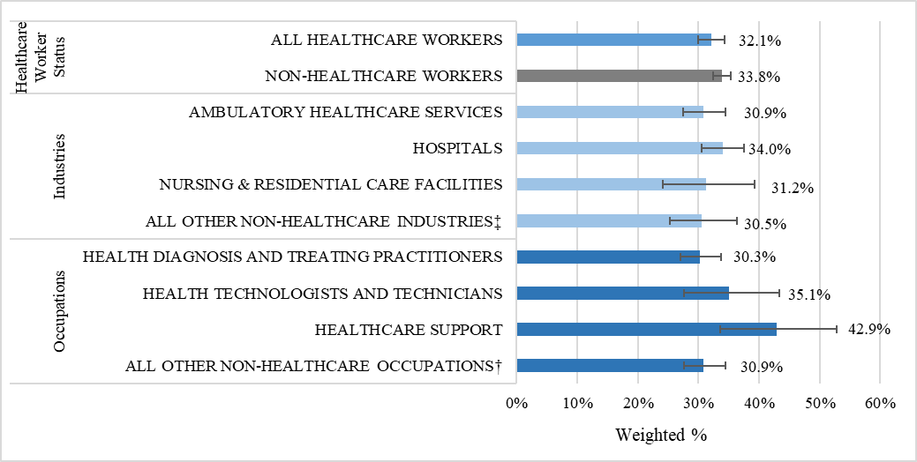
Notes: 1) Census Occupations Codes: Health diagnosing and treating practitioners (COC 3000-3260), Health technologists and technicians (COC 3300-3540), Healthcare support occupations (COC 3600-3655); 2) Census Industry Codes: Ambulatory healthcare services (CIC 7970-8180), Hospitals (CIC 8190), Nursing and residential care facilities (CIC 8270-8290); 3) * refers to a percent that is statistically significantly different from that of the reference group (REF); 4) ‡ refers to all other industries in which healthcare workers are employed; 5) † refers to all other occupations in which healthcare workers are employed;6) Sample size: N = 2,350 (healthcare workers); N= 5,298 (non-healthcare workers). 7) Data Source: Massachusetts COVID-19 Community Impact Survey, Massachusetts Department of Public Health, Fall 2020
- Nearly a third of healthcare workers (32.1%) who drank alcohol reported an increase in use since February 2020. This was similar to the percentage of non-healthcare workers (33.8%).
- Among healthcare workers, the percentage did not vary much across industry groups. By occupation, percentages ranged from 30.3% among Health and diagnosis treating practitioners to 42.9% among those in Healthcare support occupations.

Substance Use Resources
CCIS respondents were asked what, if any, resources would be most helpful. Resources from healthcare worker respondents in the CCIS, who were employed in the past year and who reported using any substance in the last 30 days (not counting over-the-counter medications or prescription drugs) are included in Figure 29. Note that due to small sample size within healthcare industries and occupations, the data shown here reflects the answers of all healthcare workers combined.
Figure 29. Substance use resources that healthcare workers who used any substance in the past 30 days thought would be most helpful
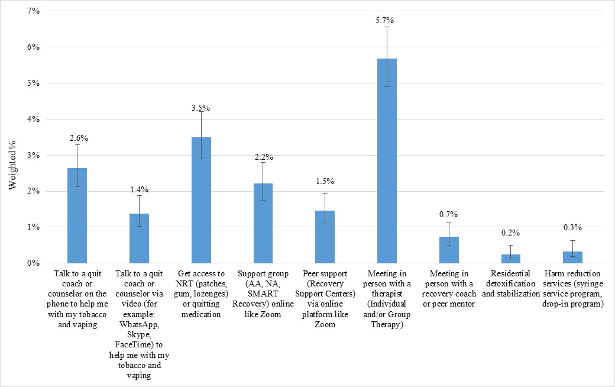
Notes: 1) Sample size = 3351 (healthcare workers); 2) The original CCIS also included a response option for “Residential programming (halfway house, sober living)” but the sample size among healthcare worker was too small to report out on, so it is omitted from this graph. 3) Data Source: Massachusetts COVID-19 Community Impact Survey, Massachusetts Department of Public Health, Fall 2020
- When asked which substance use resources might be most helpful, the highest percentage of healthcare workers selected meeting in person with a therapist (5.7%), followed by accessing nicotine replacement therapy (NRT) (3.5%) and talking to a quit coach on the phone (2.6%).

Suicide

The International Classification of Diseases 11th Revision defines suicide as “intentional self-harm with the intent to cause the death of the person” and suicidal ideation as “thoughts, ideas, or ruminations about the possibility of ending one's life, ranging from thinking that one would be better off dead to formulation of elaborate plans (World Health Organization, 2022a; World Health Organization, 2022b).”
Several studies found that during the pandemic, there was an increase in suicide among healthcare workers as well as an increase in suicidal ideation and that this increase may continue beyond the pandemic (Mannelli, 2020; Henrich et al., 2016; Papoutsi et al., 2020; Montemurro 2020; Reger at al., 2020). The increase in suicides is attributed to social isolation, fear of contracting COVID-19 as well as being diagnosed with COVID-19, depression, anxiety, and inability to access mental health care (Young et al., 2020). One study of healthcare workers found that 4% of survey respondents thought they had thoughts that they “would be better off dead” or wanted to hurt themselves in some way for several days, with an additional 1.4% reported feeling this way more than half the days or almost every day. Among adults in the U.S., it is estimated that 4% experience suicidal ideation each year (Young, et al., 2020).
According to statewide Massachusetts data from the Injury Surveillance Program at the Massachusetts Department of Public Health (Massachusetts Department of Public Health, 2021), overall emergency department (ED) visit data for suicidal ideation and suicide attempts decreased initially at the very start of the COVID-19 pandemic, yet this was likely the result of the stay-at-home order and people’s hesitation to go to the hospital for fear of COVID-19 infection. Unfortunately, suicide-related ED visits have continued to rise since April 2020. As of May 2021 (latest published data), the number of ED visits for suicidal ideation and suicide attempts are the highest they have been since January 2019.
While the CCIS did not measure suicidality, it did include a question where respondents indicated what suicide prevention resources would be most helpful. The data from healthcare workers is shown in Figure 30.

Figure 30. Percentage of healthcare workers reporting that suicide prevention resources would be helpful, by industry and occupation
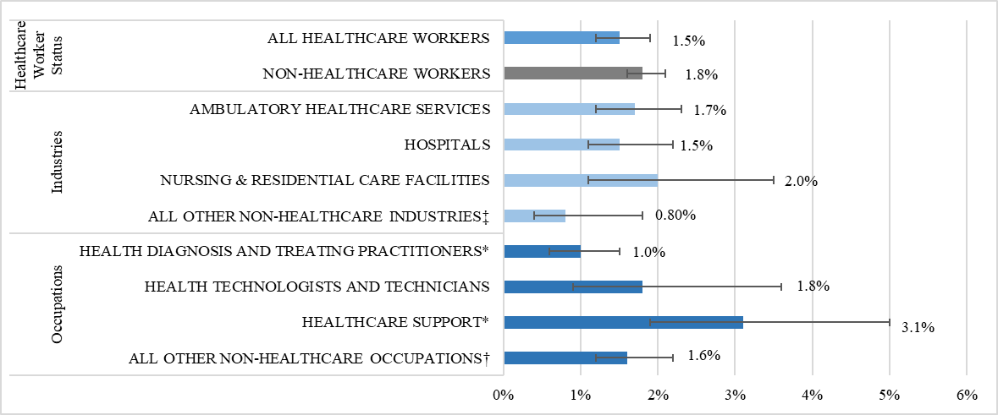
Notes: 1) Census Occupations Codes: Health diagnosing and treating practitioners (COC 3000-3260), Health technologists and technicians (COC 3300-3540), Healthcare support occupations (COC 3600-3655); 2) Census Industry Codes: Ambulatory healthcare services (CIC 7970-8180), Hospitals (CIC 8190), Nursing and residential care facilities (CIC 8270-8290); 3) * refers to a percent that is statistically significantly different from that of the reference group (REF); 4) ‡ refers to all other industries in which healthcare workers are employed; 5) † refers to all other occupations in which healthcare workers are employed; 6) Sample size: N = 5,922 (healthcare workers); N= 12,945 (non-healthcare workers). 7) Data Source: Massachusetts COVID-19 Community Impact Survey, Massachusetts Department of Public Health, Fall 2020
- Overall, 1.5% of healthcare workers reported that suicide prevention resources would be helpful, which was similar to the percentage of non-healthcare workers (1.8%).
- Due to small numbers, findings among subgroups of healthcare workers are imprecise. Worth noting, by occupation, the percentage was highest among those in Healthcare support occupations (3.1%) and lowest among Health diagnosis and treating practitioners (1.0%).

Current Efforts to Support Mental Health and Related Resources

Vaccine Equity Initiative

The Massachusetts Department of Public Health’s (DPH)Vaccine Equity Initiative works with populations and communities hardest hit by COVID-19 to improve awareness and acceptance of the COVID-19 vaccine, increase access to vaccination services, and decrease gaps in vaccination rates. Within the Vaccine Equity Initiative, the Employer/Employee team informs workplace-centered outreach strategies to best support the working people of Massachusetts. This approach is critical as work is a social determinant of health and has been an important driver of COVID-19 risk and inequities. Employers, unions, and worker groups have played an important role in vaccinations and COVID-19 mitigation.
The Employer/Employee team within the Vaccine Equity Initiative has provided resources to employers and workers to assist with vaccination and broader COVID-19 mitigation. This included promoting the “COVID-19 Temporary Emergency Paid Sick Leave Program,” a program in place from May 2021 through March 2022 that required employers to make paid leave time available to employees for COVID-related illnesses, quarantine, and vaccinations and provides employers with an opportunity to apply for reimbursement from the state. Other outreach strategies of the Vaccine Equity Initiative team have included direct contact with businesses, industry associations, and unions; development of worker- and employer-specific communication materials; engaging with community liaisons (DPH staff working closely with local communities); and providing technical assistance on COVID-19 mitigation strategies at work. While these efforts have not been healthcare worker specific, nor have they been mental health-specific, by aiming to address overall COVID-19 mitigation in workplaces and vaccination efforts among workers, DPH aims to improve the health and wellbeing of all people in Massachusetts.
It should be noted that healthcare workers were included in the first phase of COVID-19 vaccine rollout. This was not restricted to clinical staff only, thus taking an equitable approach to the vaccine distribution, and a testament to many of the findings reflected in this report on the additional risks that healthcare workers of all kinds took on during the pandemic.

Related Research, Trainings, and Other Resources (Not Exhaustive)

Assessment of Social Service Providers During the COVID-19 Pandemic
DPH’s Bureau of Community Health and Prevention’s Injury Prevention & Control Program, in partnership with UMass Amherst, conducted an assessment on the impact of COVID-19 on social service providers, with a specific focus on burnout. Based on the assessment, they aimed to identify and disseminate related resources. Social service workers (included in the definition of healthcare workers in this report) included the following: Emergency Medical Technicians (EMTs)/Paramedics, Early Education and Early Intervention providers, Home Visitors/Community Health Workers (CHWs), Youth Providers, and other related professions. Anonymous surveys were administered between February and March of 2021 and asked questions regarding changes in service delivery, burnout, understanding of suicide and their capacity to support clients who are suicidal, and perceptions of clients’ needs.
The survey revealed high levels of burnout and stress among all groups and that tailored resources were needed. Based on these findings, the Injury Prevention and Control Program and UMass Amherst team developed trainings/resources on self-care, and trauma-informed practices, and developed an awareness campaign with Riverside Trauma Center. Moving forward, the team is building trauma-informed practices, self-care, and suicide prevention into training for home visitors, community health workers, and youth-serving providers.

Suicide Prevention Resources
The Suicide Prevention Program, within DPH’s Bureau of Community Health and Prevention, offers trainings to help behavioral health professionals better identify someone who is suicidal and help with their suicidality. Trainings have been offered for over 15 years and are updated as new evidenced-based practices are identified. The Suicide Prevention Program provides education and screening trainings for health professionals who want to learn how to identify at-risk individuals in their practices. Additionally, instructional trainings such as Safety Planning Interventions that teach professionals how to create a safety plan with an individual who is in a suicidal crisis are also available. With the onset of COVID-19 and in-person trainings not being possible, the Suicide Prevention Program has continued to offer all trainings virtually. The Suicide Prevention Program keeps a robust training calendar which offers courses throughout the year, including many at no cost, to ensure availability to anyone looking to learn more about suicide prevention. For more information on trainings offered, please view the DPH Suicide Prevention Training Calendar.
Furthermore, the Suicide Prevention Program helps promote the National Suicide Prevention Hotline (which became 988 as of July 16th, 2022). The Suicide Prevention Program has collaborated with the Massachusetts Bay Transportation Authority (MBTA) to advertise this number and continues to promote it in all trainings. In addition, the new Behavioral Health Help Line will launch in January 2023 and will be a centralized access point for all Behavioral Health needs, including crisis, urgent, & routine care.
In September 2020, the Suicide Prevention Program was one of eleven grantees awarded the Comprehensive Suicide Prevention Grant, a five-year grant from the Centers for Disease Control and Prevention (CDC). The goal of this grant is to reduce the number of suicidal incidents and deaths among populations within the state whose suicide rate is above the state’s 2018 overall rate of 10/100,000. For Massachusetts, these populations include: working-aged males, Hispanic/Latinx, veterans/military, and specific occupations and industries. To this end, the Suicide Prevention Program is working closely with DPH’s Occupational Health Surveillance Program to conduct a cross-analysis to identify the occupations and industries with the highest suicide death rates in Massachusetts. Identifying gaps in healthcare and behavioral healthcare systems is also a priority toward the final goal of reducing suicide deaths, suicide attempts, and ideation.

Mental Health Resources for Healthcare Workers Experiencing Stress, Anxiety and Trauma
DPH has put together a website specifically aimed at healthcare workers experiencing stress, anxiety, and trauma. The website contains links to resources such as counseling services, helplines, and other support mechanisms specially geared towards healthcare workers: https://www.mass.gov/info-details/mental-health-resources-for-health-care-workers-experiencing-stress-anxiety-and-trauma

Efforts to Support the Substance Use Disorder Workforce:
The DPH’s Bureau of Substance Addiction Services (BSAS) has implemented numerous policies to allow for flexibility in staffing better substance use disorder (SUD) providers and staff who were already facing ongoing workforce shortages. Examples include withdrawing guidelines requiring licensed SUD facilities to staff to their licensed capacity and allowing programs to staff according to their daily census of patients providing needed flexibility to programs and staff; allowing LPNs or other Qualified Health Care Professionals (as defined by 105 CMR 164.006) to supervise nursing staff, provided that the supervisor is educationally prepared at or above the level of the nursing staff under their supervision; and allowing Opioid Treatment Programs to close one day per week in alignment with federal regulations. Due to the persistent nature of the workforce shortage, BSAS intends to maintain these flexibilities and identify other opportunities to support staff recruitment, retention, and wellness particularly for staff with lived experience who may be at higher risk for relapse due to the ongoing stress and trauma associated with the COVID-19 pandemic.

Select Efforts to Support Healthcare Workers:
From April 2020 to July 2021, the Massachusetts Department of Public Health’s Bureau of Health Care Safety and Quality (BHCSQ) administered the COVID-19 Outreach Project, in which DPH staff members were assigned long-term care facilities (LTCF) to call and collect real-time data about COVID-19 outbreaks, offer guidance, and connect facilities to resources. DPH resources included PPE, COVID-19 testing supplies, and deploying COVID-19 vaccine clinics to healthcare facilities and personnel. Furthermore, DPH also coordinated and deployed clinical staffing support to facilities throughout the pandemic through the Massachusetts National Guard and Rapid Response Teams.
Calls were made on a daily or weekly cadence depending on the severity of the facilities’ COVID-19 outbreaks. By the end of the program, 22,209 phone calls were made, 74% of LTCFs had received at least one PPE shipment from the state stockpile, and 39% of LTCFs had at least one Rapid Response Team or MA National Guard deployment providing supplemental staffing.
DPH staff then conducted in-depth semi-structured interviews with staff members from 22 LTCFs to evaluate the Outreach Project. In these interviews, most LTCF staff expressed feeling overwhelmed and emotionally drained throughout the pandemic. During the first wave of the pandemic, staff stress and anxiety was influenced by a number of factors including the loss of residents and colleagues, lack of adequate resources and knowledge about the novel disease, and concerns about safety. Several interviewees reported the Outreach Project calls as sources of emotional and/or mental health support as their DPH contacts provided opportunities for LTCF staff to express their anxieties and grief, in addition to offering technical guidance and resources. Furthermore, regular phone calls with the same DPH contact over an extended period made staff in LTCF feel that they had a reliable person to reach out to for help. This opened new channels for communication, trust, and timely responses to COVID-19 outbreaks in facilities.
As the pandemic continued, LTCF staff expressed feeling less acute stress and anxiety and more fatigue and burnout as they struggled to keep up with ongoing heightened requirements related to infection control and data reporting along with worsening staffing shortages. While the Outreach Project ended in July 2021, largely due to staff members needing to return to their usual survey duties in the field, DPH public health nurse advisors continue to communicate with LTCFs experiencing outbreaks to ensure they have the resources needed to safely care for residents.
In addition, pursuant to an Order issued by the Commissioner of Public Health to focus health care personnel resources on responding to COVID-19 (Commonwealth of Massachusetts. April 3, 2020), DPH directed all Massachusetts healthcare facilities to implement their policies and procedures for expedited provider credentialing in their emergency management plan and transfer of licensed and certified clinical staff between healthcare facilities. To help nursing homes address staffing shortages during the pandemic, CMS provided a blanket waiver for the nurse aide training and certification requirements to permit nurse aides to work for longer than four months without having completed their training.

Other statewide programs to support workers
Throughout the course of the pandemic, many other programs were implemented or expanded to help further support the workers in the Commonwealth. Programs such as the COVID-19 Essential Employee Premium Pay provides $500 payments to 500,000 low-income workers, and the Paid Family and Medical Leave (PFML) (Chapter 121 of the Acts of 2018) provides resources to help people in Massachusetts take paid time off work for family or medical reasons. Helplines were established at different agencies (e.g., DPH, Office of the Attorney General, Department of Labor Standards) throughout the Commonwealth at various points of the pandemic to address concerns about COVID-19 exposure/enforcement, as well as experiences in nursing homes/health care facilities. MEMA and DPH continue to facilitate mask and other PPE distribution to targeted entities across the Commonwealth.

Conclusion

To examine the impact of the COVID-19 pandemic on the mental health of Massachusetts healthcare workers, this report included an in-depth review of current scientific literature and data from a novel survey of Massachusetts residents during the early phase of the pandemic. It also included a detailed description of the healthcare workforce in Massachusetts to help better understand the demographic composition of the workforce at the start of the pandemic. Finally, the report highlighted some of the ongoing DPH efforts to support this workforce.
Findings from the scientific literature demonstrated that in addition to healthcare workers experiencing increased rates of COVID-19, pandemic-related impacts ranged from sleep disruptions and fatigue to increased anxiety, depression, burnout, and suicide. Potential work-related stressors specific to healthcare workers include increased patient load, exposure to infectious patients, initial shortages in personal protective equipment and lack of a vaccine or at-home COVID-19 testing, working outside of their areas of expertise, frequently evolving infection control and treatment guidance, frequent exposure to dying patients, fear of exposing family members to the virus, financial impacts, stigma, and isolation. The risk of COVID-19 and associated health impacts is not borne equally across all people, nor is it borne equally across healthcare workers. This was also true in Massachusetts, where at the start of the pandemic, there were nearly 570,000 healthcare workers employed in a variety of settings and jobs. Industry and occupation subgroups of healthcare workers differed by key employment and demographic characteristics. Data from the CCIS suggested that potential work-related stressors (e.g., disruptions to employment, being unable to work remotely, having employer-provided protections), as well as mental health and substance use outcomes also varied across subgroups of healthcare workers.
Structural racism plays a role in people of color being disproportionately employed in jobs with hazardous physical and/or psychosocial working conditions and underpins the observed racial inequities in various pandemic-related health outcomes, including and beyond COVID-19 infection (Hawkins, 2020; Krieger, 2010). For example, the workforce data included in this report demonstrated that workers of color were overrepresented in Nursing and residential care facilities in Massachusetts leading up to the pandemic, with nearly one-third being Black, non-Hispanic/non-LatinX workers. An estimated 4 in 5 were women. Additionally, a relatively large percentage of workers in this industry (32.9%) were employed in Healthcare support occupations, who had the lowest median income of the three healthcare occupation groups. In the CCIS, healthcare workers in Nursing and residential care facilities were most likely to experience 3 or more PTSD-like reactions to the pandemic and 15 or more days of poor mental health in the previous month. The vast majority (88.9%) worked outside the home and three quarters (75.2%) reported work-related reasons for not being able to physically distance from others when outside the home. In addition to potential stress due to elevated work-related exposure risk, relatively high percentages of these workers also experienced economic-related stressors. They were most likely of any industry subgroup of healthcare workers to experience reduced hours and to be worried about paying upcoming expenses or bills.
Many of the stressors that healthcare workers faced in the fall of 2020 are still present today, in the fall of 2022. While the wide availability and uptake of the vaccine as an added layer of protection may bring some comfort, concerns may remain regarding the extent of workforce and patient vaccinations and related mandates, as well as the continual need for employer-provided protections such as appropriate ventilation.
The data included in this report demonstrate that the impact of COVID-19 on healthcare workers extends beyond coronavirus infection and has greatly impacted the mental health of this workforce. This risk is not borne equally across all healthcare worker populations. Resources and tools have been put in place across DPH and other state agencies, yet continued support for this crucial workforce in Massachusetts is needed.

APPENDIX

Relevant Questions from the Adult COVID-19 Community Impact Survey (CCIS)

Additional information on the CCIS is available at https://www.mass.gov/resource/covid-19-community-impact-survey.
Employment
Which of the following best describes your current work situation?
- Retired
- A homemaker
- Employed full time (35 or more hours per week)
- Employed part time (less than 35 hours per week)
- Out of work for more than one year
- Out of work for less than one year
- Furloughed (temporarily unemployed)
- Self-employed (including those working as independent contractors)
- None of the above
What kind of work do / did you do? For example, registered nurse, janitor, cashier, auto mechanic. If you have more than one job, please answer for your primary job.
- (Free text occupation response)
What kind of business do you work in? For example, hospital, elementary school, manufacturing, restaurant. If you have more than one job, please answer for your primary job.
- (Free text industry response)
Has your employment status or the nature of your work changed in any of the following ways due to COVID-19? Select all that apply.
- I permanently lost my job
- I temporarily lost my job
- My hours were reduced
- My hours were increased
- I have started a new / different job
- I have been assigned a different role at work
- I am working from home
- I have needed to take paid leave from work
- I have needed to take unpaid leave from work
- Other (please specify):
- My employment status and the nature of my work has not changed due to COVID-19
- I am not currently employed
Why did your employment status or the nature of your work change? Select all that apply.
- My employer laid me off or reduced my work hours
- I needed to take care of my child / children
- I needed to take care of a sick family member
- I was afraid to get COVID-19 at work
- I was afraid to get COVID-19 on my way to work
- Other (please specify):
- My employment status and the nature of my work has not changed due to COVID-19
Has your employer given you any of the following to protect you against COVID-19? Select all that apply.
- I am not currently employed
- I have been working from home
- Personal protective equipment (PPE)
- Social distancing (increasing the physical space between people to avoid spreading illness)
- Cleaning of work setting
- Monitoring of symptoms of staff / customers
- Hand sanitizer
- Additional health and safety training
- Other (please specify):
- None of the above
If you are currently working, do you have paid sick leave you can use through your employer?
- Yes
- No
- Don't know
- I am not currently employed
Expenses and Basic Needs
Which types of expense or bills are you most worried about paying in the next few weeks? Select all that apply.
- Housing; Rent, mortgage, property taxes, condo fees, housing insurance
- Utilities: Cable, cell, electricity, water, gas, heating
- Vehicle: Lease, car loan payment, car insurance
- Debt: Credit card debt, student loan debt, bank fees
- Insurance: Health insurance, disability insurance, life insurance
- School tuition / Daycare cost
- Other (please specify):
- I'm not worried about paying bills or expenses right now

COVID-19 Risk, Precautions, and Testing
When you are outside of the home are you able to keep 6 feet between yourself and others?
- I don't leave the home
- Yes
- No
Why not? Select all that apply.
- I have to take public transportation to get to work
- I have to take public transportation to do errands
- The building where I live is crowded
- The streets where I live are crowded
- My workplace is crowded
- In order to do my work, I need to be physically close others
- The place where I buy groceries is crowded
- The places where I eat are crowded
- Other (please specify):
Did you ever get tested for COVID-19?
- Yes
- No
- Don't know
Has you or anyone you know tested positive for COVID-19? Select all that apply.
- No one I know tested positive for COVID-19
- I tested positive for COVID-19
- Someone I live with tested positive for COVID-19
- Other (please specify):
Has someone close to you died from COVID-19?
- Yes
- No
- Don't know

Mental Health
Now thinking about your mental health, which includes stress, depression, and problems with emotions, on how many days during the past 30 days was your mental health not good?
- ____ Days
In the past month, have you had any of the following reactions to things you have seen, heard, or experienced related to the COVID-19 outbreak:
- Had nightmares or thought about it when you didn't want to?
- Tried not to think about it or went out of your way to avoid situations that reminded you of it?
- Been constantly on guard, watchful, or easily startled?
- Felt numb or detached from people, activities, or your surroundings?
- Felt guilty or unable to stop blaming yourself or others for it or any problems it may have caused?
  - Yes, I have had three or more of these reactions in the past month
  - Yes, I have had one or two of these reactions in the past month, but not as many as three or more
  - No, I have not had any of these reactions in the past month, but I know someone else who has
  - No, I have not had any of these reactions in the past month, and I don't know anyone else who has either
  - I choose not to answer this question
Which of these resources would be most helpful to you right now to help you with your mental health and well-being? Select all that apply.
- Information on how to see a therapist
- Suicide prevention and crisis resources
- Talking to a health professional on the phone
- Talking to a health professional over video chat
- Going to a support group using online platform (for example: Zoom)
- Meeting in person with a health professional (individual and/or group therapy)
- Using an application on a mobile phone or tablet for mental health support
Other resource(s) (please specify):
Substance Use
During the past 30 days, have you used any of the following products? Select all that apply.
- Conventional tobacco like cigarettes, cigars, chew
- E-Cigarettes / Vape products (JUUL, Vuse, FRUYT, or you mixed your own)
- Alcohol
- Heroin
- Other Opioids (fentanyl, dope, methadone, oxycodone, Vicodin)
- Marijuana or cannabis (dope, grass, hashish, weed)
- Cocaine (coke, yip, blow) / Crack (freebase, rock)
- Amphetamine (speed) / Methamphetamine (meth, crystal, tina)
- Inhalant (huffing aerosols, solvents, gases, or nitrites; whip-its / nitrous oxide)
- Ecstasy, MDMA (Molly), LSD, Ketamine
- Over the counter drugs (dextromorphan, DXM, DM, dres, robo, rojo, tussin)
- Prescription drugs (benzo, barbiturate, tranquilizers, clonidine, ritalin, adderal)
- I have not used any of these in the past 30 days
Compared to before the COVID-19 outbreak (February 2020), how often are you using these products now?
- A lot more
- Somewhat more
- About the same
- Somewhat less
- A lot less
Which of the following resources would be most helpful to you right now? Select all that apply.
- Talk to a quit coach or counselor on the phone to help me with my tobacco and vaping
- Talk to a quit coach or counselor via video (for example: WhatsApp, Skype, FaceTime) to help me with my tobacco and vaping
- Get access to Nicotine Replacement Treatment (patches, gum, lozenges) or quitting medication
- Support group (AA, NA, SMART Recovery) online like Zoom
- Peer support (Recovery Support Centers) via online platform like Zoom
- Meeting in person with a therapist (Individual and/or Group Therapy)
- Meeting in person with a recovery coach or peer mentor
- Residential detoxification and stabilization
- Residential programming (halfway house, sober living)
- Harm reduction services (syringe service program, drop-in program)
- Other resource(s) (please specify):
- No resources

Demographics
How old are you? (note: this was a screening question to determine whether a person completed the adult (≥25 years) or youth (14-24 years) version of the survey.)
Are you Hispanic or Latino?
- Yes
- No
What is your race? Select all that apply.
- American Indian or Alaska Native (please specify tribal nation):
- Asian
- Black
- Native Hawaiian or other Pacific Islander (please specify):
- White
- Other race (please specify):
- Unknown / Not specified
Do you speak language(s) other than English at home?
- Yes
- No
What is your current gender identity?
- Male
- Female
- Nonbinary, Genderqueer, not exclusively male or female
- I am questioning / not sure of my gender identity
- Other (please specify):
- I don't understand what this question is asking
- I prefer not to answer
Are you transgender or of transgender experience?
- Yes
- No
- I am not sure
- I don't understand what this question is asking
- I prefer not to answer
What is your sexual orientation?
- Asexual
- Bisexual and/or Pansexual
- Gay or Lesbian
- Straight (Heterosexual)
- Queer
- I am questioning / not sure of my sexuality
- Other (please specify):
- I don't understand what this question is asking
What is the highest grade or year of school you have finished?
- I finished 8th grade or less
- I have finished 9th, 10th or 11th grade
- I have graduated high school or equivalent (for example: GED)
- I have finished trade, vocational, or technical school
- I started college, but I haven't graduated
- Associate's degree (for example: AA, AS)
- Bachelor's degree (for example: BA, BS, AB)
- Graduate degree (for example: master's, professional, doctorate)
In 2019, what was your total annual household income before taxes?
- < $25,000
- $25,000 - $34,999
- $35,000 - $49,999
- $50,000 - $74,999
- $75,000 - $99,999
- $100,000 - $149,999
- $150,000 - $199,999
- $200,000 and above
- Don't know
Please select all that apply to you.
- I am deaf or hard of hearing.
- I am blind or I have trouble seeing even when I am wearing glasses.
- I have trouble concentrating, remembering, or making decisions because of a
- physical, mental, or emotional condition.
- I have trouble walking or climbing stairs.
- I have trouble getting dressed or taking a bath or shower.
- I have difficulty doing errands alone such as visiting a doctor's office or shopping.
- None of the above apply to me.

REFERENCES
Amboss. (2022) Trauma- and stressor-related disorders- Knowledge @ AMBOSS https://www.amboss.com/us/knowledge/trauma--and-stressor-related-disorders/ Accessed: July 15, 2022.
American Medical Association. (2022) ARC Issue Bried: Confidential care to support physician health and wellness. https://www.ama-assn.org/system/files/issue-brief-physician-health-wellness.pdf Accessed: July 15, 2022.
Arnetz, J. E., Goetz, C. M., Sudan, S., Arble, E., Janisse, J., & Arnetz, B. B. (2020). Personal Protective Equipment and Mental Health Symptoms Among Nurses During the COVID-19 Pandemic. Journal of occupational and environmental medicine, 62(11), 892–897. https://doi.org/10.1097/JOM.0000000000001999
Ballantyne, H., & Achour, N. (2022). The Challenges of Nurse Redeployment and Opportunities for Leadership during COVID-19 Pandemic. Disaster medicine and public health preparedness, 1–19. Advance online publication. https://doi.org/10.1017/dmp.2022.43
Bansal, P., Bingemann, T. A., Greenhawt, M., Mosnaim, G., Nanda, A., Oppenheimer, J., Sharma, H., Stukus, D., & Shaker, M. (2020). Clinician Wellness During the COVID-19 Pandemic: Extraordinary Times and Unusual Challenges for the Allergist/Immunologist. The journal of allergy and clinical immunology. In practice, 8(6), 1781–1790.e3. https://doi.org/10.1016/j.jaip.2020.04.001
Bryant R. A. (2019). Post-traumatic stress disorder: a state-of-the-art review of evidence and challenges. World psychiatry : official journal of the World Psychiatric Association (WPA), 18(3), 259–269. https://doi.org/10.1002/wps.20656
Bucca, A., Ullrich, L., Rahman, A., Smith, C., Johnson, M., Allanson-Dundon, A., Corwin, D., James, J. A., Marchionni, C., Bratis, L., & Bendas, E. (2022). Unmasking the Truth of Health Care Workers' Well-being During the COVID-19 Pandemic. Critical care nurse, e1–e7. Advance online publication. https://doi.org/10.4037/ccn2022769
Centers for Disease Control and Prevention (CDC). (2020) Behavioral Risk Factor Surveillance System Survey Questionnaire. Atlanta, Georgia: U.S. Department of Health and Human Services
Chen, R., Sun, C., Chen, J. J., Jen, H. J., Kang, X. L., Kao, C. C., & Chou, K. R. (2021). A Large-Scale Survey on Trauma, Burnout, and Posttraumatic Growth among Nurses during the COVID-19 Pandemic. International journal of mental health nursing, 30(1), 102–116. https://doi.org/10.1111/inm.12796
Chervoni-Knapp T. (2022). The Staffing Shortage Pandemic. Journal of radiology nursing, 41(2), 74–75. https://doi.org/10.1016/j.jradnu.2022.02.007
Chew, N., Lee, G., Tan, B., Jing, M., Goh, Y., Ngiam, N., Yeo, L., Ahmad, A., Ahmed Khan, F., Napolean Shanmugam, G., Sharma, A. K., Komalkumar, R. N., Meenakshi, P. V., Shah, K., Patel, B.,
Chan, B., Sunny, S., Chandra, B., Ong, J., Paliwal, P. R., … Sharma, V. K. (2020). A multinational, multicentre study on the psychological outcomes and associated physical symptoms amongst healthcare workers during COVID-19 outbreak. Brain, behavior, and immunity, 88, 559–565. https://doi.org/10.1016/j.bbi.2020.04.049
Commonwealth of Massachusetts. (2020, March 23) COVID-19: Essential Services | Mass.gov https://www.mass.gov/info-details/covid-19-essential-services Accessed: July 15, 2022.
Commonwealth of Massachusetts. (2020, December 7) Order of the Commissioner of Public Health regarding scheduling and performance of elective invasive procedures. https://www.mass.gov/doc/dph-elective-surgery-order/download Accessed: July 15, 2022.

Commonwealth of Massachusetts. (2020, April 3) Order rescinding and replacing the March 29, 2020 Order of the Commissioner of Public Health maximizing health care provider availability. https://www.mass.gov/doc/order-maximizing-available-healthcare-providers-april-2020/download Accessed: July 15, 2022.
Commonwealth of Massachusetts. (2022, December 15) COVID-19 Interactive Data Dashboard. https://www.mass.gov/info-details/covid-19-response-reporting Accessed: December 19, 2022.
Contreras, Z., Ngo, V., Pulido, M., Washburn, F., Meschyan, G., Gluck, F., Kuguru, K., Reporter, R., Curley, C., Civen, R., Terashita, D., Balter, S., & Halai, U.-A. (2021, July 27). Industry sectors highly affected by worksite outbreaks of coronavirus disease, Los Angeles County, California, USA, March 19-September 30, 2020. Emerging infectious diseases. Retrieved July 15, 2022, from https://www.ncbi.nlm.nih.gov/pmc/articles/PMC8237894/
Council of State and Territorial Epidemiologists (2020) Update to the standardized surveillance case definition and national notification for 2019 novel coronavirus disease (COVID-19). https://cdn.ymaws.com/www.cste.org/resource/resmgr/ps/positionstatement2020/Interim-20-ID-02_COVID-19.pdf Accessed: July 15, 2022.
Czeisler, M. É., Lane, R. I., Petrosky, E., Wiley, J. F., Christensen, A., Njai, R., Weaver, M. D., Robbins, R., Facer-Childs, E. R., Barger, L. K., Czeisler, C. A., Howard, M. E., & Rajaratnam, S. (2020). Mental Health, Substance Use, and Suicidal Ideation During the COVID-19 Pandemic - United States, June 24-30, 2020. MMWR. Morbidity and mortality weekly report, 69(32), 1049–1057. https://doi.org/10.15585/mmwr.mm6932a1
d'Ettorre, G., Ceccarelli, G., Santinelli, L., Vassalini, P., Innocenti, G. P., Alessandri, F., Koukopoulos, A. E., Russo, A., d'Ettorre, G., & Tarsitani, L. (2021). Post-Traumatic Stress Symptoms in Healthcare Workers Dealing with the COVID-19 Pandemic: A Systematic Review. International journal of environmental research and public health, 18(2), 601. https://doi.org/10.3390/ijerph18020601
Easterly, J. (2021, August 10). CISA guidance on the Essential Critical Infrastructure Workforce 508C. Guidance on the Essential Critical Infrastructure Workforce. Retrieved July 13, 2022, from https://www.cisa.gov/sites/default/files/publications/CISA_Guidance_on_the_Essential_Critical_Infrastructure_Workforce_508C.pdf
Feingold, J. H., Peccoralo, L., Chan, C. C., Kaplan, C. A., Kaye-Kauderer, H., Charney, D., Verity, J., Hurtado, A., Burka, L., Syed, S. A., Murrough, J. W., Feder, A., Pietrzak, R. H., & Ripp, J. (2021). Psychological Impact of the COVID-19 Pandemic on Frontline Health Care Workers During the Pandemic Surge in New York City. Chronic stress (Thousand Oaks, Calif.), 5, 2470547020977891. https://doi.org/10.1177/2470547020977891
Flotte, T. R., Larkin, A. C., Fischer, M. A., Chimienti, S. N., DeMarco, D. M., Fan, P. Y., & Collins, M. F. (2020). Accelerated Graduation and the Deployment of New Physicians During the COVID-19 Pandemic. Academic medicine : journal of the Association of American Medical Colleges, 95(10), 1492–1494. https://doi.org/10.1097/ACM.0000000000003540
Friedman, M. J., Resick, P. A., Bryant, R. A., Strain, J., Horowitz, M., & Spiegel, D. (2011). Classification of trauma and stressor-related disorders in DSM-5. Depression and anxiety, 28(9), 737–749. https://doi.org/10.1002/da.20845
Galea, S., Ahern, J., Resnick, H., Kilpatrick, D., Bucuvalas, M., Gold, J., & Vlahov, D. (2002). Psychological sequelae of the September 11 terrorist attacks in New York City. The New England journal of medicine, 346(13), 982–987. https://doi.org/10.1056/NEJMsa013404
Gupta, N., Dhamija, S., Patil, J., & Chaudhari, B. (2021). Impact of COVID-19 pandemic on healthcare workers. Industrial psychiatry journal, 30(Suppl 1), S282–S284. https://doi.org/10.4103/0972-6748.328830;

Hawkins, D., Davis, L., & Kriebel, D. (2021). COVID‐19 deaths by occupation, Massachusetts, March 1–July 31, 2020. American journal of industrial medicine, 64(4), 238-244.
Hawkins D. (2020). Differential occupational risk for COVID-19 and other infection exposure according to race and ethnicity. American journal of industrial medicine, 63(9), 817–820. https://doi.org/10.1002/ajim.23145
Henrich, N. J., Dodek, P. M., Alden, L., Keenan, S. P., Reynolds, S., & Rodney, P. (2016). Causes of moral distress in the intensive care unit: A qualitative study. Journal of critical care, 35, 57–62. https://doi.org/10.1016/j.jcrc.2016.04.033
Hensel, J. M., Ruiz, C., Finney, C., & Dewa, C. S. (2015). Meta-analysis of risk factors for secondary traumatic stress in therapeutic work with trauma victims. Journal of traumatic stress, 28(2), 83–91. https://doi.org/10.1002/jts.21998
Hossain, F., & Clatty, A. (2021). Self-care strategies in response to nurses' moral injury during COVID-19 pandemic. Nursing ethics, 28(1), 23–32. https://doi.org/10.1177/0969733020961825
Hossain, M. M., Tasnim, S., Sultana, A., Faizah, F., Mazumder, H., Zou, L., McKyer, E., Ahmed, H. U., & Ma, P. (2020). Epidemiology of mental health problems in COVID-19: a review. F1000Research, 9, 636. https://doi.org/10.12688/f1000research.24457.1
Jaschek, G., Carter-Pokras, O. D., He, X., Lee, S., & Canino, G. (2016). Association of Types of Life Events with Depressive Symptoms among Puerto Rican Youth. PloS one, 11(10), e0164852. https://doi.org/10.1371/journal.pone.0164852
Kang, L., Ma, S., Chen, M., Yang, J., Wang, Y., Li, R., Yao, L., Bai, H., Cai, Z., Xiang Yang, B., Hu, S., Zhang, K., Wang, G., Ma, C., & Liu, Z. (2020). Impact on mental health and perceptions of psychological care among medical and nursing staff in Wuhan during the 2019 novel coronavirus disease outbreak: A cross-sectional study. Brain, behavior, and immunity, 87, 11–17. https://doi.org/10.1016/j.bbi.2020.03.028
Kisely, S., Warren, N., McMahon, L., Dalais, C., Henry, I., & Siskind, D. (2020). Occurrence, prevention, and management of the psychological effects of emerging virus outbreaks on healthcare workers: rapid review and meta-analysis. BMJ (Clinical research ed.), 369, m1642. https://doi.org/10.1136/bmj.m1642
Krieger N. (2010). Workers are people too: societal aspects of occupational health disparities--an ecosocial perspective. American journal of industrial medicine, 53(2), 104–115. https://doi.org/10.1002/ajim.20759
Lu, M. (2020) Visualizing the Occupations with the Highest COVID-19 Risk. Visual Capitalist. https://www.visualcapitalist.com/the-front-line-visualizing-the-occupations-with-the-highest-covid-19-risk/ Accessed: July 15, 2022.
Mannelli C. (2020). Whose life to save? Scarce resources allocation in the COVID-19 outbreak. Journal of medical ethics, 46(6), 364–366. https://doi.org/10.1136/medethics-2020-106227
Markkanen, P., Brouillette, N., Quinn, M., Galligan, C., Sama, S., Lindberg, J., & Karlsson, N. (2021). "It changed everything": The safe Home care qualitative study of the COVID-19 pandemic's impact on home care aides, clients, and managers. BMC health services research, 21(1), 1055. https://doi.org/10.1186/s12913-021-07076-x
Massachusetts Department of Public Health (2022, July 8). COVID-19 Dashboard – Dashboard of Public Health Indicators. Retrieved from https://www.mass.gov/doc/weekly-covid-19-public-health-report-december-17-2020/download
Massachusetts Department of Public Health. Data Brief: Opioid-Related Overdose Deaths among Massachusetts Residents. June 2022. https://www.mass.gov/doc/opioid-related-overdose-deaths-among-ma-residents-june-2022/download
Massachusetts Department of Public Health. COVID-19 Data Brief 2020: Suicides, Suicide Attempts, and Suicidal Ideation in Massachusetts. Fall 2021. https://www.mass.gov/doc/covid-19-data-brief-2020-suicides-suicide-attempts-and-suicidal-ideation-in-massachusetts-0/download Accessed: July 15, 2022.
Mattila, E., Peltokoski, J., Neva, M. H., Kaunonen, M., Helminen, M., & Parkkila, A. K. (2021). COVID-19: anxiety among hospital staff and associated factors. Annals of medicine, 53(1), 237–246. https://doi.org/10.1080/07853890.2020.1862905
Mazure, C. M., Bruce, M. L., Maciejewski, P. K., & Jacobs, S. C. (2000). Adverse life events and cognitive-personality characteristics in the prediction of major depression and antidepressant response. The American journal of psychiatry, 157(6), 896–903. https://doi.org/10.1176/appi.ajp.157.6.896
Montemurro N. (2020). The emotional impact of COVID-19: From medical staff to common people. Brain, behavior, and immunity, 87, 23–24. https://doi.org/10.1016/j.bbi.2020.03.032.
National Institute of Mental Health. (2021) Substance Use and Co-Occurring Mental Disorders https://www.nimh.nih.gov/health/topics/substance-use-and-mental-health Accessed: July 15, 2022.
Nowrouzi-Kia, B., Sithamparanathan, G., Nadesar, N., Gohar, B., & Ott, M. (2021). Factors associated with work performance and mental health of healthcare workers during pandemics: a systematic review and meta-analysis. Journal of public health (Oxford, England), fdab173. Advance online publication. https://doi.org/10.1093/pubmed/fdab173
Papoutsi, E., Giannakoulis, V. G., Ntella, V., Pappa, S., & Katsaounou, P. (2020). Global burden of COVID-19 pandemic on healthcare workers. ERJ open research, 6(2), 00195-2020. https://doi.org/10.1183/23120541.00195-2020
Prins, A., Bovin, M. J., Kimerling, R., Kaloupek, D. G, Marx, B. P., Pless Kaiser, A., & Schnurr, P. P. (2015). Primary Care PTSD Screen for DSM-5 (PCPTSD-5) [Measurement instrument]. Available from https://www.ptsd.va.gov
Psycom. (2022) Depression Definition and DSM-5 Diagnostic Criteria https://www.psycom.net/depression/major-depressive-disorder/dsm-5-depression-criteria. Accessed: July 15, 2022.
Rabow, M. W., Huang, C. S., White-Hammond, G. E., & Tucker, R. O. (2021). Witnesses and Victims Both: Healthcare Workers and Grief in the Time of COVID-19. Journal of pain and symptom management, 62(3), 647–656. https://doi.org/10.1016/j.jpainsymman.2021.01.139
Reger, M. A., Stanley, I. H., & Joiner, T. E. (2020). Suicide Mortality and Coronavirus Disease 2019-A Perfect Storm?. JAMA psychiatry, 77(11), 1093–1094. https://doi.org/10.1001/jamapsychiatry.2020.1060
Roberts A, Rogers J, Mason R, Siriwardena AN, Hogue T, Whitley GA, Law GR. Alcohol and other substance use during the COVID-19 pandemic: A systematic review. Drg Alcohol Depend. 2021 Dec 1;229(Pt A):109150. https://doi.org/10.1016/j.drugalcdep.2021.109150 . Epub 2021 Oct 29. PMID: 34749198; PMCID: PMC8559994.
SAMHSA Center for Substance Abuse Treatment (US). Trauma-Informed Care in Behavioral Health Services. Rockville (MD): Substance Abuse and Mental Health Services Administration (US); 2014. (Treatment Improvement Protocol (TIP) Series, No. 57.) Exhibit 1.3-4, DSM-5 Diagnostic Criteria for PTSD. Available from: https://www.ncbi.nlm.nih.gov/books/NBK207191/box/part1_ch3.box16/
Shang, J., Chastain, A. M., Perera, U., Quigley, D. D., Fu, C. J., Dick, A. W., Pogorzelska-Maziarz, M., & Stone, P. W. (2020). COVID-19 Preparedness in US Home Health Care Agencies. Journal of the American Medical Directors Association, 21(7), 924–927. https://doi.org/10.1016/j.jamda.2020.06.002
South Dakota Secretary of State, Steve Barnett. (2020, April 28) Executive Order 2020-20 https://covid.sd.gov/docs/2020-20.pdf Accessed: July 15, 2022.
State of New Jersey. (2020, March 23) Executive Order No. 109 - government of New Jersey. https://nj.gov/infobank/eo/056murphy/pdf/EO-109.pdf Accessed: July 15, 2022.
State of Vermont Executive Department. (2020, June 15) Addendum 8 to Order No. 01-20 https://governor.vermont.gov/content/addendum-8-amended-and-restated-executive-order-01-20-0 Accessed: July 15, 2022.
Stojanov, J., Malobabic, M., Stanojevic, G., Stevic, M., Milosevic, V., & Stojanov, A. (2021). Quality of sleep and health-related quality of life among health care professionals treating patients with coronavirus disease-19. The International journal of social psychiatry, 67(2), 175–181. https://doi.org/10.1177/0020764020942800
Substance Abuse and Mental Health Services Administration, Impact of the DSM-IV to DSM-5 Changes on the National Survey on Drug Use and Mental Health Services Administration (US); 2016 Jun. Table 3.15, DSM-IV to DSM-V Generalized Anxiety Disorder Comparison. Available from: https://www.ncbi.nlm.nih.gov/books/NBK519704/table/ch3.t15. Accessed: July 15, 2022.
Tan, B., Chew, N., Lee, G., Jing, M., Goh, Y., Yeo, L., Zhang, K., Chin, H. K., Ahmad, A., Khan, F. A., Shanmugam, G. N., Chan, B., Sunny, S., Chandra, B., Ong, J., Paliwal, P. R., Wong, L., Sagayanathan, R., Chen, J. T., Ng, A., … Sharma, V. K. (2020). Psychological Impact of the COVID-19 Pandemic on Health Care Workers in Singapore. Annals of internal medicine, 173(4), 317–320. https://doi.org/10.7326/M20-1083
Tuna, T., & Özdin, S. (2021). Levels and Predictors of Anxiety, Depression, and Burnout Syndrome in Physicians During the COVID-19 Pandemic. International journal of mental health and addiction, 19(6), 2470–2483. https://doi.org/10.1007/s11469-021-00505-2
Wang, C., Pan, R., Wan, X., Tan, Y., Xu, L., Ho, C. S., & Ho, R. C. (2020). Immediate Psychological Responses and Associated Factors during the Initial Stage of the 2019 Coronavirus Disease (COVID-19) Epidemic among the General Population in China. International journal of environmental research and public health, 17(5), 1729. https://doi.org/10.3390/ijerph17051729
Washington State. (2021a) COVID-19 Case Rates by Industry and Occupation. https://lni.wa.gov/safety-health/safety-research/files/2022/103_09_2022_IO_by_TimePeriod.pdf Accessed: July 15, 2022.
Washington State (2021b) COVID-19 Confirmed Cases by Industry Sector. Washington State. https://doh.wa.gov/sites/default/files/2022-02/IndustrySectorReport.pdf Accessed: July 15, 2022.
Werner, E. A., Aloisio, C. E., Butler, A. D., D'Antonio, K. M., Kenny, J. M., Mitchell, A., Ona, S., & Monk, C. (2020). Addressing mental health in patients and providers during the COVID-19 pandemic. Seminars in perinatology, 44(7), 151279. https://doi.org/10.1016/j.semperi.2020.151279
World Health Organization (2020, March 11) WHO Director-General’s opening remarks at the media briefing on COVID-19 – 11 March 2020. https://www.who.int/director-general/speeches/detail/who-director-general-s-opening-remarks-at-the-media-briefing-on-covid-19---11-march-2020. Accessed: July 15, 2022.
World Health Organization (WHO) International Statistical Classification of Diseases and Related Health Problems (2022a) ICD-11 for Mortality and Morbidity Statistics https://icd.who.int/browse11/l-m/en#/http://id.who.int/icd/entity/219257631 Accessed: July 15, 2022.
World Health Organization (WHO) International Statistical Classification of Diseases and Related Health Problems (2022b) ICD-11 for Mortality and Morbidity Statistics https://icd.who.int/browse11/l-m/en#/http://id.who.int/icd/entity/778734771 Accessed: July 15, 2022.
World Health Organization (WHO) International Statistical Classification of Diseases and Related Health Problems (2022c) ICD-11 for Mortality and Morbidity Statistics http://id.who.int/icd/entity/129180281 Accessed: December 12, 2022
Yang, B. K., Carter, M. W., & Nelson, H. W. (2021). Trends in COVID-19 cases, deaths, and staffing shortages in US nursing homes by rural and urban status. Geriatric nursing (New York, N.Y.), 42(6), 1356–1361. https://doi.org/10.1016/j.gerinurse.2021.08.016
Young, K. P., Kolcz, D. L., O'Sullivan, D. M., Ferrand, J., Fried, J., & Robinson, K. (2021). Health Care Workers' Mental Health and Quality of Life During COVID-19: Results From a Mid-Pandemic, National Survey. Psychiatric services (Washington, D.C.), 72(2), 122–128. https://doi.org/10.1176/appi.ps.202000424

https://budget.digital.mass.gov/summary/fy22/outside-section/section-123-covid-19-trauma-study
“Healthcare support occupations” is an example of a U.S. Bureau of Census Occupation Code. Other standardized codes used in this report also include those from the U.S. Bureau of Census Industry Codes. Standard referencing to these codes involves capitalizing the first letter of the code. That practice is followed throughout this report.
Data Description: The estimates for the demographics section of this report were obtained from the National Institute for Occupational Safety and Health subset of the Current Population Survey via the Employment Labor Force query system. Weighted Massachusetts datasets from 2015-2019 (pre-pandemic data) were used to determine average annual values to increase the reliability of the estimates. All estimates were rounded to the nearest thousand for convenience. https://wwwn.cdc.gov/Wisards/cps/cps_estimates.aspx
“Ambulatory healthcare services” is an example of a U.S. Bureau of Census Industry Code. Other standardized codes used in this report also include those from the U.S. Bureau of Census Occupation Codes. Standard referencing to these codes involves capitalizing the first letter of the code. That practice is followed throughout this report.

