COVID-19
Vaccine Management

December 14, 2020

Massachusetts Department of Public Health Immunization Division
Shumethia Seal, MPH Vaccine Manager

- Requirements to receive COVID-19 vaccine.
- Methods for ordering COVID-19 vaccine.
- COVID-19 vaccine storage and handling (including transport requirements).
- Planned redistribution from depots to individual locations and from larger to smaller locations.
- Managing vaccine inventory, including accessing and managing product expiration dates.
- Reporting vaccine inventory.
- Managing temperature excursions.
- Document and report vaccine wastage/spoilage.

Learning Objectives

12/14/20 https://www.mass.gov/covid-19-vaccine-in-massachusetts 2

COVID-19 Vaccine Eligibility Considerations

Decisions about which eligible patients receive the COVID Vaccine should be based on the clinical judgement of hospitals and providers, consistent with the terms of the EUAs and with this guidance.

- Provider criteria for the COVID Vaccine use should be as clear, transparent, and objective as possible, and be based on biological factors related only to the likelihood and magnitude of benefit from the medical resources and should at all times minimize inequitable outcomes.

- Factors that have no bearing on the likelihood or magnitude of benefit, include but are not limited to, race, disability, gender, sexual orientation, gender identity, ethnicity, ability to pay or insurance status, socioeconomic status, English language proficiency, perceived social worth, perceived quality of life, immigration status, incarceration status, homelessness or past or future use of resources.

12/14/20 https://www.mass.gov/covid-19-vaccine-in-massachusetts 3

Evolving Recommendations

Always check the websites below and other websites provided within this
presentation for the latest guidance and information.
- Pfizer EUA Webpage: https://www.cvdvaccine-us.com
- CDC’s Healthcare Professionals: Preparing for COVID-19 Vaccination: https://www.cdc.gov/vaccines/covid-19/hcp/index.html
- CDC’s COVID Vaccination Training and Education:
https://www2.cdc.gov/vaccines/ed/covid19/

https://www.mass.gov/covid-19-vaccine-in-massachusetts
12/14/20 4

Requirements to receive COVID-19
vaccine

Registered with the Massachusetts Immunization Information System (MIIS).
  - Submit a unique Massachusetts COVID- 19 Vaccine Program (MCVP) agreement.

The MCVP Agreement is emailed as a link to contacts associated with the MIIS and State Vaccine Program.

12/14/20 https://www.mass.gov/covid-19-vaccine-in-massachusetts 5

MCVP
Agreement

12/14/20

Providers agree to:
- Follow state prioritization guidelines for vaccinating populations.
- Agree to report immunization administration data within 24 hours of administration.
- Organization must not sell or seek reimbursement
for COVID-19 vaccine or ancillary supplies.
- Must administer regardless of ability to pay.
- Must provide Emergency Use Authorization fact sheet.
- Must comply with CDC and manufacturer guidance for vaccine management.
- Comply with MDPH guidance for handling temperature excursions.
When completing the MCVP Agreement, sites are also completing the redistribution agreement.
https://www.mass.gov/covid-19-vaccine-in-massachusetts 6

All facilities designated a primary and back-up COVID-19 Vaccine coordinator when completing the MCVP agreement.

Training

12/14/20

COVID-19 Vaccine Coordinators will ensure that COVID-19 vaccines are stored and handled correctly.

- All staff members who receive vaccine deliveries, handle or administer vaccines must be trained in vaccine related practices and procedures.

https://www.mass.gov/covid-19-vaccine-in-massachusetts 7

Ordering and Receiving COVID- 19 Vaccine

  - In the initial phases of distribution, MDPH Immunization Division will allocate and order COVID-19 vaccine for providers.

Ordering

12/14/20
- When an order is created, the Primary and Back-Up Vaccine Coordinators will receive an email advising of the order.
- Sites should review this order and ensure that there is space for this vaccine.
- Sites will have a short window to have the order cancelled.
- Vaccine will arrive within 48-72 hours of this order being created.

- Eventually, sites will be able to place orders for COVID- 19 vaccine directly in the MIIS.
https://www.mass.gov/covid-19-vaccine-in-massachusetts 9

Shipment

12/14/20

Once an order is received, it will be fulfilled by CDC distributor and/or vaccine manufacturer.
  - Accurate contact information is necessary, providing an unmonitored email in your MCVP Agreement can result in a rejected order.

- Depending on the vaccine product ordered, sites will receive the following shipments:
  - COVID-19 vaccine
  - Ancillary kit
  - Dry Ice replenishment

https://www.mass.gov/covid-19-vaccine-in-massachusetts 10

Contact Information
Critical system email addresses to accept for vaccine distribution and ancillary kits.
Address | Purpose
SNSSupport@McKesson.com | Communization about ancillary kits
Pfizer.logistics@controlant.com | Communization from Controlant including:  - Notice at time of vaccine shipment with tracking information.  - Exceptions for either shipment delay or cancellation.  - Delivery Quality Report
donotreply@Pfizer.com | Confirmation of the ancillary kit shipment
cvgovernment@Pfizer.com | Pfizer customer service.

It is incredibly important to provide email addresses that will continue to be monitored.

Unmonitored emails will result
in rejected orders.

12/14/20
https://www.mass.gov/covid-19-vaccine-in-massachusetts 11

Pfizer COVID- 19 Vaccine
Tray Dimensions: 229mm x 229mm x 40mm (approx. 9in x 9in x 1.5 in)
Minimum Order: 975 dose On Site Vaccination Storage:
- -80ºC to -60ºC in ultra cold storage unit for up to 6 months
- -80ºC to -60ºC in the original thermal shipping container for up to 30 days, if replenished with dry ice upon receipt and every 5 days.
- 2ºC to 8ºC in a storage unit for up to 120 hours (5 days) Thawing
- A tray of 195 vials may take up to 3 hours to thaw in the refrigerator (2ºC to 8ºC )
- Vials needed for immediate use may be thawed at room temperature (30 minutes). Can be at room temperature for no more than 2 hours.
Diluted product must be used in 6 hours from the time of dilution, stored between 2ºC to 25ºC .

12/14/20 https://www.mass.gov/covid-19-vaccine-in-massachusetts 12

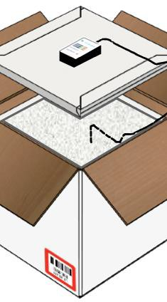
Pfizer COVID-19 Vaccine –
Thermal Shipper
- Vaccine is shipped directly from Pfizer.
- Vaccine is shipped in a container that includes dry ice and digital data logger to monitor temperature.
- Thermal shipping container dimensions – 400mm x 400mm x 560mm (approx. 15 ¾ in x 15 ¾ in x 22in).
- Container holds a maximum of 5 cartons/trays (4,875 doses).
- If using thermal shipping container to store vaccine, add dry ice pellets (9mm to 16mm) within 24 hours of delivery and every 5 days or as needed to maintain temperatures for up to 30 days.
- Dry ice will be delivered within 24 hours of vaccine delivery to refill the thermal shipping container for the first re-ice only.
- Do Not Use or Store dry ice or liquid nitrogen in confined areas, walk-in
refrigerators, or rooms without ventilation.
- A full shipping container with vaccine and dry ice weighs approximately
70 pounds.
12/14/20 https://www.mass.gov/covid-19-vaccine-in-massachusetts 13

Pfizer COVID-19 – Product Packaging

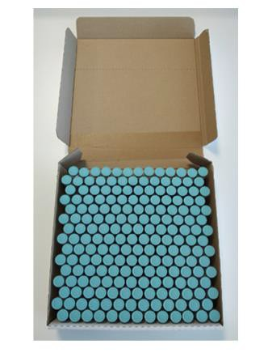
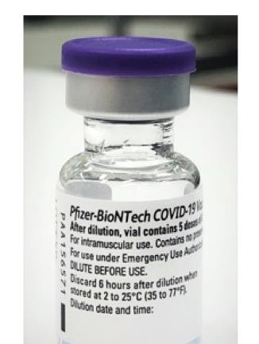
Vials
  - 2mL Type 1 glass preservative-free
  - MDV has 0.45 mL frozen liquid
product
  - 5 doses per vial after dilution

Trays
  - Single tray holds 195 vials
  - 975 doses per tray

12/14/20
https://www.mass.gov/covid-19-vaccine-in-massachusetts 14

Pfizer Vaccine -

The ancillary kits shipped for the Pfizer vaccine are combined kits with syringes for vaccine administration, mixing supplies and diluent.
Supports administration of 975 doses and includes 0.9% preservative-free normal saline diluent.
Dimensions: 214in x 20 in x 24 in (40lbs)
Includes:

- 829 needles (22-25G x 1”)
- 2458 alcohol pads

- 200 needles (22-25Gx1.5”) • 1000 vaccination record cards

Ancillary Kits
- 205 mixing needles (21 -
25G x 1.5”)
- 1024 syringes (1mL)
- 205 syringes (3mL or 5mL)
- 200 diluent vials

- 10 needle gauge and length charts
- 20 face shields

12/14/20 https://www.mass.gov/covid-19-vaccine-in-massachusetts 15

Dry Ice Kit
If Pfizer COVID-19 vaccine is ordered, the US
Government will supply an initial replenishment of Dry Ice.
- Dry Ice replenishment will arrive within 24 hours of vaccine delivery.
- Dry Ice Kit contents will include
  - Gloves
  - 1 Face Shield
  - 1 Ice scoop
  - OSHA dry ice safety card

12/14/20 https://www.mass.gov/covid-19-vaccine-in-massachusetts 16

Moderna COVID-19
Vaccine

12/14/20
Manufacturer: Moderna
Carton Dimensions: 53mm x 53mmX137mm (2in x 2in X 5 3/8in)
Minimum Order: 100 doses
Presentation: 10-dose multidose vial/10 MDV per carton
Distribution: Centrally distributed, will come from CDC distributor McKesson
On Site Vaccine Storage for unopened (non-punctured) vials:
  - -25ºC to -15ºC in vaccine storage unit up to 6 months.
  - 2ºC to 8ºC in vaccine storage unit for up to 30 days as long vial has not been entered.
  - 15ºC to 25ºC for 12 hours after removed from refrigeration.
On Site Vaccine Storage for Open (needle-punctured) multi-dose vials:
  - 2ºC to 25ºC for a maximum of 6 hours. Discard any punctured vial after 6 hours.
Considerations: Freezer temperature settings will require adjustment if this vaccine and varicella-containing vaccines are in the same unit. The temperature range for this vaccine is limited compared to varicella-containing vaccines.
https://www.mass.gov/covid-19-vaccine-in-massachusetts 17

Moderna Vaccine – Ancillary Kit

12/14/20

When a site receives Moderna vaccine they will receive a standard syringe kit for vaccine administration
Dimensions: 14inx13inx9in (3.5lbs) – supports 100 doses (plus overage)
Contents:
  - 85 safety needles (22-25G x 1”)
  - 20 safety needles (22-25G x 1.5”)
  - 105 syringes (1mL or 3mL)
  - 210 alcohol pads
  - 100 vaccination record cards
  - 1 needle gauge and length chart
  - 2 face shields
  - 4 surgical masks
Considerations: products and brand may vary.
https://www.mass.gov/covid-19-vaccine-in-massachusetts 18

COVID-19 Vaccine Storage and Handling - EUA

Since COVID-19 vaccines may initially be authorized for use under an Emergency Use Authorization (EUA), providers should refer to the EUA fact sheet for Healthcare providers and manufacturer information for detailed storage and handling information for each vaccine.
https://www.fda.gov/emergency-preparedness-and-response/coronavirus-
disease-2019-covid-19/pfizer-biontech-covid-19-vaccine

12/14/20 https://www.mass.gov/covid-19-vaccine-in-massachusetts 19

Vaccine Storage Units
 | Temperature Range | Storage Unit
 | 2ºC to 8ºC | - As a best practice, vaccines should be stored in purpose-built units or pharmaceutical-grade units. They are designed specifically for the storage of vaccines.  - Household-grade units can be an acceptable alternative, but the freezer must not  be used, and temperature must be monitored closely.
 | -15ºC to -50ºC | - Standalone freezers should be used for storage.  - Freezer compartments of Household units are not acceptable.  - Freezer temperature settings will require adjustment if Moderna COVID-19 vaccine and varicella-containing vaccines are in the same unit.
 | -60ºC to -80ºC | - Freezers designed to reach ultra-cold temperatures should be used.  - Vaccines that require ultra-cold temperature storage cannot be stored in a standard freezer.  - Neither CDC nor MDPH recommend that providers purchase ultra-cold storage units. Vaccines requiring ultra-cold storage conditions will be shipped in containers that can maintain ultra-cold temperatures for an extended time.
12/14/20 https://www.mass.gov/covid-19-vaccine-in-massachusetts 20

Temperature Monitoring

12/14/20
It is essential that providers continuously monitor vaccine storage unit temperatures. CDC and MDPH recommend that a digital data logger (DDL) is used.

DDLs:
    - Provide the most accurate storage unit temperature information by using a buffered probe.
    - Records temperatures continuously.
    - Identifies alarms and how long vaccine storage units have been out of range (temperature excursion).

* Not all DDLs can measure ultra-cold temperatures. Sites may use monitoring equipment that uses an air-probe or a probe designed specifically for ultra-cold temperatures.

https://www.mass.gov/covid-19-vaccine-in-massachusetts 21

Temperature Monitoring
Storage units must be monitored regularly. Even using a continuously monitoring temperature device like a DDL, providers must also record the following at least twice a day:

- Minimum and Maximum Temperature
- Date/Time
- Name of person checking and recording temperatures
- Actions taken if a temperature excursion occurred.

- Some DDLs keep a record of this information.
- Temperature records must be kept for a minimum of three years.

12/14/20 https://www.mass.gov/covid-19-vaccine-in-massachusetts 22

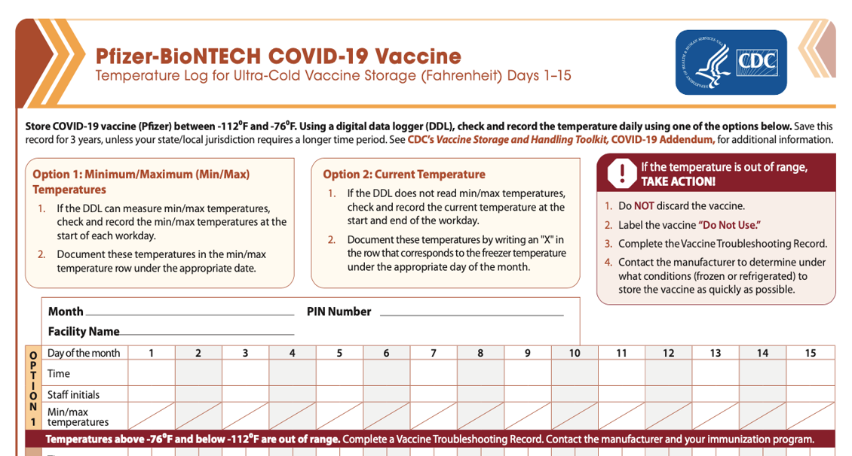

12/14/20 https://www.mass.gov/covid-19-vaccine-in-massachusetts 23

S&H- Pfizer COVID-19 Vaccine
If using thermal shipper for storage, it should only opened twice a day for a maximum of 3 minutes to maintain temperature.
Trays
- When removing a tray that has less than 195 vials from frozen storage (< -60ºC), the tray may be at room temperature (< 25ºC) for up to 5 minutes for transfer between ultra low temperatures environments or to remove vials for thawing or use.
- After vial trays are returned to frozen storage following room temperature exposure, they must remain in frozen storage for at least 2 hours before they can be removed again.
- Do not open the trays or remove vials until you are ready for thawing or use.
Vials
- Once an individual vial is removed from the vial tray at room temperature, it has begun thawing. It should not be returned to frozen storage. It should be thawed for use.
- Vials should be stored upright and protected from light.

12/14/20 https://www.mass.gov/covid-19-vaccine-in-massachusetts 24

Vaccine S&H Best Practices

- Vials are glass and should be handled with care.
- Vials should be protected from light and when
possible kept in the original packaging.
- Vials should always remain upright.
- Providers should develop and maintain clearly written and detailed storage and handlings Standard Operating Procedures (SOP).
- Vaccines may need to be mixed with a diluent prior to administration. Allows follow the manufacturer’s guidance for use of the diluent.
- Store vaccines and diluents in original packaging.
- Rotate vaccines and diluents so that vaccine that expires first are in the front and will be used first.

12/14/20 https://www.mass.gov/covid-19-vaccine-in-massachusetts 25

Whenever possible, vaccine should be shipped to the location where it will be administered to prevent breaks in the cold chain.

Redistribution

12/14/20

Vaccine may need to be redistributed due to the following
reasons:
  - Larger organizations whose vaccine is shipped to a central depot and requires redistribution to additional clinic locations.
  - Vaccines need to be redistributed to prevent wastage.
  - Vaccine needs to be transported for clinics.

All sites/facilities receiving vaccine, even if redistributed from another location, MUST complete the Massachusetts COVID-19 Vaccine Program (MCVP) agreement.
https://www.mass.gov/covid-19-vaccine-in-massachusetts 26

Transferring Inventory

Prior to physically transporting inventory, sites must:
- Ensure that the receiving site has a completed MCVP agreement.
- Contact the Vaccine Unit to virtually transfer vaccines so that inventories continue
to be accurate.
  - Eventually sites will be able to initiate transfers directly in the MIIS.

Have an SOP and a plan to ensure that the cold chain isn’t broken.

12/14/20 https://www.mass.gov/covid-19-vaccine-in-massachusetts 27

Transport

Vaccines must be transported in a stable storage unit and monitored with a DDL.
  - The time for transport alone or transport plus the clinic workday should
be a maximum of 8 hours.
  - Transport equal amounts of vaccines, diluents, and ancillary supplies.
  - Upon arrival, vaccines should immediately be stored in appropriate units
with a DDL.
  - A partially used vial cannot be transferred from one provider to another.
  - Transport will vary depending on vaccine, for more information consult
manufacturer.

12/14/20 https://www.mass.gov/covid-19-vaccine-in-massachusetts 28

Transport –
Pfizer Vaccine

12/14/20

Pfizer vaccine should be stored at ultra-cold temperatures, but there is stability to store vaccine at 2ºC to 8ºC.

When transporting Pfizer Vaccine:
- Only full and unopened trays (195) should be redistributed at freezer temperatures. If transporting a full tray of 975 doses, providers may transport at ultra cold temperatures in the original Pfizer shipper with dry ice.

If transporting vials outside of the tray,
providers can only transfer at 2ºC to 8ºC.
  - Pfizer COVID-19 vaccine begins to thaw once it is taken out of the tray.
https://www.mass.gov/covid-19-vaccine-in-massachusetts 29

Transport – Moderna Vaccine

Moderna vaccine must be transferred frozen. It cannot be transferred at
2ºC to 8ºC.

12/14/20 https://www.mass.gov/covid-19-vaccine-in-massachusetts 30

Inventory Management

Massachusetts Immunization Information
System
(MIIS)

Registration with the MIIS is required to receive COVID-19 vaccine.

- The MIIS is also integral to inventory
management.

- Sites should be onboarded with the MIIS to ensure that vaccine administration data is reported to the MIIS. For assistance, please contact the MIIS Registry Help Desk at MIIShelpdesk@MassMail.State.MA.US.

- As immunization data is reported to the registry,
your inventory will automatically be adjusted.

12/14/20 https://www.mass.gov/covid-19-vaccine-in-massachusetts 32

COVID-19
Expiration Dates

12/14/20

EUA vaccine labels may not include expiration dates.
  - CDC will post a COVID-19 Vaccine Expiration Date Tracking Tool on its website once vaccine available.
    - This link is currently not available.

Expiration dates may change as additional stability data become available.

https://www.mass.gov/covid-19-vaccine-in-massachusetts 33

Beyond Use Date (BUD)

12/14/20
Some vaccines have a BUD, which is based on storage information in the package insert. Examples of vaccines with BUDs include:

    - Reconstituted vaccines have a limited period of use once the vaccine is mixed with a diluent.
    - Multidose vials might have a specified period of use once they have been entered with a needle.
    - Manufacturer-shortened expiration dates may apply when vaccines are exposed to inappropriate storage units.

In the COVID-19 vaccine ancillary kits, CDC has provided vaccine labels to help keep track of BUDs for COVID-19 vaccine.

https://www.mass.gov/covid-19-vaccine-in-massachusetts 34

Reporting Inventory – Vaccine Finder and MIIS

Vaccine Finder
- One of the requirement to receive COVID-19 Vaccine is to COVID-19 vaccine inventory every 24 hours.
- MDPH Immunization Division will take
responsibility of this requirement for providers.
  - Providers will not need to directly report
vaccine inventory to Vaccine Finder
MIIS
To ensure that the MIIS has the most accurate data:
  - Ensure that your site is onboarded with the MIIS and can submit vaccine administration data directly to the registry.
  - Complete COVID-19 Vaccine reconciliations in the MIIS Vaccines Module.

12/14/20 https://www.mass.gov/covid-19-vaccine-in-massachusetts 35

Temperature Excursion

Any temperature outside of the recommended temperature ranges are considered a temperature excursion.
- If a temperature excursion occurs, providers must contact vaccine manufacturer to ensure viability.
- Providers should document all temperature excursions, including:
  - Date/Time of Excursion
  - Problem and Details
  - Who was contacted about
temperature excursion
  - Resolution
- Providers must keep this information on
hand for 3 years.

12/14/20 https://www.mass.gov/covid-19-vaccine-in-massachusetts 36

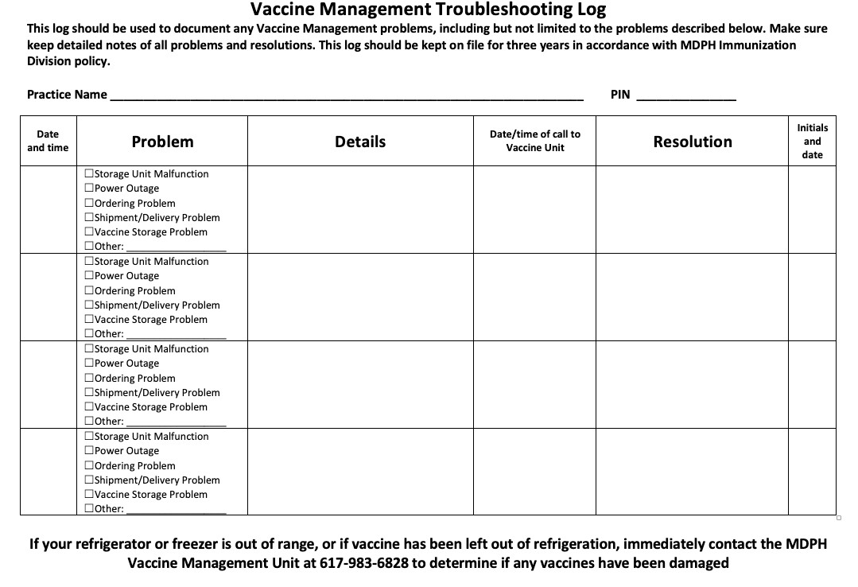

Temperature Excursion Documentation

Example of Temperature Troubleshooting Record

12/14/20 https://www.mass.gov/covid-19-vaccine-in-massachusetts 37

Wastage and Spoilage

At this time, CDC has not given guidance about how COVID-19 vaccine that has been wasted/spoiled will
be handled.

The ‘Vaccines’ module in the MIIS is currently used to process storage/handling issues and return spoiled
our wasted routine. We expect that this will be the method to return vaccines.

- Spoiled vaccine is non-viable vaccine in its original container (vial or syringe). This includes expired vaccine or vaccine spoiled due to temperature excursions, transport conditions, or emergency situations such as a power failure.
- Wasted vaccine is non-viable vaccine that is not in its original container. This includes vaccine in an open vial, drawn into a syringe, or compromised because its container was dropped or broken.

Every effort should be made to prevent spoiled or wasted vaccine.

12/14/20 https://www.mass.gov/covid-19-vaccine-in-massachusetts 38

Resources
Please continue to monitor these webpages as more information becomes available and information may change.

MDPH COVID-19 Vaccine Webpage
https://www.mass.gov/covid-19-vaccine-in-massachusetts
MDPH Vaccine Management Website
https://www.mass.gov/resource/vaccine-management
CDC Storage and Handling Toolkit
https://www.cdc.gov/vaccines/hcp/admin/storage/toolkit/index.html
Pfizer Website
https://www.cvdvaccine-us.com/resources
There will be a QR code on the shipment that will lead to a public facing website.
CDC Info by Vaccine (Pfizer)
https://www.cdc.gov/vaccines/covid-19/info-by-product/pfizer/index.html

12/14/20 https://www.mass.gov/covid-19-vaccine-in-massachusetts 39

Thank You

Vaccine Management Unit: DPH-Vaccine-
Management@massmail.state.ma.us

