

Executive Office of Health and Human Services

Department of Public Health  
Bureau of Health Care Safety and Quality

67 Forest Street, Marlborough, MA 01752

CHARLES D. BAKER

Governor

KARYN E. POLITO

Lieutenant Governor

MARYLOU SUDDERS

Secretary

MONICA BHAREL, MD, MPH Commissioner

**Tel: 617-624-6000**

**www.mass.gov/dph**

**Memorandum**

**TO:** Long-Term Care Facilities

**FROM:** Margret Cooke, JD, Deputy Commissioner

**SUBJECT:** COVID-19 Vaccination Reporting for Long-Term Care Facilities

**DATE:** March 26, 2021

The Massachusetts Department of Public Health (DPH) continues to work with state, federal, and local partners on the outbreak of Coronavirus Disease 2019 (COVID-19), caused by the virus SARS-CoV-2, and we continue to appreciate the essential role you have in responding to this evolving situation.

Long-term care facilities must report cumulative weekly COVID-19 vaccination rates for residents and staff in the manner specified in this memorandum.

**Long-Term Care Facilities Certified by the Centers for Medicare & Medicaid Services**

Facilities participating in the National Healthcare Safety Network (NHSN) must report cumulative weekly COVID-19 vaccination coverage for residents and staff through the Long-Term Care Facility Component.  The weekly COVID-19 vaccination modules provide consistent reporting and comparable data across facilities.  NHSN data can be used to monitor COVID-19 vaccination trends over time, identify facilities with lower resident and/or staff vaccination rates, and inform planning and implementation decisions regarding vaccine supply and distribution.

Training, data collection forms, and instructions can be found on the following NHSN website under ‘Weekly HCP & Resident COVID-19 Vaccination’: <https://www.cdc.gov/nhsn/ltc/weekly-covid-vac/index.html> .

Facilities can access the COVID-19 vaccination modules by logging into NHSN (via SAMS) as they would for any of the other NHSN reporting, Secure Access Management Service (cdc.gov). On the NHSN Home page, select the ‘COVID-19’option on the left-hand navigation bar. Staff and resident data should be entered by selecting ‘COVID-19 Vaccination-HCW’ and ‘COVID-19 Vaccination-Residents’ respectively. This reporting is separate from the ‘Daily Entry’ where facilities are currently entering weekly case counts and supply data. For reference, please see the image below:

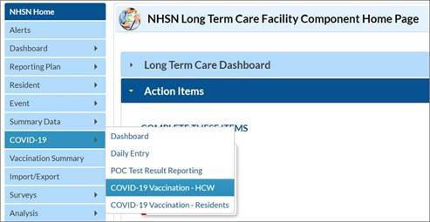

Beginning Sunday, April 4, 2021, long term care facilities certified by CMS must complete the two vaccination modules each week, no later than Sunday at 11:59 PM, in alignment with the CMS weekly deadline.

**Non-Certified Long-Term Care Facilities and Rest Homes**

Licensed, non-certified long-term care facilities and rest homes must participate in a weekly call with a Department contact to report cumulative weekly COVID-19 vaccination information for residents and staff. The Department contact assigned to your facility will outreach to the administrator or other agreed upon contact.

For questions, please contact [DPH.BHCSQ@MassMail.State.MA.US](mailto:DPH.BHCSQ@MassMail.State.MA.US).