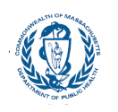
Massachusetts Department of Public Health

COVID-19 Vaccination Uptake Among Pregnant and Postpartum People in Massachusetts, December 1, 2020 – March 31, 2022

Key Takeaways for Healthcare Providers

Center for Birth Defects Research and Prevention

Healthcare Providers are Trusted Messengers

•The following data are tailored for providers, giving background and context on vaccination uptake among pregnant people in MA.

•Healthcare providers play a critical role in counseling and recommending their patients to get vaccinated against COVID-19.

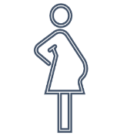
Background

• COVID-19 vaccination is recommended for people who are pregnant, recently pregnant, or might become pregnant in the future.

• Despite these recommendations, studies suggest that COVID-19 vaccine uptake is lower among pregnant people compared with non-pregnant people.

Sources:
1. https://www.cdc.gov/coronavirus/2019ncov/vaccines/recommendations/pregnancy.html
2. https://www.ncbi.nlm.nih.gov/pmc/articles/PMC9145279/3.
3. https://www.sciencedirect.com/science/article/pii/S2211335522000201

Methods

- We estimated vaccination uptake (receipt of >1 doses of COVID-19 vaccine) among pregnant and postpartum people in MA.

• To identify pregnant people, we relied upon MA vital records (birth certificates & fetal death certificates). Thus, we were limited to identifying those with completed deliveries (during December 1, 2020 – March 31, 2022).

• We linked* data from MA vital records and MA Immunization Information System (MIIS) COVID-19 vaccination to identify pregnant people with and without receipt of one or more doses of COVID-19 vaccine as of May 23, 2022.

*We used probabilistic and deterministic linkages; this process and the inability to ascertain vaccinations that were not in MIIS may lead to an undercount of vaccinations among pregnant people.

COVID-19 Vaccine Timeline of Events in MA

12/15/2020: Phase 1 of vaccine roll out
2/18/2021: Pregnancy now a priority condition for vaccination eligibility
7/30/2021: ACOG recommends pregnant people get vaccinated

8/13/2021: Boosters and third doses available‡

2/1/2021: Phase 2 of vaccine roll out
4/19/2021: Phase 3 of vaccine roll out
8/11/2021: CDC recommends all pregnant people get vaccinated
9/29/2021: CDC issues HAN urging COVID-19 vax for pregnant people

Phase 1
• December 15, 2020: Clinical and non-clinical health care workers doing direct and COVID-facing care
• December 28, 2020: Long term care facilities, rest homes and assisted living facilities
• January 11, 2021: First responders
• January 18, 2021: Congregate care settings
• January 21, 2021: Home-based health care workers, health care workers doing non-COVID-facing care
Phase 2
• February 1, 2021: People 75+
• February 18, 2021: People 65+, People with 2 or more certain medical conditions (including pregnancy), People who live or work in low income and affordable senior housing
• March 11, 2021: K-12 educators, K-12 school staff, and childcare workers
• March 22, 2021: People 60+, Workers in certain categories
• April 5, 2021: People 55+, People with 1 or more certain medical conditions (including pregnancy)

Phase 3
• April 19, 2021: People aged 16 and older can get vaccinated
• May 12, 2021: People aged 12 and older can get vaccinated

‡ Pregnant people eligible for boosters.

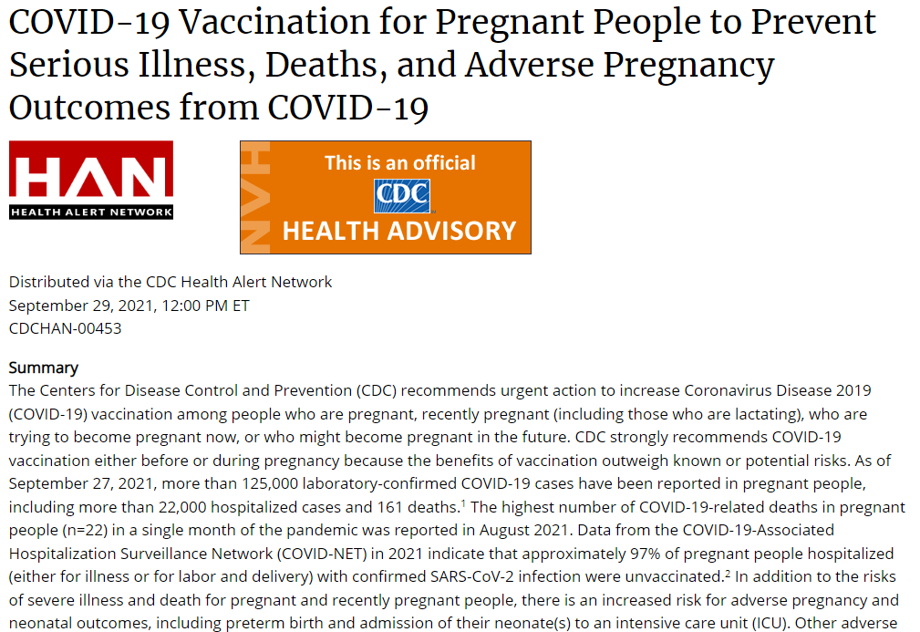

To read the full Health Alert, visit: https://emergency.cdc.gov/han/2021/han00453.asp

Contextualizing the Data

• In this analysis, we present racialized data, or data that are grouped into socially constructed race/ethnicity categories that are often used to perpetuate and support systems of privilege and oppression.

• Differences in vaccination uptake by race/ethnicity reflect structural and institutional racism which drive barriers to healthcare access, medical mistrust, and marginalization in communities of color.

• For more granular information on each race/ethnicity grouping presented, see Appendix A for further disaggregated data.
https://www.mass.gov/doc/racial-equity-data-road-map-pdf/download

Results

1. Among people who delivered between May 1, 2021– March 30, 2022 (n=66450)*, 37% received >1 doses of COVID-19 vaccine before or during pregnancy.

Month of Delivery | May 2021 | Jun 2021 | Jul 2021 | Aug 2021 | Sep 2021 | Oct 2021 | Nov 2021 | Dec 2021 | Jan 2022 | Feb 2022 | Mar 2022 | Weighted Avg.
Proportion Vaccinated (Receipt of one or more doses) Before or During Pregnancy | 22.0% | 26.2% | 28.8% | 30.7% | 34.5% | 40.6% | 41.9% | 43.9% | 47.4% | 49.8% | 50.6% | 37.3%

Data Source: Massachusetts Immunization Information System, Bureau of Infectious Diseases and Laboratory Sciences (current through May 23, 2022) & Registry of Vital Records and Statistics (current through March 31, 2022)
Analyses conducted by Massachusetts Department of Public Health COVID-19 Pregnancy Surveillance Team
*Data are restricted to May 1, 2020 - March 31, 2022 because vaccinations were not widely available in MA until April 16, 2021.

2. However, among people who delivered between May 1, 2021 – January 2022*(n=55339), an additional 17% went on to get vaccinated after delivery.

Month of Delivery | May 2021 | Jun 2021 | Jul 2021 | Aug 2021 | Sep 2021 | Oct 2021 | Nov 2021 | Dec 2021 | Jan 2022 | Weighted Avg.
Proportion Vaccinated (Receipt of one or more doses) After Delivery | 31.1% | 25.7% | 22.9% | 20.4% | 16.1% | 12.0% | 8.4% | 6.4% | 3.4% | 16.7%

Data Source: Massachusetts Immunization Information System, Bureau of Infectious Diseases and Laboratory Sciences (current through May 23, 2022) & Registry of Vital Records and Statistics (current through March 30, 2022)
Analyses conducted by Massachusetts Department of Public Health COVID-19 Pregnancy Surveillance Team
*Data are restricted to this time period for this point estimate to ensure that everyone had the opportunity (at least a 2-month window) to get vaccinated after delivery.

3. COVID-19 vaccination uptake before or during pregnancy has increased over time but plateaued after completed deliveries as of October 2021.

Vaccine Timing by Month of Delivery

N=5073

1%
3%
5%
4%

46%

3%

51%

Dec-20

N=5063

43%

1%

50%

Jan-21

N=4981

37%

12%

3%

48%

Feb-21

N=5927

23%

24%

7%

46%

Mar-21

N=5898

18%

20%

16%

46%

Apr-21

N=6345

18%

13%

22%

47%

May-21

N=6410

15%

11%

26%

48%

Jun-21

N=6523

12%

11%

29%

48%

Jul-21

N=6542

10%

10%

31%

49%

Aug-21

N=6453

9%

8%

34%

49%

Sep-21
N=6125

7% 5%

40%

47%

Oct-21

N=5835
5% 4%

39%

50%

Nov-21

N=5681 3%
5%

39%

50%

Dec-21

N=5470
2% 6%

41%

49%

Jan-22

N=5193
1% 9%

41%

49%

Feb-22
N=5938 1%
12%

38%

48%

Mar-22

No Vax Reported Vax During Preg Vax Before Preg Vax Recently After (6 wks) Delivery Vax Later than 6wks After Delivery
Vax: receipt of 1 or more dose(s) of COVID-19 vaccine.

Vaccination Before or During Pregnancy by Race/Ethnicity*

67%

4. Vaccination uptake before or during pregnancy was lowest among pregnant people who identified as non-Hispanic (NH) American Indian/Alaska Native (AI/AN) (n=459), Hispanic (n=19457), NH Black (n=9832), or NH Other/Unknown (n=2025).

56%

38% 38%
NH Asian/NHOPI** 33% 34%

NH White 32% 30% NH Other 25%

NH AI/AN 18%

Hispanic 11%
NH Black 11%
May-July 2021 Month of Delivery January-March 2022
Data Source: Massachusetts Immunization Information System, Bureau of Infectious Diseases and Laboratory Sciences (current through May 23, 2022) & Registry of Vital Records and Statistics (current
T through March 31, 2022) For race/ethnicity, Hispanic was top-coded over all groups followed by American Indian/Alaska Native, Black, Asian/NHOPI, White, then Other/Unknown
**NHOPI: Native Hawaiian or Other Pacific Islander
5. Vaccination uptake before or during pregnancy was lowest among those who preferred to speak a language other than English.

Vaccination Status by Preferred Spoken Language*

Cape Verdean Creole N=212
11%
10%
78%

Portuguese N=1508
9%
18%
73%

Spanish N=3845
11%
19%
70%

Haitian Creole N=428
18%
16%
66%

English N=57206
15%
40%
45%

Other N=756

23%
37%
40%

No Vax Reported Vax Before or During Preg Vax After Preg
Vax: receipt of one or more 1 dose(s) of COVID-19 vaccine.
*Data are restricted to May 1, 2020 - March 31, 2022 because vaccinations were not widely available in MA until April 16, 2021.

6. Vaccination uptake before or during pregnancy was lowest among those 24 years of age or younger.

Vaccination Status by Age*

Less than 20 N=1231
13%
13%
74%

20-24 N=6180
15%
17%
68%

25-29 N=13864
16%
27%
57%

30-34 N=25654
14%
42%
44%
35-39 N=15826
13%
47%
41%
40+ N=3560
13%
45%
43%

No Vax Reported Vax Before or During Preg Vax After Preg
Vax: receipt of one or more dose(s) of COVID-19 vaccine.
*Data are restricted to May 1, 2020 - March 31, 2022 because vaccinations were not widely available in MA until April 16, 2021.

7. Vaccination uptake before or during pregnancy was lower among those with public insurance compared with private insurance.
Vaccination Status by Insurance Type at Delivery*

Private Insurance N=39714

14%
48%
38%
Public Insurance N=22813

15%
21%
64%

No Vax Reported Vax Before or During Preg Vax After Preg
Vax: receipt of 1 or more dose(s) of COVID-19 vaccine.
*Data are restricted to May 1, 2020 - March 31, 2022 because vaccinations were not widely available in MA until April 16, 2021.

Next steps you can take as a provider

• Recommend the vaccine to your patients, especially those who are pregnant, recently pregnant, or who might become pregnant in the future.

• In MA, vaccination uptake before or during pregnancy is lower among those who identify as non-Hispanic (NH) American Indian/Alaska Native, Hispanic, or NH Black, and those who prefer to speak a language other than English.
• For multilingual COVID-19 Materials, visit: https://www.mass.gov/resource/multilingual-covid-19-materials (includes “Pregnancy and the COVID-19 vaccine” FAQ flyer in 12 languages) or https://www.pnqinma.org/patient-hub

• Learn how to provide more culturally and linguistically appropriate maternal health care here: https://thinkculturalhealth.hhs.gov/education/maternal-health-care

• Stay up-to-date on the growing body of literature documenting the disproportionate impact of COVID-19 on pregnant people and the safety and efficacy of COVID-19 vaccination during pregnancy.
• LitCovid is a curated hub for tracking literature about COVID-19 (website: LitCovid: Pregnancy)

Resources & Supports

• You can go to VaxFinder.mass.gov to search for a vaccine appointment in Massachusetts at locations including mobile pop-up clinics, health care, pharmacies, grocery stores, and local Boards of Health and VaxAbilities.com to find disability-friendly vaccination events across Massachusetts.

• For more information on how Massachusetts is embedding equity into their COVID-19 vaccine roll-out, visit the Vaccine Equity Initiative.

• Download the Perinatal Neonatal Quality Improvement Network (PNQIN)’s Best Practices for COVID-19 Vaccination Document.

• See PNQIN’s Communication Skills Training tailored for providers counseling pregnant and postpartum patients regarding COVID-19 vaccination.

• More MDPH Resources
Immunization Division Main Number
For questions about immunization recommendations, disease reporting, etc. Phone: 617-983-6800 (24/7 MDPH Epi line)
Fax: 617-983-6840
Website: https://www.mass.gov/topics/immunization

MIIS Help Desk Phone: 617-983-4335 Fax: 857-323-8321
Email questions to: miishelpdesk@mass.gov
Website: https://www.mass.gov/massachusetts-immunization-information-system-miis

MDPH Vaccine Unit Phone: 617-983-6828
Email questions to: dph-vaccine-management@mass.gov
Website: https://www.mass.gov/service-details/vaccine-management

COVID-19 Email Box
Email questions to: COVID-19-Vaccine-Plan-MA@mass.gov

Acknowledgments

• Tommy Aluko

• Kathryn Ahnger-Pier

• Claudia Catalano

• Anne Marie Darling

• Megan Hatch

• Monina Klevens

• Susan Manning

• Eirini Nestoridi

• Michelle Reid

• Katie Stetler

• Mahsa Yazdy

Appendix A.1. Among those self-identified as Hispanic/Latinx, vaccination uptake* was lowest among those who also identify as Hispanic/Latina/Other, Guatemalan, or Brazilian.
Hispanic/Latinx | N | % Vaccinated
Hispanic/Latinx Overall | 13826 | 36.0%
Colombian | 438 | 45.9%
White | 697 | 45.6%
Mexican American | 584 | 42.3%
American | 1633 | 41.8%
Dominican | 3110 | 38.0%
Honduran | 445 | 37.1%
Hispanic/Latina/White | 8714 | 36.9%
Hispanic/Latina/Black | 2348 | 36.2%
Other South American** | 671 | 35.8%
Puerto Rican | 4352 | 35.2%
Salvadoran | 1131 | 33.7%
Hispanic/Latina/Other | 2232 | 31.6%
Guatemalan | 1196 | 31.4%
Brazilian | 1361 | 30.8%
*Vaccination uptake: receipt of one or more doses of COVID-19 vaccine before, during or after pregnancy among deliveries occurring between May 1, 2021 and March 31, 2022. **Other South American includes those identifying with the following ethnicities/cultures: Argentinian, Bolivian, Ecuadorian, Peruvian, Uruguayan, and Venezuelan

Appendix A.2. Among those who self-identified as American Indian or Alaska Native, vaccination uptake* was lowest among those who also identify as Cape Verdean, or members of the Nipmuc Tribe or Cherokee Tribe.

American Indian or Alaska Native | N | % Vaccinated
American Indian or Alaska Native Overall | 354 | 36.4%
Choctaw Tribe | 8 | 62.5%
Chippewa Tribe | 11 | 54.5%
Mi’kmaq Tribe | 28 | 50.0%
European | 86 | 44.2%
American | 173 | 41.6%
White | 190 | 41.1%
Portuguese | 31 | 38.7%
Other Tribe** | 185 | 36.8%
Black | 75 | 33.3%
African American | 76 | 31.6%
Blackfoot Tribe | 58 | 31.0%
Cape Verdean | 26 | 30.8%
Nipmuc Tribe | 14 | 28.6%
Cherokee Tribe | 162 | 21.6%
*Vaccination uptake: receipt of one or more doses of COVID-19 vaccine before, during or after pregnancy among deliveries occurring between May 1, 2021 and March 31, 2022. *Other Tribe includes those identifying with the following tribes: Chickasaw, Comanche, Creek, Lakota, Lumbee, Massasoit, Pequot, Potawatomi, and Wampanoag

Appendix A.3. Among those self-identified as Asian/Native Hawaiian/Pacific Islander, vaccination uptake* was lowest among those who also identify as Filipino, Laotian, or Black.

Asian or Native Hawaiian or Other Pacific Islander | N | % Vaccinated
Asian/Native Hawaiian or Other Pacific Islander Overall | 5865 | 65.1%
Japanese | 157 | 72.0%
Asian Indian | 1763 | 68.4%
Cambodian | 430 | 67.4%
Chinese | 1507 | 66.7%
Middle Eastern | 74 | 66.2%
Vietnamese | 527 | 64.7%
Korean | 312 | 64.1%
American | 486 | 61.3%
European | 166 | 57.2%
White | 418 | 54.8%
Other Ethnicity** | 63 | 52.4%
Filipino | 257 | 51.4%
Laotian | 60 | 46.7%
Black | 62 | 45.2%
*Vaccination uptake: receipt of one or more doses of COVID-19 vaccine before, during or after pregnancy among deliveries occurring between May 1, 2021 and March 31, 2022.
**Other Ethnicity includes those identifying with the following ethnicities/cultures: Afghani, Bangladeshi, Burmese, French Canadian, Greek, Hmong, Italian, Kazakh, Kyrgyz, Māori, Nepalese, Pakistani, Polish, Sri Lankan, Taiwanese, Thai, Trinidadian, Ukrainian, and West Indian

Appendix A.4. Among those self-identified as Black, vaccination uptake was lowest among those who also identify as Portuguese, Brazilian, or American Indian/Alaska
Native.
Black | N | % Vaccinated
Black Overall | 7547 | 43.6%
African | 1360 | 55.8%
European | 184 | 47.3%
African American | 3283 | 44.7%
Caribbean | 474 | 42.4%
American | 560 | 41.4%
White | 567 | 41.3%
Haitian | 1458 | 40.7%
Hispanic/Latina/Black | 240 | 38.3%
Puerto Rican | 246 | 37.4%
Dominican | 96 | 35.4%
Portuguese | 128 | 34.4%
Brazilian | 110 | 33.6%
American Indian or Alaska Native | 84 | 33.3%
*Other Ethnicity includes those identifying with the following ethnicities/cultures: Bajan, Bermudian, French Canadian, Irish, Jamaican, Native American and West Indian

Appendix A.5. Among those self-identified as White, vaccination uptake* was lowest among those who also identify as African American, American Indian/Alaska Native, or Puerto Rican.

White | N | % Vaccinated
White Overall | 39495 | 56.4%
European | 8640 | 63.2%
Other Ethnicity** | 1004 | 62.2%
Middle Eastern | 907 | 58.7%
American | 28808 | 57.9%
Refused Ethnicity | 251 | 57.4%
African | 255 | 56.1%
Asian | 197 | 53.8%
Russian | 575 | 50.4%
Portuguese | 1692 | 47.6%
African American | 415 | 44.1%
American Indian or Alaska Native | 173 | 41.6%
Puerto Rican | 284 | 40.1%
*Vaccination uptake: receipt of one or more doses of COVID-19 vaccine before, during or after pregnancy among deliveries occurring between May 1, 2021 and March 31, 2022.
*Other Ethnicity includes those identifying with the following ethnicities/cultures: Albanian, Armenian, Australian, Canadian, French Canadian, Greek, Irish, Italian, Jewish, Polish and Turkish

Appendix A.6. Among those who self-identified as belonging to another or unknown race/ethnicity, vaccination uptake* was lowest among those who also identify as Black, Cape Verdean, or Hispanic/Latina/Other.

Other/Unknown Race/Ethnicity | N | % Vaccinated
Other/Unknown Race/Ethnicity Overall | 1840 | 50.7%
European | 344 | 66.6%
American | 372 | 61.8%
White | 1056 | 61.4%
Middle Eastern | 122 | 58.2%
Asian | 57 | 50.9%
Portuguese | 124 | 48.4%
African | 60 | 46.7%
African American | 57 | 38.6%
Hispanic Latina White | 67 | 37.3%
Black | 73 | 35.6%
Cape Verdean | 91 | 29.7%
Hispanic/Latina/Other | 47 | 25.5%
*Vaccination uptake: receipt of one or more doses of COVID-19 vaccine before, during or after pregnancy among deliveries occurring between May 1, 2021 and March 31, 2022.

