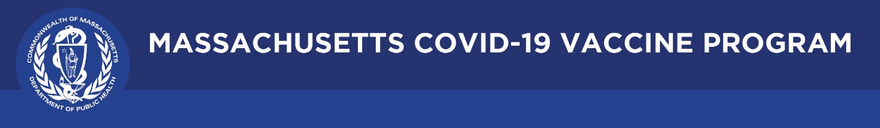

October 1, 2021

Dear Colleagues:

Happy Fall! We have new resources to share this week. We hope you find them helpful.

New COVID-19 Booster Information
Visit COVID-19 booster frequently asked questions for information about what boosters are, who is eligible, and how to get one. Individuals can check if they are eligible for a booster at mass.gov/BoosterCheck. Lots more on our new webpage: mass.gov/COVID19booster.

New What is a Vaccine Ambassador?
Read the new Mass Public Health Blog to learn about our Vaccine Ambassador Program and how to invite an Ambassador to present information or answer questions at a community meeting.

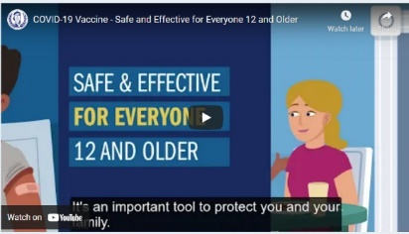
Reminder Animated video: COVID-19 Vaccine for 12+
With students back in school, we continue to emphasize that the COVID-19 vaccine is safe and effective for everyone 12 and older. Please share this video with your networks. It can be downloaded in multiple languages.

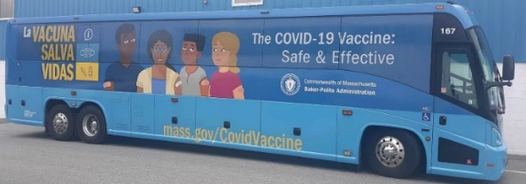
Reminder Mobile pop-up vaccination clinics
Mobile pop-up vaccination clinics are happening in cities and towns across MA - at community centers, parks, fire stations, and other locations. Find one near you: http://mass.gov/MobileVax

Thank you for all you are doing to promote vaccine safety and confidence!

