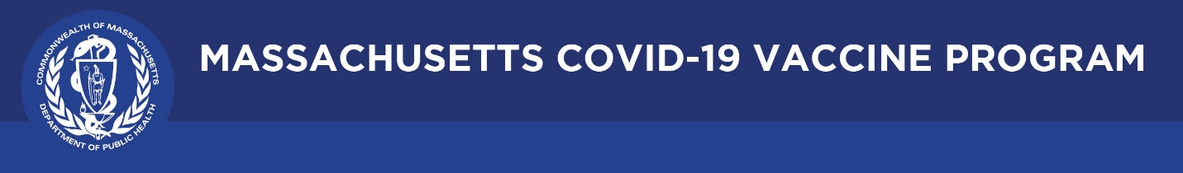

October 21, 2021

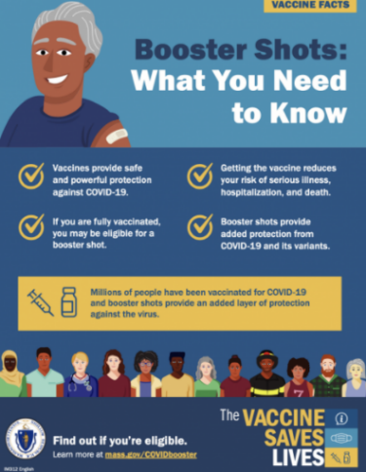
Dear Colleagues:

We hope you find this week’s resources to be helpful.

New Booster Shot Flyer
This updated flyer shares information about the importance of getting a booster shot when you’re eligible. Translated versions of this flyer will be available later this month.

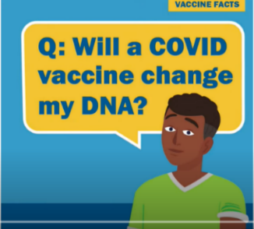
Reminder Vaccine Ads aimed at Young Adults
Our research with young adults in Massachusetts identified specific barriers to vaccination they wanted addressed. Our videos address them. Please share:
- You Can’t Get COVID-19 from the Vaccine
- The COVID-19 Vaccine will not Change Your DNA

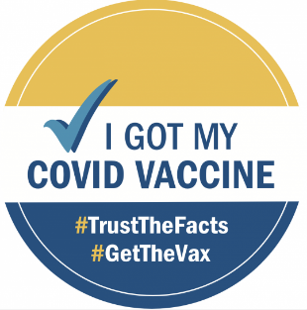
Reminder Requesting a Copy of Your COVID-19 Vaccination Record
Individuals who have misplaced their COVID-19 vaccination card can learn how to obtain a copy by visiting www.mass.gov/myvaxrecord.

Thank you for all you are doing to promote vaccine safety and confidence!

