October 7, 2021

Dear Colleagues:

We have new resources to share this week. We hope you find them helpful.
New Trusted sources PSA on boosters
Dr. Kimi Kobayashi of UMass Memorial Medical Center recorded a short video for us, recommending the COVID-19 vaccine and getting the booster shot when you’re eligible. Please use the video in your outreach.

New Booster checkbox online
On Vaxfinder, you’ll now find a box to check if you are looking specifically for a Pfizer booster dose.

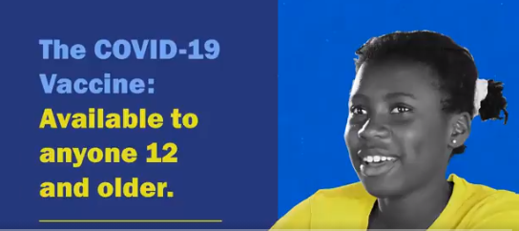
New Video: youth provide their reasons to get the shot
Why should young people be vaccinated against COVID-19? A new series of 15 sec videos stars youth in their own words. Here’s what one had to say. Here’s another. Share these videos with this page: COVID-19 vaccinations for people under age 18.

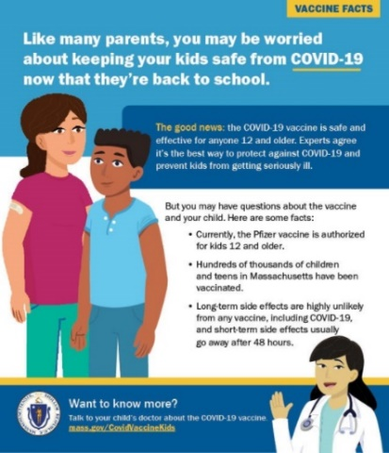
New Vaccine facts for parents
Download and share these two ads (see one at right) intended for a parent audience:
- COVID-19 Vaccine Facts for Parents
- COVID-19 Vaccine: Parent Questions

Thank you for all you are doing to promote vaccine safety and confidence!

