November 4, 2021

Dear Colleagues:

Here are the latest resources to share this week. We hope you find them helpful.

New Webpage for children ages 5-11
The FDA and CDC have just authorized Pfizer vaccination for children ages 5 to 11. Find the information including FAQs at COVID-19 vaccinations for children ages 5-11 | Mass.gov. Parents are encouraged to contact their health care provider for an appointment or visit VaxFinder.mass.gov where appointments are updated daily.

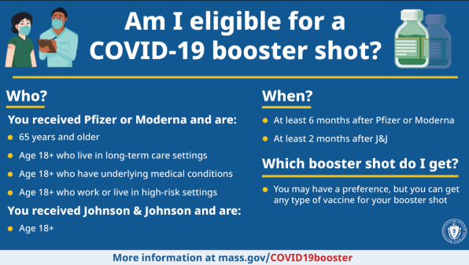
New Booster Eligibility Graphic
Use this new graphic, available in 11 languages, to determine if you’re eligible for a booster shot. Visit COVID-19 booster frequently asked questions for information about boosters.

New Reorganized Trust the Facts, Get the Vax website
We’ve reorganized the webpage housing the TV ads, animated
videos, and other materials for our public awareness campaign. Find a summary, toolkit, and videos and flyers by audience.

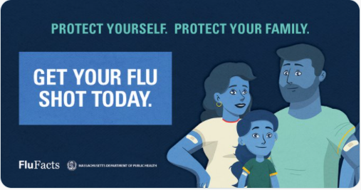
New Get your flu shot!
Flu season is here and our blue ‘smurf’ family is back. Please share with your networks and include a reminder that you can get a COVID-19 vaccine and a flu vaccine at the same visit. Go to www.mass.gov/flufacts for graphics, materials, and more.

Thank you for all you are doing to promote vaccine safety and confidence!

