March 12, 2021

Dear Colleagues:

We hope that you find these new communications resources helpful as we work together to provide consistent information and build trust in the COVID-19 vaccine.

New ‘Trusted Sources’ Video Project PSAs
DPH is inviting community leaders to self-record short, personal videos promoting trust in the COVID vaccine. Please share these videos via your social media networks using our #TrusttheFacts hashtag:
- Amy Pessia, Executive Director, Merrimack Valley Food Bank
- Rachel Rollins, Suffolk County District Attorney
- Dr. James Lederer, Chief Medical Officer, Berkshire Health Systems
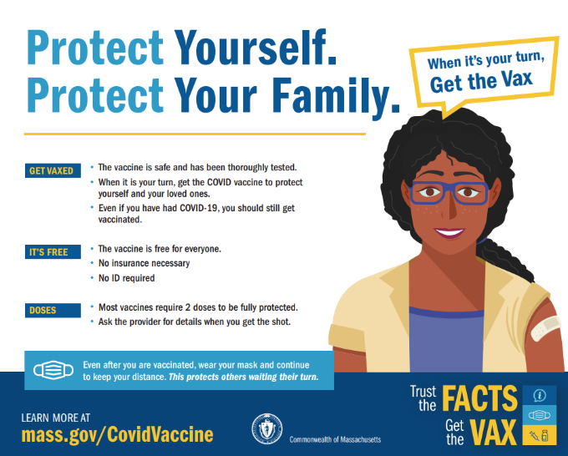
New Trust the Facts. Get the Vax. print ads
Print ads, developed as part of our multilingual public awareness campaign, were added to Trust the Facts, Get the Vax Campaign Materials | Mass.gov. Feel free to download the ads and use them in your materials and newsletters.

New Information for K-12 and childcare workers
Visit https://www.mass.gov/info-details/covid-19-vaccinations-for-k-12-educators-child-care-workers-and-school-staff for information about eligibility and appointment scheduling for this group.

New Materials for people who are 65+ or with 2+ certain medical conditions
- Frequently Asked Questions
- Vaccine Information for Individuals 65+ (flier)
- Vaccine Information for People with Certain Medical Conditions (flier)

Updated FAQ for the general public
This FAQ (available in 10 languages) has been updated to include the Johnson & Johnson (Janssen) vaccine. Translations of the revised version are in progress.

We hope you find these materials useful. Please share and forward as appropriate.

