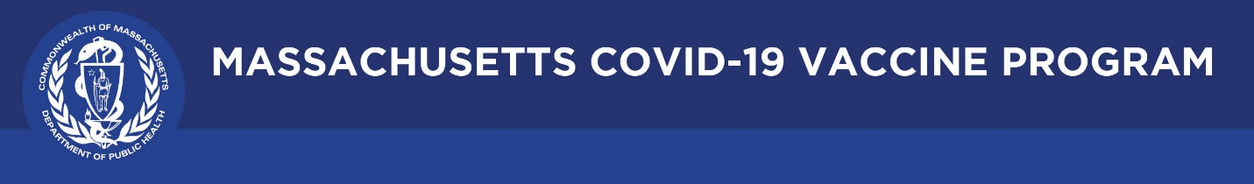

March 18, 2021

Dear Colleagues:

We have some new communications resources to share this week. We hope you find them helpful as we work together to promote vaccination across the Commonwealth.

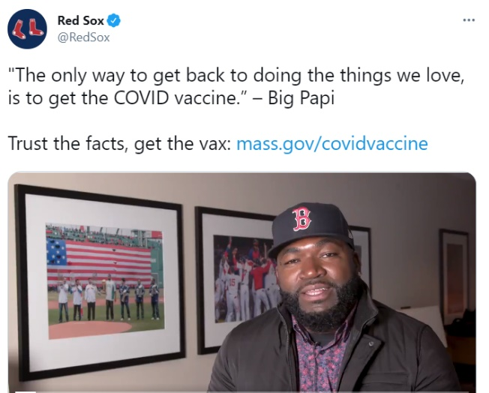
New ‘Trusted Sources’ Video Project PSAs
DPH is inviting community leaders to self-record short (one minute) videos promoting trust in the COVID vaccine. Please share via your networks using our #TrusttheFacts hashtag:
- David Ortiz (Big Papi), Boston Red Sox: English & Spanish
- Dr. Mattie Castiel, Commissioner for Health & Human Services, City of Worcester

Updated Eligibility graphics
Use these new graphics for your newsletters and social media showing COVID-19 vaccine eligibility dates for everyone who lives, works, or studies in Massachusetts.

Updated Vaccine Equity Initiative website
Visit COVID-19 Vaccine Equity Initiative | Mass.gov for the latest on the initiative in 20 of our hardest hit communities to increase equity in COVID-19 vaccine awareness and access.

New FAQ for certain workers eligible in Phase 2
Visit COVID-19 vaccinations for certain workers | Mass.gov for an FAQ and other COVID-19 vaccine eligibility requirements and information for workers in certain categories.

New Guidance for people who are fully vaccinated against COVID-19
Until more people are vaccinated, some prevention measures will continue to be necessary, even for individuals fully vaccinated. Review MA’s Guidance for people who are fully vaccinated against COVID-19.

New CDC ‘plain language’ materials in multiple languages
- Facts about COVID-19 Vaccines
- Communication Resources for COVID-19 Vaccines
- Myths and Facts about COVID-19 Vaccines
- Benefits of Getting a COVID-19 Vaccine

Thank you all for all you are doing to promote vaccine safety and confidence.

