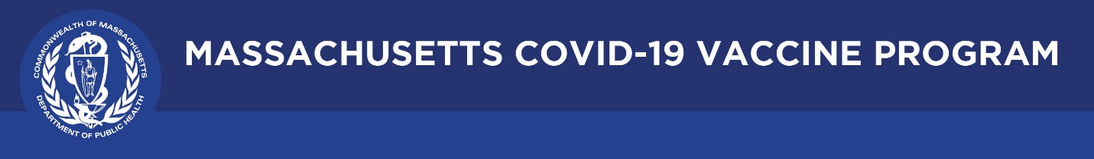

March 5, 2021

Dear Colleagues:

We hope you find these new communications resources helpful as we all work together to provide consistent information and build trust in the COVID-19 vaccine.

Key messages about the Janssen (Johnson & Johnson) vaccine
- We have reached a new milestone in the fight against the COVID-19 pandemic. The Johnson & Johnson vaccine has been approved for use by the FDA and the CDC.
- In US and global studies, the vaccine was safe and highly effective against severe disease, hospitalization and death. It provided 93% protection against hospitalization from COVID-19.
- The J&J vaccine requires only a single shot – so if you are offered J&J, you are “one and done” and don’t need to make a second appointment to return a month later for a second shot.
- The J&J vaccine is easier to transport and easier to store because it does not need to be frozen. This means more sites in more settings – like community clinics and mobile vans – can use this vaccine as supplies become available.
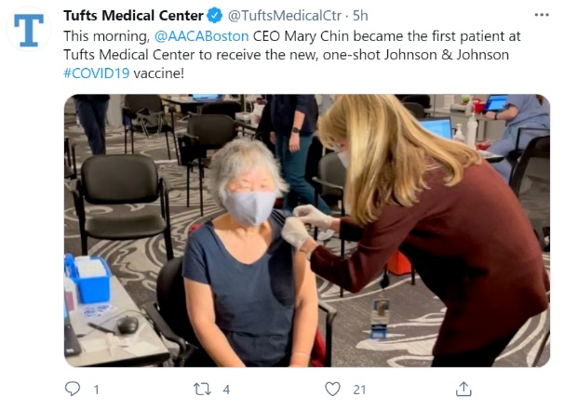
- The J&J vaccine was shown to be effective against the new COVID-19 variants, with research on the J&J vaccine conducted in countries with these more infectious variants including South Africa and Brazil. The Pfizer and Moderna vaccines also have considerable effectiveness against the variants.
- Adding the J&J vaccine to our toolbox means more people can get vaccinated, and get us all vaccinated faster, which increases the number of people protected from severe disease, hospitalization, and death from COVID-19.
- All three approved COVID-19 vaccines have been demonstrated to be safe and highly effective against serious illness, hospitalization, and death. The best vaccine is the one you can get access to. Residents are urged to take whatever shot they can, as soon as it’s available.
New website for the COVID-19 Vaccine Equity Initiative
The new Vaccine Equity initiative has its own website. Learn more about the effort to reach the 20 hardest hit communities in Massachusetts: COVID-19 Vaccine Equity Initiative | Mass.gov.

Multilingual COVID-19 materials
Visit Multilingual COVID-19 Materials | Mass.gov for resources in 10 languages related to stopping the spread of COVID-19.

