April 1, 2021

Dear Colleagues:

We have some new communications resources to share this week. We hope you find them helpful as we work together to promote vaccination across the Commonwealth.

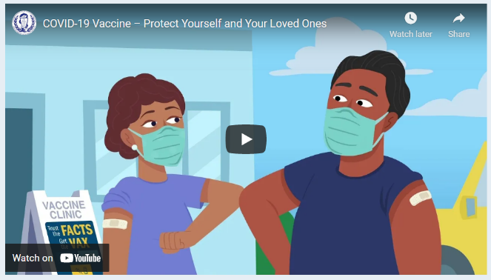
New Trust the Facts. Get the Vax. animated videos
Two new animated videos developed as part of our multilingual public awareness campaign, were added to Trust the Facts, Get the Vax Campaign Materials | Mass.gov. Feel free to use the videos in your outreach.
- COVID-19 Vaccine - What You Need to Know
- COVID-19 Vaccine - Protect Yourself and Your Loved Ones

New Guide to hosting a forum on the COVID-19 vaccine available in 10 languages
A guide for providers, community groups, and others to host meetings or local forums about the COVID-19 vaccine is now available in 10 languages. The guide includes information from DPH from commonly asked questions and encourages discussion and feedback.

Reminder Request a DPH Vaccine Ambassador
DPH COVID-19 vaccine ambassadors can attend community forums or meetings about the safety and development of the vaccine. Ambassadors are public health professionals with experience in community settings and speak 10 languages in addition to English. They can speak, answer questions, or listen to feedback to share with DPH. To date, ambassadors have attended 23 meetings with over 1,700 participants.

To request a DPH ambassador, please email miguel.arrechea@mass.gov with the following information:
- Date, time, and audience of the forum
- Desired role for the ambassador
- Language capacity or other important considerations

If possible, please request an ambassador at least two weeks before your forum. DPH will make every effort to fulfill requests.

Thank you all for all you are doing to promote vaccine safety and confidence.

