April 15, 2021

Dear Colleagues:

We have some new communications resources to share this week. We hope you find them helpful.

New Talking points about pausing the use of Johnson & Johnson COVID-19 vaccine
- On 4/13, the FDA and CDC announced a pause in the use of the one-dose J&J/Janssen vaccine because 6 people developed a rare but serious type of blood clot about 2 weeks after receiving the vaccine. A link between the vaccine and the blood clots has not been established.
- On 4/14, the Advisory Committee on Immunization Practices (ACIP) met to review the data and as of today 4/15, the pause in the use of J&J remains in effect.
- Individuals with appointments scheduled for a J&J vaccine that have questions about their upcoming appointment should contact the provider site they booked with directly. The site may be able to keep the appointment and provide a different type of vaccine, or the site may let individuals know that they will need to cancel or reschedule.
- Individuals who have received a J&J vaccine should contact their physician if they have concerns.
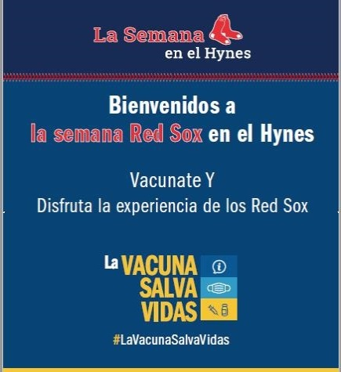
New Red Sox Week @ the Hynes - April 19-25
- The Command Center is working with a variety of partners on “Red Sox Week at the Hynes” to boost vaccine access for communities most disproportionately impacted by COVID-19. A total of 20,000 first dose appointments at the Hynes vaccination site in Boston are being booked for communities of color. Initial outreach is focused in Spanish. If you are able, please share this link in Spanish with your networks: https://www.cic-health.com/redsox/elmundo1
La Vacuna Salva Vidas = the Vaccine Saves Lives!
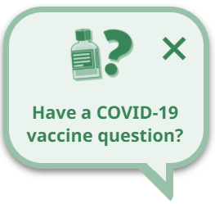
New Interactive Mass.gov Vaccine Chat Feature
- Our new vaccine helper is live on vaccine-related pages across mass.gov to help quickly answer questions about vaccine eligibility, appointments, safety, and more.

New ‘Trusted Sources’ PSA

- DPH is asking a variety of spokespeople to self-record :30 second videos promoting COVID vaccine trust. Our latest comes from Dr. Eduardo Haddad, Lawrence General Hospital. Please share these posts on your social media using our #TrusttheFacts hashtag.

Thank you for all you are doing to promote vaccine safety and confidence!

