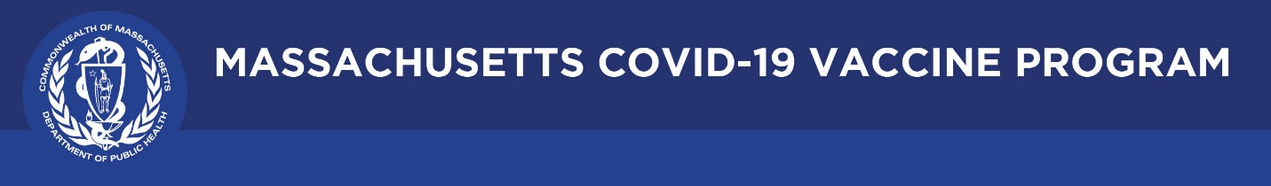

April 22, 2021

Dear Colleagues:

We have some new communications resources to share this week. We hope you find them helpful.

New Trust the Facts. Get the Vax TV ads go live today
Today we are launching new TV ads developed as part of our multilingual public awareness vaccination campaign. The first TV ad featured doctors addressing safety and effectiveness. The new ads are voiced by Massachusetts essential workers – a teacher, firefighter, grocery worker, and others speaking about the importance of vaccination. These have been added to Trust the Facts, Get the Vax Campaign Materials | Mass.gov. Feel free to use the videos in your outreach. View them here:
- English: Why I Got My COVID-19 Vaccine
- Spanish: La Vacuna Salva Vidas

New HRSA fact sheets: Care for Uninsured Individuals
These fact sheets outline patient and provider rights and responsibilities regarding access to COVID-19 vaccines, testing and treatment. These underscore that everyone is eligible for COVID-19 services, no matter their immigration status and you do not need a Social Security Number or government ID to receive free COVID-19 services.
- Fact Sheet for Patients - English - PDF | Español - PDF
- Fact Sheet for Providers - English - PDF | Español - PDF

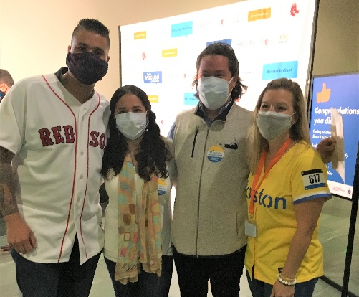
Reminder Red Sox Week @ the Hynes - April 19-25
“Red Sox Week at the Hynes” continues, focused on vaccine access for communities most disproportionately impacted by COVID-19. Outreach is in Spanish, Portuguese, and Chinese. Appointments are still available. This link can be shared in Spanish: https://www.cic-health.com/redsox/elmundo1.

(photo: former player Manny Delcarmen and Sox staffer Pam Kenn flank Red Sox ticket winners this week at the Hynes.)

Thank you for all you are doing to promote vaccine safety and confidence!

