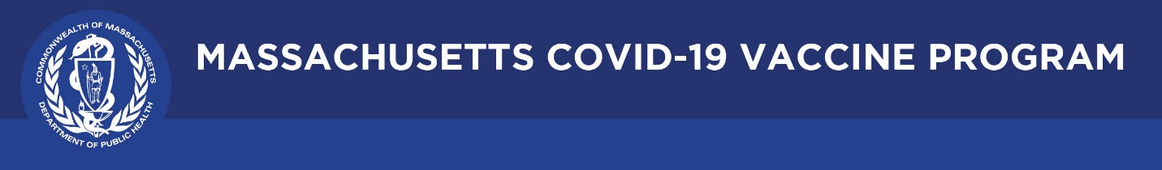

April 29, 2021

Dear Colleagues:

We have new resources to share this week. We hope you find them helpful.
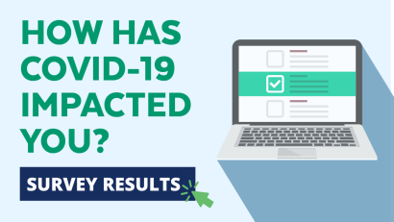
New Findings from our Community Impact Survey
Seven out of 10 Massachusetts workers experienced disruptions to their employment due to the COVID pandemic, including 10 percent who lost their jobs. New findings regarding employment were released yesterday from our DPH Community Impact Survey. Find them here: http://mass.gov/CovidSurvey.
New ‘Trusted Sources’ PSA
We have been recruiting a variety of spokespeople to publicly support COVID vaccination. In our latest video, Dr. Sharma Joseph, Tufts Medical Center, says, "No steps were skipped in the development of these vaccines. They’re all highly effective at keeping you out of the hospital and keeping you alive." Please share this link on your social media with hashtag #TrustTheFacts.
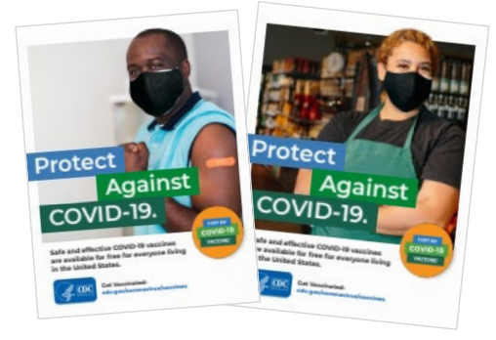
New Increasing COVID-19 Vaccine Uptake Among Members of Racial and Ethnic Minority Communities
This CDC guide includes strategies, interventions, and ready-made messages and materials, as well as information on how to connect with others to increase COVID-19 vaccination confidence and access in racial and ethnic minority communities.
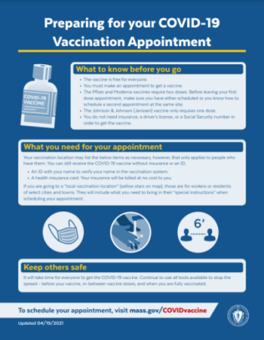

Reminder Flyer: Preparing for your Vaccine Appointment
This is a good handout to explain what you need to know before you head to your vaccine appointment, including the fact that the vaccine is free for everyone and you don’t need insurance, a driver’s license, or a Social Security number.
Download and share this flyer in your outreach.

Thank you for all you are doing to promote vaccine safety and confidence!

