April 8, 2021

Dear Colleagues:

We have some new communications resources to share this week. We hope you find them helpful.

New Updated Vaccine Equity Initiative website
The newly expanded Vaccine Equity Initiative website includes community-specific pages with breakdowns of grants, funding, and resources such as direct assistance with vaccine access, customized data, a dedicated DPH Community Liaison working with each city and town, and more.

New ‘Trusted Sources’ PSAs
DPH is asking a variety of spokespeople to self-record :30 second videos promoting COVID vaccine trust. Our latest come from:
- Grant Williams, Boston Celtics
- Kim Janey, Mayor of Boston

Please share these posts on your social media using our #TrusttheFacts hashtag.

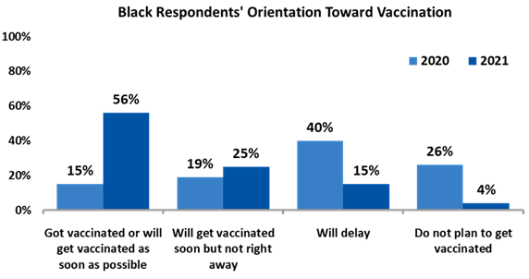
New Brand new research on vaccine confidence
In a new follow-up survey conducted for DPH and our partner MORE Advertising, vaccine confidence is up and the number of people who say they don’t plan to get vaccinated is down. The difference is even greater in Black and Latinx respondents.

(At right is just one snapshot from the survey by Market Street Research)

New Vaccine guide from the Center for Black Health & Equity
Use this informational guide for understanding immunization and the COVID-19 vaccine to:
- supplement your own research and start a dialogue with your friends and family members
- share accurate information on social media
- learn about the contributions of African American scientists and public health advocates helping to end the pandemic

Thank you for all you are doing to promote vaccine safety and confidence!

