May 13, 2021

Dear Colleagues:

Resources this week focus on the new eligibility of children ages 12-15. We hope you find them helpful.

New COVID-19 vaccination for youth ages 12+
Youth ages 12+ can now be vaccinated with the Pfizer COVID-19 vaccine.
- For details, including information on parental consent, and FAQs, visit mass.gov/vaccinesforYOUth.
- Youth age 12 and above may be preregistered beginning today at http://VaccineSignup.mass.gov.
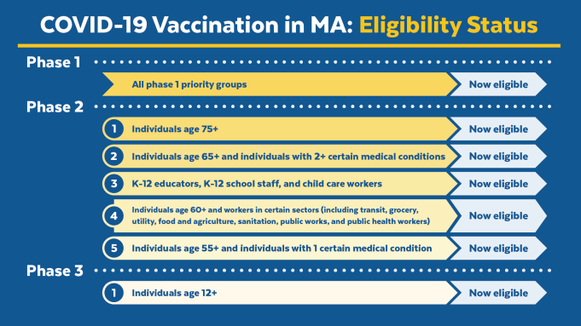
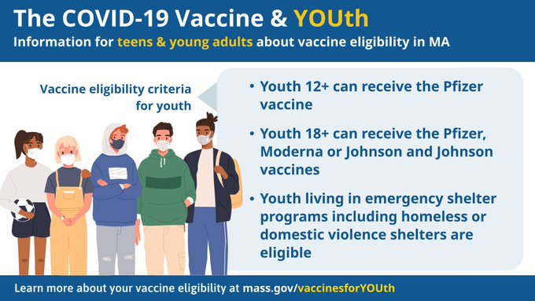
- Download our youth-related graphics for your messaging.

New Trusted Sources PSAs
We asked Dr. Carole Allen, newly-elected Massachusetts Medical Society president, to record a short video urging parents to get their children vaccinated. You can use the 30 second video in your messaging. Also, please share this link of Dr. Lloyd Fisher, President of the Mass Chapter of the American Academy of Pediatrics, and his daughter Caroline, who took part in the vaccine trials. On social, please use the hashtag #TrustTheFacts.
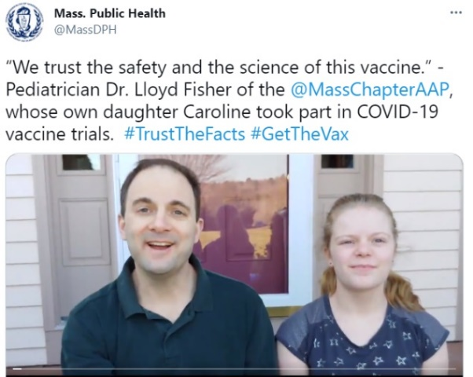

Thank you for all you are doing to promote vaccine safety and confidence!

