May 20, 2021

Dear Colleagues:

We have new resources to share this week. We hope you find them helpful.

New COVID-19 vaccine graphics for teens and young adults
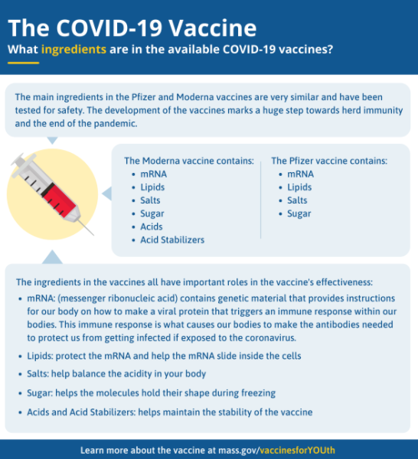
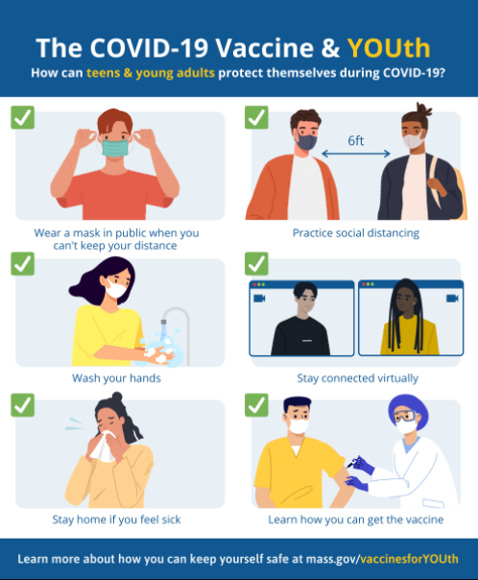
Download our youth-related graphics for your messaging, on topics such as: how teens can get the COVID-19 vaccine; ingredients in the vaccine; how teens can protect themselves during COVID-19, and how to cope with COVID-19 stress.

New Trusted Sources PSA
We asked Dr. Robyn Cohen, a pediatric pulmonologist at Boston Medical Center and mom of children ages 12 and 15, to record a short video that urges parents to get their children vaccinated. You can use the 30 second video in your messaging. On social, please use the hashtag #TrustTheFacts.

New CDC and AAP Resources for Parents and Adolescents
- COVID-19 Vaccines for Preteens and Teens is a printable fact sheet for parents that explains the benefits of a COVID-19 vaccine for their children, safety information, and what to expect during and after vaccination.
- COVID-19 Vaccines for Children and Teens provides information about the benefits of COVID-19 vaccines for adolescents aged 12 and older and what to expect during and after vaccination.
- This checklist can help parents as they prepare for their child's COVID-19 vaccination.

Thank you for all you are doing to promote vaccine safety and confidence!

