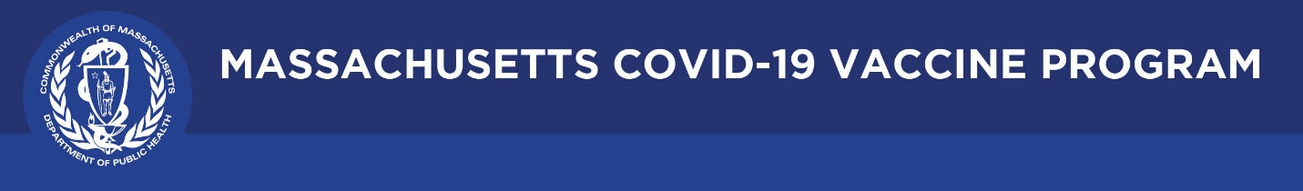

May 6, 2021

Dear Colleagues:

We have new resources to share this week. We hope you find them helpful.
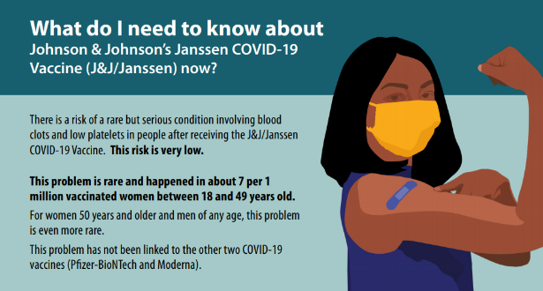
New CDC fact sheets about Johnson & Johnson (J&J)
These can be used by providers or with the public to discuss the safety of the J&J COVID-19 vaccine following the CDC and FDA recommendation to resume use after a temporary pause. Available data indicates the vaccine’s very large benefits outweigh its very small risks.
- For the public: What do I Need to Know about J & J COVID-19 Vaccine Now?
- For providers: Talking to Your Patients About the Safety of Janssen Vaccine

New Best Practices for Community and Faith-based Organizations
This two-page overview of strategies from the CDC can be used to ensure access, cultural appropriateness, language sensitivity, community involvement, and support.

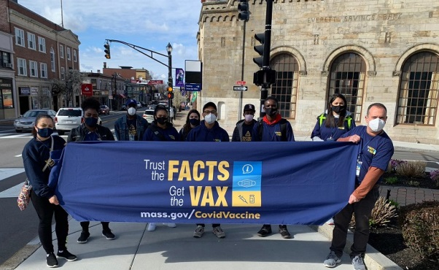
New Vaccine Equity Initiative Highlights
You can now see a snapshot of highlighted activities, photos from the field, and news clips about the efforts in our 20 priority communities to improve awareness and access to COVID vaccination. Visit the highlights page to learn more.
(photo: the team fans out in Everett)

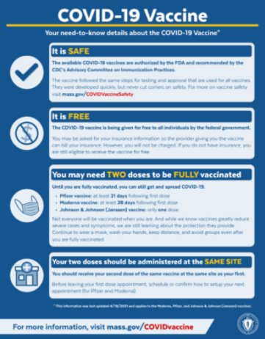
Reminder Fliers, posters, graphics: COVID-19 vaccine need-to-know details
These materials explain the key details about the COVID-19 vaccines, including that the vaccines are safe, free, and that two doses may be required. Download and share these materials in your outreach.

Thank you for all you are doing to promote vaccine safety and confidence!

