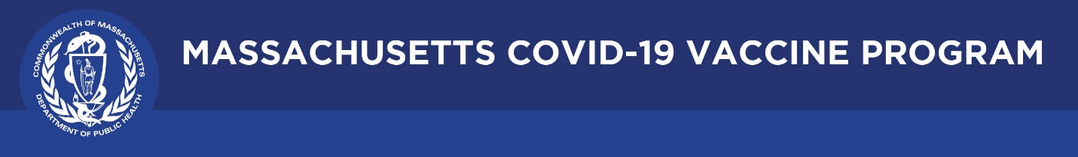

June 10, 2021

Dear Colleagues:

We will continue to share new COVID-19 vaccine resources on a regular basis. We hope you find them helpful and can share them with others working to increase vaccination in Massachusetts.
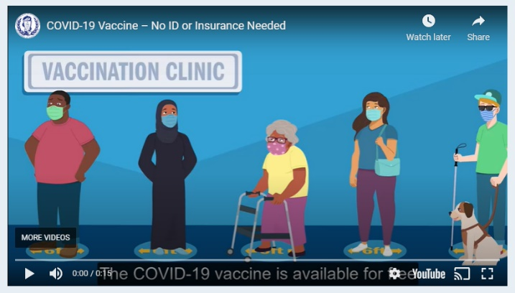
New Animated Video - No ID or Insurance Needed
Use this video to spread the word. Flyers can also be downloaded from mass.gov and posters can be ordered at the Public Health Clearinghouse at no cost.

New Editable COVID-19 Vaccination Clinic Flyer
Download and customize this flyer to promote a vaccination clinic.
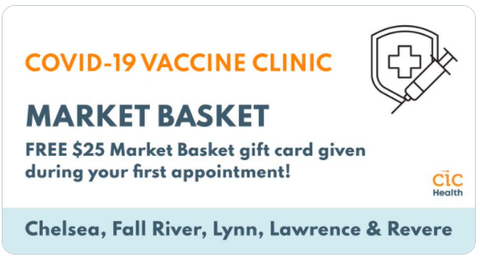

New Get Vaccinated at Market Basket!
Anyone getting the COVID-19 vaccine at a Market Basket mobile clinic in Chelsea, Fall River, Lawrence, Lynn, and Revere will receive a $25 gift card. Other cities being added. Walk-ins are welcome, and no appointment, ID, or insurance is necessary. Learn more at http://bit.ly/3uJZmcn.

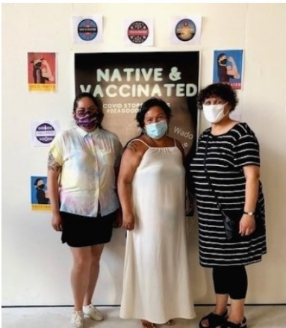
New Highlights from the Vaccine Equity Initiative
Visit COVID-19 Vaccine Equity Initiative Communities to see what's happening. This week, the North American Indian Center of Boston held a mobile vaccine clinic in Jamaica Plain with the Native American Lifelines Title 5 Urban Indian Health Services and DPH.

New Updated COVID-19 Travel Information
If you are fully vaccinated, you can resume pre-pandemic activities including travel within the United States. Learn more at COVID-19 Travel | Mass.gov.

Thank you for all you are doing to promote vaccine safety and confidence!

