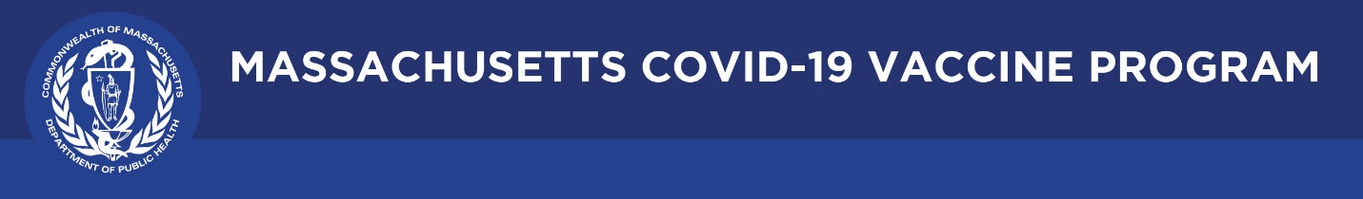

June 17, 2021

Dear Colleagues:

We have new resources to share this week. We hope these are helpful.
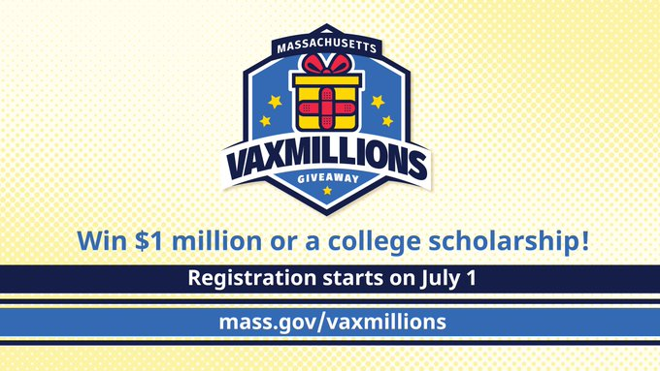

New Massachusetts VaxMillions Giveaway
Help spread the word about VaxMillions. Beginning July 1, eligible residents 18+ may enter to win one of five $1 million cash prizes, and eligible residents ages 12-17 may enter for the chance to win one of five $300,000 scholarship grants. Learn more at http://mass.gov/VaxMillions.
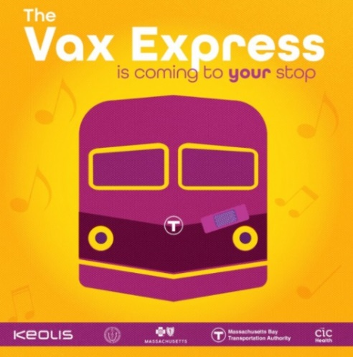
New All Aboard the Vax Express
Please let your community networks know about the Vax Express making stops along the MBTA Commuter Rail in communities with low vaccination rates. Walk-ins are welcome. Free food, music, and $25 grocery store gift cards with each vaccination. Details can be found here: https://www.cic-health.com/vaxexpress

New CDC Social Media Toolkit
CDC’s Social Media Toolkit includes digital resources and sample messages for Facebook, Instagram, and Twitter. Topics include:
- About the COVID-19 vaccines
- Benefits, safety, and effectiveness
- What to expect after vaccination
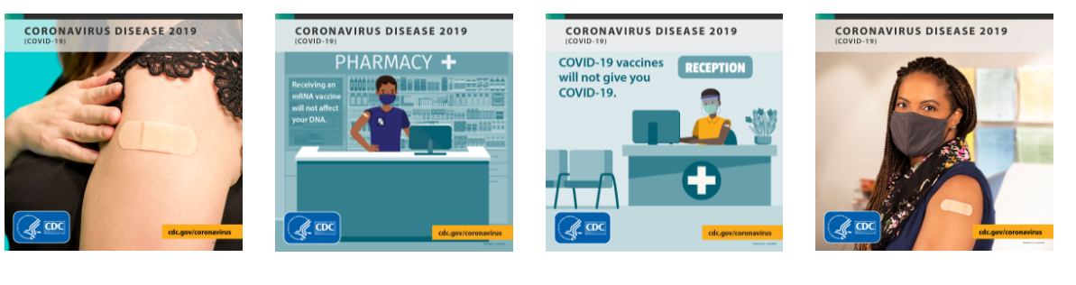

Thank you for all you are doing to promote vaccine safety and confidence!

