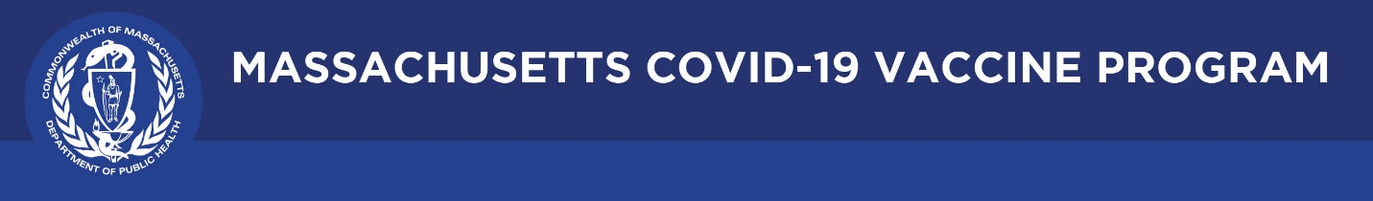

June 24, 2021

Dear Colleagues:

Below are new resources to share that we hope you find helpful.

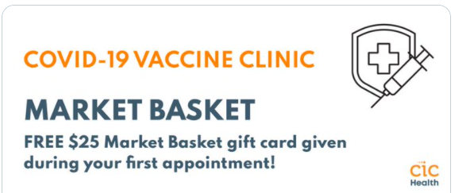
Reminder Get Vaccinated at Market Basket!
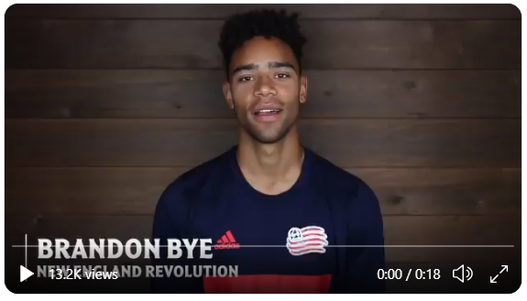
Anyone getting the COVID-19 vaccine at a Market Basket mobile clinic in Chelsea, Fall River, Lawrence, Lynn, New Bedford, and Revere will receive a $25 gift card. New dates are being added. Walk-ins are welcome, and no appointment, ID, or insurance is necessary. Learn more at http://bit.ly/3uJZmcn.

New Trusted Sources PSA
We asked the New England Revolution to record a short video for us and they delivered. Brandon Bye says: “My teammates and I got vaccianted to protect ourselves, our family, and others.” Use this 20 second video in your social media messaging with hashtag #TrustTheFacts.

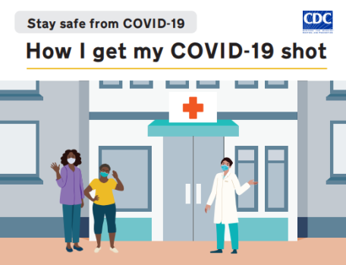
New For People with Intellectual, Developmental Disabilities
The CDC has released new COVID-19 vaccine materials for people living with intellectual and developmental disabilities who have low literacy.
- How I get my COVID-19 shot: Simple illustrations and easy-to-read messages to explain how to get a COVID-19 vaccine.
- Promotional toolkit: sample social media posts, email content, and images for sharing with your networks.

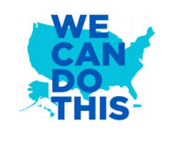
New HHS for COVID-19 Vaccine Campaign Toolkit Webinars
The HHS We Can Do This campaign offers tailored resources and toolkits to provide vaccine information. The webinars walk through how to use the campaign tools for vaccine outreach efforts.
- June 29, 1-1:30 pm: Faith-Based Toolkit
- July 1, 1-2 pm: Toolkits for Racial and Ethnic Minority Communities
- July 8, 1-1:30 pm: Older Adults Toolkit

Thank you for all you are doing to promote vaccine safety and confidence!

