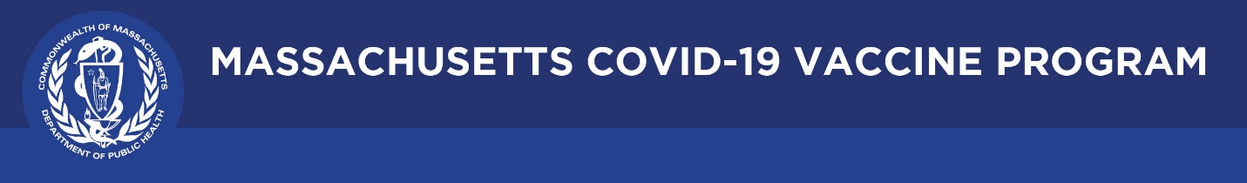

June 3, 2021

Dear Colleagues:

We will continue to share new COVID-19 vaccine resources on a regular basis. We hope you find them helpful and are able to share them with others working to increase vaccination in Massachusetts.
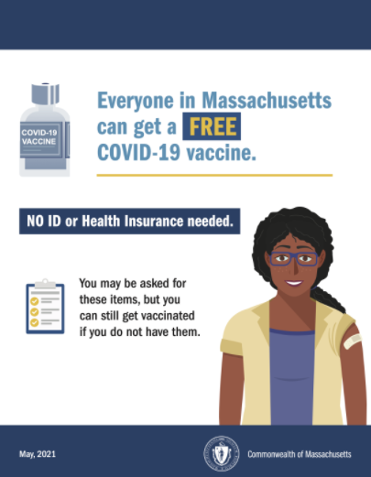
New Flyer No ID or health insurance
Please spread the word that the COVID-19 vaccine is free, and no ID or insurance is required to get vaccinated. Flyers can be downloaded from mass.gov and posters can be ordered from the Public Health Clearinghouse at no cost.

Reminder Request a DPH COVID-19 Vaccine Ambassador
DPH ambassadors can attend community forums or meetings to share information about the safety of and access to the vaccine. They can speak, answer questions, or listen to feedback to share with DPH. To invite a DPH ambassador to your forum, please complete this form.

New Trust the Facts Creative Toolkit
This creative materials toolkit gathers all the creative assets ASG and MORE Advertising have developed for our statewide vaccine campaign. This toolkit of creative assets includes flyers, social media graphics and sample posts, doorknob hangers, videos and more. Use them with your constituents and communities.

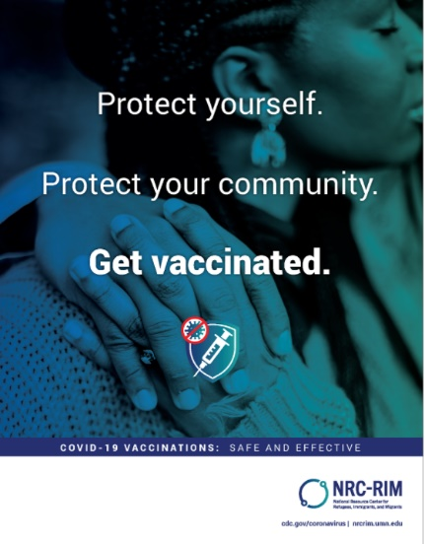
New Materials for refugees, immigrants, and migrants
The National Resource Center for Refugees, Immigrants, and Migrants (NRC-RIM), funded by the CDC, has free, customizable and translated campaigns for anyone to use. Materials are in 30+ languages that are representative of refugee populations living in Massachusetts. Visit Stop COVID-19 – Vaccine education and outreach materials | Mass.gov.

Thank you for all you are doing to promote vaccine safety and confidence!

