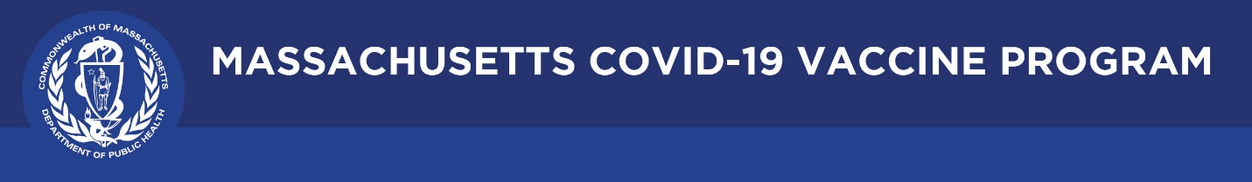

July 1, 2021

Dear Colleagues:

We have new resources to share this week. We hope you find them helpful.

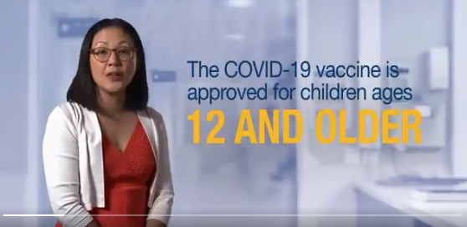

**New Pediatrician video**

Please share the [latest TV spot](https://www.youtube.com/watch?v=PB_I2P7K8nA) for our **Trust the Facts Get the Vax** public awareness campaign. It features pediatricians talking about the need to vaccinate young people age 12 and older.

**New Fact sheet: Ways to Increase COVID-19 Vaccination**

This [factsheet](https://www.mass.gov/doc/ways-to-increase-covid-19-vaccination/download) reiterates that flexible vaccination clinic options, education and awareness materials, and engagement supports are available to groups and individuals in Massachusetts to support increasing vaccine awareness and access. Please share with your networks.

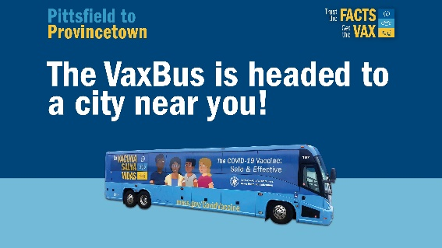

**New The VaxBus** **is headed to a city near you!**

Help promote the VaxBus – a convenient way to get a Pfizer or J&J vaccine. This mobile vaccination bus clinic is making stops in cities across the state, from Pittsfield to P-town. Walk-ins welcome. Check out the full schedule: [mass.gov/VaxBus](https://www.mass.gov/vaxbus).

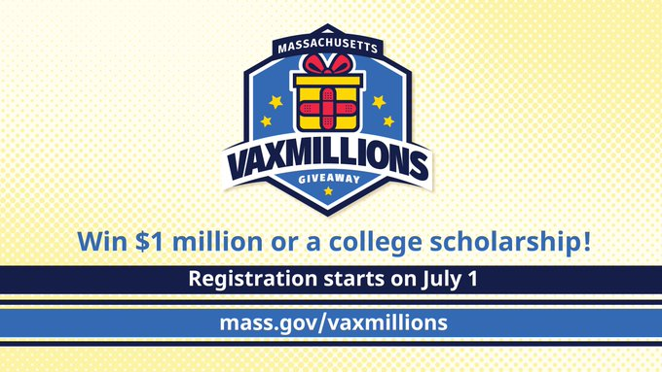

**Reminder Massachusetts VaxMillions Giveaway**

Spread the word about VaxMillions. As of today (July 1), eligible residents can register to win one of five $1M cash prizes or one of five $300K scholarship grants. TV, radio, and billboard ads will begin soon. Share the link to register: [mass.gov/VaxMillions](https://t.co/PJYBBDdGbF?amp=1)

*Thank you for all you are doing to promote vaccine safety and confidence!*