July 22, 2021

Dear Colleagues:

We have new resources to share this week. We hope you find them helpful.
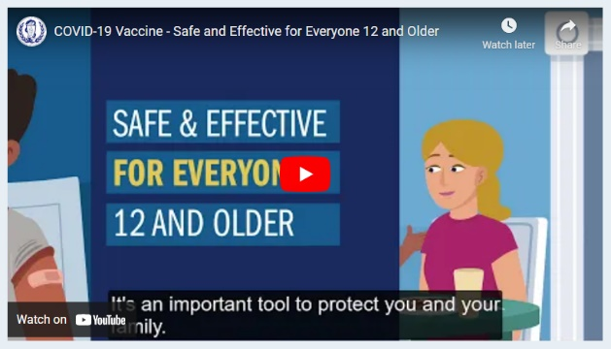

New Trust the Facts Get the Vax animated video
This short animated video, available in 10 languages, highlights vaccine safety and effectiveness for everyone 12 and older. It encourages parents to include their kids in the discussion and get advice from their doctor about the vaccine.

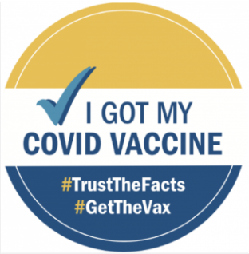

Reminder Free Vaccination Stickers for Clinics and Providers
You can order free Trust the Facts, Get the Vax “I Got My COVID Vaccine” Stickers in English and Spanish. Order here: https://massclearinghouse.ehs.state.ma.us/PROG-BID/COVIDVax.html

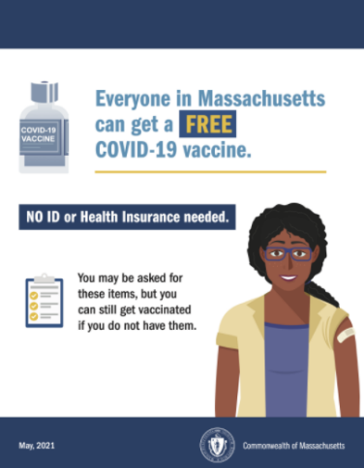
Reminder No ID or health insurance resources
Please spread the word that the COVID-19 vaccine is free, and no ID or insurance is required to get vaccinated.
- Posters and flyers are available at no cost from the MA Health Promotion Clearinghouse.
- Flyers can also be downloaded from mass.gov.
- Use this animated video in your messaging.

New Digital Toolkit: Stopping the Spread of Misinformation
The fight against COVID-19 is also a fight against misinformation. Stronger—a national advocacy campaign—has created a digital toolkit for addressing misinformation about science, medicine, and vaccines on social media.

Thank you for all you are doing to promote vaccine safety and confidence!

