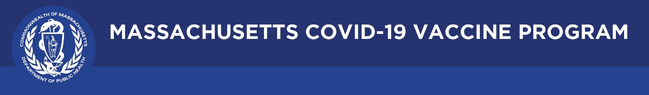

**This issue is a “how-to” for promoting a vaccine clinic**
July 29, 2021

Dear Colleagues:

To help spur larger turnouts for your clinics, including mobile ‘pop-up’ clinics, see our tips below. Find all you need in our Trust the Facts kit – posters, print ads, bodega signs, door hangers, social media graphics and more, in multiple languages here: https://www.mass.gov/doc/creative-materials-toolkit-trust-the-facts-get-the-vax/download.

We hope you find these tips and suggestions helpful. Please share with your local partners!

Ideas to promote your vaccination clinic or event:
- Post a message to your social media (download graphics at the link above) and ask all partners to do the same. Sample:
Hello, New Bedford! COVID-19 vaccination is coming to you! Our mobile clinic will be at the Ryder Street Parking Lot July 30-31 from 10am to 2pm. It’s easy, free, and no appointment, ID, or insurance is needed. More info/full schedule here: URL
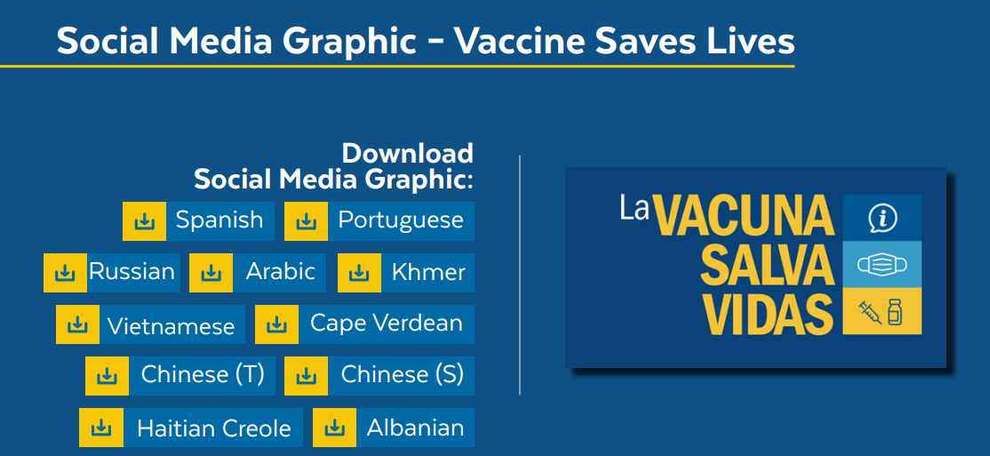
- Send out the same message above in a mass email to community members and listservs
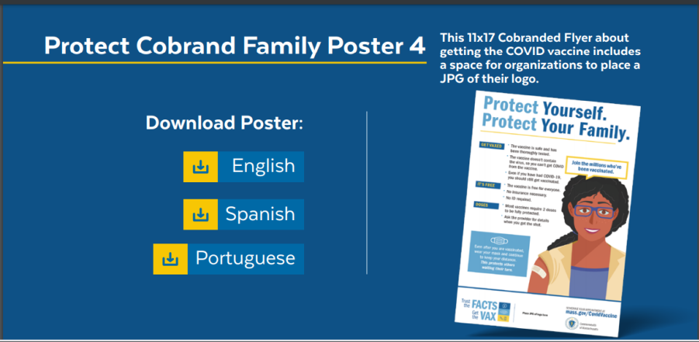
- Put up posters in heavily trafficked areas. (You can use generic Trust the Facts Get the Vax flyers like the one below and add your logo)
- Place inserts in bulletins, local newspapers, newsletters
- Conduct interviews with local media outlets to get out the word
- If funding is available:
  - consider paid PSAs on social media
  - Print and mail or hand-deliver postcards, flyers, or letters with clinic-specific information
Partners to help spread news and information:
- Elected officials with large networks who have ways to share information
- Trusted community members/leaders e.g., pastors, rabbis, community health center staff, local food bank or social service agency leaders.
- Members of your organization connecting with their personal networks
- Vaccinated community members helping to reach others
- Local newspaper, radio, and cable television outlets
- Neighborhood groups, e.g., Next Door
- Local chambers of commerce or school groups
- Community- and faith-based organizations (with at least one week’s notice)
- Local businesses, e.g., nail salons, barber shops, grocery stores, and local nonprofits
Additional outreach ideas
- Offer vaccination information at community events (partner with health care providers or DPH Vaccine Ambassadors).
- Provide vaccine encouragements at community centers/events; places of worship; retail centers; restaurants; and other places people gather.
- Partner with community organizations to staff phone banks and canvass neighborhoods.
- Partner with popular restaurants, eateries, or bars to offer incentives to get vaccinated.
- Adapt key CDC messages to the language, tone, and format that will resonate with your organization.
- Employers: print copies of CDC posters or Massachusetts posters and use them as handouts or post them in highly visible places in your offices, buildings, and other employee locations.
- Order COVID-19 vaccine posters and stickers from the MA Health Promotion Clearinghouse.

Thank you for all you are doing to promote vaccine safety and confidence!

