

August 19, 2021

Dear Colleagues:

We have new resources to share and hope you find them helpful.

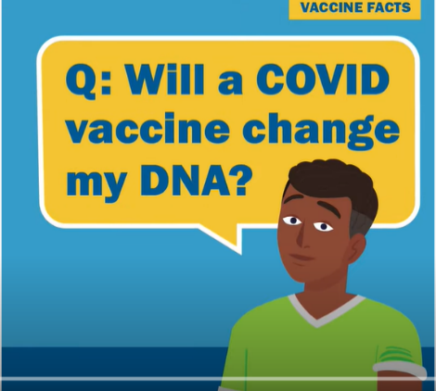

**New Vaccine Ads aimed at Young Adults**

Two new vaccination videos were recently launched that address barriers identified by young adults:

* [You Can’t Get COVID-19 from the Vaccine](https://www.youtube.com/watch?v=ROCPUGrUOWw)
* [The COVID-19 Vaccine will not Change Your DNA](https://www.youtube.com/watch?v=V0RpTWFHqbQ)

**New** **Mobile Vax Webpage**

****We launched a new webpage listing community-based, short-term vaccination clinics and how to find one near you: [mass.gov/mobilevax](https://www.mass.gov/info-details/covid-19-mobile-pop-up-vaccination-clinics).

**New Translated Fact Sheets: Ways to Increase COVID-19 Vaccination**

This factsheet outlines vaccination clinic options, awareness materials, and engagement ideas for groups and individuals to help increase vaccine awareness and access. Now available in [12 additional languages](https://www.mass.gov/info-details/covid-19-vaccine-equity-initiative-communications-materials). Please share with your networks.

**New CDC Key Talking Points on COVID-19 Vaccination during Pregnancy**

CDC recommends COVID-19 vaccination for all people aged 12 years and older, including people who are pregnant, breastfeeding, trying to get pregnant now, or might become pregnant in the future. Review these [key messages and talking points](https://cdn.ymaws.com/www.immunizationmanagers.org/resource/collection/49107373-8424-42C5-9A82-882C58A2CC10/PartnerKM_COVID-19vax_Pregnancy.pdf) for partners.

**New HHS Statement about Booster Shots**

On 8/18, public health and medical experts from the U.S. Department of Health and Human Services (HHS) released a [statement](https://www.hhs.gov/about/news/2021/08/18/joint-statement-hhs-public-health-and-medical-experts-covid-19-booster-shots.html) on the Administration’s plan for COVID-19 booster shots this fall. Stay tuned for more information from the FDA and CDC.

*Thank you for all you are doing to promote vaccine safety and confidence!*