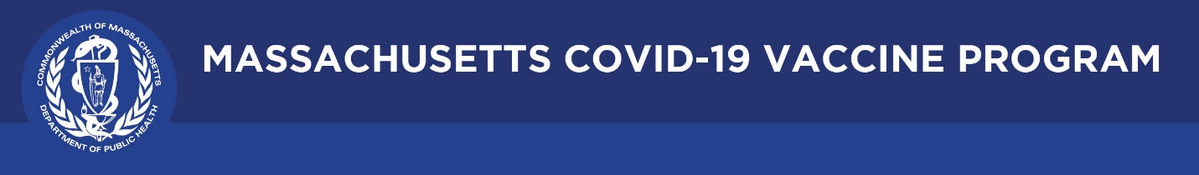

August 26, 2021

Dear Colleagues:

We have new resources to share this week. We hope you find them helpful.

New Press Release: FDA Approves the Pfizer COVID-19 Vaccine
The FDA approved the Pfizer COVID-19 Vaccine for the prevention of COVID-19 disease in individuals 16 years of age and older. The vaccine continues to be available under emergency use authorization (EUA) for individuals 12-15 years of age and for a third dose in certain immunocompromised individuals.

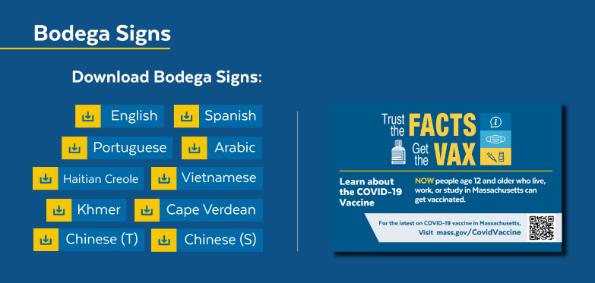
Reminder Trust the Facts Creative Toolkit
This toolkit gathers all the creative assets developed for our statewide vaccine campaign, including flyers, social media graphics and sample posts, bodega signs, doorknob hangers, videos and more. Download them to use with your constituents and communities.

Reminder Vaccination at Home is available We are committed to meeting folks where they are to deliver COVID-19 vaccines. The In-Home Vaccination Program is available free to anyone unable to get to a vaccine location. Learn more: http://bit.ly/3qnYUzN

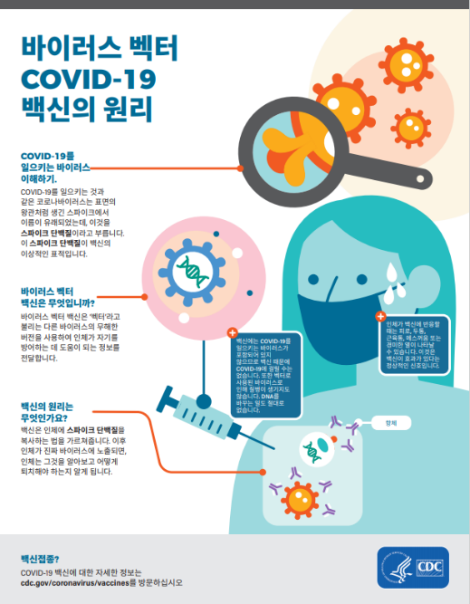
New CDC and FDA Factsheets in 26 Languages
Medline Plus houses the COVID-19 Vaccine Emergency Use Authorization factsheets and other CDC factsheets (e.g., How mRNA COVID-19 Vaccines Work) in 26 languages.

New FDA Video about COVID-19 Vaccine Safety and Diversity
FDA developed a video about COVID-19 vaccine safety and the diversity of the researchers and scientists developing vaccines. The video is in multiple languages, including American Sign Language.

Thank you for all you are doing to promote vaccine safety and confidence!

