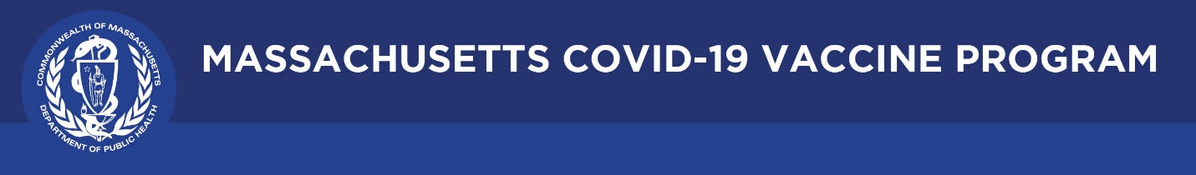

August 5, 2021

Dear Colleagues:

We have new resources to share this week. We hope you find them helpful.

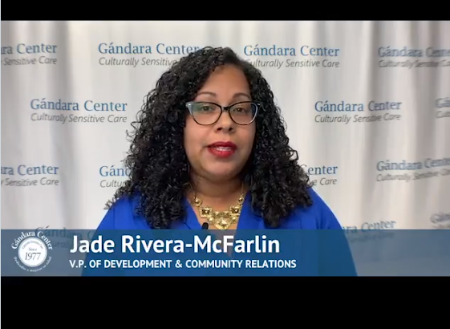
New Trusted Sources PSA
Attention Springfield area! We asked local leader Jade Rivera-McFarlin of the Gándara Center to record a video encouraging vaccination and she cited her personal reasons for getting the vaccine. You can use the 45 second video on social media using the hashtag #TrustTheFacts.

Reminder MassNotify
MassNotify works through smartphones to alert users who may have been exposed to COVID-19. This is an opt-in tool and MassNotify codes contain no personal information or location data and are completely anonymous. You can enable MassNotify on your iPhone or Android phone to add another tool to our fight against the spread of COVID-19. Learn more at www.mass.gov/massnotify.

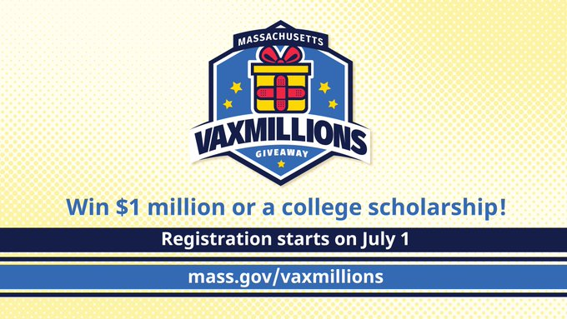
Reminder Massachusetts VaxMillions Giveaway
The second-round winners were announced today! Eligible residents can still register for the remaining drawings to win a $1M cash prize or a $300K scholarship grant. Please continue to help spread the word about VaxMillions by sharing the link to register: mass.gov/VaxMillions.

Thank you for all you are doing to promote vaccine safety and confidence!

