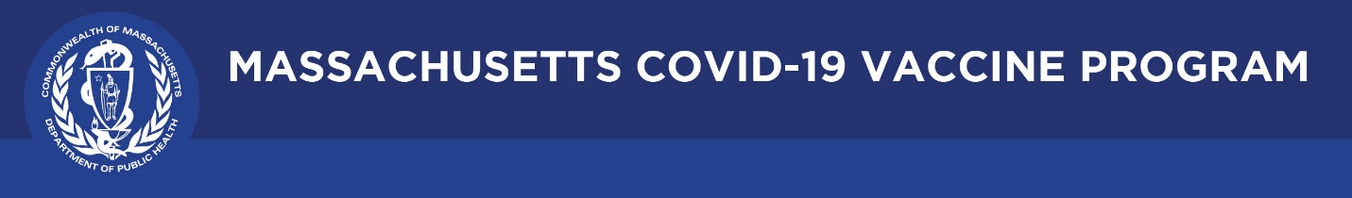

September 16, 2021

Dear Colleagues:

We have new resources to share this week. We hope you find them helpful.

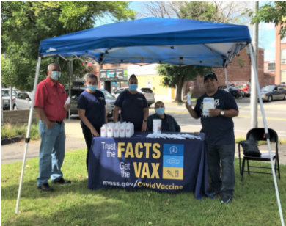
New Share successes from the COVID-19 Vaccine Equity Initiative
Check out the latest highlights of vaccine efforts in our 20 priority communities to improve awareness and access to COVID-19 vaccination.

New Materials for people with intellectual and developmental disabilities
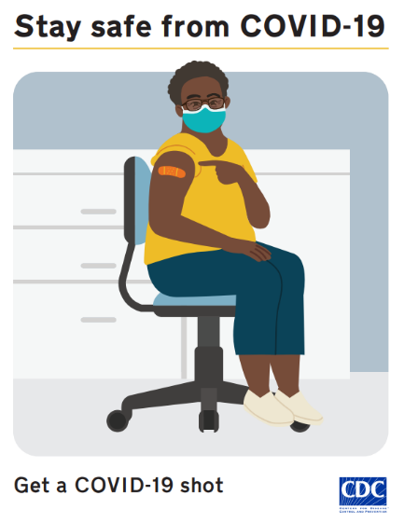
CDC created videos, posters, social stories, and interactive activities for people with intellectual and developmental disabilities and care providers. Materials (also available in Spanish) cover: getting the COVID-19 shot, washing your hands, getting a COVID-19 test, masking, and social distancing.

Reminder Materials for refugees, immigrants, and migrants
The National Resource Center for Refugees, Immigrants, and Migrants (NRC-RIM), funded by the CDC, has free, customizable and translated campaigns for anyone to use. Materials are available in 30+ languages that are representative of refugee populations arriving in the US and living in Massachusetts.

Reminder Trusted Sources PSA
As students return to school, we have recruited physicians including Dr. Frinny Polanco Walters of Boston Children’s Hospital to encourage 12+ vaccination. Please share this video with your networks.

Thank you for all you are doing to promote vaccine safety and confidence!

